Search strategy

PubMed (last search: 09th January 2020)
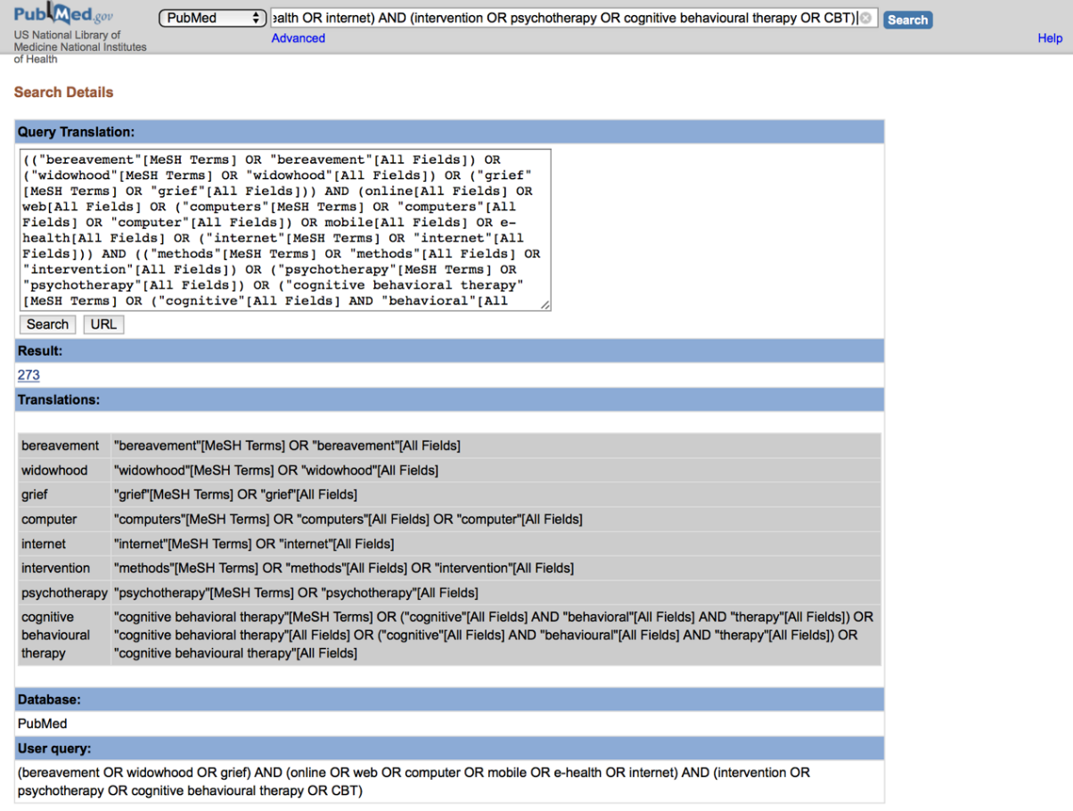

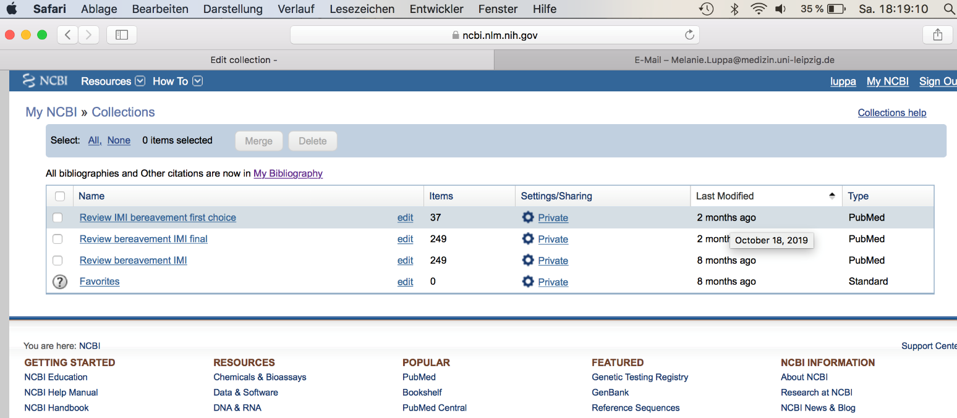

Cochrane Central Register of Controlled Trials (last search: 12th January 2020)



