Supplementary Material

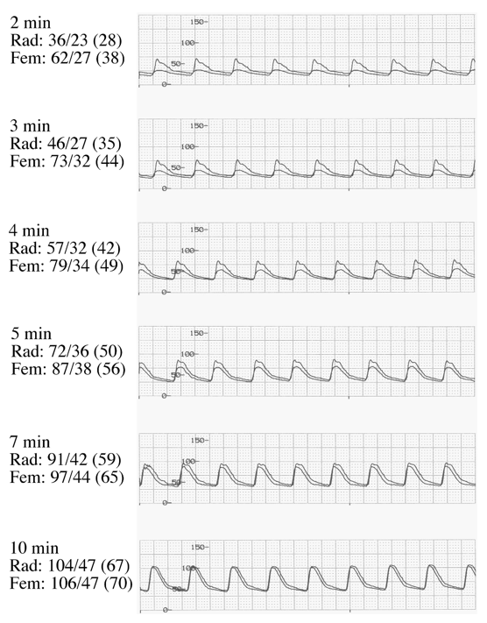

Supplement Figure 1.
Peripheral vs Central Arterial BP Monitoring. Example of BP discrepancy between femoral arterial and radial arterial BP during period of hemodynamic instability following severe post-reperfusion syndrome. (Brackets denote MAP). Provided courtesy of A. De Wolf ³¹

