Appendix S4 - Risk of Bias included studies

Head of bed elevation (n=5)
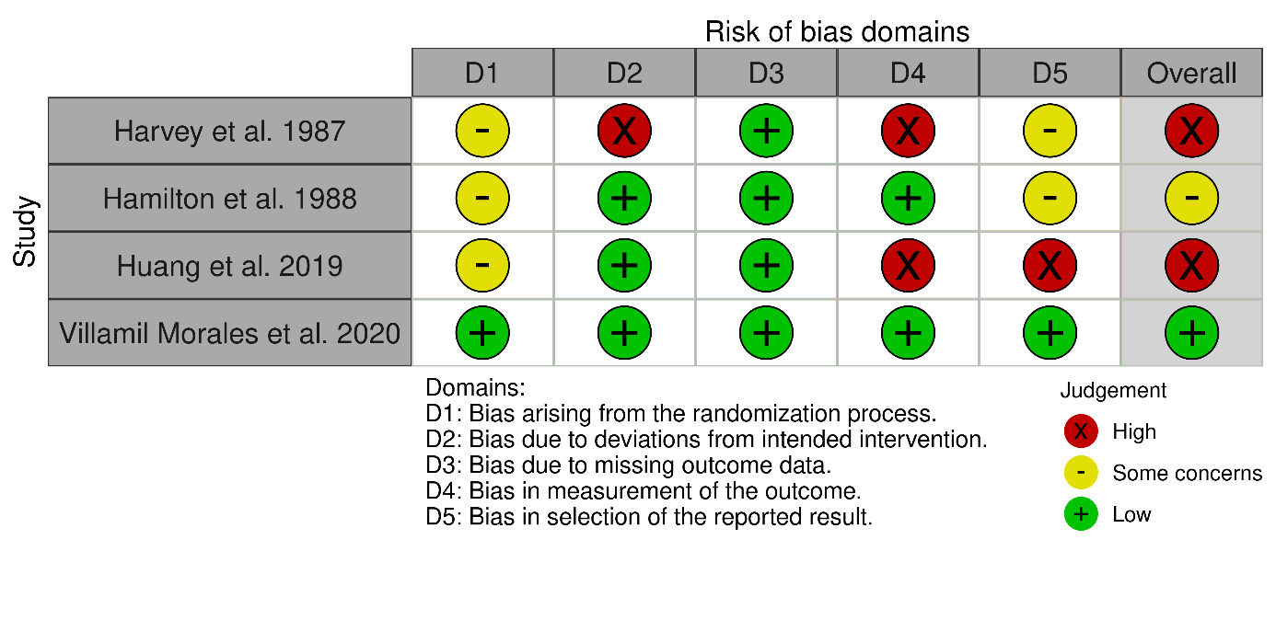
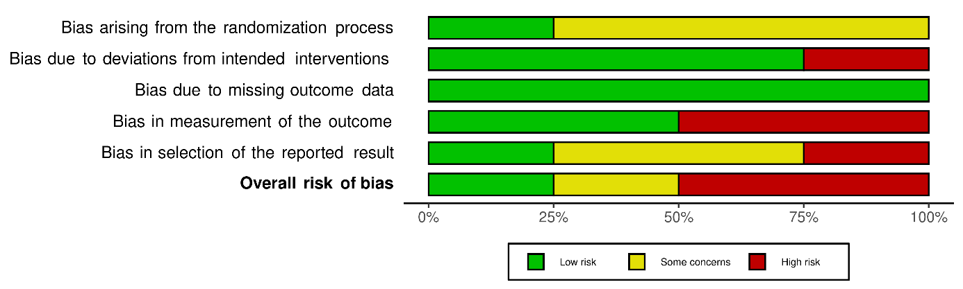
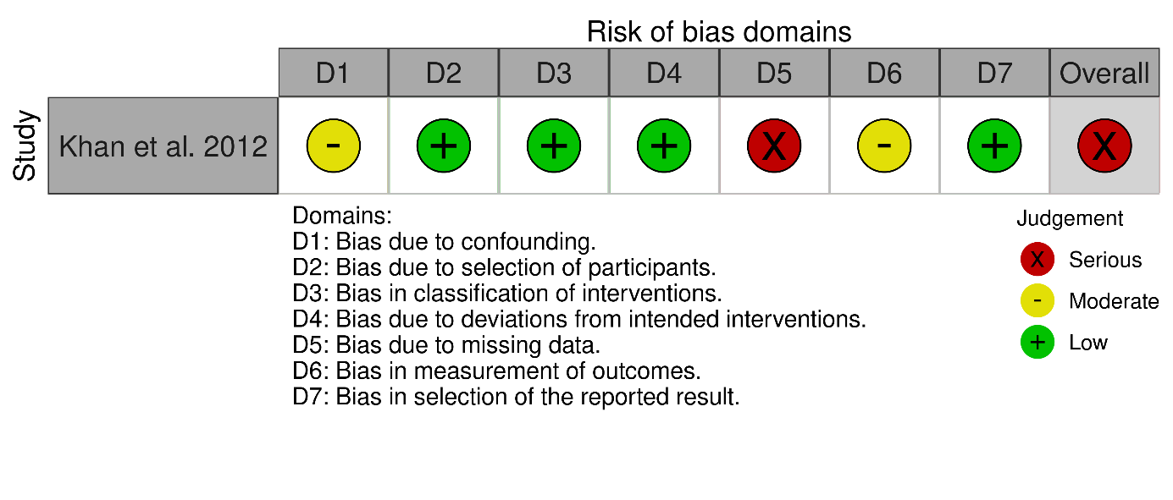

Early versus late dinner (n=2)

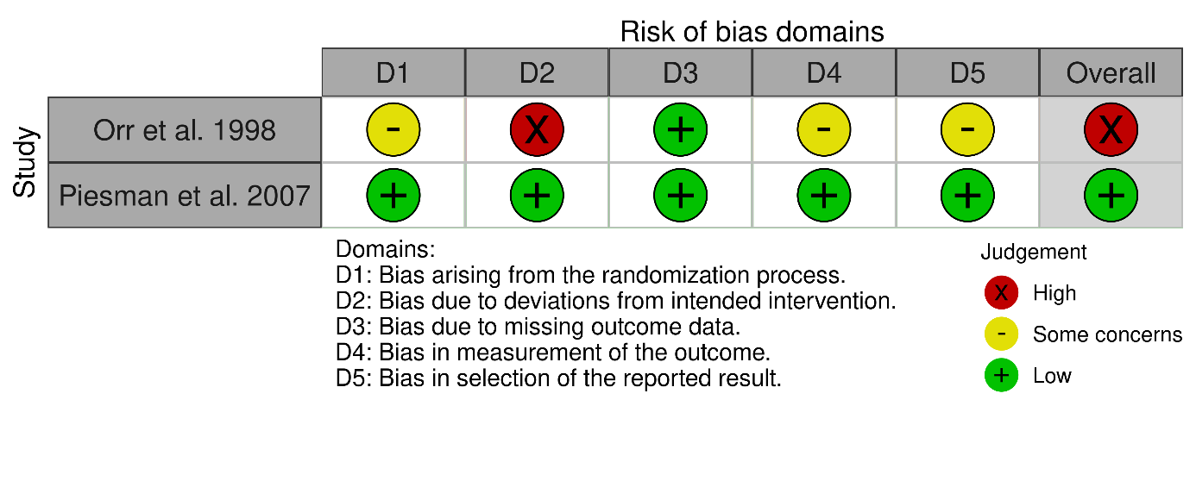

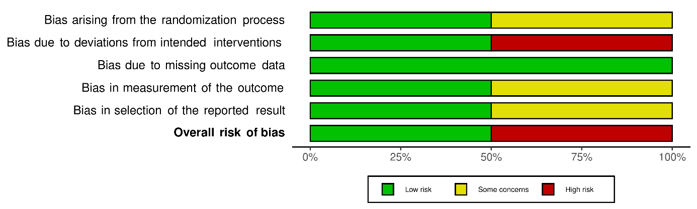

Positional therapy (n=2)

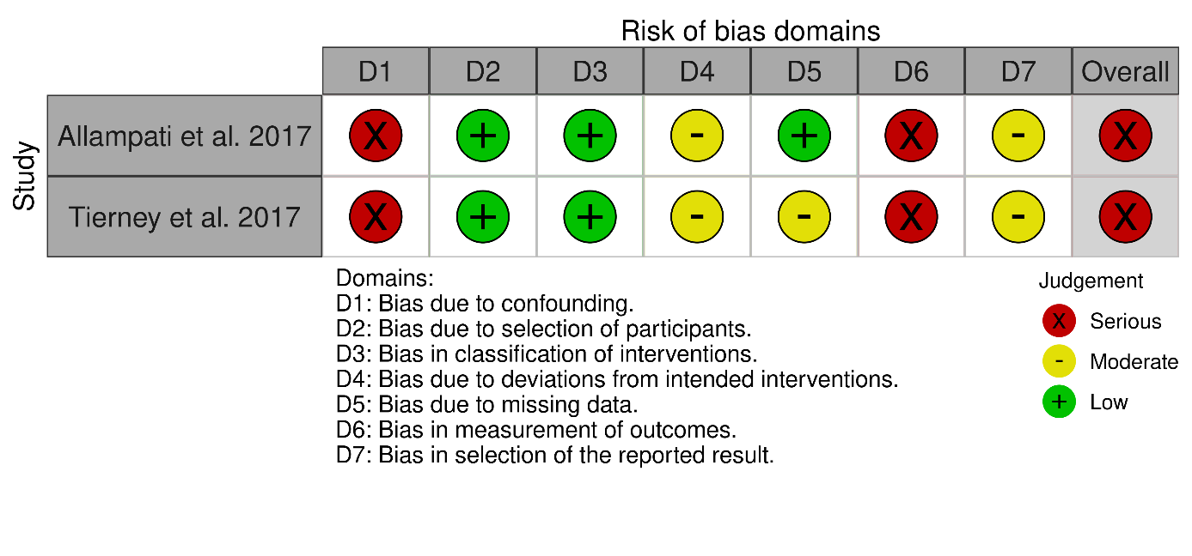

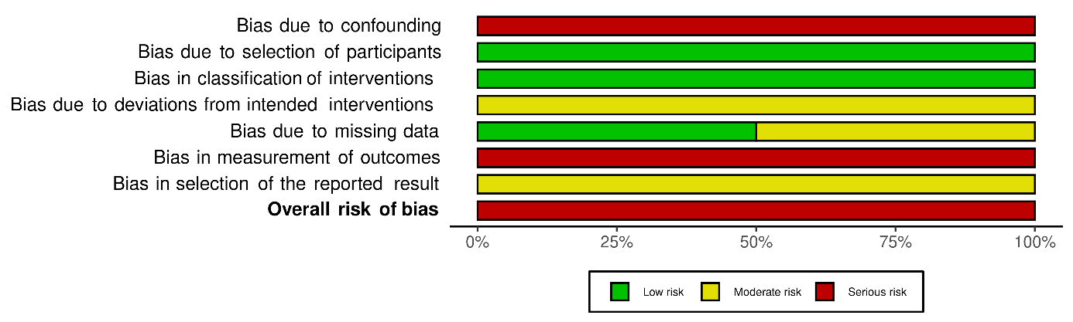

Continuous positive airway pressure (CPAP) (n=7)

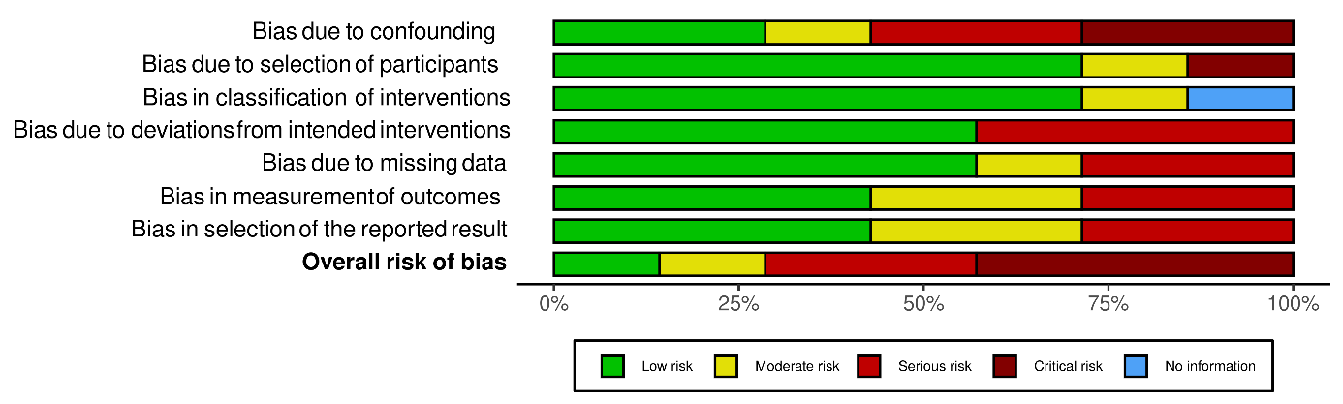

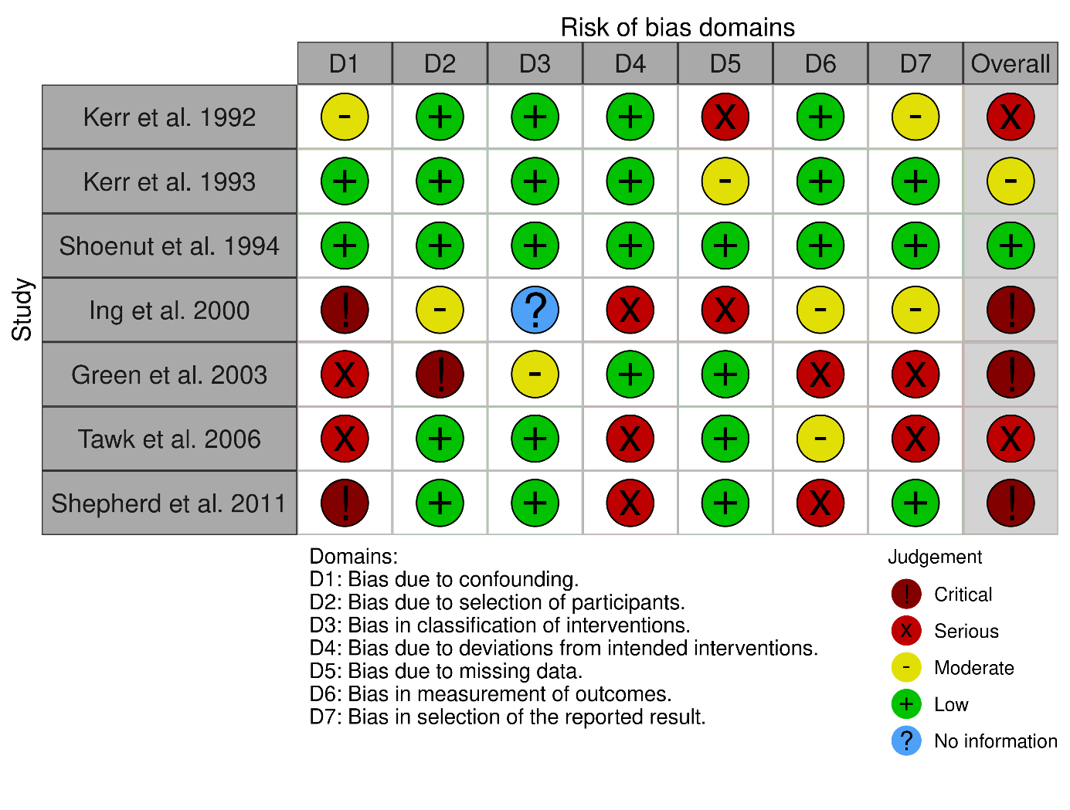

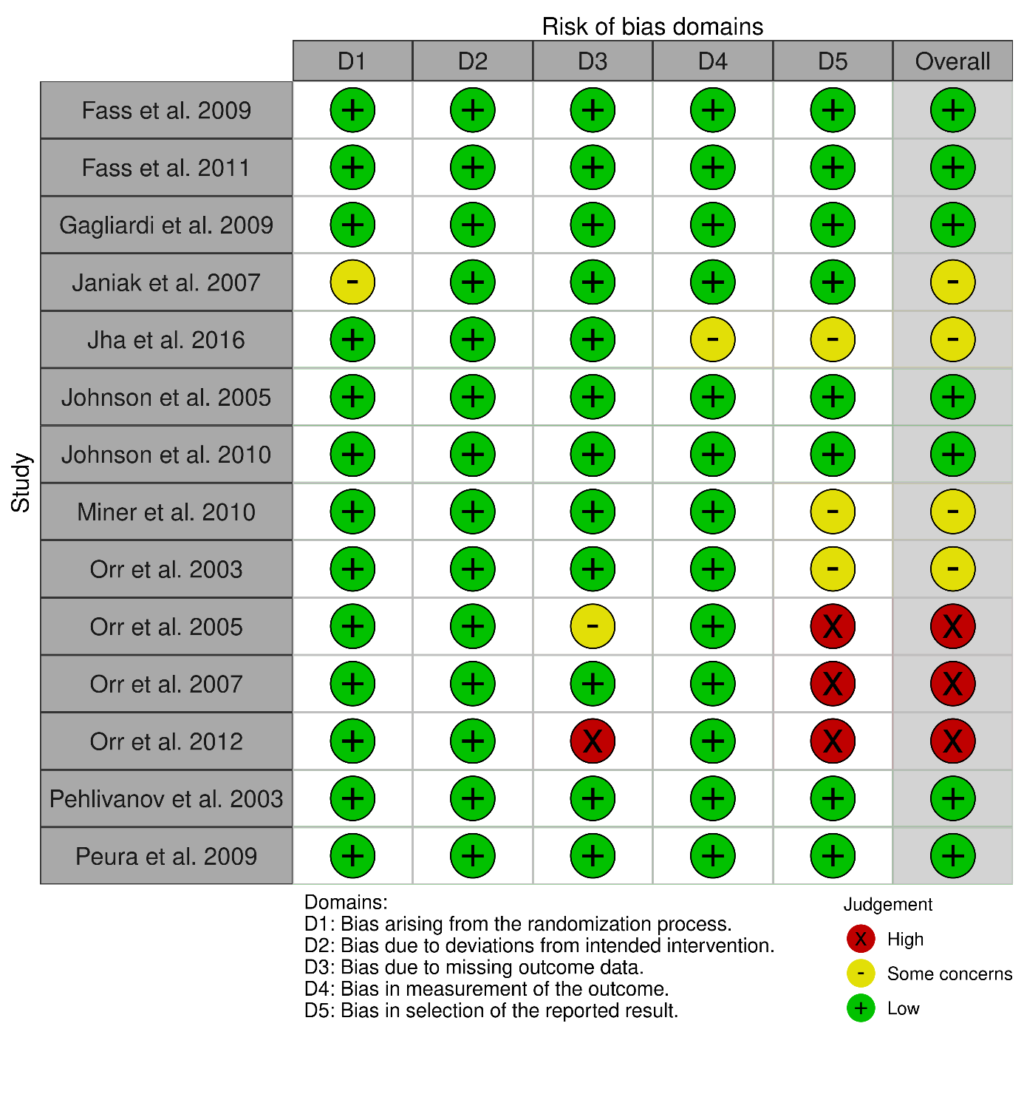
Pharmacological (n=14)
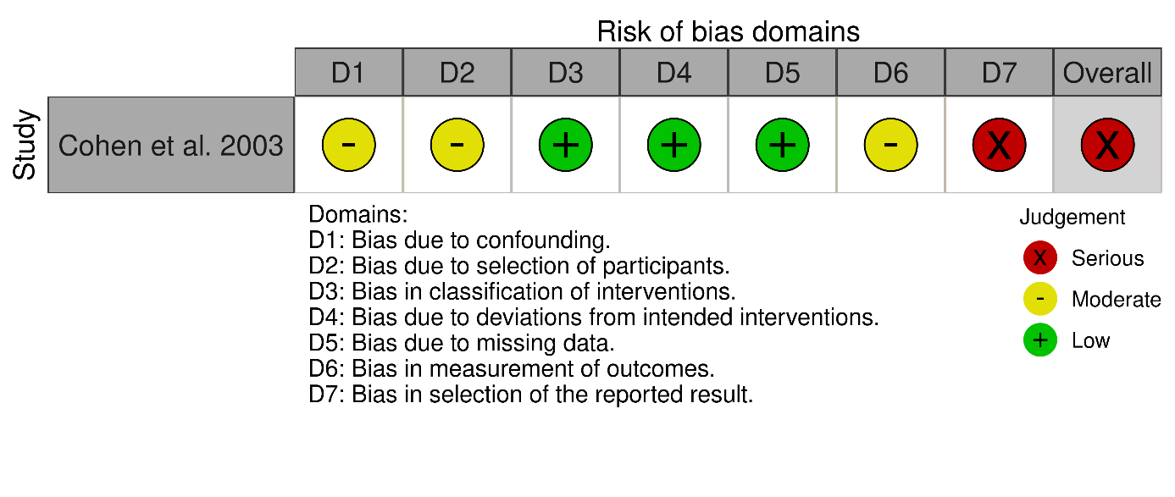
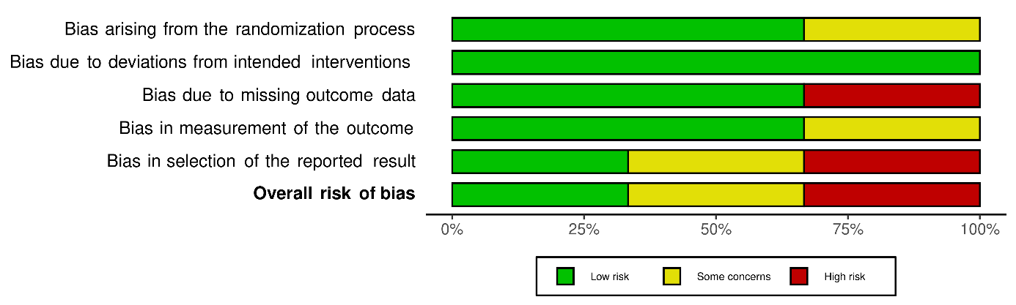
Surgery (N=1)

