Figure S2: Forrest plots of all analyses

S2.1 Forrest plot – Discontinuation rates
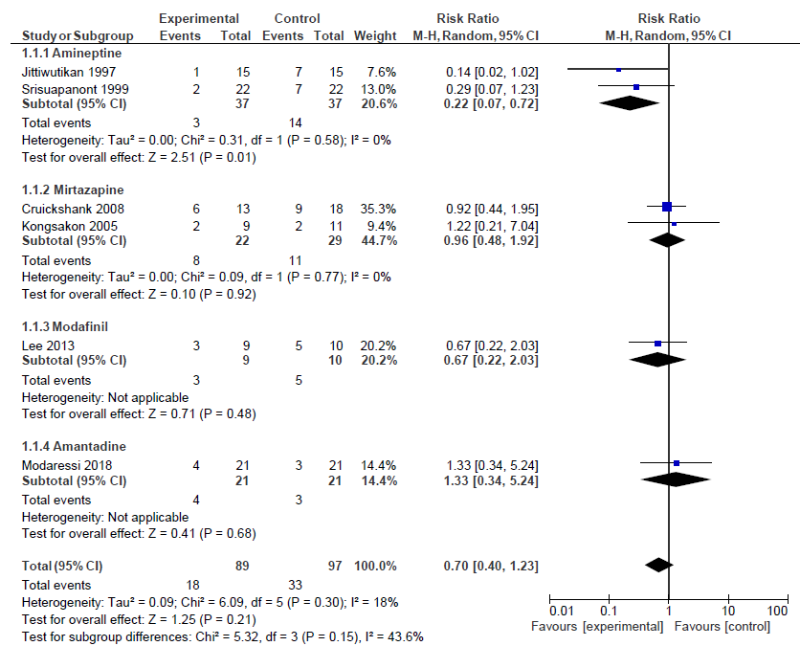

S2.2 Forrest plot – Global state
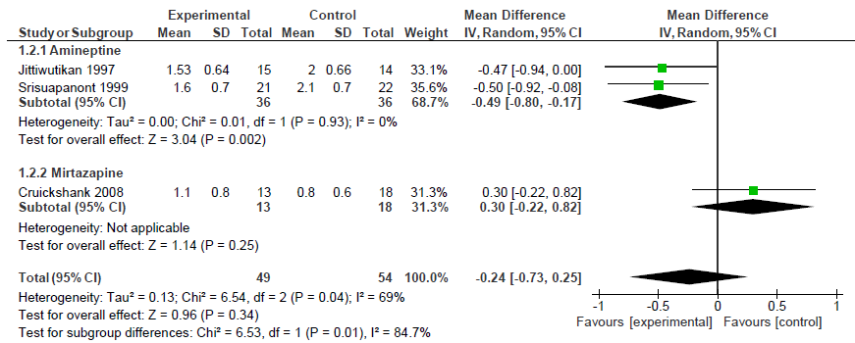

3.3 Forrest plot – Withdrawal Symptoms
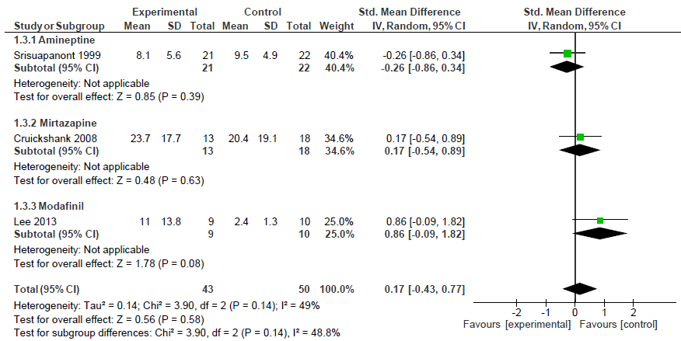

3.4 Forrest Plot - Craving
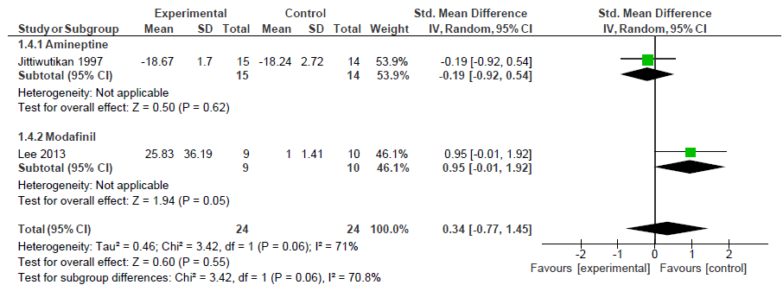

3.5 Forrest Plot - Safety


