Supplementary file 1. Search strategy across literature databases.

All searches were performed on Monday, May 24th, 2021.

PubMed:

History and Search Details

Download

Delete
Search | Actions | Details | Query | Results | Time
#1 |  |  | Search: vernal AND keratoconjunctivitis AND ("skin test" OR IgE OR allergen) Sort by: Most Recent | 170 | 18:10:48
Showing 1 to 1 of 1 entries

Cochrane Library:

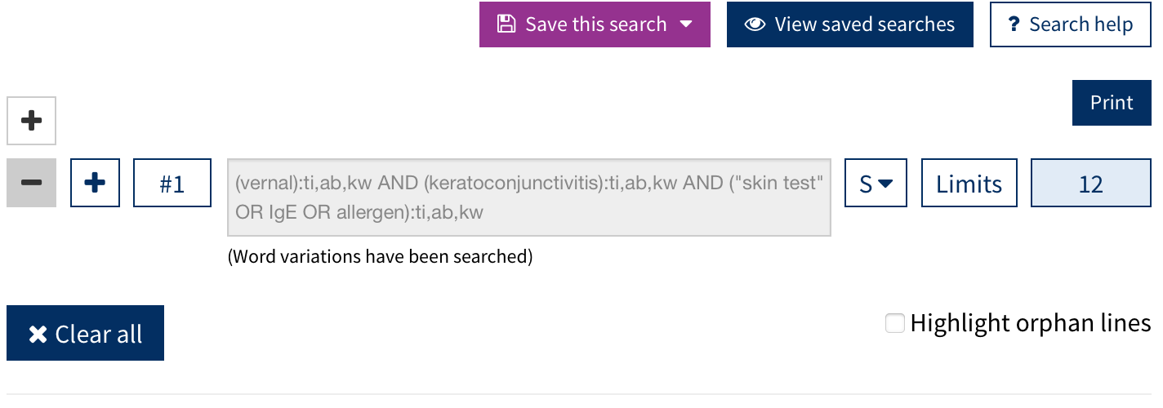

EMBASE:

Search History
(7searches found)

Search history sorted by search number ascending
 | # ▲ | Searches |  | Results |  | Type |  | Actions |  | Annotations
 | 1 | vernal.mp. [mp=title, abstract, heading word, drug trade name, original title, device manufacturer, drug manufacturer, device trade name, keyword, floating subheading word, candidate term word] | 1972 |  | Advanced |  | Display Results  More
 | 2 | keratoconjunctivitis.mp. [mp=title, abstract, heading word, drug trade name, original title, device manufacturer, drug manufacturer, device trade name, keyword, floating subheading word, candidate term word] | 7940 |  | Advanced |  | Display Results  More
 | 3 | "skin test".mp. [mp=title, abstract, heading word, drug trade name, original title, device manufacturer, drug manufacturer, device trade name, keyword, floating subheading word, candidate term word] | 41158 |  | Advanced |  | Display Results  More
 | 4 | IgE.mp. [mp=title, abstract, heading word, drug trade name, original title, device manufacturer, drug manufacturer, device trade name, keyword, floating subheading word, candidate term word] | 84647 |  | Advanced |  | Display Results  More
 | 5 | allergen.mp. [mp=title, abstract, heading word, drug trade name, original title, device manufacturer, drug manufacturer, device trade name, keyword, floating subheading word, candidate term word] | 85779 |  | Advanced |  | Display Results  More
 | 6 | 3 or 4 or 5 | 171023 |  | Advanced |  | Display Results  More
 | 7 | 1 and 2 and 6 | 233 |  | Advanced |  | Display Results  More

Web of Science (the entire database collection):

Results: 336
(from All Databases)
You searched for: TOPIC: (vernal AND keratoconjunctivitis AND ("skin test" OR IgE OR allergen))
Timespan: All years. Databases: WOS, BIOSIS, CCC, DRCI, DIIDW, KJD, MEDLINE, RSCI, SCIELO, ZOOREC.
Search language=Auto

