Supplementary Figure illustrations
Figure S1 Assessing publication bias by funnel plot: (a) effects of physical activity on mortality; (b) effects of physical activity on severity.
Figure S2 Assessing publication bias by Egger’s test: (a) effects of physical activity on mortality; (b) effects of physical activity on severity. Abbreviations: CI, Confidence interval; SND, standard.

Supplementary Table illustrations
Table S1 Data search algorithm.
Table S2 Excluded studies after assessment for eligibility
Table S1 Data search algorithm
Data base | Search strategy | Found
Pubmed | COVID* | 258,779
Pubmed | (exercise) OR ("physical activity") | 596,969
Pubmed | ("no exercise") OR ("no physical activity") | 1,880
Pubmed | (severity) OR (mortality) | 2,996,797
Pubmed | (((COVID*) AND ((exercise) OR (physical activity))) AND ((no exercise) OR (no physical activity))) AND (((severity) OR (mortality)) | 1,420
Cochrane | #1: (COVID*) | 11,793
Cochrane | #2: (exercise) OR (physical activity) | 140,894
Cochrane | #3: (no exercise) OR (no physical activity) | 57,752
Cochrane | #4: (severity) OR (mortality) | 211,130
Cochrane | #1 and #2 and #3 and #4 | 363
Scopus | (covid*) | 495,151
Scopus | (exercise OR "physical activity") | 2,126,373
Scopus | (no AND physical AND activity OR no AND exercise) | 279,496
Scopus | (severity OR mortality) OR (mortality) | 5,707,890
Scopus | (COVID*) AND (exercise OR "Physical activity") AND (no physical activity OR no exercise) AND (severity OR mortality) | 2,505
Science  Direct | (COVID) | 136,159
Science  Direct | (exercise) OR (physical activity) | 2,738,323
Science  Direct | (no exercise) OR (no physical activity) | 2,474,789
Science  Direct | (severity) OR (mortality) | 2,504,439
Science  Direct | ((COVID) AND ((exercise) OR ("physical activity"))) AND (((COVID) AND ((no exercise) OR (no physical activity))) AND ((COVID) AND ((severity) OR (mortality))) | 6,810
Embase | #1: covid* | 265,879
Embase | #2: "physical activity" OR exercise | 810,311
Embase | #3: (no AND "physical activity") OR (no AND exercise) | 217,118
Embase | #4: (severity) OR (mortality) | 2,843,191
Embase | #1 AND #2 AND #3 AND #4 | 320
OPENGREY.EU | (COVID) | 1,793
 | (exercise) OR (physical activity) | 4,826
 | (“no exercise”) OR (“no physical activity”) | 5
 | (severity) OR (mortality) | 2,023
 | (COVID) AND ((exercise) OR (physical activity)) AND ((“no exercise”) OR (“no physical activity”)) AND ((severity) OR (mortality)) | 1
ClinicalTrials.gov | (COVID) | 8,431
 | (exercise) OR (physical activity) | 19,388
 | (no exercise) OR (no physical activity) | 50
 | (severity) OR (mortality) | 5,663
 | (COVID) AND ((exercise) OR (physical activity)) AND ((“no exercise”) OR (“no physical activity”)) AND ((severity) OR (mortality)) | 0

Table S2 Excluded studies after assessment for eligibility
Authors | Year | Title | Reasons for excluding
Bliss et al. | 2022 | Impact of Exercise on Susceptibility and Severity of COVID-19 in Patients with Cancer: A Retrospective Study. | No full-text
Bielik et al. | 2021 | A Possible Preventive Role of Physically Active Lifestyle during the SARS-CoV-2 Pandemic; Might Regular Cold-Water Swimming and Exercise Reduce the Symptom Severity of COVID-19? | Inappropriate exposure grouping
de Souza et al. | 2021 | Association of physical activity levels and the prevalence of COVID-19-associated hospitalization. | Ineligible outcome
Gündoğdu  et al. | 2022 | Evaluation of the relationship between the disease severity and the level of physical activity in patients followed up with COVID-19 diagnosis. | Ineligible outcome
Gualano et al. | 2022 | Association between physical activity and immunogenicity of an inactivated virus vaccine against SARS-CoV-2 in patients with autoimmune rheumatic diseases. | Ineligible outcome
Kontopoulou  et al. | 2022 | Exercise Preferences and Benefits in Patients Hospitalized with COVID-19. | Ineligible outcome
Trapé et al. | 2021 | Effects of moderate-intensity intermittent hypoxic training on health outcomes of patients recovered from COVID-19: the AEROBICOVID study protocol for a randomized controlled trial. | Ineligible outcome
Tsushita et al. | 2022 | Survey of the effect of the SARS-CoV-2 outbreak on the job training members with high exercise intensity: Analysis of the factors causing infection spread and the effectiveness of the prevention measures. | Ineligible outcome
Güler et al. | 2021 | A survey on relationship between Gendarmerie Coast Guard Academy (GCGA) students' physical activity and COVID-19 infection. | Ineligible outcome
Chen et al. | 2022 | Causal relationship between physical activity, leisure sedentary behaviors  and COVID‑19 risk: a Mendelian randomization study | Ineligible study design
Li and Hua | 2021 | Modifiable lifestyle factors and severe COVID‑19 risk: a Mendelian randomisation study | Ineligible study design
Mohamed and Alawna | 2021 | The effect of aerobic exercise on immune biomarkers and symptoms severity and progression in patients with COVID-19: A randomized control trial. | Ineligible study design
Wang et al. | 2021 | Worldwide association of lifestyle-related factors and COVID-19 mortality. | Ineligible study design
Rahmati et al. | 2022 | Baseline physical activity is associated with reduced mortality and disease outcomes in COVID-19: A systematic review and meta-analysis. | Ineligible publication type
Clemente-Suárez et al. | 2022 | Physical activity and COVID-19. The basis for an efficient intervention in times of COVID-19 pandemic. | Ineligible publication type
Chesnut et al. | 2021 | Could diet and exercise reduce risk of COVID-19 syndemic? | Ineligible publication type
Khoramipour  et al. | 2021 | Physical activity and nutrition guidelines to help with the fight against COVID-19. | Ineligible publication type
Filgueira et al. | 2021 | The Relevance of a Physical Active Lifestyle and Physical Fitness on Immune Defense: Mitigating Disease Burden, With Focus on COVID-19 Consequences. | Ineligible publication type
Kushkestani  et al. | 2022 | SARS-COV-2 in Type 2 Diabetic Patients: Possible Roles of Exercise Training as a Medicine. | Ineligible publication type
Marino et al. | 2022 | Metabolic and inflammatory health in SARS-CoV-2 and the potential role for habitual exercise in reducing disease severity. | Ineligible publication type
Molanouri et al. | 2022 | Combined Effects of Exercise Training and Nutritional Supplementation in Cancer Patients in the Context of the COVID-19: A Perspective Study. | Ineligible publication type
Waluyo et al. | 2021 | Optimizing Early Rehabilitation Intervention: Insights from Different Outcomes in 2 Patients with Severe COVID-19. | Ineligible publication type
Filgueira et al. | 2021 | The Relevance of a Physical Active Lifestyle and Physical Fitness on Immune Defense: Mitigating Disease Burden, With Focus on COVID-19 Consequences. | Ineligible publication type
Després et al. | 2021 | Severe COVID-19 outcomes - the role of physical activity. | Ineligible publication type
Chastin et al. | 2021 | Effects of Regular Physical Activity on the Immune System, Vaccination and Risk of Community-Acquired Infectious Disease in the General Population: Systematic Review and Meta-Analysis. | Ineligible publication type

(a)
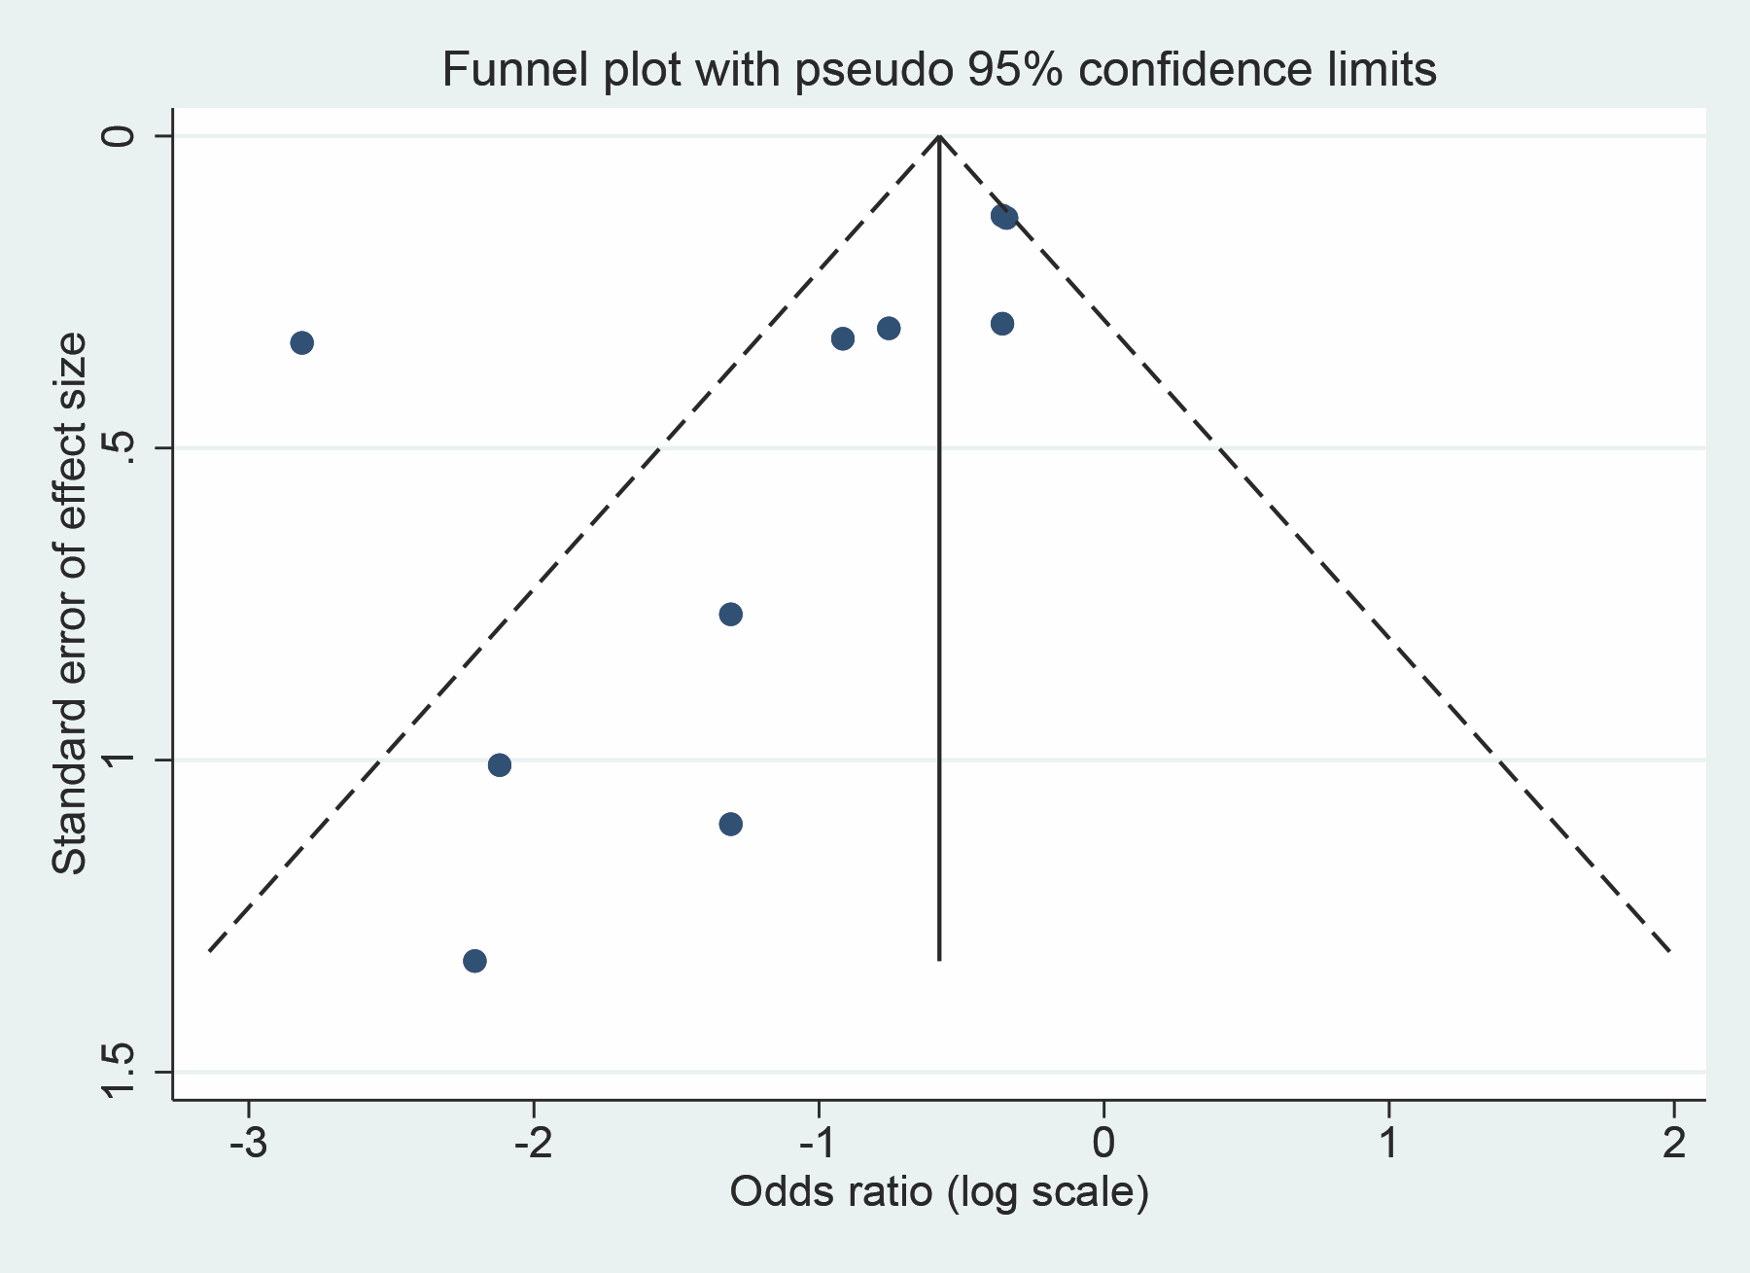
(b)
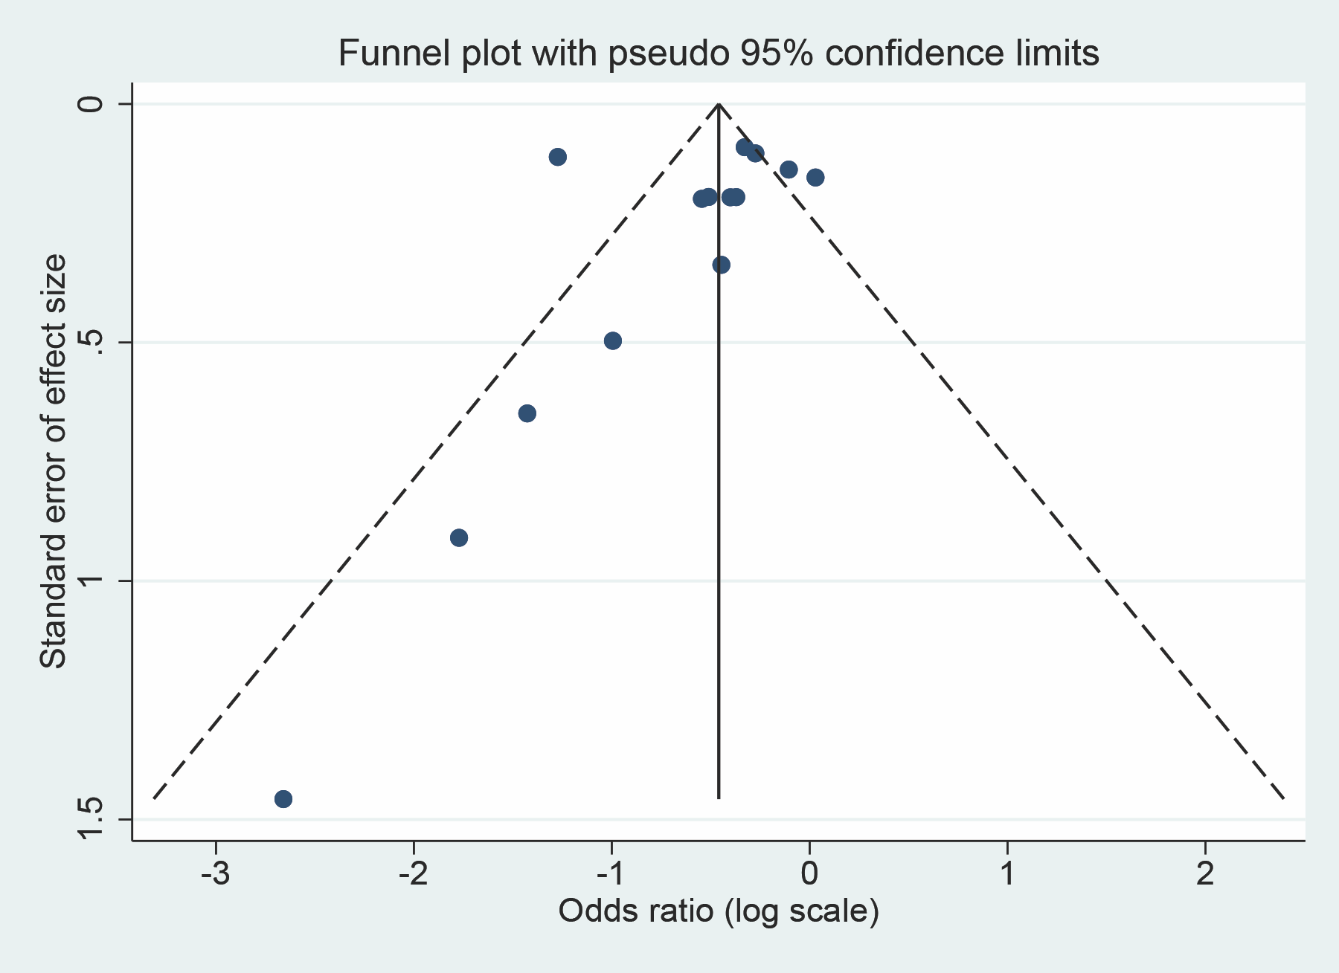
Figure S1 Assessing publication bias by funnel plot: (a) effects of physical activity on mortality; (b) effects of physical activity on severity.
(a)
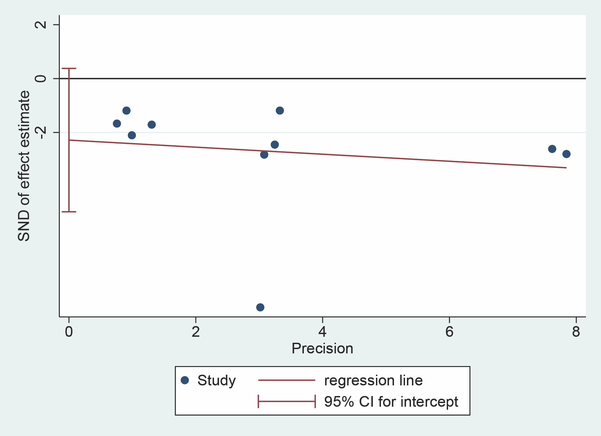
(b)
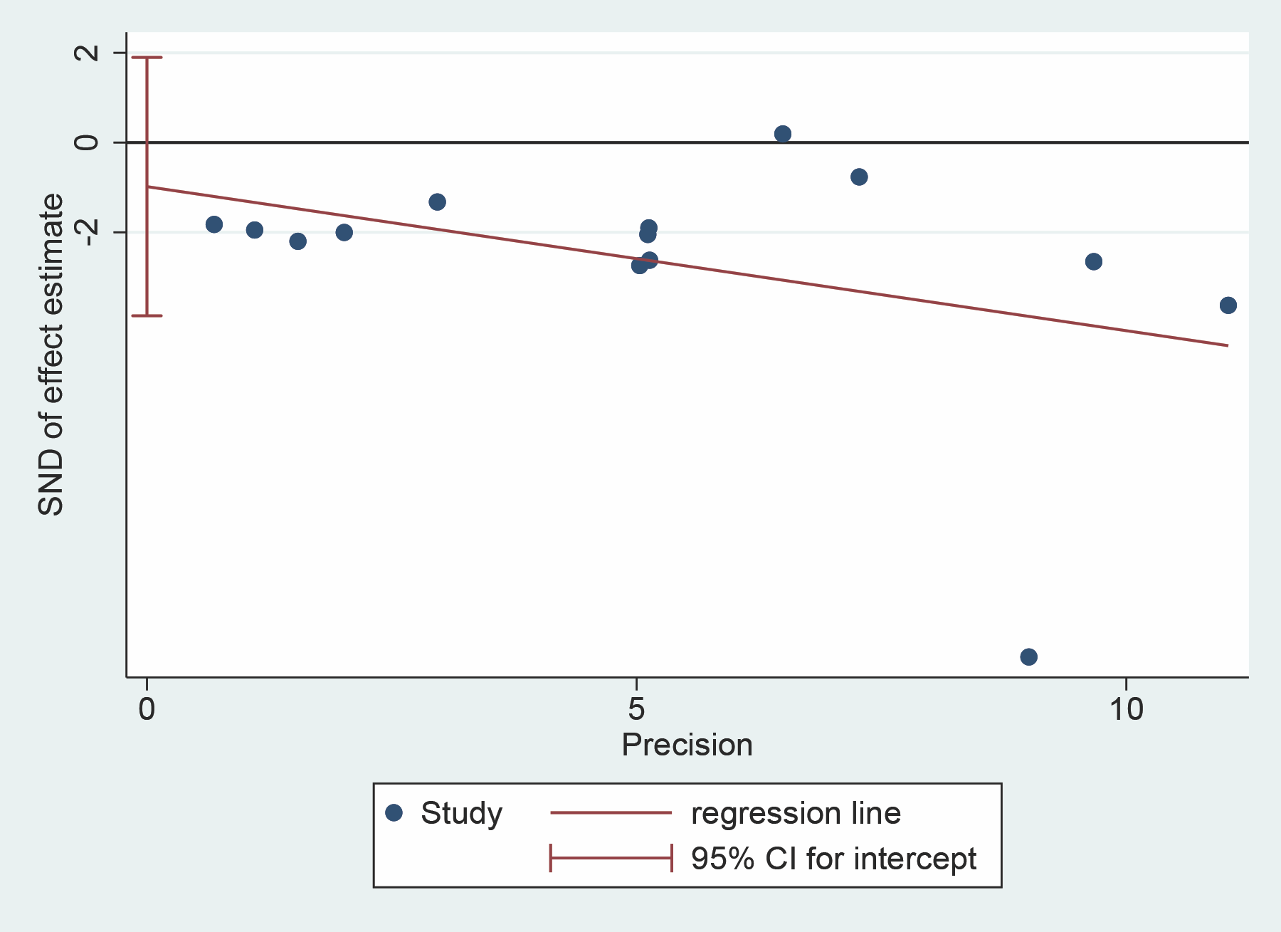
Figure S2 Assessing publication bias by Egger’s test: (a) effects of physical activity on mortality; (b) effects of physical activity on severity. Abbreviations: CI, Confidence interval; SND, standard.

