Supplementary figure 1

Sensitivity analysis of observational studies assessing the association between coffee consumption and risk of gestational diabetes mellitus. CI, confidence interval
Supplementary figure 2
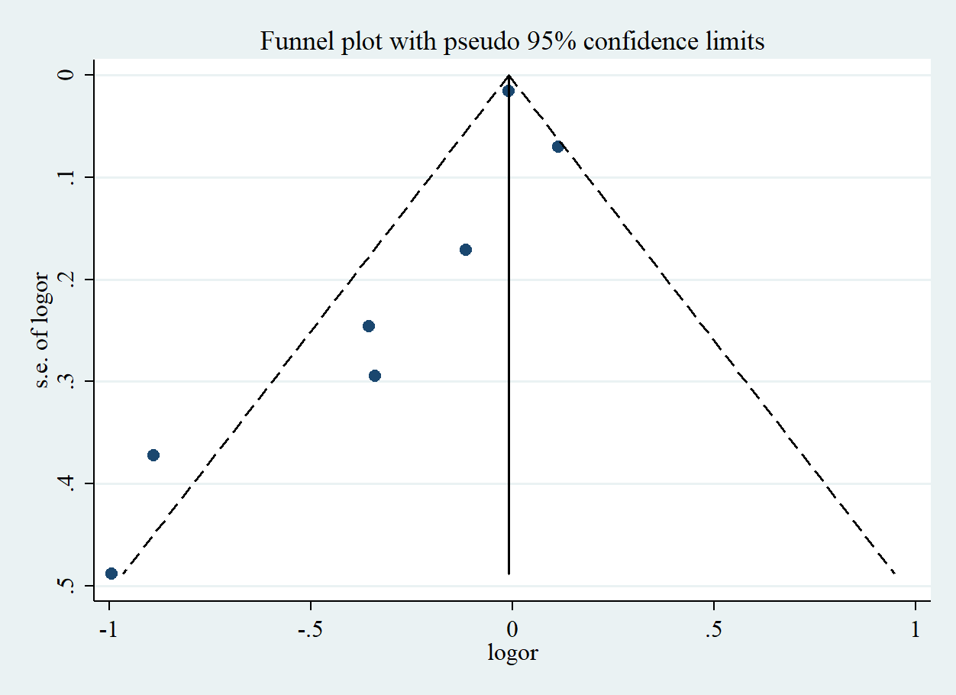

Funnel plot of the risk estimates of six studies on the association between coffee consumption and risk of GDM. Each dot represents one study. Egger’s test P<0.001. Log RR: natural logarithm of relative risk. CI, confidence interval; GDM, gestational diabetes mellitus; SE, standard error.

