Therapeutic Advances in Gastroenterology
Mucoprotective drugs can prevent and treat non-steroidal anti-inflammatory drug-induced small bowel enteropathy: a systematic review and meta-analysis of randomised controlled trials

Authors
Brigitta Teutsch^{a,b}, Eszter Boros^{a,c}, Szilárd Váncsa^{a,b}, Alex Váradiª, Levente Frimª, Szabolcs Kiss^{a,d}, Fanni Dembrovszky^{a,b}, Zsuzsanna Helyes^{b,e}, Patrícia Sarlós^{f}, Péter Hegyi^{a,g}, Bálint Erőss^{a,b,g}
Affiliations:
- Institute for Translational Medicine, Medical School, University of Pécs, Pécs, Hungary;
- János Szentágothai Research Centre, University of Pécs, Pécs, Hungary;
- Fejér County Szent György University Teaching Hospital, Székesfehérvár, Hungary;
- Doctoral School of Clinical Medicine, University of Szeged, Szeged, Hungary;
- Department of Pharmacology and Pharmacotherapy, Medical School, University of Pécs, Hungary;
- Division of Gastroenterology, First Department of Medicine, Medical School, University of Pécs,
Pécs, Hungary;
- Centre for Translational Medicine, Semmelweis University, Budapest, Hungary
Corresponding author:
Bálint Erőss MD, PhD
Institute for Translational Medicine, Medical School, University of Pécs, Pécs, Hungary
Postal address: 7624 Pécs, Hungary, Szigeti street 12
E-mail address: eross.balint@pte.hu
Telephone number: +36 30 887 4028

FIGURE LEGENDS
Fig. S1 Forest plot representing that preventive mucoprotective agents are not associated with fewer mucosal breaks compared to control
Fig. S2 Forest plot representing that preventive PGIAs are not associated with fewer reddened lesions breaks compared to control
Fig. S3 Forest plot representing that preventive mucoprotective agents are not associated with lower faecal calprotectin level compared to control, only when treated with PGIAs
Fig. S4 Forest plot and sensitivity analysis representing that preventive PGIAs are not associated with a shorter small bowel transit time compared to control
Fig. S5 Forest plot representing that treatment with mucoprotective agents and PGIAs alone are not associated with fewer mucosal breaks compared to control
Fig. S6 Forest plot representing that treatment with PGIAs is not associated with a higher haemoglobin level compared to control
Fig. S7 Risk of bias assessment at study and at domain level for mucosal erosions (Prevention group)
Fig. S8 Risk of bias assessment at study and at domain level for mucosal breaks after treatment (Prevention group)
Fig. S9 Risk of bias assessment at study and at domain level for mucosal breaks (Prevention group)
Fig. S10 Risk of bias assessment at study and at domain level for reddened lesions (Prevention group)
Fig. S11 Risk of bias assessment at study and at domain level for faecal calprotectin level (Prevention group).
Fig. S12 Risk of bias assessment at study and at domain level for small bowel transit time (Prevention group)
Fig. S13 Risk of bias assessment at study and at domain level for mucosal breaks (Treatment group
Fig. S14 Risk of bias assessment at study and at domain level for complete healing of mucosal breaks (Treatment group)
Fig. S15 Risk of bias assessment at study and at domain level for haemoglobin level (Treatment group)
Fig. S16 Risk of bias assessment at study and at domain level for adverse events (Prevention group)
Fig. S17 Risk of bias assessment at study and at domain level for serious adverse events (Prevention group)
Fig. S18 Risk of bias assessment at study and at domain level for adverse events (Treatment group)
Fig. S19 Risk of bias assessment at study and at domain level for serious adverse events (Treatment group)
Fig. S20 Risk of bias assessment at study and at domain level for outcomes (Prevention group) included only in our systematic review
Fig. S21 Risk of bias assessment at study and at domain level for outcomes (Treatment group) included only in our systematic review
Fig. S22 Trial sequential analysis for mucosal erosions (Prevention group)
Fig. S23 Trial sequential analysis for mucosal breaks after treatment (Prevention group)
Fig. S24 Trial sequential analysis for mucosal breaks (Prevention group)
Fig. S23 Trial sequential analysis for mucosal breaks after treatment (Prevention group)
Fig. S26 Trial sequential analysis for faecal calprotectin level (Prevention group)
Fig. S27 Trial sequential analysis for small bowel transit time (Prevention group)
Fig. S28 Trial sequential analysis for mucosal breaks (Treatment group)
Fig. S29 Trial sequential analysis for complete healing of mucosal breaks (Treatment group)

Fig. S30 Trial sequential analysis for haemoglobin level (Treatment group)

TABLES
Table S1 PRISMA checklist
Table S2 Characteristics of the articles
Table S3 Outcomes (Prevention group) from the articles included only in our systematic review
Table S4 Outcomes (Treatment group) from the articles included only in our systematic review
Table S5 Adverse events (Prevention group) in the articles included in our systematic review
Table S6 Serious adverse events (Prevention group) in the articles included in our systematic review
Table S7 Adverse events (Treatment group) in the articles included in our systematic review
Table S8 Serious adverse events (Treatment group) in the articles included in our systematic review
Table S9 Summary of Findings (Prevention group)
Table S10 Summary of Findings (Treatment group)
Table S11 Quality of evidence for the systematic review part (Adverse events)
Table S12 Quality of evidence for the systematic review part (Prevention group)
Table S13 Quality of evidence for the systematic review part (Treatment group)

Table S1 PRISMA checklist
Section/topic | # | Checklist item | Reported on page #
TITLE
Title | 1 | Identify the report as a systematic review, meta-analysis, or both. | 1
ABSTRACT
Structured summary | 2 | Provide a structured summary including, as applicable: background; objectives; data sources; study eligibility criteria, participants, and interventions; study appraisal and synthesis methods; results; limitations; conclusions and implications of key findings; systematic review registration number. | 2-3
INTRODUCTION
Rationale | 3 | Describe the rationale for the review in the context of what is already known. | 5-6
Objectives | 4 | Provide an explicit statement of questions being addressed with reference to participants, interventions, comparisons, outcomes, and study design (PICOS). | 5-6
METHODS
Protocol and registration | 5 | Indicate if a review protocol exists, if and where it can be accessed (e.g., Web address), and, if available, provide registration information including registration number. | 6
Eligibility criteria | 6 | Specify study characteristics (e.g., PICOS, length of follow-up) and report characteristics (e.g., years considered, language, publication status) used as criteria for eligibility, giving rationale. | 6-7  Supplementary material
Information sources | 7 | Describe all information sources (e.g., databases with dates of coverage, contact with study authors to identify additional studies) in the search and date last searched. | 6
Search | 8 | Present full electronic search strategy for at least one database, including any limits used, such that it could be repeated. | 6  Supplementary material
Study selection | 9 | State the process for selecting studies (i.e., screening, eligibility, included in systematic review, and, if applicable, included in the meta-analysis). | 7-8
Data collection process | 10 | Describe method of data extraction from reports (e.g., piloted forms, independently, in duplicate) and any processes for obtaining and confirming data from investigators. | 8
Data items | 11 | List and define all variables for which data were sought (e.g., PICOS, funding sources) and any assumptions and simplifications made. | 8
Risk of bias in individual studies | 12 | Describe methods used for assessing risk of bias of individual studies (including specification of whether this was done at the study or outcome level), and how this information is to be used in any data synthesis. | 9
Summary measures | 13 | State the principal summary measures (e.g., risk ratio, difference in means). | 9-10
Synthesis of results | 14 | Describe the methods of handling data and combining results of studies, if done, including measures of consistency (e.g., I²) for each meta-analysis. | 9-10
Risk of bias across studies | 15 | Specify any assessment of risk of bias that may affect the cumulative evidence (e.g., publication bias, selective reporting within studies). | 10
Additional analyses | 16 | Describe methods of additional analyses (e.g., sensitivity or subgroup analyses, meta-regression), if done, indicating which were pre-specified. | 10
RESULTS
Study selection | 17 | Give numbers of studies screened, assessed for eligibility, and included in the review, with reasons for exclusions at each stage, ideally with a flow diagram. | 10
Study characteristics | 18 | For each study, present characteristics for which data were extracted (e.g., study size, PICOS, follow-up period) and provide the citations. | Table 1
Risk of bias within studies | 19 | Present data on risk of bias of each study and, if available, any outcome level assessment (see item 12). | Fig. S7-S21
Results of individual studies | 20 | For all outcomes considered (benefits or harms), present, for each study: (a) simple summary data for each intervention group (b) effect estimates and confidence intervals, ideally with a forest plot. | 13-18
Synthesis of results | 21 | Present results of each meta-analysis done, including confidence intervals and measures of consistency. | 13-18
Risk of bias across studies | 22 | Present results of any assessment of risk of bias across studies (see Item 15). | -
Additional analysis | 23 | Give results of additional analyses, if done (e.g., sensitivity or subgroup analyses, meta-regression [see Item 16]). | 13-18
DISCUSSION
Summary of evidence | 24 | Summarize the main findings including the strength of evidence for each main outcome; consider their relevance to key groups (e.g., healthcare providers, users, and policy makers). | 19-22
Limitations | 25 | Discuss limitations at study and outcome level (e.g., risk of bias), and at review-level (e.g., incomplete retrieval of identified research, reporting bias). | 21
Conclusions | 26 | Provide a general interpretation of the results in the context of other evidence, and implications for future research. | 21
FUNDING
Funding | 27 | Describe sources of funding for the systematic review and other support (e.g., supply of data); role of funders for the systematic review. | 3-4

Literature search and eligibility criteria:
Searchkey:
(NSAID OR "non steroidal" OR nonsteroidal OR "anti inflammat*" OR antiinflammat* OR Aspirin OR Acetylsalicyl* OR Salicyl* OR Diflunisal OR Salsalate OR Butylpyrazolidine OR Phenylbutazone OR Mofebutazone OR Oxyphenbutazone OR Clofezone OR Kebuzone OR Suxibuzone OR “Acetic acid derivative*” OR Indometacin OR Sulindac OR Tolmetin OR Zomepirac OR Diclofenac OR Alclofenac OR Bumadizone OR Etodolac OR Lonazolac OR Fentiazac OR Acemetacin OR Difenpiramide OR Oxametacin OR Proglumetacin OR Ketorolac OR Aceclofenac OR Bufexamac OR “Enolic acid derivative*” OR Oxicam OR Piroxicam OR Tenoxicam OR Droxicam OR Lornoxicam OR Meloxicam OR “Propionic acid derivative*” OR Ibuprofen OR Naproxen OR
Ketoprofen OR Fenoprofen OR Fenbufen OR Benoxaprofen OR Suprofen OR Pirprofen OR Flurbiprofen OR Indoprofen OR
Tiaprofen OR “Tiaprofenic acid” OR Oxaprozin OR Ibuproxam OR Dexibuprofen OR Flunoxaprofen OR Alminoprofen OR
Dexketoprofen OR Naproxcinod OR Vedaprofen OR Carprofen OR Tepoxalin OR “Anthranilic acid derivative*” OR Fenamate OR
Mefenamate OR “Mefenamic acid” OR Tolfenamate OR “Tolfenamic acid” OR Flufenamate OR “Flufenamic acid” OR Meclofenamate OR “Meclofenamic acid” OR Flunixin OR Clonixin OR Coxib OR “COX-2 inhibit*” OR “Cyclooxygenase-2 inhibit*” OR Celecoxib OR Rofecoxib OR Valdecoxib OR Parecoxib OR Etoricoxib OR Lumiracoxib OR Polmacoxib OR Firocoxib OR Robenacoxib OR Mavacoxib OR Cimicoxib OR Deracoxib OR Enflicoxib OR Nabumetone OR “Niflumic acid” OR
Azapropazone OR Glucosamine OR Benzydamine OR “Glycosaminoglycan polysulfate” OR Proquazone OR Orgotein OR Nimesulide OR Feprazone OR Diacerein OR Morniflumate OR Tenidap OR Oxaceprol OR “Chondroitin sulfate” OR Aminopropionitrile OR Grapiprant) AND (enteropath* OR enteritis OR "small bowel" OR "small intestin*" OR jejun* OR ileum OR ileal OR ileitis OR “intestinal injury” OR “intestinal lesion” OR “intestinal mucosal lesion” OR “bowel injury” OR “bowel lesion” OR “bowel mucosal lesion”) AND random*.

Primary outcomes
Primary outcomes for the Prevention group were mucosal integrity (O_{I.I.1.}) and mucosal breaks after treatment (O_{I.I.2.}); for the Treatment group were mucosal injury improvement (O_{I.II.1.}) and complete healing of mucosal breaks (O_{I.II.2.}).
Mucosal integrity and injury improvement (both continuous outcomes) were assessed as the change in the number of:
- mucosal injuries (including erosions, ulcers, and presence of bleeding – Ito et al. 2014),
- mucosal breaks (including only erosions and ulcers – Kurokawa et al. 2014),
- erosions ("lesion with slough surrounded by erythema" – Ito et al. 2014),
- ulcers ("loss of the villous architecture with a clear breach of epithelium" – Ito et al. 2014), • reddened lesions (including reddened folds, denuded areas, and petechia – Fujimori et al. 2009), or
- bleeding sites ("presence of blood with or without detectable lesion" – Ito et al. 2014).
Mucosal breaks after treatment and complete healing of mucosal breaks (dichotomous outcomes) were interpreted according to the presence or absence of mucosal breaks at the end of the study. All the above-mentioned outcomes were detected with capsule endoscopy.

Table S2 Characteristics of the articles

Main characteristics of RCTs about the prevention of NSAID-induced small bowel enteropathy included in our systematic review
Study | Type of NSAID (dose/day in mg) | Type of PPI  (dose/day in mg) | Type of Intervention (dose/day in mg, and CFU/day in case of probiotics) | Type of Control (dose/day in mg, if specified)
Fujimori et al. 2011 | Diclofenac (75) | Omeprazole (20) | Rebamipide (300) | Placebo
Fujimori et al. 2009 | Diclofenac (75) | Omeprazole (20) | Misoprostol (0.6) | Placebo
Huang et al. 2014 | Diclofenac (150) | Omeprazole (20) | Isinglass (6000) | No drug
Iguchi et al. 2018 | Aspirin (100) | - | ESH (30) | No drug
Kojima et al. 2015 | Diclofenac (75) | - | Irsogladine (4) | Omeprazole (10)
Kuramoto et al. 2013 | Diclofenac (75) | - | Irsogladine (4) | Omeprazole (10)
Mortensen et al. 2019 | Aspirin (300) | - | Bif195, (5x10¹⁰) | Placebo
Nishida et al. 2011 | Aspirin (100) | - | Rebamipide (300) | Placebo
Nishimura et al. 2014 | Loxoprofen (540) | Omeprazole (20) | Irsogladine (4) | Placebo
Niwa et al. 2009 | Diclofenac (75) | Rabeprazole (20) | GGA (300) | Placebo
Niwa et al. 2008 | Diclofenac (75) | Omeprazole (20) | Rebamipide (300) | Placebo
Ota et al. 2016 | Aspirin (100) | - | Rebamipide (300) | Omeprazole (10)
Ota et al. 2019 | Aspirin (100) | - | Ecabet sodium (4000) | No drug
Scarpignato et al. 2017 | Diclofenac (75) | Omeprazole (20) | Rifaximin (400) | Placebo
Shiotani et al. 2010 | Aspirin (100) | Rabeprazole (10) | GGA (150) | Placebo
Umegaki et al. 2014 | Diclofenac (75) | - | GGA (150) | Famotidine (20)
Xiong et al. 2015 | Diclofenac (75) | - | GGA (150) | No drug
Main characteristics of RCT about the treatment of NSAID-induced small bowel enteropathy included in our systematic review
Study | Type of NSAID  (dose/day) | Type of PPI  (dose/day) | Type of Intervention  (dose/day) | Type of Control (dose/day)
Endo et al. 2011 | Aspirin (100) | Omeprazole (20) | LC (45x10⁸ – 63 x10⁹) | -
Isomura et al. 2014 | NSAID | n.a.,Y/N | Irsogladine (4) | Placebo
Kurokawa et al. 2014 | Aspirin/NSAID | n.a., Y/N | Rebamipide (300) | Placebo
Kyaw et al. 2018 | Aspirin (100) | n.a.,Y/N | Misoprostol (0.8) | Placebo
Oh et al. 2018 | Meloxicam | - | Rebamipide | Lansoprazole
Suzuki et al. 2017 | n.a. | n.a., Y/N | LG, (2x10⁹) | Placebo
Taha et al. 2018 | Aspirin/NSAID | n.a., Y/N | Misoprostol (0.8) | Placebo
Watanabe et al. 2015 | Aspirin (100) | - | Rebamipide (900) | Placebo
Watari et al. 2013 | Aspirin (100) | n.a., Y/N | Polaprezinc (150) | -
NSAID-non-steroidal anti-inflammatory drug, PPI-proton pump inhibitor, ESH-Ecabet sodium hydrate, BIF195-Bifidobacterium breve Bif195, GGAGeranylgeranylacetone, LC-Lactobacillus casei, n.a.-not available, Y/N-a part of the participants received PPI, the other part did not

Table S3 Outcomes (Prevention group) from the articles included only in our systematic review
Study | Outcome |  | i Change |  |  |  |  |  |  |  | c Change
Study | Outcome | n-I | mean | sd | median | rMin | rMax | IQR1 | IQR3 | n-C | mean | sd | median | rMin | rMax | IQR1 | IQR3 | change P | WMD | SD | CI1 | CI3
Nishimura et al. 2014 | Mucosal injuries | 19 |  |  |  |  |  |  |  | 19 |  |  |  |  |  |  |  |  | -4,70 | 0,88 | -6,42 | -2,98
Ota et al. 2019 | Mucosal injuries | 12 |  |  |  |  |  |  |  | 12 |  |  |  |  |  |  |  |  | 0,66 | 0,54 | -0,40 | 1,72
Scarpignato et al. 2017 | Mucosal breaks | 30 | 0,30 | 0,70 |  |  |  |  |  | 30 | 1,20 | 2,30 |  |  |  |  |  | 0,10 | -0,90 | 0,44 | -1,76 | -0,04
Ota et al. 2016 | Mucosal ulcers | 15 |  |  |  |  |  |  |  | 15 |  |  |  |  |  |  |  |  | -0,30 | 0,09 | -0,48 | -0,12
Umegaki et al. 2014 | Mucosal ulcers | 15 |  |  |  |  |  |  |  | 15 |  |  |  |  |  |  |  |  | -0,94 | 0,09 | -1,12 | -0,76
Nishida et al. 2011 | Mucosal erosions | 10 | 0,00 | 0,00 |  |  |  |  |  | 10 | 0,50 | 2,70
Umegaki et al. 2014 | Lewis score | 15 |  |  |  |  |  |  |  | 15 |  |  |  |  |  |  |  |  | -90,13 | 7,97 | -105,74 | -74,52
i Change-change in the mean number of outcomes included in the intervention group, c Change-change in the mean number of outcomes included in the control group, n-I-number of participants in the intervention group, n-C-number of participants in the control group, sd-standard deviation, rMin-range minimum, rMax-range maximum, IQR1-interquartile range 1, IQR3-interquartile range 3, change P-p value for the weighted mean difference, WMD-weighted mean difference, CI1-lower confidential interval, CI3-upper confidential interval.
Table S4: Outcomes (Treatment group) from the articles included only in our systematic review
Study | Outcome |  | i Change |  |  |  |  |  |  |  | c Change
Study | Outcome | n-I | mean | sd | median | rMin | rMax | IQR1 | IQR3 | n-C | mean | sd | median | rMin | rMax | IQR1 | IQR3 | change P | WMD | SD | CI1 | CI3
Nishimura et al. 2014 | Mucosal injuries | 19 |  |  |  |  |  |  |  | 19 |  |  |  |  |  |  |  |  | -4,70 | 0,88 | -6,42 | -2,98
Ota et al. 2019 | Mucosal injuries | 12 |  |  |  |  |  |  |  | 12 |  |  |  |  |  |  |  |  | 0,66 | 0,54 | -0,40 | 1,72
Fujimori et al. 2011 | Mucosal breaks | 34 |  |  |  |  |  |  |  | 34 |  |  |  |  |  |  |  |  | -11,50 | 1,98 | -15,38 | -7,62
Huang et al. 2014 | Mucosal breaks | 16 |  |  |  |  |  |  |  | 16 |  |  |  |  |  |  |  |  | -9,10 | 0,95 | -10,95 | -7,25
Nishimura et al. 2014 | Mucosal breaks | 19 |  |  |  |  |  |  |  | 19 |  |  |  |  |  |  |  |  | -0,30 | 0,22 | -0,74 | 0,14
Scarpignato et al. 2017 | Mucosal breaks | 30 | 0,30 | 0,70 |  |  |  |  |  | 30 | 1,20 | 2,30 |  |  |  |  |  | 0,10 | -0,90 | 0,44 | -1,76 | -0,04
Ota et al. 2016 | Mucosal ulcers | 15 |  |  |  |  |  |  |  | 15 |  |  |  |  |  |  |  |  | -0,30 | 0,09 | -0,48 | -0,12
Umegaki et al. 2014 | Mucosal ulcers | 15 |  |  |  |  |  |  |  | 15 |  |  |  |  |  |  |  |  | -0,94 | 0,09 | -1,12 | -0,76
Nishida et al. 2011 | Mucosal erosions | 10 | 0,00 | 0,00 |  |  |  |  |  | 10 | 0,50 | 2,70
Fujimori et al. 2011 | Reddened lesions | 34 |  |  |  |  |  |  |  | 34 |  |  |  |  |  |  |  |  | -0,60 | 0,24 | -1,07 | -0,13
Nishimura et al. 2014 | Reddened lesions | 19 |  |  |  |  |  |  |  | 19 |  |  |  |  |  |  |  | 0,04 | -7,80 | 0,27 | -8,33 | -7,28
Kuramoto et al. 2013 | Reddened lesions | 16 |  |  |  |  |  |  |  | 16 |  |  |  |  |  |  |  |  | -0,50 | 0,13 | -0,75 | -0,25
Umegaki et al. 2014 | Lewis score | 15 |  |  |  |  |  |  |  | 15 |  |  |  |  |  |  |  |  | -90,13 | 7,97 | -105,74 | -74,52
i Change-change in the mean number of outcomes included in the intervention group, c Change-change in the mean number of outcomes included in the control group, n-I-number of participants in the intervention group, n-C-number of participants in the control group, sd-standard deviation, rMin-range minimum, rMax-range maximum, IQR1-interquartile range 1, IQR3-interquartile range 3, change P-p value for the weighted mean difference, WMD-weighted mean difference, CI1-lower confidential interval, CI3-upper confidential interval.

Table S5 Adverse events (Prevention group) in the articles included in our systematic review
Author | Intervention | Number of patients with event in the Intervention group | Number of patients with no event in the Intervention group | Number of patients with event in the Control group | Number of patients with no event in the Control group
Kuramoto et al. 2013 | Irsogladine | 0 | 16 | 0 | 16
Kojima et al. 2015 | Irsogladine | 0 | 16 | 0 | 5
Mortensen et al. 2019 | B. Breve Bif195 | 8 | 30 | 14 | 23
Xiong et al. 2015 | Geranylgeranylacetone | 0 | 21 | 0 | 19

Table S6 Serious adverse events (Prevention group) in the articles included in our systematic review
Author | Intervention | Number of patients with event in the Intervention group | Number of patients with no event in the Intervention group | Number of patients with event in the Control group | Number of patients with no event in the Control group
Niwa et al. 2009 | Geranylgeranylacetone | 0 | 10 | 0 | 10
Shiotani et al. 2010 | Geranylgeranylacetone | 0 | 10 | 0 | 10
Scarpignato et al. 2017 | Rifaximin | 0 | 30 | 0 | 30
Niwa et al. 2008 | Rebamipide | 0 | 10 | 0 | 10

Table S7 Adverse events (Treatment group) in the articles included in our systematic review
Author | Intervention | Number of patients with event in the Intervention group | Number of patients with no event in the Intervention group | Number of patients with event in the Control group | Number of patients with no event in the Control group
Isomura et al. 2014 | Irsogladine | 0 | 19 | 0 | 20
Watanabe et al. 2015 | Rebamipide | 0 | 25 | 1 | 12
Endo et al. 2012 | L. Casei | 0 | 13 | 0 | 12
Taha et al. 2018 | Misoprostol | 23 | 27 | 22 | 30
Kyaw et al. 2018 | Misoprostol | 12 | 30 | 11 | 31

Table S8 Serious adverse events (Treatment group) in the articles included in our systematic review
Author | Intervention | Number of patients with event in the Intervention group | Number of patients with no event in the Intervention group | Number of patients with event in the Control group | Number of patients with no event in the Control group
Taha et al. 2018 | Misoprostol | 0 | 50 | 0 | 52
Oh et al. 2018 | Rebamipide | 0 | 15 | 0 | 18
Kurokawa et al. 2014 | Rebamipide | 0 | 31 | 0 | 30
Watanabe et al. 2015 | Rebamipide | 0 | 25 | 0 | 13
Suzuki et al. 2017 | L. Gasseri | 0 | 30 | 0 | 31
Kyaw et al. 2018 | Misoprostol | 2 | 40 | 1 | 41

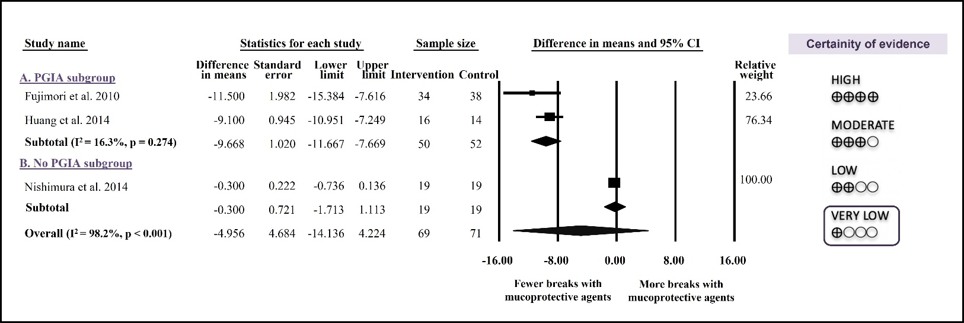Fig. S1 Forest plot representing that preventive mucoprotective agents are not associated with fewer mucosal breaks compared to control. CI-confidential interval, PGIA-prostaglandin level increasing agents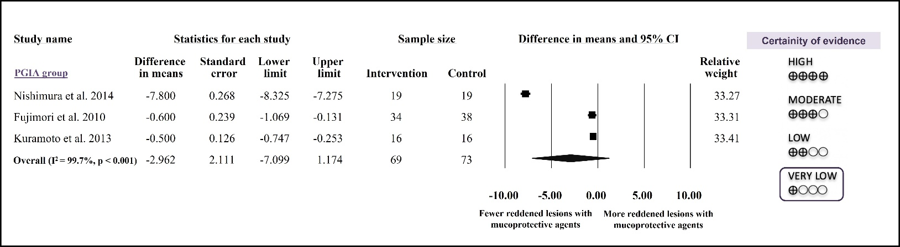Fig. S2 Forest plot representing that preventive PGIAs are not associated with fewer reddened lesions compared to control. CI-confidential interval, PGIA-prostaglandin level increasing agents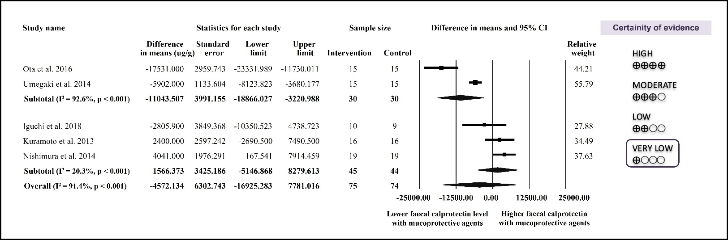Fig. S3 Forest plot representing that preventive mucoprotective agents are not associated with lower faecal calprotectin level compared to control, only when treated with PGIAs. CI-confidential interval, PGIA-prostaglandin level increasing agents

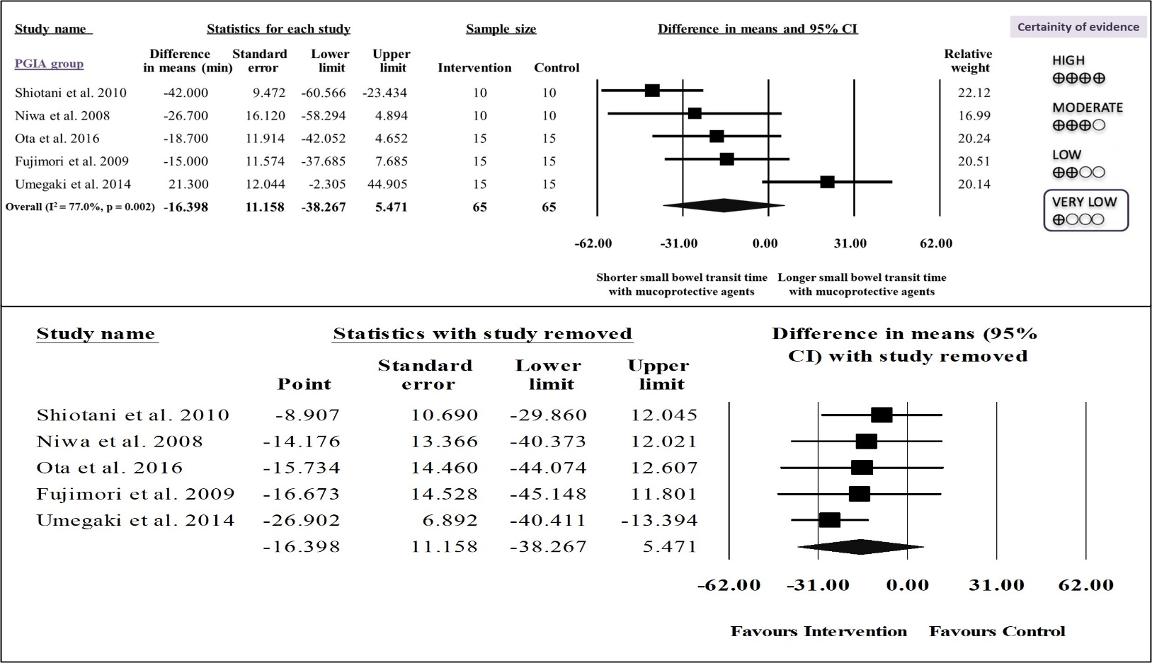Fig. S4 Forest plot and sensitivity analysis representing that preventive PGIAs are not associated with a shorter small bowel transit time compared to control. CI-confidential interval, PGIA-prostaglandin level increasing agents
Study
Intervention
Comparator
Randomization process
Deviations from intended
interventions
Missing outcome data
Measurement of the outcome
Selection of the reported result
Overall
Fujimori et al. 2010
Rebamipide
Placebo
+
?
+
+
+
?
Huang et al. 2014
Isinglass
No drug
+
+
+
+
+
+
Nishimura et al. 2014
Irsogladine
Placebo
?
+
+
?
+
?
0
10
20
30
40
50
60
70
80
90
100
Randomization process
Deviations from intended interventions
Missing outcome data
Measurement of the outcome
Selection of the reported result
Overall Bias
Low risk
Some concerns
High risk
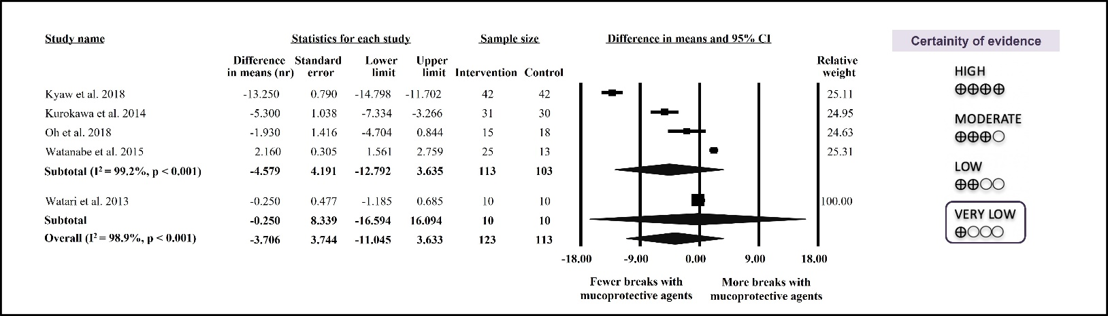Fig. S5 Forest plot representing that treatment with mucoprotective agents and PGIAs alone are not associated with fewer mucosal breaks compared to control. CI-confidential interval, PGIA-prostaglandin level increasing agents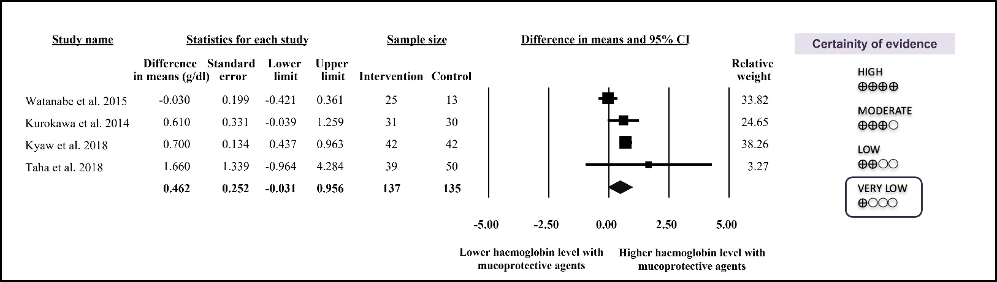
Fig. S6 Forest plot representing that treatment with PGIAs is not associated with a higher haemoglobin level compared to control. CI-confidential interval, PGIA-prostaglandin level increasing agents
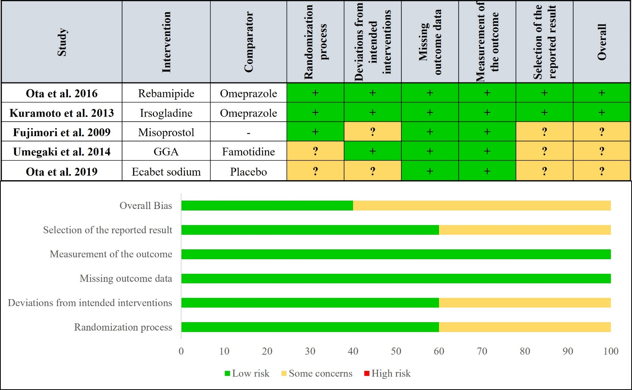
Fig. S7 Risk of bias assessment at study and at domain level for mucosal erosions (Prevention group)
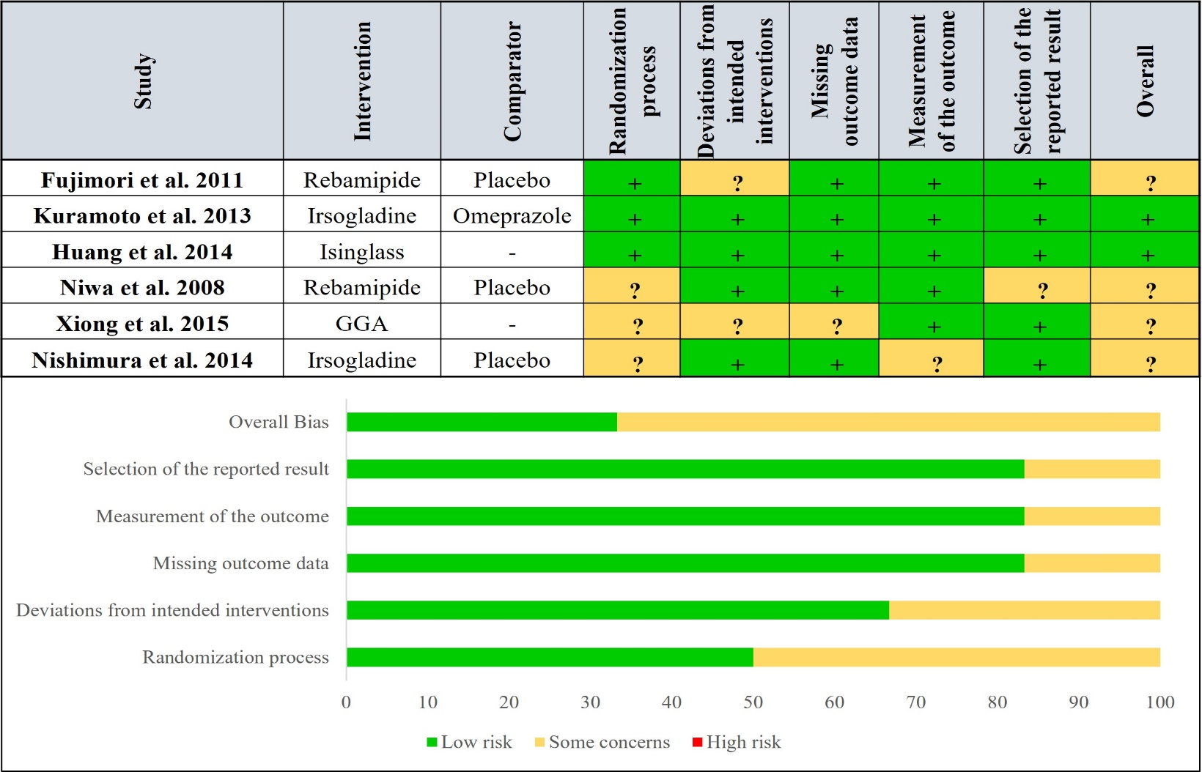Fig. S8 Risk of bias assessment at study and at domain level for mucosal breaks after treatment (Prevention group)

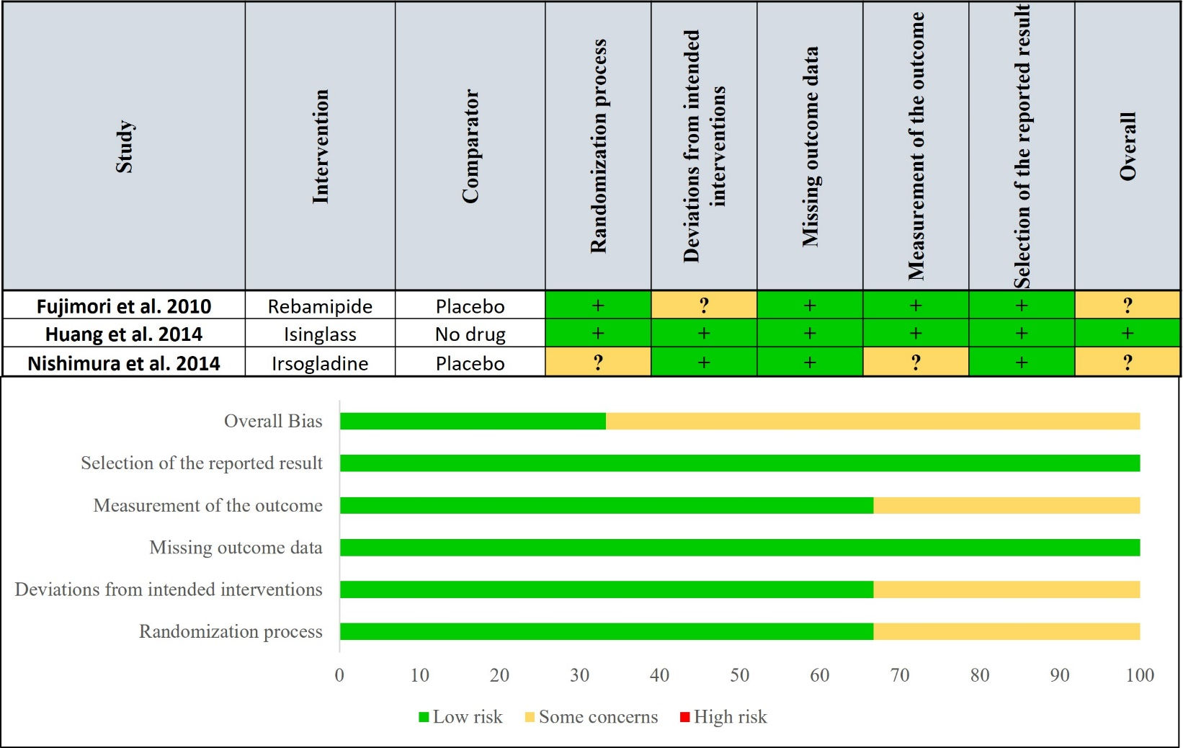
Fig. S9 Risk of bias assessment at study and at domain level for mucosal breaks (Prevention group)
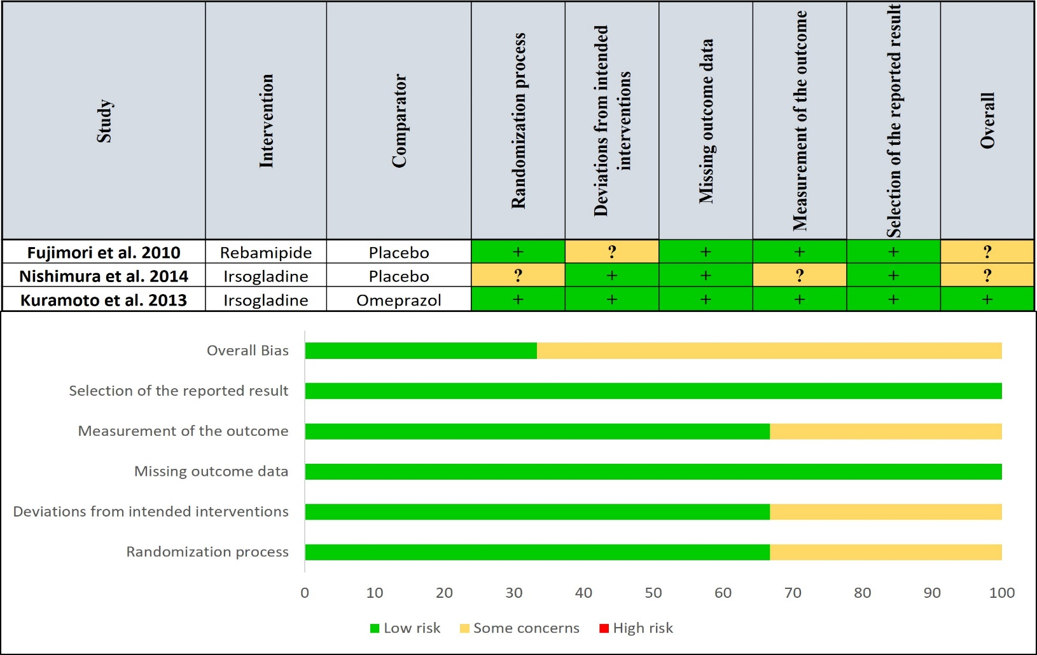
Fig. S10 Risk of bias assessment at study and at domain level for reddened lesions (Prevention group)

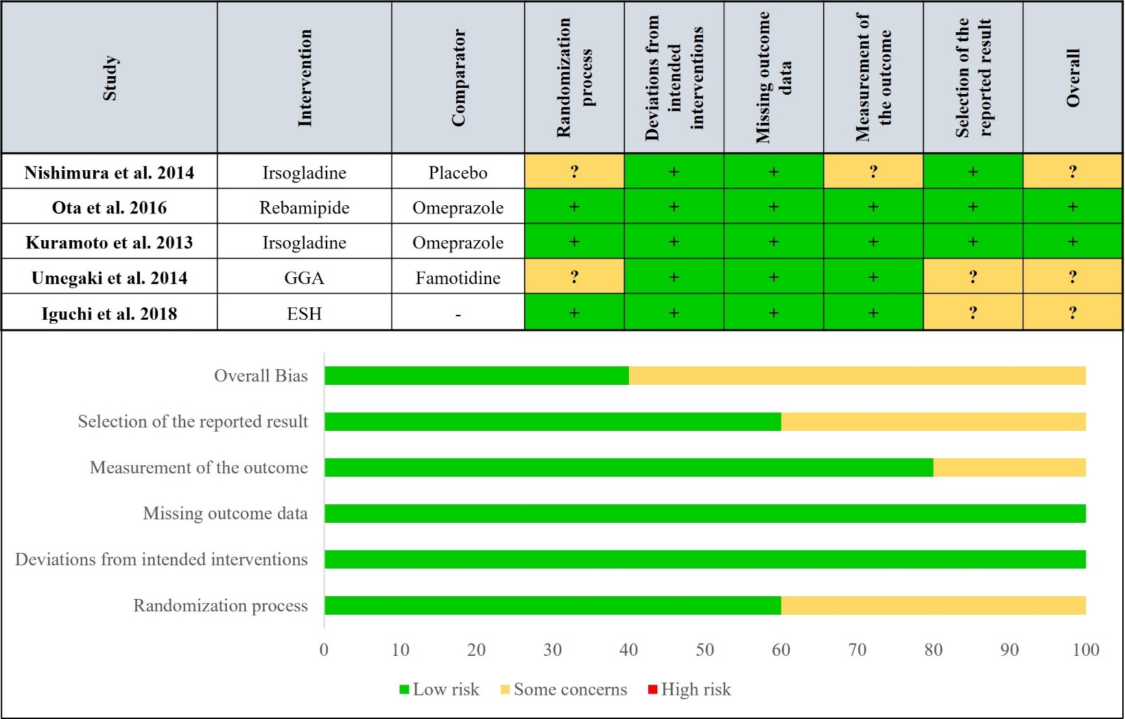
Fig. S11 Risk of bias assessment at study and at domain level for faecal calprotectin level (Prevention group)
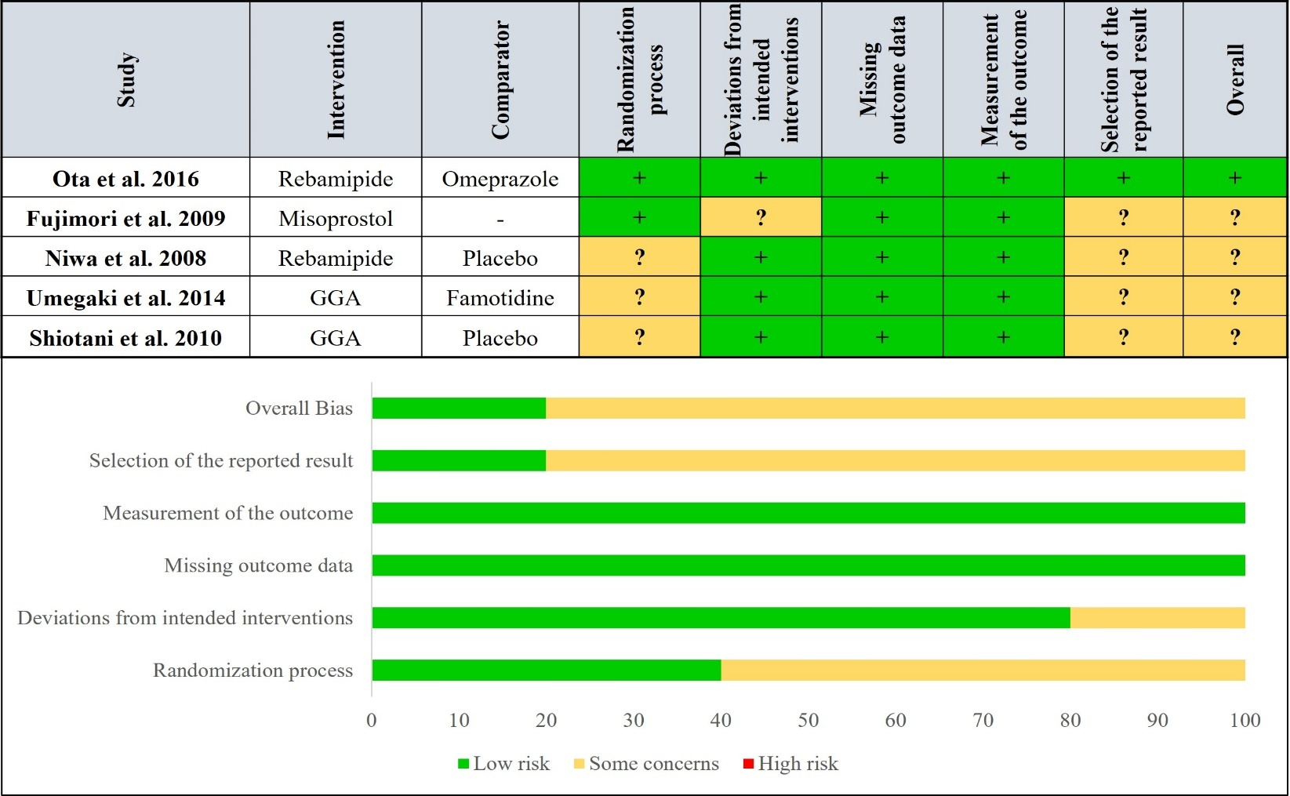
Fig. S12 Risk of bias assessment at study and at domain level for small bowel transit time (Prevention group)
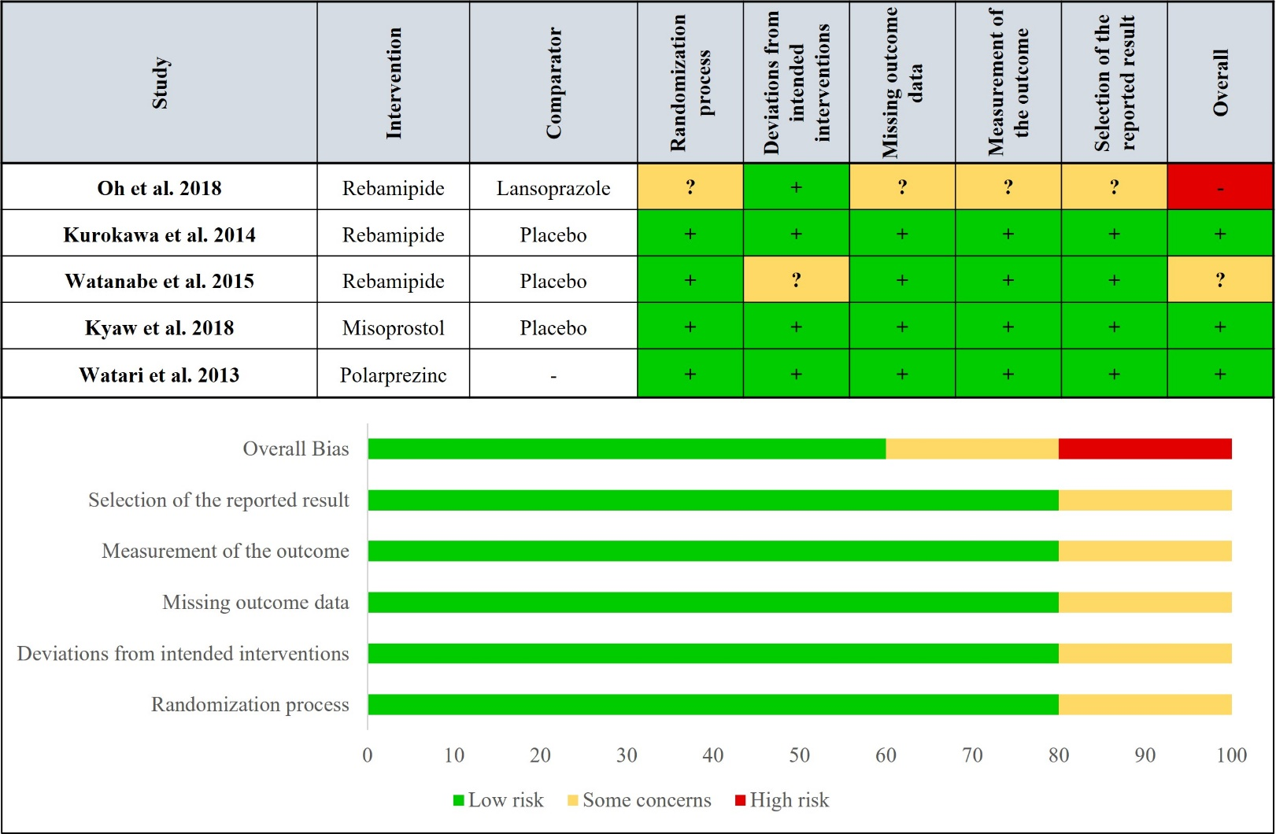Fig. S13 Risk of bias assessment at study and at domain level for mucosal breaks (Treatment group)
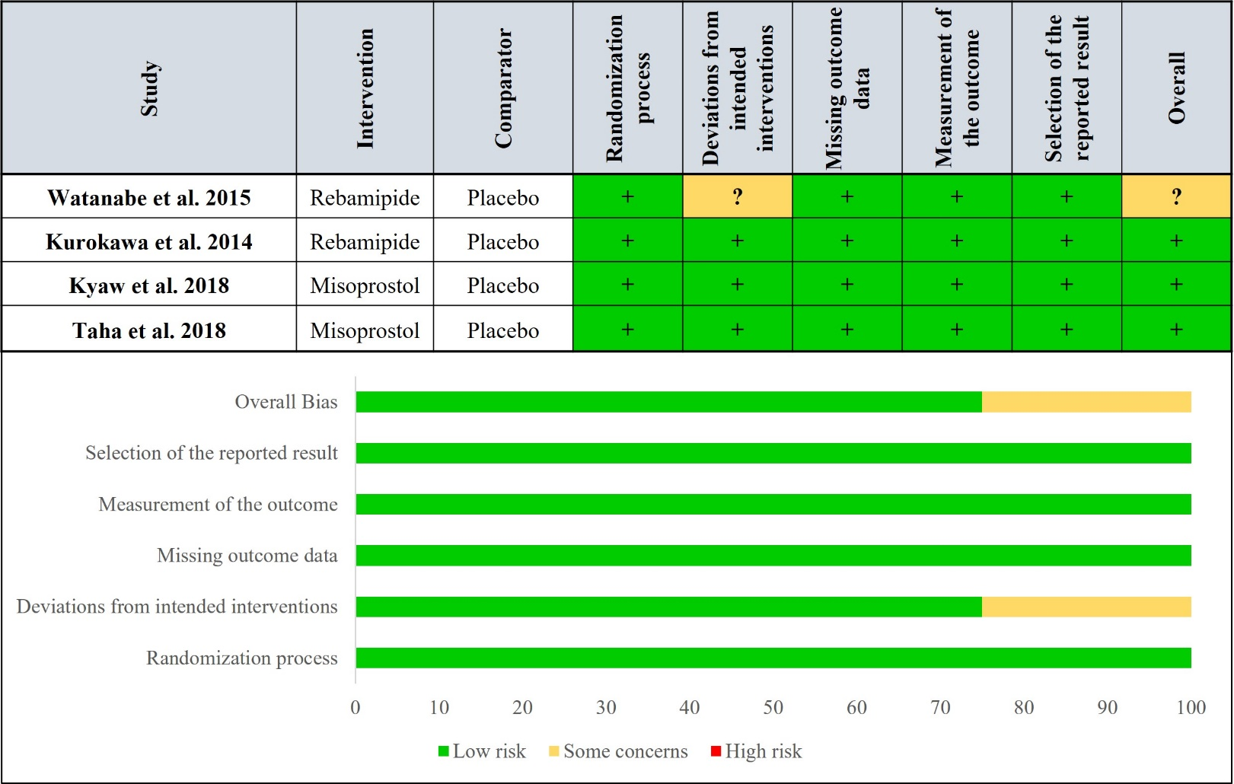
Fig. S14 Risk of bias assessment at study and at domain level for complete healing of mucosal breaks (Treatment group)
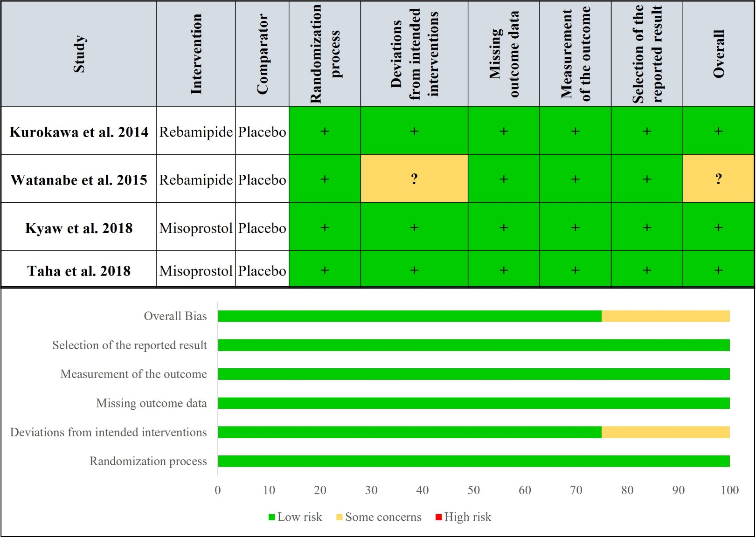
Study
Intervention
Comparator
Randomization
process
Deviations
from intended
interventions
Missing
outcome data
Measurement
of the outcome
Selection of the
reported result
Overall
Kurokawa
et al. 2014
Rebamipide
Placebo
+
+
+
+
+
+
Watanabe et al. 2015
Rebamipide
Placebo
+
?
+
+
+
?
Kyaw and Otani et al.
2018
Misoprostol
Placebo
+
+
+
+
+
+
Taha
et al. 2018
Misoprostol
Placebo
+
+
+
+
+
+
0
10
20
30
40
50
60
70
80
90
100
Randomization process
Deviations from intended interventions
Missing outcome data
Measurement of the outcome
Selection of the reported result
Overall Bias
Low risk
Some concerns
High risk
Fig. S15 Risk of bias assessment at study and at domain level for haemoglobin level (Treatment group)
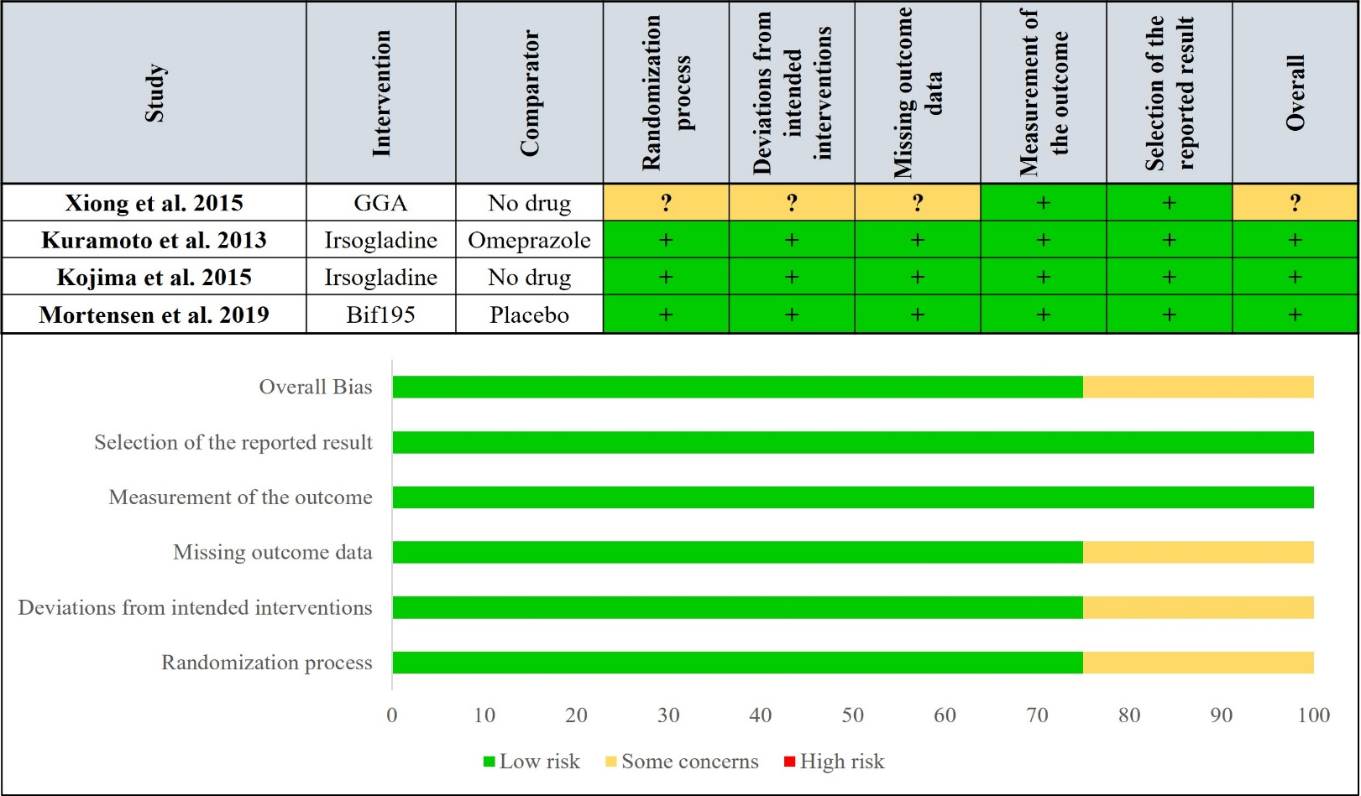
Fig. S16 Risk of bias assessment at study and at domain level for adverse events (Prevention group)
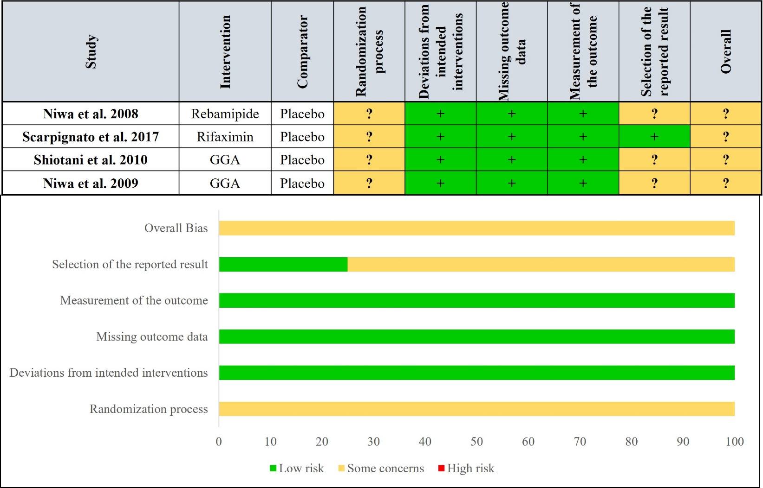
Fig. S17 Risk of bias assessment at study and at domain level for serious adverse events (Prevention group)
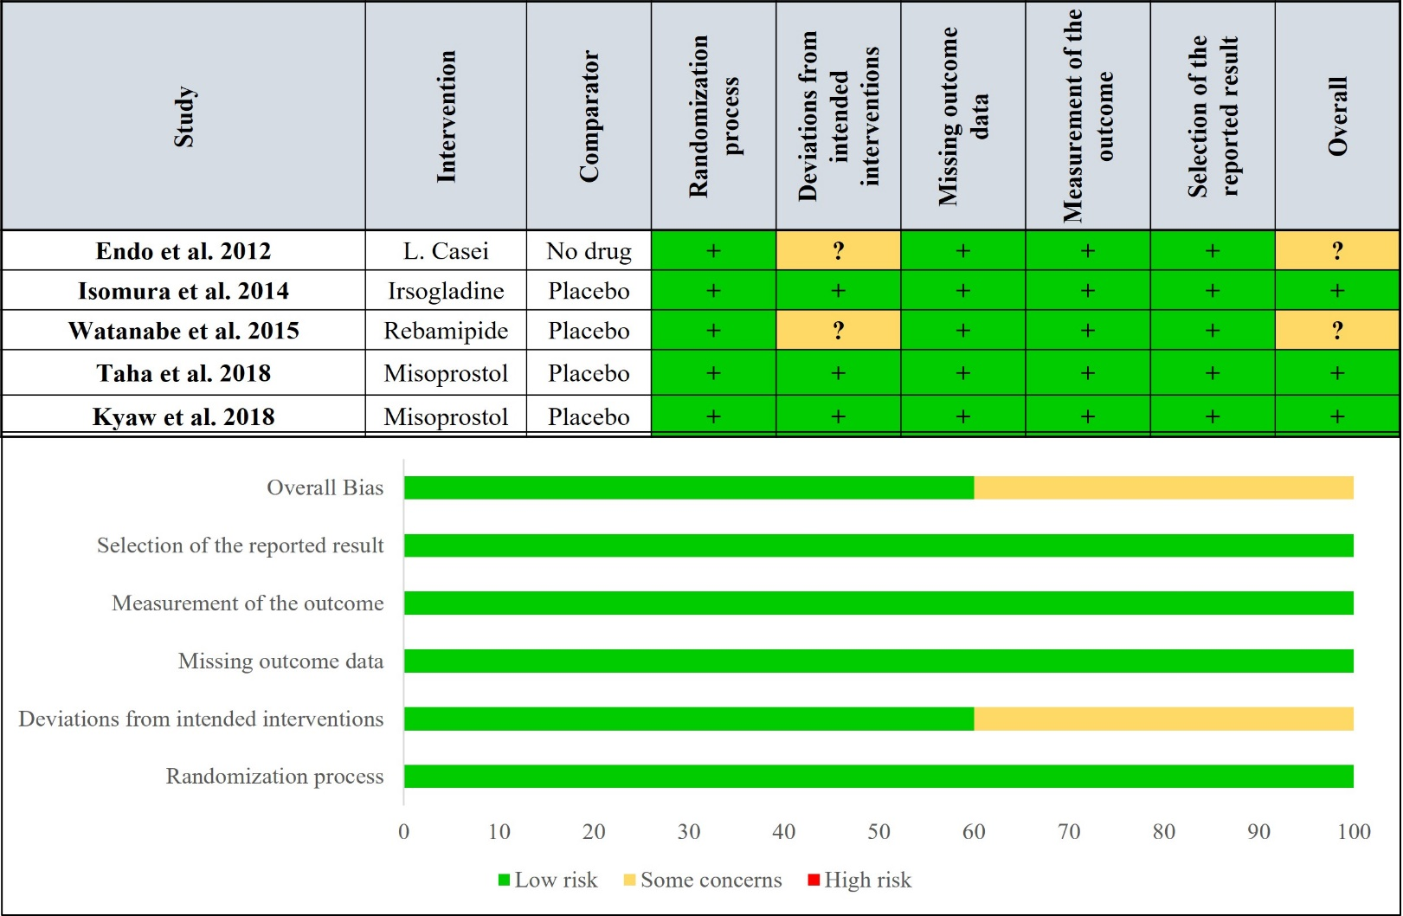
Fig. S18 Risk of bias assessment at study and at domain level for adverse events (Treatment group)
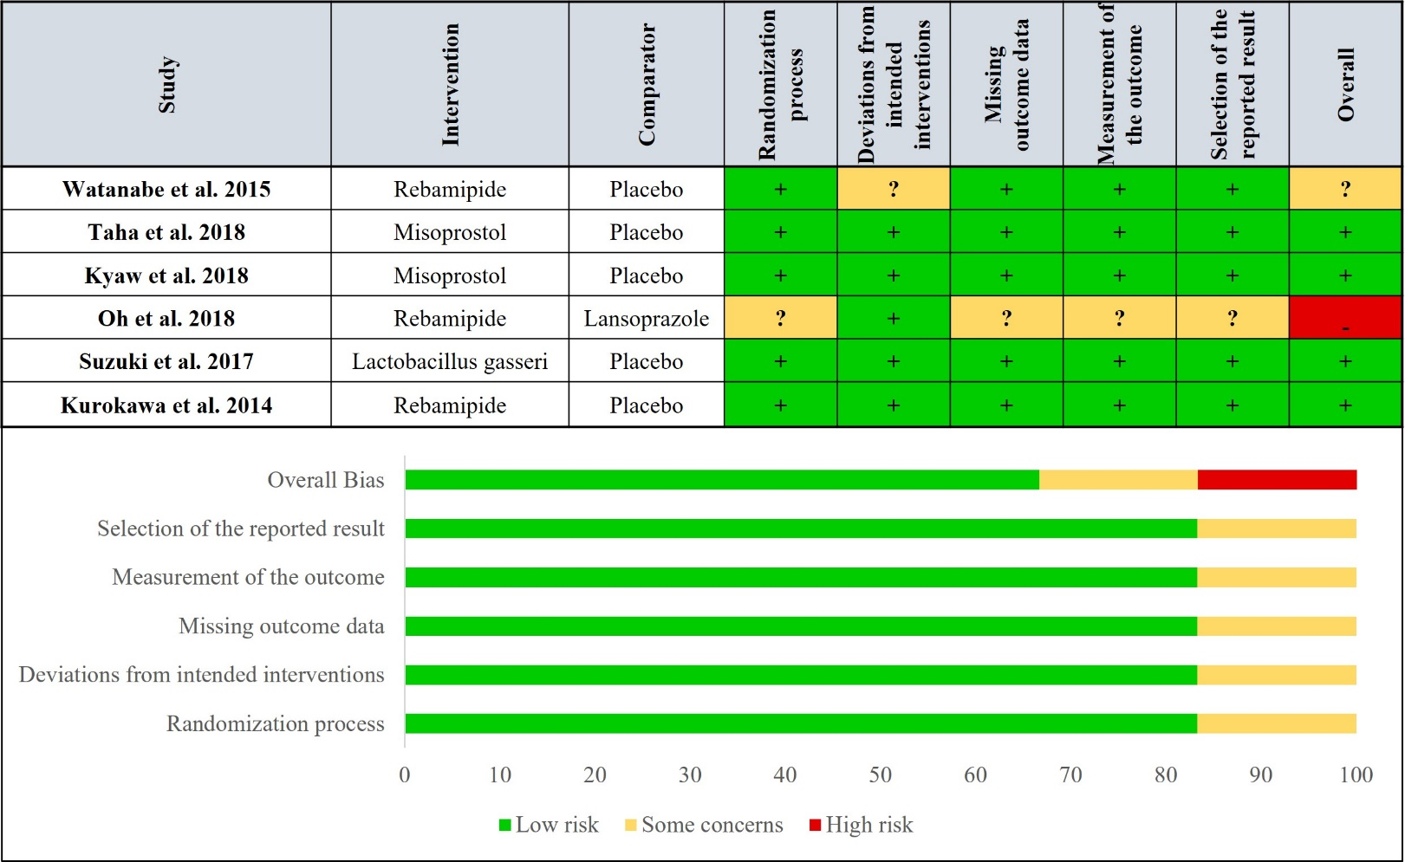
Fig. S19 Risk of bias assessment at study and at domain level for serious adverse events (Treatment group)
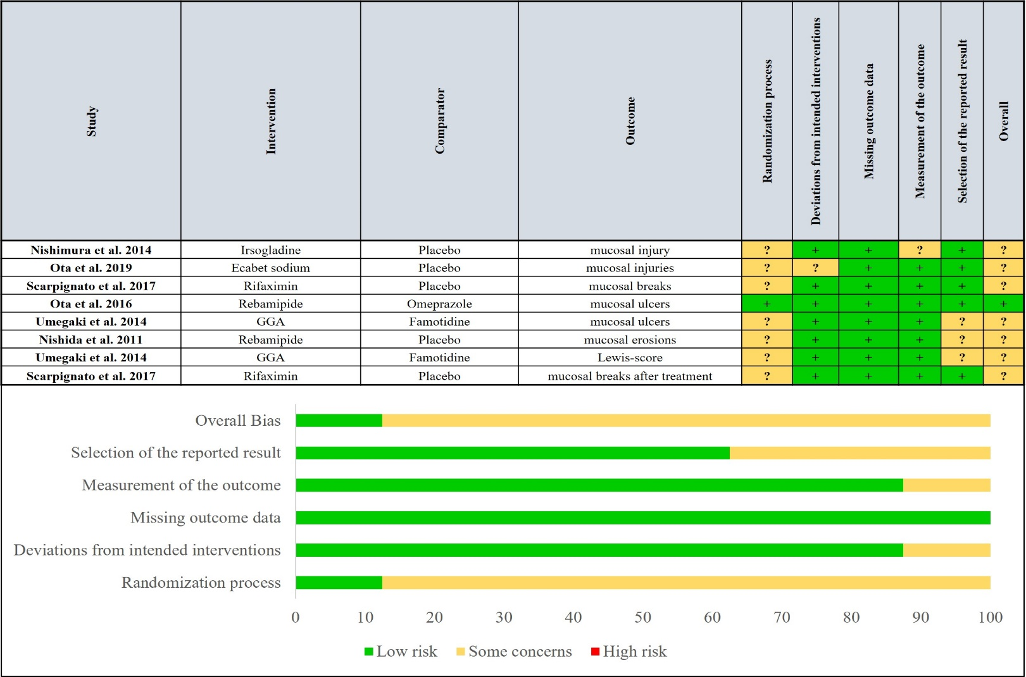
Fig. S20 Risk of bias assessment at study and at domain level for outcomes (Prevention group) included only in our systematic review
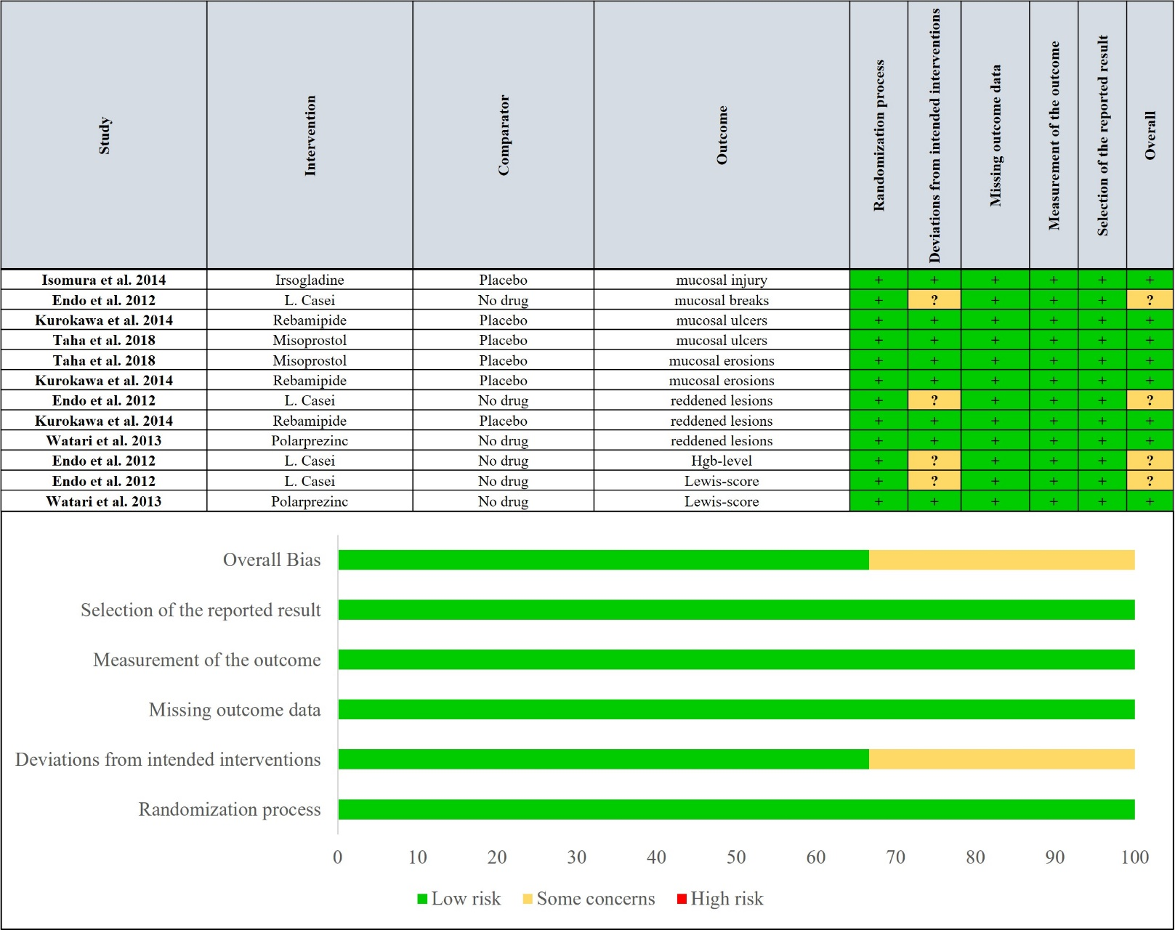
Fig. S21 Risk of bias assessment at study and at domain level for outcomes (Treatment group) included only in our systematic review
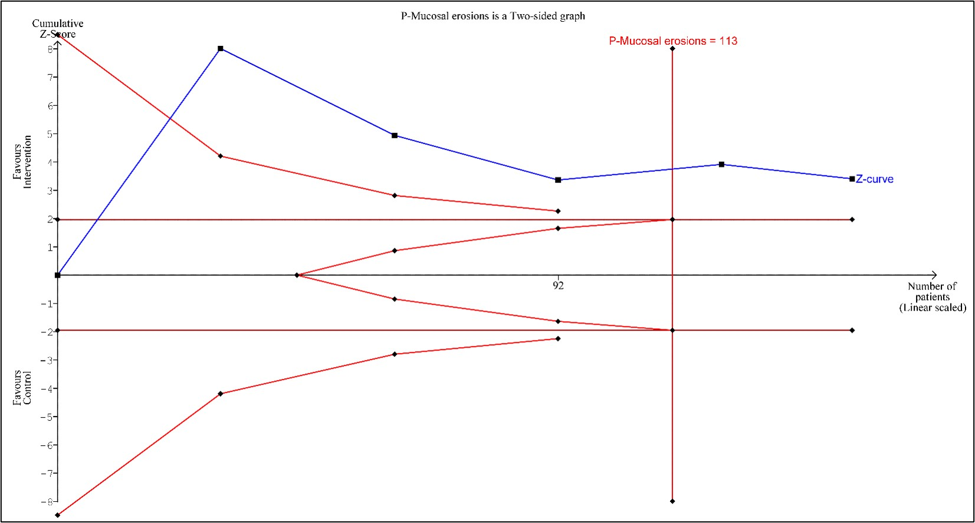Fig. S22 Trial sequential analysis for mucosal erosions (Prevention group)
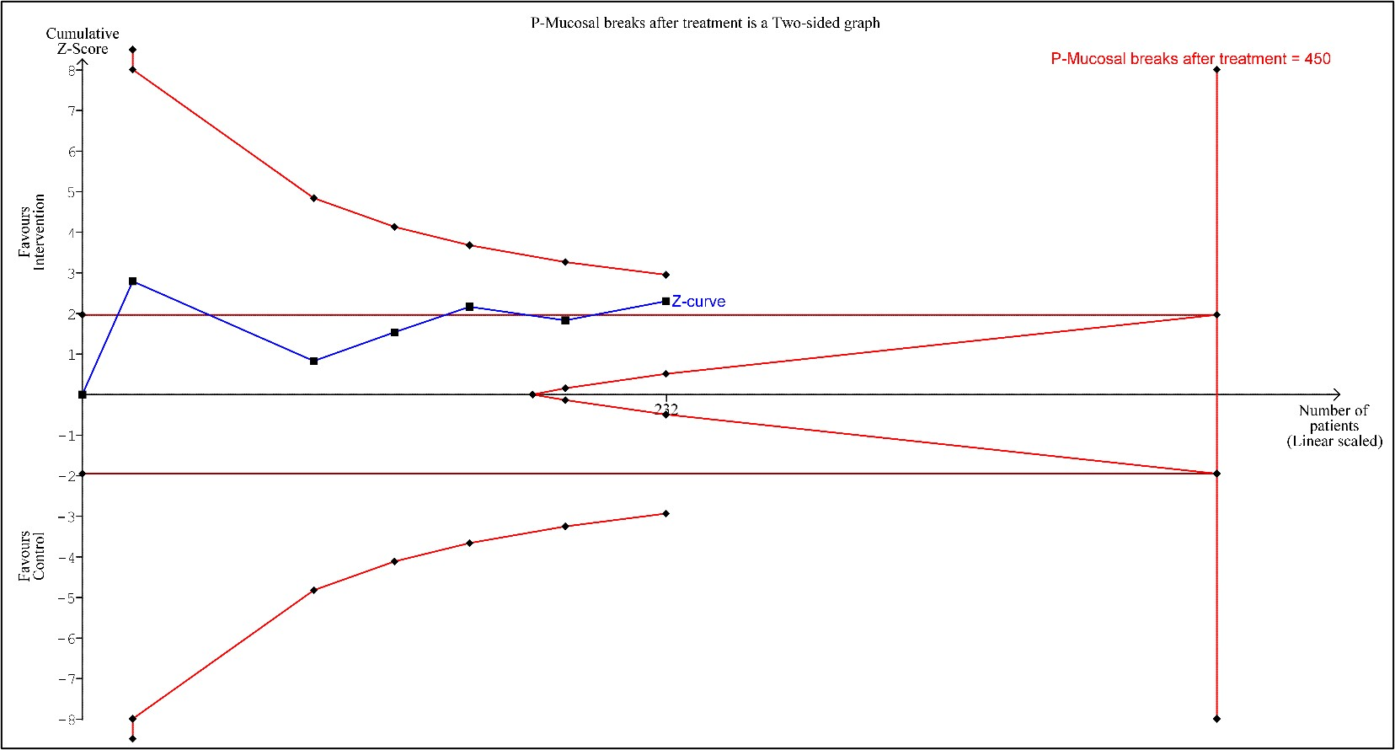
Fig. S23 Trial sequential analysis for mucosal breaks after treatment (Prevention group)
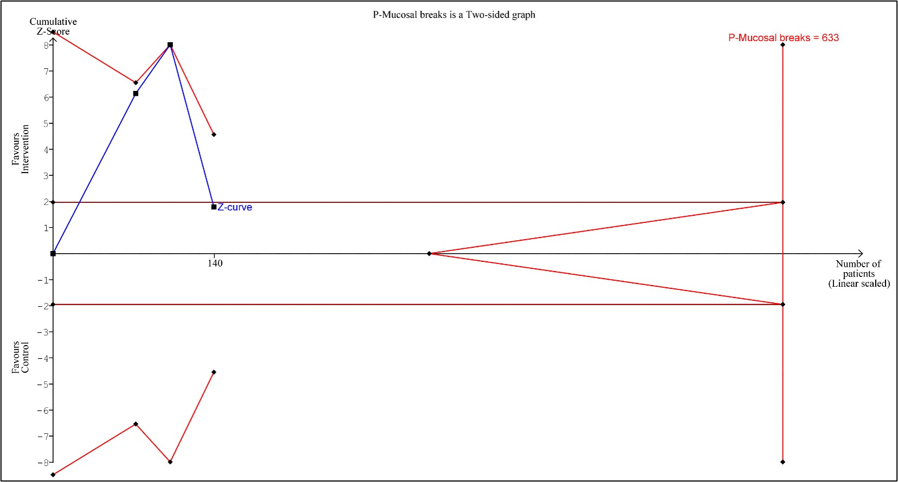
Fig. S24 Trial sequential analysis for mucosal breaks (Prevention group)

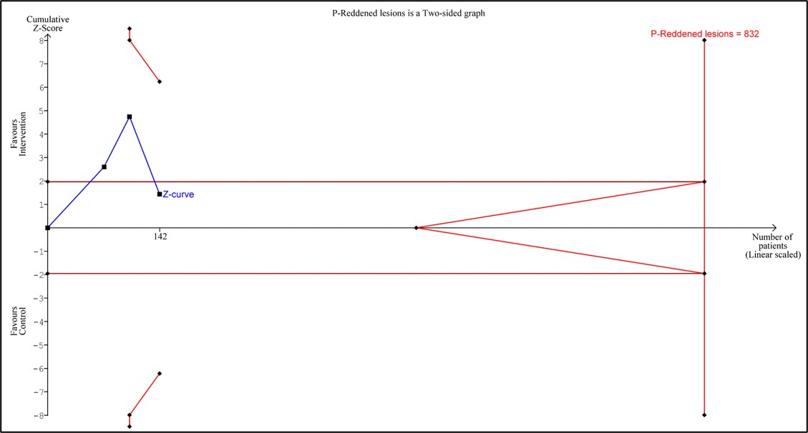
Fig. S25 Trial sequential analysis for reddened lesions (Prevention group)
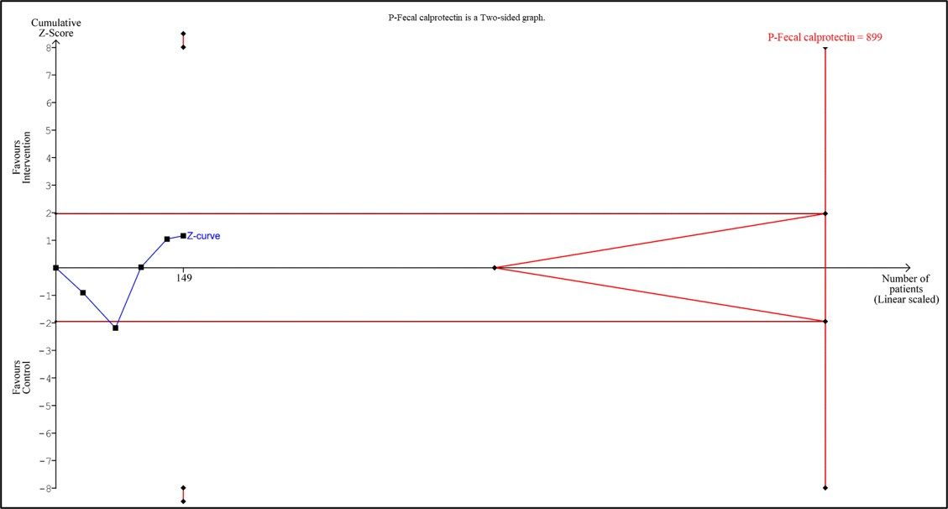
Fig. S26 Trial sequential analysis for faecal calprotectin level (Prevention group)

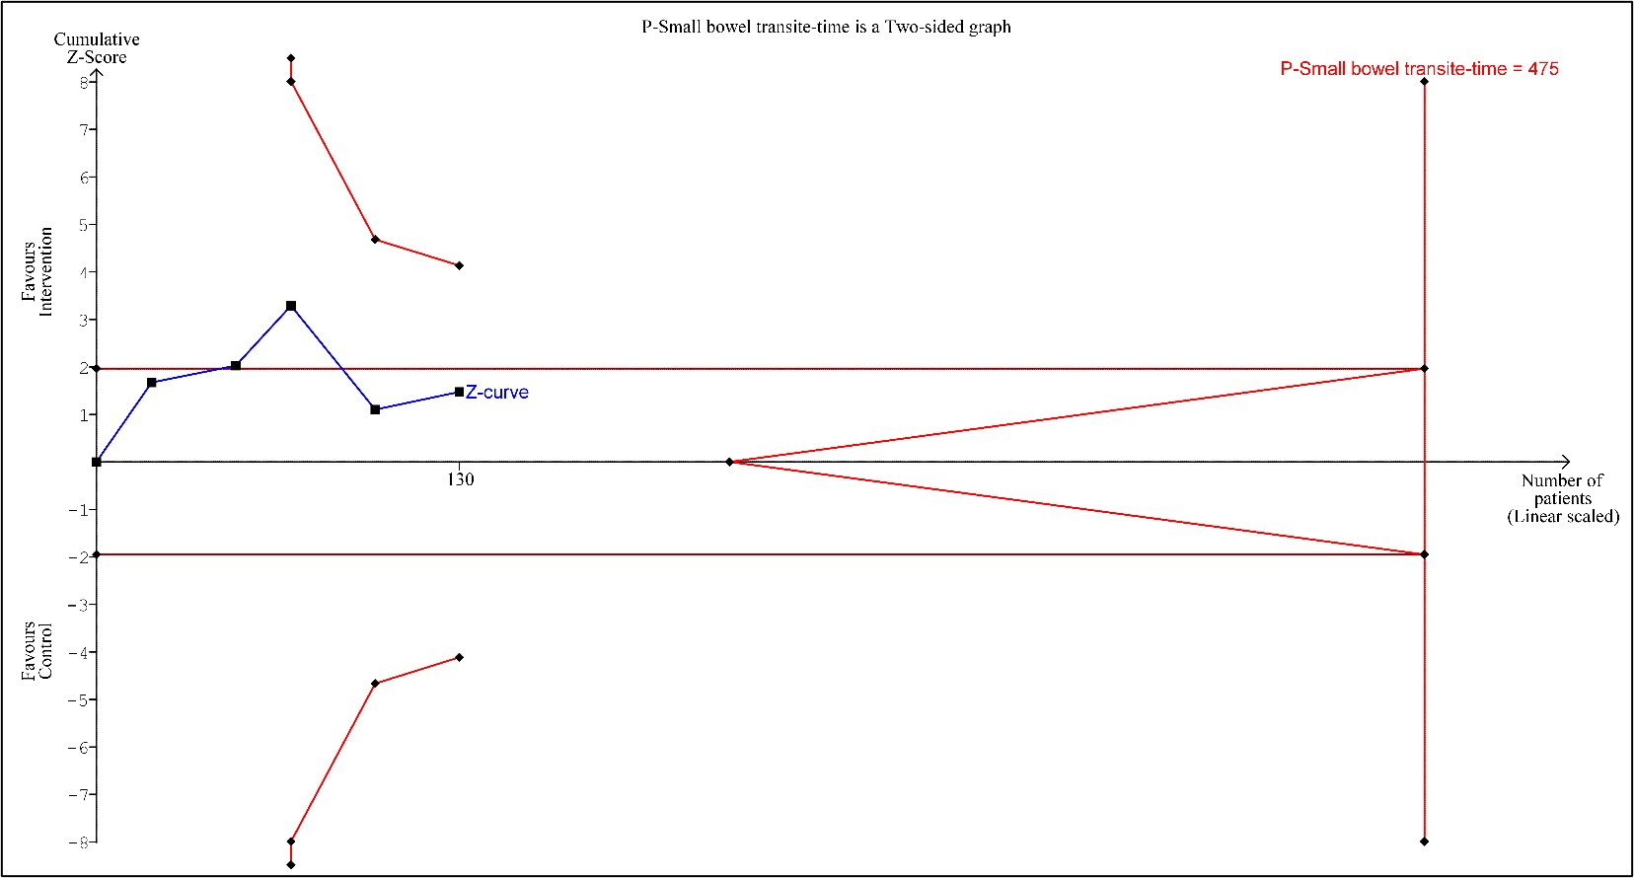
Fig. S27 Trial sequential analysis for small bowel transit time (Prevention group)
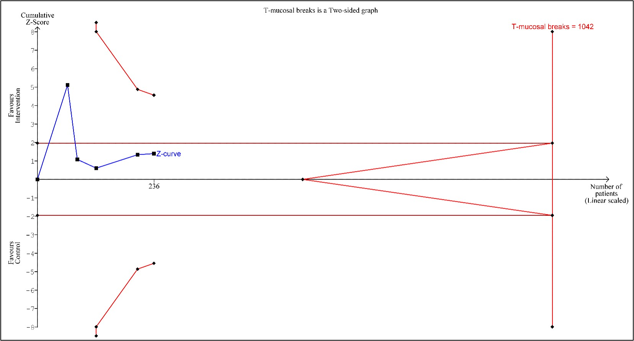
Fig. S28 Trial sequential analysis for mucosal breaks (Treatment group)

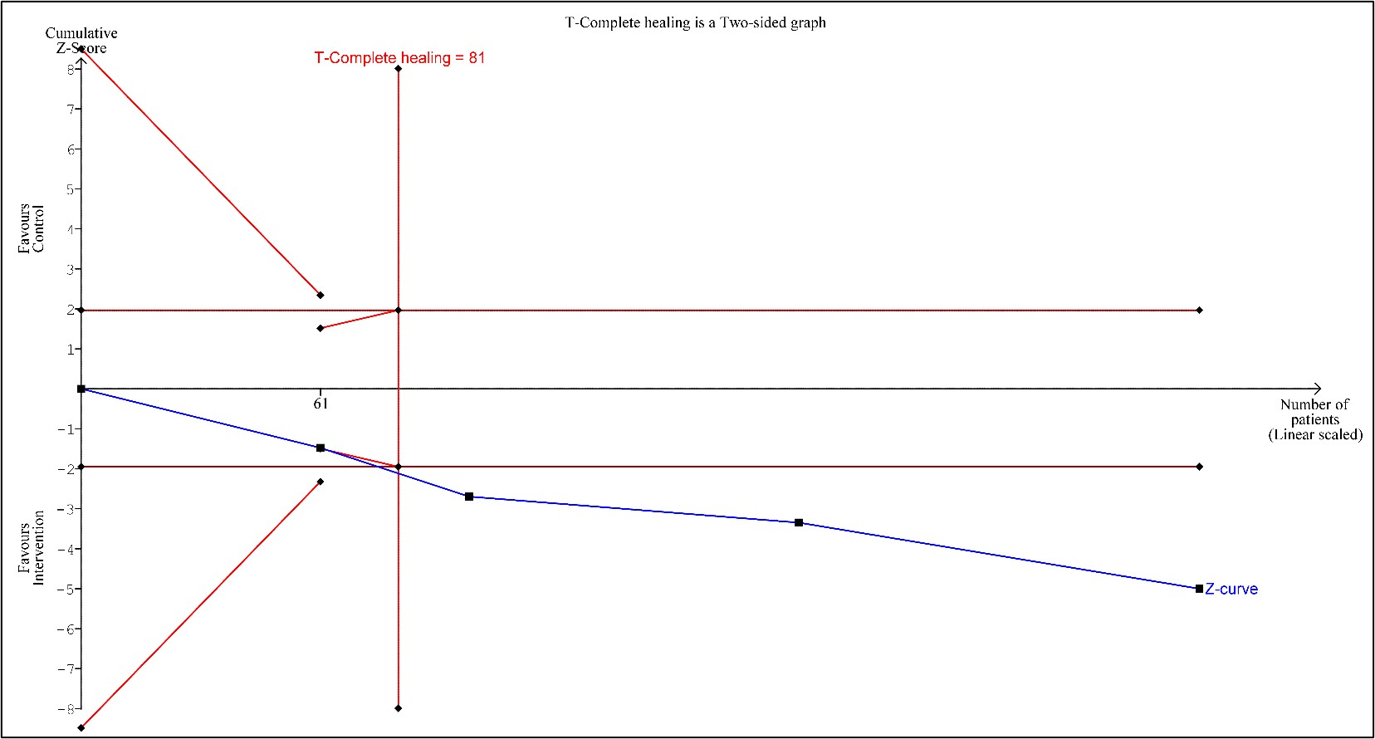
Fig. S29 Trial sequential analysis for complete healing of mucosal breaks (Treatment group)
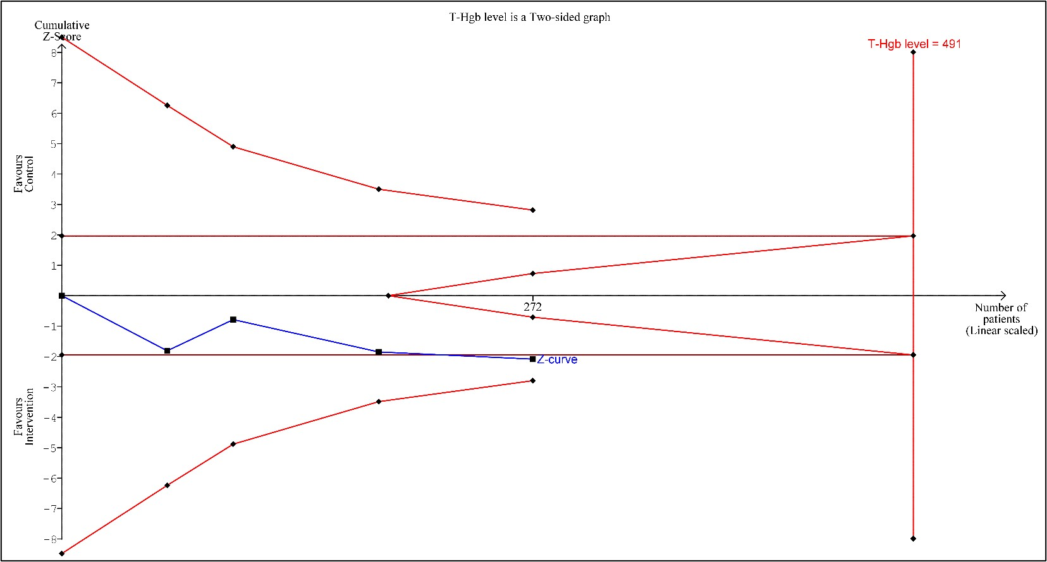
Fig. S30 Trial sequential analysis for haemoglobin level (Treatment group)

Table S9 Summary of Findings (Prevention group)
Mucoprotective drugs compared to Placebo/PPI/H2-R-antagonists for prevention and treatment of NSAID-induced small bowel enteropathy
Patient or population: prevention and treatment of NSAID-induced small bowel enteropathy
Setting:
Intervention: Mucoprotective drugs
Comparison: Placebo/PPI/H2-R-antagonists
Outcomes | Anticipated absolute effects* (95% CI) |  | Relative effect  (95% CI) | № of participants  (studies) | Certainty of the evidence  (GRADE) | Comments
Outcomes | Risk with Placebo/PPI/H2-R-antagonists | Risk with Mucoprotective drugs
Mucosal erosions (Prevention group)  assessed with: capsule endoscopy |  | MD 1.2 number fewer  (0.5 more to 2.2 fewer) | - | 146  (5 RCTs) | ⨁◯◯◯  VERY LOW ^{a,b,c,d,e} | Preventive treatment with mucoprotective drugs was associated with a lower increase in the mean number of mucosal erosions.
Mucosal breaks after treatment (Prevention group)  assessed with: capsule endoscopy | 534 per 1,000 | 305 per 1,000  (152 to 517) | OR 0.382  (0.156 to 0.933) | 232  (6 RCTs) | ⨁◯◯◯  VERY LOW ^{a,e,f,g,h} | Preventive treatment with mucoprotective drugs was associated with a lower chance for the formation of mucosal breaks after treatment.
Mucosal breaks (Prevention group)  assessed with: capsule endoscopy | The mean mucosal breaks (Prevention group) was 0 number | MD 5 number lower  (14.1 lower to 4.2 higher) | - | 140  (3 RCTs) | ⨁◯◯◯  VERY LOW ^{a,e,h,i,j}
Reddened lesions (Prevention group)  assessed with: capsule endoscopy | The mean reddened lesions (Prevention group) was 0 number | MD 3 number lower  (7.1 lower to 1.2 higher) | - | 142  (3 RCTs) | ⨁◯◯◯  VERY LOW ^{a,e,h,k,l}
Faecal calprotectin level (Prevention group)  assessed with: laboratory measurement |  | MD 4572 ug/g fewer  (16925 fewer to 7781 more) | - | 149  (5 RCTs) | ⨁◯◯◯  VERY LOW ^{e,h,m,n} | Preventive treatment with mucoprotective drugs was not associated with a higher decrease in faecal calprotectin level only when treated with PGIAs.
Small bowel transit time (Prevention group)  assessed with: capsule endoscopy |  | MD 16.4 minutes fewer  (38.3 fewer to 5.5 more) | - | 130  (5 RCTs) | ⨁◯◯◯  VERY LOW ^{a,e,h,o,p} | Preventive treatment with PGIAs was not associated with a higher decrease in small bowel transit time.
*The risk in the intervention group (and its 95% confidence interval) is based on the assumed risk in the comparison group and the relative effect of the intervention (and its 95% CI).
CI: Confidence interval; MD: Mean difference; OR: Odds ratio
GRADE Working Group grades of evidence
High certainty: We are very confident that the true effect lies close to that of the estimate of the effect
Moderate certainty: We are moderately confident in the effect estimate: The true effect is likely to be close to the estimate of the effect, but there is a possibility that it is substantially different
Low certainty: Our confidence in the effect estimate is limited: The true effect may be substantially different from the estimate of the effect
Very low certainty: We have very little confidence in the effect estimate: The true effect is likely to be substantially different from the estimate of effect

Table S10 Summary of Findings (Treatment group)
Mucoprotective drugs compared to Placebo/PPI/H2-R-antagonists for prevention and treatment of NSAID-induced small bowel enteropathy
Patient or population: prevention and treatment of NSAID-induced small bowel enteropathy
Setting:
Intervention: Mucoprotective drugs
Comparison: Placebo/PPI/H2-R-antagonists
Outcomes | Anticipated absolute effects* (95% CI) |  | Relative effect  (95% CI) | № of participants  (studies) | Certainty of the evidence  (GRADE) | Comments
Outcomes | Risk with Placebo/PPI/H2-R-antagonists | Risk with Mucoprotective drugs
Mucosal breaks (Treatment group)  assessed with: capsule endoscopy |  | MD 3.7 lower  (11 lower to 3.6 higher) | - | 236  (4 RCTs) | ⨁◯◯◯  VERY LOW ^{b,c,d,e,f} | Treatment with mucoprotective drugs could not reduce the mean number of mucosal breaks in NSAID-induced SBE.
Complete healing of mucosal breaks (Treatment group)  assessed with: capsule endoscopy | 109 per 1,000 | 398 per 1,000  (255 to 562) | OR 5.387  (2.785 to 10.419) | 285  (4 RCTs) | ⨁⨁⨁◯  MODERATE ^{a,b,g} | Treatment with mucoprotective drugs was associated with a higher chance for complete healing of mucosal breaks.
Haemoglobin level (Treatment group)  assessed with: laboratory measurement |  | MD 0.5 g/dl more  (0 to 1 more) | - | 272  (4 RCTs) | ⨁◯◯◯  VERY LOW ^{b,c,h,i} | Treatment with PGIAs could not increase the haemoglobin level.
*The risk in the intervention group (and its 95% confidence interval) is based on the assumed risk in the comparison group and the relative effect of the intervention (and its 95% CI).
CI: Confidence interval; MD: Mean difference; OR: Odds ratio
GRADE Working Group grades of evidence
High certainty: We are very confident that the true effect lies close to that of the estimate of the effect
Moderate certainty: We are moderately confident in the effect estimate: The true effect is likely to be close to the estimate of the effect, but there is a possibility that it is substantially different
Low certainty: Our confidence in the effect estimate is limited: The true effect may be substantially different from the estimate of the effect
Very low certainty: We have very little confidence in the effect estimate: The true effect is likely to be substantially different from the estimate of effect

Table S11 Quality of evidence for the systematic review part (Adverse events)
Mucoprotective drugs compared to Placebo/PPI/H2-R-antagonists for prevention and treatment of NSAID-induced small bowel enteropathy
Patient or population: prevention and treatment of NSAID-induced small bowel enteropathy
Setting: adverse events
Intervention: Mucoprotective drugs
Comparison: Placebo/PPI/H2-R-antagonists
Outcomes | Anticipated absolute effects* (95% CI) |  | Relative effect  (95% CI) | № of participants  (studies) | Certainty of the evidence  (GRADE) | Comments
Outcomes | Risk with Placebo/PPI/H2-R-antagonists | Risk with Mucoprotective drugs
Adverse events (prevention) | not pooled | not pooled | not pooled | 146  (4 RCTs) | ⨁⨁◯◯  LOW ^{a,b,c,d} | Adverse events were detected only when Bifidobacterium breve was administered however, in the control group the event number was higher.
Serious adverse events (prevention) | not pooled | not pooled | not pooled | 120  (4 RCTs) | ⨁⨁◯◯  LOW ^{a,b,c,d} | Serious adverse events were not detected.
Adverse events (treatment) | not pooled | not pooled | not pooled | 209  (5 RCTs) | ⨁⨁◯◯  LOW ^{a,b,c,d} | Adverse events were detected only when Misoprostol was administered however, in the control group the event number was high as well.
Serious adverse events (treatment) | not pooled | not pooled | not pooled | 376  (6 RCTs) | ⨁◯◯◯  VERY LOW ^{a,b,c,d,e} | Serious adverse events were detected only when Misoprostol was administered.
*The risk in the intervention group (and its 95% confidence interval) is based on the assumed risk in the comparison group and the relative effect of the intervention (and its 95% CI).
CI: Confidence interval
GRADE Working Group grades of evidence
High certainty: We are very confident that the true effect lies close to that of the estimate of the effect
Moderate certainty: We are moderately confident in the effect estimate: The true effect is likely to be close to the estimate of the effect, but there is a possibility that it is substantially different
Low certainty: Our confidence in the effect estimate is limited: The true effect may be substantially different from the estimate of the effect
Very low certainty: We have very little confidence in the effect estimate: The true effect is likely to be substantially different from the estimate of effect

Table S12 Quality of evidence for the systematic review part (Prevention group)
Mucoprotective drugs compared to Placebo/PPI/H2-R-antagonists for prevention and treatment of NSAID-induced small bowel enteropathy
Patient or population: prevention and treatment of NSAID-induced small bowel enteropathy
Setting:
Intervention: Mucoprotective drugs
Comparison: Placebo/PPI/H2-R-antagonists
Outcomes | Anticipated absolute effects* (95% CI) |  | Relative effect  (95% CI) | № of participants  (studies) | Certainty of the evidence  (GRADE) | Comments
Outcomes | Risk with Placebo/PPI/H2-R-antagonists | Risk with Mucoprotective drugs
Mucosal injuries (prevention)  assessed with: capsule endoscopy | The mean mucosal injuries (prevention) was 0 | not pooled | - | 62  (2 RCTs) | ⨁◯◯◯  VERY LOW ^{a,b,c,d,e} | Nishimura et al. 2014 found that treatment with Irsogladine leads to a lower increase in the mean number of mucosal injuries, while Ota et al. 2019 found a higher increase with Ecabet sodium.
Mucosal breaks (prevention)  assessed with: capsule endoscopy | The mean mucosal breaks (prevention) was 0 | 0  (0 to 0 ) | - | 60  (1 RCT) | ⨁⨁◯◯  LOW ^{b,d,e,f} | A lower increase was assessed in the mean number of mucosal breaks when the patients were treated with Rebamipide, Isinglass, Irsogladine, and Rifaximin.
Mucosal ulcers (prevention)  assessed with: capsule endoscopy | The mean mucosal ulcers (prevention) was 0 | not pooled | - | 60  (2 RCTs) | ⨁⨁◯◯  LOW ^{a,b,d,e} | Preventive treatment of mucosal ulcers with Rebamipide and GGA showed a beneficial effect.
Mucosal erosions (prevention)  assessed with: capsule endoscopy |  | 0  (0 to 0 ) | - | 20  (1 RCT) | ⨁⨁◯◯  LOW ^{a,d,e} | Mucosal erosions were not observed after Rebamipide treatment. ^{g}
Lewis score (prevention)  assessed with: capsule endoscopy |  | MD 90.1 lower  (105.7 lower to 74.5 lower) | - | 30  (1 RCT) | ⨁⨁◯◯  LOW ^{a,b,d,e} | Umegaki et al. 2014 administered GGA as a preventive treatment and assessed a decrease in the mean Lewis score of patients
Mucosal breaks after treatment (prevention)  assessed with: capsule endoscopy | 765 per 1,000 | 0 per 1,000  (0 to 0) | not estimable | 41  (1 RCT) | ⨁⨁⨁◯  MODERATE ^{b,d,e} | In the intervention group, only 6 patients developed mucosal breaks at the end of the treatment, meanwhile, in the control group mucosal breaks were assessed in 13 patients.
*The risk in the intervention group (and its 95% confidence interval) is based on the assumed risk in the comparison group and the relative effect of the intervention (and its 95% CI).
CI: Confidence interval; MD: Mean difference
GRADE Working Group grades of evidence
High certainty: We are very confident that the true effect lies close to that of the estimate of the effect
Moderate certainty: We are moderately confident in the effect estimate: The true effect is likely to be close to the estimate of the effect, but there is a possibility that it is substantially different
Low certainty: Our confidence in the effect estimate is limited: The true effect may be substantially different from the estimate of the effect
Very low certainty: We have very little confidence in the effect estimate: The true effect is likely to be substantially different from the estimate of effect

Table S13 Quality of evidence for the systematic review part (Treatment group)
Mucoprotective drugs compared to Placebo/PPI/H2-R-antagonists for prevention and treatment of NSAID-induced small bowel enteropathy
Patient or population: prevention and treatment of NSAID-induced small bowel enteropathy
Setting:
Intervention: Mucoprotective drugs
Comparison: Placebo/PPI/H2-R-antagonists
Outcomes | Anticipated absolute effects* (95% CI) |  | Relative effect  (95% CI) | № of participants  (studies) | Certainty of the evidence  (GRADE) | Comments
Outcomes | Risk with Placebo/PPI/H2-R-antagonists | Risk with Mucoprotective drugs
Mucosal injuries (treatment)  assessed with: capsule endoscopy |  | MD 7.1 fewer  (12.1 fewer to 2.1 fewer) | - | 39  (1 RCT) | ⨁⨁⨁◯  MODERATE ^{a,c,d} | Irsogladine decreased the mean number of mucosal injuries.
Mucosal breaks (treatment)  assessed with: capsule endoscopy |  | 6.1 fewer  (13.3 fewer to 1.1 more) | - | 25  (1 RCT) | ⨁⨁⨁◯  MODERATE ^{a,c,d} | Endo el al. 2011 used Lactobacillus Casei as an intervention with the potential of healing of mucosal breaks.
Mucosal ulcers (treatment)  assessed with: capsule endoscopy | The mean mucosal ulcers (treatment) was 0 | not pooled | - | 163  (2 RCTs) | ⨁⨁◯◯  LOW ^{a,b,c,d} | The beneficial effect of Rebamipide and Misoprostol resulted in the reduction of mucosal ulcers.
Mucosal erosions (treatment)  assessed with: capsule endoscopy | The mean mucosal erosions (treatment) was 0 | not pooled | - | 163  (2 RCTs) | ⨁⨁◯◯  LOW ^{a,b,c,d} | The beneficial effect of Rebamipide and Misoprostol resulted in the reduction of mucosal erosions.
Reddened lesions (treatment)  assessed with: capsule endoscopy | The mean reddened lesions (treatment) was 0 | not pooled | - | 106  (3 RCTs) | ⨁⨁◯◯  LOW ^{a,b,c,d} | Reddened lesions, when treated with Lactobacillus Casei, Rebamipide, and Polaprezinc, showed a decrease in the mean number.
Haemoglobin level (treatment)  assessed with: laboratory measurements |  | MD 90 fewer  (135.1 fewer to 44.9 fewer) | - | 25  (1 RCT) | ⨁⨁⨁◯  MODERATE ^{a,c,d} | Treatment with Lactobacillus casei showed an increase in the haemoglobin level compared to no intervention.
Lewis score (treatment)  assessed with: capsule endoscopy | The mean lewis score (treatment) was 0 | not pooled | - | 45  (2 RCTs) | ⨁⨁◯◯  LOW ^{a,b,c,d} | Endo et al. 2011 using Lactobacillus casei as an intervention and Watari et al. 2013 treating patients with Polaprezinc resulted in a decrease in the Lewis score
*The risk in the intervention group (and its 95% confidence interval) is based on the assumed risk in the comparison group and the relative effect of the intervention (and its 95% CI).
CI: Confidence interval; MD: Mean difference
GRADE Working Group grades of evidence
High certainty: We are very confident that the true effect lies close to that of the estimate of the effect
Moderate certainty: We are moderately confident in the effect estimate: The true effect is likely to be close to the estimate of the effect, but there is a possibility that it is substantially different
Low certainty: Our confidence in the effect estimate is limited: The true effect may be substantially different from the estimate of the effect
Very low certainty: We have very little confidence in the effect estimate: The true effect is likely to be substantially different from the estimate of effect

