TERMINOLOGY ACCORDING TO CTCAE v4.03 | ADVERSE EVENTS INCLUDED
CONDUCTION DISORDERS (HEREAFTER NAMED “ARRHYTHMIA” FOR PLAINNESS) | ARRHYTHMIA; ARRHYTHMIA SUPRAVENTRICULAR; ATRIAL FIBRILLATION; ATRIAL FIBRILATION PAROXISM; ATRIAL FLUTTER; ATRIOVENTRICULAR BLOCK; ATRIOVENTRICULAR BLOCK COMPLETE; BRADYCARDIA; CARDIAC FLUTTER; EXTRASSYSTOLES; PALPITATIONS; PAROXYSTIC TACHYCARDIA; SINUS BRADYCARDIA; SINUS NODE DYSFUNCTION; SINUS TACHYCARDIA; SUPRAVENTRICULAR EXTRASYSTOLES; SUPRAVENTRICULAR TACHYCARDIA; TACHYCARDIA; VENTRICULAR TACHYCARDIA; VENTRICULAR FIBRILLATION; WOLFF-PARKINSON-WHITE SYNDROME
CARDIAC ARREST | CARDIAC ARREST; CARDIAC DEATH; CARDIORESPIRATORY ARREST; SUDDEN CARDIAC DEATH; SUDDEN DEATH
HEART FAILURE | ACUTE LEFT VENTRICULAR FAILURE; ACUTE CARDIOVASCULAR FAILURE; BNP INCREASED; CARDIAC DESCOMPENSATION; CARDIAC DISORDER; CARDIAC FAILURE; CARDIAC FAILURE (ACUTE); CARDIAC FAILURE AGGRAVATED; CARDIAC FAILURE CONGESTIVE; CARDIOMYOPATHY; CARDIOPULMONARY FAILURE; CARDIOVASCULAR DISORDER; CARDIOGENIC SHOCK; CIRCULATORY COLLAPSE; EJECTION FRACTION DECREASED; HEART FAILURE; LEFT ATRIAL ENLARGEMENT; LEFT VENTRICULAR FAILURE; LEFT VENTRICULAR DYSFUNCTION; RIGHT VENTRICULAR FAILURE; STRESS CARDIOMYOPAHTY
AORTIC VALVE DISEASE | AORTIC VALVE INCOMPETENCE; AORTIC VALVE STENOSIS
STROKE | BRAIN EDEMA; BRAIN HEMORRHAGE; CENTRAL NERVOUS SYSTEM HEMORRHAGE; CEREBELLAR HEMORRHAGE; CEREBRAL INFARCTION; CEREBRAL ISCHAEMIA; CEREBRAL HEMORRHAGE; CEREBRAL LACUNAR INFARCTION; CEREBROVASCULAR ACCIDENT; EMBOLIC STROKE; ISCHAEMIC CEREBRAL INFARCION; HEMORRHAGIC STROKE; ISCHAEMIC STROKE; INTRACRANIAL ANEURYSM; INTRACRANIAL HEMORRHAGE; INTRACRANIAL TUMOR HEMORRHAGE; VASOGENIC CEREBRAL EDEMA; TRANSIENT ISCHAEMIC ATTACK; VENTRICULAR HEMORRHAGE  NOT INCLUDED: HEMIPARESIS; HEMIPLEGIA; SUBARACNOID HEMORRHAGE; SUBDURAL HEMORRHAGE
CHEST PAIN | CHEST DISCOMFORT; CHEST PAIN
FLUSHING | FLUSHING; HOT FLUSH; HYPERAEMIA
HYPERTENSION | HYPERTENSION; HYPERTENSIVE CRISIS
HYPOTENSION | HYPOTENSION; ORTHOSTATIC HYPOTENSION
RESPIRATORY, THORACIC AND MEDIASTINAL DISORDERS - OTHER, SPECIFY | MEDIASTINAL DISORDERS; PNEUMOMEDIASTINUM
MYOCARDIAL INFARCTION | ACUTE MYOCARCIAL INFARCTION; ACUTE CORONARY SYNDROME; ANGINA PECTORIS; ANGINA UNSTABLE; ARTERIOSCLEROSIS CORONARY ARTERY; HEART ATTACK; CORONARY ARTERY DISEASE; CORONARY ARTERY INSUFFICIENCY; MYOCARDIAL INFARCTION; MYOCARDIAL ISCHAEMIA; MYOCARDIAL NECROSIS MARKER INCREASED; SILENT MYOCARDIAL INFARCTION; TROPONIN
MYOCARDITIS | EOSINOPHILIC MYOCARDITIS; MYOCARDITIS
VASCULAR DISORDERS - OTHER, SPECIFY | AORTIC DISSECTION; CAROTID ARTERY ANEURYSM; CAROTID ARTERY STENOSIS; ISCHAEMIC COLITIS; INFERIOR VENA CAVA STENOSIS; INFERIOR VENA CAVA SYNDROME; PERIPHERAL ISCHAEMIA; SUPERIOR VENA CAVA STENOSIS; SUPERIOR VENA CAVA SYNDROME; VENOUS STENOSIS
PERICARDIAL EFFUSION / PERICARDIAL TAMPONADE / PERICARDITIS (HEREAFTER NAMED “PERICARDIAL EVENTS” FOR PLAINNESS) | CARDIAC TAMPONADE; PERICARDIAL EFFUSION; PERICARDITIS
PULMONARY EDEMA | ACUTE PULMONARY EDEMA; PULMONARY EDEMA; PULMONARY EDEMA ACUTE
PULMONARY HYPERTENSION | PULMONARY HYPERTENSION
MULTI-ORGAN FAILURE | HYPOVOLEMIC SHOCK: SHOCK  NOT INCLUDED: HEMORRHAGIC SHOCK
THROMBOEMBOLIC EVENT | ARTERIAL THROMBOSIS; CEREBRAL THROMBOSIS; DEEP VEIN THROMBOSIS; EMBOLISM; HEMORRHAGIC INFARCTION; JUGULAR VEIN THROMBOSIS; PULMONARY EMBOLISM; THROMBOSIS (NON-SPECIFIED); VENA CAVA THROMBOSIS; VENOUS THROMBOSIS
SUPPLEMENTARY TABLE 1 – Summary of the terms used for adverse effects (AEs) categorized according to CTCAE v4.03.

BIAS DOMAIN / STUDY | Random sequence generation | Allocation concealment | Blinding of participants and personnel | Blinding of outcome assessment | Incomplete outcome data | Selective reporting | Others
Andre et al. 2020 | low risk | low risk | high risk | low risk | low risk | low risk | unclear risk
Antonia et al. 2017 | low risk | low risk | low risk | low risk | low risk | high risk | unclear risk
Arance et al. 2019 | low risk | low risk | low risk | low risk | low risk | low risk | unclear risk
Ascierto et al. 2017 | low risk | low risk | low risk | low risk | low risk | low risk | low risk
Balar et al. 2018 | unclear risk | unclear risk | high risk | high risk | low risk | low risk | unclear risk
Bang et al. 2016 | low risk | unclear risk | high risk | high risk | low risk | low risk | unclear risk
Barlesi et al. 2018 | low risk | low risk | high risk | high risk | low risk | low risk | unclear risk
Bazhenova et al. 2019 | unclear risk | unclear risk | high risk | high risk | unclear risk | low risk | unclear risk
Beer et al. 2017 | low risk | low risk | low risk | low risk | low risk | low risk | unclear risk
Bellmunt et al. 2017 | low risk | low risk | high risk | high risk | low risk | low risk | unclear risk
Borgahei et al. 2015 | low risk | low risk | high risk | high risk | low risk | low risk | unclear risk
Brahmer et al. 2015 | low risk | low risk | high risk | high risk | low risk | low risk | high risk
Burtness et al.2019 | low risk | low risk | high risk | high risk | low risk | low risk | high risk
Carbone et al. 2017 | low risk | unclear risk | high risk | high risk | low risk | low risk | unclear risk
Cohen et al. 2019 | low risk | low risk | high risk | high risk | low risk | low risk | low risk
Cortés et al. 2019 | unclear risk | unclear risk | high risk | high risk | unclear risk | low risk | unclear risk
Eggermont et al. 2018 | low risk | low risk | low risk | low risk | low risk | low risk | low risk
Eng et al. 2019 | low risk | low risk | high risk | high risk | low risk | low risk | high risk
Eggermont et al. 2015 | low risk | low risk | low risk | low risk | low risk | low risk | low risk
Ferris el al. 2019 | low risk | low risk | high risk | high risk | low risk | low risk | low risk
Ferris el al. 2020 | unclear risk | unclear risk | high risk | high risk | low risk | low risk | high risk
Finn et al. 2020 | low risk | low risk | low risk | low risk | low risk | low risk | unclear risk
Galsky et al. 2020 (1) | unclear risk | low risk | low risk | low risk | low risk | low risk | high risk
Galsky et al. 2020 (2) | low risk | low risk | high risk | high risk | low risk | low risk | high risk
Hellmann et al. 2019 | low risk | low risk | high risk | high risk | low risk | low risk | high risk
Herbst et al. 2016 | low risk | low risk | high risk | high risk | low risk | low risk | low risk
Kang et al. 2017 | low risk | low risk | low risk | low risk | low risk | low risk | low risk
Kato et al. 2019 | low risk | low risk | high risk | high risk | low risk | low risk | low risk
Lebbé et al. 2019 | low risk | low risk | low risk | low risk | low risk | low risk | high risk
Long et al. 2018 | unclear risk | low risk | low risk | low risk | low risk | low risk | unclear risk
Maio et al. 2017 | low risk | low risk | low risk | low risk | low risk | low risk | high risk
Moehler et al. 2016 | unclear risk | unclear risk | high risk | high risk | low risk | low risk | unclear risk
Mok et al. 2019 | low risk | low risk | high risk | high risk | low risk | low risk | high risk
Motzer et al. 2015 | low risk | low risk | high risk | high risk | low risk | low risk | unclear risk
Motzer et al. 2019 | low risk | low risk | high risk | high risk | low risk | low risk | high risk
O'Day et al. 2010 | unclear risk | unclear risk | low risk | low risk | low risk | low risk | unclear risk
Owonikoko et al. 2019 | unclear risk | low risk | low risk | low risk | low risk | low risk | unclear risk
Planchard et al. 2020 | low risk | low risk | high risk | high risk | low risk | low risk | high risk
Powles el al. 2018 | unclear risk | unclear risk | high risk | high risk | low risk | low risk | unclear risk
Powles el al. 2020 | unclear risk | low risk | high risk | high risk | low risk | low risk | unclear risk
Pujade-Lauraine et al. 2018 | unclear risk | low risk | high risk | high risk | low risk | low risk | unclear risk
Reardon et al. 2020 | low risk | low risk | high risk | high risk | low risk | low risk | high risk
Reck el al. 2016 | low risk | low risk | high risk | low risk | low risk | low risk | unclear risk
Reck el al. 2018 | low risk | low risk | high risk | low risk | low risk | low risk | high risk
Ribas et al. 2013 | unclear risk | low risk | high risk | high risk | low risk | low risk | high risk
Rittmeyer et al. 2017 | low risk | low risk | high risk | high risk | low risk | low risk | unclear risk
Rizvi et al. 2020 | low risk | low risk | high risk | high risk | low risk | low risk | high risk
Robert et al. 2015 | low risk | low risk | high risk | high risk | low risk | low risk | unclear risk
Robert et al. 2015 (2) | low risk | low risk | high risk | high risk | low risk | low risk | unclear risk
Shah et al. 2019 | unclear risk | low risk | high risk | high risk | low risk | low risk | high risk
Shitara et al. 2018 | low risk | low risk | high risk | high risk | low risk | low risk | high risk
Tabernero et al. 2019 | low risk | low risk | high risk | high risk | low risk | low risk | low risk
Tarhini et al. 2017 | unclear risk | unclear risk | high risk | high risk | low risk | low risk | unclear risk
Weber et al. 2015 | low risk | low risk | high risk | high risk | low risk | low risk | high risk
Wolchok et al. 2017 | low risk | low risk | low risk | low risk | low risk | low risk | high risk
Wu et al. 2019 | low risk | low risk | high risk | high risk | low risk | low risk | unclear risk
Yau et al. 2019 | unclear risk | low risk | high risk | low risk | low risk | low risk | unclear risk

SUPPLEMENTARY TABLE 2 – Bias risk to assigned to each using predefined quality criteria according to Higgins et. Al.

Andre et al. 2020 | 3 | COLORECTAL, ADVANCED | ANTI PD-1 | PEMBROLIZUMAB | 1 | 153 | STANDARD CHEMO | 32.4 | 0 | 0
Antonia et al. 2017 | 3 | LUNG (NSCLC), ADJUVANT | ANTI PD-L1 | DURVALUMAB | 1 | 473 | PLACEBO | 14.5 | 69 | 43
Arance et al. 2019 | 3 | MELANOMA, ADVANCED | ANTI PD-1 | PEMBROLIZUMAB | 1 | 216 | STANDARD TKI  +  ATEZOLIZUMAB | 7 | 25 | 14
Ascierto et al. 2017 | 3 | MELANOMA, ADVANCED | ANTI CTLA-4 | IPILIMUMAB | 1 | 726 | IPILIMUMAB (DDR) | 14.5 | 53 | 53
Balar et al. 2018 | 3 | UROTHELIAL, ADVANCED | ANTI PD-1 | PEMBROLIZUMAB | 1 | 49 | EPACADOSTAT +  PEMBROLIZUMA B | N/A | 1 | 1
Bang et al. 2016 | 3 | GASTRIC/GEJ, ADVANCED | ANTI PD-L1 | AVELUMAB | 1 | 184 | STANDARD CHEMO | 24.1 | 8 | 8
Barlesi et al. 2018 | 3 | LUNG (NSCLC), ADVANCED | ANTI PD-L1 | AVELUMAB | 1 | 264 | STANDARD CHEMO | 18.9 | 31 | 31
Bazhenov a et al. 2019 | 3 | LUNG (SQUAMOUS), ADVANCED | ANTI PD-1 | NIVOLUMAB | 1 | 127 | IPILIMUMAB + NIVOLUMAB | 17.4 | 0 | 0
Bazhenov a et al. 2019 | 3 | LUNG (SQUAMOUS), ADVANCED | COMBINATION | IPILIMUMAB + NIVOLUMAB | 2 | 125 | NIVOLUMAB | 17.4 | 1 | 1
Beer et al. 2017 | 3 | PROSTATE,  ADVANCED | ANTI CTLA-4 | IPILIMUMAB | 1 | 399 | PLACEBO | 57 | 108 | 48
Bellmunt et al. 2017 | 3 | UROTHELIAL, ADVANCED | ANTI PD-1 | PEMBROLIZUMAB | 1 | 266 | STANDARD CHEMO | N/A | 11 | 11
Borghaei et al. 2015 | 3 | LUNG (NSCLC), ADVANCED | ANTI PD-1 | NIVOLUMAB | 1 | 287 | STANDARD CHEMO | N/A | 18 | 18
Brahmer et al. 2015 | 3 | LUNG (SQUAMOUS), ADVANCED | ANTI PD-1 | NIVOLUMAB | 1 | 131 | STANDARD CHEMO | N/A | 20 | 10
Burtness et al. 2019 | 3 | HEAD AND NECK (SQUAMOUS), ADVANCED | ANTI PD-1 | PEMBROLIZUMAB | 1 | 300 | STANDARD CHEMO +/- PEMBROLIZUMA B +/- CETUXIMAB | N/A | 32 | 13
Carbone et al. 2017 | 3 | LUNG (NSCLC), ADVANCED | ANTI PD-1 | NIVOLUMAB | 1 | 267 | STANDARD CHEMO | N/A | 37 | 28
Cohen et al. 2019 | 3 | HEAD AND NECK (SQUAMOUS), ADVANCED | ANTI PD-1 | PEMBROLIZU MAB | 1 | 246 | STANDARD CHEMO | 7.5 | 16 | 4
Cortés et al. 2019 | 3 | BREAST (TNBC), ADVANCED | ANTI PD-1 | PEMBROLIZUMAB | 1 | 309 | STANDARD CHEMO | 9.9 | 12 | 12
Eggermon t et al.  2015 | 3 | MELANOMA, ADJUVANT | ANTI CTLA-4 | IPILIMUMAB | 1 | 471 | PLACEBO | 32.88 | 18 | 18
Eggermon t et al.  2018 | 3 | MELANOMA, ADJUVANT | ANTI PD-1 | PEMBROLIZUMAB | 1 | 509 | PLACEBO | 15 | 84 | 10
Eng et al. 2019 | 3 | COLORECTAL, ADVANCED | ANTI PD-L1 | ATEZOLIZUMAB | 1 | 90 | STANDARD CHEMO OR STANDARD TKI  + ATEZOLIZUMAB | 7.3 | 5 | 4
Ferris et al. 2019 | 3 | HEAD AND NECK (SQUAMOUS), ADVANCED | ANTI PD-1 | NIVOLUMAB | 1 | 236 | STANDARD CHEMO | N/A | 28 | 11
Ferris et al. 2020 | 3 | HEAD AND NECK (SQUAMOUS), ADVANCED | ANTI PD-L1 | DURVALUMAB | 1 | 237 | STANDARD CHEMO | 7.6 | 20 | 9
Ferris et al. 2020 | 3 | HEAD AND NECK (SQUAMOUS), ADVANCED | COMBINATIO N | DURVALUMAB  + TREMELIMUMAB | 2 | 246 | STANDARD CHEMO | 6.3 | 28 | 11
Finn et al. 2020 | 3 | HEPATOCELLULAR, ADVANCED | ANTI PD-1 | PEMBROLIZUMAB | 1 | 279 | PLACEBO | 13.8 | 20 | 10
Galsky et al. 2020  (1) | 2 | UROTHELIAL, ADVANCED | ANTI PD-1 | PEMBROLIZUMAB | 1 | 55 | PLACEBO | 12.9 | 9 | 5
Galsky et al. 2020  (2) | 3 | UROTHELIAL, ADVANCED | ANTI PD-L1 | ATEZOLIZUMAB | 1 | 354 | STANDARD CHEMO +/- ATEZOLIZUMAB | 11.8 | 5 | 5
Hellmann et al. 2019 | 3 | LUNG (NSCLC), ADVANCED | COMBINATIO N | IPILIMUMAB + NIVOLUMAB | 1 | 576 | STANDARD CHEMO +/- NIVOLUMAB | N/A | 3 | 3
Hellmann et al. 2019 | 3 | LUNG (NSCLC), ADVANCED | ANTI PD-1 | NIVOLUMAB | 2 | 391 | STANDARD CHEMO +/- NIVOLUMAB | N/A | 0 | 0
Herbst et al. 2016 | 2/3 | LUNG (NSCLC), ADVANCED | ANTI PD-1 | PEMBROLIZUMAB | 1 | 682 | PEMBROLIZUMA B (DDR) OR STANDARD  CHEMO | N/A | 122 | 70
Kang et al. 2017 | 3 | GASTRIC/GEJ, ADVANCED | ANTI PD-1 | NIVOLUMAB | 1 | 330 | PLACEBO | 8.87 | 2 | 2
Kato et al. 2019 | 3 | ESOPHAGEAL, ADVANCED | ANTI PD-1 | NIVOLUMAB | 1 | 209 | STANDARD CHEMO | N/A | 1 | 1
Lebbé et al. 2019 | 3 | MELANOMA, ADVANCED | COMBINATIO N | IPILIMUMAB + NIVOLUMAB | 1 | 358 | IPILIMUMAB + NIVOLUMAB  (DDR) | N/A | 47 | 15
Long et al. 2018 | 3 | MELANOMA, ADVANCED | ANTI PD-1 | PEMBROLIZUMAB | 1 | 352 | EPACADOSTAT +  PEMBROLIZUMA B | 14 | 32 | 13
Maio et al. 2017 | 2 | MESOTHELIOMA, ADVANCED | ANTI CTLA-4 | TREMELIMUMAB | 1 | 380 | PLACEBO | N/A | 49 | 39
Moehler et al. 2016 | 2 | GASTRIC/GEJ, ADVANCED | ANTI CTLA-4 | IPILIMUMAB | 1 | 57 | BSC +/- STANDARD CHEMO | N/A | 9 | 4
Mok et al. 2019 | 3 | LUNG (NSCLC), ADVANCED | ANTI PD-1 | PEMBROLIZUMAB | 1 | 636 | STANDARD CHEMO | 12.8 | 151 | 62
Motzer et al. 2015 | 3 | RENAL CELL CARCINOMA, ADVANCED | ANTI PD-1 | NIVOLUMAB | 1 | 406 | STANDARD TKI | N/A | 74 | 39
Motzer et al. 2019 | 3 | RENAL CELL CARCINOMA, ADVANCED | COMBINATIO N | IPILIMUMAB + NIVOLUMAB | 1 | 547 | STANDARD TKI | 32.4 | 128 | 53
O'Day et al. 2010 | 3 | MELANOMA, ADVANCED | ANTI CTLA-4 | IPILIMUMAB | 1 | 131 | VACCINE +/- IPILIMUMAB | N/A | 26 | 12
Owonikok o et al.  2019 | 3 | LUNG (NSCLC), ADVANCED | ANTI PD-1 | NIVOLUMAB | 1 | 279 | PLACEBO | 9 | 24 | 11
Owonikok o et al.  2019 | 3 | LUNG (NSCLC), ADVANCED | COMBINATIO N | IPILIMUMAB + NIVOLUMAB | 2 | 278 | PLACEBO | 9 | 32 | 16
Planchard et al. 2020 | 3 | LUNG (NSCLC), ADVANCED | ANTI PD-L1 | DURVALUMAB | 1 | 179 | STANDARD CHEMO | 9.1 | 12 | 12
Planchard et al. 2020 | 3 | LUNG (NSCLC), ADVANCED | ANTI CTLA-4 | TREMELIMUMAB | 2 | 60 | STANDARD CHEMO | 9.1 | 2 | 2
Planchard et al. 2020 | 3 | LUNG (NSCLC), ADVANCED | COMBINATIO N | DURVALUMAB  + TREMELIMUMAB | 3 | 173 | STANDARD CHEMO | 9.1 | 15 | 15
Powles et al. 2018 | 3 | UROTHELIAL, ADVANCED | ANTI PD-L1 | ATEZOLIZUMAB | 1 | 459 | STANDARD CHEMO | N/A | 44 | 21
Powles et al. 2020 | 3 | UROTHELIAL, ADVANCED | ANTI PD-L1 | AVELUMAB | 1 | 350 | BSC | N/A | 1 | 1
Pujade- Lauraine et al. 2018 | 3 | OVARIAN, ADVANCED | ANTI PD-L1 | AVELUMAB | 1 | 187 | STANDARD CHEMO +/- AVELUMAB | 12.4 | 5 | 5
Reardon et al. 2020 | 3 | GLIOBLASTOMA, ADVANCED | ANTI PD-1 | NIVOLUMAB | 1 | 182 | BEVACIZUMAB | 9.5 | 2 | 1
Reck et al. 2016 | 3 | LUNG (NSCLC), ADVANCED | ANTI PD-1 | PEMBROLIZUMAB | 1 | 154 | STANDARD CHEMO | 11.2 | 23 | 11
Reck et al. 2018 | 3 | LUNG (NSCLC), ADVANCED | ANTI PD-1 | NIVOLUMAB | 1 | 282 | STANDARD CHEMO | N/A | 11 | 11
Ribas et al. 2013 | 3 | MELANOMA, ADVANCED | ANTI CTLA-4 | TREMELIMUMAB | 1 | 325 | STANDARD CHEMO | N/A | 2 | 2
Rittmeyer et al. 2017 | 3 | LUNG (NSCLC), ADVANCED | ANTI PD-L1 | ATEZOLIZUMAB | 1 | 609 | STANDARD CHEMO | 21 | 93 | 38
Rizvi et al. 2020 | 3 | LUNG (NSCLC), ADVANCED | ANTI PD-L1 | DURVALUMAB | 1 | 369 | STANDARD CHEMO | 30.2 | 99 | 31
Rizvi et al. 2020 | 3 | LUNG (NSCLC), ADVANCED | COMBINATIO N | DURVALUMAB  + TREMELIMUMAB | 2 | 371 | STANDARD CHEMO | 30.2 | 137 | 41
Robert et al. 2015  (1) | 3 | MELANOMA, ADVANCED | ANTI PD-1 | PEMBROLIZUMAB | 1 | 555 | PEMBROLIZUMA B (DDR) OR IPILIMUMAB | 7.9 | 50 | 38
Robert et al. 2015  (1) | 3 | MELANOMA, ADVANCED | ANTI CTLA-4 | IPILIMUMAB | 2 | 256 | PEMBROLIZUMA  B | 7.9 | 8 | 5
Robert et al. 2015  (2) | 3 | MELANOMA, ADVANCED | ANTI PD-1 | NIVOLUMAB | 1 | 206 | STANDARD CHEMO | 8.9 | 18 | 4
Shah et al. 2019 | 3 | ESOPHAGEAL, ADVANCED | ANTI PD-1 | PEMBROLIZUMAB | 1 | 314 | STANDARD CHEMO | 7.1 | 12 | 12
Shitara et al. 2018 | 3 | GASTRIC/GEJ, ADVANCED | ANTI PD-1 | PEMBROLIZUMAB | 1 | 294 | STANDARD CHEMO | 7.9 | 7 | 0
Tabernero et al. 2019 | 3 | GASTRIC/GEJ, ADVANCED | ANTI PD-1 | PEMBROLIZUMAB | 1 | 254 | STANDARD CHEMO +/- PEMBROLIZUMA B | 11.3 | 17 | 13
Tarhini et al. 2017 | 3 | MELANOMA, ADJUVANT | ANTI CTLA-4 | IPILIMUMAB | 1 | 101  9 | INTERFERON | 37.3 | 4 | 4
Weber et al. 2015 | 3 | MELANOMA, ADVANCED | ANTI PD-1 | NIVOLUMAB | 1 | 268 | STANDARD CHEMO | N/A | 53 | 31
Wolchok et al. 2017 | 3 | MELANOMA, ADVANCED | ANTI PD-1 | NIVOLUMAB | 1 | 313 | IPILIMUMAB | 60 | 69 | 11
Wolchok et al. 2017 | 3 | MELANOMA, ADVANCED | ANTI CTLA-4 | IPILIMUMAB | 2 | 311 | IPILIMUMAB +/- NIVOLUMAB | 60 | 63 | 13
Wolchok et al. 2017 | 3 | MELANOMA, ADVANCED | COMBINATIO N | IPILIMUMAB + NIVOLUMAB | 3 | 313 | IPILIMUMAB | 60 | 83 | 33
Wu et al. 2019 | 3 | LUNG (NSCLC), ADVANCED | ANTI PD-1 | NIVOLUMAB | 1 | 337 | STANDARD CHEMO | N/A | 18 | 6
Yau et al. 2019 | 3 | HEPATOCELLULAR, ADVANCED | ANTI PD-1 | NIVOLUMAB | 1 | 367 | STANDARD TKI | N/A | 57 | 25

SUPPLEMENTARY TABLE 3 – Characteristics of included trials in final analysis. PH – phase; ICI – immune checkpoint inhibitor; N – number of patients included at safety analysis; Chemo – chemotherapy; TKI – tyrosine kinase inhibitor; DDR – different dose regimen; NSCLS – non-small cell lung cancer; GEJ – gastroesophageal junction; TNBC – triple negative breast cancer; PD-1 – programmed cell death protein 1; PD-L1 - programmed cell death ligand 1; CTLA-4 – cytotoxic T-lymphocyte-associated antigen 4; CV – cardiovascular; AEs – adverse events.

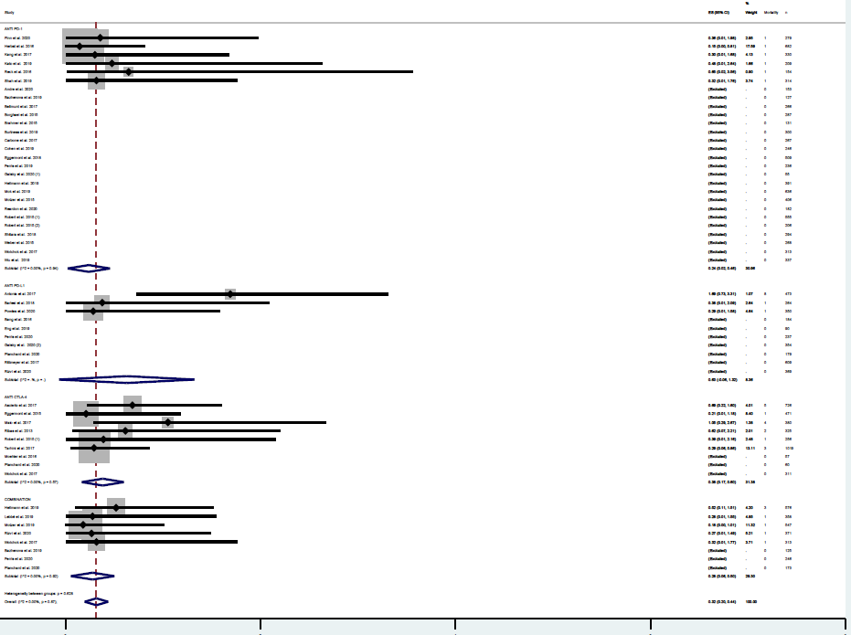
SUPPLEMENTARY FIGURE 4 – Incidence of cardiovascular deaths in studies testing ICIs according to the mechanism of action. Incidence rates are represented by boxes and whiskers indicate 95% CI; size of squares is proportional to amount of data of each trial. Numbers in brackets for selected studies identifies different studies from same author published on the same year.

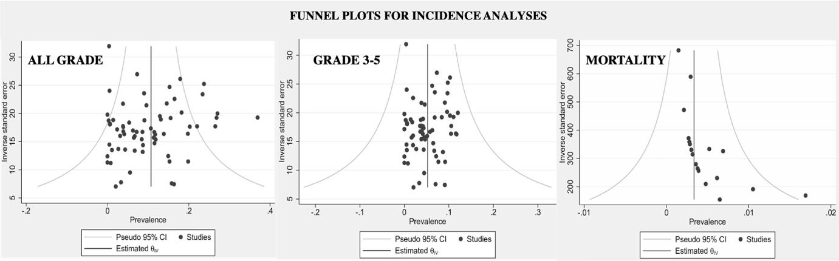

SUPPLEMENTARY FIGURE 5 – A: Funnel plot for incidence analysis of all grade cardiovascular AEs. Dots represent included studies; B: Funnel plot for incidence analysis of grade 3-5 cardiovascular AEs. Dots represent included studies; C: Funnel plot for incidence analysis of cardiovascular mortality. Dots represent included studies.

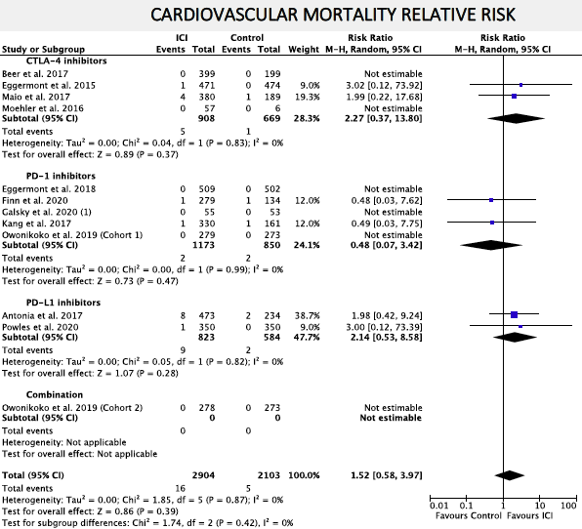

SUPPLEMENTARY FIGURE 6 – Forest plot of relative risk (RR) of cardiovascular deaths associated with ICIs versus placebo/BSC. RR are represented by boxes and whiskers indicate 95% CIs; size of squares is proportional to amount of data of each trial.

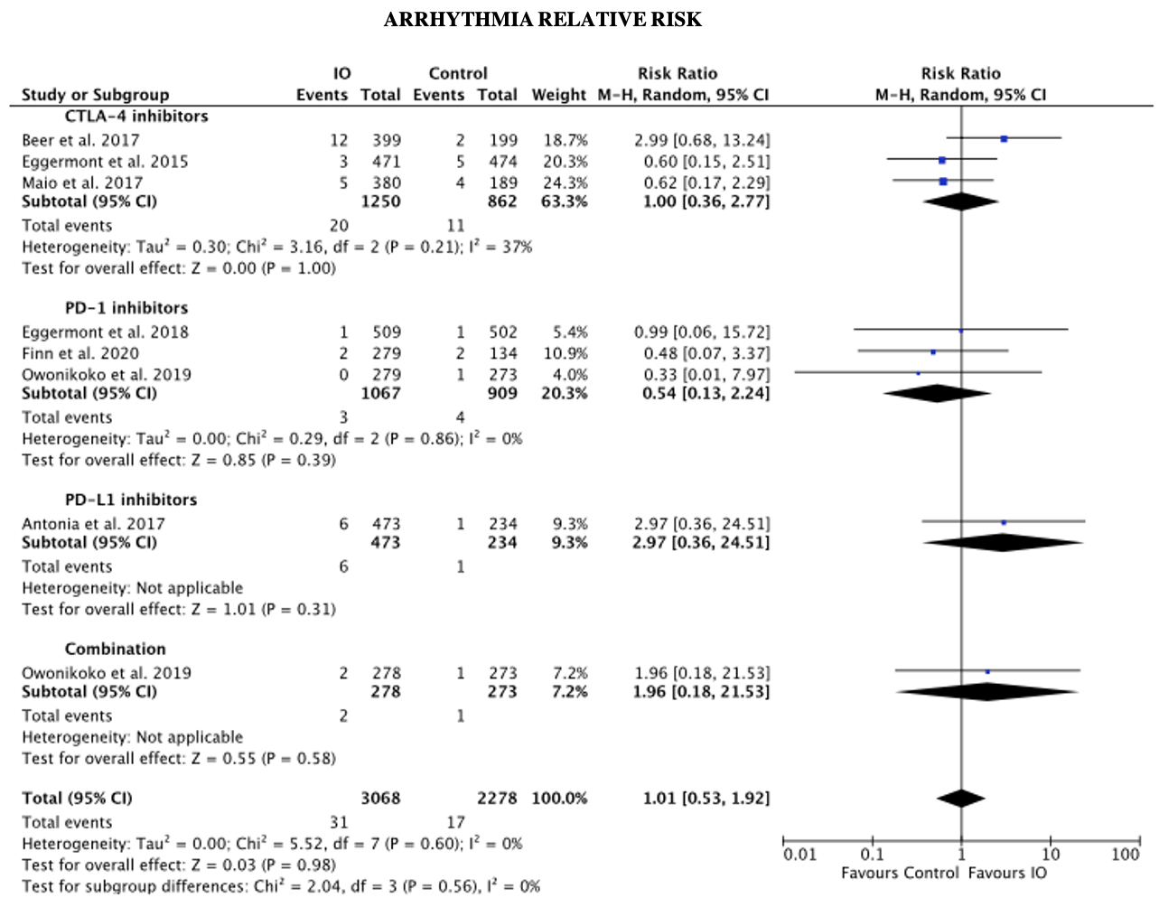
SUPPLEMENTARY FIGURE 7 – Forest plot of relative risk (RR) of arrhythmia associated with ICIs versus placebo/BSC. RR are represented by boxes and whiskers indicate 95% CIs; size of squares is proportional to amount of data of each trial.

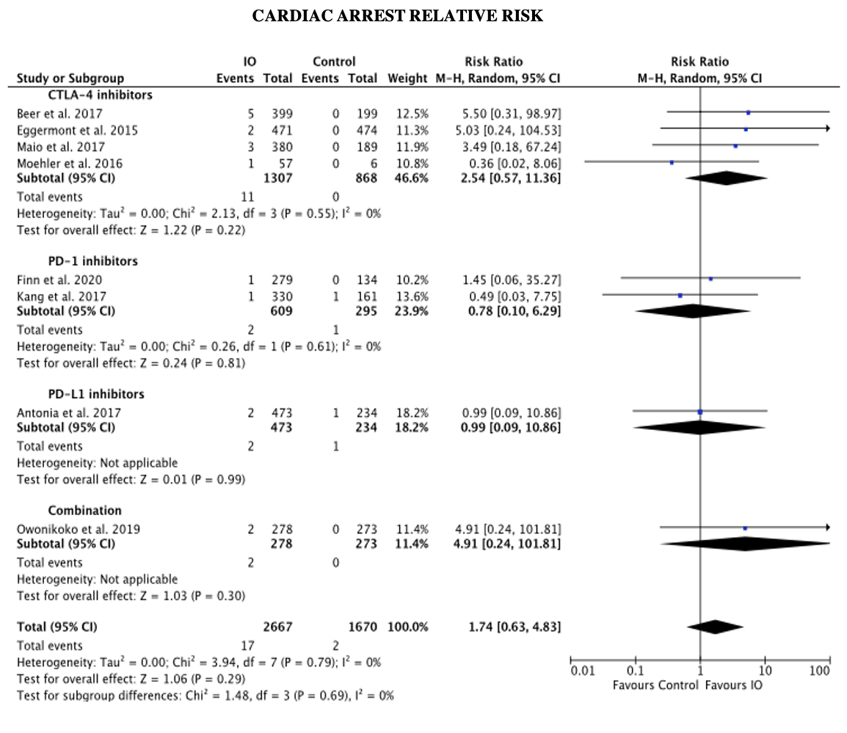
SUPPLEMENTARY FIGURE 8 – Forest plot of relative risk (RR) of cardiac arrest associated with ICIs versus placebo/BSC. RR are represented by boxes and whiskers indicate 95% CIs; size of squares is proportional to amount of data of each trial.

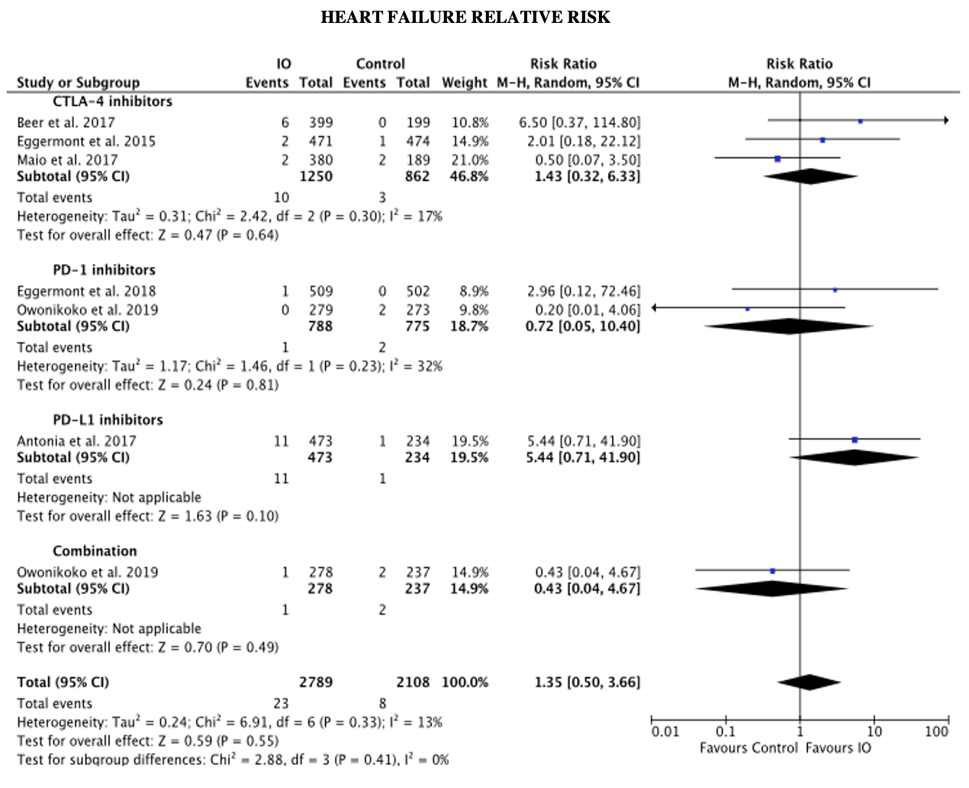
SUPPLEMENTARY FIGURE 9 – Forest plot of relative risk (RR) of heart failure associated with ICIs versus placebo/BSC. RR are represented by boxes and whiskers indicate 95% CIs; size of squares is proportional to amount of data of each trial.

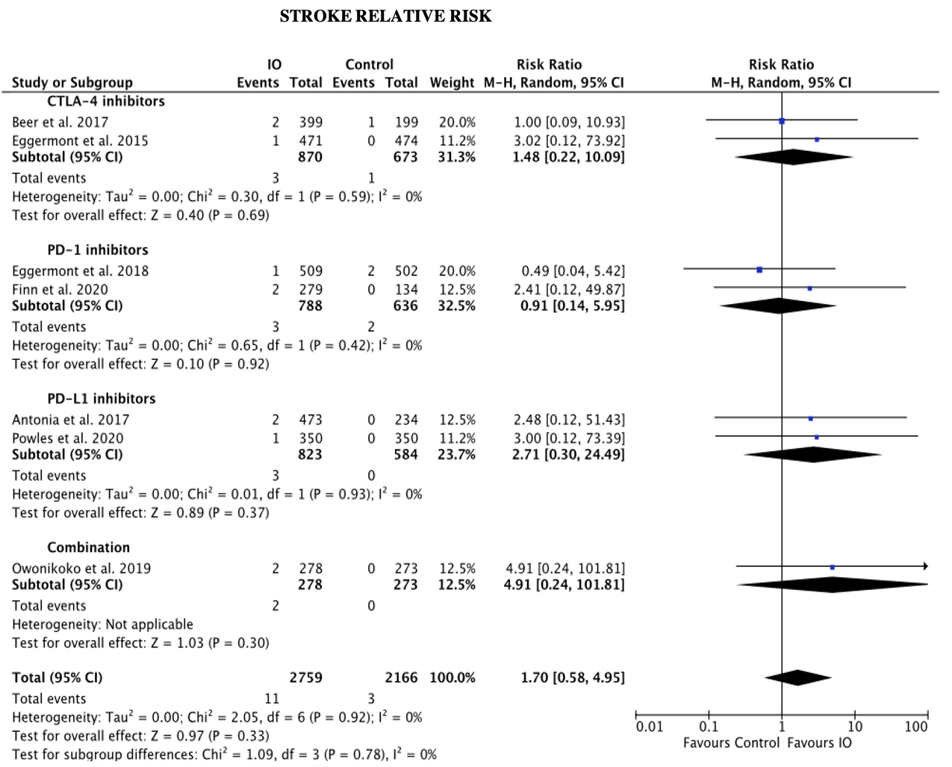
SUPPLEMENTARY FIGURE 10 – Forest plot of relative risk (RR) of stroke associated with ICIs versus placebo/BSC. RR are represented by boxes and whiskers indicate 95% CIs; size of squares is proportional to amount of data of each trial.

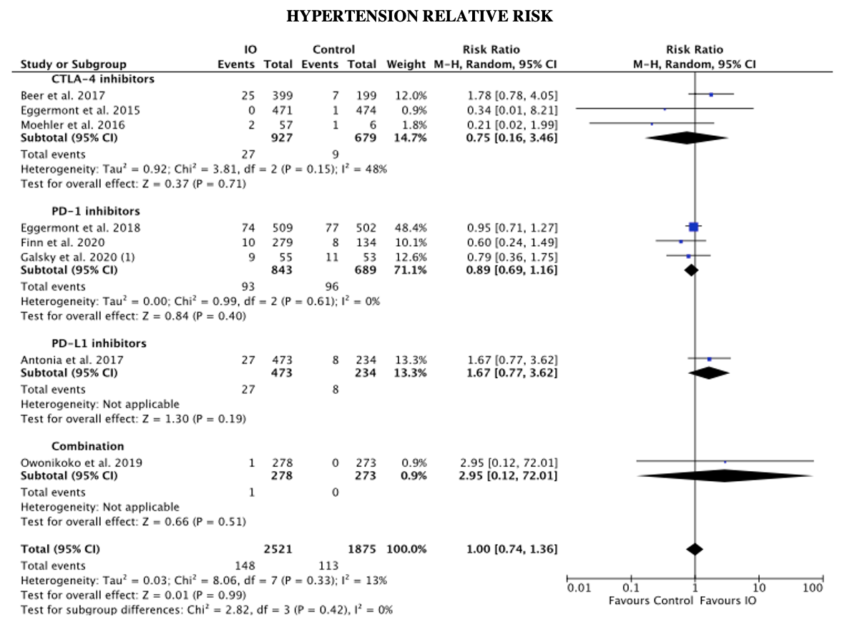
SUPPLEMENTARY FIGURE 11 – Forest plot of relative risk (RR) of hypertension associated with ICIs versus placebo/BSC. RR are represented by boxes and whiskers indicate 95% CIs; size of squares is proportional to amount of data of each trial. Numbers in brackets for selected studies identifies different studies from same author published on the same year.

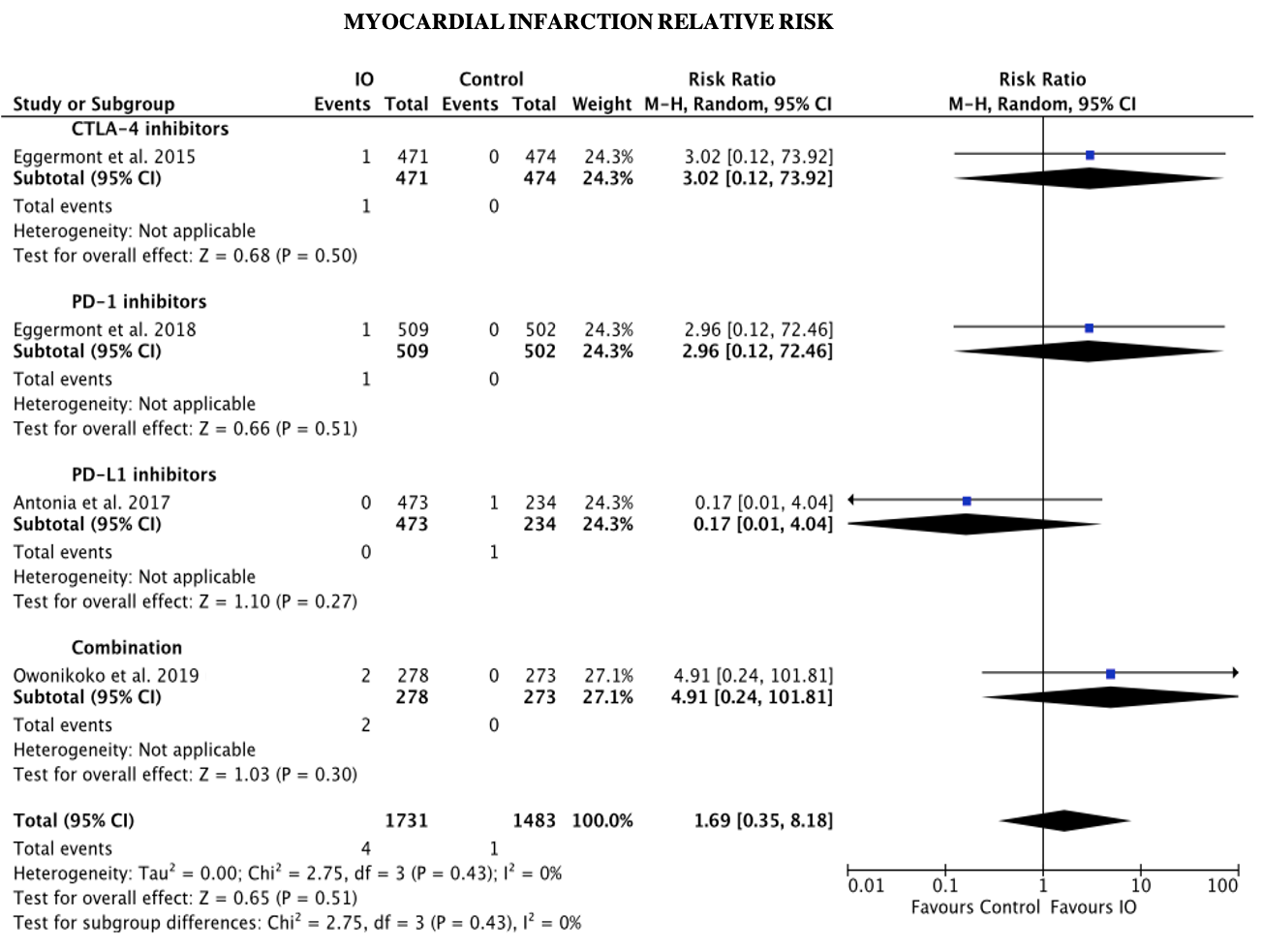
SUPPLEMENTARY FIGURE 12 – Forest plot of relative risk (RR) of myocardial infarction associated with ICIs versus placebo/BSC. RR are represented by boxes and whiskers indicate 95% CIs; size of squares is proportional to amount of data of each trial.

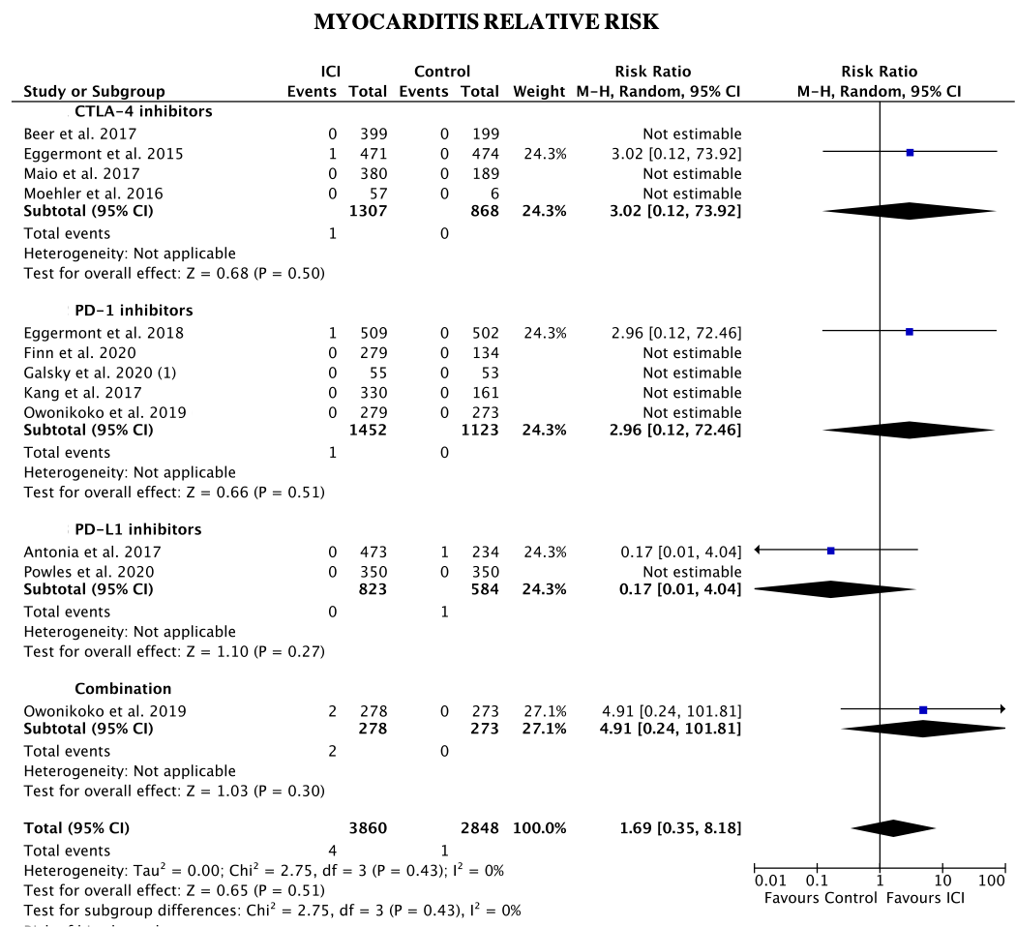
SUPPLEMENTARY FIGURE 13 – Forest plot of relative risk (RR) of myocarditis associated with ICIs versus placebo/BSC. RR are represented by boxes and whiskers indicate 95% CIs; size of squares is proportional to amount of data of each trial. Numbers in brackets for selected studies identifies different studies from same author published on the same year.

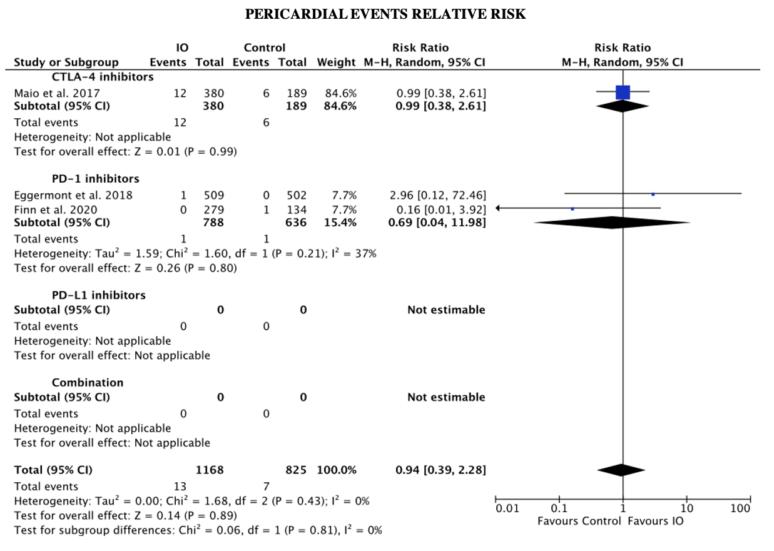
SUPPLEMENTARY FIGURE 14 – Forest plot of relative risk (RR) of pericardial events associated with ICIs versus placebo/BSC. RR are represented by boxes and whiskers indicate 95% CIs; size of squares is proportional to amount of data of each trial.

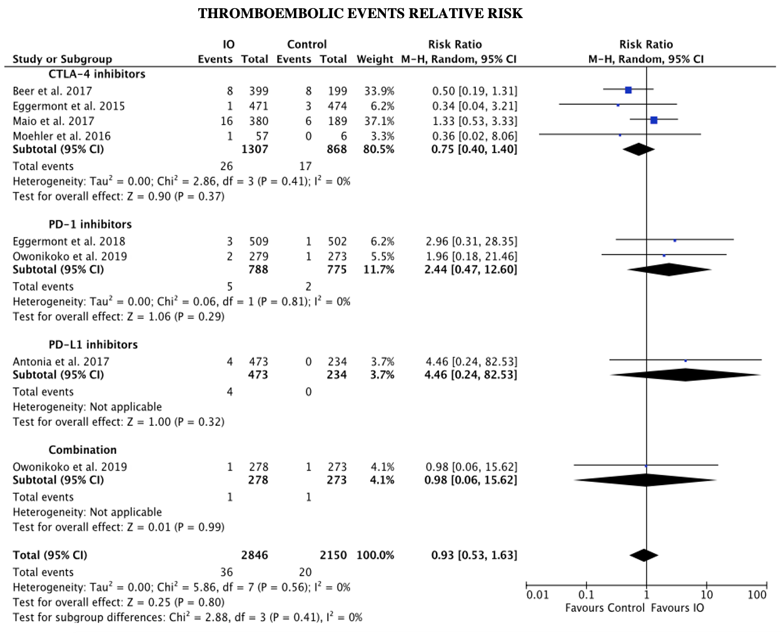
SUPPLEMENTARY FIGURE 15 – Forest plot of relative risk (RR) of thromboembolic events associated with ICIs versus placebo/BSC. RR are represented by boxes and whiskers indicate 95% CIs; size of squares is proportional to amount of data of each trial.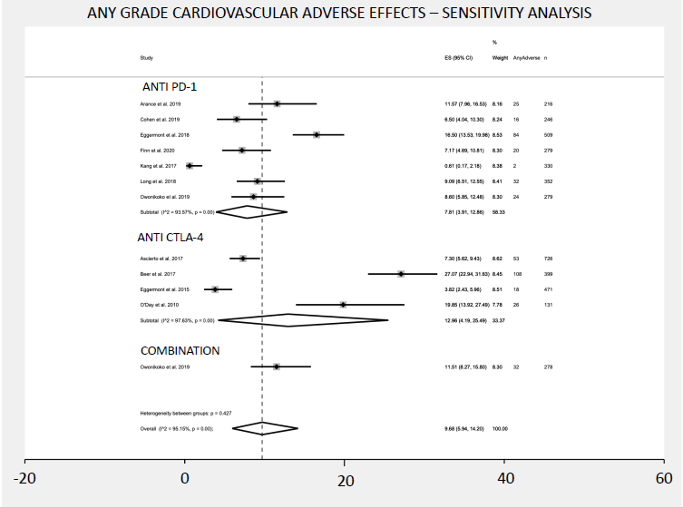
SUPPLEMENTARY FIGURE 16 – Forest plot of relative risk (RR) of all-grade cardiovascular AEs associated with ICIs versus placebo/BSC. RR are represented by boxes and whiskers indicate 95% CIs; size of squares is proportional to amount of data of each trial.

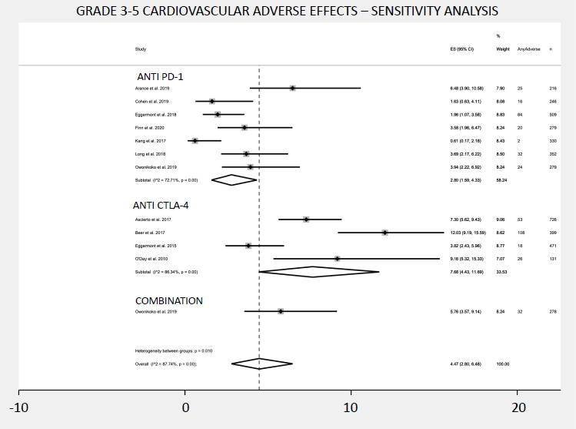
SUPPLEMENTARY FIGURE 17 – Forest plot of relative risk (RR) of grade 3-5 cardiovascular AEs associated with ICIs versus placebo/BSC. RR are represented by boxes and whiskers indicate 95% CIs; size of squares is proportional to amount of data of each trial.

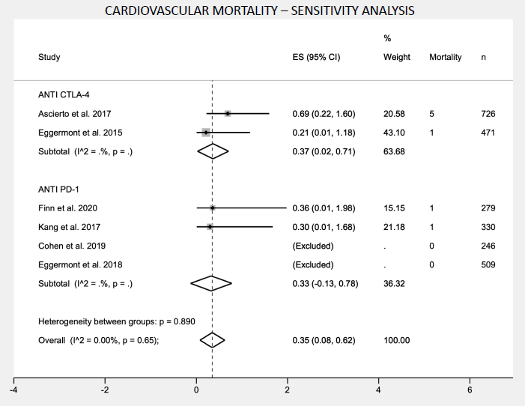
SUPPLEMENTARY FIGURE 18 – Forest plot of relative risk (RR) of cardiovascular deaths associated with ICIs versus placebo/BSC. RR are represented by boxes and whiskers indicate 95% CIs; size of squares is proportional to amount of data of each trial.

