Supplementary Figure 1. Forest plot for odd ratio (OR) of gastrointestinal (GI) group versus nonGI group for mortality in subgroup: GI group older than non-GI group.

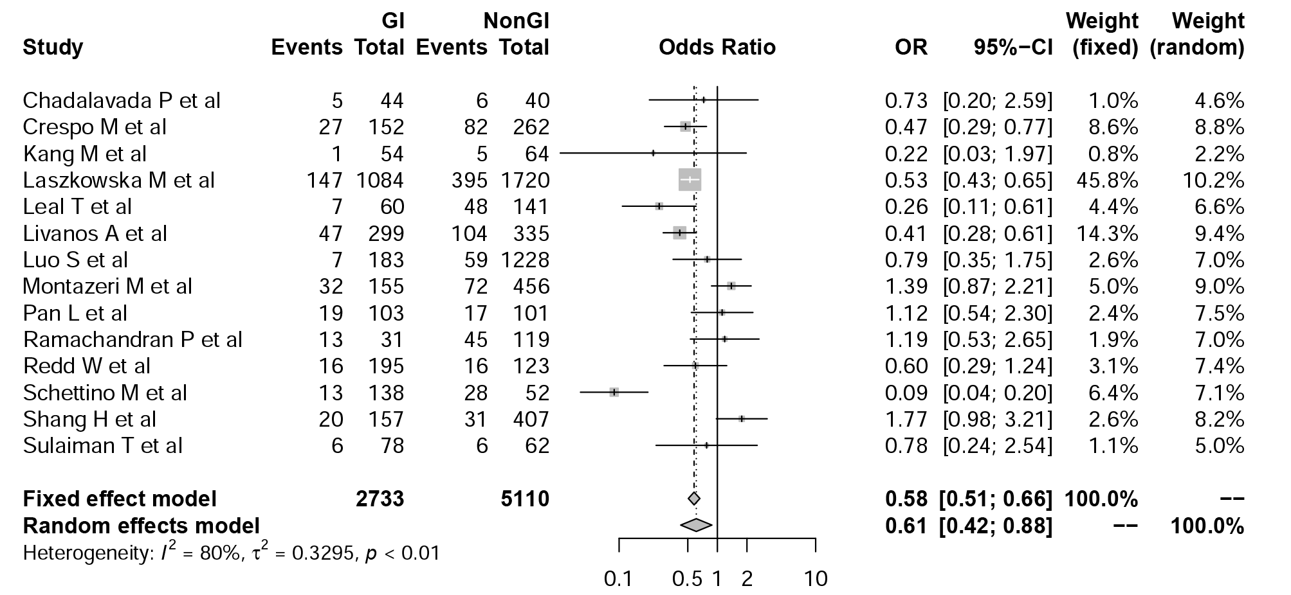
Supplementary Figure 2. Forest plot for odd ratio (OR) of gastrointestinal (GI) group versus nonGI group for mortality in subgroup: GI group younger than non-GI group.

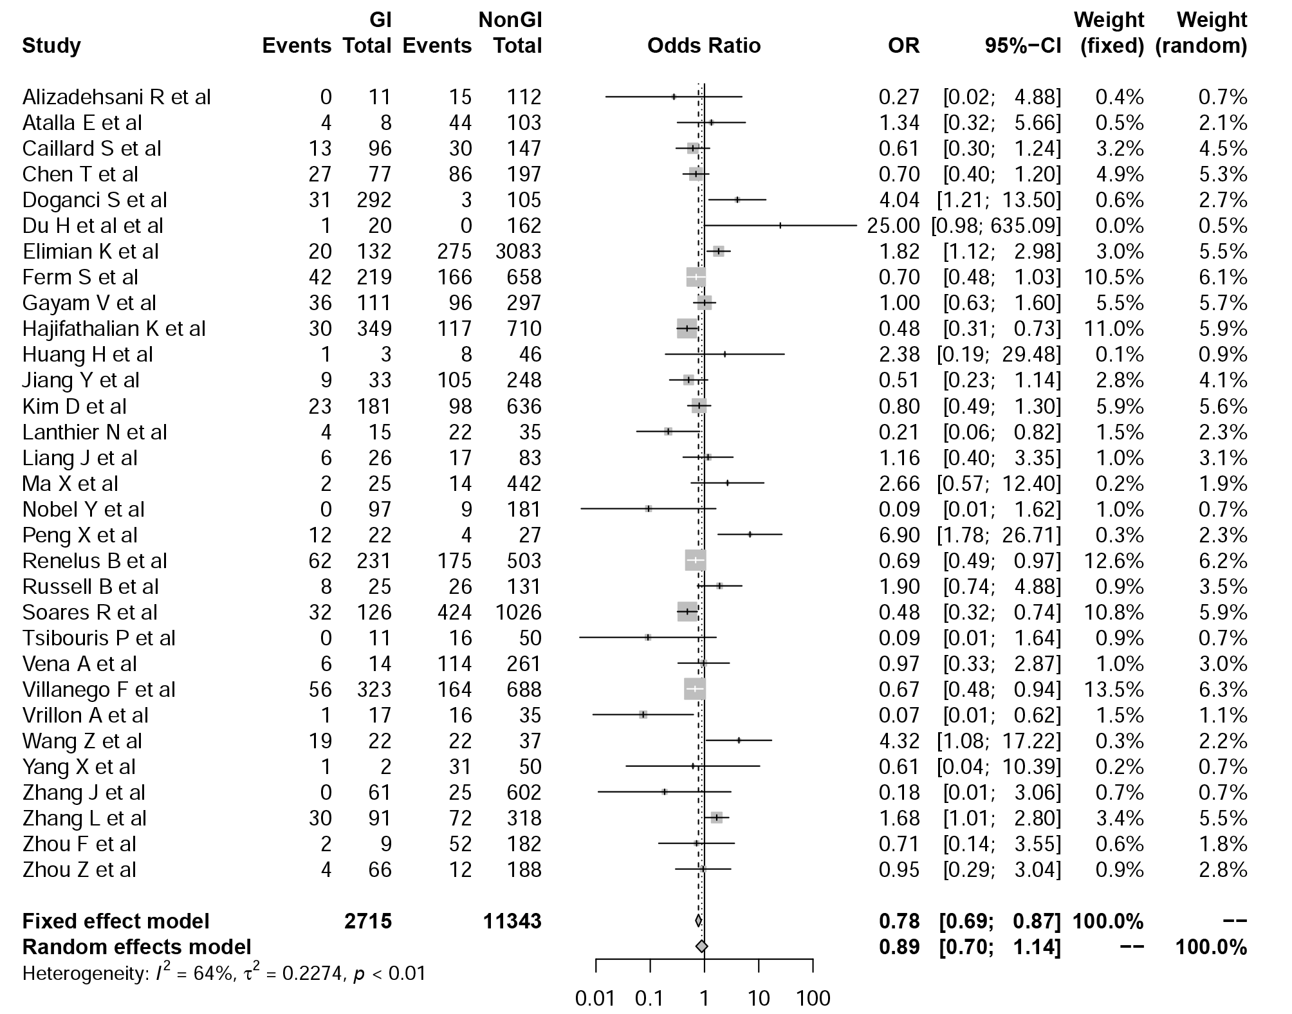
Supplementary Figure 3. Forest plot for odd ratio (OR) of gastrointestinal (GI) group versus nonGI group for mortality in subgroup: unknown average age of GI group and non-GI group.

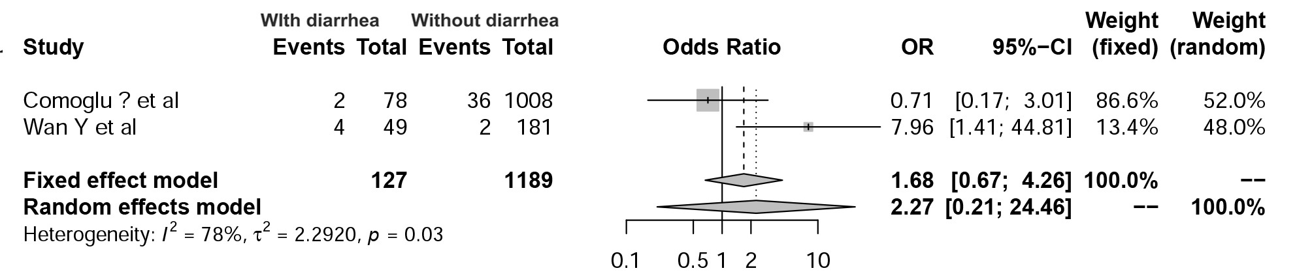
Supplementary Figure 4. Forest plot for odd ratio (OR) of diarrhea group versus without diarrhea group for mortality in subgroup: GI group older than non-GI group.

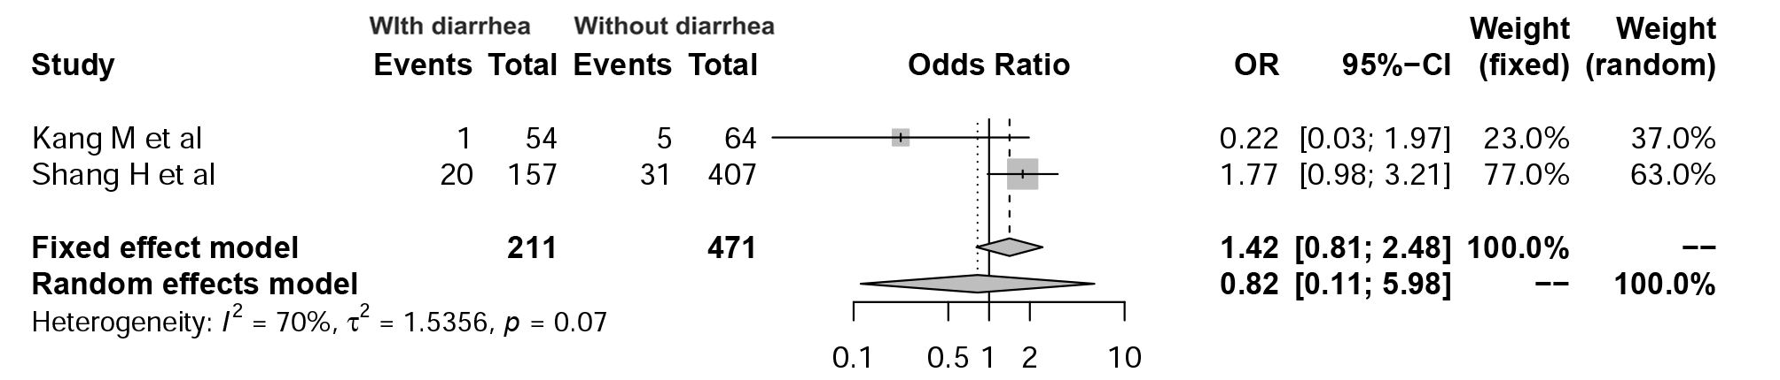
Supplementary Figure 5. Forest plot for odd ratio (OR) of diarrhea group versus without diarrhea group for mortality in subgroup: GI group younger than non-GI group.

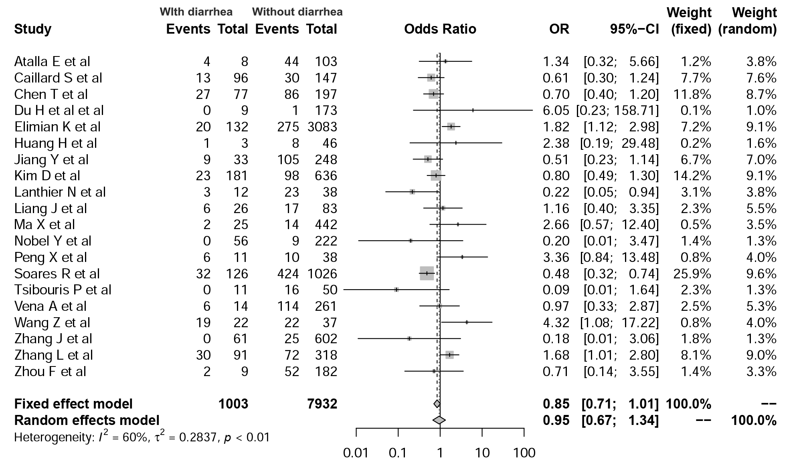
Supplementary Figure 6. Forest plot for odd ratio (OR) of diarrhea group versus without diarrhea group for mortality in subgroup: unknown average age of GI group and non-GI group.

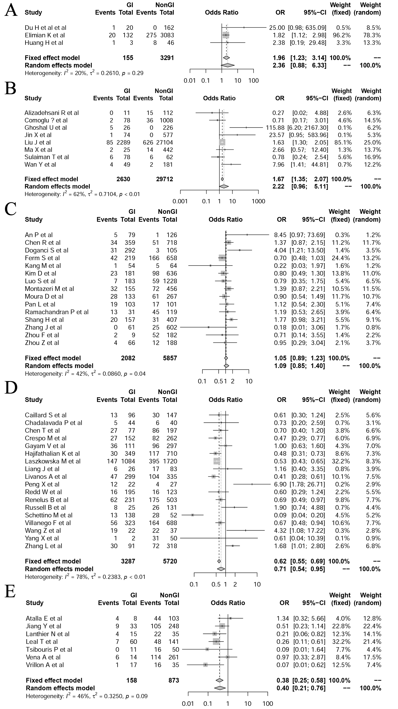
Supplementary Figure 7. Forest plots for odd ratio (OR) of gastrointestinal (GI) group versus nonGI group for mortality in different age stratifications: (A) 0~39 years old; (B) 40~49 years old; (C) 50~59 years old; (D) 60~69 years old; (E) 70 and >70 years old.

