Supplementary data
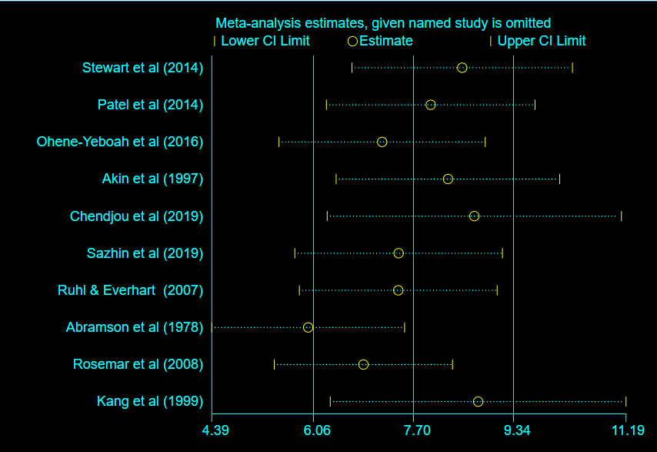
S1 Figure: Sensitivity analysis of the pooled prevalence of inguinal hernia
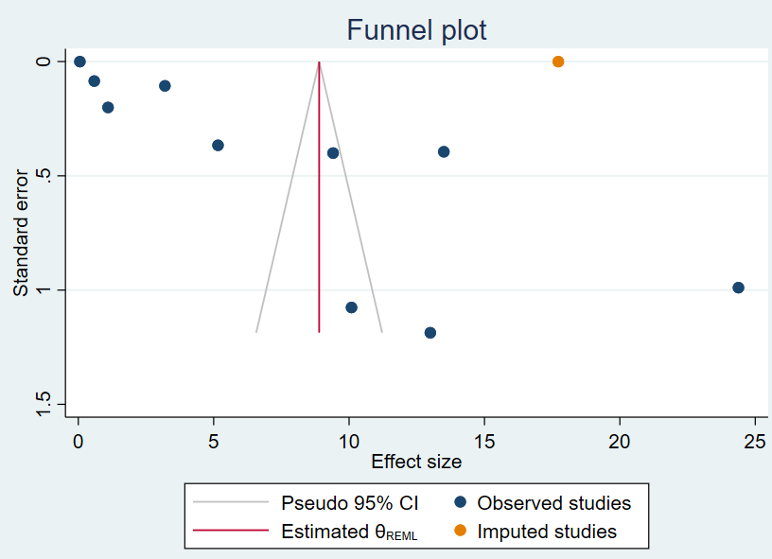
S2 Figure: Funnel plot after trim and fill analysis

