Support Information
S_1: PRISMA Checklist
Section and Topic | Item # | Checklist item | Location where item is reported
TITLE
Title | 1 | Identify the report as a systematic review. | 1
ABSTRACT
Abstract | 2 | See the PRISMA 2020 for Abstracts checklist. | 1
INTRODUCTION
Rationale | 3 | Describe the rationale for the review in the context of existing knowledge. | 1-2
Objectives | 4 | Provide an explicit statement of the objective(s) or question(s) the review addresses. | 2
METHODS
Eligibility criteria | 5 | Specify the inclusion and exclusion criteria for the review and how studies were grouped for the syntheses. | 2-3
Information sources | 6 | Specify all databases, registers, websites, organisations, reference lists and other sources searched or consulted to identify studies. Specify the date when each source was last searched or consulted. | 2
Search strategy | 7 | Present the full search strategies for all databases, registers and websites, including any filters and limits used. | 2
Selection process | 8 | Specify the methods used to decide whether a study met the inclusion criteria of the review, including how many reviewers screened each record and each report retrieved, whether they worked independently, and if applicable, details of automation tools used in the process. | 3
Data collection process | 9 | Specify the methods used to collect data from reports, including how many reviewers collected data from each report, whether they worked independently, any processes for obtaining or confirming data from study investigators, and if applicable, details of automation tools used in the process. | 3
Data items | 10a | List and define all outcomes for which data were sought. Specify whether all results that were compatible with each outcome domain in each study were sought (e.g. for all measures, time points, analyses), and if not, the methods used to decide which results to collect. | 3
Data items | 10b | List and define all other variables for which data were sought (e.g. participant and intervention characteristics, funding sources). Describe any assumptions made about any missing or unclear information. | 3
Study risk of bias assessment | 11 | Specify the methods used to assess risk of bias in the included studies, including details of the tool(s) used, how many reviewers assessed each study and whether they worked independently, and if applicable, details of automation tools used in the process. | 3
Effect measures | 12 | Specify for each outcome the effect measure(s) (e.g. risk ratio, mean difference) used in the synthesis or presentation of results. | 3
Synthesis methods | 13a | Describe the processes used to decide which studies were eligible for each synthesis (e.g. tabulating the study intervention characteristics and comparing against the planned groups for each synthesis (item #5)). | 3
Synthesis methods | 13b | Describe any methods required to prepare the data for presentation or synthesis, such as handling of missing summary statistics, or data conversions. | 3
Synthesis methods | 13c | Describe any methods used to tabulate or visually display results of individual studies and syntheses. | 3
Synthesis methods | 13d | Describe any methods used to synthesize results and provide a rationale for the choice(s). If meta-analysis was performed, describe the model(s), method(s) to identify the presence and extent of statistical heterogeneity, and software package(s) used. | 3
Synthesis methods | 13e | Describe any methods used to explore possible causes of heterogeneity among study results (e.g. subgroup analysis, meta-regression). | 3
Synthesis methods | 13f | Describe any sensitivity analyses conducted to assess robustness of the synthesized results. | 3
Reporting bias assessment | 14 | Describe any methods used to assess risk of bias due to missing results in a synthesis (arising from reporting biases). | 9
Certainty assessment | 15 | Describe any methods used to assess certainty (or confidence) in the body of evidence for an outcome. | 3
RESULTS
Study selection | 16a | Describe the results of the search and selection process, from the number of records identified in the search to the number of studies included in the review, ideally using a flow diagram. | 3, Figure 1
Study selection | 16b | Cite studies that might appear to meet the inclusion criteria, but which were excluded, and explain why they were excluded. | Figure 1
Study characteristics | 17 | Cite each included study and present its characteristics. | 3
Risk of bias in studies | 18 | Present assessments of risk of bias for each included study. | 4
Results of individual studies | 19 | For all outcomes, present, for each study: (a) summary statistics for each group (where appropriate) and (b) an effect estimate and its precision (e.g. confidence/credible interval), ideally using structured tables or plots. | 7-8, Table 2, Table 3
Results of syntheses | 20a | For each synthesis, briefly summarise the characteristics and risk of bias among contributing studies. | 7-8
Results of syntheses | 20b | Present results of all statistical syntheses conducted. If meta-analysis was done, present for each the summary estimate and its precision (e.g. confidence/credible interval) and measures of statistical heterogeneity. If comparing groups, describe the direction of the effect. | 7-8, Figure 2, Figure 3, 4, 5, S_5 Fig 1, S_5 Fig 2, 3, 4
Results of syntheses | 20c | Present results of all investigations of possible causes of heterogeneity among study results. | 7-8, Table 4
Results of syntheses | 20d | Present results of all sensitivity analyses conducted to assess the robustness of the synthesized results. | 7-8, S_6 Fig 1-4, S_6 Fig 5-8
Reporting biases | 21 | Present assessments of risk of bias due to missing results (arising from reporting biases) for each synthesis assessed. | 7-8, S_7 Fig 1, 2, 3, 4, S_7 Fig 5, 6, 7, 8
Certainty of evidence | 22 | Present assessments of certainty (or confidence) in the body of evidence for each outcome assessed. | 7-8
DISCUSSION
Discussion | 23a | Provide a general interpretation of the results in the context of other evidence. | 9-12
Discussion | 23b | Discuss any limitations of the evidence included in the review. | 14
Discussion | 23c | Discuss any limitations of the review processes used. | 14
Discussion | 23d | Discuss implications of the results for practice, policy, and future research. | 14-15
OTHER INFORMATION
Registration and protocol | 24a | Provide registration information for the review, including register name and registration number, or state that the review was not registered. | 2
Registration and protocol | 24b | Indicate where the review protocol can be accessed, or state that a protocol was not prepared. | 2
Registration and protocol | 24c | Describe and explain any amendments to information provided at registration or in the protocol. | 2
Support | 25 | Describe sources of financial or non-financial support for the review, and the role of the funders or sponsors in the review. | 15
Competing interests | 26 | Declare any competing interests of review authors. | 15
Availability of data, code and other materials | 27 | Report which of the following are publicly available and where they can be found: template data collection forms; data extracted from included studies; data used for all analyses; analytic code; any other materials used in the review. | -
S_2：MOOSE Checklist for Meta-analyses of Observational Studies
Item No | Recommendation | Reported on Page No
Reporting of background should include
1 | Problem definition | 1
2 | Hypothesis statement | 2
3 | Description of study outcome(s) | 2
4 | Type of exposure or intervention used | 2
5 | Type of study designs used | 2
6 | Study population | 2
Reporting of search strategy should include
7 | Qualifications of searchers (eg, librarians and investigators) | 2
8 | Search strategy, including time period included in the synthesis and key words | 2
9 | Effort to include all available studies, including contact with authors | 2-3
10 | Databases and registries searched | 2
11 | Search software used, name and version, including special features used (eg, explosion) | 3
12 | Use of hand searching (eg, reference lists of obtained articles) | 2
13 | List of citations located and those excluded, including justification | Figure 1
14 | Method of addressing articles published in languages other than English | Figure 1
15 | Method of handling abstracts and unpublished studies | Figure 1
16 | Description of any contact with authors | -
Reporting of methods should include
17 | Description of relevance or appropriateness of studies assembled for assessing the hypothesis to be tested | 3
18 | Rationale for the selection and coding of data (eg, sound clinical principles or convenience) | 3
19 | Documentation of how data were classified and coded (eg, multiple raters, blinding and interrater reliability) | 3
20 | Assessment of confounding (eg, comparability of cases and controls in studies where appropriate) | 3
21 | Assessment of study quality, including blinding of quality assessors, stratification or regression on possible predictors of study results | 3
22 | Assessment of heterogeneity | 3
23 | Description of statistical methods (eg, complete description of fixed or random effects models, justification of whether the chosen models account for predictors of study results, dose-response models, or cumulative meta-analysis) in sufficient detail to be replicated | 3
24 | Provision of appropriate tables and graphics | Figure 1, S_7
Reporting of results should include
25 | Graphic summarizing individual study estimates and overall estimate | Figure 2, Figure 3
26 | Table giving descriptive information for each study included | Table 1
27 | Results of sensitivity testing (eg, subgroup analysis) | Table 2, Table 3, S_5
28 | Indication of statistical uncertainty of findings | -
Reporting of discussion should include
29 | Quantitative assessment of bias (eg, publication bias) | 11
30 | Justification for exclusion (eg, exclusion of non-English language citations) | -
31 | Assessment of quality of included studies | 14
Reporting of conclusions should include
32 | Consideration of alternative explanations for observed results | 15
33 | Generalization of the conclusions (ie, appropriate for the data presented and within the domain of the literature review) | 15
34 | Guidelines for future research | 15
35 | Disclosure of funding source | 15

S_3: Search terms and Strategies

SEARCH 1: PubMed

(MSM OR (men who have sex with men) OR ((man OR men OR male*) AND (gay OR same-sex OR homosexual OR queer OR bisexual* OR transsexual* OR transgender)) OR LGBT OR GBT) OR (Homosexuality OR Transsexualism OR Bisexuality OR Homosexual* OR Transexual* OR Bisexual* OR Transgender)
AND
((physical OR sexual* OR verbal* OR emotional* OR psychological*) AND (domestic OR partner OR spous* OR dating OR relationship) AND (violence OR abus* OR aggression OR batting OR victimization OR assault OR rape))

SEARCH 2: CINAHL

(MSM OR (men who have sex with men) OR ((man OR men OR male*) AND (gay OR same-sex OR homosexual OR queer OR bisexual* OR transsexual* OR transgender)) OR LGBT OR GBT) OR (Homosexuality OR Transsexualism OR Bisexuality OR Homosexual* OR Transexual* OR Bisexual* OR Transgender)
AND
((physical OR sexual* OR verbal* OR emotional* OR psychological*) AND (domestic OR partner OR spous* OR dating OR relationship) AND (violence OR abus* OR aggression OR batting OR victimization OR assault OR rape))

SEARCH 3: MEDLINE (EBSCOhost)

(MSM OR (men who have sex with men) OR ((man OR men OR male*) AND (gay OR same-sex OR homosexual OR queer OR bisexual* OR transsexual* OR transgender)) OR LGBT OR GBT) OR (Homosexuality OR Transsexualism OR Bisexuality OR Homosexual* OR Transexual* OR Bisexual* OR Transgender)
AND
((physical OR sexual* OR verbal* OR emotional* OR psychological*) AND (domestic OR partner OR spous* OR dating OR relationship) AND (violence OR abus* OR aggression OR batting OR victimization OR assault OR rape))

SEARCH 4: PsycINFO

(MSM OR (men who have sex with men) OR ((man OR men OR male*) AND (gay OR same-sex OR homosexual OR queer OR bisexual* OR transsexual* OR transgender)) OR LGBT OR GBT) OR (Homosexuality OR Transsexualism OR Bisexuality OR Homosexual* OR Transexual* OR Bisexual* OR Transgender)
AND
((physical OR sexual* OR verbal* OR emotional* OR psychological*) AND (domestic OR partner OR spous* OR dating OR relationship) AND (violence OR abus* OR aggression OR batting OR victimization OR assault OR rape))

SEARCH 5: CNKI (中国知网)

SU=('男男' + '同性'+ '同性恋' + '双性恋'+ '跨性别者') AND SU=('亲密伴侣暴力' + '暴力' +'家庭暴力' + '家暴') OR TI=('男男' + '同性'+ '同性恋' + '双性恋'+ '跨性别者') AND TI=('亲密伴侣暴力' + '暴力' + '家庭暴力' + '家暴') OR KY=('男男' + '同性'+ '同性恋' + '双性恋'+ '跨性别者') AND KY=('亲密伴侣暴力' + '暴力' +'家庭暴力' + '家暴') OR AB=('男男' + '同性'+ '同性恋' + '双性恋'+ '跨性别者') AND AB=('亲密伴侣暴力' + '暴力' + '家庭暴力' + '家暴' )

SEARCH 6: WANFANGDATA (万方数据)

主题:("男男" OR "同性"OR"同性恋" OR"双性恋"OR"跨性别者" ) AND 主题:("亲密伴侣暴力" OR "暴力" OR "家暴" OR "家庭暴力" ) OR 关键词:("男男" OR "同性"OR"同性恋" OR"双性恋"OR"跨性别者" ) AND 关键词:("亲密伴侣暴力" OR "暴力" OR "家暴" OR "家庭暴力" ) OR 题名:("男男" OR "同性性"OR"同性恋" OR"双性恋"OR"跨性别者" ) AND 题名:("亲密伴侣暴力" OR "暴力" OR "家暴" OR "家庭暴力" ) OR 摘要:("男男" OR "同性"OR"同性恋" OR"双性恋"OR"跨性别者" ) AND 摘要:("亲密伴侣暴力" OR "暴力" OR "家暴" OR "家庭暴力" )

SEARCH 7: Weipu (CQVIP) Data (维普)

M=(男男 OR 同性 OR 同性恋 OR 双性恋 OR 跨性别者 ) AND M=(亲密伴侣暴力 OR 暴力 OR 家暴 OR 家庭暴力) OR R=(男男 OR 同性 OR 同性恋 OR 双性恋 OR 跨性别者 ) AND R=(亲密伴侣暴力 OR 暴力 OR 家暴 OR 家庭暴力)

SEARCH 8: Manual research method

Key terms: MSM and intimate partner violence, MSM and domestic violence, abusive same-sex intimate relationship

Checking the identified articles via the following journals:
Trauma, Violence, & Abuse,
Journal of Aggression Maltreatment & Trauma,
AIDS Behavior,
Journal of the Aassociation of Nurses in AIDS Care,
Journal of Homosexuality,
Journal of Interpersonal Violence,
Journal of Injury and Violence,
Journal of Gay & Lesbian Social Service,
Journal of Family Violence,
LGBT Health

S_4: List of all included studies
1. Li, Y., Baker, J. J., Korostyshevskiy, V. R., Slack, R. S., & Plankey, M. W. (2012). The association of intimate partner violence, recreational drug use with HIV seroprevalence among MSM. AIDS Behav, 16(3), 491-498, doi:10.1007/s10461-012-0157-6.
2. Stephenson, R., Sato, K. N., & Finneran, C. (2013). Dyadic, Partner, and Social Network Influences on Intimate Partner Violence among Male-Male Couples. West J Emerg Med, 14(4), 316-323, doi:10.5811/westjem.2013.2.15623.
3. Yu, Y., Xiao, S., & Liu, K. Q. (2013). Dating violence among gay men in China. J Interpers Violence, 28(12), 2491-2504, doi:10.1177/0886260513479028.
4. Kai-hao, L., Jing, L., Zhi-min, T., Xiao-bin, C., Wei-bin, C., Hui-fang, X., et al. (2019). Association between intimate partner violence and unprotected anal intercourse among men who have sex with men in Guangzhou. Modern Preventive Medicine, 46(16), 3005-3008.
5. Pruitt, K. L., White, D., Mitchell, J. W., & Stephenson, R. (2015). Sexual agreements and intimate-partner violence among male couples. International Journal of Sexual Health, 27(4), 429-441, doi:10.1080/19317611.2015.1037037.
6. Greenwood, G. L., Relf, M. V., Huang, B., Pollack, L. M., Canchola, J. A., & Catania, J. A. (2002). Battering victimization among a probability-based sample of men who have sex with men. Am J Public Health, 92(12), 1964-1969, doi:10.2105/ajph.92.12.1964.
7. Welles, S. L., Corbin, T. J., Rich, J. A., Reed, E., & Raj, A. (2011). Intimate partner violence among men having sex with men, women, or both: early-life sexual and physical abuse as antecedents. J Community Health, 36(3), 477-485, doi:10.1007/s10900-010-9331-9.
8. Nieves-Rosa, L. E., Carballo-Dieguez, A., & Dolezal, C. (2000). Domestic Abuse and HIV-Risk Behavior in Latin American Men Who Have Sex with Men in New York City. Journal of Gay & Lesbian Social Services, 11(1), 77-90, doi:10.1300/J041v11n01_04.
9. Koblin, B. A., Torian, L., Xu, G., Guilin, V., Makki, H., MacKellar, D., et al. (2006). Violence and HIV-related risk among young men who have sex with men. AIDS Care, 18(8), 961-967, doi:10.1080/09540120500467182.
10. Williams, J. K., Wilton, L., Magnus, M., Wang, L., Wang, J., Dyer, T. P., et al. (2015). Relation of Childhood Sexual Abuse, Intimate Partner Violence, and Depression to Risk Factors for HIV Among Black Men Who Have Sex With Men in 6 US Cities. Am J Public Health, 105(12), 2473-2481, doi:10.2105/ajph.2015.302878.
11. Stephenson, R., Khosropour, C., & Sullivan, P. (2010). Reporting of Intimate Partner Violence among Men Who Have Sex with Men in an Online Survey. West J Emerg Med, 11(3), 242-246, doi:10.1001/jama.283.15.2008.
12. Wei, D., Hou, F., Hao, C., Gu, J., Dev, R., Cao, W., et al. (2019). Prevalence of Intimate Partner Violence and Associated Factors Among Men Who Have Sex with Men in China. J Interpers Violence, 886260519889935, doi:10.1177/0886260519889935.
13. Stephenson, R., de Voux, A., & Sullivan, P. S. (2011). Intimate Partner Violence and Sexual Risk-taking among Men Who Have Sex with Men in South Africa. West J Emerg Med, 12(3), 343-347.
14. Liu, Y., Zhang, Y., Ning, Z., Zheng, H., Ding, Y., Gao, M., et al. (2018). Intimate partner violence victimization and HIV infection among men who have sex with men in Shanghai, China. Biosci Trends, 12(2), 142-148, doi:10.5582/bst.2018.01035.
15. Stephenson, R., Rentsch, C., Salazar, L. F., & Sullivan, P. S. (2011). Dyadic Characteristics and Intimate Partner Violence among Men Who Have Sex with Men. West J Emerg Med, 12(3), 324-332.
16. Dunkle, K. L., Wong, F. Y., Nehl, E. J., Lin, L., He, N., Huang, J., et al. (2013). Male-on-male intimate partner violence and sexual risk behaviors among money boys and other men who have sex with men in Shanghai, China. Sex Transm Dis, 40(5), 362-365, doi:10.1097/OLQ.0b013e318283d2af.
17. Davis, A., Best, J., Wei, C., Luo, J., Van Der Pol, B., Meyerson, B., et al. (2015). Intimate Partner Violence and Correlates With Risk Behaviors and HIV/STI Diagnoses Among Men Who Have Sex With Men and Men Who Have Sex With Men and Women in China: A Hidden Epidemic. Sex Transm Dis, 42(7), 387-392, doi:10.1097/olq.0000000000000302.
18. Davis, A., Kaighobadi, F., Stephenson, R., Rael, C., & Sandfort, T. (2016). Associations Between Alcohol Use and Intimate Partner Violence Among Men Who Have Sex with Men. LGBT Health, 3(6), 400-406, doi:10.1089/lgbt.2016.0057.
19. Tran, A., Lin, L., Nehl, E. J., Talley, C. L., Dunkle, K. L., & Wong, F. Y. (2014). Prevalence of Substance Use and Intimate Partner Violence in a Sample of A/PI MSM. J Interpers Violence, 29(11), 2054-2067, doi:10.1177/0886260513516006.
20. Stults, C. B., Javdani, S., Greenbaum, C. A., Kapadia, F., & Halkitis, P. N. (2016). Intimate Partner Violence and Sex Among Young Men Who Have Sex With Men. J Adolesc Health, 58(2), 215-222, doi:10.1016/j.jadohealth.2015.10.008.
21. Wong, C. F., Weiss, G., Ayala, G., & Kipke, M. D. (2010). Harassment, discrimination, violence, and illicit drug use among young men who have sex with men. AIDS Educ Prev, 22(4), 286-298, doi:10.1521/aeap.2010.22.4.286.
22. Finneran, C., & Stephenson, R. (2014). Intimate partner violence, minority stress, and sexual risk-taking among U.S. men who have sex with men. J Homosex, 61(2), 288-306, doi:10.1080/00918369.2013.839911.
23. Duncan, D. T., Goedel, W. C., Stults, C. B., Brady, W. J., Brooks, F. A., Blakely, J. S., et al. (2018). A Study of Intimate Partner Violence, Substance Abuse, and Sexual Risk Behaviors Among Gay, Bisexual, and Other Men Who Have Sex With Men in a Sample of Geosocial-Networking Smartphone Application Users. Am J Mens Health, 12(2), 292-301, doi:10.1177/1557988316631964.
24. Finneran, C., & Stephenson, R. (2014). Antecedents of intimate partner violence among gay and bisexual men. Violence Vict, 29(3), 422-435, doi:10.1891/0886-6708.vv-d-12-00140.
25. Finneran, C., Chard, A., Sineath, C., Sullivan, P., & Stephenson, R. (2012). Intimate Partner Violence and Social Pressure among Gay Men in Six Countries. West J Emerg Med, 13(3), 260-271, doi:10.5811/westjem.2012.3.11779.
26. Feldman, M. B., Díaz, R. M., Ream, G. L., & El-Bassel, N. (2007). Intimate partner violence and HIV sexual risk behavior among Latino gay and bisexual men. Journal Of LGBT Health Research, 3(2), 9-19, doi:10.1300/J463v03n02_02.
27. Houston, E., & McKirnan, D. J. (2007). Intimate partner abuse among gay and bisexual men: risk correlates and health outcomes. J Urban Health, 84(5), 681-690, doi:10.1007/s11524-007-9188-0.
28. Bacchus, L. J., Buller, A. M., Ferrari, G., Peters, T. J., Devries, K., Sethi, G., et al. (2017). Occurrence and impact of domestic violence and abuse in gay and bisexual men: A cross sectional survey. Int J STD AIDS, 28(1), 16-27, doi:10.1177/0956462415622886.
29. Toro-Alfonso, J., & Rodríguez-Madera, S. (2004). Domestic Violence in Puerto Rican Gay Male Couples: Perceived Prevalence, Intergenerational Violence, Addictive Behaviors, and Conflict Resolution Skills. Journal of Interpersonal Violence, 19(6), 639-654, doi:10.1177/0886260504263873.
30. Wall, K. M., Sullivan, P. S., Kleinbaum, D., & Stephenson, R. (2014). Actor-partner effects associated with experiencing intimate partner violence or coercion among male couples enrolled in an HIV prevention trial. BMC Public Health, 14, 209, doi:10.1186/1471-2458-14-209.
31. Bimbi, D. S., Palmadessa, N. A., & Parsons, J. T. (2007). Substance use and domestic violence among urban gays, lesbians and bisexuals. J LGBT Health Res, 3(2), 1-7, doi:10.1300/J463v03n02_01.
32. Barrientos, J., Escartín, J., Longares, L., & Rodríguez-Carballeira, Á. (2018). Sociodemographic characteristics of gay and lesbian victims of intimate partner psychological abuse in Spain and Latin America. Revista de Psicología Social, 33(2), 240-274, doi:10.1080/02134748.2018.1446393.
33. Kelly, B. C., Izienicki, H., Bimbi, D. S., & Parsons, J. T. (2011). The intersection of mutual partner violence and substance use among urban gays, lesbians, and bisexuals. Deviant Behavior, 32(5), 379-404, doi:10.1080/01639621003800158.
34. Parsons, J. T., Grov, C., & Golub, S. A. (2012). Sexual compulsivity, co-occurring psychosocial health problems, and HIV risk among gay and bisexual men: further evidence of a syndemic. Am J Public Health, 102(1), 156-162, doi:10.2105/ajph.2011.300284.
35. Stephenson, R., Freeland, R., & Finneran, C. (2016). Intimate partner violence and condom negotiation efficacy among gay and bisexual men in Atlanta. Sex Health, doi:10.1071/sh15212.
36. Strasser, S. M., Smith, M., Pendrick-Denney, D., Boos-Beddington, S., Chen, K., & McCarty, F. (2012). Feasibility study of social media to reduce intimate partner violence among gay men in metro atlanta, georgia. West J Emerg Med, 13(3), 298-304, doi:10.5811/westjem.2012.3.11783.
37. Oringher, J., & Samuelson, K. W. (2011). Intimate partner violence and the role of masculinity in male same-sex relationships. Traumatology, 17(2), 68-74, doi:10.1177/1534765610395620.
38. Li, D., & Zheng, L. (2017). Intimate Partner Violence and Controlling Behavior Among Male Same-Sex Relationships in China: Relationship With Ambivalent Sexism. J Interpers Violence, 886260517724835, doi:10.1177/0886260517724835.
39. Kubicek, K., McNeeley, M., & Collins, S. (2016). Young men who have sex with men’s experiences with intimate partner violence. Journal of Adolescent Research, 31(2), 143-175, doi:10.1177/0743558415584011.
40. Longares, L., Escartín, J., Barrientos, J., & Rodríguez-Carballeira, Á. (2018). Psychological abuse in Spanish same-sex couples: prevalence and relationship between victims and perpetrators. Innovation: The European Journal of Social Science Research, 31(2), 125-141, doi:10.1080/13511610.2017.1326304.
41. Turell, S. C. (2000). A descriptive analysis of same-sex relationship violence for a diverse sample. Journal of Family Violence, 15(3), 281-293, doi:10.1023/A:1007505619577.
42. Stephenson, R., Sharma, A., Mimiaga, M. J., Garofalo, R., Brown, E., Bratcher, A., et al. (2019). Concordance in the reporting of intimate partner violence among male-male couples. Journal of Family Violence, doi:10.1007/s10896-019-00076-w.
43. Peng, L., She, R., Gu, J., Hao, C., Hou, F., Wei, D., et al. (2020). The mediating role of self-stigma and self-efficacy between intimate partner violence (IPV) victimization and depression among men who have sex with men in China. BMC Public Health, 20(1), 2, doi:10.1186/s12889-019-8125-y.
44. Dickerson-Amaya, N., & Coston, B. M. (2019). Invisibility Is Not Invincibility: The Impact of Intimate Partner Violence on Gay, Bisexual, and Straight Men's Mental Health. Am J Mens Health, 13(3), 1557988319849734, doi:10.1177/1557988319849734.
45. Bartholomew, K., Regan, K. V., White, M. A., & Oram, D. (2008). Patterns of abuse in male same-sex relationships. Violence Vict, 23(5), 617-636, doi:10.1891/0886-6708.23.5.617.
46. Yu, Y., & Xiao, S. (2017). Health and life satisfaction for Chinese gay men in Guangzhou, China. Journal of Central South University, 42(12), 1407-1416, doi:10.11817/j.issn.1672-7347.2017.12.009.
47. Mustanski, B., Garofalo, R., Herrick, A., & Donenberg, G. (2007). Psychosocial health problems increase risk for HIV among urban young men who have sex with men: Preliminary evidence of a syndemic in need of attention. Annals of Behavioral Medicine, 34(1), 37-45, doi:10.1007/BF02879919.
48. Yong, Y., Shuiyuan, X., & Ting, W. (2018). A case-control study on dating violence among gay men in Guangzhou. Chinese Mental Health Journal, 32(04), 335-338.
49. Reuter, T. R., Newcomb, M. E., Whitton, S. W., & Mustanski, B. (2017). Intimate Partner Violence Victimization in LGBT Young Adults: Demographic Differences and Associations with Health Behaviors. Psychol Violence, 7(1), 101-109, doi:10.1037/vio0000031.
50. Wei, D., Hou, F., Cao, W., Hao, C., Gu, J., Peng, L., et al. (2020). Effects of emotion regulation and perpetrator-victim roles in intimate partner violence on mental health problems among men who have sex with men in China. Epidemiol Psychiatr Sci, 29, e159, doi:10.1017/s2045796020000712.
51. Sharma, A., Kahle, E., Sullivan, S., & Stephenson, R. (2020). Sexual Agreements and Intimate Partner Violence Among Male Couples in the U.S.: An Analysis of Dyadic Data. Arch Sex Behav, doi:10.1007/s10508-020-01783-y.
52. Bosco, S. C., Robles, G., Stephenson, R., & Starks, T. J. (2020). Relationship Power and Intimate Partner Violence in Sexual Minority Male Couples. J Interpers Violence, 886260520916271, doi:10.1177/0886260520916271.

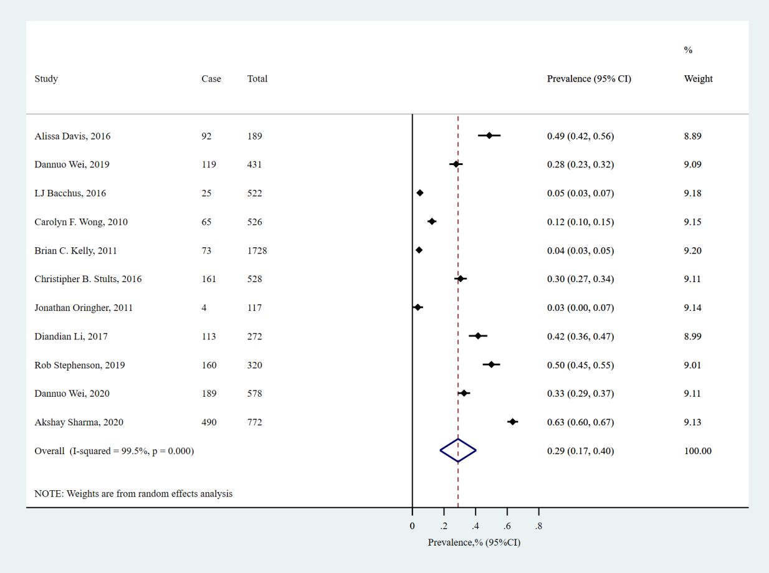
S_5 Fig 1. Forest plot of prevalence of any type of IPV in perpetration across all recall periods

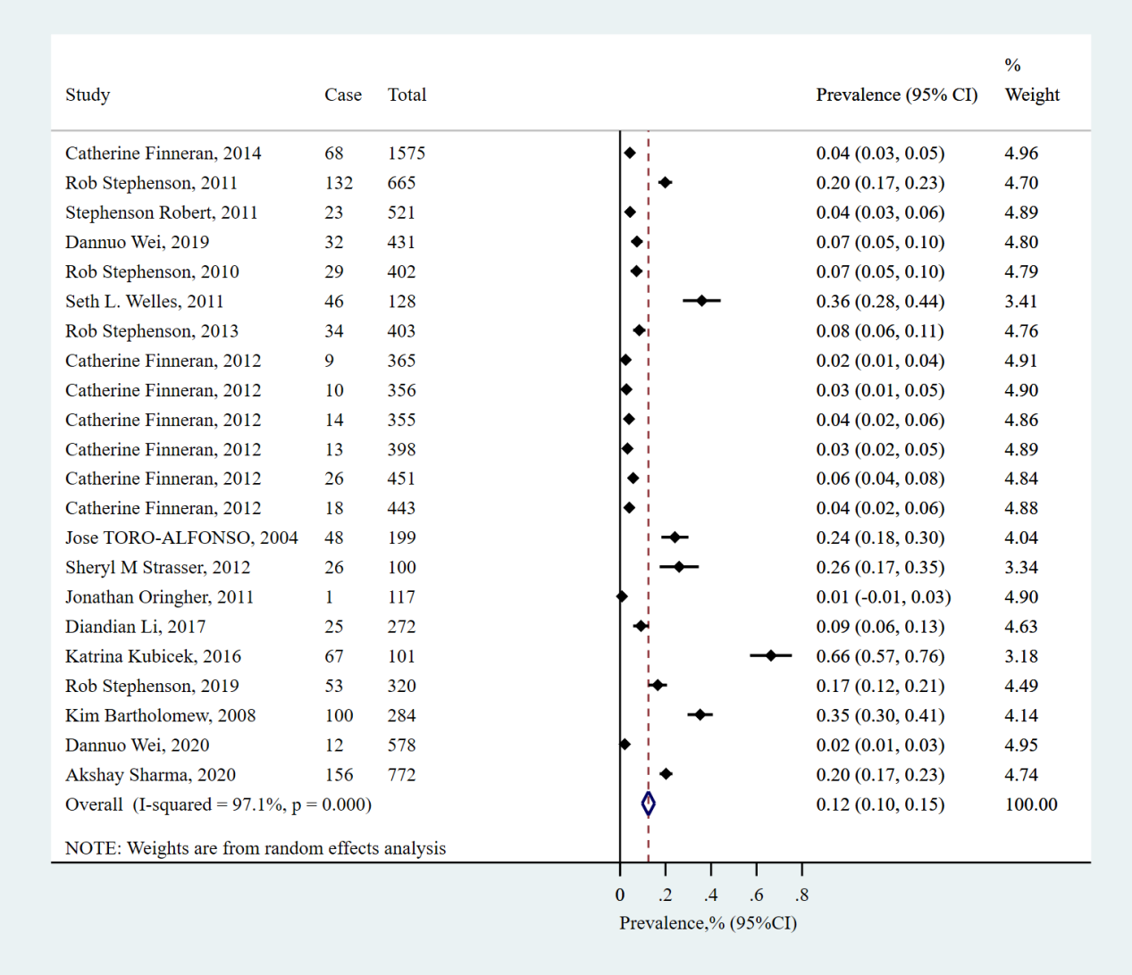
S_5 Fig 2. Forest plot of prevalence of physical IPV in perpetration across all recall periods

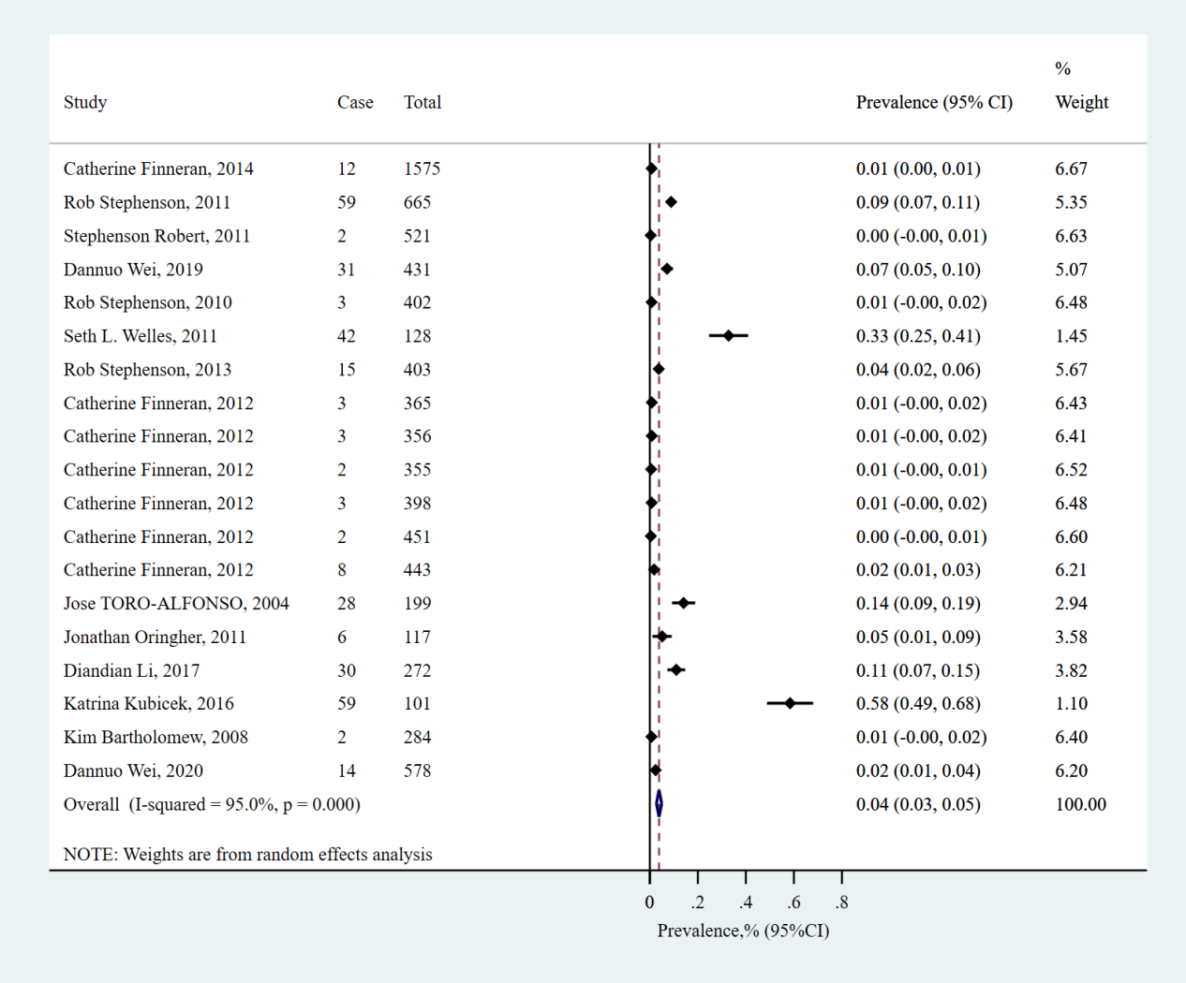
S_5 Fig 3. Forest plot of prevalence of sexual IPV in perpetration across all recall periods

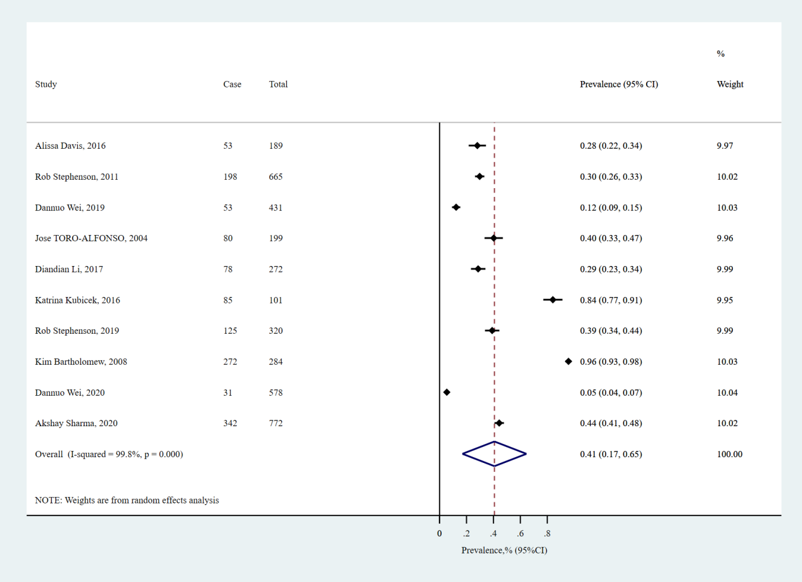
S_5 Fig 4. Forest plot of prevalence of emotional IPV in perpetration across all recall periods

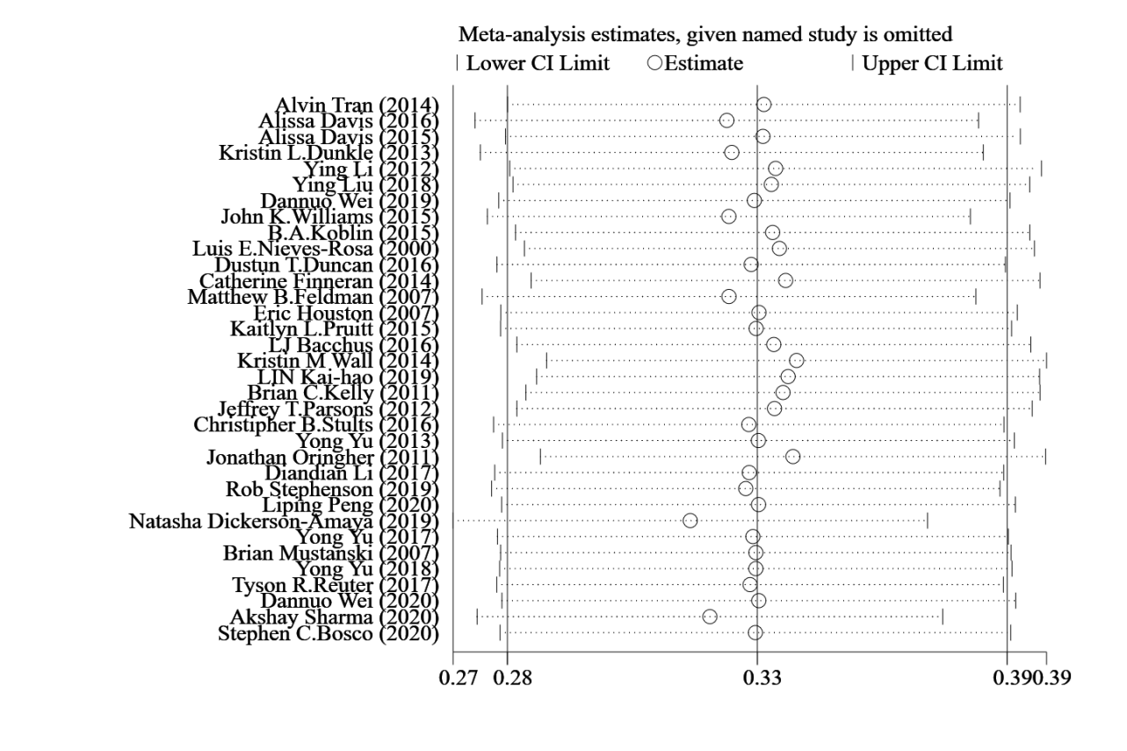
S_6 Fig 1. Sensitivity analysis of prevalence of any type of IPV in victimization

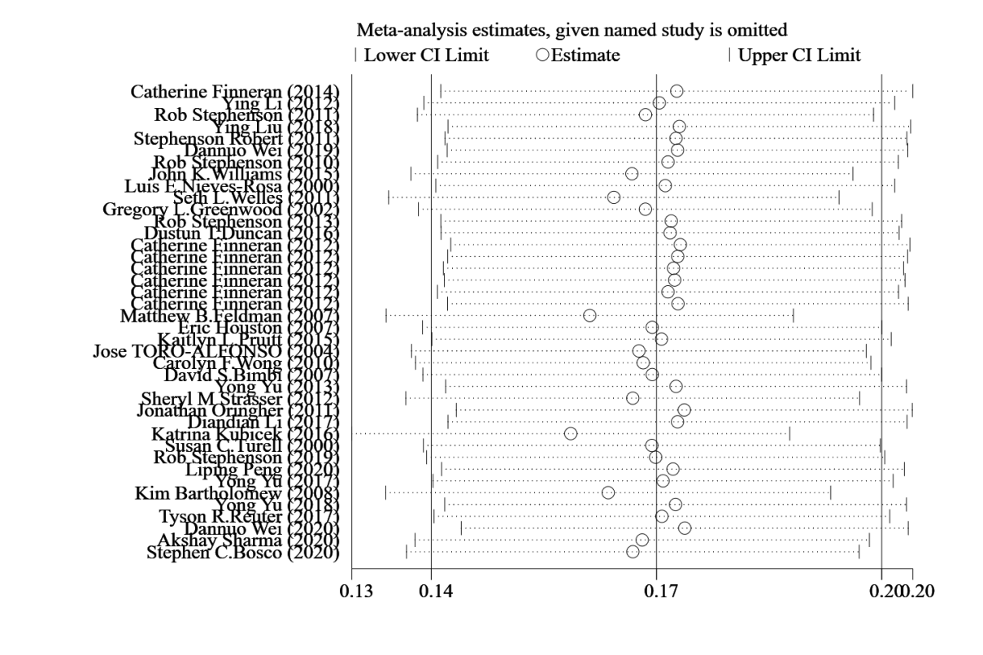
S_6 Fig 2. Sensitivity analysis of prevalence of physical violence in victimization

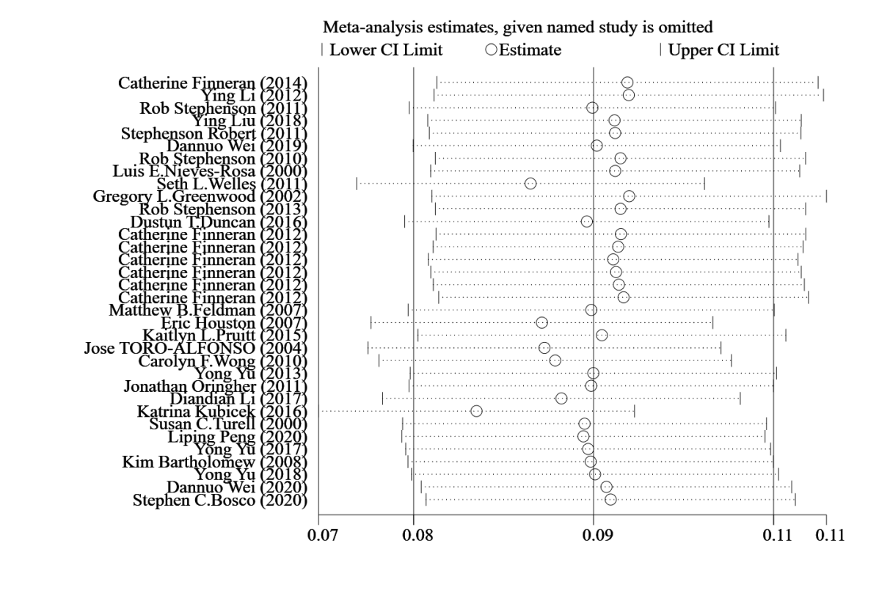
S_6 Fig 3. Sensitivity analysis of prevalence of sexual violence in victimization

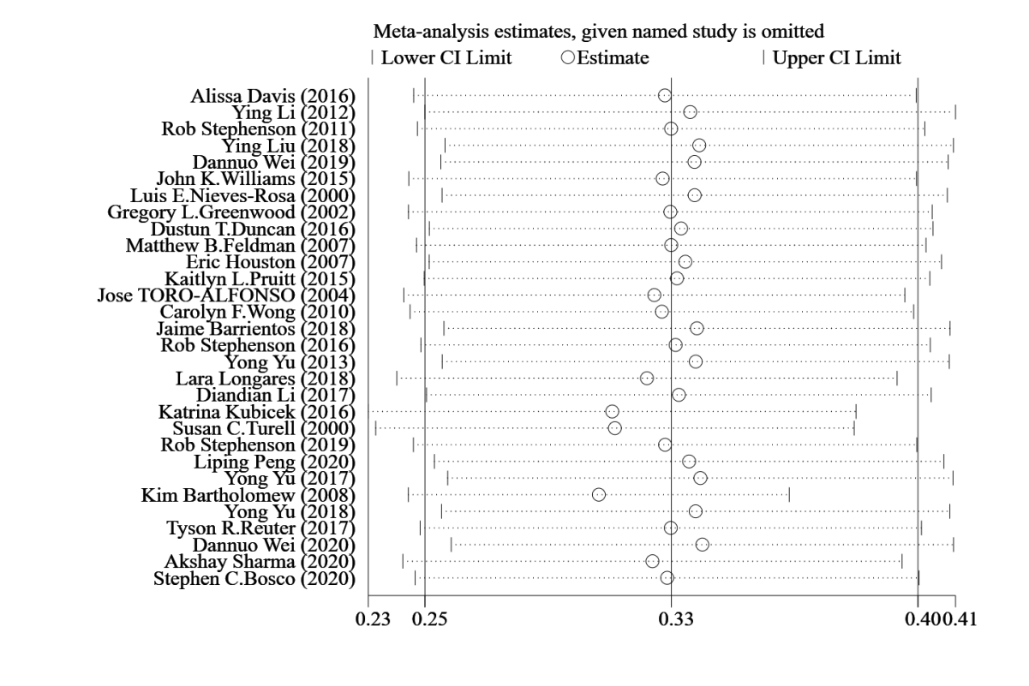
S_6 Fig 4. Sensitivity analysis of prevalence of emotional violence in victimization

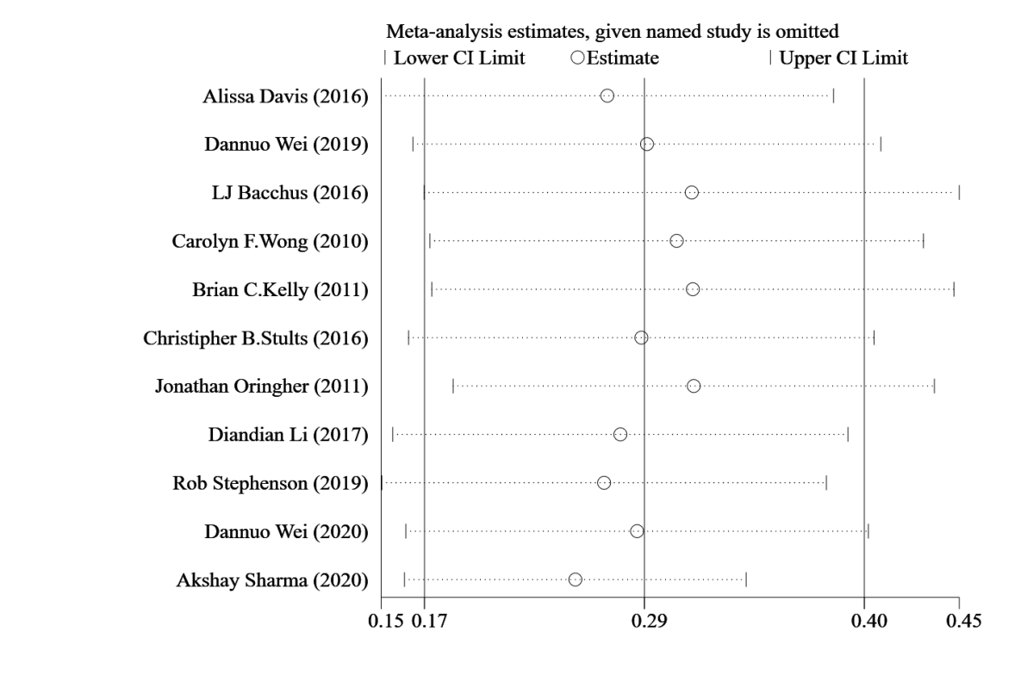
S_6 Fig 5. Sensitivity analysis of prevalence of any type of IPV in perpetration

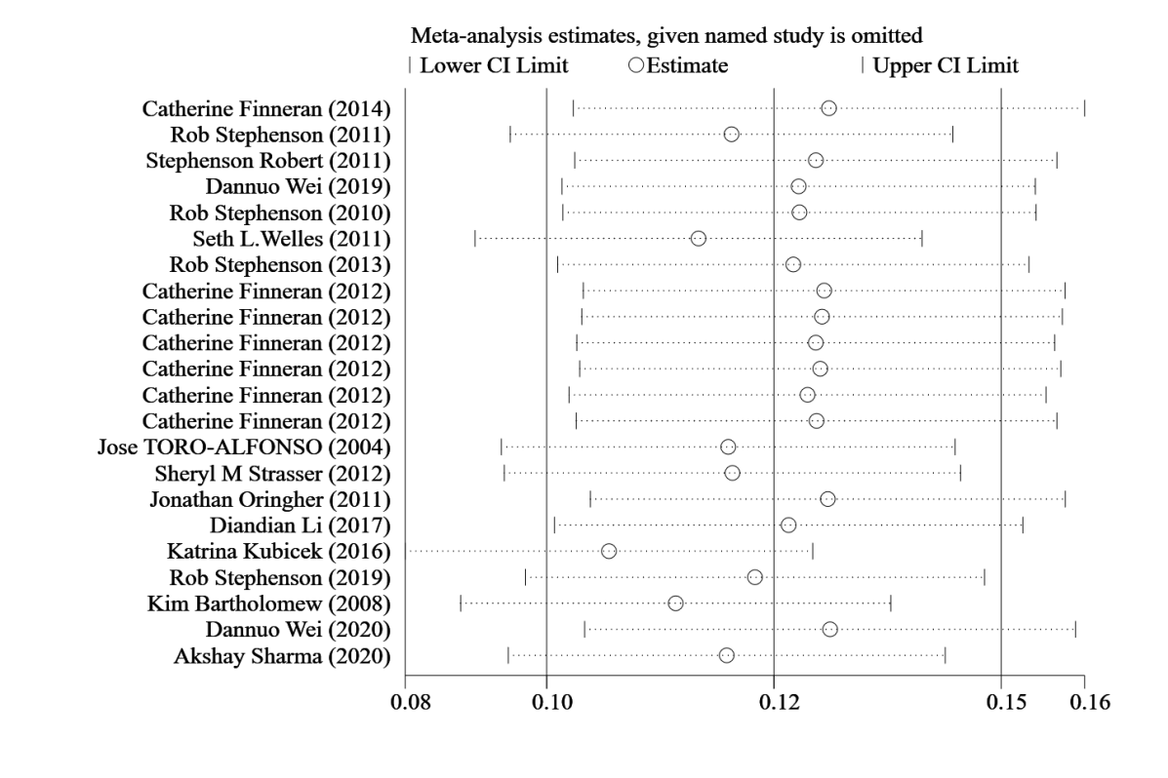
S_6 Fig 6. Sensitivity analysis of prevalence of physical violence in perpetration

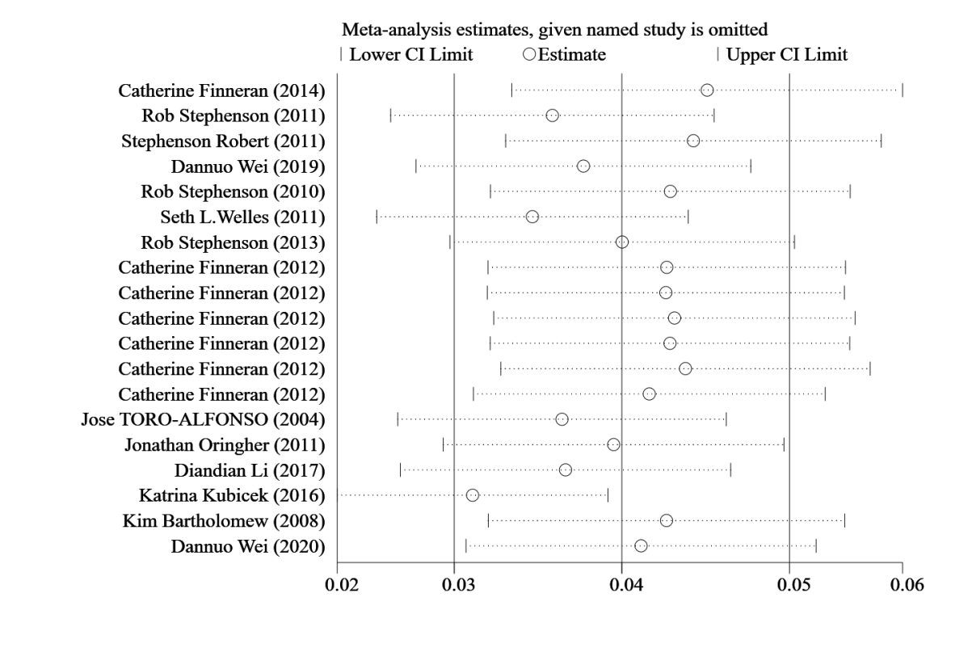
S_6 Fig 7. Sensitivity analysis of prevalence of sexual violence in perpetration

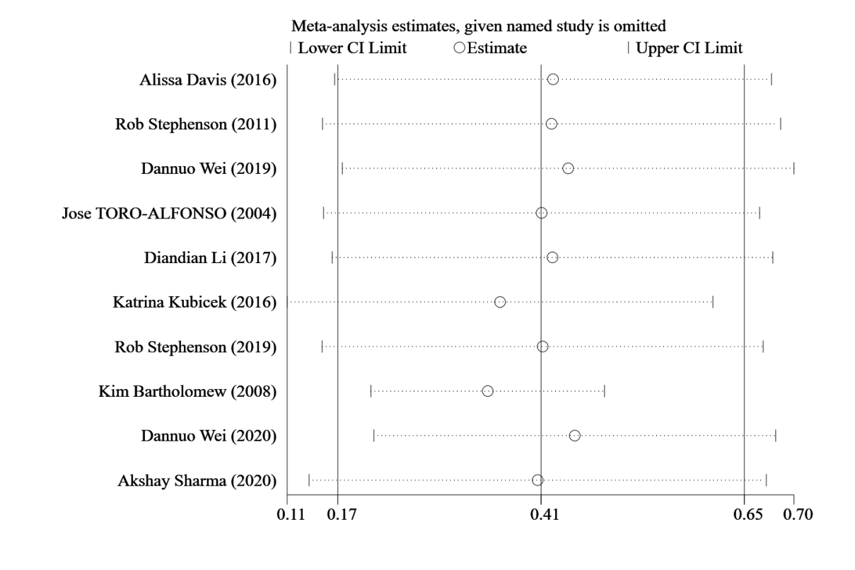
S_6 Fig 8. Sensitivity analysis of prevalence of emotional violence in perpetration

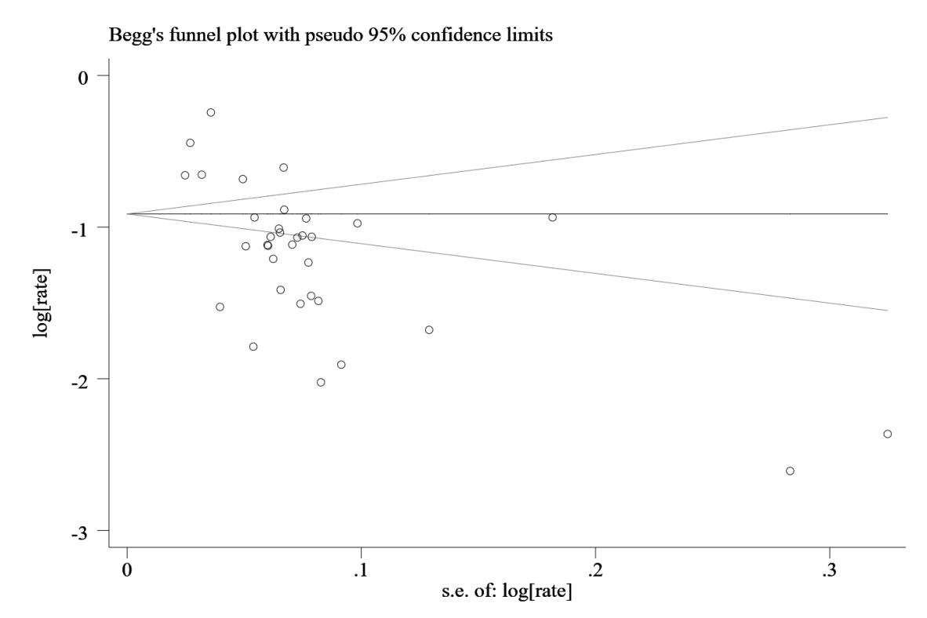
S_7 Fig 1. Begg’s funnel plot of prevalence of any type of IPV in victimization

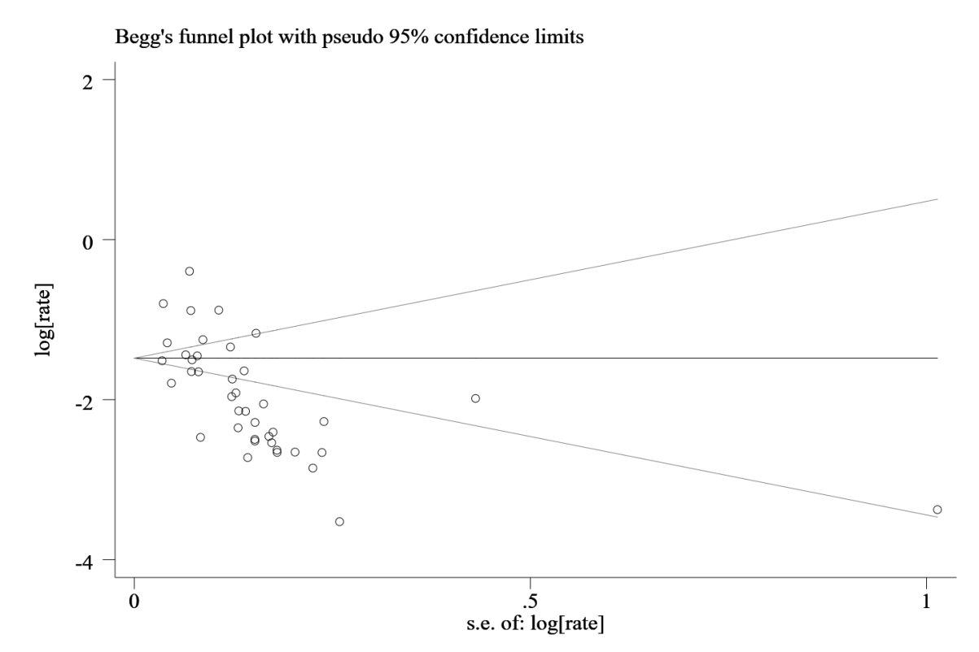
S_7 Fig 2. Begg’s funnel plot of prevalence of physical violence in victimization

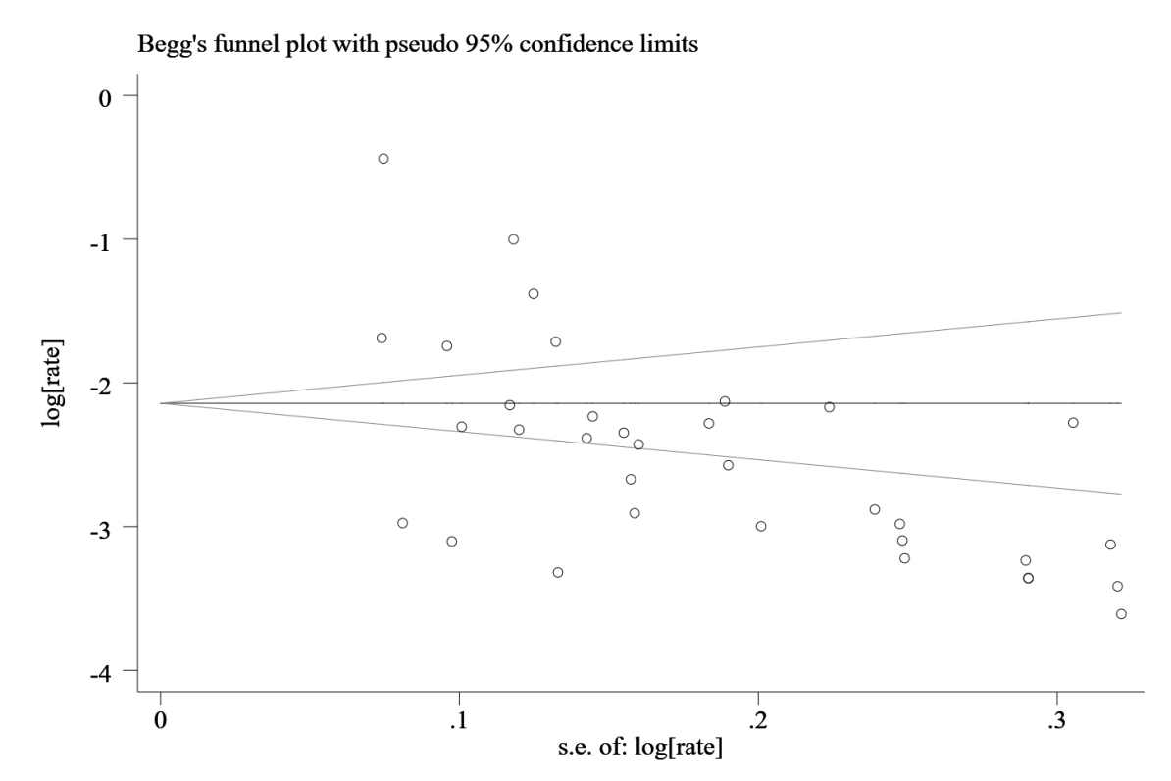
S_7 Fig 3. Begg’s funnel plot of prevalence of sexual violence in victimization

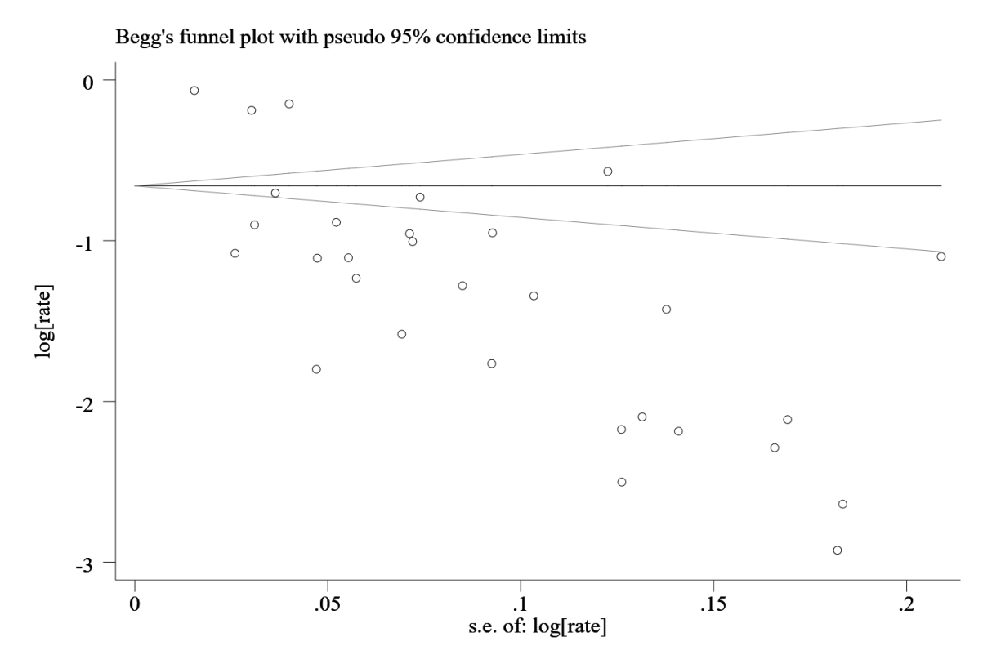
S_7 Fig 4. Begg’s funnel plot of prevalence of emotional violence in victimization

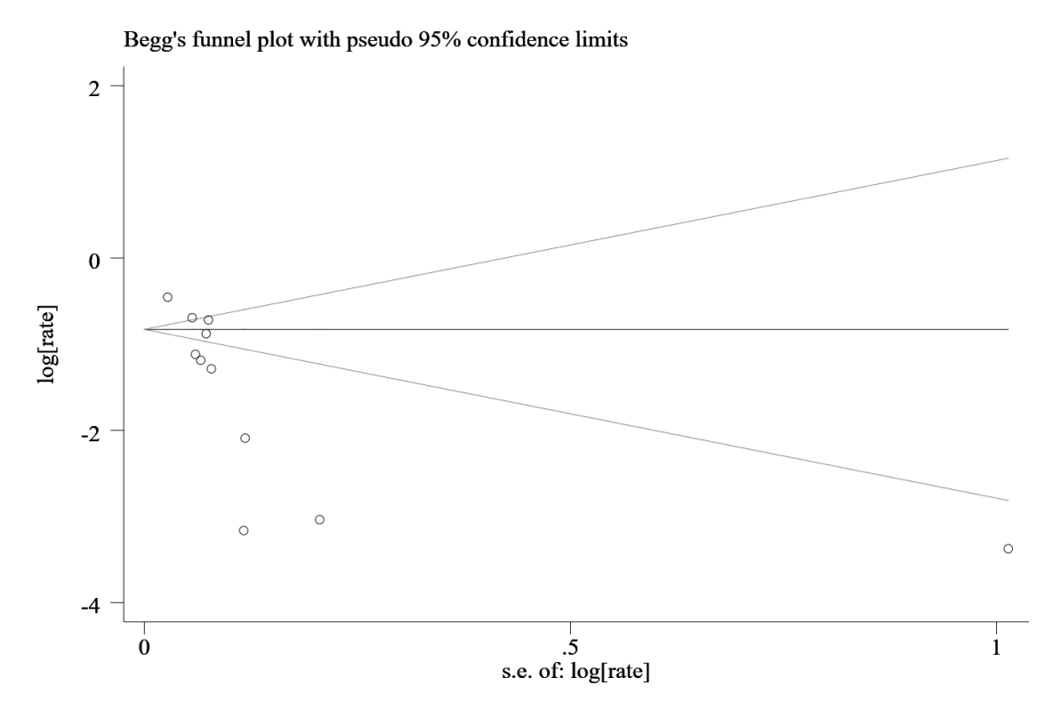
S_7 Fig 5. Begg’s funnel plot of prevalence of any type of IPV in perpetration

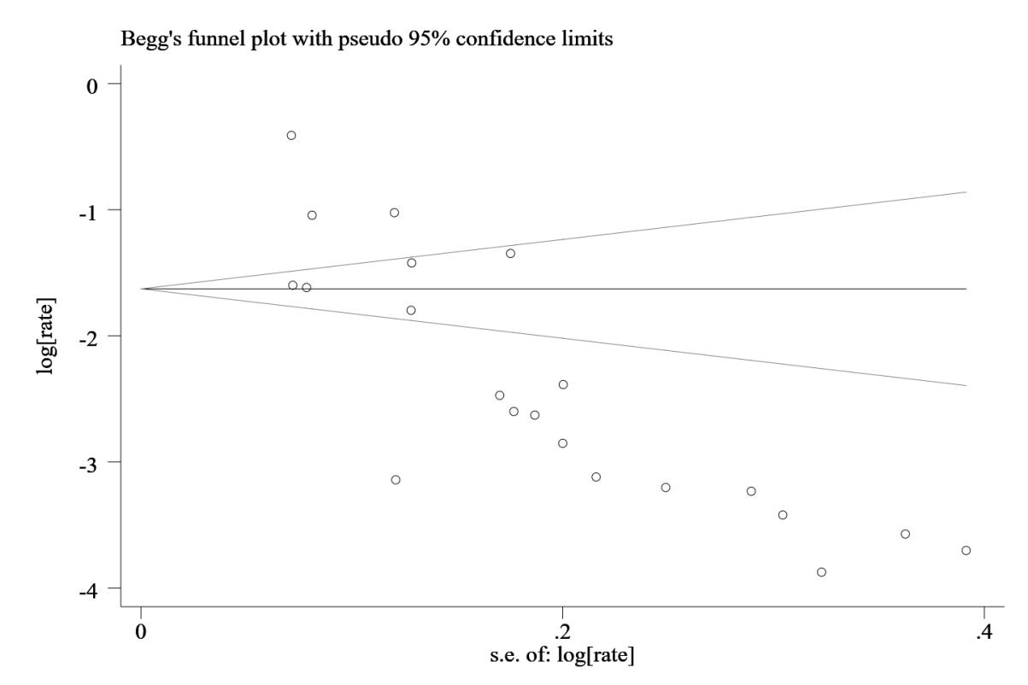
S_7 Fig 6. Begg’s funnel plot of prevalence of physical violence in perpetration

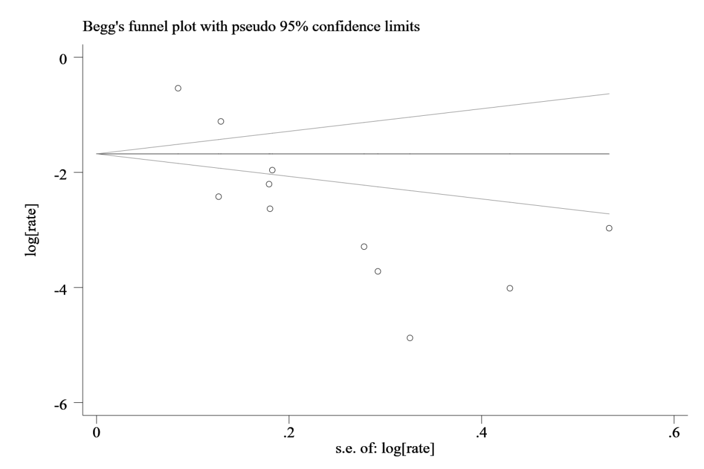
S_7 Fig 7. Begg’s funnel plot of prevalence of sexual violence in perpetration

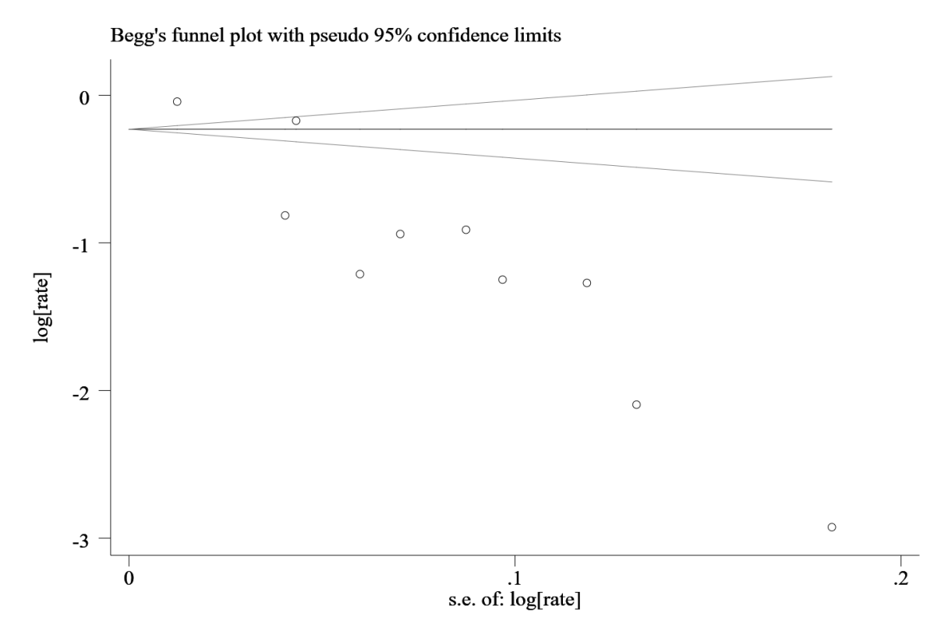
S_7 Fig 8. Begg’s funnel plot of prevalence of emotional violence in perpetration

S_8: Quality assessment for quantitative studies
S_8.1 Quality assessment for quantitative studies (n=55)
# | 1st Author (Year) | Q1 | Q2 | Q3 | Q4 | Q5 | Q6 | Q7 | Q8 | Q9 | Q10 | Q11 | Q12 | Q13 | Q14 | Q15 | Total Score | Quality Rating
1 | Ying Li (2012) | 0 | 0 | 0 | 0 | 0 | 1 | 1 | 0 | 0 | 1 | 1 | 0 | 1 | 1 | 1 | 7 | Adequate
2 | Rob Stephenson (2013) | 0 | 1 | 0 | 1 | 0 | 1 | 1 | 0 | 0 | 1 | 0 | 0 | 1 | 1 | 1 | 8 | Adequate
3 | Yong Yu (2013) | 0 | 1 | 0 | 1 | 0 | 1 | 1 | 1 | 0 | 1 | 0 | 1 | 1 | 1 | 1 | 10 | Adequate
4 | LIN Kai-hao (2019) | 0 | 1 | 0 | 1 | 0 | 1 | 0 | 0 | 0 | 0 | 1 | 0 | 0 | 1 | 1 | 6 | Adequate
5 | Kaitlyn L. Pruitt (2015) | 0 | 1 | 0 | 0 | 0 | 1 | 1 | 1 | 1 | 1 | 0 | 0 | 1 | 1 | 1 | 9 | Adequate
6 | Gregory L. Greenwood (2002) | 1 | 0 | 0 | 0 | 0 | 0 | 1 | 1 | 0 | 1 | 0 | 0 | 1 | 1 | 1 | 7 | Adequate
7 | Seth L. Welles (2011) | 0 | 1 | 0 | 1 | 0 | 1 | 1 | 1 | 0 | 1 | 0 | 0 | 1 | 1 | 1 | 9 | Adequate
8 | Luis E. Nieves-Rosa (2000) | 0 | 1 | 0 | 0 | 0 | 1 | 1 | 0 | 0 | 1 | 1 | 0 | 1 | 1 | 1 | 8 | Adequate
9 | B. A. Koblin (2015) | 0 | 1 | 0 | 1 | 0 | 1 | 1 | 0 | 0 | 0 | 0 | 0 | 0 | 1 | 1 | 6 | Adequate
10 | John K. Williams (2015) | 0 | 1 | 0 | 1 | 0 | 1 | 1 | 0 | 0 | 1 | 1 | 0 | 1 | 1 | 1 | 9 | Adequate
11 | Rob Stephenson (2010) | 0 | 1 | 0 | 1 | 0 | 0 | 1 | 0 | 0 | 1 | 0 | 0 | 1 | 1 | 1 | 7 | Adequate
12 | Dannuo Wei (2019) | 0 | 1 | 0 | 1 | 0 | 1 | 1 | 1 | 0 | 1 | 1 | 1 | 1 | 1 | 1 | 11 | Acceptable
13 | Stephenson Robert (2011) | 0 | 1 | 0 | 1 | 0 | 0 | 0 | 0 | 0 | 1 | 0 | 0 | 1 | 1 | 1 | 6 | Adequate
14 | Ying Liu (2018) | 0 | 1 | 0 | 1 | 0 | 1 | 0 | 1 | 0 | 1 | 1 | 0 | 1 | 1 | 1 | 9 | Adequate
15 | Rob Stephenson (2011) | 0 | 1 | 0 | 0 | 0 | 1 | 1 | 1 | 0 | 1 | 0 | 0 | 1 | 1 | 1 | 8 | Adequate
16 | Kristin L. Dunkle (2013) | 0 | 1 | 0 | 1 | 0 | 0 | 1 | 0 | 0 | 1 | 0 | 0 | 1 | 1 | 1 | 7 | Adequate
17 | Alissa Davis (2015) | 0 | 1 | 0 | 1 | 0 | 0 | 1 | 0 | 0 | 1 | 0 | 0 | 1 | 1 | 1 | 7 | Adequate
18 | Alissa Davis (2016) | 0 | 1 | 0 | 1 | 0 | 1 | 1 | 1 | 0 | 1 | 0 | 0 | 1 | 1 | 1 | 9 | Adequate
19 | Alvin Tran (2014) | 0 | 1 | 0 | 1 | 0 | 1 | 1 | 1 | 0 | 1 | 1 | 0 | 1 | 1 | 1 | 10 | Adequate
20 | Christipher B. Stults (2016) | 0 | 1 | 0 | 0 | 0 | 1 | 1 | 1 | 0 | 0 | 0 | 0 | 1 | 1 | 1 | 7 | Adequate
21 | Carolyn F. Wong (2010) | 0 | 1 | 0 | 1 | 0 | 1 | 1 | 1 | 0 | 1 | 0 | 0 | 1 | 1 | 1 | 9 | Adequate
22 | Catherine Finneran (2014) | 0 | 1 | 0 | 1 | 0 | 1 | 1 | 1 | 0 | 1 | 0 | 0 | 1 | 1 | 1 | 9 | Adequate
23 | Dustun T. Duncan (2016) | 0 | 0 | 0 | 1 | 0 | 1 | 1 | 0 | 0 | 0 | 0 | 0 | 1 | 1 | 1 | 6 | Adequate
24 | Catherine Finneran (2014) | 0 | 1 | 0 | 1 | 0 | 1 | 1 | 0 | 0 | 0 | 0 | 0 | 1 | 1 | 1 | 7 | Adequate
25 | Catherine Finneran (2012) | 0 | 1 | 0 | 0 | 0 | 0 | 1 | 1 | 0 | 1 | 1 | 0 | 1 | 1 | 1 | 8 | Adequate
26 | Matthew B. Feldman (2007) | 0 | 1 | 0 | 1 | 0 | 1 | 1 | 0 | 0 | 1 | 0 | 0 | 1 | 1 | 1 | 8 | Adequate
27 | Eric Houston (2007) | 0 | 1 | 0 | 1 | 0 | 1 | 1 | 0 | 0 | 1 | 1 | 0 | 1 | 1 | 1 | 9 | Adequate
28 | LJ Bacchus (2016) | 0 | 1 | 0 | 1 | 0 | 1 | 1 | 1 | 0 | 1 | 1 | 0 | 1 | 1 | 1 | 10 | Adequate
29 | Jose (2004) | 0 | 1 | 0 | 1 | 0 | 0 | 1 | 1 | 0 | 1 | 0 | 0 | 1 | 1 | 1 | 8 | Adequate
30 | Kristin M Wall (2014) | 0 | 1 | 0 | 1 | 1 | 1 | 1 | 1 | 0 | 0 | 0 | 0 | 1 | 1 | 1 | 9 | Adequate
31 | David S. Bimbi (2007) | 0 | 1 | 0 | 1 | 0 | 1 | 1 | 1 | 0 | 0 | 0 | 0 | 0 | 1 | 1 | 7 | Adequate
32 | Jaime Barrientos (2018) | 0 | 0 | 0 | 1 | 0 | 1 | 1 | 0 | 0 | 0 | 1 | 0 | 0 | 1 | 1 | 6 | Adequate
33 | Brian C. Kelly (2011) | 0 | 0 | 0 | 1 | 0 | 0 | 1 | 1 | 0 | 1 | 0 | 0 | 1 | 1 | 1 | 7 | Adequate
34 | Jeffrey T. Parsons (2012) | 0 | 0 | 0 | 1 | 0 | 1 | 1 | 0 | 0 | 0 | 1 | 0 | 0 | 1 | 1 | 6 | Adequate
35 | Rob Stephenson (2016) | 0 | 1 | 0 | 1 | 0 | 1 | 1 | 1 | 0 | 1 | 0 | 0 | 1 | 1 | 1 | 9 | Adequate
36 | Sheryl M Strasser (2012) | 0 | 1 | 0 | 1 | 0 | 0 | 1 | 1 | 0 | 1 | 1 | 0 | 1 | 1 | 1 | 9 | Adequate
37 | Jonathan Oringher (2011) | 0 | 0 | 0 | 1 | 0 | 0 | 1 | 1 | 0 | 1 | 0 | 0 | 1 | 1 | 1 | 7 | Adequate
38 | Diandian Li (2017) | 0 | 1 | 0 | 1 | 0 | 0 | 1 | 1 | 0 | 1 | 1 | 0 | 1 | 1 | 1 | 9 | Adequate
39 | Katrina Kubicek (2016) | 0 | 1 | 0 | 1 | 0 | 1 | 1 | 1 | 0 | 1 | 1 | 1 | 1 | 1 | 1 | 11 | Acceptable
40 | Lara Longares (2018) | 0 | 1 | 0 | 1 | 0 | 0 | 1 | 1 | 0 | 0 | 1 | 0 | 0 | 1 | 1 | 7 | Adequate
41 | Carvalho, Amana F. (2011) | 0 | 0 | 0 | 1 | 0 | 0 | 1 | 0 | 0 | 0 | 0 | 0 | 1 | 1 | 1 | 5 | Unacceptable
42 | Susan C. Turell (2000) | 0 | 1 | 1 | 1 | 0 | 0 | 0 | 0 | 0 | 1 | 0 | 0 | 1 | 1 | 1 | 7 | Adequate
43 | Rob Stephenson (2019) | 0 | 1 | 0 | 1 | 0 | 1 | 1 | 1 | 0 | 1 | 0 | 0 | 1 | 1 | 1 | 9 | Adequate
44 | Liping Peng (2020) | 0 | 1 | 0 | 1 | 0 | 1 | 1 | 1 | 0 | 1 | 1 | 0 | 1 | 1 | 1 | 10 | Adequate
45 | Natasha Dickerson-Amaya (2019) | 0 | 1 | 0 | 1 | 0 | 0 | 1 | 1 | 0 | 1 | 1 | 0 | 1 | 1 | 1 | 9 | Adequate
46 | Logie, C. H. (2019) | 0 | 1 | 0 | 1 | 0 | 0 | 1 | 0 | 0 | 0 | 0 | 0 | 0 | 1 | 1 | 5 | Unacceptable
47 | Kim Bartholomew (2008) | 0 | 1 | 0 | 1 | 0 | 1 | 1 | 1 | 0 | 1 | 1 | 0 | 1 | 1 | 1 | 10 | Adequate
48 | Yong Yu (2017) | 0 | 1 | 1 | 1 | 0 | 1 | 1 | 1 | 0 | 1 | 0 | 0 | 1 | 1 | 1 | 10 | Adequate
49 | Beymer, Matthew R. (2016) | 0 | 0 | 0 | 1 | 0 | 1 | 1 | 0 | 0 | 0 | 0 | 0 | 0 | 1 | 1 | 5 | Unacceptable
50 | Brian Mustanski (2007) | 0 | 0 | 0 | 1 | 0 | 1 | 1 | 0 | 0 | 0 | 1 | 0 | 0 | 1 | 1 | 6 | Adequate
51 | Yong Yu (2018) | 0 | 1 | 0 | 1 | 0 | 0 | 1 | 1 | 0 | 1 | 0 | 0 | 1 | 1 | 1 | 8 | Adequate
52 | Tyson R. Reuter (2017) | 0 | 0 | 0 | 1 | 0 | 1 | 1 | 1 | 0 | 1 | 0 | 0 | 1 | 1 | 1 | 8 | Adequate
53 | Dannuo Wei (2020) | 0 | 1 | 0 | 1 | 0 | 1 | 1 | 1 | 0 | 1 | 0 | 0 | 1 | 1 | 1 | 9 | Adequate
54 | Akshay Sharma (2020) | 0 | 1 | 0 | 1 | 1 | 1 | 1 | 1 | 0 | 1 | 1 | 0 | 1 | 1 | 1 | 11 | Acceptable
55 | Stephen C. Bosco (2020) | 0 | 1 | 0 | 1 | 0 | 1 | 1 | 1 | 0 | 1 | 0 | 0 | 1 | 1 | 1 | 9 | Adequate
Note:
Quality Rating: Acceptable: 11-15; Adequate: 6-10; Unacceptable: 0-5

S_8.2 Methodological quality evaluation of descriptive research on same-sex intimate partner violence
Criteria | Y | N
Q1. Are representative sampling procedures (e.g., random selection, systematic sampling) used to select individual participants?
Q2. Are eligibility criteria for participation in the study specified?
Q3. Are exclusion criteria specified?
Q4. Dose the study specify how participants’ sexual orientation is measured or categorized?
Q5. Are partners within the same relationship either (a) not both included in the same sample or (b) paired in the analysis of the data?
Q6. Is the timing of data collection specified?
Q7. Is the methodology described in sufficient detail as to permit replication?
Q8. Are standardized, psychometrically sound (acceptable reliability and validity described in the text) assessment instruments utilized?
Q9. Is a control for social desirability used?
Q10. Is the study clear as to the type(s) of abuse measured within the study?
Q11. Are definitions of the types of abuse measured presented?
Q12. Are the conditions under which participants completed the surveys or participated in the research standardized?
Q13. Do the variables measured represent multiple levels (attitudinal, behavioral, and observational)?
Q14. Are appropriate statistical analyses used?
Q15. Are conclusions drawn appropriately?
Note: Y=Yes; N=No

