Problematic Social Media Use in Adolescents and Young Adults: A Meta-Analysis

Appendix A

Table 1: Quality assessment rating for each study included in the meta-analysis.
First author (year) | Quality Rating
Holmgren (2017) | 6 stars
Wang (2018) | 7 stars
Apaolaza (2019) | 5 stars
Hou (2019) | 6 stars
Kircaburun (2019) | 6 stars
Mitra (2019) | 5 stars
Kim (2020) | 5 stars
Kircaburun, Demetrovics (2020) | 7 stars
Kircaburun, Grifiths (2020) | 6 stars
Stockdale (2020) | 6 stars
Wong (2020) | 8 stars
Yildiz (2020) | 5 stars
Yunxiang (2020) | 7 stars
Brailovskaia; Lithuanian sample (2021) | 7 stars
Brailovskaia; German sample (2021) | 7 stars
Giordano (2021) | 7 stars
He (2021) | 6 stars
Kilincel (2021) | 7 stars

Table 2: Questionnaires used for each study to measure problematic use and the outcome variables.
First author (year) | Problematic Use Measure | Outcome Measure
Holmgren (2017) | Problematic Use of Mobile Phone Scale (modified for social media use) | Center of Epidemiologic Studies Depression Scale
Wang (2018) | The Social Networking Intrusion Questionnaire | Center of Epidemiologic Studies Depression Scale
Apaolaza (2019) | Compulsive Mobile SNS Use | Perceived Stress Scale
Hou (2019) | Social Media Intrusion Questionnaire | Center of Epidemiologic Studies Depression Scale  State-Trait Anxiety Inventory  Perceived Stress Scale
Kircaburun (2019) | Bergen Social Media Addiction Scale | The Short Depression-Happiness Scale
Mitra (2019) | Social Media Disorder Scale | The Clinically Useful Depression Outcome Scale
Chen (2020) | Social Networking Websites Addiction Scale | Social Phobia Scale
Kim (2020) | Social Networking Addiction Tendency | Anxiety Tendency Questionnaire
Kircaburun, Demetrovics (2020) | Problematic Social Media Use Questionnaire | The Short Depression-Happiness Scale
Kircaburun, Grifiths (2020) | Problematic Social Media Use Questionnaire | The Short Depression-Happiness Scale
Stockdale (2020) | Problematic Use of Mobile Phone Scale (modified for social media use) | Center of Epidemiologic Studies Depression Scale  Spence Child Anxiety Inventory
Wong (2020) | Bergen Social Media Addiction Scale | The Depression Anxiety Stress Scale
Yildiz (2020) | Social Media Disorder Scale | Social Anxiety Scale for Adolescents
Brailovskaia; Lithuanian sample (2021) | Bergen Social Media Addiction Scale | The Depression Anxiety Stress Scale
Brailovskaia; German  sample (2021) | Bergen Social Media Addiction Scale | The Depression Anxiety Stress Scale
Giordano (2021) | Bergen Social Media Addiction Scale | Patient Health Questionnaire-4
He (2021) | Social Media Dependence Questionnaire | Perceived Stress Scale
Kilincel (2021) | Social Media Disorder Scale | State-Trait Anxiety Inventory

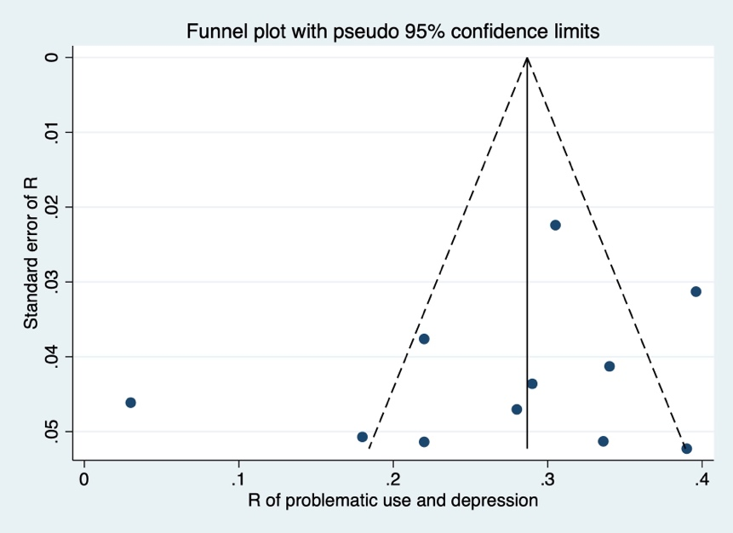
Figure 1. Funnel plot of depressive symptoms and problematic social media use.

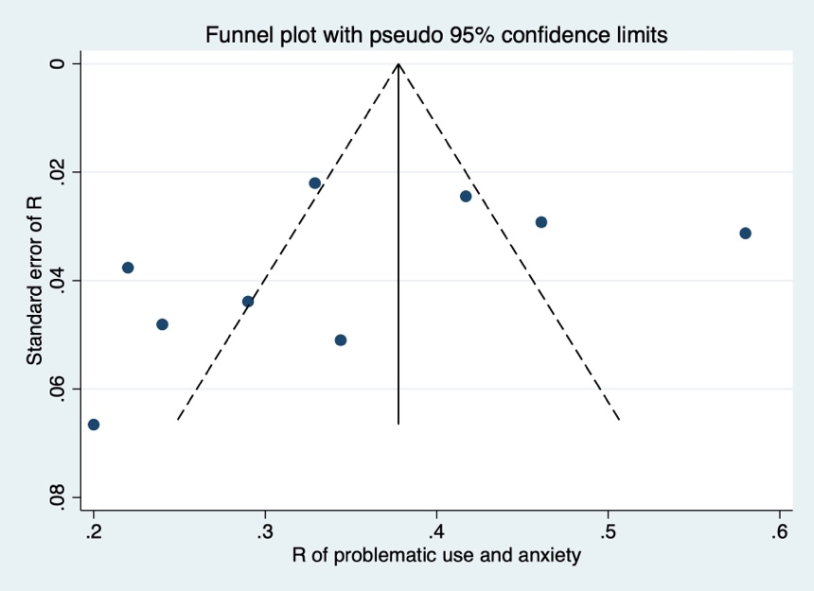
Figure 2. Funnel plot of anxiety symptoms and problematic social media use.

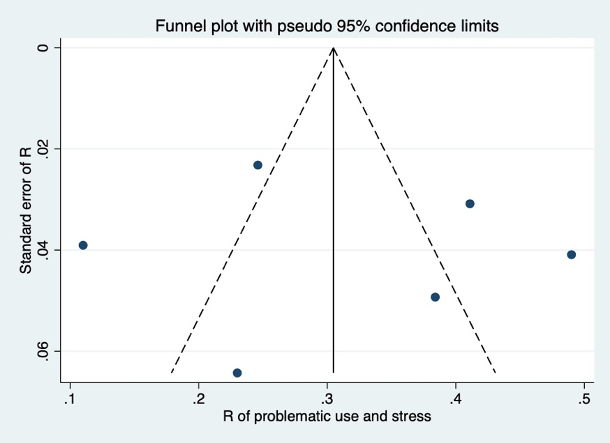
Figure 3. Funnel plot of stress and problematic social media use.
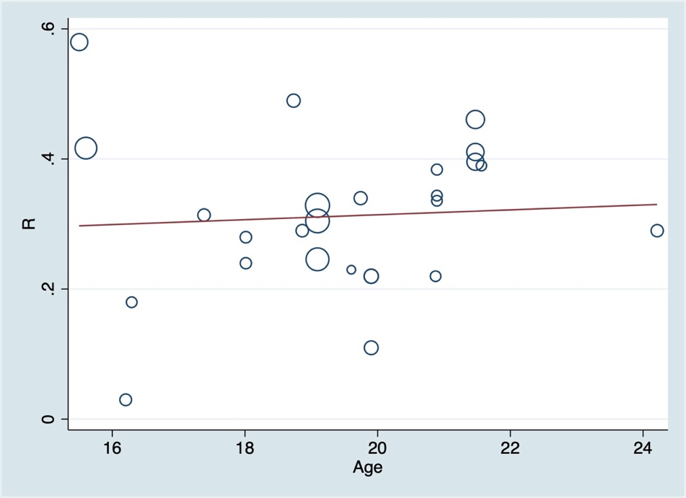
Figure 4. Meta-regression plot assessing age as a covariate

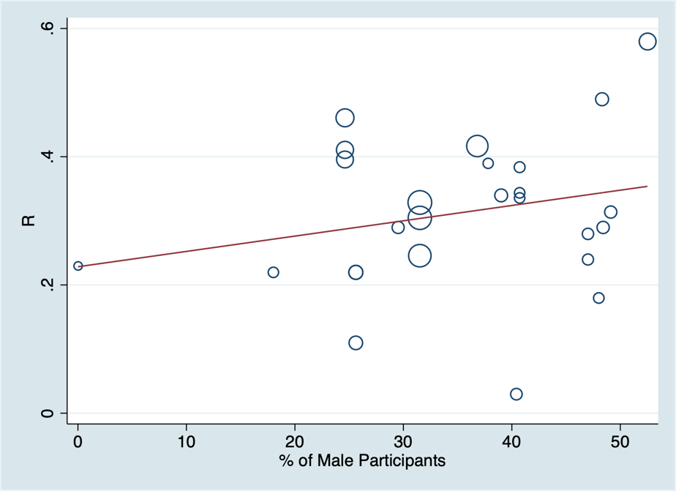
Figure 5. Meta-regression plot assessing sex as a covariate

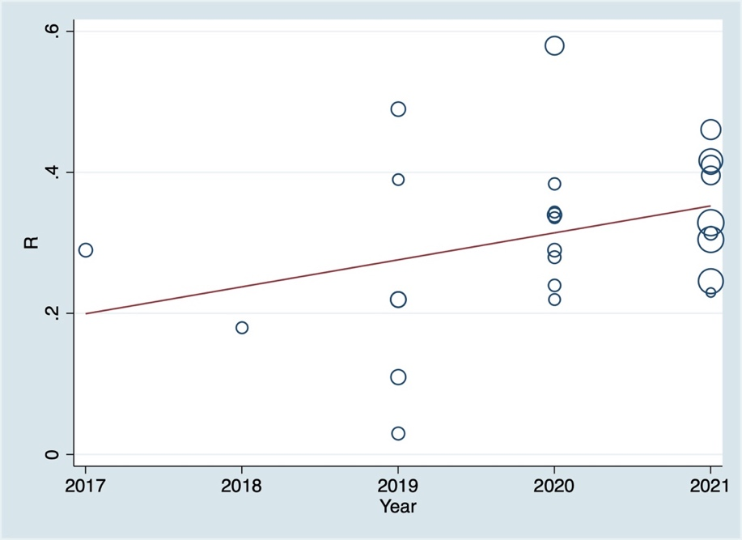
Figure 6. Meta-regression plot assessing year of publication as a covariate

