Operative Management of Midshaft Clavicle Fractures Demonstrates Better Long-Term Outcomes: A Systematic Review and Meta-analysis of Randomised Controlled Trials

Michael Zhipeng Yan ¹; Wing-sze Yuen¹; Sung-ching Yeung¹; Christie Wong Wing-yin¹; Sonia Choi-ying Wong¹;Walter Wang Si-qi¹; Elaine Tian¹; Shireen Rashed¹, ; Colin Shing Yat Yung¹, Christian Xinshuo Fang^{1*}

¹ Department of Orthopaedics and Traumatology, The University of Hong Kong, Queen Mary Hospital, Hong Kong Special Administrative Region, China
*Corresponding authors

Supplementary Appendix

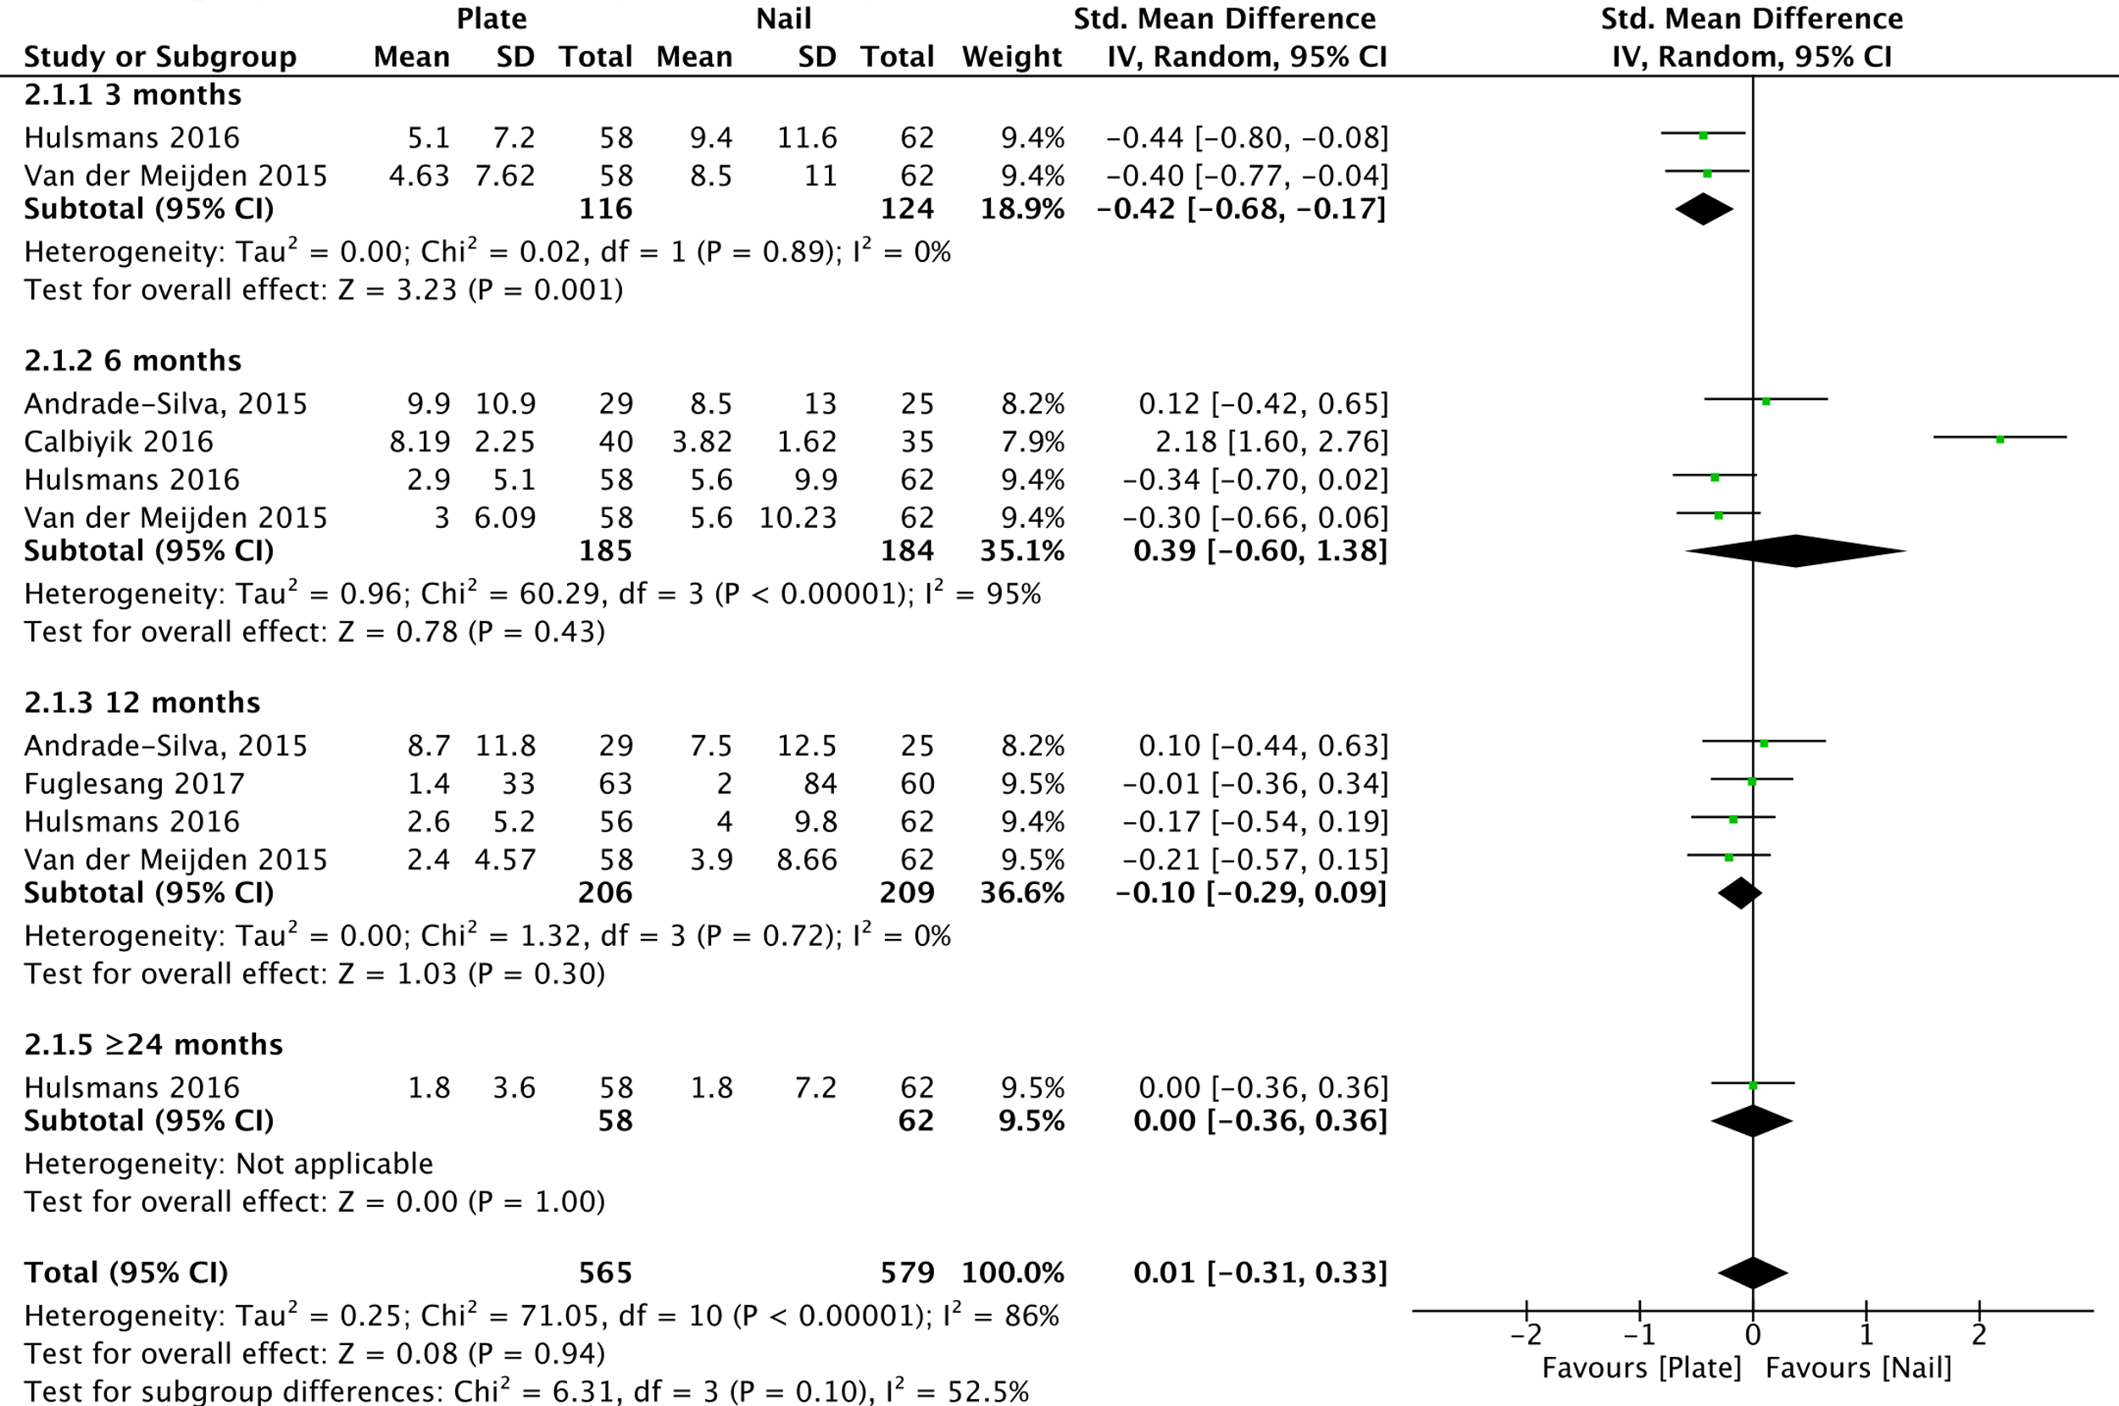S1. Meta-analysis of DASH Score outcomes comparing between plate fixation versus intramedullary nailing at 3, 6, 12, and ≥24 months in pooled studies. The standard-mean difference was 0.01 (95% CI -0.31 to 0.33; p=0.94).

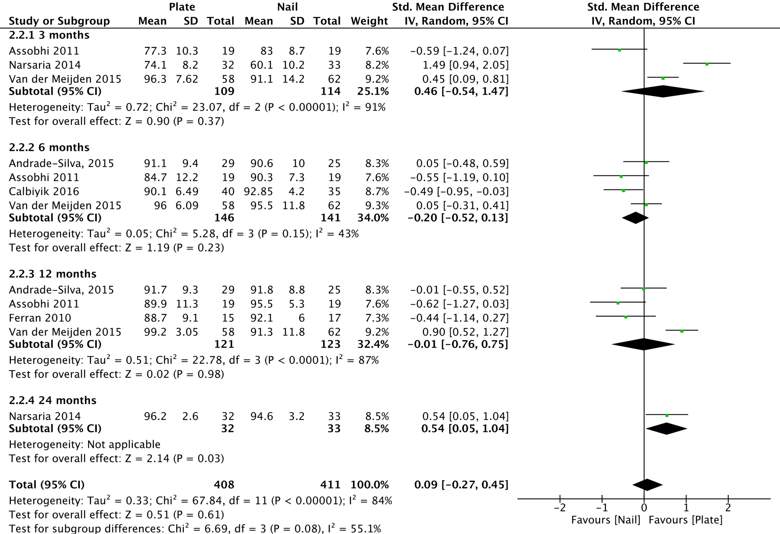S2. Meta-analysis of CMS outcomes comparing between plate fixation and intramedullary nailing in pooled studies at 3, 6, 12 and ≥24 months. The standard mean difference was 0.09 (95% CI -0.27 to 0.45; p=0.61).

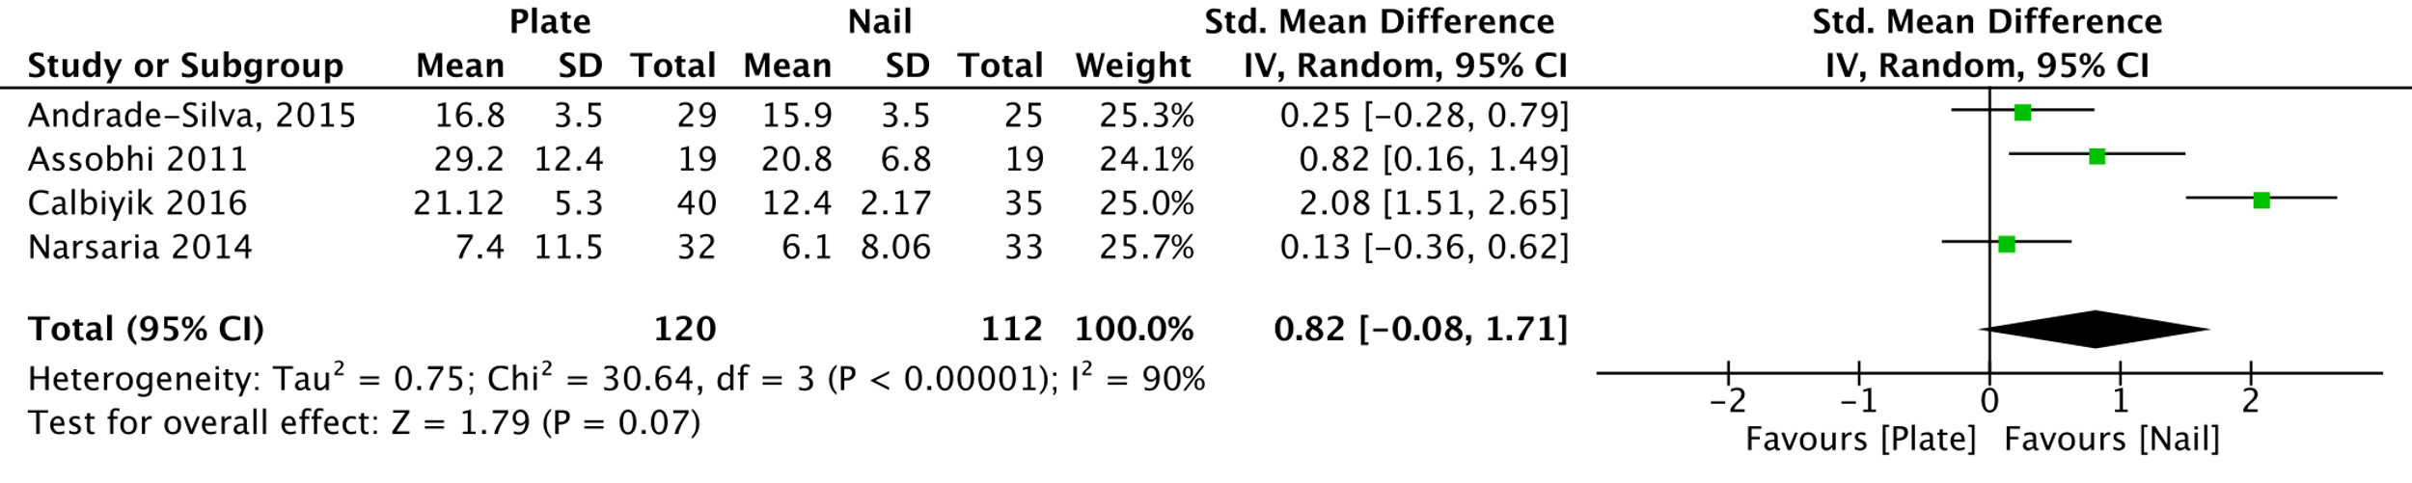S3. Meta-analysis of time to bony union comparison between plate fixation and intramedullary nailing in pooled studies. The standard mean difference is 0.82 (95% CI -0.08 to 1.71; p=0.07).

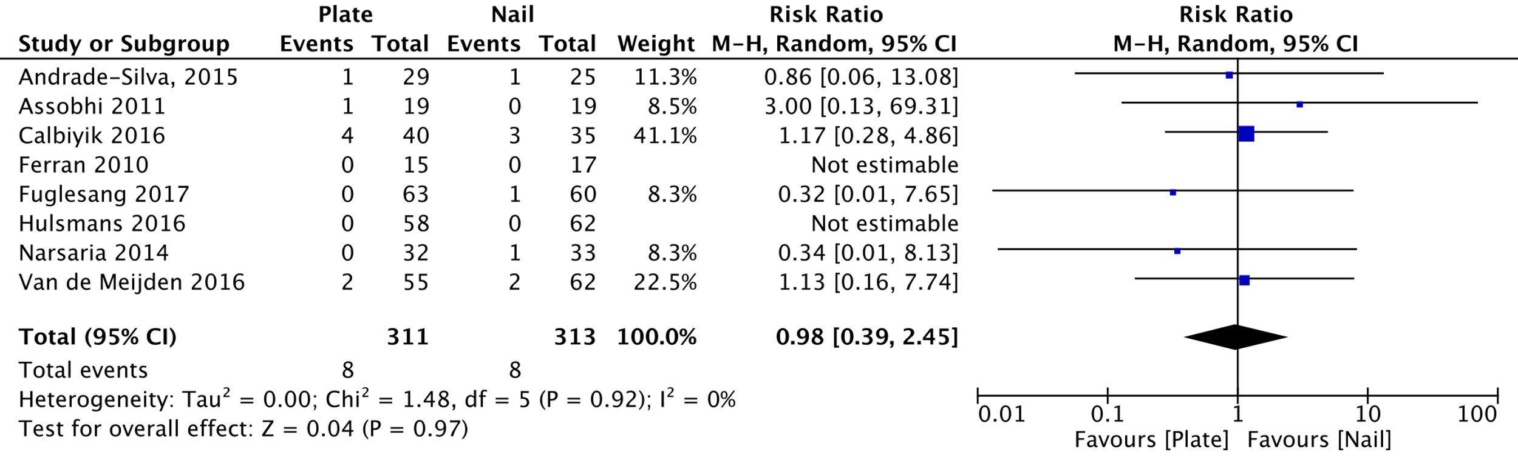S4. Meta-analysis of bone-related major complications (including bone non-union, malunion and implant failure) between plate fixation and intramedullary nailing in pooled studies. The risk ratio for complications is 0.98 (95% CI 0.39 to 2.45; p=0.97).

S5. Distribution of implants in the pooled study comparing between surgical outcomes beween conservative and operative treatment.
LCP: Locking Clavicle Plate Fixation (in blue);
DCP: Dynamic Compression Plate Fixation (in yellow) ;
(LCP+DCP): Hybrid Plate Fixation in green);
Nail Fixation (in orange);
Pin Fixation (in purple);
Screw Fixation (in red).

S6. Distribution of Implants in the pooled study of intra-surgical group comparison between Nail and Plate.
IM nail: Intramedullary Nail Fixation (in blue); ESIN + Titanium Elastic Nail Fixation (in yellow) ; Knowles Pin Fixation (in green)

S7. Risk of Bias summary
S8. Risk of bias graph

S9a. Funnel plot of operative treatment versus non-operative treatment treatment.(Overall DASH score)

S9b. Funnel plot of operative treatment versus non-operative treatment treatment.(Early DASH score at 3 months)
S9c. Funnel plot of operative treatment versus non-operative treatment.(Intermediate DASH score at 6-12 months)

S9d. Funnel plot of operative treatment versus non-operative treatment.(Late DASH score at 24 months)

S10a. Funnel plot of operative treatment versus non-operative treatment treatment.(Overall CMS)
S10b. Funnel plot of operative treatment versus non-operative treatment.(early CMS at 3 months)
S10c. Funnel plot of operative treatment versus non-operative treatment.(Intermediate CMS at 6-12 months)
S10d. Funnel plot of operative treatment versus non-operative treatment.(Late CMS at 24 months)

S11. Funnel plot of intra-surgical comparison: surgical plate fixation versus intramedullary nail fixation.(Overall DASH score)

S12. Funnel plot of intra-surgical comparison: surgical plate fixation versus intramedullary nail fixation.(Overall CMS)

S13. Funnel plot of intra-surgical comparison: surgical plate fixation versus intramedullary nail fixation.(Time to union)

S14. Funnel plot of intra-surgical comparison: surgical plate fixation versus intramedullary nail fixation.(Risk ratio of bone-related complications rate)

