Supplemental 5: Forest plot of Moderator analysis: Text message interventions

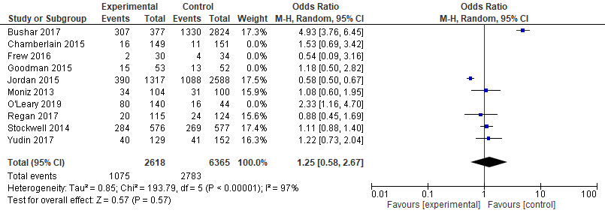

Other interventions


