Appendices

PubMed Search |  | Date: 29/11/2020
#1 | Search: ("Adrenergic alpha-Antagonists"[Mesh] OR "Adrenergic alpha Receptor Antagonists" OR "alpha-Adrenergic Receptor Blockaders" OR "alpha Adrenoceptor Blockade" OR "Adrenergic alpha-Blockers" OR "alpha-Adrenergic Blocking Agents" OR "alpha-Adrenoceptor Blocking Agents" OR "Doxazosin"[Mesh] OR "Tamsulosin"[Mesh] OR "Terazosin" OR "Alfuzosin" OR "Silodosin" OR "Prazosin"[Mesh] OR "Indoramin"[Mesh] OR "Urapidil" OR "Naftopidil" OR "Trimazosin" OR "Bunazosin") AND ("Heart Failure"[Mesh] OR "Cardiac Failure" OR "Myocardial Failure" OR "Heart Decompensation" OR "Cardiac Decompensation" OR "Myocardial Decompensation" OR "Heart Insufficiency" OR "Cardiac Insufficiency" OR "Myocardial Insufficiency") Filters: Clinical Study, Clinical Trial, Clinical Trial Protocol, Clinical Trial, Phase I, Clinical Trial, Phase II, Clinical Trial, Phase III, Clinical Trial, Phase IV, Comparative Study, Controlled Clinical Trial, Journal Article, Letter, Multicenter Study, Observational Study, Pragmatic Clinical Trial, Randomized Controlled Trial, Humans, English, Portuguese, Spanish, MEDLINE Sort by: Publication Date |  | 424
Cochrane Central Register of Controlled Trials Search |  | Date: 29/11/2020
#1 | ("Adrenergic alpha-Antagonists" OR "Adrenergic alpha Receptor Antagonists" OR "alpha-Adrenergic Receptor Blockaders" OR "alpha Adrenoceptor Blockade" OR "Adrenergic alpha-Blockers" OR "alpha-Adrenergic Blocking Agents" OR "alpha-Adrenoceptor Blocking Agents" OR "Doxazosin" OR "Tamsulosin" OR "Terazosin" OR "Alfuzosin" OR "Silodosin" OR "Prazosin" OR "Indoramin" OR "Urapidil" OR "Naftopidil" OR "Trimazosin" OR "Bunazosin") AND ("Heart Failure" OR "Cardiac Failure" OR "Myocardial Failure" OR "Heart Decompensation" OR "Cardiac Decompensation" OR "Myocardial Decompensation" OR "Heart Insufficiency" OR "Cardiac Insufficiency" OR "Myocardial Insufficiency") in All Text |  | 203
Web of Science Core Collection Search |  | Date: 29/11/2020
#1 | ALL FIELDS: (("Adrenergic alpha-Antagonists" OR "Adrenergic alpha Receptor Antagonists" OR "alpha-Adrenergic Receptor Blockaders" OR "alpha Adrenoceptor Blockade" OR "Adrenergic alpha-Blockers" OR "alpha-Adrenergic Blocking Agents" OR "alpha-Adrenoceptor Blocking Agents" OR "Doxazosin" OR "Tamsulosin" OR "Terazosin" OR "Alfuzosin" OR "Silodosin" OR "Prazosin" OR "Indoramin" OR "Urapidil" OR "Naftopidil" OR "Trimazosin" OR "Bunazosin") AND ("Heart Failure" OR "Cardiac Failure" OR "Myocardial Failure" OR "Heart Decompensation" OR "Cardiac Decompensation" OR "Myocardial Decompensation" OR "Heart Insufficiency" OR "Cardiac Insufficiency" OR "Myocardial Insufficiency")) Refined by: LANGUAGES: ( ENGLISH OR SPANISH ) AND DOCUMENT TYPES: ( ARTICLE OR PROCEEDINGS PAPER OR LETTER OR EARLY ACCESS ) Timespan: All years. Indexes: SCI-EXPANDED, SSCI, A&HCI, CPCI-S, CPCI-SSH, BKCI-S, BKCI-SSH, ESCI, CCR-EXPANDED, IC. |  | 403
Appendix I – Search Equation.

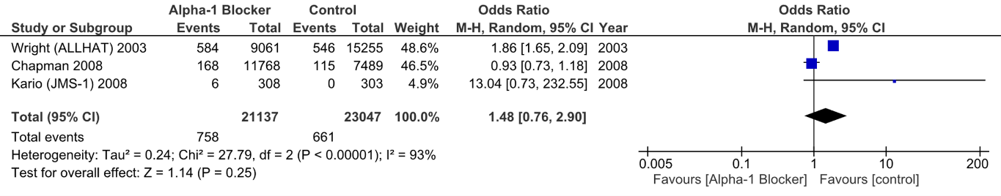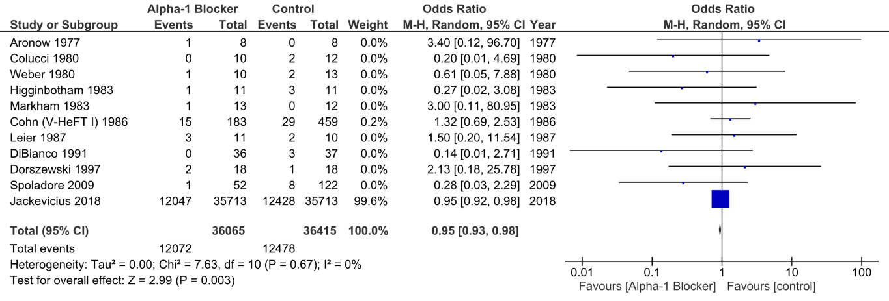
A
B
Appendix II – AHF events – All study designs: A – CHF patients; B – AHT patients. AHF, acute heart failure; CHF, chronic heart failure; AHT, arterial hypertension.
Note: In the retrospective cohort by Spoladore and co-workers³⁵, there were two deaths attributed to and nine readmissions explained by AHF, even though it was not clearly stated that the two deceased patients were, in fact, included in the rehospitalized subgroup. We assumed, for analysis purposes, that these two patients were, indeed, among those nine readmitted to hospital.

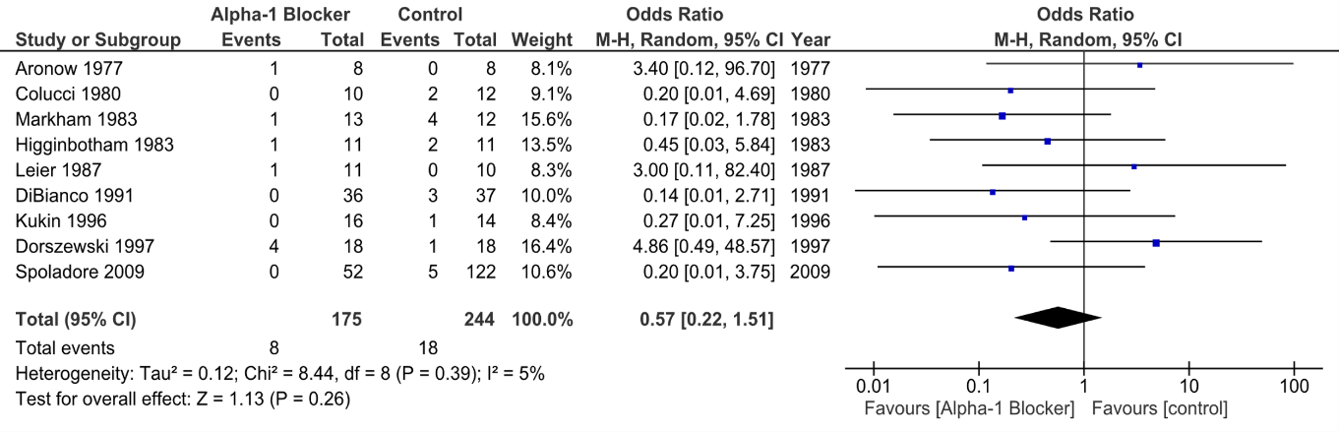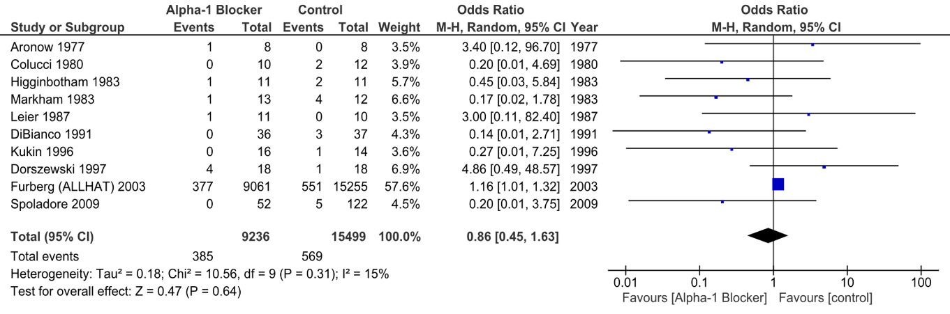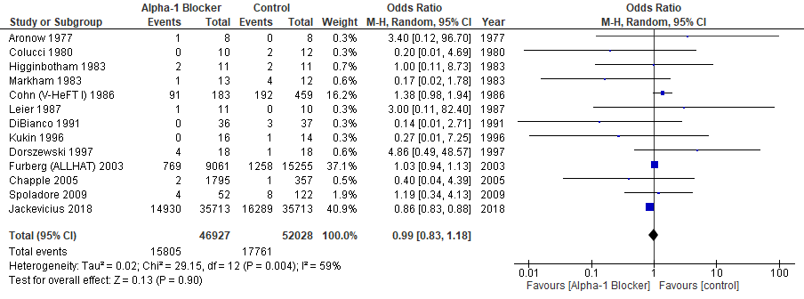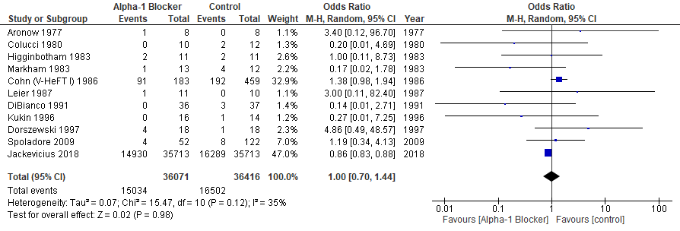
C
D
A
B
Appendix III – Mortality – All study designs: All-cause mortality: A – Unselected patients; B – CHF patients; CV mortality: C – Unselected patients; D – CHF patients. CHF, chronic heart failure; CV, cardiovascular.
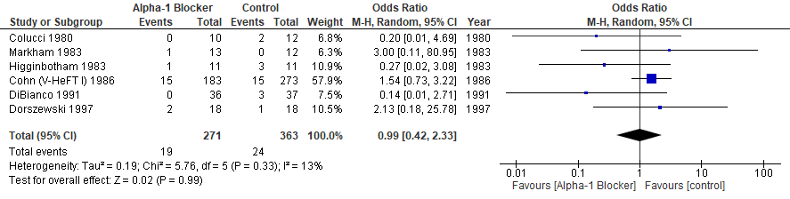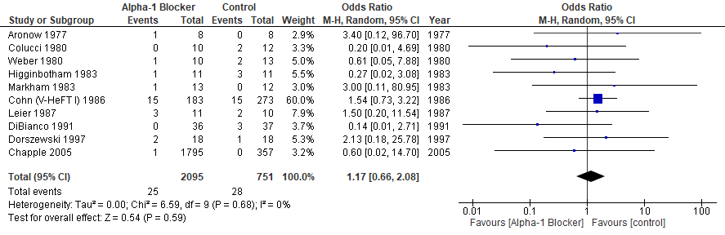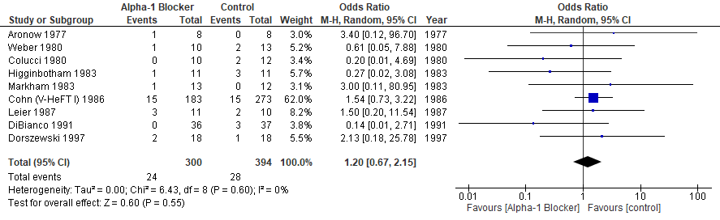
A
B
C
Appendix IV – AHF events – Placebo-controlled design: A – Unselected patients; B – CHF patients; C – HFrEF patients. AHF, acute heart failure; CHF, chronic heart failure; HFrEF, heart failure with reduced ejection fraction.
Note: In these sub-analyses, the patients under hydralazine and isosorbide dinitrate in the V-HeFT I⁹ study were excluded.

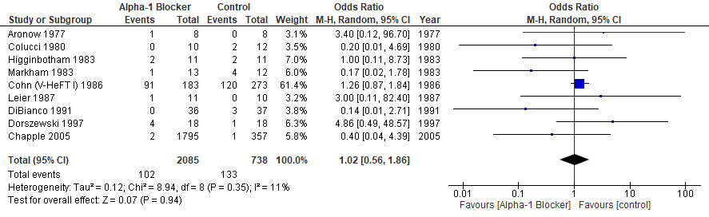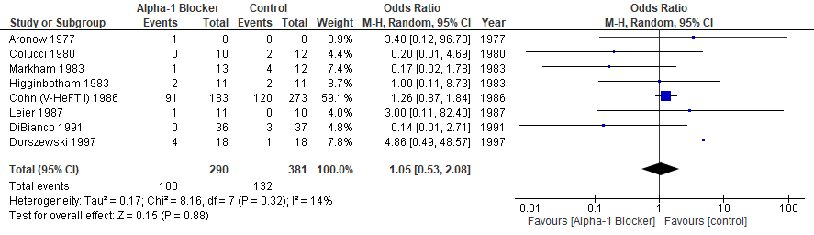
A
B
Appendix V – All-cause mortality – Placebo-controlled design: A – Unselected patients; B – CHF patients CHF, chronic heart failure.

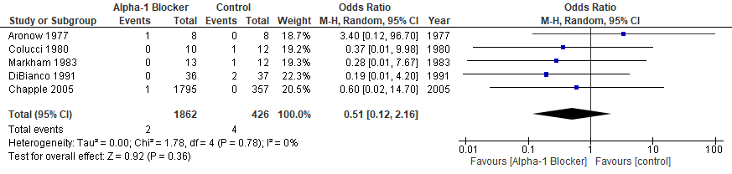
Appendix VI – ACS events – Placebo-controlled design: Unselected patients ACS, acute coronary syndrome.

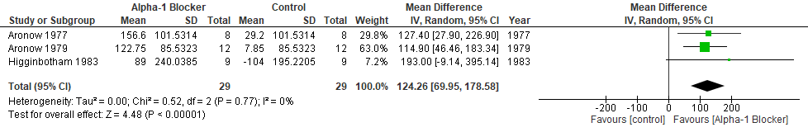
Appendix VII – ED change from baseline – Placebo-controlled design: Unselected patients. ED, exercise duration.

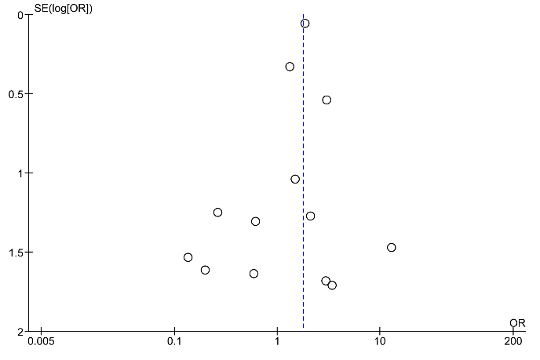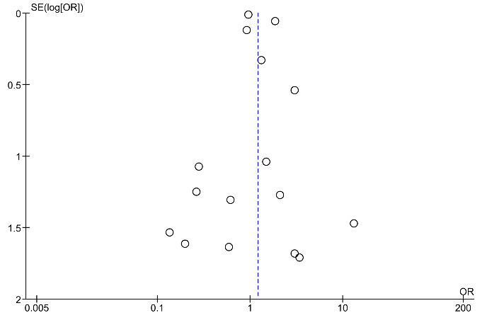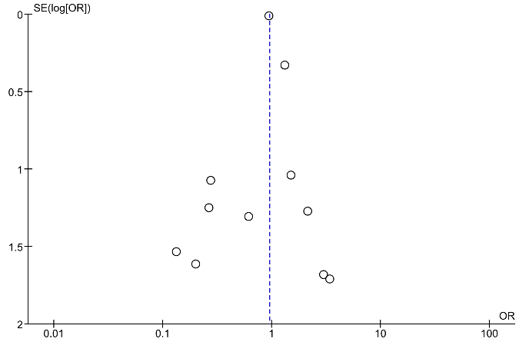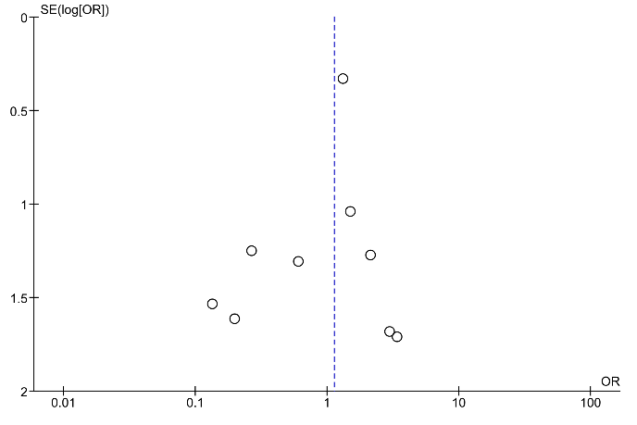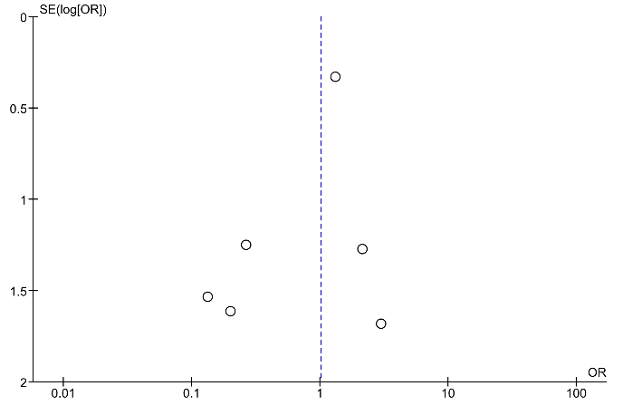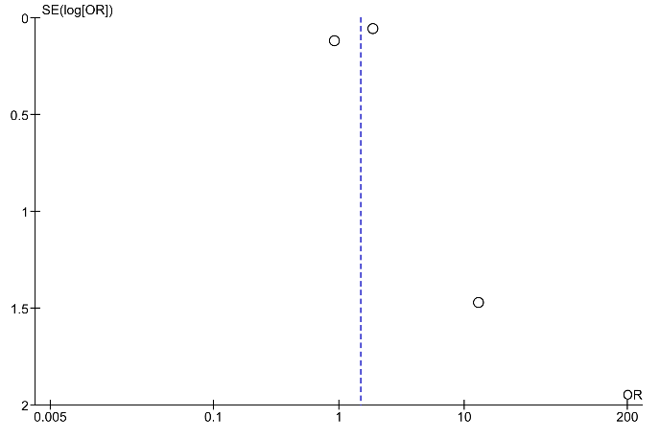
A1
A2
B1
B2
C
D
Appendix VIII – AHF events – Funnel plot: Unselected patients (A): A1 – All study designs, A2 – RCTs; CHF patients (B): B1 – All study designs, B2 – RCTs; HFrEF patients (C) – RCTs; AHT patients (D) – All study designs. AHF, acute heart failure; RCTs, randomized controlled trials; CHF, chronic heart failure; HFrEF, heart failure with reduced ejection fraction; AHT, arterial hypertension.

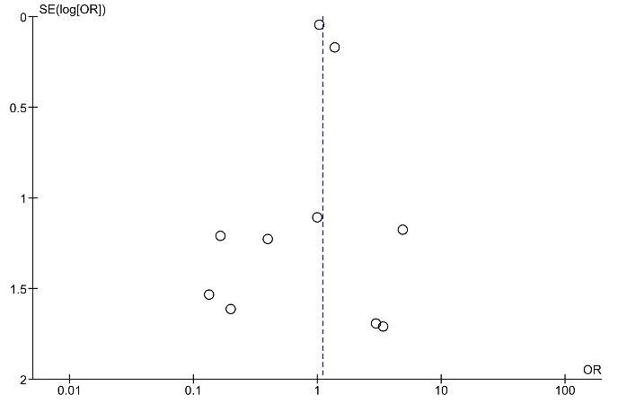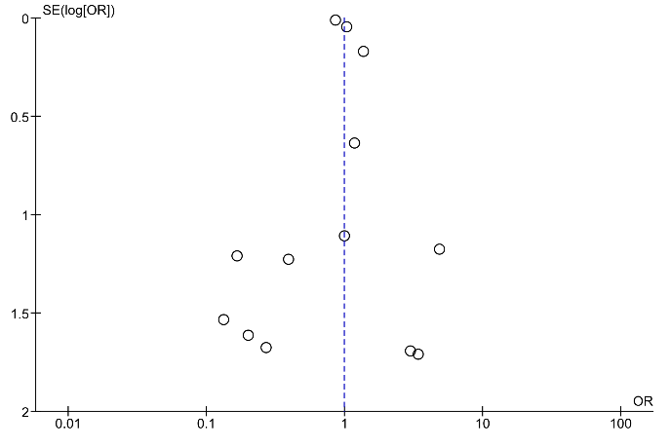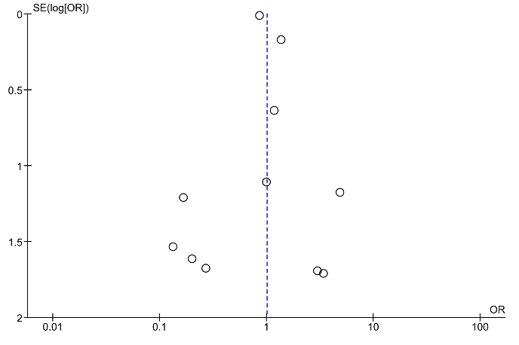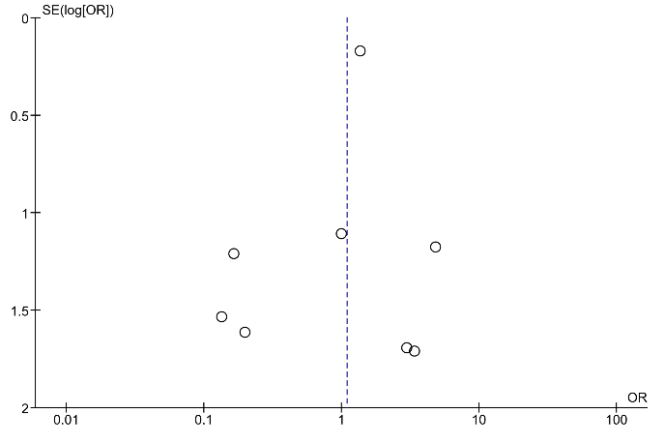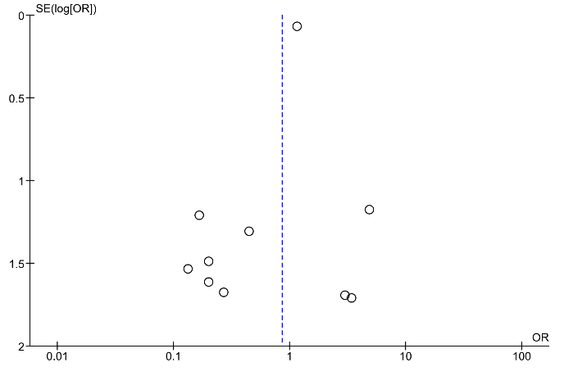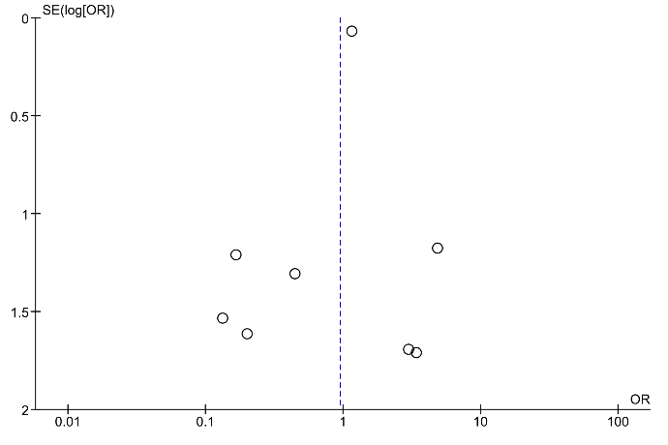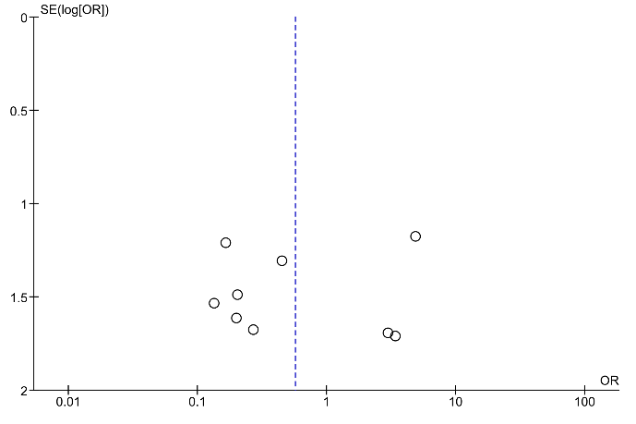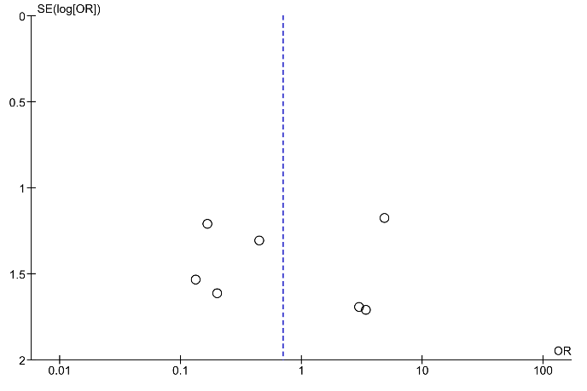
A1
A2
B1
B2
C1
C2
D1
D2
Appendix IX – Mortality – Funnel plot: All-cause mortality – Unselected patients (A): A1 – All study designs, A2 – RCTs; CHF patients (B): B1 – All study designs, B2 – RCTs; CV mortality – Unselected patients (C): C1 – All study designs; C2 – RCTs; CHF patients (D): D1 – All study designs, D2 – RCTs. RCTs, randomized controlled trials; CHF, chronic heart failure; CV, cardiovascular.
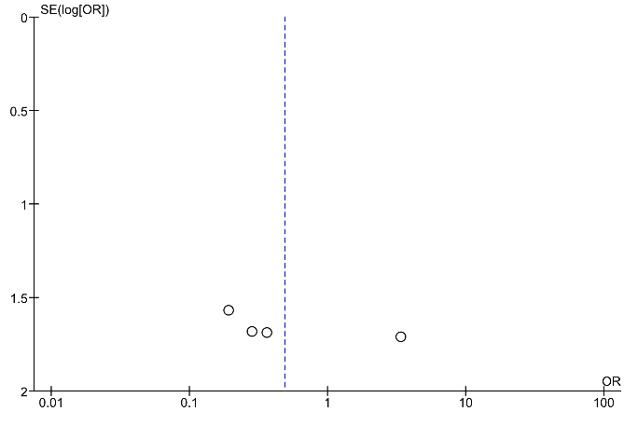
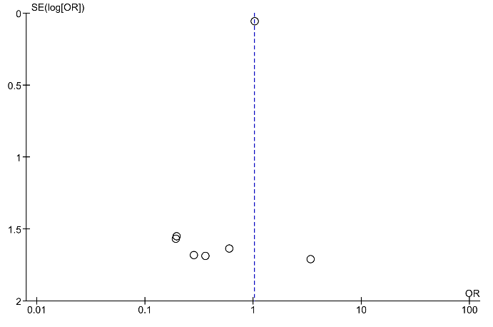
A
B

Appendix X – ACS events – Funnel plot: Unselected patients (A) - RCTs; CHF patients (B) – RCTs. ACS, acute coronary syndrome; RCTs, randomized controlled trials; CHF, chronic heart failure.

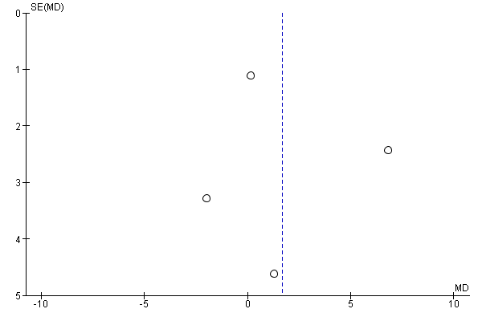

Appendix XI - LVEF change from baseline – Funnel plot: Unselected patients - All study designs. LVEF, left ventricular ejection fraction.

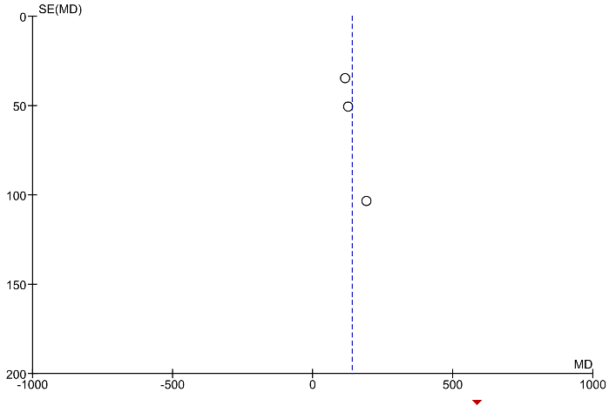
Appendix XII – ED change from baseline – Funnel plot: Unselected patients - All study designs. ED, exercise duration.

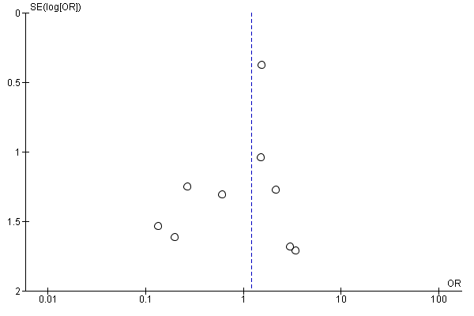
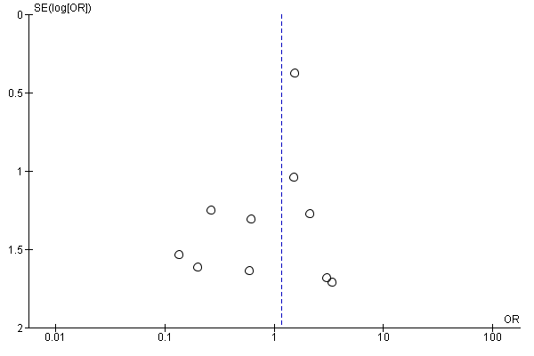
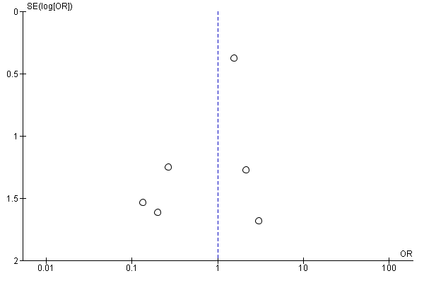
A
B
C

Appendix XIII – AHF events – Funnel plot: Placebo-controlled design: Unselected patients (A); CHF patients (B); HFrEF patients (C). AHF, acute heart failure; CHF, chronic heart failure; HFrEF, heart failure with reduced ejection fraction.

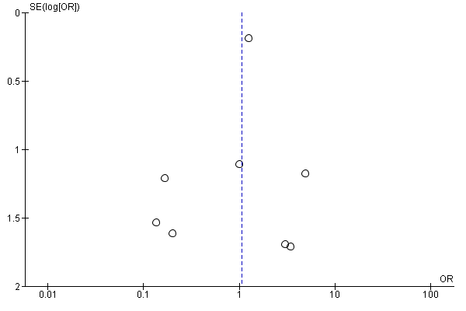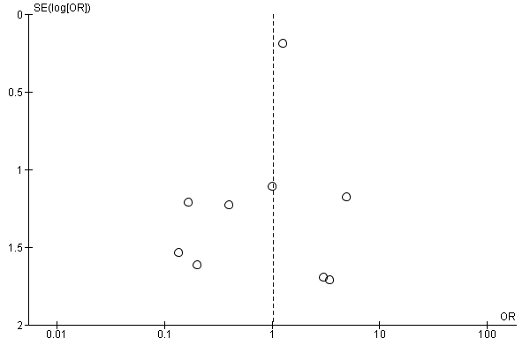
B
A
Appendix XIV – All-cause mortality – Funnel plot: Placebo-controlled design: Unselected patients (A); CHF patients (B). CHF, chronic heart failure.

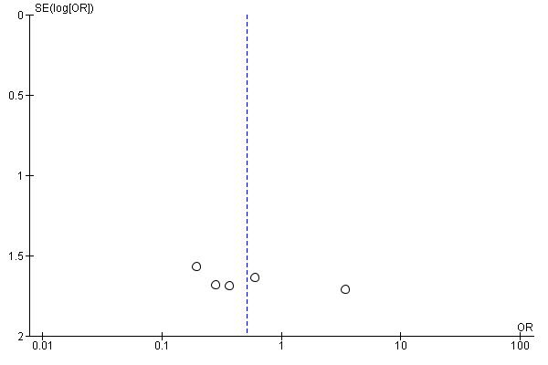
Appendix XV – ACS events – Funnel plot: Placebo-controlled design: Unselected patients. ACS, acute coronary syndrome.

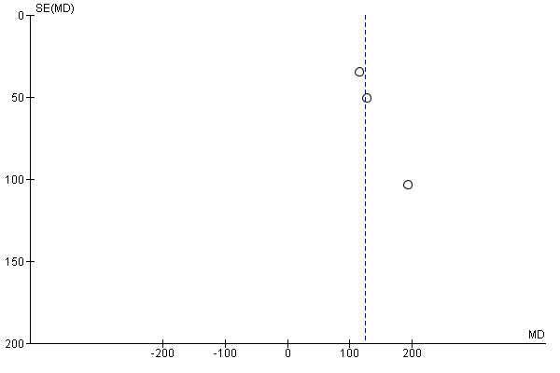
Appendix XVI – ED change from baseline – Funnel plot: Placebo-controlled design: Unselected patients. ED, exercise duration.

