ONLINE DATA SUPPLEMENT

Twenty-eight studies were selected for the systematic review and meta-analysis, based on Participant, Intervention, Comparison, Outcome Study (PICOs) and quality assessment criteria, as showed in the tables (e-tables 1 and 2).
Risk of bias was assessed by one reviewer (CB) using a scale adapted from the Newcastle-Ottawa Quality Assessment Scale for cohort studies to provide quality assessment of cross-sectional studies
Since all included studies were observational cohort studies without a non-exposed group, “non-respondents and “ascertainment of the exposure” domains were not assessed.
Accordingly, the scale ranged between 0 and 10. Satisfactory Studies were classified as 5-6 points and unsatisfactory studies as 0 to 4 points.

E-TABLES

e-table 1. New-Castle Ottawa scale for quality assessment of cross-sectional studies
Author | Selection |  |  |  | Comparability | Outcome |  | Number of Stars
 | Representativeness of the sample | Sample size | Non-respondents | Ascertainment of the exposure | Comparability | Assessment of outcome | Statistical test
Tschope [35] | * |  | NA | NA |  | * | * | 3
Borlaug [2] | * |  | NA | NA | * | * | * | 4
Maeder [30] | * |  | NA | NA |  | * | * | 3
Abudiab [12] | * |  | NA | NA | * | * | * | 4
Santos [27] | * |  | NA | NA | * | * | * | 4
Houstis [13] | * |  | NA | NA | * | * | * | 4
Obokata [14] | * |  | NA | NA | * | * | * | 4
Reddy [29] | * |  | NA | NA | * | * | * | 4
Nanayakkara [24] | * |  | NA | NA |  | * | * | 3
Eisman [3] | * |  | NA | NA | * | * | * | 4
McCabe [23] | * |  | NA | NA |  | * | * | 3
Platz [25] | * |  | NA | NA |  | * | * | 3
Obokata [16] | * |  | NA | NA | * | * | * | 4
Reddy [17] | * |  | NA | NA | * | * | * | 4
Van Empel [18] | * |  | NA | NA |  | * | * | 3
Wolsk [19] | * |  | NA | NA | * | * | * | 4
Telles [26] | * |  | NA | NA | * | * | * | 4
Sorimachi [32] | * |  | NA | NA | * | * | * | 4
Ahmad [33] | * |  | NA | NA | * | * | * | 4
Andersen [28] | * |  | NA | NA |  | * | * | 3
Gorter [15] | * |  | NA | NA |  | * | * | 3
Ho [4] | * |  | NA | NA | * | * | * | 4
Beale [21] | * |  | NA | NA |  | * | * | 3
Chen [22] | * |  | NA | NA | * | * | * | 4
Obokata [31] | * |  | NA | NA |  | * | * | 3
Fermoyle [20] | * |  | NA | NA |  | * | * | 3
Koepp [35] | * |  | NA | NA | * | * | * | 4

e-table 2. Participant, Intervention, Comparison, Outcome Study (PICOs)
Study | Participants | Intervention | Control | Outcomes | Study design
Tschope [34] | Patients with exertional symptoms undergo RHC at rest and during exercise | None | yes | NTproBNP and hemodynamics in HFpEF and controls | Cross-sectional
Borlaug [2] | Patients with exertional symptoms undergo RHC at rest and during exercise | None | yes | Exercise hemodynamics in HFpEF vs NCD | Cross-sectional
Maeder [30] | Patients with exertional symptoms undergo RHC at rest and during exercise | None | yes | Hemodynamics (including PAWP/Workload) and ex-echo in HFpEF vs controls | Cross-sectional
Abudiab [12] | Patients with exertional symptoms undergo RHC at rest and during exercise | None | yes | Hemodynamic and CPET in HFpEF vs controls | Cross-sectional
Santos [27] | Patients with exertional symptoms undergo RHC at rest and during exercise | None | yes | Hemodynamics and CPET in ePVH patients with peak VO2<80% vs controls | Cross-sectional
Houstis [13] | Patients with exertional symptoms undergo RHC at rest and during exercise | None | yes | CPET, O2 delivery and hemodynamics in HFpEF vs controls | Cross-sectional
Obokata [14] | Patients with exertional symptoms undergo RHC at rest and during exercise | None | yes | Echo, plasma volume, hemodynamics and NTproBNP in obese-HFpEF vs non-obese-HFpEF and non-obese controls | Cross-sectional
Reddy [29] | Patients with exertional symptoms undergo RHC at rest and during exercise | None | yes | Arterial properties and hemodynamics during exercise in HFpEF and hypertensive controls | Cross-sectional
Nanayakkara [24] | Patients with exertional symptoms undergo RHC at rest and during exercise | None | yes | Hemodynamics (including O2 delivery, PAWP/workload) in HFpEF older vs younger | Cross-sectional
Eisman [3] | Patients with exertional symptoms undergo RHC at rest and during exercise | None | yes | Hemodynamics (PAWP/CO slope) and cardiac death, incident resting PAWP  elevation, or heart failure hospitalization in HFpEF vs controls vs DOE-nlrW | Cross-sectional
McCabe [23] | Patients with exertional symptoms undergo RHC at rest and during exercise | None | yes | RV coupling and exercise hemodynamics in obese−ePVH, obese+ePVH and controls | Cross-sectional
Platz [25] | Patients with exertional symptoms undergo RHC at rest and during exercise | None | yes | Exercise hemodynamics and LUS | Cross-sectional
Obokata [16] | Patients with exertional symptoms undergo RHC at rest and during exercise | None | yes | CT-proET-1, MR-proADM, RV function and hemodynamics HFpEF vs controls | Cross-sectional
Reddy [17] | Patients with exertional symptoms undergo RHC at rest and during exercise | None | yes | LA strain reservoir and hemodynamics HFpEF vs NCD | Cross-sectional
Van Empel [18] | Patients with exertional symptoms undergo RHC at rest and during exercise | None | yes | transcardiac O2 gradient and hemodynamics HFpEF vs controls | Cross-sectional
Wolsk [19] | Patients with exertional symptoms undergo RHC at rest and during exercise | None | yes | hemodynamics HFpEF vs controls | Cross-sectional
Telles [26] | Patients with exertional symptoms undergo RHC at rest and during exercise | None | yes | Strain LA and hemodynamics HFpEF | Cross-sectional
Sorimachi [32] | Patients with exertional symptoms undergo RHC at rest and during exercise | None | yes | Visceral adipose tissue and hemodynamics in HFpEF men vs women | Cross-sectional
Ahmad [33] | Patients with exertional symptoms undergo RHC at rest and during exercise | None | yes | coronary  microvascular dysfunction and hemodynamics HFpEF vs controls | Cross-sectional
Andersen [28] | Patients with exertional symptoms undergo RHC at rest and during exercise | None | no | Exercise diastolic LV function and hemodynamics in pts with recent MI and LVEF ≥45%, | Cross-sectional
Gorter [15] | Patients with exertional symptoms undergo RHC at rest and during exercise | None | no | Hemodynamics, RV function and LVTMP in non-PH-HFpEF vs IpCPH vs CpCPH | Cross-sectional
Ho [4] | Patients with exertional symptoms undergo RHC at rest and during exercise | None | no | Combined endpoint of CV hospitalization  or death, HF hospitalization in HFpEF | Cross-sectional
Beale [21] | Patients with exertional symptoms undergo RHC at rest and during exercise | None | no | Exercise echo and hemodynamics in HFpEF women vs men | Cross-sectional
Chen [22] | Patients with exertional symptoms undergo RHC at rest and during exercise | None | no | Exercise echo (diastolic stress, test, LV GLS) and hemodynamics in HFpEF | Cross-sectional
Obokata [31] | Patients with exertional symptoms undergo RHC at rest and during exercise | None | no | Hemodynamics (including Qp) in HFpEF after IASD implant | Cross-sectional
Fermoyle [20] | Patients with exertional symptoms undergo RHC at rest and during exercise | None | no | Hemodynamics and CPET in HFpEF low vs high TPG | Cross-sectional
Koepp [35] | Patients with exertional symptoms undergo RHC at rest and during exercise | None | no | Hemodynamics and CPET in HFpEF EAT- vs EAT+ | Cross-sectional

Abbreviations. CO=cardiac output; CpCPH=combined post-capillary pulmonary hypertension; CPET=cardiopulmonary exercise test; CT-proET-1=C-terminal pro-endothelin-1; CV=cardiovascular; DOE-NIrW=dyspnea on exertion with normal resting PCWP and left ventricular ejection fraction; EAT=epicardial adipose tissue; EF= ejection fraction; EPVH=exercise pulmonary venous hypertension; GLS=global longitudinal strain; HFpEF=heart failure with preserved ejection fraction; IASD=interatrial shunt device; IpCPH=isolated post-capillary pulmonary hypertension; LA=left atrium; LUS=lung ultrasound; LV=left ventricle; LVTMP=left ventricular transmural pressure; MR-proADM=mid-regional pro-adrenomedullin; NCD=non cardiac dyspnea; NTproBNP= N-terminal pro b-type natriuretic peptide; PH=pulmonary hypertension; O2=oxygen; Qp=pulmonary blood flow; PAWP=pulmonary artery wedge pressure; RHC=right heart catheterization; RV=right ventricle; TPG=transpulmonary pressure gradient; VO2=oxygen consumption.

e-table 3. Clinical characteristics of heart failure with preserved ejection fraction cohorts as reported in individual studies.
Author | Year | N | Subgroups | Age, years | Female sex, % | BMI, Kg/m² | Obesity, % | HTN, % | DM, % | CAD, % | COPD, % | AF, % | Diuretics, % | Bblockers, % | ARBs  /ACEi, %
Tschope [35] | 2005 | 15 |  | 55±7 | 47 | 26.3±4.0 |  | 47 | 12 | 13
Borlaug [2] | 2010 | 32 |  | 65±13 | 72 | 35.0±5.9 | 56 | 72 | 16 |  |  | 6 | 53 | 44 | 38
Maeder [31] | 2010 | 14 |  | 69±10 | 36 | 29.6±4.6 |  |  | 14 |  |  |  | 29 | 36 | 57
Abudiab [13] | 2013 | 109 |  | 67±11 | 72 | 33.2±7.0 |  | 82 | 33 |  |  |  | 69 | 61
Andersen [29] | 2013 | 61 |  | 62±8 | 11 | 28.0±4.0 |  | 48 | 10 | 100 |  |  | 8 | 87 | 36
Santos [28] | 2015 | 31 |  | 65±12 | 26 | 32.5±5.5 |  | 77 | 29 | 45 |  | 23 | 65 | 61 | 55
Houstis [14] | 2017 | 79 |  | 62±11 | 44 | 30 (26-33) |  | 62 | 24 |  |  |  | 44 | 64 | 27
Obokata [15] | 2017 | 96 | BMI<30 | 70±10 | 64 | 40.8±5.6 |  |  | 15 |  |  | 19 | 49 | 58 | 37
Obokata [15] | 2017 | 99 | BMI≥35 | 65±11 | 64 | 26.0±2.7 |  |  | 33 |  |  | 8 | 53 | 52 | 49
Reddy [30] | 2017 | 98 |  | 68±10 | 56 | 34.1±7.9 |  | 98 | 31 | 35 |  |  | 43 | 58 | 59
Nanayakkara [25] | 2017 | 21 | Younger | 62±7.5 | 57 | 32.1±6.3
Nanayakkara [25] | 2017 | 19 | Older | 75±4.6 | 42 | 29.5±3.8
Eisman [3] | 2018 | 32 | Overt HFPEF | 67±13 | 59 | 32.2±7.1 |  | 66 | 34 |  |  |  | 72 | 56 | 42
Eisman [3] | 2018 | 45 | PAWP/CO>2 | 63±16 | 71 | 28.8±6.6 |  | 49 | 16 |  |  |  | 33 | 40 | 27
Gorter [16] | 2018 | 21 | No PH | 63±13 | 62 | 34±10 |  | 89 | 10 | 29 |  | 10 | 52 | 52 | 48
Gorter [16] | 2018 | 95 | IpcPH | 68±11 | 63 | 35±8 |  | 92 | 33 | 34 |  | 32 | 59 | 62 | 44
Gorter [16] | 2018 | 45 | CpcPH | 60±11 | 64 | 32±6 |  | 93 | 25 | 31 |  | 61 | 68 | 57 | 45
McCabe [24] | 2018 | 8 |  | 62±9 | 38 | 38.4±10.4 | 100 | 75 | 12 | 25 |  |  | 50 | 50 | 25
Platz [26] | 2018 | 13 |  | 70 (60-77) | 62 | 31 (27-36) |  | 77 | 25 | 15 | 15 | 50 | 62 |  | 31
Ho [4] | 2019 | 243 |  | 63±12 | 60 | 31.3±7.0 |  | 68 | 21 | 19 | 5 | 20 | 44 | 64 | 27
Obokata [17] | 2019 | 38 |  | 62±11 | 50 | 34.1±6.8 |  | 92 | 39 | 29 |  | 18 | 39 | 74 | 71
Reddy [18] | 2019 | 238 |  | 68±10 | 62 | 32.9±7.1 |  | 90 | 29 | 32 |  | 17 | 49 | 56 | 43
Van Empel [19] | 2019 | 9 |  | 74±6 |  | 29 (27-30) |  | 67 | 11 | 0
Wolsk [20] | 2019 | 108 |  | 70±8 | 59 | 34±7 |  |  | 43 |  | 15 | 42
Beale [22] | 2019 | 47 | Males | 68 (63-74) | 0 | 30 (28-33) |  | 72 | 20 |  | 9 | 45 | 24 | 48 | 56
Beale [22] | 2019 | 114 | Females | 71 (67-76) | 100 | 30 (27-34) |  | 76 | 12 |  | 11 | 37 | 31 | 53 | 72
Chen [23] | 2019 | 34 |  | 70±12 | 74 | 26.1±4.5 |  | 71 | 38 | 18 |  |  | 44 | 65 | 56
Telles [27] | 2019 | 49 |  | 69±8 | 71 | 30.2±5.0 | 51 | 67 | 14 | 14 | 14 | 26
Obokata [32] | 2019 | 79 |  | 70±8 | 59 | 33±6 |  | 81 | 38 |  |  | 41
Fermoyle [21] | 2020 | 30 |  | 69 (60-73) | 70 | 30.6±5.4
Sorimachi [33] | 2020 | 63 | Females | 64±14 | 100 | 32.5±7.9 |  | 70 | 22 |  |  | 27 | 44 | 52 | 37
Sorimachi [33] | 2020 | 42 | Males | 66±15 |  | 31.6±7.9 |  | 69 | 19 |  |  | 29 | 38 | 60 | 57
Ahmad [34] | 2020 | 22 |  | 60±10 | 68 | 31.1±5.7 |  | 55 | 27 |  |  | 9 | 9 | 55 | 18
Koepp [36] | 2020 | 92 | EAT- | 66±10 | 57 | 34.5±4.2 | 100% | 79 | 21 |  |  | 17 | 46 | 51 | 43
Koepp [36] | 2020 | 77 | EAT+ | 67±12 | 68 | 39.9±6.6 | 100% | 84 | 30 |  |  | 25 | 49 | 56 | 45

Abbreviations. ACEi=angiotensin-converting-enzyme inhibitors; AF= atrial fibrillation, ARBs=angiotensin II receptor blockers; BMI=body mass index; CAD=coronary artery disease; CO=cardiac output, COPD=chronic obstructive pulmonary disease, CPCPH=combined post-capillary pulmonary hypertension; DM= diabetes mellitus; HFpEF=heart failure with preserved ejection fraction, HTN=hypertension, IPCPH=isolated post-capillary pulmonary hypertension; OSAS=obstructive sleep apnea syndrome; PAWP=pulmonary artery wedge pressure; PH=pulmonary hypertension.

e-table 4. Clinical characteristics of control cohorts as reported in individual studies.
Author | Year | N | Subgroups | Age, years | Female Sex, % | BMI, kg/m2 | Obesity, % | HTN, % | DM, % | CAD, % | COPD, % | AF, % | OSAS, % | Diuretics, % | Bblockers, % | ACEi/ARBs, %
Tschope [35] | 2005 | 15 |  | 55±7 | 27 | 26.1±0.4 |  | 27 | 0 | 6
Borlaug [2] | 2010 | 23 |  | 47±17 | 45 | 27.3±5.5 | 40 | 57 | 22 |  |  | 9 |  | 35 | 35 | 30
Maeder [31] | 2010 | 8 |  | 61±12 | 37 | 25.0±5.1 |  |  | 0 |  |  |  |  | 0 | 0 | 0
Abudiab [13] | 2013 | 73 |  | 59±14 | 75 | 29.1±5.5 |  | 64 | 16
Santos [28] | 2015 | 31 |  | 65±12 | 26 | 28.8±6.2 |  | 56 | 13 | 19 |  | 19 |  | 33 | 26 | 19
Houstis [14] | 2017 | 55 |  | 61±11 | 55 | 29 (27-32) |  | 54 | 6 |  |  |  |  | 19 | 31 | 28
Obokata [15] | 2017 | 71 |  | 62±10 | 58 | 25.4±2.8 | 0 | 72 | 13 |  |  | 4 | 11 | 14 | 23 | 21
Reddy [30] | 2017 | 22 |  | 62±12 | 45 | 26.9±4.1 |  | 100 | 23 | 27 |  |  |  | 13 | 50 | 41
Eisman [3] | 2018 | 65 | PAWP/CO<2 | 52±16 | 58 | 28.9±6.8 |  | 46 | 8 |  |  |  |  | 22 | 30 | 28
Eisman [3] | 2018 | 33 |  | 49±18 | 64 | 25.9±4.3 |  | 21 | 3 |  |  |  |  | 3 | 9 | 15
McCabe [24] | 2018 | 8 | Obese | 51±9 | 38 | 37.0±4.3 | 100 | 25 | 13 | 13 |  |  |  | 13 | 13 | 25
McCabe [24] | 2018 | 6 | Non obese | 59±5 | 33 | 25.8±2.3 | 0 | 17 | 0 | 0 |  |  |  | 17 | 0 | 0
Platz [26] | 2018 | 12 |  | 62 (59-70) | 58 | 29 (25-34) |  | 92 | 17 | 17 | 33 | 8 | 17 | 33 |  | 75
Obokata [17] | 2019 | 20 |  | 62±11 | 50 | 27.5±4.8 |  | 90 | 20 | 20 |  | 10 |  | 15 | 40 | 50
Reddy [18] | 2019 | 125 |  | 58±14 | 56 | 28.4±5.5 |  | 71 | 16 | 22 |  | 0 |  | 24 | 30 | 26
Van Empel [19] | 2019 | 12 | Hypertensive | 62±3.5 |  | 32 (28-33) |  | 100 | 0 | 0
Van Empel [19] | 2019 | 7 | Normotensive | 54±5.3 |  | 24 (21-26) |  | 0 | 0 | 0
Wolsk [20] | 2019 | 42 |  | 59±11 | 52 | 25±3 |  |  | 0 |  | 0 | 0
Telles [27] | 2019 | 22 |  | 67±10 | 77 | 20.3±5.4 | 51 | 67 |  | 14 | 14 | 27
Sorimachi [33] | 2020 | 29 | Females | 64±14 | 100 | 31.1±7.5 |  | 54 | 14 |  |  | 3 |  | 8 | 40 | 13
Sorimachi [33] | 2020 | 22 | Males | 66±14 | 0 | 31.3±5.1 |  | 67 | 9 |  |  | 5 |  | 10 | 21 | 25
Ahmad [34] | 2020 | 29 |  | 54±10 | 76 | 28.6±6.3 |  | 52 | 7 |  |  | 4 |  | 10 | 35 | 14

Abbreviations. ACEi=angiotensin-converting-enzyme inhibitors; AF= atrial fibrillation, ARBs=angiotensin II receptor blockers; BMI=body mass index; CAD=coronary artery disease; CO=cardiac output, COPD=chronic obstructive pulmonary disease, CPCPH=combined post-capillary pulmonary hypertension; DM= diabetes mellitus; HTN=hypertension; IPCPH=isolated post-capillary pulmonary hypertension; OSAS=obstructive sleep apnea syndrome; PAWP=pulmonary artery wedge pressure; PH=pulmonary hypertension.
e-table 5. Clinical characteristics of patients with heart failure with preserved ejection fraction and control subjects across included studies. Data are reported as median (interquartile range).
 | HFpEF patients |  | Controls
 | Median (IQR) | Cohorts with missing data | Median (IQR) | Cohorts with missing data
Age, years | 66.67 (63.00-69.00) | 0 | 60.00 (54.08-62.00) | 0
Female sex, % | 61.00 (47.75-68.00) | 1 | 55.50 (37.75-64.25) | 2
BMI, Kg/m2 | 32.00 (30.00-33.60) | 0 | 27.85 (25.82-29.27) | 0
Hypertension, % | 75.55 (67.25-82.00) | 5 | 56.50 (41.25-71.25) | 2
Diabetes, % | 23.00 (14.75-31.50) | 3 | 9.00 (0.00-16.00) | 1
CAD, % | 29.00 (16.50-34.50) | 20 | 14.00 (3.00-19.50) | 11
Atrial fibrillation, % | 25.00 (17.00-36.80) | 14 | 5.00 (3.50-9.50) | 11
Obesity, % | 78.00 (52.25-100.00) | 29 | 44.50 (42.75-48.25) | 20
OSAS, % | 41.50 (25.25-57.00) | 29 | 14.00 (12.50-15.50) | 20
COPD, % | 12.70 (9.38-14.75) | 29 | 14.00 (7.00-23.50) | 19
Use of diuretics, % | 47.50 (38.25-53.00) | 9 | 14.50 (10.00-22.50) | 6
NTproBNP, ng/L | 340.00 (194.00-637.90) | 13 | 83.00 (61.00-100.00) | 9
Hb, g/dL | 12.50 (12.20-13.60) | 11 | 13.80 (13.15-14.10) | 7
LVM, g | 92.00 (89.00-95.00) | 19 | 86.00 (81.25-89.75) | 14
LAVI, ml/m2 | 39.00 (34.10-41.50) | 18 | 29.00 (24.00-29.00) | 11
E/E’ | 12.90 (11.50-14.00) | 12 | 9.00 (8.03-9.45) | 8
LVEF, % | 63.00 (61.00-63.50) | 7 | 62.00 (61.10 – 63.00) | 4

Abbreviations. IQR= interquartile range; BMI=body mass index; CAD=coronary artery disease; COPD=chronic obstructive pulmonary disease; Hb=hemoglobin; HfpEF= heart failure with preserved ejection fraction; LAVI=left atrial volume indexed; LVM=left ventricular mass; LVEF= left ventricular ejection fraction; NTproBNP= N-terminal pro b-type natriuretic peptide; OSAS= obstructive sleep apnea syndrome.
e-table 6. Rest and exercise hemodynamics of heart failure with preserved ejection fraction cohorts in supine position as reported in individual studies
Author | Year | N | PAWP rest, mmHg | PAWP peak, mmHg | CO rest, L/min | CO peak, L/min | CI rest, L/min/m2 | CI peak, L/min/m2 | RAP rest, mmHg | RAP peak, mmHg
Tschope [35] | 2005 | 15 | 7±2 | 24±8
Borlaug [2] | 2010 | 32 | 11±2 | 32±6 |  |  | 2.8±0.6 | 4.9±1.0 | 5±2 | 15±4
Maeder [31] | 2010 | 14 | 10±4 | 23±6 |  |  | 2.6±0.5 | 4.6±16 | 5±3
Abudiab [13] | 2013 | 109 | 16±6 | 33±8 | 5.4±1.7 | 9.2±2.8 | 2.6±0.8 | 4.4±1.2 | 9±4
Andersen [29] | 2013 | 61 | 13±4 | 33±8 |  |  | 2.7±0.5 | 7.8±1.4 | 7±2 | 14±5
Obokata [15] | 2017 | 96 | 15±5 | 30±5 |  |  | 2.6±0,6 | 4.2±1.3 | 8±3 | 17±6
Obokata [15] | 2017 | 99 | 17±6 | 33±7 |  |  | 2.6±0,6 | 4.3±1.3 | 11±5 | 21±7
Reddy [30] | 2017 | 98 | 18±6 | 34±7 |  | 8.4±2.9 | 2.5±0.6 |  | 11±5 | 22±6
Nanayakkara [25] | 2017 | 21 | 12±5 | 27±6 | 5.8±1.1 | 10.1±3.3 | 2.9±0.5 | 5.0±1.4
Nanayakkara [25] | 2017 | 19 | 13±5 | 30±7 | 4.8±1.2 | 8.5±3.0 | 2.5±0.4 | 4.4±1.6
Gorter [16] | 2018 | 21 | 18±4 | 30±5 |  |  | 2.6±0.7 | 4.7±1.4 | 10±4 | 17±6
Gorter [16] | 2018 | 95 | 21±5 | 34±6 |  |  | 2.7±0.6 | 3.9±1.1 | 12±4 | 22±6
Gorter [16] | 2018 | 45 | 20±4 | 32±7 |  |  | 2.2±0.6 | 3.2±1.0 | 13±5 | 26±8
Obokata [17] | 2019 | 38 | 18±6 | 34±6 | 5.0±1.2 | 7.7±2.4 |  |  | 11±4 | 23±6
Reddy [18] | 2019 | 238 | 16±6 | 32±6 | 5.2±1.4 | 8.3±2.9 |  |  | 10±4 | 19±8
Van Empel [19] | 2019 | 9 | 14±6 | 32±6 |  |  | 2,6±0,6 | 4,3±1,5
Wolsk [20] | 2019 | 108 | 19±6 | 35±7 | 5.6±2.0 | 9±3 | 2.8±0.8 | 4.3±2.0 | 5±2 | 19±5,5
Beale [22] | 2019 | 47 | 15±5 | 30 (27-33) |  |  | 2.5 (2.2-2.9) | 4.6 (3.4-5.9) | 6 (6-10) | 17 (13-19)
Beale [22] | 2019 | 114 | 14±5 | 30 (27-34) |  |  | 2.6 (2.3-3.0) | 4.3 (3.7-5.0) | 7 (6-9) | 16 (12-19)
Chen [23] | 2019 | 34 | 18±7 | 29±9 | 5.3±2.2 | 9.5±4.0 |  |  | 9±4 | 15±6
Telles [27] | 2019 | 49 | 15±5 | 40±5 | 4.9±1.2 | 8.5±2.8 | 2.5±0.6 | 4.5±2.3 | 8±3 | 19±10
Obokata [32] | 2019 | 79 | 18±6 | 34±7 | 5.3±1.7 | 8.6±2.8 |  |  | 9±3 | 19±5
Fermoyle [21] | 2020 | 30 | 13 (11-16) | 24±10 | 6.0±2.7 | 10.0±3.1 | 3.0±1.1 | 5.2±1.4
Sorimachi [33] | 2020 | 63 | 16±5 | 31±7 |  |  |  |  | 10±5 | 19±8
Sorimachi [33] | 2020 | 42 | 16±5 | 29±5 |  |  |  |  | 10±4 | 20±5
Ahmad [34] | 2020 | 22 | 13±3 | 28±4
Koepp [36] | 2020 | 92 | 15±5 | 31±6 |  |  | 2.5±0.6 | 4.2±1.3 | 9±4 | 19±6
Koepp [36] | 2020 | 77 | 18±7 | 34±7 |  |  | 2.6±0.7 | 4.1±1.4 | 11±5 | 22±9

Abbreviations. CI=cardiac index; CO=cardiac output; N= number of patients; PAWP=pulmonary artery wedge pressure; RAP=right atrial pressure.
e-table 7. Rest and exercise hemodynamics of control cohorts in supine position as reported in individual studies
Author | Year | N | PAWP rest, mmHg | PAWP peak, mmHg | CO rest, L/min | CO peak, L/min | CI rest, L/min/m2 | CI peak, L/min/m2 | RAP rest, mmHg | RAP peak, mmHg
Tschope [35] | 2005 | 15 | 6±2 | 14±5
Borlaug [2] | 2010 | 23 | 9±3 | 13±5 |  |  | 3.2±0.8 | 6.7±1.4 | 4±2 | 6±3
Maeder [31] | 2010 | 8 | 10±4 | 20±7 |  |  | 3.5±1 | 7.4±1.4 | 5±3
Abudiab [13] | 2013 | 73 | 9±3 | 14±4 | 5.4±1.4 | 12.5±2.8 | 2.8±0.7 | 6.4±1.3 | 4±2
Obokata [15] | 2017 | 71 | 8±3 | 15±5 |  |  | 2.7±0.7 | 5.3±1.6 | 4±2 | 8±4
Reddy [30] | 2017 | 22 | 8±3 | 14±5 |  | 12.0±4.0 | 2.7±0.8 |  | 4±9 | 9±3
Obokata [17] | 2019 | 20 | 8±3 | 15±5 | 5.3±1.9 | 8.2±1.9 |  |  | 4±2 | 8±4
Reddy [18] | 2019 | 125 | 9±3 | 14±5 | 5.5±1.6 | 10.3±4.0 |  |  | 5±2 | 8±4
Van Empel [19] | 2019 | 12 | 9±4 | 17±4 |  |  | 2.8±0.7 | 6.7±2.1
Van Empel [19] | 2019 | 7 | 8±3 | 16±5 |  |  | 2.9±0.5 | 7.2±0.8
Wolsk [20] | 2019 | 42 | 9±3 | 21±8 | 5.1±1.0 | 16.0±3.0 | 2.7±0.4 | 8.4±1.3 | 5±2 | 10±5
Telles [27] | 2019 | 22 | 8±3 | 17±5 | 5.1±1.3 | 10.4±2.5 | 2.7±0.6 | 5.5±1.2 | 4±3 | 10±5
Sorimachi [33] | 2020 | 29 | 9±3 | 13±5 |  |  |  |  | 5±2 | 8±4
Sorimachi [33] | 2020 | 22 | 9±3 | 16±5 |  |  |  |  | 6±3 | 11±4
Ahmad [34] | 2020 | 29 | 10±2 | 18±4

Abbreviations. CI=cardiac index; CO=cardiac output; N= number of patients; PAWP=pulmonary artery wedge pressure; RAP=right atrial pressure.

e-table 8. Rest and exercise hemodynamics of heart failure with preserved ejection fraction cohorts in upright position as reported in individual studies
Author | Year | N | PAWP rest, mmHg | PAWP peak, mmHg | CO rest, L/min | CO peak, L/min | CI rest, L/min/m2 | CI peak, L/min/m2 | RAP rest, mmHg | RAP peak, mmHg
Santos [28] | 2015 | 31 | 15±5 | 27 (23-30) | 4.6±1.7 | 11.0±4.0 | 2.7±0.6 | 5.1±4.0 | 8±4 | 13±6
Houstis [14] | 2017 | 79 | 16 (12-19) | 26 (24-31) |  | 10.0±3.1
Eisman [3] | 2018 | 35 | 20±3 |  | 4.5±1.2 | 10.1±2.8 |  |  | 4±2 | 14±6
Eisman [3] | 2018 | 45 | 10±3 | 25±8 | 4.8±1.3 | 10.4±2.7 |  |  | 1±2 | 10±4
McCabe [24] | 2018 | 8 | 11±2 | 26±5 | 5.9±2.3 | 13.2±2.7 |  |  | 6±2 | 16±5
Platz [26] | 2018 | 13 | 10 (9-18) | 24 (19-28) | 4.3 (3.5-6.7) | 9.5 (7.9-12.5) |  |  | 10 (8-12) | 10 (7-13)
Ho [4] | 2019 | 243 | 15±6 | 25±7 | 5.0±1.6 | 10.7±3.3

Abbreviations. CI=cardiac index; CO=cardiac output; N= number of patients; PAWP=pulmonary artery wedge pressure; RAP=right atrial pressure.

e-table 9. Rest and exercise hemodynamics of control cohorts in upright position as reported in individual studies
Author | Year | N | PAWP rest, mmHg | PAWP peak, mmHg | CO rest, L/min | CO peak, L/min | CI rest, L/min/m2 | CI peak, L/min/m2 | RAP rest, mmHg | RAP peak, mmHg
Santos [28] | 2015 | 31 | 12±5 | 15 (12-20) | 4.8±1.4 | 15±4 | 2.8±0.5 | 7.2±1.8 | 6±3 | 8±7
Houstis [14] | 2017 | 55 | 11 (9-12) | 22 (16-28) |  | 14.0±3.6
Eisman [3] | 2018 | 65 | 10±3 | 18±6 | 5.4±1.8 | 13.3±3.4 |  |  | 1±2 | 8±5
Eisman [3] | 2018 | 33 | 9±3 |  | 5.9±1.3 | 15.1±3.0 |  |  | 2±2 | 8±3
McCabe [24] | 2018 | 8 | 11±2 | 15±4 | 6.6±1.5 | 17.1±4.2 |  |  | 6±4 | 10±3
McCabe [24] | 2018 | 6 | 7±3 | 13±2 | 5.6±1.1 | 17.0±1.8 |  |  | 1±1 | 6±2
Platz [26] | 2018 | 12 | 7 (6-9) | 14 (10-16) | 5.7 (4.5-6.7) | 11.9 (10.8-13.3) |  |  | 4 (3-6) | 6 (5-8)

Abbreviations. CI=cardiac index; CO=cardiac output; N= number of patients; PAWP=pulmonary artery wedge pressure; RAP=right atrial pressure.

e-table 10.

 | HFpEF |  | Controls |  |  |  |  | Unadjusted meta-regression models |  |  | Adjusted meta-regression models
Outcome | Mean (95% CI) | N estimate | Mean (95% CI) | N estimate | N estimate tot |  | P-value |  | N estimate | P-value |  | N estimate
REST
PAWP, mmHg | 14.23 (12.04-16.42) | 9 | 8.41 (7.47-9.35) | 8 | 17 |  | <0.0001 |  | 17 | 0,3832 |  | 17
CO, L/min | 5.17 (4.94-5.40) | 5 | 5.31 (5.03-5.60) | 6 | 11 |  | 0,4721 |  | 11 | 0,1519 |  | 11
CI, L/min/m2 | 2.61 (2.44-2.78) | 4 | 2.68 (2.39-2.96) | 4 | 8 |  | 0,6787 |  | 8 | 0,0655 |  | 8
RAP, mmHg | 7.74 (6.29-9.19) | 7 | 3.99 (2.43-5.54) | 7 | 14 |  | <0.0001 |  | 14 | 0,5103 |  | 14
PEAK
PAWP, mmHg | 30.14 (27.74-32.54) | 9 | 16.84 (14.78-18.90) | 7 | 16 |  | <0.0001 |  | 16 | 0,0003 |  | 16
CO, L/min | 9.45 (8.34-10.57) | 5 | 13.33 (11.26-15.41) | 6 | 11 |  | 0,0017 |  | 11 | 0,8988 |  | 11
CI, L/min/m² | 5.23 (4.01-6.45) | 5 | 7.12 (5.65-8.59) | 4 | 9 |  | 0,0422 |  | 9 | 0,6776 |  | 9
RAP, mmHg | 16.65 (14.98-18.32) | 7 | 8.43 (7.77-9.08) | 6 | 13 |  | <0.0001 |  | 13 | 0,0093 |  | 13
DELTA PEAK-REST
PAWP, mmHg | 15.71 (13.71-17.71) | 9 | 8.58 (6.61-10.55) | 7 | 16 |  | <0.0001 |  | 16 | <0.0001 |  | 16
CO, L/min | 4.32 (3.07-5.58) | 5 | 8.04 (5.93-10.14) | 6 | 11 |  | 0,0046 |  | 11 | 0,9868 |  | 11

Abbreviations. 95% CI=95% of the confidence interval; CI=cardiac index; CO=cardiac output; HFpEF=heart failure with preserved ejection fraction; N=number; PAWP=pulmonary artery wedge pressure; RAP=right atrial pressure. Adjustment was performed using meta-regression models including age, sex, body mass index and body position as covariates.

E-FIGURES

e-figure 1. Forest plots with pooled standardized mean pulmonary artery wedge pressure values at rest both in heart failure with preserved ejection fraction and in controls.
Abbreviations. HFpEF=heart failure with preserved ejection fraction; PAWP=pulmonary artery wedge pressure.

e-figure 2. Forest plots with pooled standardized mean PAWP values at rest in patients with HFpEF, stratified by HFpEF definitions and body position.
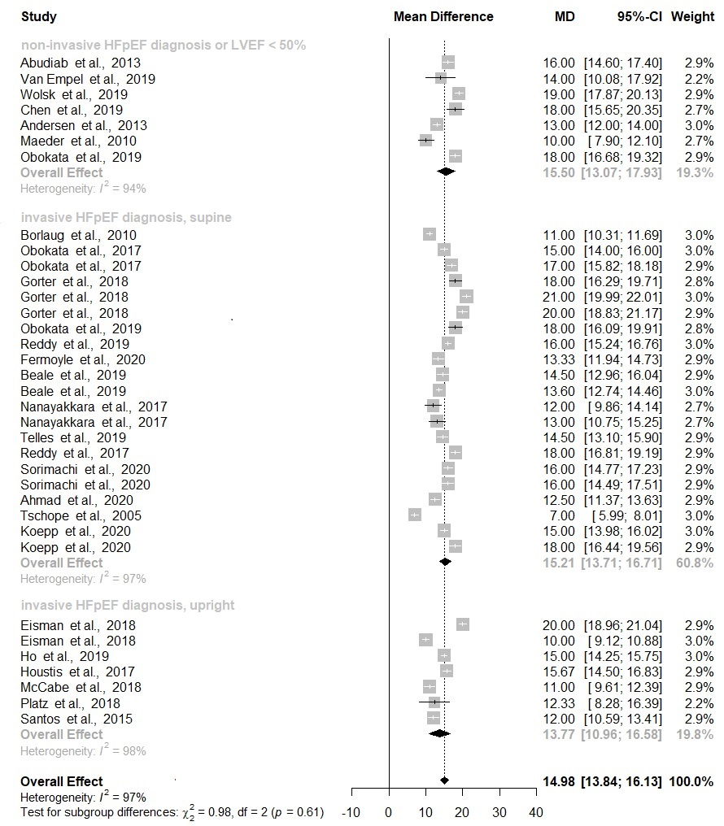Abbreviations. HFpEF=heart failure with preserved ejection fraction; LVEF=left ventricular ejection fraction; PAWP=pulmonary artery wedge pressure.
e-figure 3. Forest plots with pooled standardized mean PAWP values at peak exercise in patients with HFpEF, stratified by HFpEF definitions and body position.
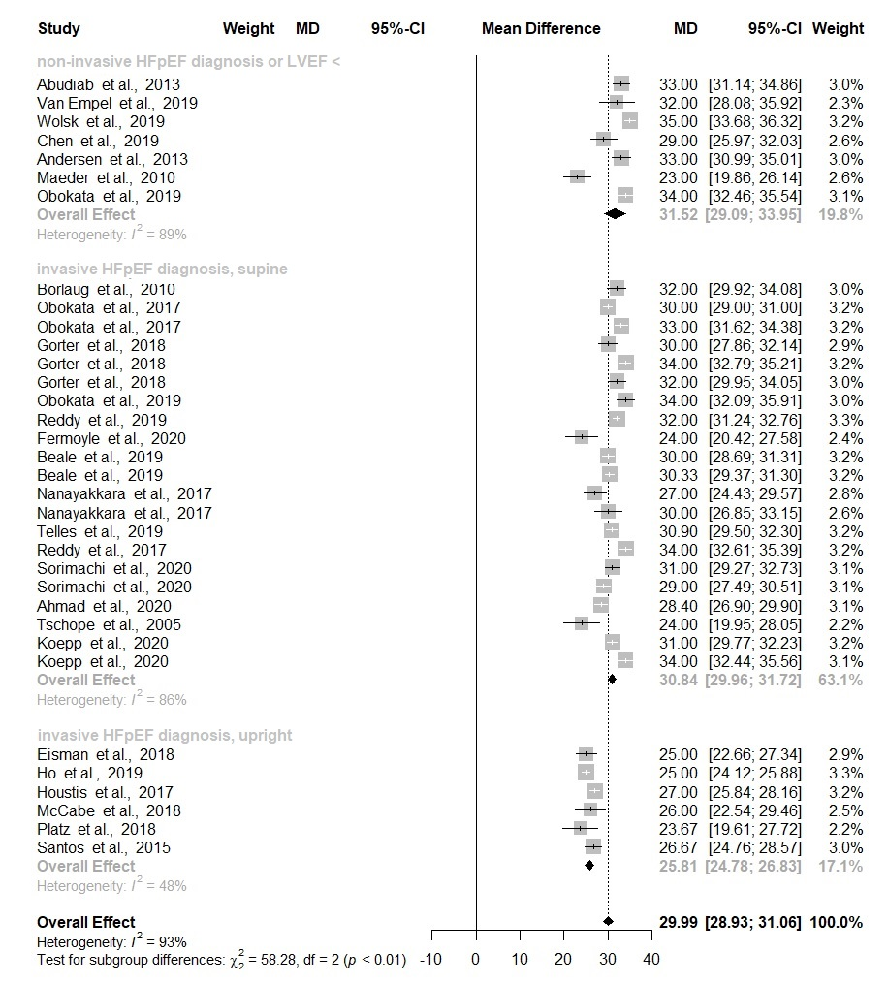
Abbreviations. HFpEF=heart failure with preserved ejection fraction; LVEF=left ventricular ejection fraction; PAWP=pulmonary artery wedge pressure.

e-figure 4. Pulmonary artery wedge pressure (PAWP) / cardiac output (CO) regression slopes in cohorts of patients with heart failure and preserved ejection fraction (HFpEF) and in control subjects cohorts, stratified by body position. The panel on the top represents the mean PAWP/CO slope of cohorts (both HFpEF and control subjects) studied in the supine position. The panel on the bottom represents the mean PAWP/CO slope of cohorts (both HFpEF and control subjects) studied in the upright position. In both panels the red line represents the proposed normative PAWP/CO slope value of 2 mmHg/L/min.

