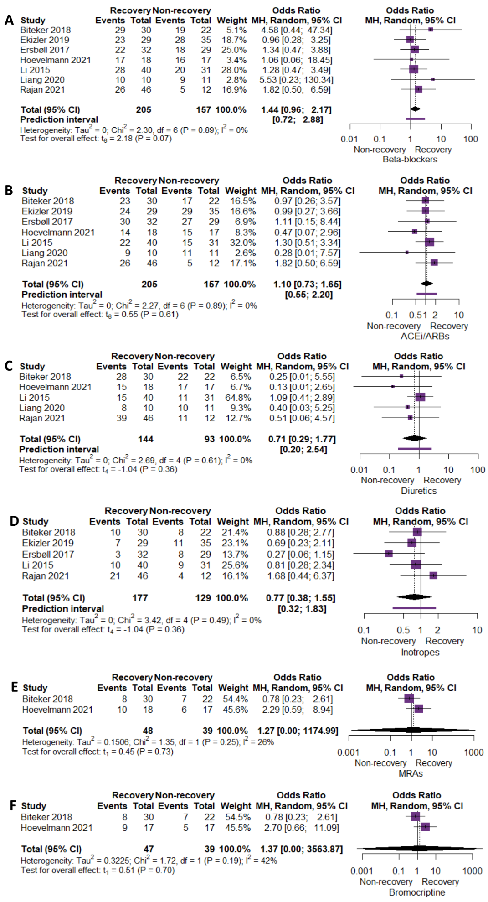
Supporting Information – Figure-S1: The comparison of baseline treatment between recovery and non-recovery group (A: β-blockers, B: Renin-angiotensin system inhibitors, C: Diuretics, D: Inotropes, E: Mineralocorticoid receptor antagonists, F: Bromocriptine) (ACEi: angiotensin converting enzyme inhibitors, ARBs: angiotensin receptor blockers, MRAs: mineralocorticoid receptor antagonists)
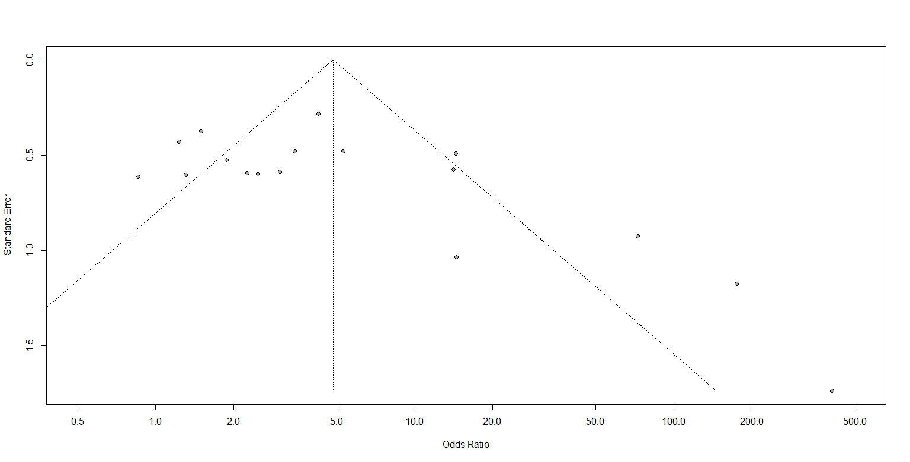
Supporting Information – Figure-S2: Odds ratio of LVEF funnel plot analysis

