Supplementary Material 1 Electronic database Search Strategy from inception up to June 2022
Database | Terms used | Hits
PubMed | ((((((Vitamin D[MeSH Terms]) OR (Vitamin D Deficiency[MeSH Terms])) OR (Cholecalciferol[MeSH Terms])) OR (Ergocalciferols[MeSH Terms])) OR (Calcifediol[MeSH Terms])) OR (25-Hydroxyvitamin D 2[MeSH Terms])) AND ((Malaysia[MeSH Terms]) OR (Malaysia[Text Word])) | 75
Scopus | (TITLE ( "Vitamin D" OR "Vitamin D Deficiency" OR "Cholecalciferol" OR "Ergocalciferols" OR "Calcifediol" OR "25-Hydroxyvitamin D 2" ) AND TITLE-ABS-KEY ( Malaysia OR Perlis OR Kedah OR Perak OR Selangor OR "Kuala Lumpur" OR Putrajaya OR Melaka OR "Negeri Sembilan" OR Johor OR Pahang OR Kelantan OR Terengganu OR Sabah OR Sarawak OR Labuan ) ) | 85
Web of Science (WoS) | ts = (" vitamin D" AND "Malaysia") | 107
MyJurnal  www.myjurnal.my | Vitamin D only | 32

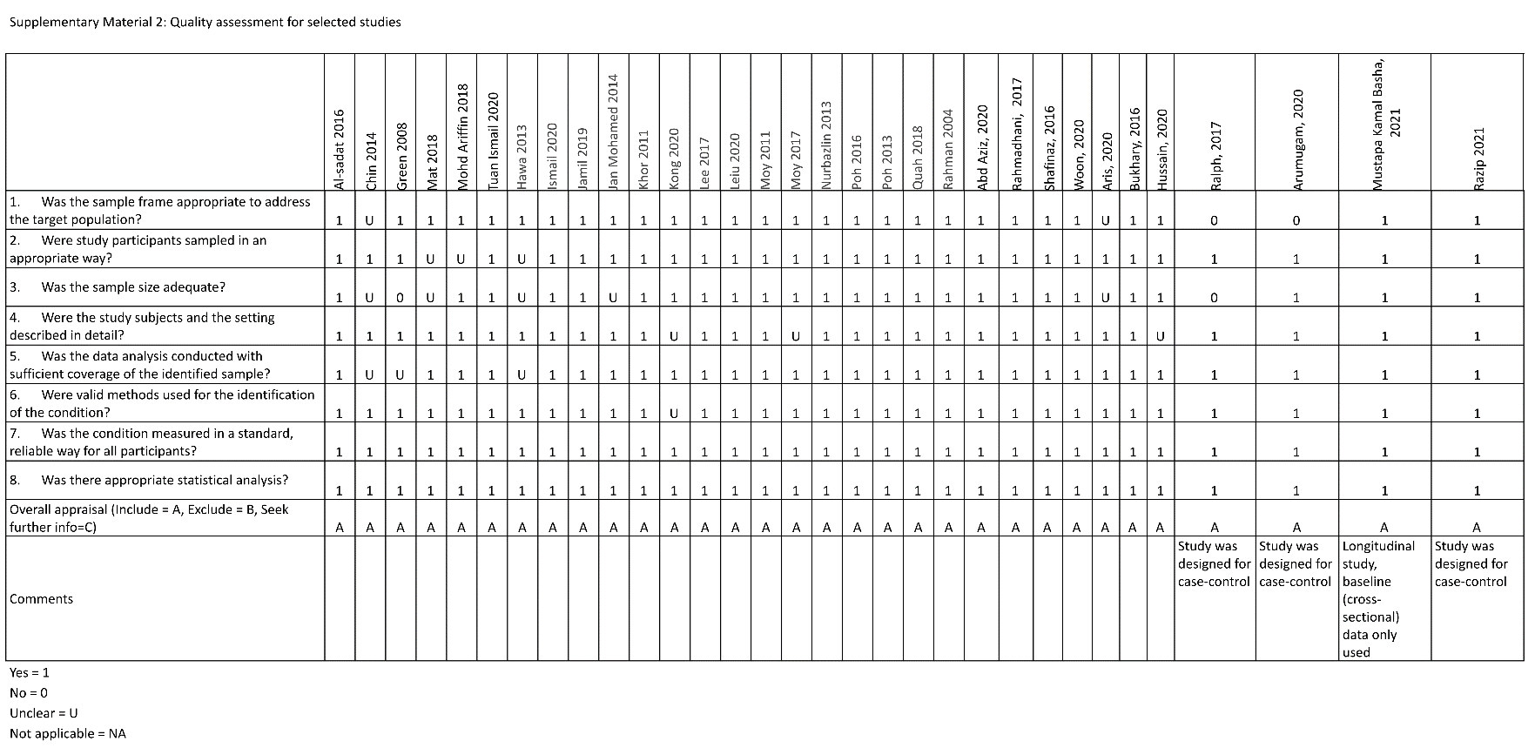

Supplementary Material 3. Pooled proportion of 25-hydroxyvitamin D level <50 nmol/L for urban individuals
Supplementary Material 4. Pooled proportion of 25-hydroxyvitamin D level <50 nmol/L for rural individuals

Supplementary Material 5. Pooled proportion of 25-hydroxyvitamin D level <50 nmol/L for females

Supplementary Material 6. Pooled proportion of 25-hydroxyvitamin D level <50 nmol/L for males

Supplementary Material 7. Pooled proportion of 25-hydroxyvitamin D level <50 nmol/L for Malay

Supplementary Material 8. Pooled proportion of 25-hydroxyvitamin D level <50 nmol/L for Malaysian Indian
Supplementary Material 9. Pooled proportion of 25-hydroxyvitamin D level <50 nmol/L for Malaysian Chinese

