eMethods
eTables:
eTable 1. Summary of findings of previous meta-analyses
eTable 2. Table of excluded studies with reasons for exclusion.
eTable 3: Quality assessment of individual patient data meta-analyses included in the systematic review, using the Assessing the Methodological Quality of Systematic Reviews (AMSTAR 2) tool.
eReferences used in the Supplement.
eFigures:
eFigures 1-43

eMethods
Complete search algorithm used in MEDLINE search.
((((large[All Fields] AND volume[All Fields]) OR (low[All Fields] AND aspects[All Fields])) OR (low[All Fields] AND dwi-aspects[All Fields])) AND (stroke[All Fields]) AND ("thrombectomy"[MeSH Terms] OR "thrombectomy"[All Fields])) OR ((((large[All Fields] AND volume[All Fields]) OR (low[All Fields] AND aspects[All Fields])) OR (low[All Fields] AND dwi-aspects[All Fields])) AND (stroke[All Fields]) AND endovascular[All Fields])

Complete search algorithm used in SCOPUS search.
( ALL ( {large volume} OR {low aspects} OR {low dwi-aspects} ) AND ALL ( {stroke} ) AND ALL ( {thrombectomy} OR {endovascular} ) )

eTable 1. Summary of findings of previous Meta-analyses
 | N of studies | 90d mRS 0-2 | sICH | 90d mortality
Sarraj (2020) [15] | 5, ASPECTS<6 | Favors EVT | Neutral | Favors EVT
Sarraj (2020) [15] | 2 with core>50ml | Favors EVT | Neutral | Favors EVT
Sarraj (2020) [15] | 2 with core>70ml | Favors EVT | Neutral | Favors EVT
Diestro (2020) [16] | 9, ASPECTS<6 | Favors EVT | Neutral | Neutral
Cagnazzo (2020) [17] | 17, ASPECTS<7 | Favors EVT | Neutral | Neutral
Kerleroux (2021) [18] | 2 with core>50ml | Favors EVT | Neutral | Favors EVT
Kerleroux (2021) [18] | 4 with core>70ml | Favors EVT | Neutral | Favors EVT
Jiang (2022) [19] | 11, ASPECTS<8 | Favors EVT | Neutral* | Favors EVT
Jiang (2022) [19] | 5, ASPECTS<6 | Favors EVT | Neutral* | Favors EVT
Jiang (2022) [19] | 5 with core>50ml | Favors EVT | Neutral* | Neutral
Jiang (2022) [19] | 4 with core>70ml | Neutral | Neutral* | Neutral

*: sICH or PH2

eTable 2. Summary of excluded studies with reasons for exclusion.
Study Name | Reason(s) for Exclusion
Bracard et al. ¹ | Included in Román et al.²
Broocks et al. ³ | Results presented as successful recanalization vs unsuccessful recanalization/best medical treatment
Broocks et al. ⁴ | Results presented as successful recanalization vs unsuccessful recanalization/best medical treatment
Deb-Chatterji et al. ⁵ | Same registry as Meyer et al. ⁶
Desilles et al. ⁷ | Included DWI-ASPECTS 6
Kerleroux et al. ⁸ | Included DWI-ASPECTS 6, excluded patients with infarct volume <70ml
Li et al. ⁹ | No ASPECTS 0-4
McDonough et al. ¹⁰ | Results presented as successful recanalization vs unsuccessful recanalization/best medical treatment
Mourand et al. ¹¹ | Same registry as Derraz et al. ¹²
Muir et al. ¹³ | Included in Román et al.²
Ohta et al. ¹⁴ | Included DWI-ASPECTS 6
Ospel et al. ¹⁵ | Included in Román et al.²
Panni et al. ¹⁶ | Same registry as Panni et al. ¹⁷
Wasser et al. ¹⁸ | Used SI-ASPECTS
SI-ASPECTS: ASPECTS using CT angiography Source Images

eTable 3: Quality assessment of individual patient data meta-analyses included in the systematic review, using the Assessing the Methodological Quality of Systematic Reviews (AMSTAR 2) tool¹⁹.
 | Criterion | Román et al.²
1 | Did the research questions and inclusion criteria for the review include the components of PICO? | Yes
2 | Did the report of the review contain an explicit statement that the review methods were established prior to the conduct of the review and did the report justify any significant deviations from the protocol? | Yes
3 | Did the review authors explain their selection of the study designs for inclusion in the review? | Yes
4 | Did the review authors use a comprehensive literature search strategy? | Yes
5 | Did the review authors perform study selection in duplicate? | Yes
6 | Did the review authors perform data extraction in duplicate? | Yes
7 | Did the review authors provide a list of excluded studies and justify the exclusions? | No
8 | Did the review authors describe the included studies in adequate detail? | Yes
9 | Did the review authors use a satisfactory technique for assessing the risk of bias (RoB) in individual studies that were included in the review? | Yes
10 | Did the review authors report on the sources of funding for the studies included in the review? | No
11 | If meta-analysis was performed did the review authors use appropriate methods for statistical combination of results? | Yes
12 | If meta-analysis was performed, did the review authors assess the potential impact of RoB in individual studies on the results of the meta-analysis or other evidence synthesis? | Yes
13 | Did the review authors account for RoB in individual studies when interpreting/ discussing the results of the review? | Yes
14 | Did the review authors provide a satisfactory explanation for, and discussion of, any heterogeneity observed in the results of the review? | Yes
15 | If they performed quantitative synthesis did the review authors carry out an adequate investigation of publication bias (small study bias) and discuss its likely impact on the results of the review? | No
16 | Did the review authors report any potential sources of conflict of interest, including any funding they received for conducting the review? | Yes
 | Total | 13/16

eReferences used in the Supplement.
1. Bracard S, Ducrocq X, Mas JL, et al. Mechanical thrombectomy after intravenous alteplase versus alteplase alone after stroke (THRACE): a randomised controlled trial. The Lancet Neurology. 2016;15(11):1138-1147.
2. Román LS, Menon BK, Blasco J, et al. Imaging features and safety and efficacy of endovascular stroke treatment: a meta-analysis of individual patient-level data. The Lancet Neurology. 2018;17(10):895-904.
3. Broocks G, Hanning U, Flottmann F, et al. Clinical benefit of thrombectomy in stroke patients with low ASPECTS is mediated by oedema reduction. Brain : a journal of neurology. 2019;142(5):1399-1407.
4. Broocks G, Kniep H, Schramm P, et al. Patients with low Alberta Stroke Program Early CT Score (ASPECTS) but good collaterals benefit from endovascular recanalization. Journal of neurointerventional surgery. 2020;12(8):747-752.
5. Deb-Chatterji M, Pinnschmidt H, Flottmann F, et al. Predictors of independent outcome of thrombectomy in stroke patients with large baseline infarcts in clinical practice: a multicenter analysis. Journal of neurointerventional surgery. 2020;12(11):1064-1068.
6. Meyer L, Bechstein M, Bester M, et al. Thrombectomy in Extensive Stroke May Not Be Beneficial and Is Associated With Increased Risk for Hemorrhage. Stroke. 2021;52(10):3109-3117.
7. Desilles JP, Consoli A, Redjem H, et al. Successful Reperfusion With Mechanical Thrombectomy Is Associated With Reduced Disability and Mortality in Patients With Pretreatment Diffusion-Weighted Imaging-Alberta Stroke Program Early Computed Tomography Score ≤6. Stroke. 2017;48(4):963-969.
8. Kerleroux B, Janot K, Dargazanli C, et al. Perfusion Imaging to Select Patients with Large Ischemic Core for Mechanical Thrombectomy. Journal of stroke. 2020;22(2):225-233.
9. Li W, Li S, Dai M, Wang S, Xiong Y. Comparisons of ASPECTS 5 and 6 for endovascular treatment in anterior circulation occlusive stroke. Interventional neuroradiology : journal of peritherapeutic neuroradiology, surgical procedures and related neurosciences. 2017;23(5):516-520.
10. Broocks G, Jafarov H, McDonough R, et al. Relationship between the degree of recanalization and functional outcome in acute ischemic stroke is mediated by penumbra salvage volume. J Neurol. 2021;268(6):2213-2222.
11. Mourand I, Abergel E, Mantilla D, et al. Favorable revascularization therapy in patients with ASPECTS ≤ 5 on DWI in anterior circulation stroke. Journal of neurointerventional surgery. 2018;10(1):5-9.
12. Derraz I, Ahmed R, Mourand I, et al. FLAIR vascular hyperintensities predict functional outcome after endovascular thrombectomy in patients with large ischemic cores. European radiology. 2022.
13. Muir KW, Ford GA, Messow CM, et al. Endovascular therapy for acute ischaemic stroke: the Pragmatic Ischaemic Stroke Thrombectomy Evaluation (PISTE) randomised, controlled trial. Journal of neurology, neurosurgery, and psychiatry. 2017;88(1):38-44.
14. Ohta T, Morimoto M, Okada K, et al. Mechanical Thrombectomy in Anterior Circulation Occlusion Could Be More Effective than Medical Management Even in Low DWI-ASPECTS Patients. Neurologia medico-chirurgica. 2018;58(4):156-163.
15. Ospel JM, Kappelhof M, Kashani N, et al. Effect of age and baseline ASPECTS on outcomes in large-vessel occlusion stroke: results from the HERMES collaboration. Journal of neurointerventional surgery. 2021;13(9):790-793.
16. Panni P, Gory B, Xie Y, et al. Acute Stroke With Large Ischemic Core Treated by Thrombectomy. Stroke. 2019;50(5):1164-1171.
17. Panni P, Michelozzi C, Richard S, et al. Effect of workflow metrics on clinical outcomes of low diffusion-weighted imaging Alberta Stroke Program Early Computed Tomography Score (DWI-ASPECTS) patients subjected to mechanical thrombectomy. Journal of neurointerventional surgery. 2020;12(8):742-746.
18. Wasser K, Papanagiotou P, Brunner F, et al. Impact of ASPECTS on computed tomography angiography source images on outcome after thrombolysis or endovascular therapy in large vessel occlusions. European journal of neurology. 2016;23(11):1599-1605.
19. Shea BJ, Reeves BC, Wells G, et al. AMSTAR 2: a critical appraisal tool for systematic reviews that include randomised or non-randomised studies of healthcare interventions, or both. 2017;358:j4008.
20. Sterne JA, Hernán MA, Reeves BC, et al. ROBINS-I: a tool for assessing risk of bias in non-randomised studies of interventions. Bmj. 2016;355:i4919.
21. Hill MD, Demchuk AM, Goyal M, et al. Alberta Stroke Program early computed tomography score to select patients for endovascular treatment: Interventional Management of Stroke (IMS)-III Trial. Stroke. 2014;45(2):444-449.
22. Yoo AJ, Zaidat OO, Chaudhry ZA, et al. Impact of pretreatment noncontrast CT Alberta Stroke Program Early CT Score on clinical outcome after intra-arterial stroke therapy. Stroke. 2014;45(3):746-751.

eFigure 1. Risk of bias summary: review authors' judgements about each risk of bias item for each included RCT.
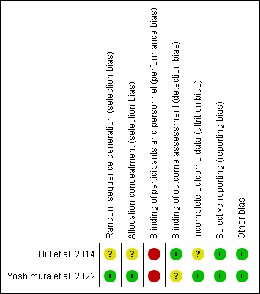

eFigure 2. Risk of bias graph: review authors' judgements about each risk of bias item presented as percentages across all included RCTs.
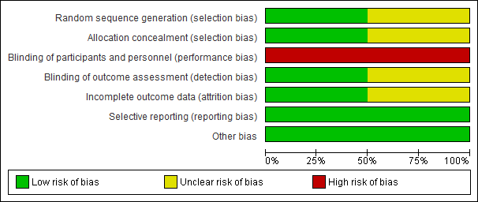
eFigure 3. Traffic Light Plot presenting the quality assessment of included observational studies using the Risk Of Bias In Non-randomized Studies of Interventions (ROBINS-I) tool²⁰.
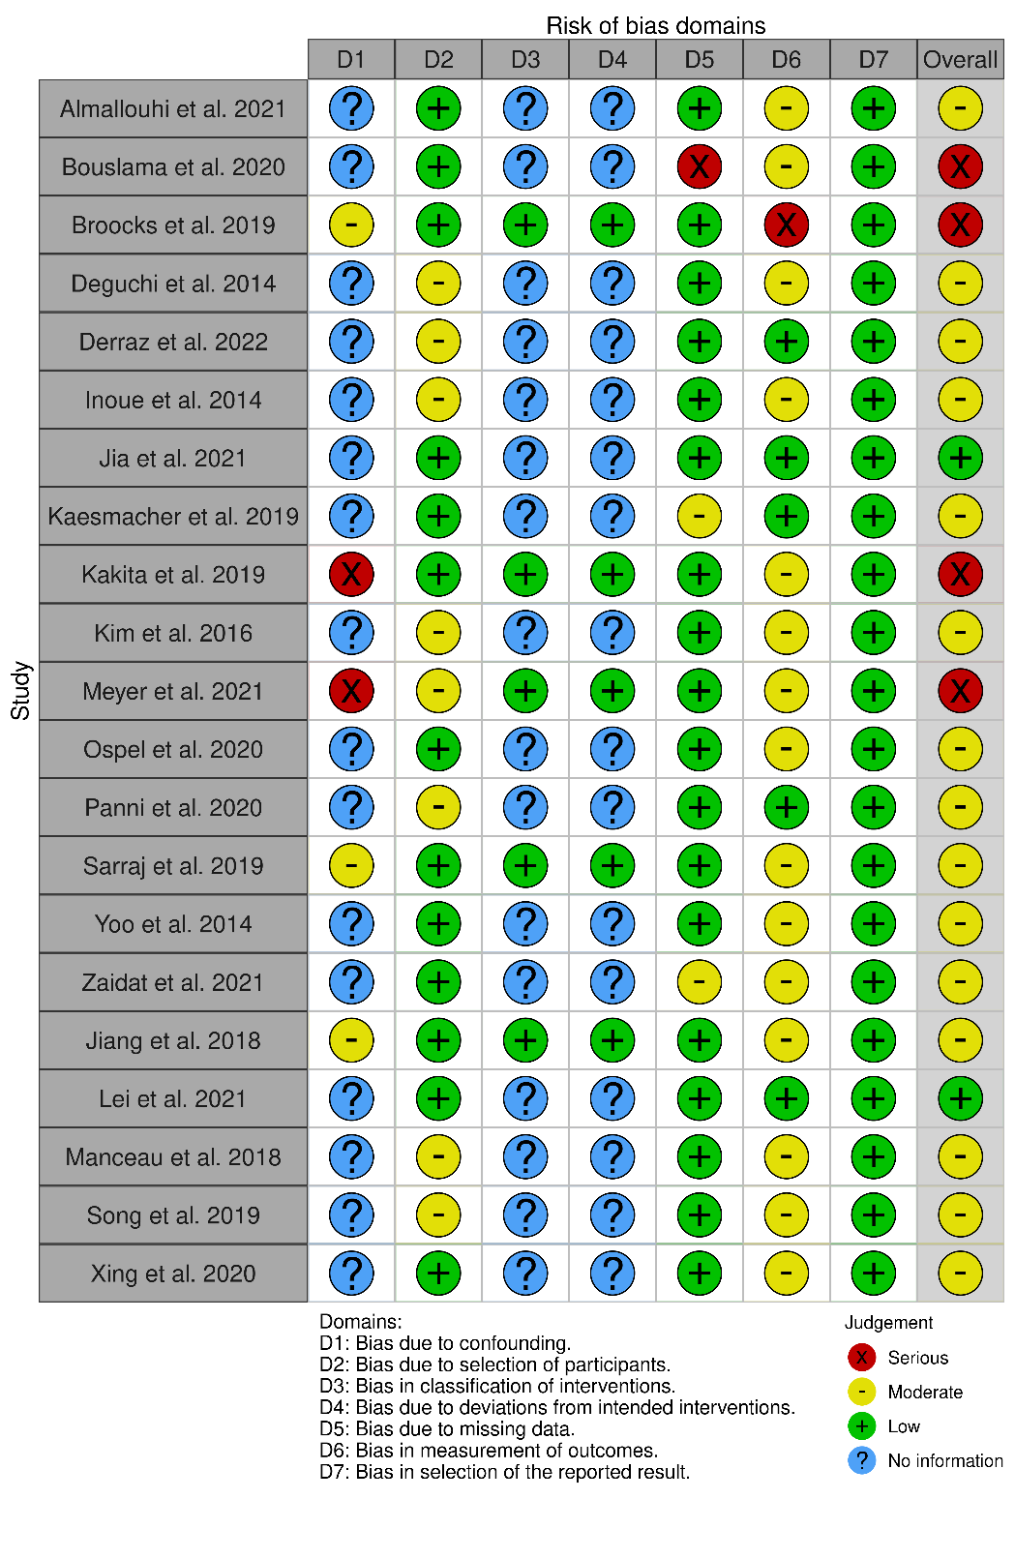

eFigure 4. Summary Plot presenting the quality assessment of included observational studies using the Risk Of Bias In Non-randomized Studies of Interventions (ROBINS-I) tool²⁰.

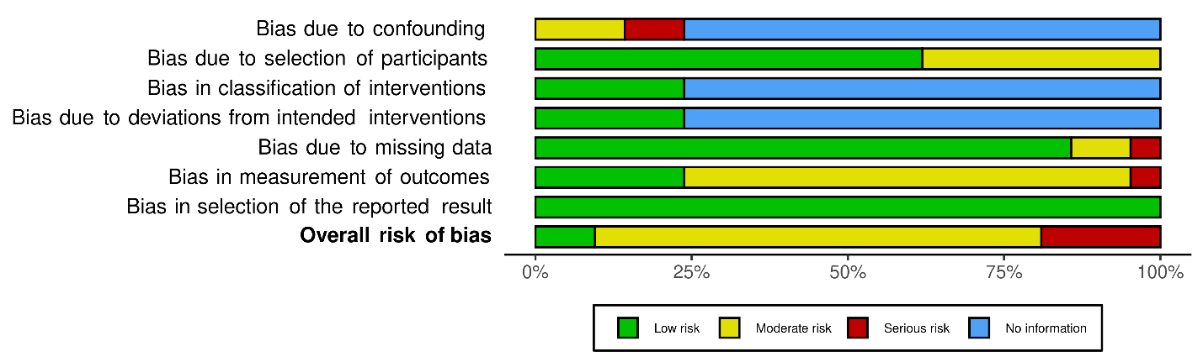

eFigure 5: Forest plot presenting the pooled proportion of EVT-treated patients achieving mRS 0-3 at 3months, stratified by study design and after removing the studies² that excluded patients presenting an ASPECTS of 5 (sensitivity analysis).
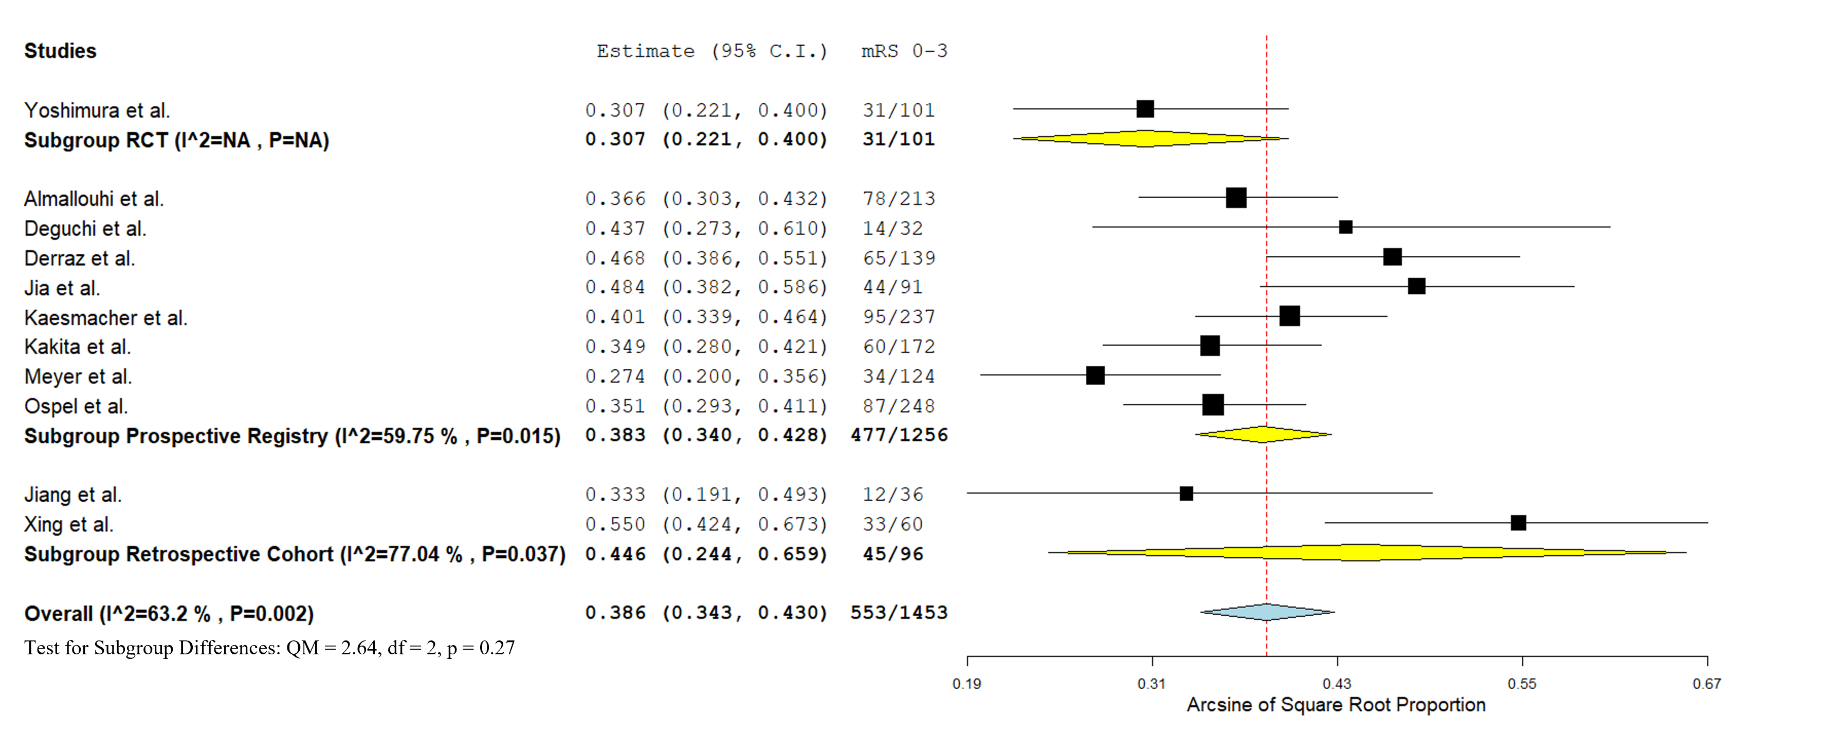

eFigure 6: Forest plot presenting the pooled proportion of EVT-treated patients achieving mRS 0-2 at 3months, stratified by study design.
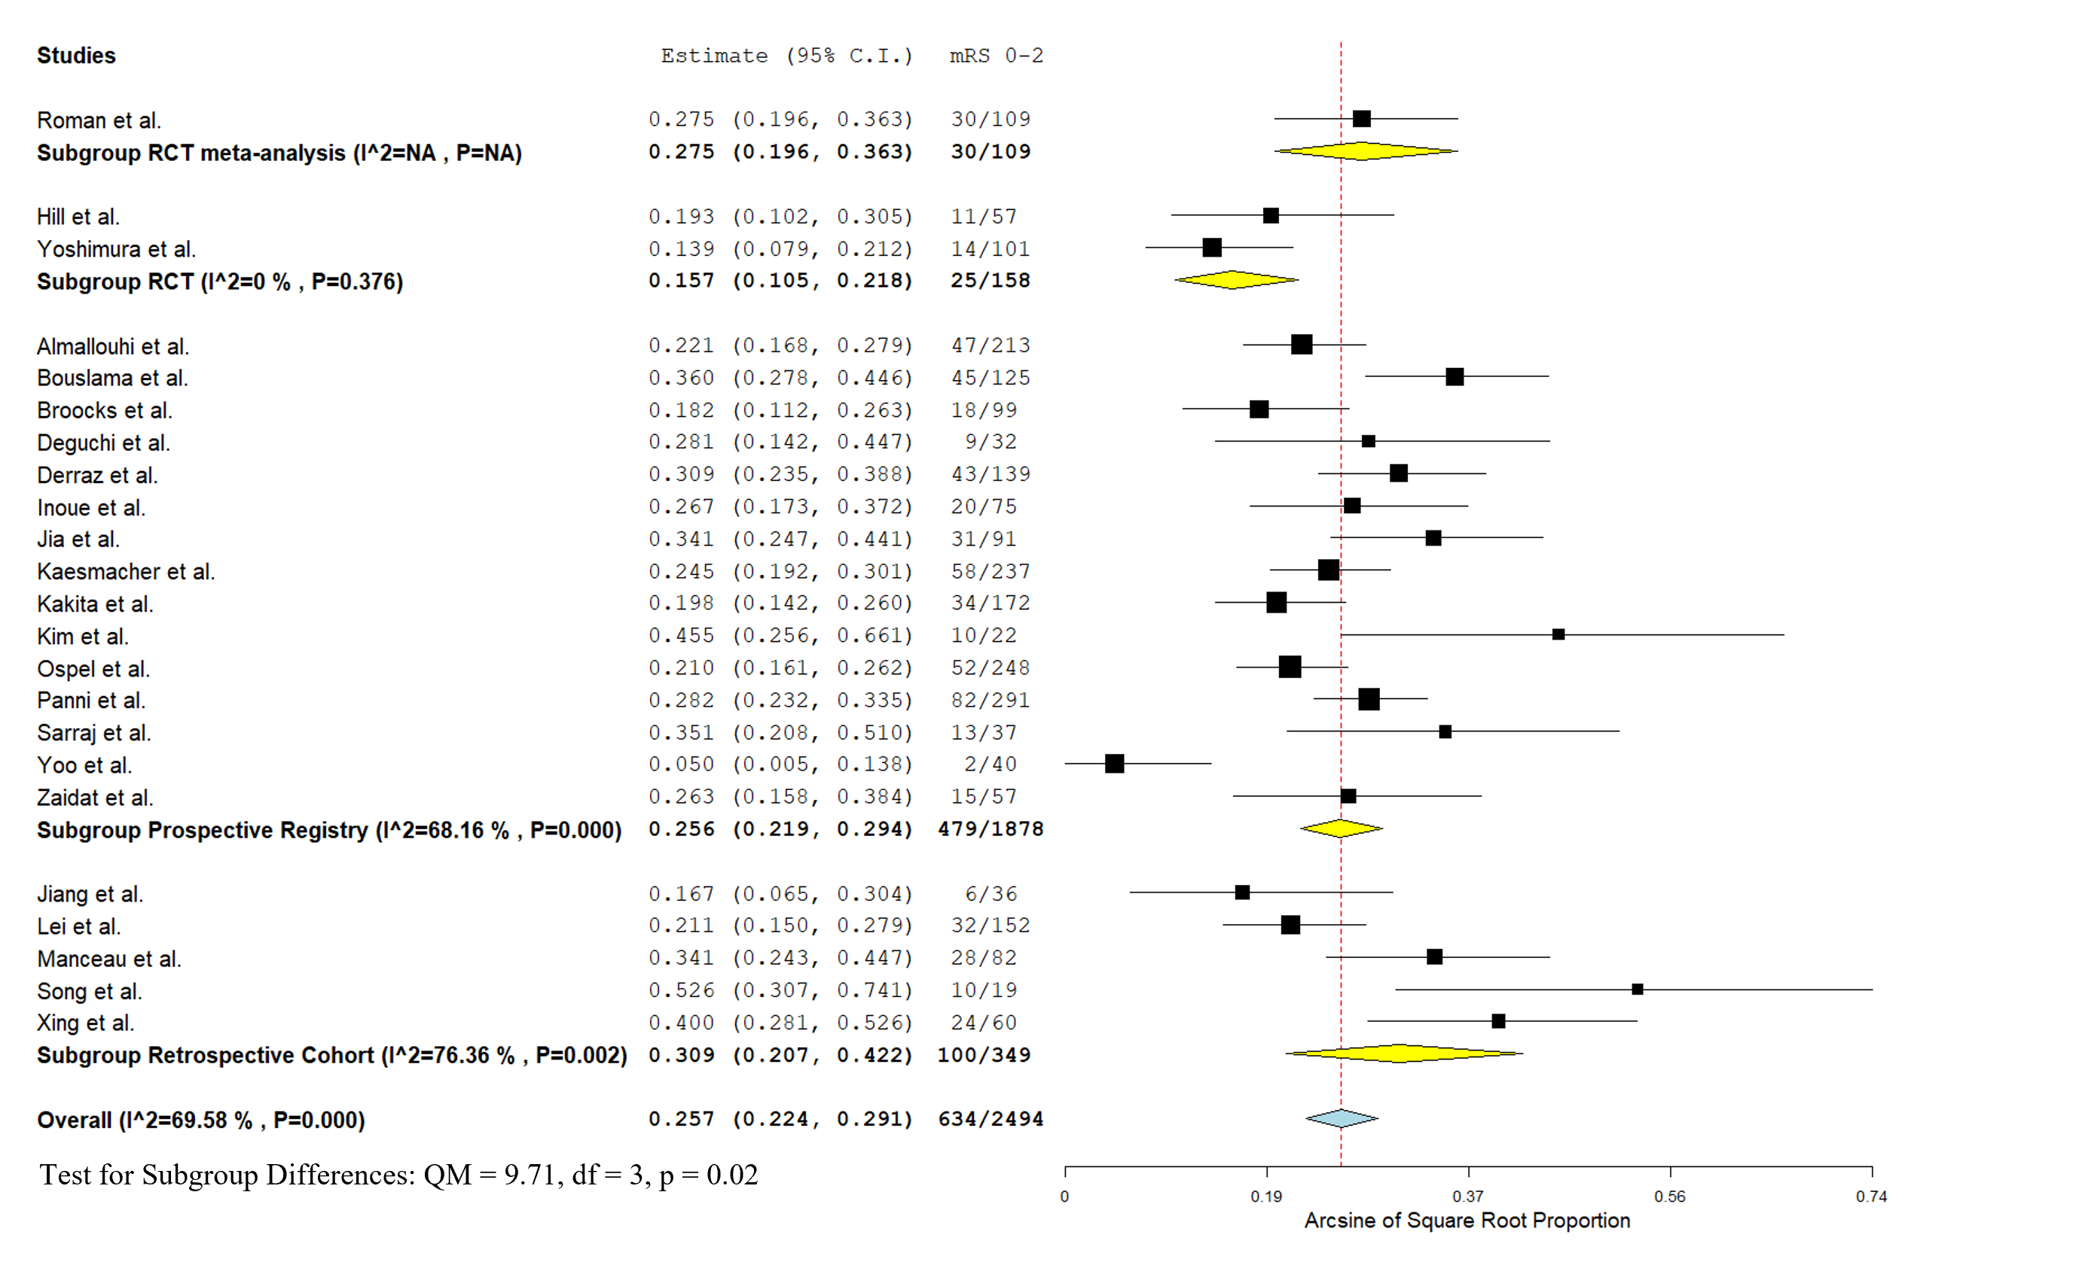

eFigure 7: Forest plot presenting the pooled proportion of EVT-treated patients achieving mRS 0-2 at 3months, stratified by study design and after removing the studies^{21,22} that excluded patients presenting an ASPECTS of 5 (sensitivity analysis).
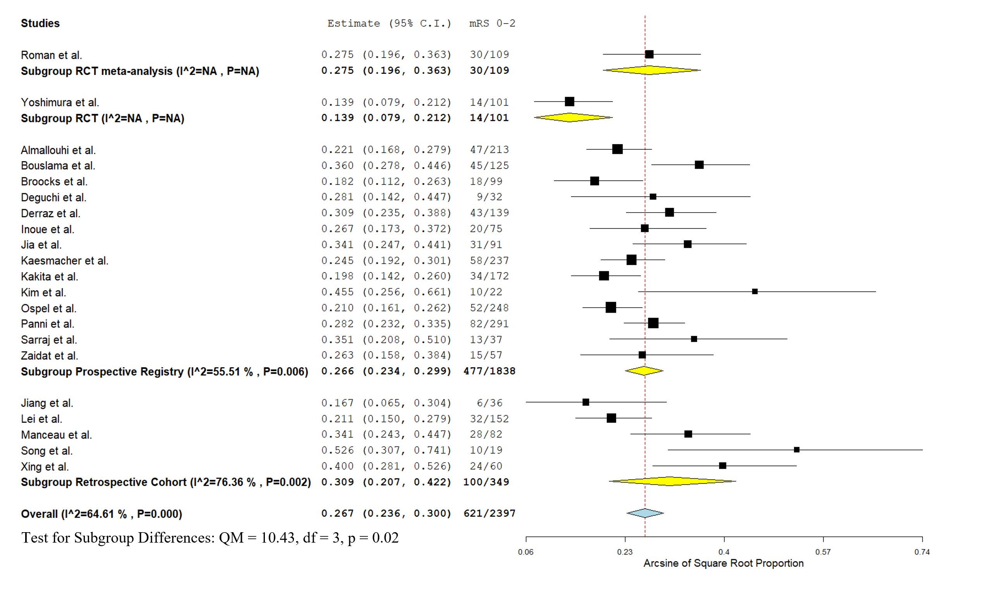
eFigure 8: Forest plot presenting the pooled proportion of EVT-treated patients presenting symptomatic intracranial hemorrhage (sICH), stratified by study design.
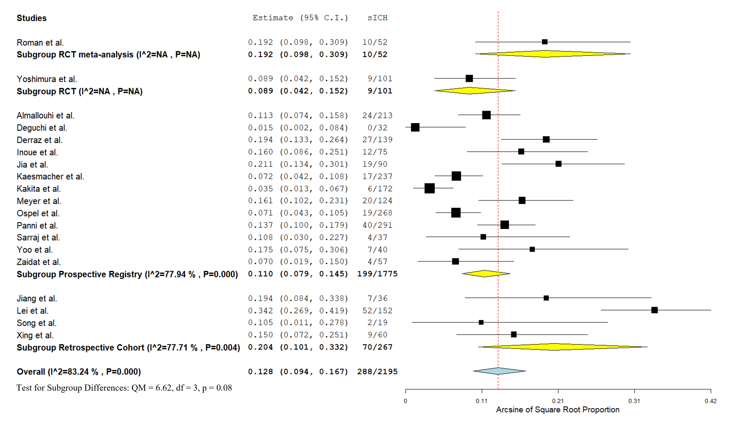

eFigure 9: Forest plot presenting the pooled proportion of EVT-treated patients presenting symptomatic intracranial hemorrhage (sICH), stratified by study design and after removing the studies^{2,22} that excluded patients presenting an ASPECTS of 5 (sensitivity analysis).
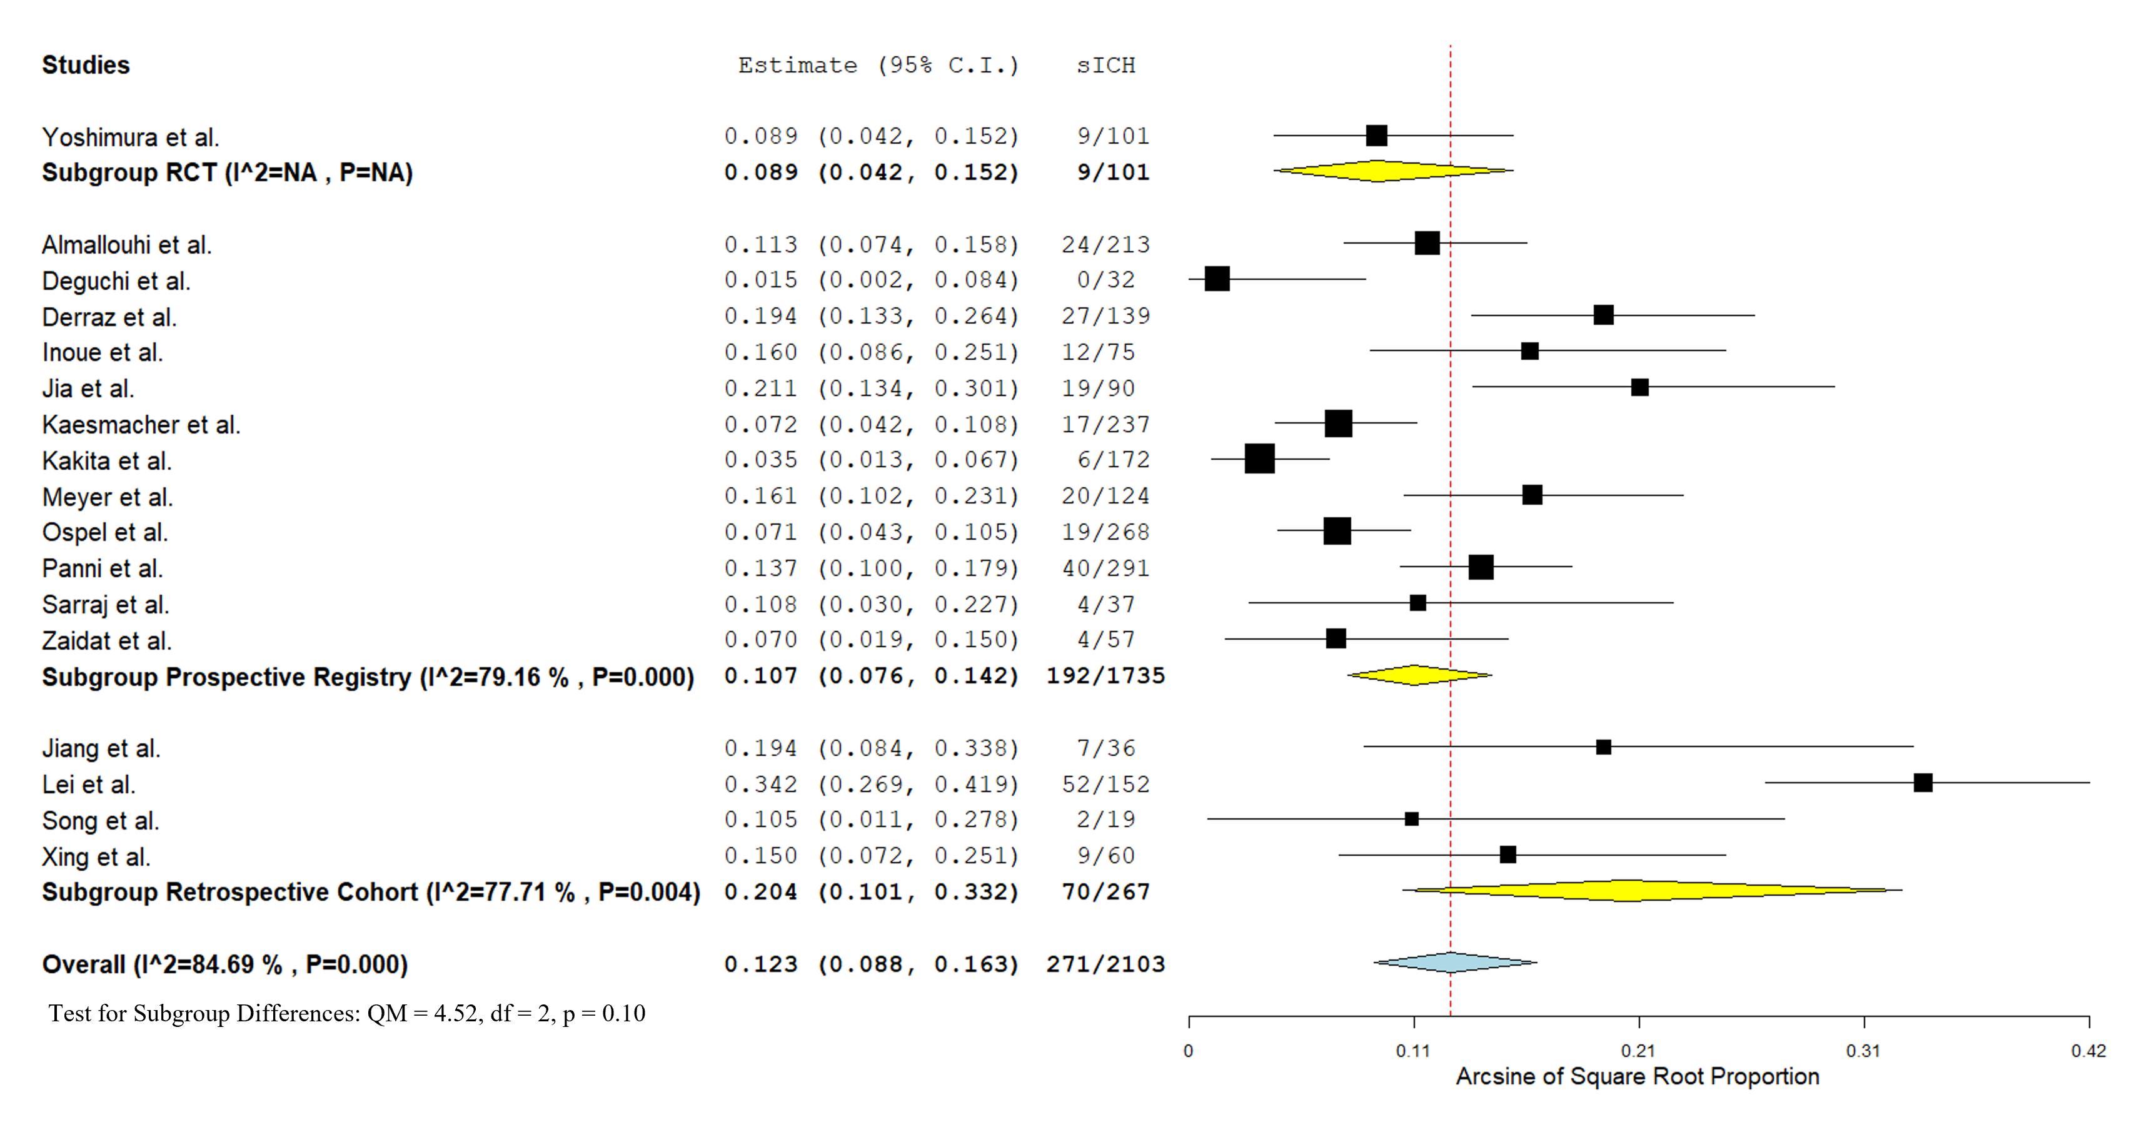

eFigure 10: Forest plot presenting the pooled 3-month mortality of EVT-treated patients, stratified by study design.
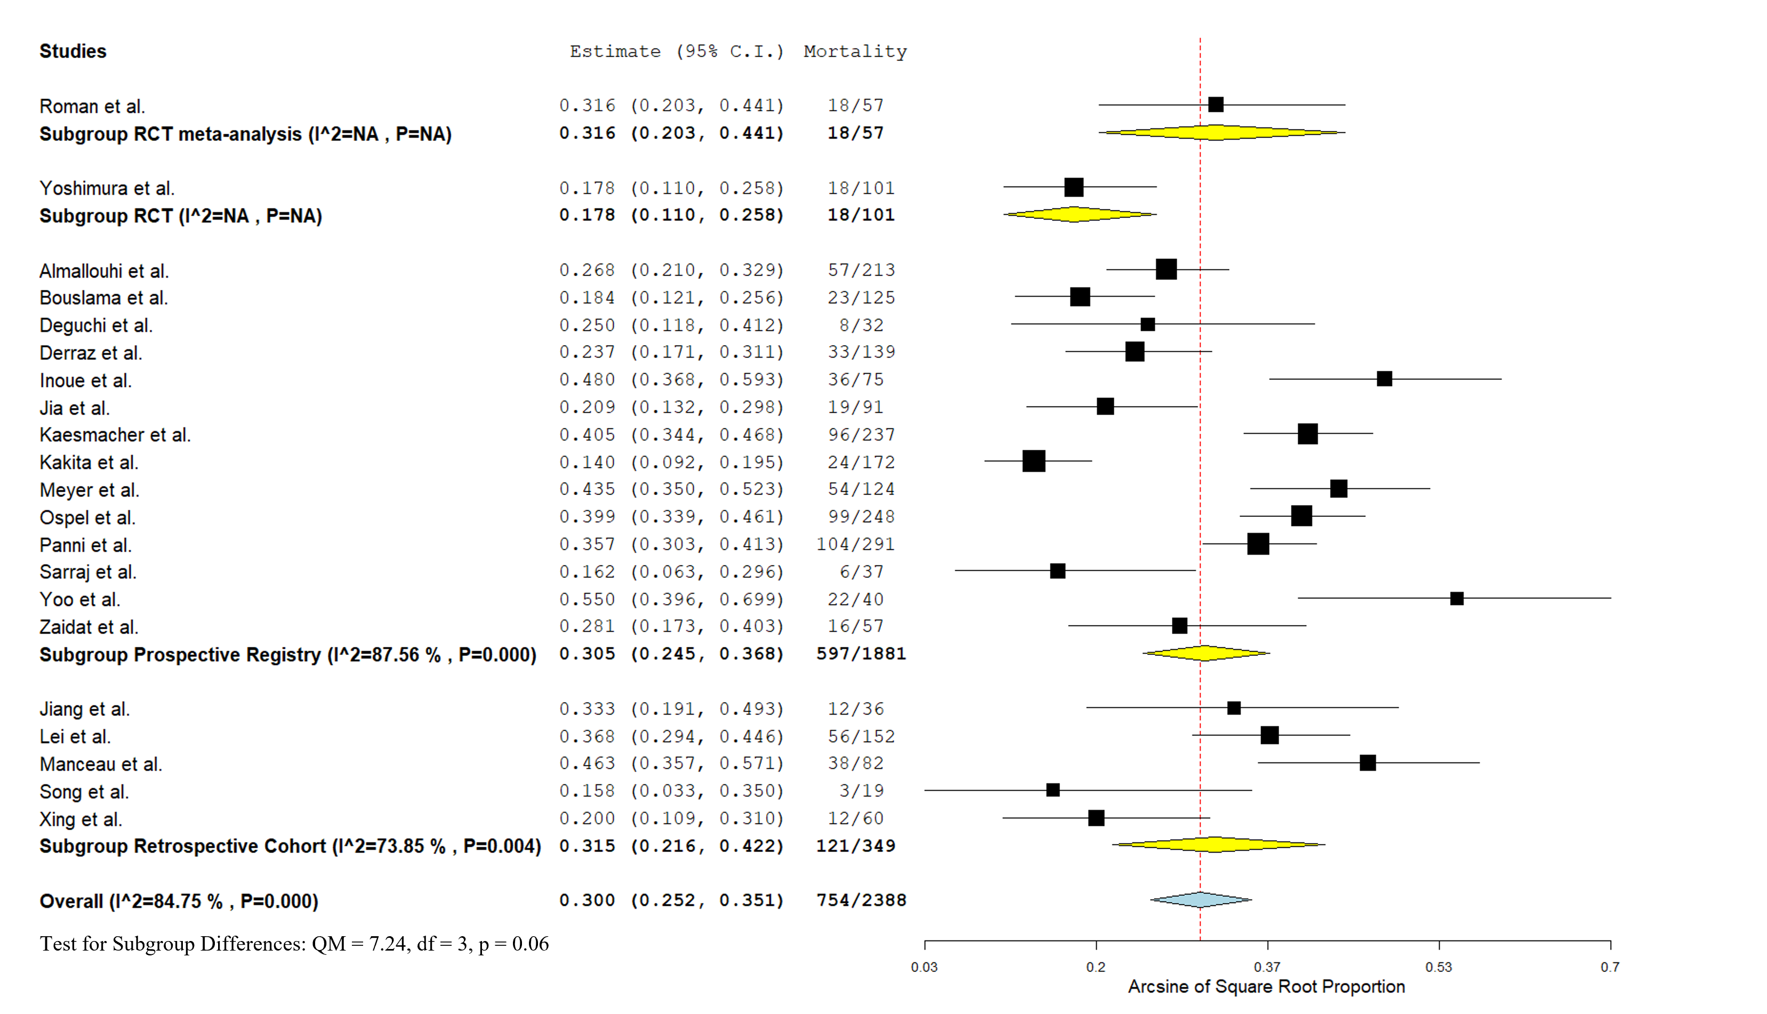

eFigure 11: Forest plot presenting the pooled 3-month mortality of EVT-treated patients, stratified by study design and after removing the studies^{2,22} that excluded patients presenting an ASPECTS of 5 (sensitivity analysis).
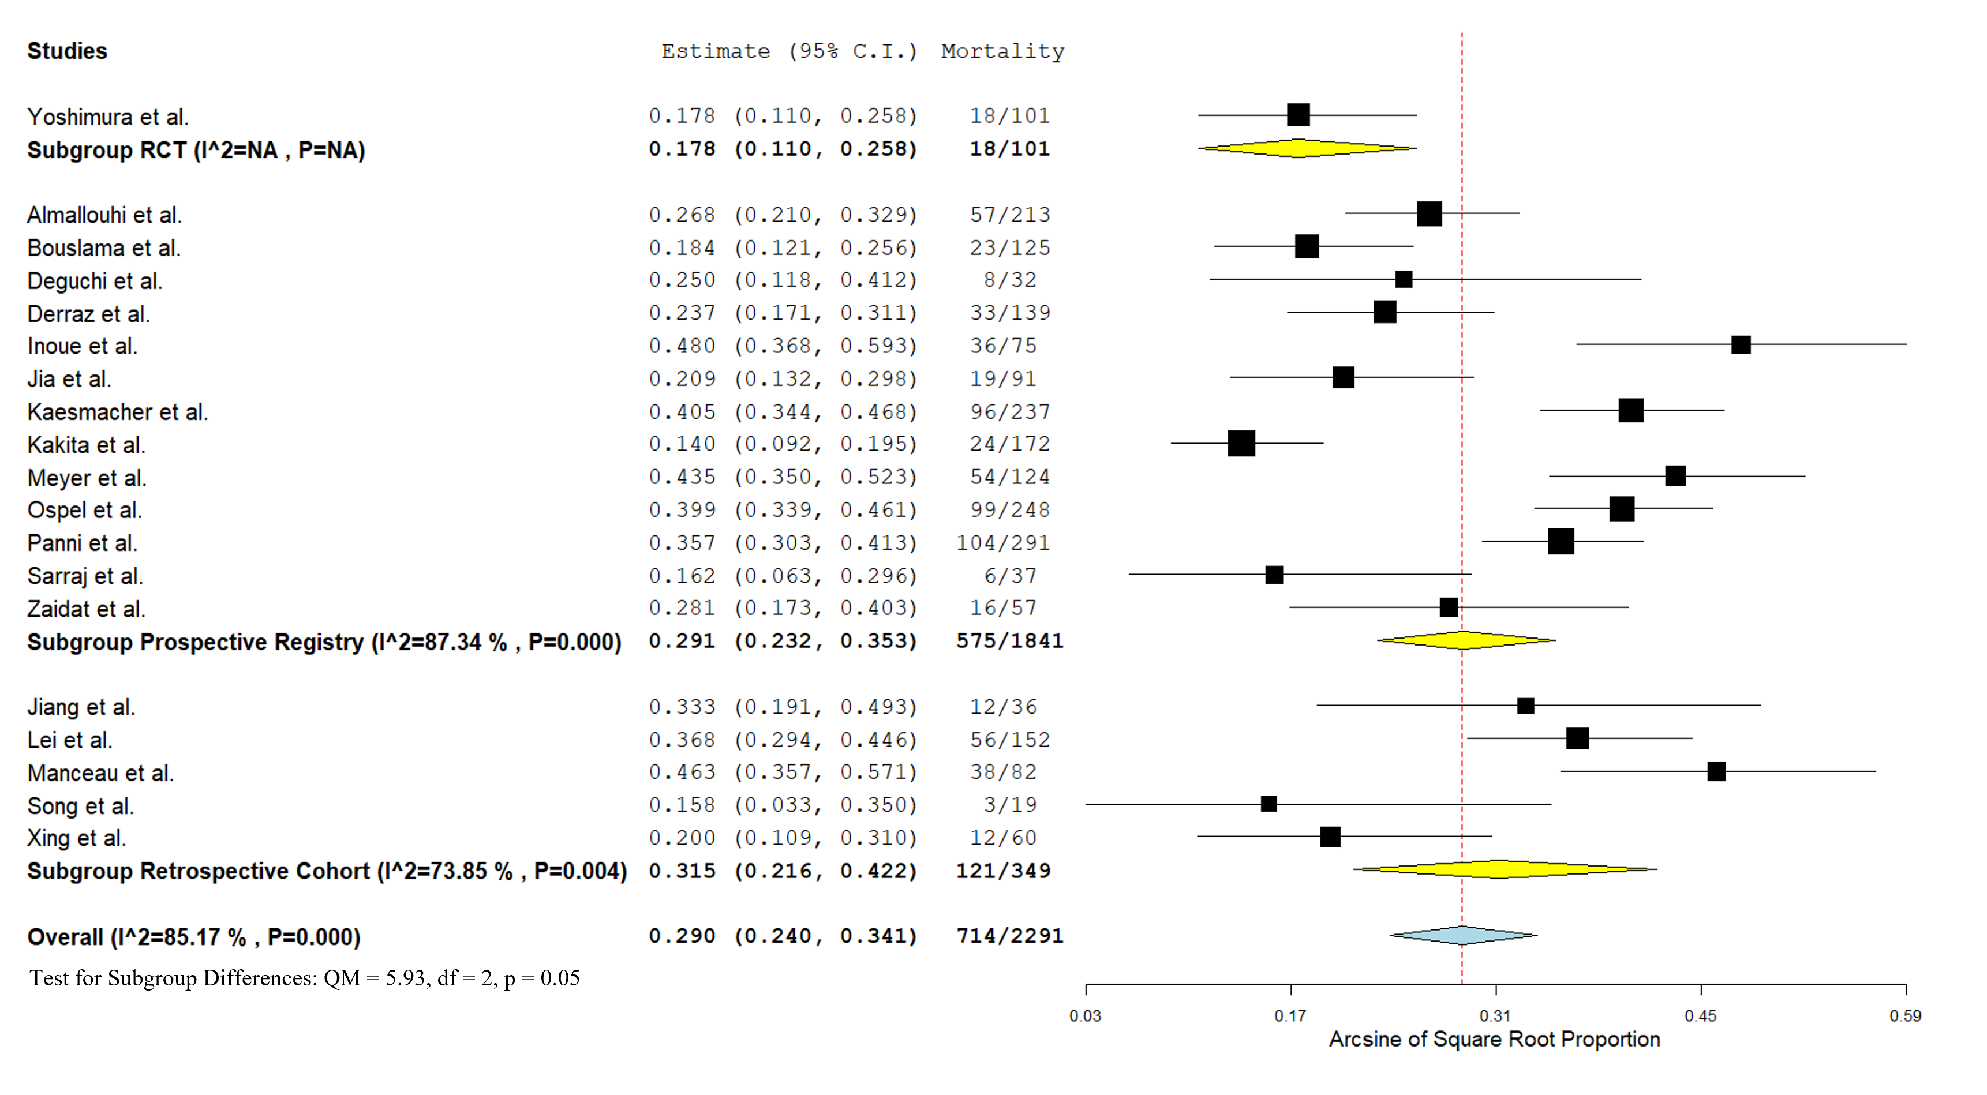

eFigure 12: Funnel plot on the reported rates of EVT-treated patients achieving mRS 0-3 at 3months (p for Egger's test= 0.4487).
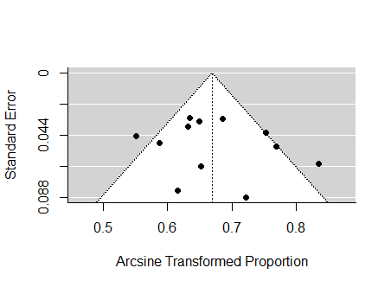

eFigure 13: Funnel plot on the reported rates of EVT-treated patients achieving mRS 0-2 at 3months (p for Egger's test= 0.1833).
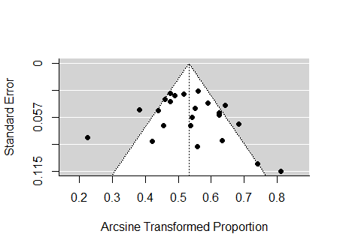

eFigure 14: Funnel plot on the reported rates of sICH among EVT-treated patients (p for Egger's test= 0.6904).
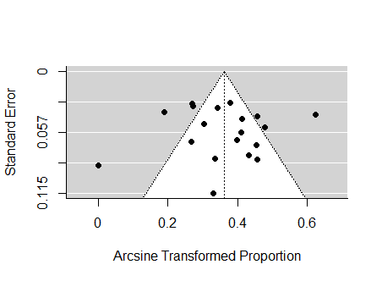

eFigure 15: Funnel plot on the reported 3-month mortality among EVT-treated patients (p for Egger's test= 0.5026).
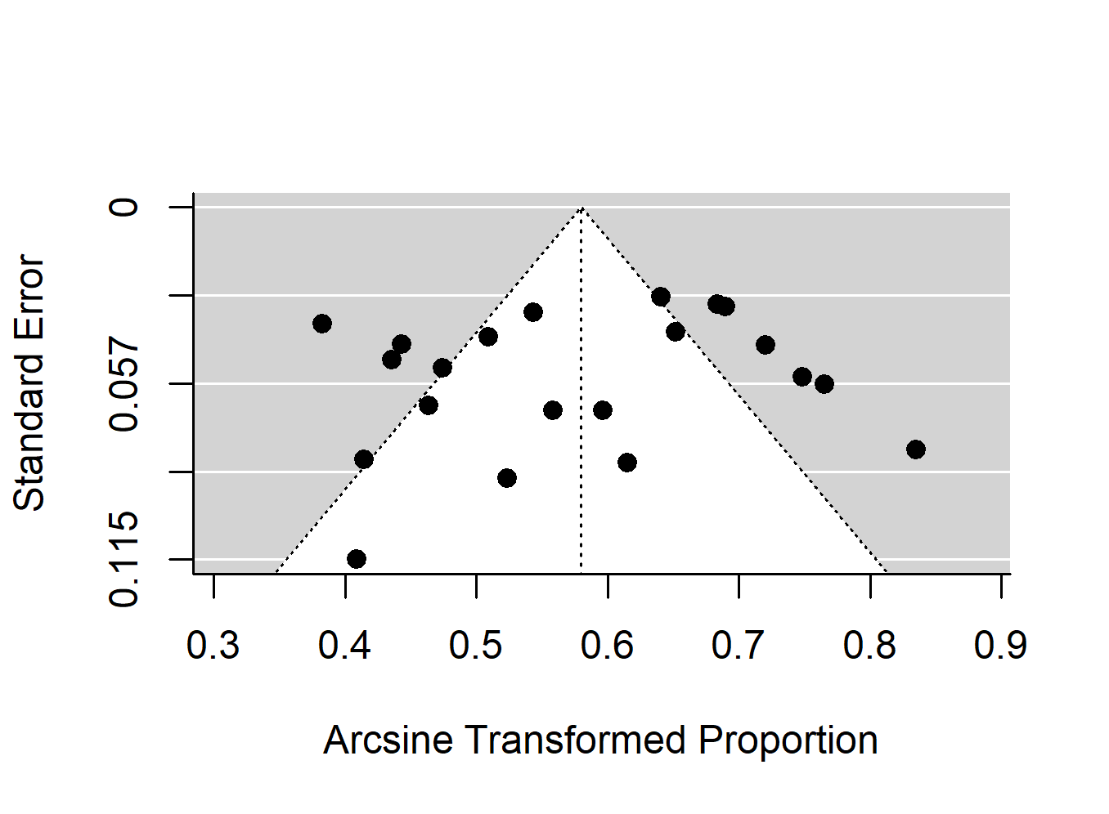

eFigure 16: Forest plot presenting the pooled proportion of males among EVT-treated patients, stratified by study design.
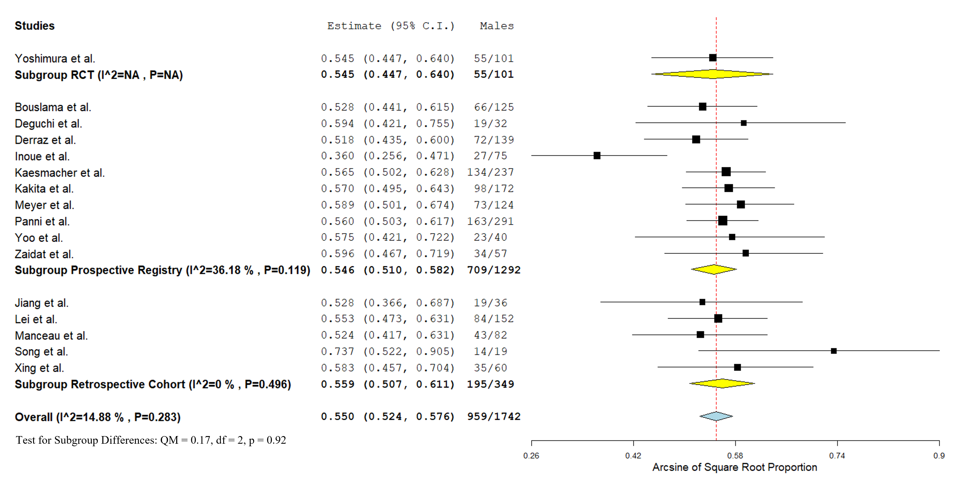
eFigure 17: Forest plot presenting the mean age among EVT-treated patients, stratified by study design.
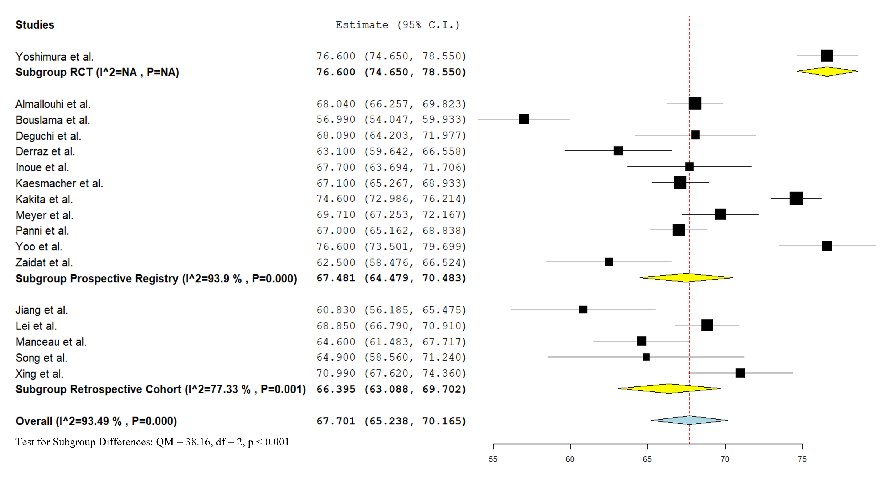

eFigure 18: Forest plot presenting the mean NIHSS score at admission among EVT-treated patients, stratified by study design.
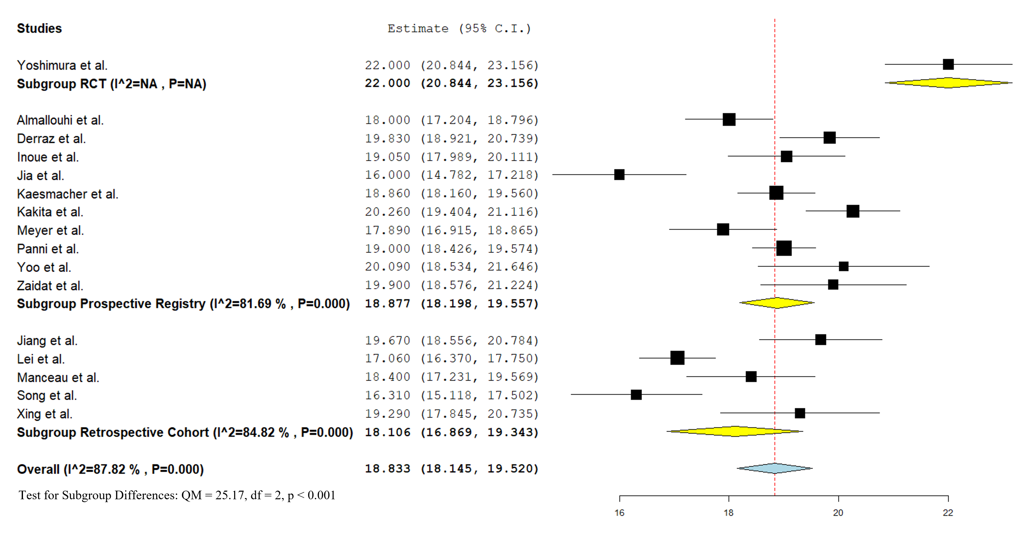
eFigure 19: Forest plot presenting the mean ASPECTS at admission among EVT-treated patients, stratified by study design.
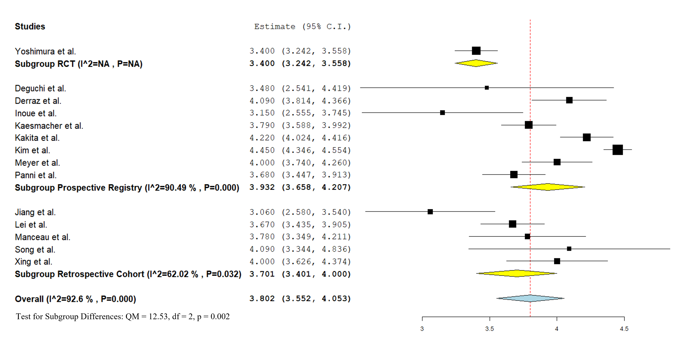
eFigure 20: Forest plot presenting the pooled proportion of EVT-treated patients having received intravenous thrombolysis (IVT), stratified by study design.
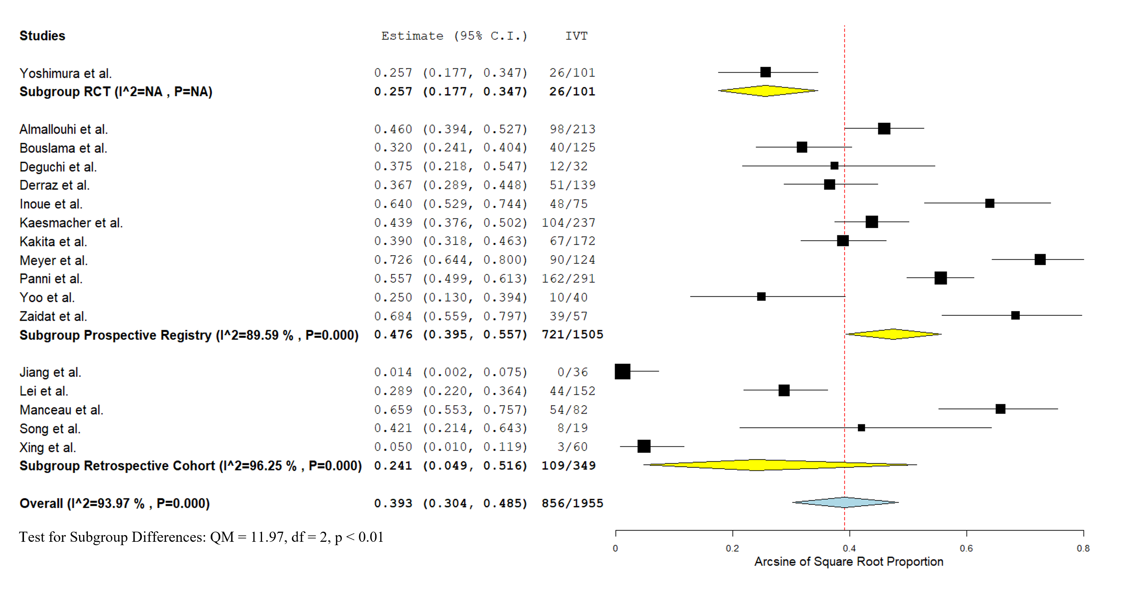

eFigure 21: Regression plot presenting the interaction between ASPECTS at admission and pooled proportion of EVT-treated patients achieving mRS 0-2 at 3months (coefficient = 0.121; 95%CI: -0.013, 0.254; omnibus p-value = 0.076).
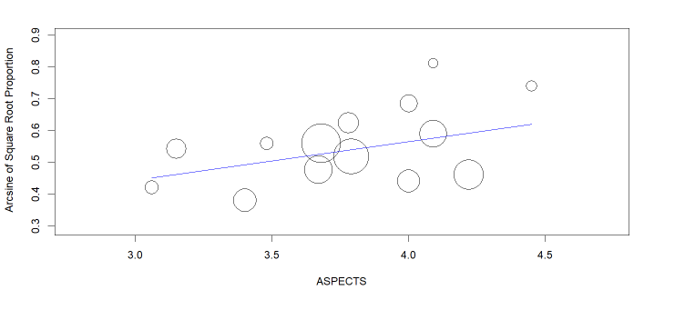

eFigure 22: Regression plot presenting the interaction between ASPECTS at admission and pooled proportion of EVT-treated patients presenting sICH (coefficient = -0.052; 95%CI: -0.254, 0.150; omnibus p-value = 0.612).
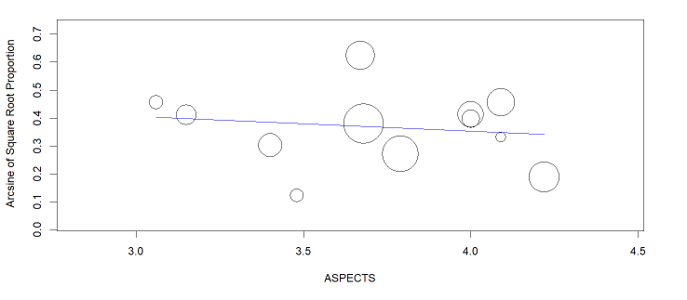

eFigure 23: Regression plot presenting the interaction between ASPECTS at admission and pooled mortality at 3 months among EVT-treated patients (coefficient = -0.109; 95%CI: -0.276, 0.058; omnibus p-value = 0.202).
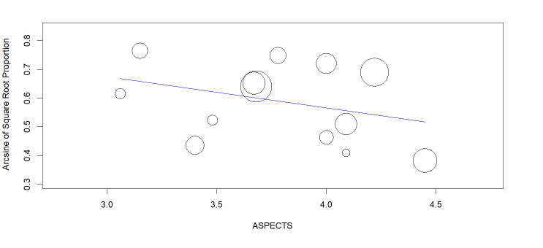

eFigure 24: Forest plot presenting the odds ratio of achieving mRS 0-3 at 3months among EVT-treated patients versus BMT-treated patients, stratified by study design and after removing the studies² that excluded patients presenting an ASPECTS of 5 (sensitivity analysis).
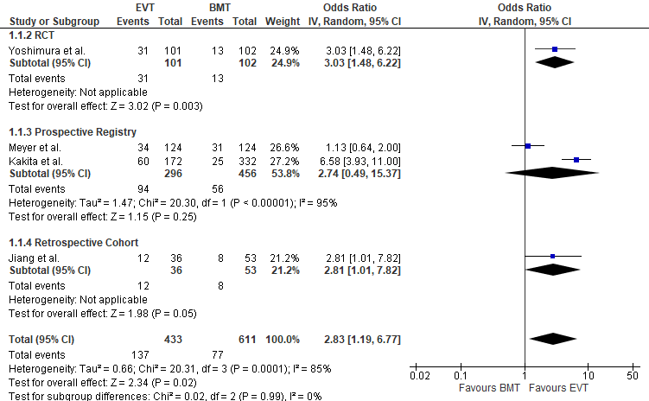

eFigure 25: Forest plot presenting the odds ratio of achieving mRS 0-3 at 3months among EVT-treated patients versus BMT-treated patients, after calculation of the fragility index (FI=5). After 5 specific event-status modifications (a total of 1 trial was modified: Roman et al.: 5 events suppressed in EVT arm), the conclusion of the meta-analysis was turned to statistically non-significant.
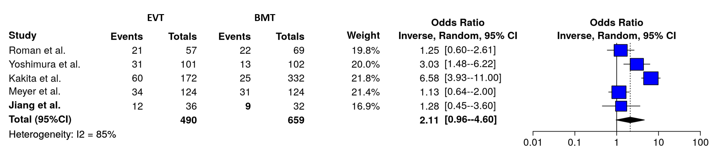

eFigure 26: Forest plot presenting the odds ratio of achieving mRS 0-2 at 3months among EVT-treated patients versus BMT-treated patients, stratified by study design.
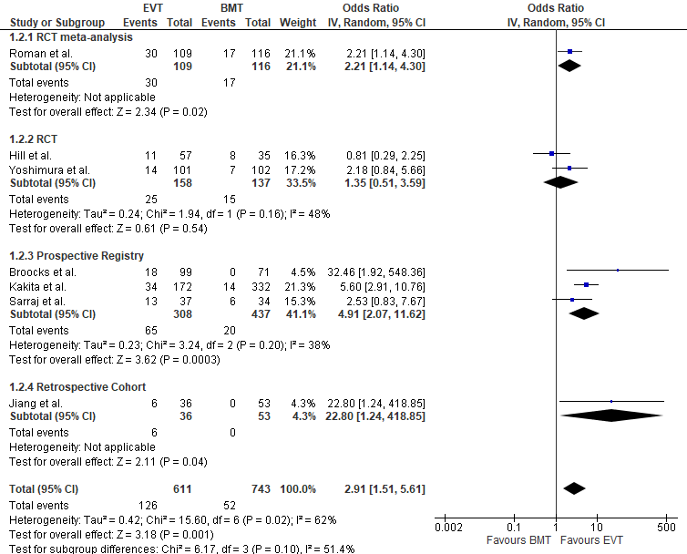

eFigure 27: Forest plot presenting the odds ratio of achieving mRS 0-2 at 3months among EVT-treated patients versus BMT-treated patients, stratified by study design and after removing the studies²¹ that excluded patients presenting an ASPECTS of 5 (sensitivity analysis).
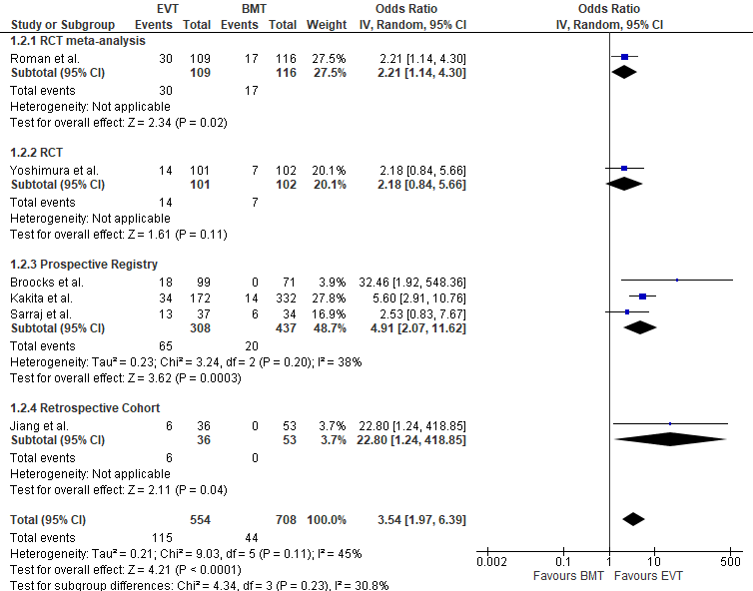
eFigure 28: Forest plot presenting the odds ratio of achieving mRS 0-2 at 3months among EVT-treated patients versus BMT-treated patients, after calculation of the fragility index (FI=10). After 10 specific event-status modifications (a total of 1 trial was modified: Hill et al.: 10 events added in BMT arm), the conclusion of the meta-analysis was turned to statistically non-significant.
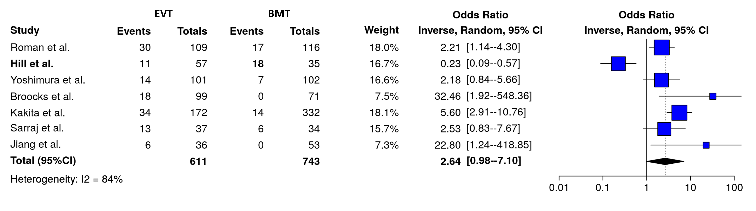
eFigure 29: Forest plot presenting the odds ratio of symptomatic intracranial hemorrhage (sICH) among EVT-treated patients versus BMT-treated patients, stratified by study design.
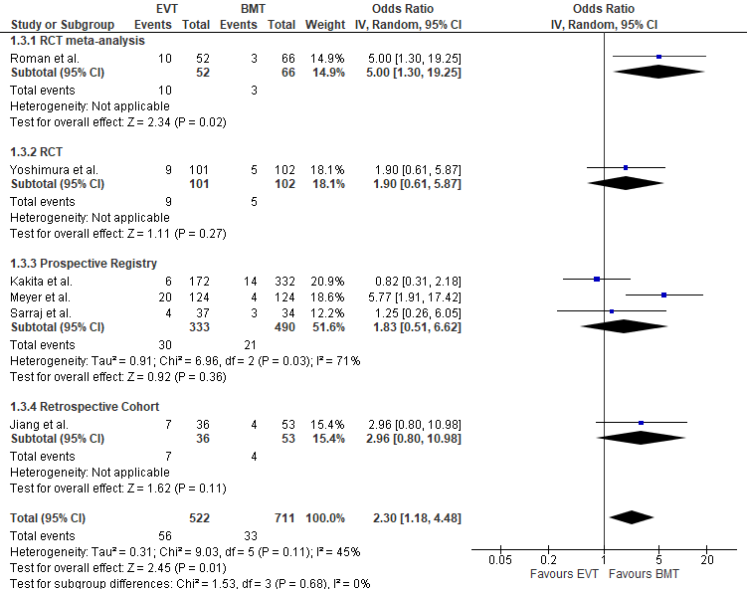

eFigure 30: Forest plot presenting the odds ratio of symptomatic intracranial hemorrhage (sICH) among EVT-treated patients versus BMT-treated patients, stratified by study design and after removing the studies² that excluded patients presenting an ASPECTS of 5 (sensitivity analysis).
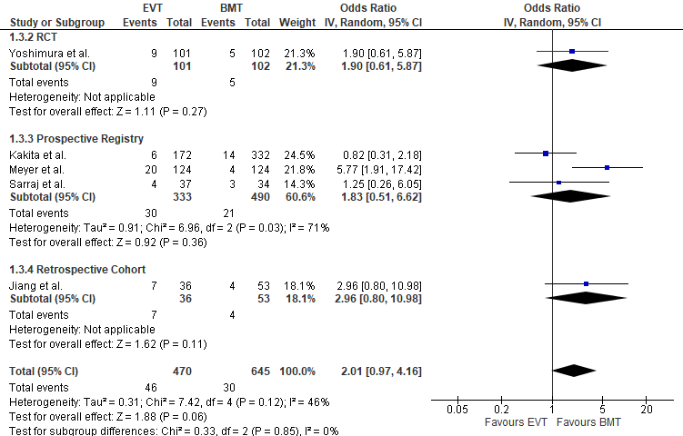
eFigure 31: Forest plot presenting the odds ratio of symptomatic intracranial hemorrhage (sICH) among EVT-treated patients versus BMT-treated patients, after calculation of the fragility index (FI=3). After 3 specific event-status modifications (a total of 1 trial was modified: Sarraj et al.: 3 events added in BMT arm), the conclusion of the meta-analysis was turned to statistically non-significant.
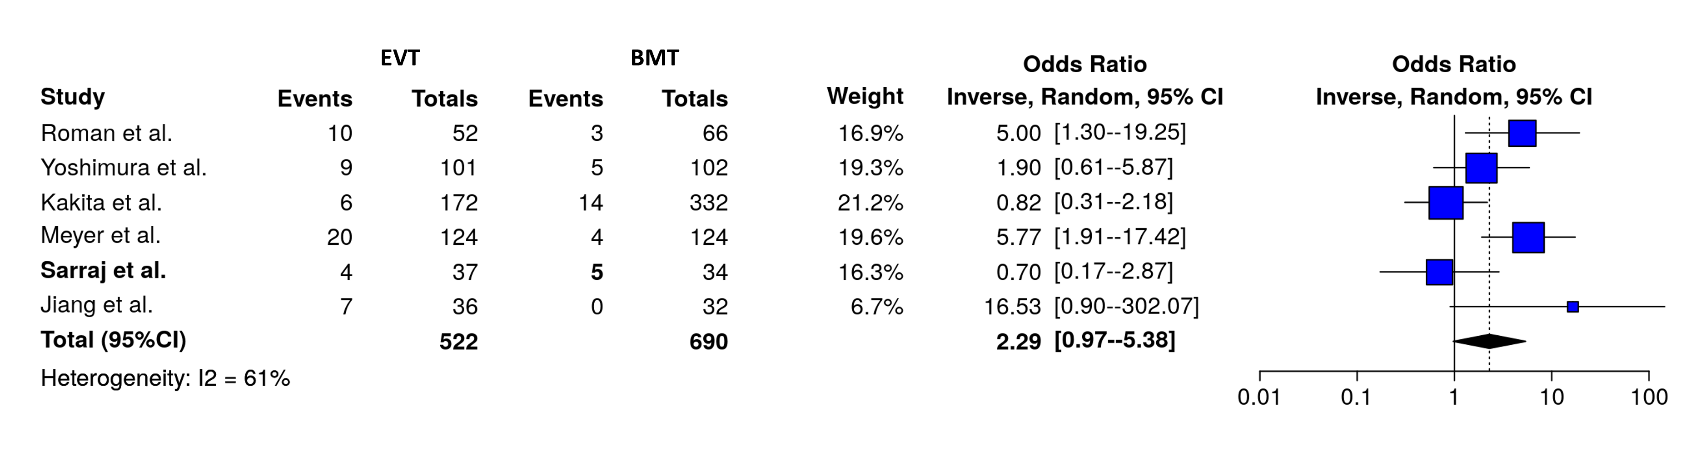

eFigure 32: Forest plot presenting the odds ratio of mortality at 3 months among EVT-treated patients versus BMT-treated patients, stratified by study design.
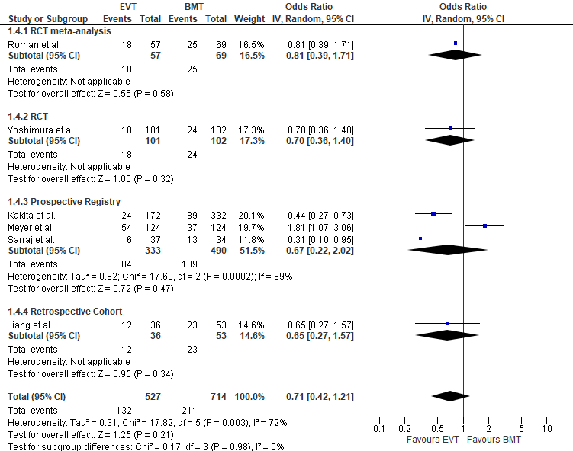

eFigure 33: Forest plot presenting the odds ratio of mortality at 3 months among EVT-treated patients versus BMT-treated patients, stratified by study design and after removing the studies² that excluded patients presenting an ASPECTS of 5 (sensitivity analysis).
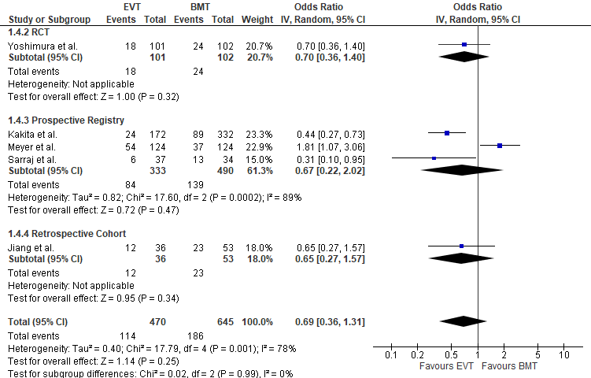
eFigure 34: Forest plot presenting the odds ratio of mortality at 3 months among EVT-treated patients versus BMT-treated patients, after calculation of the fragility index (FI=12). After 12 specific event-status modifications (a total of 1 trial was modified: Meyer et al.: 1 event suppressed in EVT arm and 11 events added in BMT arm), the conclusion of the meta-analysis was turned to statistically significant.
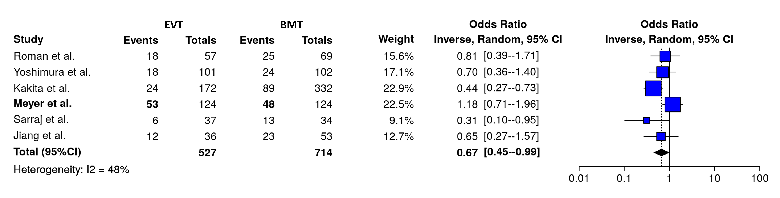

eFigure 35: Funnel plot on the reported rates of EVT- vs. BMT- treated patients achieving mRS 0-3 at 3months (p for Egger's test= 0.8413).
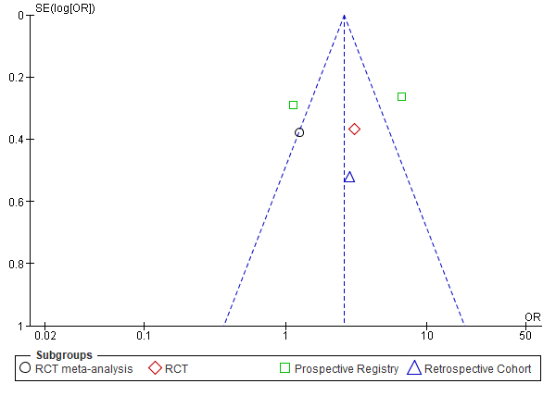
eFigure 36: Funnel plot on the reported rates of EVT- vs. BMT- treated patients achieving mRS 0-2 at 3months (p for Egger's test= 0.0966).
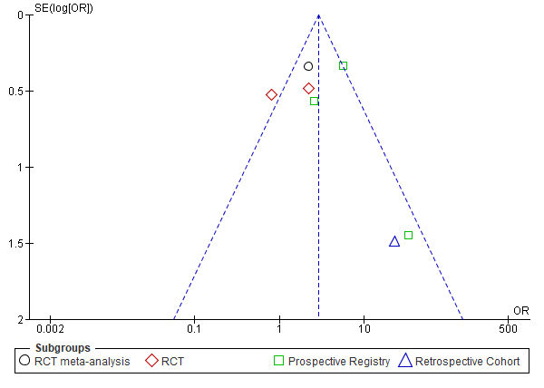

eFigure 37: Funnel plot on the reported rates of sICH among EVT- vs. BMT- treated patients (p for Egger's test= 0.6981).
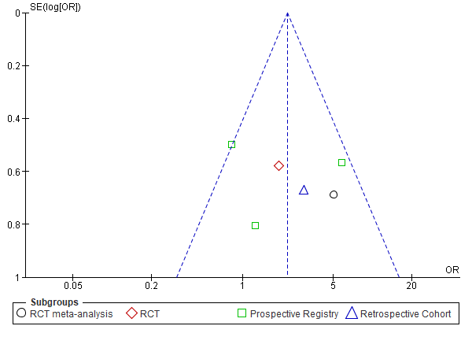
eFigure 38: Funnel plot on the reported 3-month mortality among EVT- vs. BMT- treated patients (p for Egger's test= 0.3345).
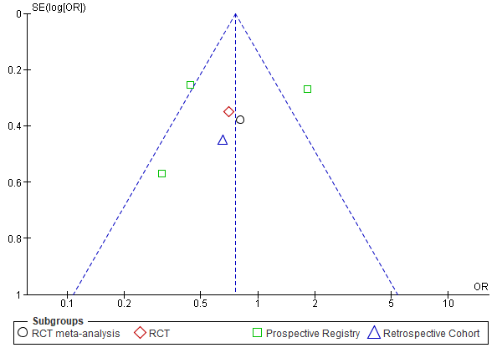

eFigure 39: Forest plot presenting the odds ratio of males among EVT-treated patients versus to BMT-treated patients, stratified by study design.
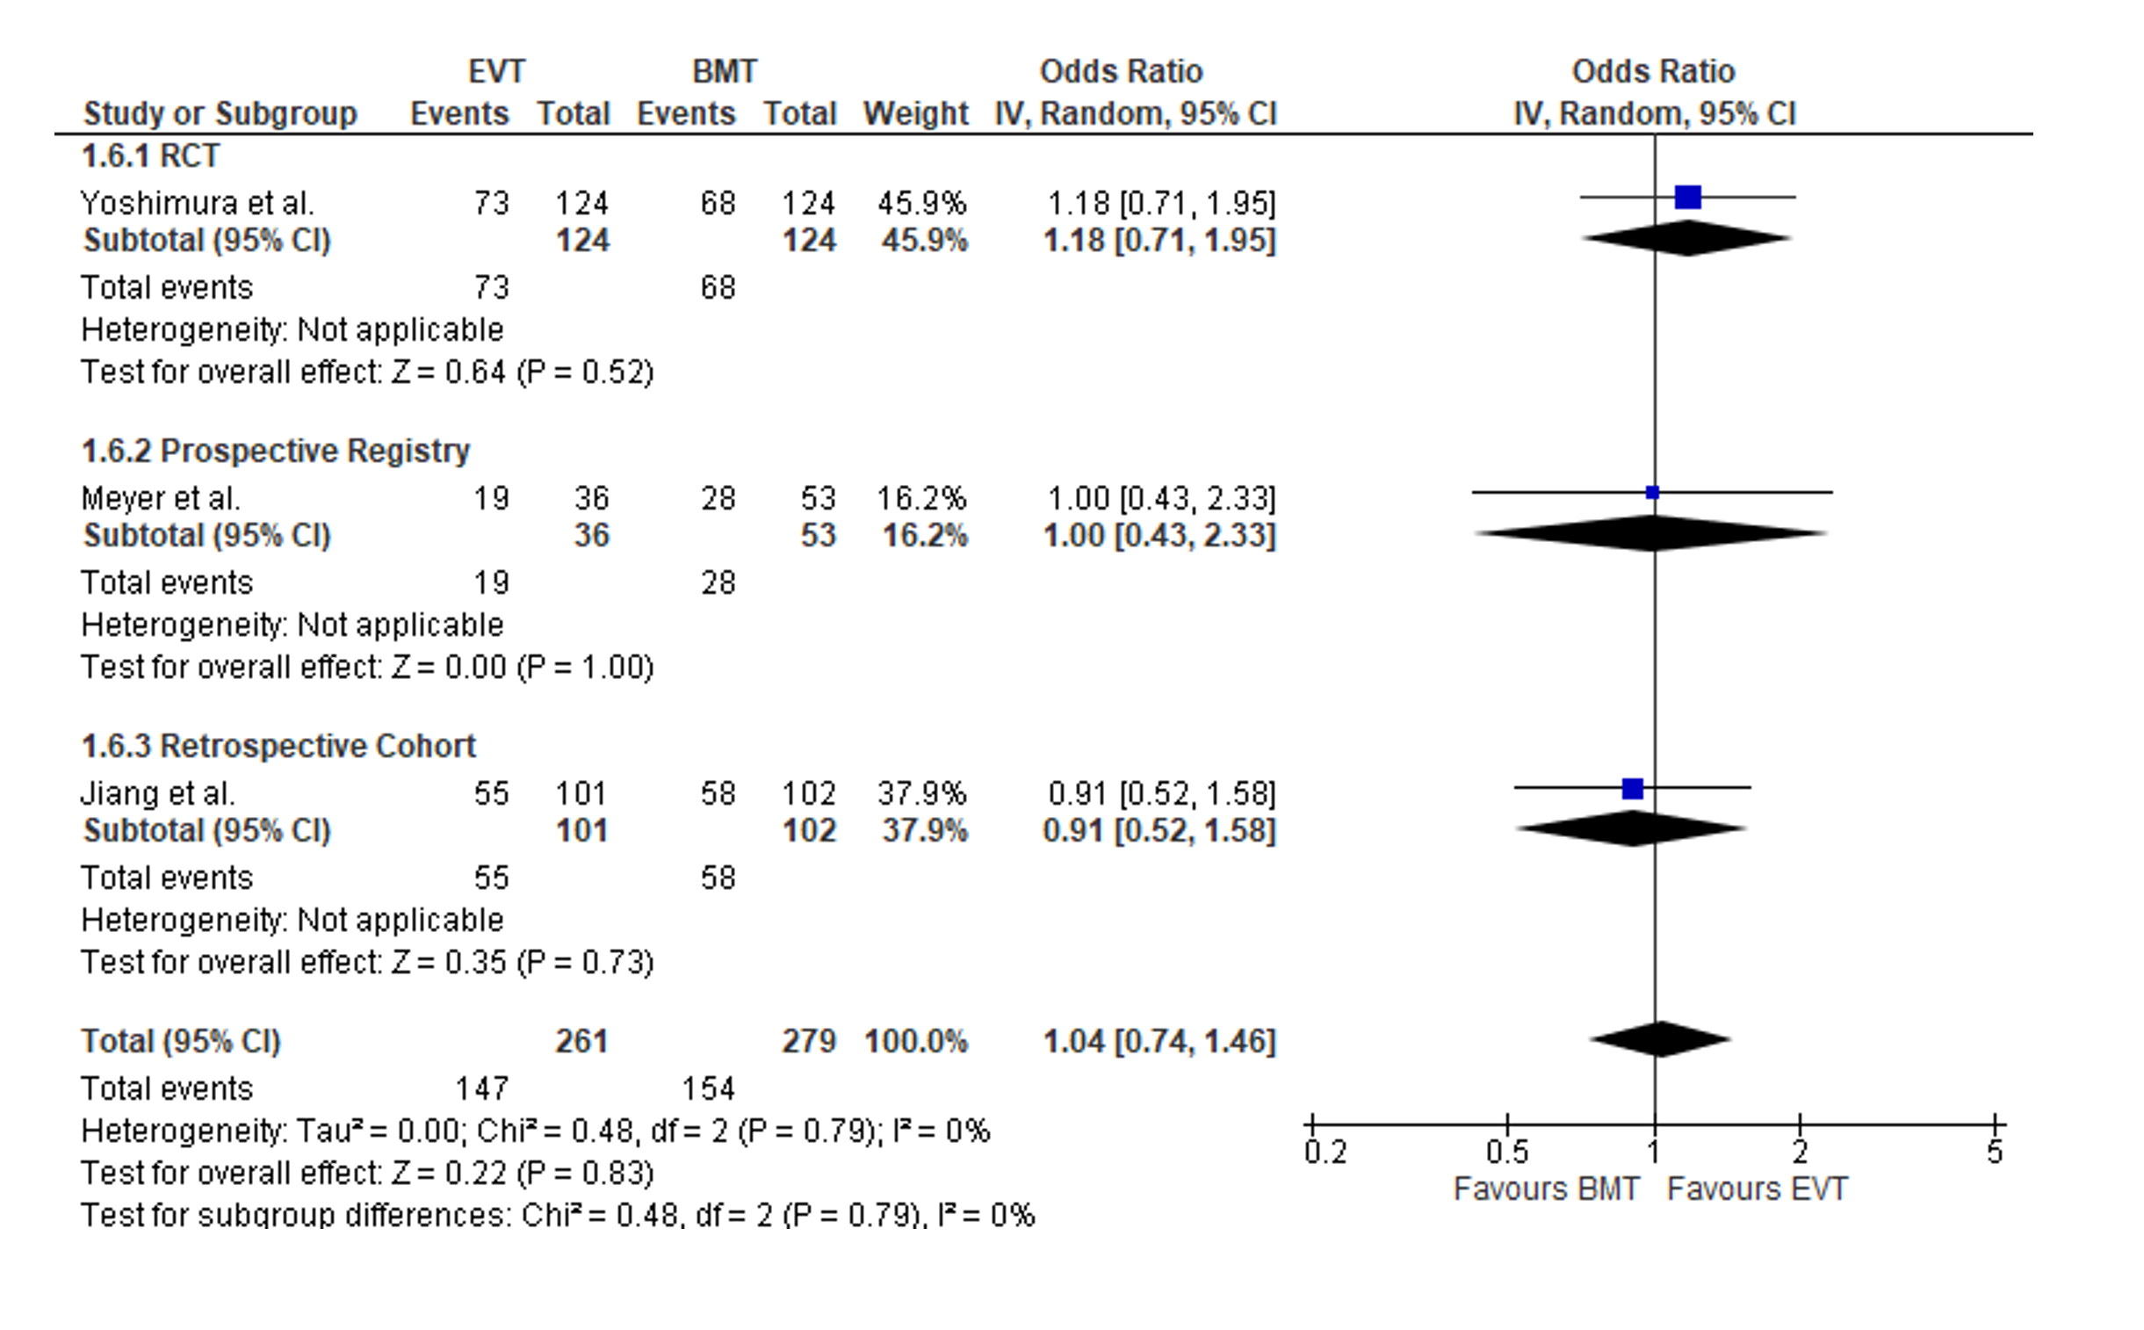
eFigure 40: Forest plot presenting the mean difference of age among EVT-treated patients versus to BMT-treated patients, stratified by study design.
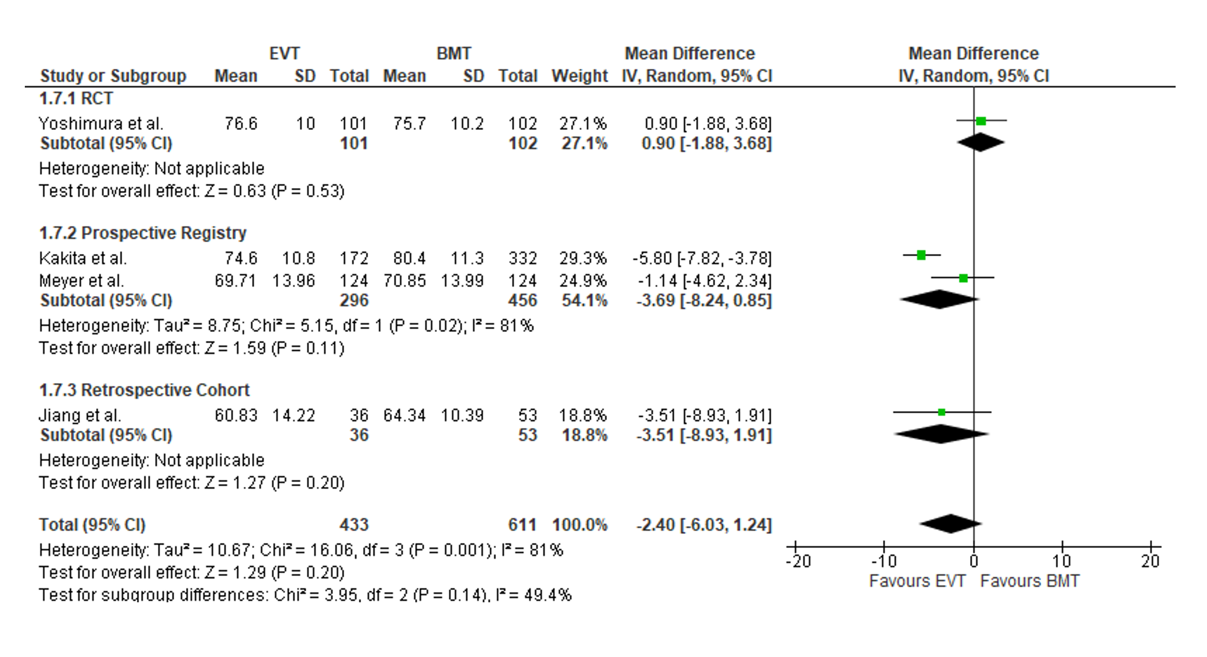
.
eFigure 41: Forest plot presenting the mean difference of NIHSS score at admission among EVT-treated patients versus to BMT-treated patients, stratified by study design.
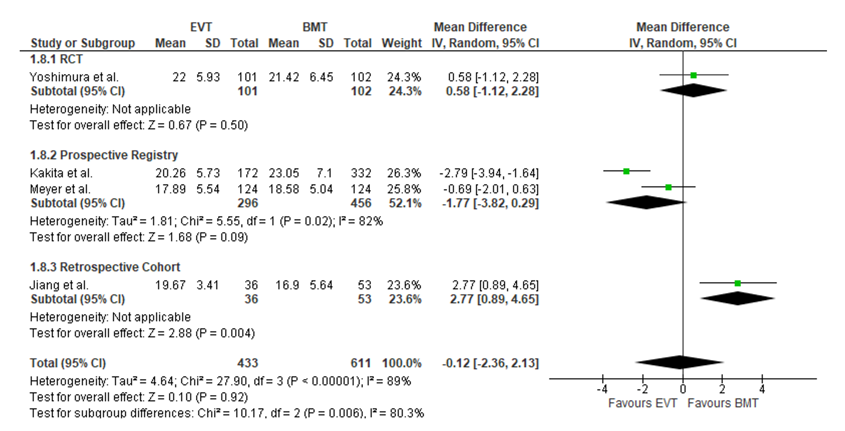
eFigure 42: Forest plot presenting the mean difference of ASPECTS at admission among EVT-treated patients versus to BMT-treated patients, stratified by study design.
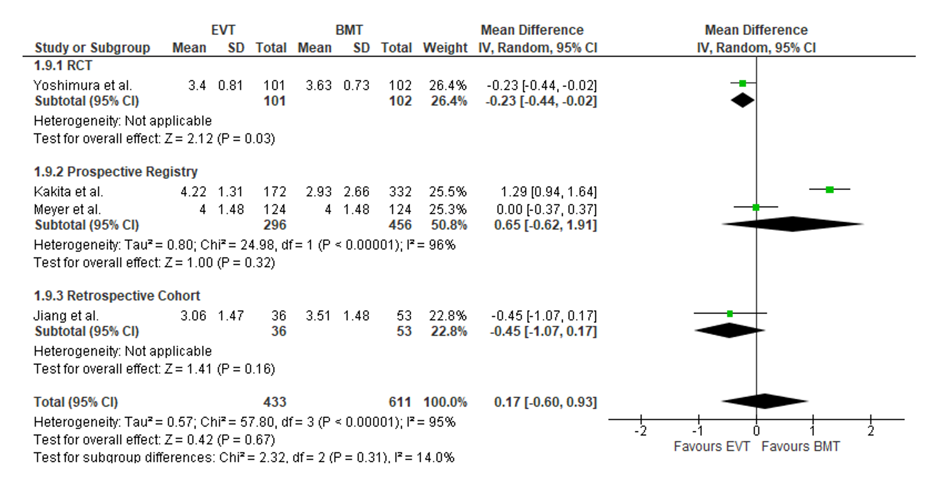

eFigure 43: Forest plot presenting the odds ratio of having received intravenous thrombolysis (IVT) among EVT-treated patients versus to BMT-treated patients, stratified by study design.
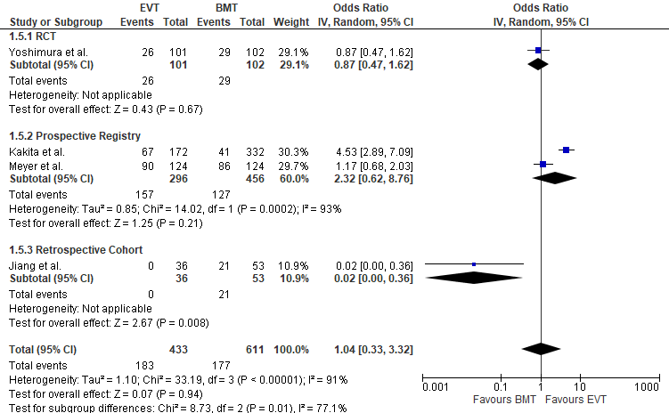

eFigure 44. Forest plot presenting single-arm meta-analysis where we assessed subgroup differences for mRS 3-5 and mRS 0-2.
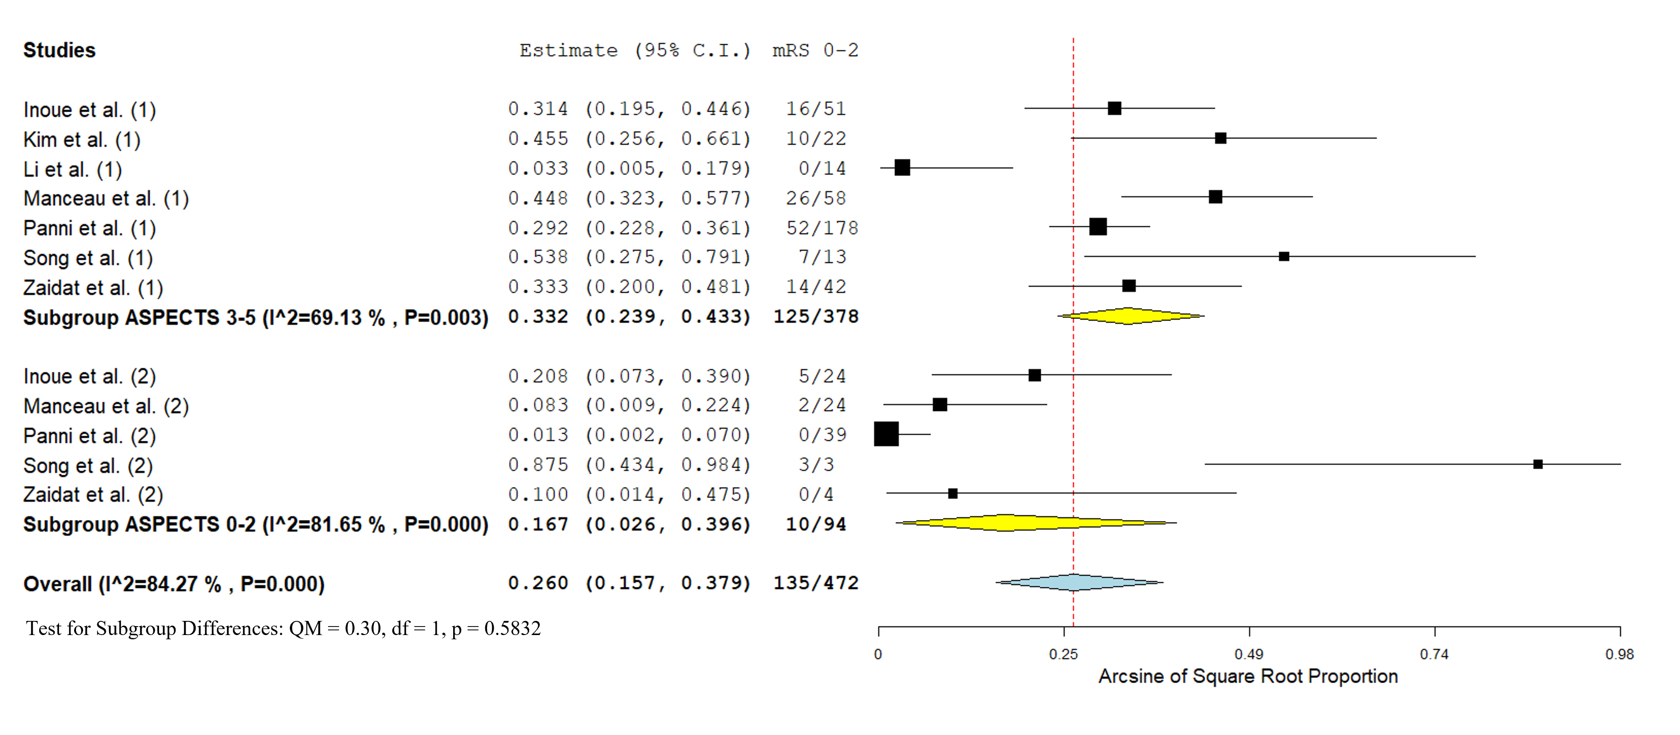

eFigure 45. Forest plot presenting two-arm meta-analysis where we assessed subgroup differences for mRS 3-5 and mRS 0-2.


