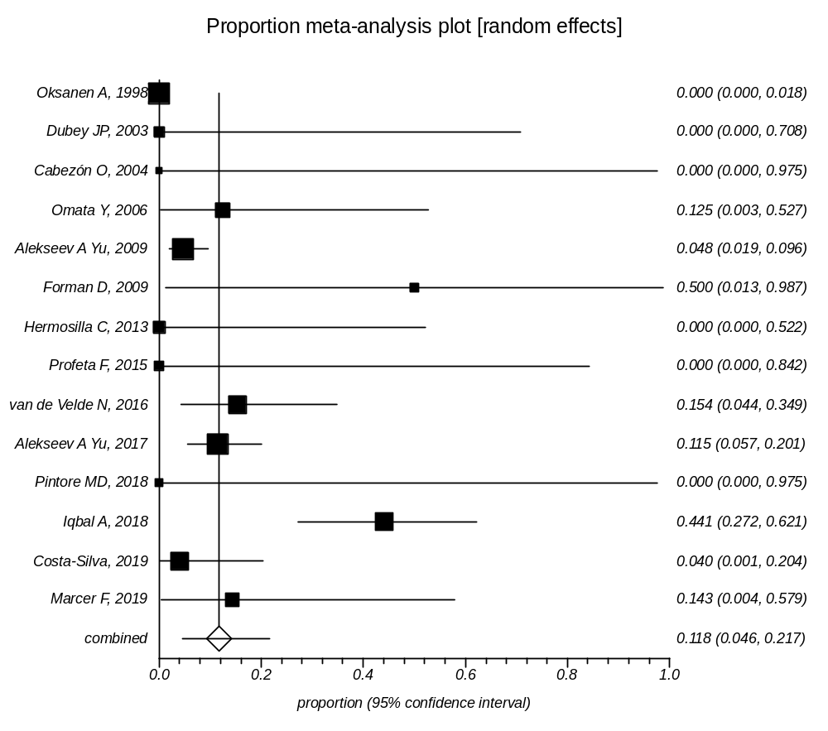
Supplementary Data 10: Forest plot of prevalence of Toxoplasma infection in Whale

