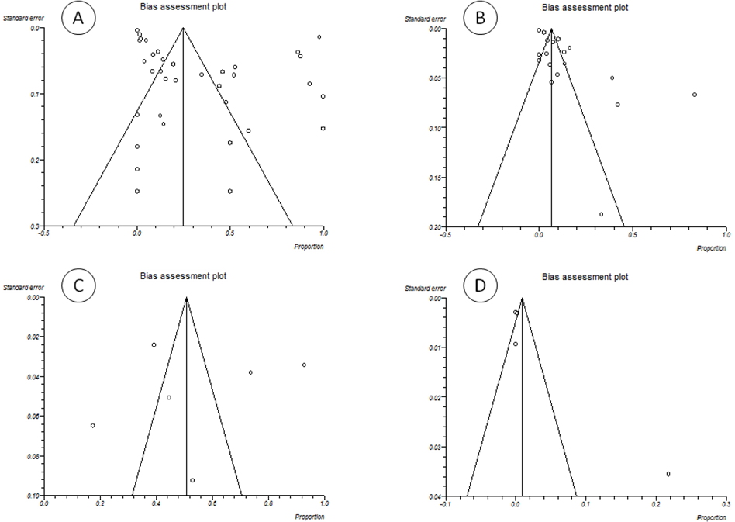
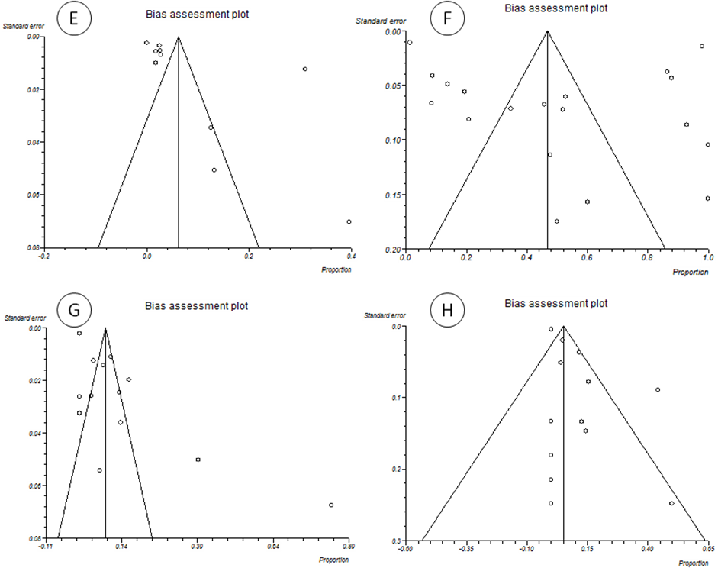
Supplementary Data 2. Funnel plot of standard error by logit event rate to assess publication or other types of bias across prevalence studies. A: Cetaceans, B: Pinniped, C: Marine fissipeds, D: Fishes, E: Mollusca, F: Dolphin, G: Seals, H: Whale.

