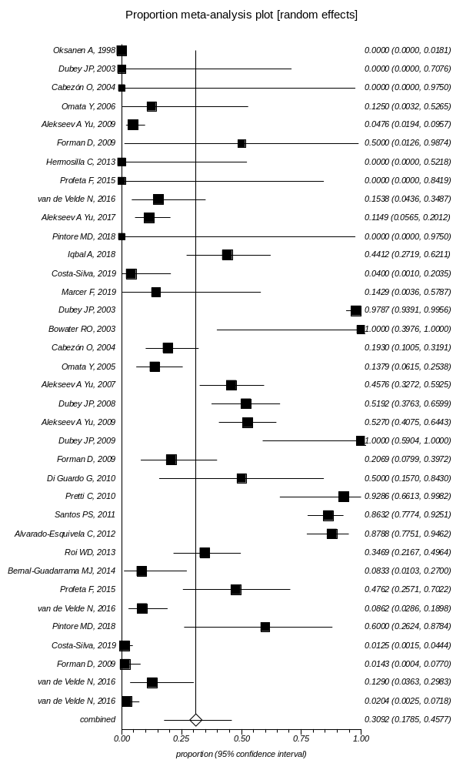
Supplementary Data 3: Forest plot of prevalence of Toxoplasma infection in Cetaceans

