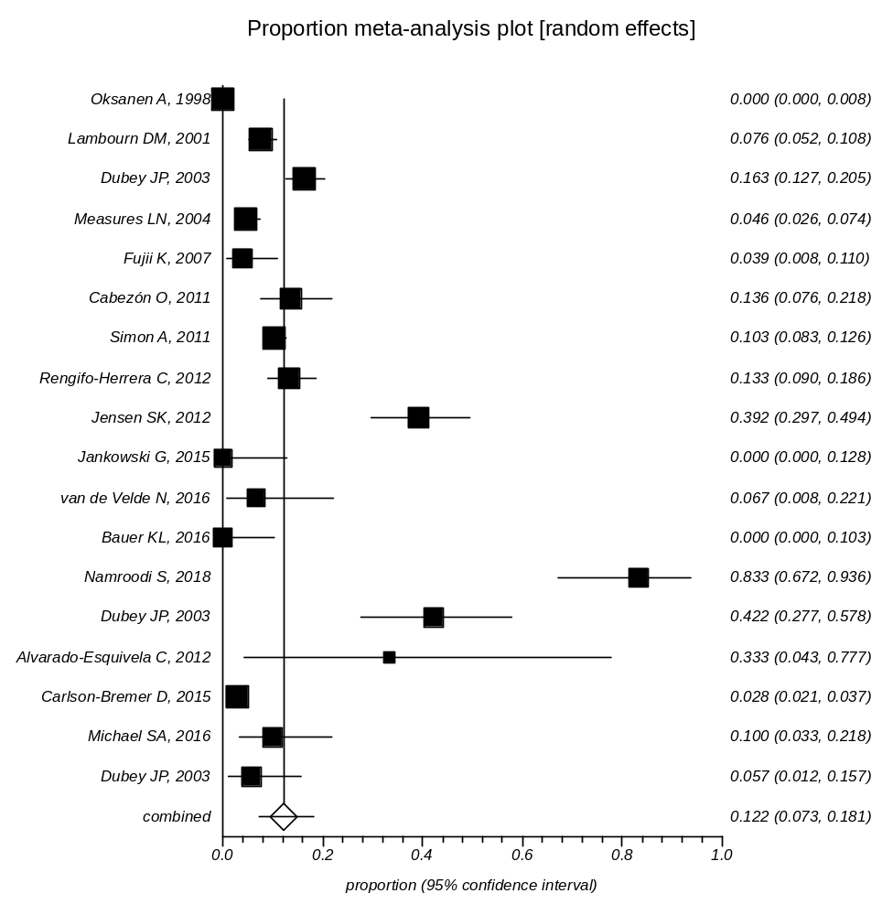
Supplementary Data 4: Forest plot of prevalence of Toxoplasma infection in Pinniped

