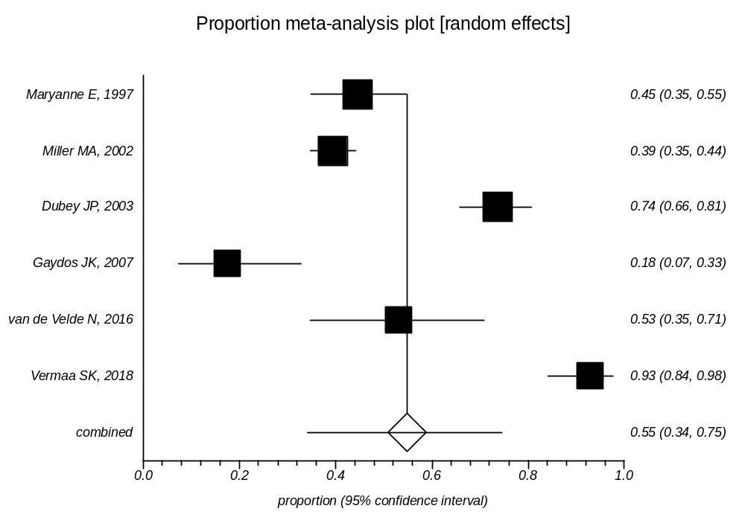
Supplementary Data 5: Forest plot of prevalence of Toxoplasma infection in Marine fissipeds

