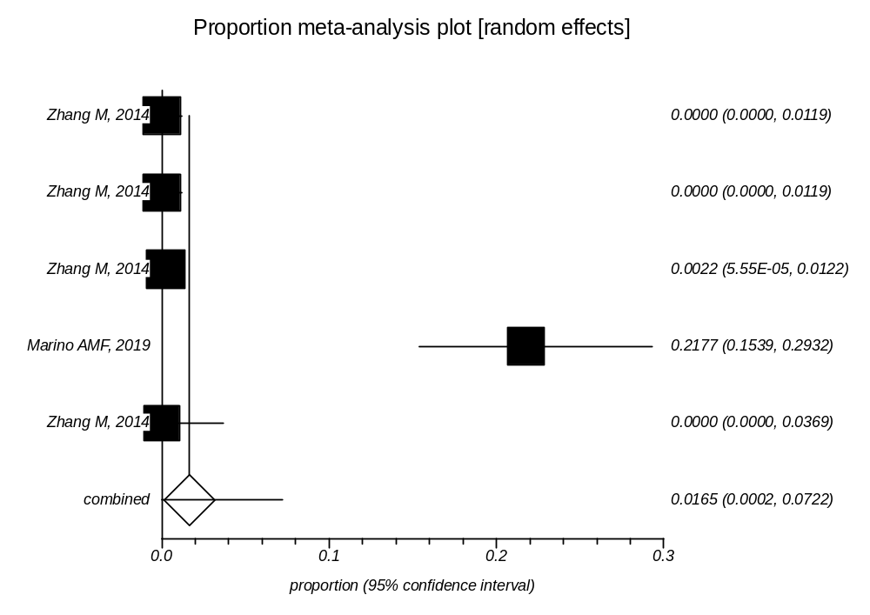
Supplementary Data 6: Forest plot of prevalence of Toxoplasma infection in Fishes

