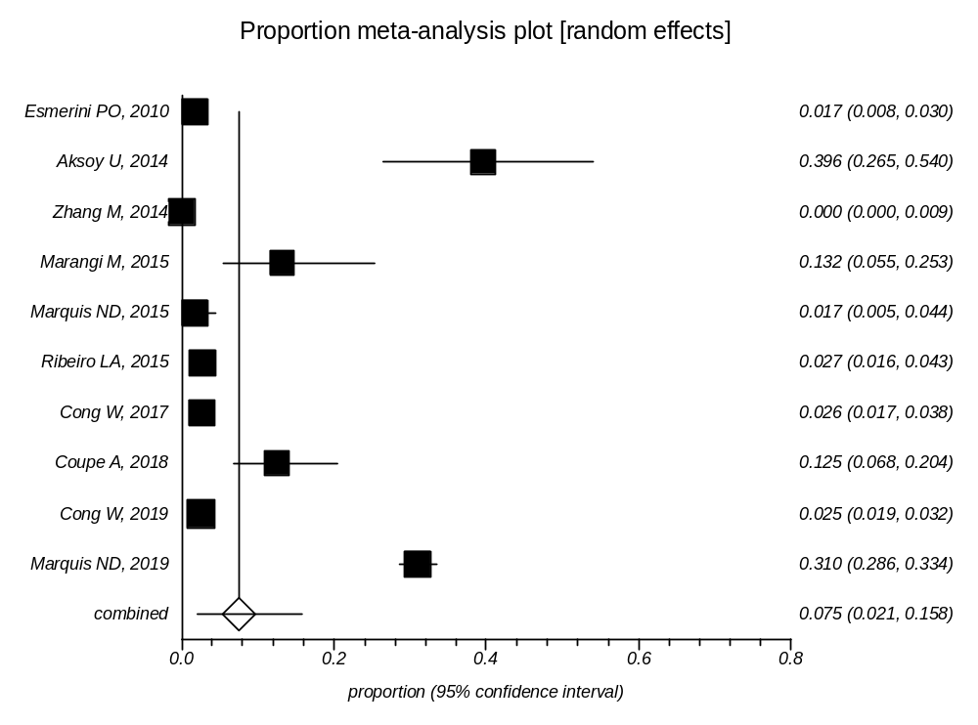

Supplementary Data 7: Forest plot of prevalence of Toxoplasma infection in Mollusca

