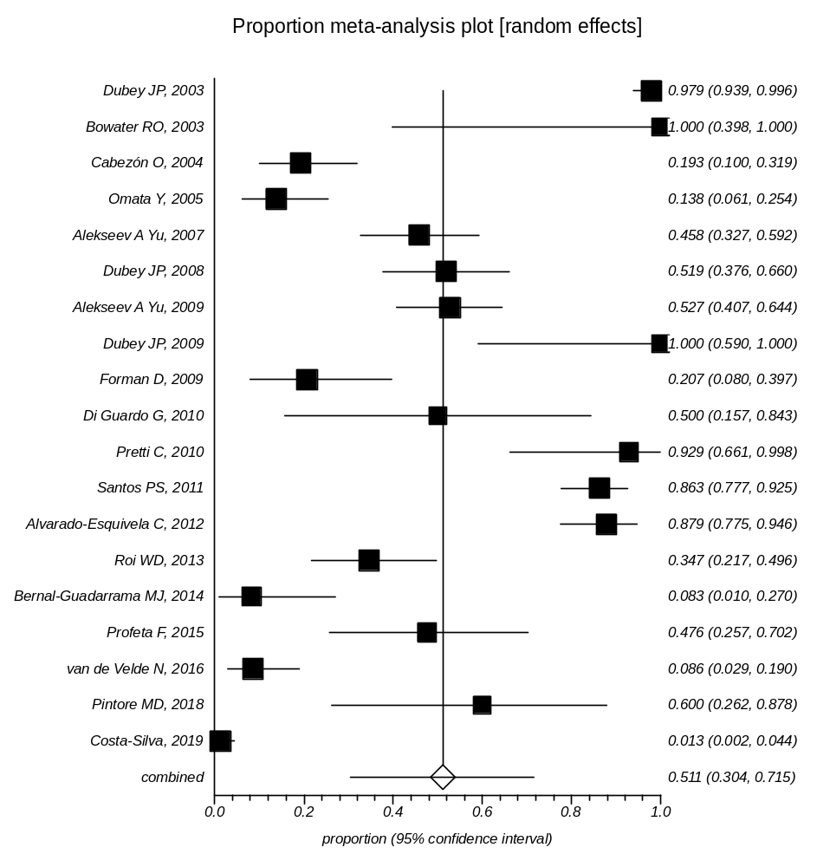
Supplementary Data 8: Forest plot of prevalence of Toxoplasma infection in Dolphin

