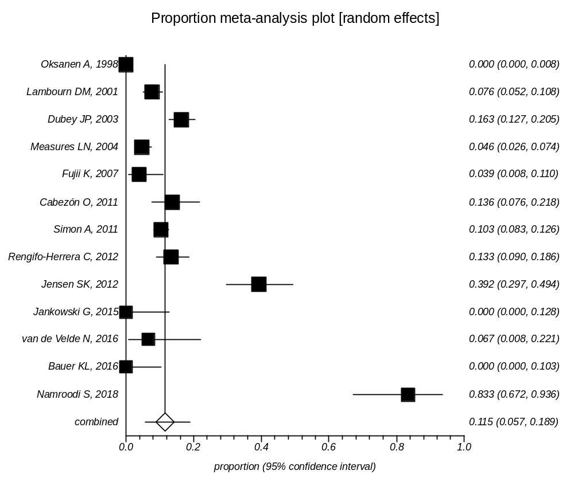
Supplementary Data 9: Forest plot of prevalence of Toxoplasma infection in Seals

