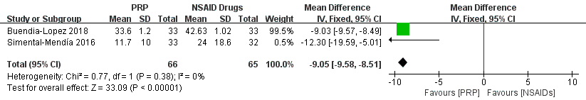
Figure S1 Forest plot analysis of WOMAC score at 6th month between PRP and NSAIDs.

