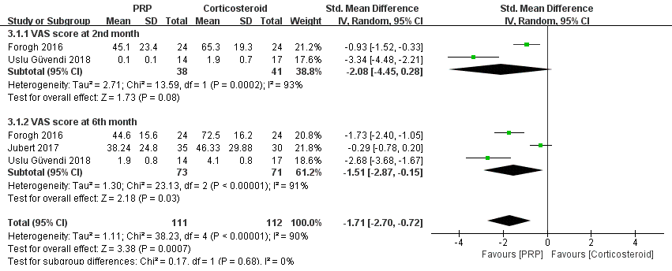
Figure S2 Forest plot analysis of VAS score between PRP and CS.

