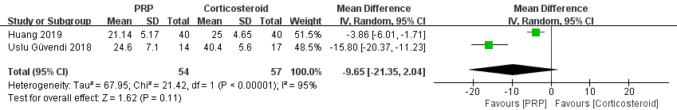
Figure S3 Forest plot analysis of WOMAC score at 6th month between PRP and CS.

