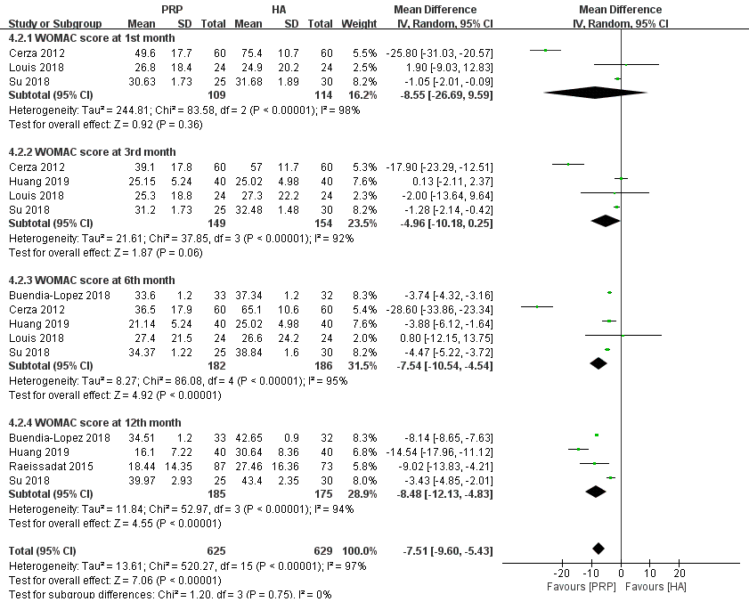
Figure S4 Forest plot analysis of WOMAC score between PRP and HA.

