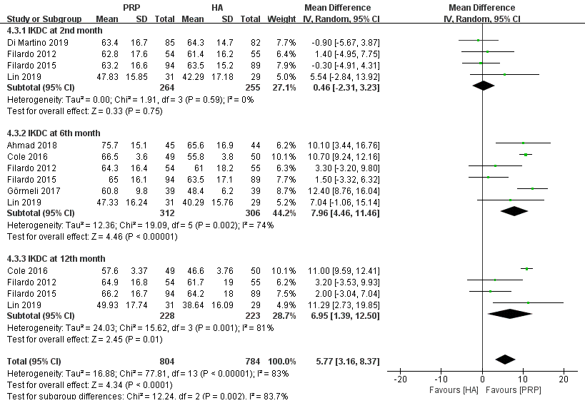
Figure S5 Forest plot analysis of IKDC subjective score between PRP and HA.

