Supplementary Online Content

eAppendix 1. Search Terms
eAppendix 2. Addition to Methods
eTable 1. Relevant Characteristics of all 44 RCTs Included in the Network Meta-analysis
eTable 2. Summary of Study Characteristics per Treatment Group
eTable 3. Risk of Bias for Each Included Study
eFigure 1. Risk of Bias Assessment
eTable 4. Indirectness for Each Included Study
eFigure 2. Indirectness
eTable 5: Confidence in Network Meta-analysis (CINEMA) Rating
eAppendix 3. Baseline Differences
eAppendix 4. Additional Results from Network Meta-analyses: Main Analyses
eAppendix 5. Additionals Results from Network Meta-analyses: Sensitivity Analyses
eAppendix 6. Additional Results from Pairwise Meta-analyses on Symptom Seveirty
eAppendix 7. Additional Results from Network Meta-analyses: Comparative Acceptability
eAppendix 8. Additional Results from Pairwise Meta-analyses on Comparative Acceptability
eAppendix 1. Search Terms

MEDLINE (Ovid)
Diagnosis | Exp Anxiety Disorders/
Diagnosis | ((trauma* adj3 stress) or (stress adj3 disorder*) or PTSD).tw.
Design | randomized controlled trial.pt. OR controlled clinical trial.pt. OR randomized.tw. OR placebo.tw. OR clinical trials as topic.sh. OR randomly.tw. OR trial.tw. OR groups.tw.
Intervention | self disclosure/
Intervention | (((express* or emotion* or guid* or experiment* or self or reflective*) adj3 (writ* or disclos* or express*)) or Pennebaker or ((psychotherap* or therap* or intervention* or disclos*) adj3 writ*) or interapy or ((computer or internet or web or journal*) adj5 (treatment* or therap* or intervention* or disclos*))).mp.

EMBASE (Ovid)
Diagnosis | posttraumatic stress disorder/
Diagnosis | ((trauma* adj3 stress) or (stress adj3 disorder*) or PTSD).tw.
Design | random*.mp. OR clinical trial*.mp. OR exp treatment outcome/ OR exp controlled clinical trial/
Intervention | self disclosure/
Intervention | (((express* or emotion* or guid* or experiment* or self or reflective*) adj3 (writ* or disclos* or express*)) or Pennebaker or ((psychotherap* or therap* or intervention* or disclos*) adj3 writ*) or interapy or ((computer or internet or web or journal*) adj5 (treatment* or therap* or intervention* or disclos*))).mp.

PsycINFO (Ovid)
Diagnosis | posttraumatic stress disorder/ OR emotional trauma/ OR stress reactions/ OR traumatic neurosis/ or child abuse/
Diagnosis | ((trauma* adj3 stress) or (stress adj3 disorder*) or PTSD).tw.
Design | exp Treatment Effectiveness Evaluation/ OR exp Treatment Outcomes/ OR *placebo/ OR exp followup studies/ OR placebo*.mp. OR random*.mp. OR "comparative stud*".mp. OR (clinical adj3 trial).mp. OR (evaluat* adj3 stud*).mp. OR (prospectiv* adj3 stud*).mp. OR ((singl* or doubl* or trebl* or tripl*) adj3 (blind* or mask*)).mp. OR (research adj3 design).mp.
Intervention | *self disclosure/
Intervention | (((express* or emotion* or guid* or experiment* or self or reflective*) adj3 (writ* or disclos* or express*)) or Pennebaker or ((psychotherap* or therap* or intervention* or disclos*) adj3 writ*) or interapy or ((computer or internet or web or journal*) adj5 (treatment* or therap* or intervention* or disclos*))).mp.

CENTRAL
Diagnosis | MeSH descriptor: [Stress, Psychological] this term only OR MeSH descriptor: [Stress Disorders, Traumatic] 1 tree(s) exploded
Diagnosis | (trauma* NEAR3 stress) OR (stress NEAR3 disorder*) OR PTSD
Design | -
Intervention | MeSH descriptor: [Self Disclosure] this term only
Intervention | (((express* or emotion* or guid* or experiment* or self or reflective*) NEAR3 (writ* or disclos* or express*)) or Pennebaker or ((psychotherap* or therap* or intervention* or disclos*) NEAR3 writ*) or interapy or ((computer or internet or web or journal*) NEAR5 (treatment or therap* or intervention* or disclos*)))
Additional Filter | Trials

eAppendix 2. Addition to Methods

A. Definition of Population

We included studies only if all study participants had experienced a traumatic event (as defined in DSM IV).
A study was considered to have included participants with full PTSD if at least 80% of all study participants fulfilled diagnostic criteria for PTSD (e.g., DSM III, DSM IV, or DSM 5) or if the authors described the sample as “participants with PTSD”. We considered a study to have included participants with subclinical / subthreshold / partial PTSD if authors gave a clear definition of subclinical of subthreshold PTSD. For instance, it was necessary to report symptoms above a pre-defined cutoff score for PTSD for inclusion in a particular study (e.g., scores above 33 in IES-R, above 45 on CAPS, above 44 on PCL, above 2.5 on HTQ), or study participants had to report experiencing at least one, but not all, of the symptom clusters of reexperiencing, avoidance or hyperarousal. For the presence of PTSD symptoms, we required the presence of elevated PTSD symptoms on a validated PTSD scale, however it was not required that all participants reported scores higher than a cut-off for PTSD. We included studies also if study authors described the sample as “participants with relevant PTSD symptoms”, for instance.

B. Definition of Trauma-focused Treatments

Definition of established psychotherapeutic PTSD treatments
Psychotherapeutic PTSD treatments had to be implemented at the level of individual patients, rather than in group, family, or couple therapy; they had to include face-to-face contact between the patient and the therapist, as opposed to telephone or internet-based interactions between patient and therapist; they had to be standardized (similar dose of treatment for all patients and treatment based on the same rational for all patients in one study); they had to consist primarily of verbal communication; and they had to directly address the trauma or subsequent PTSD symptoms. PTSD treatments were not considered for the analyses if they included experimental manipulations of an established treatment approach (e.g., dismantling of individual treatment components).

Definition of expressive writing treatments
We defined trauma-focused writing as a writing treatment that targeted the traumatic event the participant had experienced. We classified expressive writing treatments as 1st expressive writing (original; EW) and 2nd enhanced writing (EW+). We allowed any delivery method (e.g., paper and pencil, computerized, or internet-based intervention), as long as it was a purely written intervention and not mixed with any other intervention like verbal cognitive behavioral therapy.
EW: Authors either explicitly referred to the original paradigm by Pennebaker & Beale (1986),¹ or writing treatments were similarly structured as the original writing paradigm (e.g., 3 to 4 sessions of 15 to 30 minutes duration). Importantly, to be considered EW no therapist involvement was allowed. Also, no individualized instructions for each writing session were allowed.
EW+: The treatment description 1st did not explicitly refer to the original Pennebaker writing paradigm AND 2nd writing treatments included additional elements assumed to increase their efficacy: the treatments included either the presence of a therapist during writing sessions, or any therapist feedback. In many cases experimental manipulation of the writing content was used (e.g., more directive writing instructions which changed for each writing session). Enhanced writing treatments also typically used more or longer writing sessions compared with the original paradigm. However, the use of longer sessions alone was not sufficient to classify a writing treatment as enhanced.

Exclusion criteria
Writing treatments that were administered in addition to one of the writing treatments (EW or EW+), and which didn’t fulfill the criteria for neither EW nor EW+ (ie, not writing about one’s own trauma, not being allowed to read the written account, not being allowed to write about the same event every session) were excluded from the analyses.
Studies that used only experimental manipulations of formal aspects of the writing task (e.g., writing in the first person vs writing in the third person, e.g., Andersson & Conley, 2013; Kenardy & Tan, 2016)^{2,3} but which had no additional comparator were not included in the analyses.

C. Risk of Bias in the Included Studies

To evaluate the quality of studies and potential risk of bias (RoB), we rated to the predefined criteria in the “Cochrane Handbook for Systematic Reviews of Interventions”.⁴ For the application of the RoB criteria in the context of psychotherapy research, we adhered to the recommendations by Munder & Barth.⁵
For each included study the risk for five potential bias categories was assessed: 1st selection bias (sequence generation, and allocation sequence concealment), 2nd performance bias (use of only passive control, weiting intervention described as control, and non-equivalent duration of active interventions), 3rd detection bias (non-blind assessors in case of observer rated outcome assessment), 4th attrition bias (incomplete outcome dara, and inadequate analysis strategy, i.e. no intention-to-treat), and 5th reporting bias (no specification of one primary outcome, and results for some outcome measures not reported completely).
1st we rated “low” risk of selection bias, if both relevant categories (sequence generation and concealment of allocation were considered as “low”. Risk for selection bias was considered “high”, if both categories were considered “high” or one was considered “high” and one “unclear”. All other cases of mixed codings for the two categories were considered “unclear”. Sequence generation was considered adequate (i.e. low risk of bias), if participants were randomly assigned to treatment conditions stating a randomization procedure that ensured that similarity of groups at baseline was warranted (e.g., computerized random sequence generation). Concealment of allocation was considered adequate if the procedures described ensured that the investigators responsible for patient selection did not suspect which treatment was next before allocation (e.g., if allocation to treatments was conducted by an external third party).
2nd risk of performance bias was considered “low” if two equally credible treatments were compared, even if participants and treatment providers were not blinded. Risk of performance bias was rated “high”, if participants as well as assessors were not blinded and knew which therapy the participant received and if the treatments differed with respect to their credibility. The credibility rating was based on three sources of information: 1st the use of an active comparator, 2nd whether the writing intervention itself was described as a control treatment within the study, and 3rd whether the amount of treatment was comparable across the different treatment groups. If all three items were considered as “low” risk of bias, risk for performance bias was considered “low”, if all at least one item was considered high and none of the items was considered “low” risk of performance bias was considered “high”. In all other cases of mixed ratings risk of performance bias was considered “unclear”.
3rd risk of detection bias was rated “high” if outcome assessors knew which therapy a participant was assigned to (i.e., non-blind assessment of observer-rated outcomes). Risk of detection bias was considered “low” if only self-rated outcome measures were used⁵, or if observer-rated outcomes were assessed by blind assessors.
4th risk of attrition bias was considered “high” if missing outcome data varied largely across conditions and analyses were not conducted according to the intention to treat (ITT) principle. Risk of attrition bias was considered “low” if all participants were analysed as randomized. Incase of mixed or unclear evidence risk of attrition bias was considered “unclear”.
5th risk of reporting bias was considered “low” if a primary outcome was specified and results for effect size generation was reported for all mentioned outcome measures. Risk of reporting bias was considered “high”, if either data for effect size generation was not provided for all outcome measures or no orimary outcome was prespecified and nonw of the two relevant items was considered as “low” risk of bias. In cases of mixed evidence we considered risk of bias as “unclear”.
If relevant information on any quality criterion were not reported, or if the reported information was insufficient for a clear “high” or “low” rating we coded the respective criterion as “unclear”.
We rated a study as “high” regarding overall RoB, if one or more of the five dimensions were rated with “high” RoB. We rated a study as “low” regarding overall RoB, if all dimensions were rated “low”. In any other case we considered the study to have “some concerns” regarding RoB.

C. Indirectness

We rated the indirectness of the available evidence as recommended by Guyatt et al. 2011.⁶ We assessed whether 1st a study differed from the studies of interest with respect to 1st the relevant study population, 2nd the applied intervention, 3rd the evaluated outcomes, and 4th whether a study provided direct evidence for at least one of the comparisons of interest.
Overall indirectness was considered “low,” if at least 3 items were rated as “low” and maximum one item was rated “unclear”. If at least one item was rated “high” the overall rating could not be “low”. Overall indirectness was considered “high” if at least 2items were rated as “high” or 2 items were rated “high”. All other combinations were rated “moderate”.
It is important to note the difference between the rating of indirectness, ie the assessment whether a study reflects a typicaly study intended to be included in the meta-analysis, and indirect evidence, which refers to evidence which has not directliy been observed in a study, but can only be inferred from available evidence via indirect paths. This may for instance be the case if two treatments have never been compared in one study, but both have been compared with a third treatment. The comparisons with the third treatment can then be used to infer about the comparison between the two initial treatments.

D. Confidence in Network Meta-analysis (CINEMA)

We assessed the quality of the entire network using the CINEMA framework.⁷ This includes evaluations of within study bias, across study bias, indirectness, imprecision, heterogeneity and incoherence. The RoB rating was used for evaluating within study bias. For across study bias we assumed that the likelihood of unpublished data was small because we included dissertation theses and conducted our searches in 5 databases and screened the reference lists of previous relevant meta-analyses and systematic reviews. For the evaluation of indirectness, we used the rating as described above. For the evaluation of imprecision, heterogeneity and incoherence we defined the clinically important effect size as 0.6.⁸ For the overall rating of confidence we used the recommendations suggested by Guyatt et al., 2011.⁹

E. Hierarchy of PTSD Outcome Scales

1=IES,¹⁰ 2= IES-R,¹¹ 3=PDS,¹² 4=PCL-S/M/C,¹³ 5=CAPS,¹⁴ 6=other (see eTable 1)

F. Deviations from the published protocol

Deviations from the protocol¹⁰ include the following:
- We defined the analysis including the longest available follow-up as primary outcome in the manuscript, while initially planned the analyses using end-of-treatment data as primary outcome, because we expected all studies would report results at this time-point. Unexpectedly, a number of studies reported only data which were assessed more than one month after treatment termination, which we defined as long-term outcomes. In order to be able to include all studies in our main analysis, we defined the analysis using the longest available follow-up data as primary outcome data in our manuscript. Nevertheless, we report all results in Table 2 in our manuscript: 1. results relying on end-of-treatment data only, 2. results relying on longer-term data only and 3. results using the longest available follow-up (i.e. including all studies = our main analysis).
- We did not conduct the sensitivity analysis excluding studies that reported adjusted means, because the available information regarding adjustment of means was insufficient in the primary studies in order to allow for valid interpretations.
- Due to the very high levels of heterogeneity and inconsistency we conducted additional sensitivity analyses in order to explore sources of variation between treatment effects; we especially conducted an analysis excluding the two-arm comparisons between enhanced writing and waiting-list, which we describe in more detail as exploratory analyses in the manuscript, because this was the analysis in which the largest amount of heterogeneity and inconsistency were explained.
- We report risk ratios instead of odds ratios, as described in the protocol, because risk ratios were considered easier to interpret.

1. Pennebaker JW, Beall SK. Confronting a traumatic event: toward an understanding of inhibition and disease. Journal of Abnormal Psychology. 1986;95(3):274.
2. Andersson MA, Conley CS. Optimizing the perceived benefits and health outcomes of writing about traumatic life events. Stress and Health: Journal of the International Society for the Investigation of Stress. 2013;29(1):40-49.
3. Kenardy J, Tan L-J. The Role of Avoidance Coping in the Disclosure of Trauma. Behav Change. 2006;23(1):42-54.
4. Higgins JPT, Green S. Cochrane handbook for systematic reviews of interventions. In: Version 5.1.0 ed.: The Cochrane Collaboration; updated March 2011: www.cochrane-handbook.org.
5. Munder T, Barth J. Cochrane’s risk of bias tool in the context of psychotherapy outcome research. Psychotherapy Research. 2018;28(3):347-355.
6. Guyatt GH, Oxman AD, Kunz R, et al. GRADE guidelines: 8. Rating the quality of evidence—indirectness. J Clin Epidemiol. 2011;64(12):1303-1310.
7. Salanti G, Del Giovane C, Chaimani A, Caldwell DM, Higgins JPT. Evaluating the quality of evidence from a network meta-analysis. PLoS One. 2014;9(7):e99682.
8. Stefanovics EA, Rosenheck RA, Jones KM, Huang G, Krystal JH. Minimal clinically important differences (MCID) in assessing outcomes of post-traumatic stress disorder. Psychiatr Q. 2018;89(1):141-155.
9. Guyatt GH, Oxman AD, Vist G, et al. GRADE guidelines: 4. Rating the quality of evidence—study limitations (risk of bias). J Clin Epidemiol. 2011;64(4):407-415.
10. Horowitz M, Wilner N, Alvarez W. Impact of Event Scale: A measure of subjective stress. Psychosomatic Medicine. 1979;41(3):209-218.
11. Weiss D, Marmar C. The Impact of Event Scale-Revised. Wilson JP, Keane TM, editors. Assessing psychological trauma and PT-SD. New York Guliford Press; 1997.
12. Foa EB, Cashman L, Jaycox L, Perry K. The validation of a self-report measure of posttraumatic stress disorder: The Posttraumatic Diagnostic Scale. Psychol Assess. 1997;9(4):445-451.
13. Weathers FW, Huska JA, Keane TM. PCL-C for DSM-IV. Boston: National Center for PTSD-Behavioral Science Division. 1991.
14. Blake DD, Weathers FW, Nagy LM, et al. The development of a clinician-administered PTSD scale. J Trauma Stress. 1995;8(1):75-90.
15. Gerger H, Gaab J, Werner C. A network meta-analysis on the efficacy and acceptability of writing interventions for traumatised adults. PROSPERO International Prospective Register of Systematic Reviews [Internet]. 2018.
eTable 1. Relevant Characteristics of all 44 RCTs Included in the Network Meta-analysis
First author  (publication year) | Interventions  (number of patients at baseline) | Baseline M | PTSD severity measure | Treatment duration:  weeks / number of sessions | Reference to original paradigm / Therapist contact | Treatment drop-outs | Trauma type | Age  M | Sex female % | Time to last available follow-up
Gidron  (1996) | expressive writing (8),  neutral writing control (6) | M=40.0 (SD=5.5),  M=39.7 (SD=18.3) | IES | 3 days /  3 sessions | Explicit / no | NR | Mixed trauma | NR | 57 | 35 days
Greenbergª (1996) | real-trauma writing (34),  neutral writing control (28) | M=16.6 (SD=10.0),  M=12.5 (SD=10.0) | IES intrusion subscale | 1 day /  1 session | Similar but no reference / no | 6 | NR | 19 | 100 | 28 days
Barry*  (2001) | expressive writing (15),  waitlist control (15) | M=1.8 (SD=1.2),  M=1.3 (SD=1.0) ^{b} | IES-R | 4 days /  4 sessions | Similar but no reference / no | 10 | Newborn at NICU | 33 | 100 | 28 days
Batten*  (2001) | expressive writing (30),  neutral writing control (56) | M=14.1 (SD=8.0),  M=11.1 (SD=7.6) | TSI avoidance subscale | 1 week /  4 sessions | Similar but no reference / no | 6 | Sexual abuse / assault | 35 | 100 | 84 days
Lange  (2001) | Expressive writing (13),  waitlist control (12) | M=17.5 (SD=6.5),  M=13.6 (SD=7.0) | IES intrusion subscale | 5 weeks /  10 sessions | Enhanced writing / therapist feedback | 5 | Mixed trauma | 22 | 53 | 42 days
Yanko*ª  (2001) | own trauma realistic writing (24),  neutral writing control (22) | NR | IES | 3 days /  3 sessions | Similar bat no reference / no | 7 | Mixed trauma | 19 | 100 | 28 days
Largo-Marsh** (1996 / 2002) | expressive writing (12),  EMDR (12) | M=1.7 (SD=0.7),  M=2.1 (SD=0.6) ^{b} | IES intrusion subscale | NA /  up to 3 sessions | Enhanced writing / session with therapist | NR | Mixed trauma | 34 | 71 | 30 days
Schoutrop (2002) | expressive writing (26),  waitlist control (22) | M=15.6 (SD=5.1),  M=16.8 (SD=3.0) | IES intrusion subscale | 2 weeks /  5 sessions | Similar but no reference / no | NR | NR | 22 | 75 | 42 days
Lange  (2003) | expressive writing (69),  waitlist control (32) | M=20.2 (SD=7.5),  M=19.9 (SD=8.2) | IES intrusion subscale | 5 weeks /  10 sessions | Enhanced writing / therapist feedback | 44 | Mixed trauma | 39 | NR | 42 days
Deters  (2003) | expressive writing (30),  neutral writing control (27) | M=1.7 (SD=0.9),  M=1.6 (SD=0.9) ^{b} | IES-R | 2 weeks /  4 sessions | Similar but no reference / no | 0 | Mixed trauma | 23 | 73 | 42 days
Sloan  (2004) | expressive writing (26),  neutral writing control (23) | M=17.6 (SD=6.8),  M=16.6 (SD=5.3) | PDS | 3 days /  3 sessions | Explicit / no | 0 | Mixed trauma | 19 | 100 | 28 days
Koopman (2005) | expressive writing (25),  neutral writing control (22) | M=46.5 (SD=15.6),  M=44.3 (SD=14.0) | PCL-S | 4 week /  4 sessions | Similar but no reference / no | NR | Intimate partner violence | 37 | 100 | 122 days
Nguyen*  (2005) | expressive writing (30),  neutral writing control/waiting list (33) | M=2.0 (SD=0.6),  M=2.0 (SD=0.7) ^{b} | HTQ | 4 days /  4 sessions | Explicit / no | 0 | Ex-political detainees | 61 | 0 | 30 days
Sloanª  (2005) | same trauma writing (28),  neutral writing control (25) | M=20.0 (SD=6.1),  M=19.8 (SD=9.5) | PDS | 3 days /  3 sessions | Explicit / no | 0 | NR | 19 | 73 | 56 days
Freyd  (2005) | expressive writing (49),  neutral writing control (49) | M=79.3 (SD=20.3),  M=79.3 (SD=20.3) | TSC | 3 weeks /  3 sessions | Similar but no reference / no | 22 | Mixed trauma | 42 | 56 | 182 days
Wagner  (2006) | interapy (26),  waitlist control (25) | M=24.3 (SD=6.8),  M=26.6 (SD=4.9) | IES intrusion subscale | 5 weeks /  10 sessions | Enhanced writing / therapist feedback | 4 | Complicated grief | 37 | 93 | 91 days
Sloan  (2007) | emotional expression writing (28)^{c},  insight and cognitive writing (27)^{c},  neutral writing control (27) | M=20.7 (SD=9.1),  M=17.5 (SD=9.1),  M=17.3 (SD=5.7) | PDS | 3 days /  3 sessions | Similar but no reference / no | 1 | Mixed / trauma | 19 | 80 | 28 days
Knaevelsrud (2007) | interapy (49),  waitlist control (46) | M=23.0 (SD=6.4),  M=23.3 (SD=7.9) | IES-R | 5 weeks / 1  0 sessions | Enhanced writing / therapist feedback | 9 | Mixed trauma | 35 | 90 | 91 days
Possemato ** (2008 / 2010) | expressive writing (25),  neutral writing control (23) | M=37.0 (SD=12.0),  M=37.0 (SD=11.0) | PCL-C | 3 days /  3 sessions | Similar but no reference / no | 4 | Kidney transplant | 46 | 54 | 91 days
Resickª  (2008) | expressive writing (48),  CPT (53), | M=29.4 (SD=9.7),  M=29.2 (SD=9.5), | PDS | 6 weeks /  12 sessions | Enhanced writing / sessions with therapist | 40 | Mixed trauma | 35 | 100 | 182 days
Smyth  (2008) | expressive writing (14),  neutral writing control (10) | NR | PSS-I | 1 day /  3 sessions | Similar but no reference / no | 1 | Mixed trauma | NR | 56 | 91 days
van Emmerik (2008) | structured writing (44),  CBT (41),  waitlist control (41) | M=47.9 (SD=13.8),  M=46.4 (SD=12.3),  M=49.1 (SD=14.7) | IES | Acute PTSD:  5 weeks / 5 sessions  Chronic PTSD:  5 weeks /  10 sessions | Enhanced writing / sessions with therapist | NA | Mixed trauma | 40 | 67 | 500 days
Bugg  (2009) | expressive writing (31),  information control (36) | M=21.5 (SD=12.0),  M=22.0 (SD=9.8) | PDS | 3 days /  3 sessions | Explicit / no | 15 | Mixed trauma | 37 | 32 | 152 days
Kearns  (2010) | expressive writing,  neutral writing control (total 73) | M=34.6 (SD=15.8),  M=36.4 (SD=19.1) | TSC | 4 week /  4 sessions | Similar but no reference / no | 1 | Sexual abuse / assault | 19 | 100 | 30 days
Lichtenthal (2010) | expressive writing (16),^{c}  benefit-finding writing (17)^{c},  sense-making writing (19)^{c},  neutral writing control (16) | M=29.1 (SD=9.1),  M=27.5 (SD=8.6),  M=28.8 (SD=8.7),  M=31.6 (SD=10.7) | PCL-C | 2 weeks /  3 sessions | Explicit / no | NA | Significant interpersonal loss | 20 | 26 | 91 days
Beyer*  (2011) | instant message expressive writing (41)^{c},  expressive writing with feedback (41)^{c},  standard expressive writing (41),  neutral writing control (40) | M=1.9 (SD=0.9),  M=1.6 (SD=0.9),  M=2.2 (SD=1.1),  M=2.0 (SD=0.9) ^{b} | IES-R | 7-10 days /  3 sessions | Explicit / no | 16 | Mixed trauma | 22 | 83 | 42 days
Kersting  (2011) | expressive writing (45),  waitlist control (33) | M=33.1 (SD=13.2),  M=34.6 (SD=11.4) | IES | 5 weeks /  10 sessions | Enhanced writing / therapist feedback | 19 | Loss of child during pregnancy | 34 | 100 | 91 days
Slavin-Spennyª (2011) | active fascilitator writing (31)  expressive writing (36),  neutral writing control (34) | M=2.0 (SD=1.2),  M=2.0 (SD=1.1) ^{b} | IES intrusion subscale | 1 day /  1 session | Similar but no reference / no | 9 | NR | 22 | 82 | 42 days
Sloan  (2011) | expressive writing (21),  neutral writing control (21) | M=24.8 (SD=5.5),  M=25.2 (SD=5.2) | PDS | 3 days /  3 sessions | Explicit / no | 0 | Mixed / traumatic events | 19 | NA | 30 days
Zakowski (2011) | expressive writing (43),  neutral writing control (45) | M=8.3 (SD=8.0),  M=7.6 (SD=6.7) | IES avoidance subscale | 3 days /  3 sessions | Explicit / no | 10 | Gynaecological cancer | 58 | 100 | 7 days
Ironson  (2013) | augmented-trauma writing (120),  neutral writing control (122) | M=27.7 (SD=23.8),  M=28.7 (SD=23.5) | Davidson PTSD scale | 2-4 weeks /  4 sessions | Enhanced writing / no | 26 | NR | 43 | 39 | 365 days
Sloan  (2012) | expressive writing (22),  waitlist control (24) | M=61.4 (SD=15.0),  M=70.6 (SD=18.6) | CAPS | 5 weeks /  5 sessions | Enhanced writing / sessions with therapist | 2 | Mixed trauma | 41 | 65 | 91 days
Jensen-Johansen (2013) | expressive writing (243),  neutral writing control (243)  natural course (2912) | M=17.6 (SD=14.5),  M=20.2 (SD=15.9) | IES | 3 weeks /  3 sessions | Explicit / no | 18 | Treatment for breast cancer | 54 | 100 | 273 days
Kersting  (2013) | expressive writing (115),  waitlist control (113) | M=30.5 (SD=12.0),  M=31.7 (SD=11.6) | IES-R | 5 weeks /  10 sessions | Enhanced writing / therapist feedback | 29 | Loss of child during pregnancy | 34 | 92 | 365 days
Milbury  (2014) | expressive writing (138),  neutral writing control (139) | M=17.8 (SD=15.1),  M=19.6 (SD=15.0) | IES | 10 days /  4 sessions | Explicit / no | 66 | Renal cell carcinoma | 61 | 41 | 304 days
Southern* (2014) | narrative writing (10)^{c},  repeated expressive writing (8)^{c},  neutral writing control (10) | M=2.3 (SD=1.0),  M=2.1 (SD=0.9),  M=2.7 (SD=0.8) ^{b} | IES-R | 4 days /  4 sessions | Similar but no reference other group/ no | 50 | Domestic violence | 37 | 100 | 30 days
Truijensª  (2014) | written imaginal exposure (20),  neutral writing control (19) | M=49.1 (SD=12.1),  M=46.9 (SD=12.3) | IES | 1 day /  1 session | Similar but no reference / no | 0 | Mixed trauma | 24 | 78 | 7 days
Stockton (2014) | expressive writing (14),  neutral writing control (10) | M=19.9 (SD=7.1),  M=13.3 (SD=10.2) | IES intrusion subscale | 9 days /  3 sessions | Explicit / no | 19 | Mixed trauma | 33 | 22 | 42 days
Sayer  (2015) | expressive writing (508),  neutral writing control (507),  waitlist control (277) | Med=36.0 (IQR=25.5-50.0),  Med=35.0 (IQR=25.0-51.0),  Med=39.0 (IQR=28.0-51.0) | PCL-M | 10 days /  4 sessions | Explicit / no | 220 | Veterans of Afghanistan and Iraque wars | 37 | 39 | 182 days
Knaevelsrud (2015) | interapy (79),  waitlist control (80) | M=30.4 (SD=8.2),  M=30.7 (SD=8.1) | PDS | 5 weeks /  10 sessions | Enhanced writing / therapist feedback | 65 | War | 28 | 72 | 91 days
Horsch  (2016) | expressive writing (33),  treatment as usual (32) | M=4.1 (SD=2.9),  M=4.1 (SD=3.2) ^{b} | PPQ | 3 days /  3 sessions | Explicit / no | 4 | Very preterm birth | 32 | 100 | 91 days
Alessandri* (2017) | expressive writing (44),  directive protocol (42) | M=41.0 (SD=20.6),  M=36.4 (SD=)19.6 | MPSSR-SR | 3 days /  3 sessions | Similar but no reference / no | 1 | Mixed traumat | 20 | 77 | 30 days
Knaevelsrud (2017) | integrative testimonial therapy (47),  waitlist control (47) | M=22.8 (SD=8.8),  M=21.9 (SD=8.8) | PDS | 6 weeks /  11 sessions | Enhanced writing / therapist feedback | 9 | War (WW II) | 71 | 65 | 365 days
Sloan***  (2018) | written exposure therapy (63),  cognitive processing therapy (63) | M=36.1 (SD=8.9),  M=37.1 (SD=10.0) | CAPS | 12 weeks / 12 sessions | Enhanced writing / sessions with therapist | 29 | Mixed trauma | 44 | 48 | 420 days
CAPS, Clinician Administered PTSD Scale;¹ CBT, cognitive behavioral therapy; EMDR, eye movement desensitization and reprocessing; DTS, Davidson PTSD scale,² HTQ, Harvard Trauma Questionnaire;³ IES, Impact of Event Scale;⁴ IES-R, Impact of Event Scale-Revised;⁵ M, mean; MPSS-SR, Modified PTSD Symptoms Scale-Self Report;⁶ NR, nor teported; PCL, PTSD Checklist;⁷ PDS, Posttraumatic Diagnostic Scale;⁸ PPQ, Perinatal PTSD Questionnaire;⁹ PTSD, posttraumatic stress disorder; PSS-I, PTSD Symptom Scale Interview;¹⁰ SD, standard deviation; TSI, Trauma Symptom Inventory;¹¹ TSC, Trauma Symptom Checklist;¹²
ª In these studies additional groups were included, which did not match with the definition of either defined treatment group. They were omitted from the analyses.
^{b} In these studies means and standard deviations were calculated as the average of each item (not as the sum scores of the questionnaire/scale)
^{c} If two treatments within one category were considered very similar, they were combined.
* Dissertation thesis
** Published article and dissertation thesis identified
*** The latest follow-up data for this study was extracted from an additional published article (Thompson-Hollands J, Marx BP, Lee DJ, Resick PA,Sloan DM. Long-term treatment gains of a brief exposure -based treatment for PTSD. Depression Anxiety. 2018; 35; 985-991.).
1 Blake DD, Weathers FW, Nagy LM, et al. The development of a clinician-administered PTSD scale. J Trauma Stress. 1995;8(1):75-90.
2 Davidson, J. R. T., Book, S. W., Colket, J. T., Tupler, L. A., Roth, S., David, D., Hertzberg, M., Mellman, T., Beckham, J. C., Smith, R., Davison, R. M., Katz, R., & Feldman, M. (1997). Assessment of a new self-rating scale for post-traumatic stress disorder. Psychological Medicine, 27, 153-160.
3 Mollica RF, Caspi-Yavin Y, Bollini P, Truong T, Tor S, Lavelle J. The Harvard Trauma Questionnaire: validating a cross-cultural instrument for measuring torture, trauma, and posttraumatic stress disorder in Indochinese refugees. J Nerv Ment Dis. 1992.
4 Horowitz M, Wilner N, Alvarez W. Impact of Event Scale: A measure of subjective stress. Psychosomatic Medicine. 1979;41(3):209-218.
5 Weiss D, Marmar C. The Impact of Event Scale-Revised. Wilson JP, Keane TM, editors. Assessing psychological trauma and PT-SD. New York Guliford Press; 1997.
6 Falsetti SA, Resnick HS, Resick PA, Kilpatrick DG. The modified PTSD symptom scale: a brief self-report measure of posttraumatic stress disorder. The Behavior Therapist. 1993.
7 Weathers FW, Huska JA, Keane TM. PCL-C for DSM-IV. Boston: National Center for PTSD-Behavioral Science Division. 1991.
8 Foa EB, Cashman L, Jaycox L, Perry K. The validation of a self-report measure of posttraumatic stress disorder: The Posttraumatic Diagnostic Scale. Psychol Assess. 1997;9(4):445-451.
9 DeMier RL, Hynan MT, Harris HB, Manniello RL. Perinatal stressors as predictors of symptoms of posttraumatic stress in mothers of infants at high risk. J Perinatol. 1996;16(4):276–280.
10 Foa EB, Riggs DS, Dancu CV. Reliability and validity of a brief instrument for assessing posttraumatic stress disorder. Journal of Traumatic Stress. 1993; 6; 459-473.
11 Briere J, Elliott DM, Harris K, Cotman A. Trauma symptom inventory. Journal of Interpersonal Violence. 1995;10(4): 387-401.
12 Briere J, Runtz M. The Trauma Symptom Checklist (TSC-33) early data on a new scale. Journal of Interpersonal Violence. 1989;4(2):151-163.

eTable 2. Summary of Study Characteristics per Treatment Group

Treatment group | Number of studies | Days of treatment | Treatment sessions | Age | Gender | PTSD Diagnosis | Time to follow up | Sample size | Mixed trauma | Treatment described as control | Treatment location
 |  | Mean of study means | Mean of study means | Mean of study means | Mean of study means | Percent of studies with full or subthreshholdPTSD diagnosis | Median of study means | Median of study means | Percent of studies with no restricted trauma type | Number of studies (%) | Percent of studies with home-based treatment
EW | 30 | 7.7 | 3.17 | 31.75 | 72.55 | 33.33 | 42 | 29 | 56.67 | 1 (3.33) | 36.67
EW+ | 15 | 35 | 8.47 | 37.27 | 74.14 | 32 | 91 | 47 | 66.67 | 1 (6.67) | 60
NW | 25 | 8.92 | 3.08 | 31.61 | 73.29 | 30.43 | 42 | 27 | 60 | 25 (100) | 40
PT | 6 | 33 | 6.3 | 32.5 | 74.17 | 83.33 | 112 | 42 | 100 | 1 (16.67) | 0
WL | 23 | - | - | 38.65 | 71.44 | 66.67 | 91 | 33 | 30.43 | 23 (100) | not applicable
- not assessed; EW, expressive writing; EW+, enhanced writing; NW, neutral writing; PT, psychotherapy; WL, waiting list

eTable 3. Risk of Bias for Each Included Study (Sorted by Publication Year)

Author | Publication year | Selection bias | Performance bias | Detection bias | Attrition bias | Reporting bias | Total RoB
Gidron | 1996 | unclear | low | low | unclear | unclear | some concerns
Greenberg | 1996 | unclear | low | low | high | unclear | high
Barry* | 2001 | high | high | low | unclear | high | high
Batten* | 2001 | low | low | low | high | high | high
Lange | 2001 | low | high | low | high | unclear | high
Yanko* | 2001 | unclear | unclear | low | unclear | high | high
Largo-Marsh** | 2002 | high | unclear | low | low | unclear | high
Schoutrop | 2002 | unclear | high | low | low | unclear | high
Lange | 2003 | low | high | low | high | unclear | high
Deters | 2003 | unclear | low | low | high | unclear | high
Sloan | 2004 | unclear | low | low | unclear | unclear | some concerns
Koopman | 2005 | unclear | low | low | unclear | unclear | some concerns
Nguyen* | 2005 | low | high | low | unclear | low | high
Sloan | 2005 | unclear | low | low | high | unclear | high
Freyd | 2005 | unclear | low | low | high | high | high
Wagner | 2006 | low | high | low | high | unclear | high
Sloan | 2007 | unclear | low | low | high | unclear | high
Knaevelsrud | 2007 | unclear | high | low | unclear | low | high
Possemato** | 2008 | low | low | low | high | unclear | high
Resick | 2008 | unclear | low | low | high | unclear | high
Smyth | 2008 | unclear | low | unclear | high | high | high
van Emmerik | 2008 | low | unclear | low | unclear | unclear | some concerns
Bugg | 2009 | unclear | high | low | high | low | high
Kearns | 2010 | unclear | low | low | high | low | high
Lichtental | 2010 | high | low | low | high | unclear | high
Beyer | 2011 | low | low | low | unclear | low | some concerns
Kersting | 2011 | unclear | high | low | high | unclear | high
Slavin-Spenny | 2011 | low | low | low | low | unclear | some concerns
Sloan | 2011 | unclear | low | low | unclear | unclear | some concerns
Zakowski | 2011 | unclear | low | low | high | high | high
Ironson | 2012 | unclear | low | low | low | unclear | some concerns
Sloan | 2012 | low | high | low | low | low | high
Jensen-Johansen | 2013 | low | low | low | unclear | unclear | some concerns
Kersting | 2013 | unclear | high | low | unclear | low | high
Milbury | 2014 | low | low | low | low | unclear | some concerns
Southern* | 2014 | unclear | low | low | high | low | high
Truijens | 2014 | unclear | low | low | unclear | low | some concerns
Stockton* | 2014 | high | low | low | high | low | high
Sayer | 2015 | low | low | low | low | unclear | some concerns
Knaevelsrud | 2015 | low | high | low | low | low | high
Horsch | 2016 | low | high | low | unclear | low | high
Alessandri* | 2017 | low | unclear | low | unclear | low | some concerns
Knaevelsrud | 2017 | low | high | low | low | low | high
Sloan | 2018 | low | unclear | low | low | low | some concerns
* Dissertation; ** Published article and dissertation thesis identified

eFigure 2. Risk of Bias Contributions

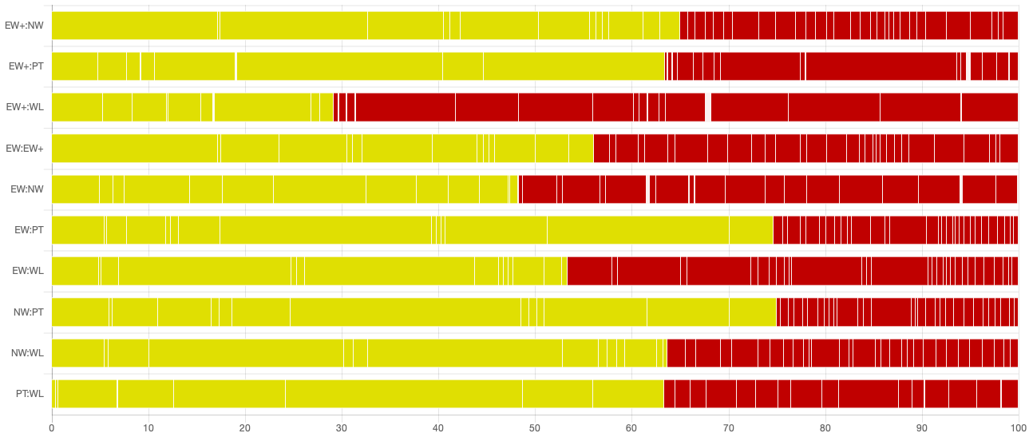

Proportion of evidence that is considered at low (green), moderate (yellow), and high risk of bias (red); EW, expressive writing; EW+, enhanced writing; NW, neutral writing; PT, psychotherapy; WL, waiting list

eTable 4. Indirectness for Each Included Study (Sorted by Publication Year)

Author | Publication year | Population | Intervention | Outcomes | Comparisons | Indirectness total
Gidron | 1996 | low | low | low | low | low
Greenberg | 1996 | high | unclear | low | low | moderate
Barry* | 2001 | high | low | low | low | moderate
Batten* | 2001 | high | low | low | low | moderate
Lange | 2001 | unclear | high | low | low | moderate
Yanko* | 2001 | high | low | low | low | moderate
Largo-Marsh** | 2002 | low | high | low | low | moderate
Schoutrop | 2002 | unclear | unclear | low | low | moderate
Lange | 2003 | low | high | low | low | moderate
Deters | 2003 | unclear | low | low | low | low
Sloan | 2004 | high | low | low | low | moderate
Koopman | 2005 | high | low | low | low | moderate
Nguyen* | 2005 | high | low | low | low | moderate
Sloan | 2005 | unclear | low | low | low | low
Freyd | 2005 | unclear | unclear | low | low | moderate
Wagner | 2006 | high | high | low | low | high
Sloan | 2007 | unclear | low | low | low | low
Knaevelsrud | 2007 | low | high | low | low | moderate
Possemato** | 2008 | high | low | low | low | moderate
Resick | 2008 | high | high | low | low | high
Smyth | 2008 | low | unclear | high | low | moderate
van Emmerik | 2008 | low | unclear | low | low | moderate
Bugg | 2009 | unclear | low | low | low | low
Kearns | 2010 | high | low | low | low | moderate
Lichtental | 2010 | unclear | low | low | low | low
Beyer | 2011 | high | low | low | low | moderate
Kersting | 2011 | high | high | low | low | high
Slavin-Spenny | 2011 | unclear | unclear | low | low | moderate
Sloan | 2011 | unclear | low | unclear | low | moderate
Zakowski | 2011 | high | low | low | low | moderate
Ironson | 2012 | high | high | low | low | high
Sloan | 2012 | unclear | high | high | low | high
Jensen-Johansen | 2013 | high | low | low | low | moderate
Kersting | 2013 | high | high | low | low | high
Milbury | 2014 | high | low | low | low | moderate
Southern* | 2014 | high | low | low | low | moderate
Truijens | 2014 | low | unclear | low | low | low
Stockton* | 2014 | high | low | low | low | moderate
Sayer | 2015 | high | low | low | low | moderate
Knaevelsrud | 2015 | high | high | low | low | high
Horsch | 2016 | high | low | low | low | moderate
Alessandri* | 2017 | unclear | low | low | low | low
Knaevelsrud | 2017 | high | high | low | low | high
Sloan | 2018 | low | high | high | low | high
* Dissertations; ** Published article and dissertation thesis identified

eFigure 3. Indirectness Contributions

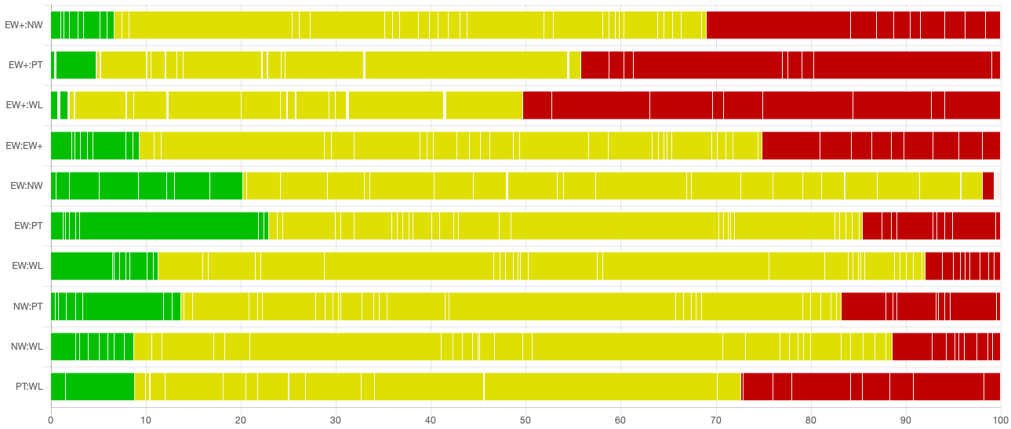

Proportion of evidence that is contributed by studies which are considered low (green), moderate (yellow), or high red) regarding indirectness; EW, expressive writing; EW+, enhanced writing; NW, neutral writing; PT, psychotherapy; WL, waiting list

eTable 5: Confidence in Network Meta-analysis (CINEMA) Rating

Comparison | Number of studies | Within-study biasª | Across-studies bias^{b} | Indirectness^{c} | Imprecision^{d} | Heterogeneity^{d} | Incoherence^{d} | Confidence rating
EW:EW+ | 1 | Some concerns | Undetected | Some concerns | No concerns | Some concerns | No concerns | Moderate
EW:NW | 24 | Major concerns | Undetected | Some concerns | No concerns | Some concerns | No concerns | Low
EW:PT | 2 | Some concerns | Undetected | Some concerns | No concerns | Some concerns | No concerns | Moderate
EW:WL | 7 | Some concerns | Undetected | Some concerns | No concerns | Some concerns | No concerns | Moderate
EW+:NW | 2 | Some concerns | Undetected | Some concerns | No concerns | Some concerns | Some concerns | Moderate
EW+:PT | 4 | Some concerns | Undetected | Some concerns | No concerns | Major concerns | No concerns | Low
EW+:WL | 10 | Major concerns | Undetected | Major concerns | No concerns | No concerns | Some concerns | Low
NW:PT | 1 | Some concerns | Undetected | Some concerns | No concerns | Some concerns | No concerns | Moderate
NW:WL | 2 | Some concerns | Undetected | Some concerns | No concerns | Some concerns | Some concerns | Moderate
PT:WL | 1 | Some concerns | Undetected | Some concerns | No concerns | No concerns | No concerns | Moderate
EW, expressive writing; EW+, enhanced writing; NW, neutral writing; PT, psychotherapy; WL, waiting list
ª Risk of bias assessment (see eAppendix 2 for a more detailed description)
^{b} We assumed that the likelihood of unpublished data was small because we included dissertation theses and conducted our searches in 5 databases and screened the reference lists of previous relevant meta-analyses and systematic reviews.
^{c} Indirectness rating (see eAppendix 2 for a more detailed description)
^{d} For the evaluation of imprecision, heterogeneity and incoherence we defined the clinically important effect size as 0.6.

eAppendix 3. Baseline Differences

##########################################################################
> ## ------------------------------------------------------BASELINE--------

Original data (with adjusted standard errors for multi-arm studies):

treat1 treat2 TE seTE seTE.adj narms multiarm
ew004 EW WL 0.3726 0.3688 0.3688 2
ew005 EW NW 0.3748 0.2705 0.2705 2
ew006 EW NW 0.1658 0.2301 0.3206 3 *
ew006 EW+ NW -0.3328 0.2040 0.2385 3 *
ew006 EW EW+ 0.4993 0.1986 0.2289 3 *
ew009 EW WL -0.0436 0.2451 0.2451 2
ew017 EW NW 0.0224 0.5401 0.5401 2
ew018 EW NW 0.4105 0.2580 0.2580 2
ew023 EW WL -0.0162 0.2481 0.2481 2
ew024 EW+ NW -0.0405 0.1286 0.1286 2
ew025 EW NW -0.1642 0.0909 0.2593 3 *
ew025 EW WL -0.1580 0.0665 0.0686 3 *
ew025 NW WL 0.0063 0.0665 0.0686 3 *
ew026 EW NW -0.1021 0.2342 0.2342 2
ew028 EW+ WL -0.0971 0.1325 0.1325 2
ew029 EW+ WL -0.1190 0.2294 0.2294 2
ew030 EW NW 0.1454 0.2927 0.2927 2
ew032 EW+ WL 0.0398 0.2139 0.2139 2
ew034 EW+ WL 0.5592 0.4095 0.4095 2
ew036 EW+ PT -0.6936 0.4227 0.4227 2
ew044 EW NW -0.1193 0.1203 0.1203 2
ew048 EW WL 0.0048 0.2523 0.2523 2
ew054 EW NW 0.0000 0.2889 0.2889 2
ew055 EW+ PT 0.0897 0.2064 0.2064 2
ew060 EW NW 0.0063 0.0628 0.0708 3 *
ew060 EW WL -0.0806 0.0747 0.0959 3 *
ew060 NW WL -0.0870 0.0747 0.0960 3 *
ew061 EW WL -0.2763 0.2912 0.2912 2
ew064 EW PT -0.2067 0.2457 0.3020 3 *
ew064 NW PT -0.1797 0.2489 0.3103 3 *
ew064 EW NW -0.0270 0.2392 0.2869 3 *
ew065 EW NW 0.1602 0.2867 0.2867 2
ew066 EW+ WL -0.5442 0.3011 0.3011 2
ew067 EW NW 0.0250 0.2752 0.2752 2
ew068 EW NW 0.2211 0.2357 0.2357 2
ew069 EW NW -0.0733 0.3087 0.3087 2
ew071 EW NW 0.0000 0.4140 0.4140 2
ew073 EW NW -0.5146 0.4013 0.4013 2
ew075 EW NW -0.1285 0.3207 0.3207 2
ew078 EW+ PT 0.1068 0.2172 0.2643 3 *
ew078 PT WL -0.1990 0.2214 0.2749 3 *
ew078 EW+ WL -0.0923 0.2172 0.2642 3 *
ew082 EW NW 0.0000 0.2952 0.2952 2
ew083 EW NW 0.0892 0.2134 0.2134 2
ew084 EW PT 0.2323 0.2165 0.2165 2
ew086 EW NW 0.0987 0.2654 0.2654 2
ew087 EW NW 0.0000 0.2020 0.2020 2
ew088 EW+ WL -0.0416 0.2053 0.2053 2
ew089 EW+ WL -0.0367 0.1586 0.1586 2
ew090 EW+ WL 0.0997 0.2064 0.2064 2
ew092 EW NW -0.3379 0.2874 0.2874 2
ew093 EW+ PT -0.1045 0.1783 0.1783 2
ew094 EW NW 0.7469 0.4305 0.4305 2
ew095 EW+ WL -0.3811 0.2829 0.2829 2

Number of studies: k = 44
Number of treatments: n = 5
Number of pairwise comparisons: m = 54
Number of designs: d = 10

Random effects model

Treatment estimate (sm = 'SMD'):
EW EW+ NW PT WL
EW . 0.0628 -0.0053 0.0288 -0.0601
EW+ -0.0628 . -0.0680 -0.0339 -0.1229
NW 0.0053 0.0680 . 0.0341 -0.0549
PT -0.0288 0.0339 -0.0341 . -0.0890
WL 0.0601 0.1229 0.0549 0.0890 .

Lower 95%-confidence limit:
EW EW+ NW PT WL
EW . -0.0572 -0.0766 -0.1583 -0.1375
EW+ -0.1827 . -0.1859 -0.2116 -0.2293
NW -0.0661 -0.0498 . -0.1546 -0.1338
PT -0.2159 -0.1437 -0.2228 . -0.2739
WL -0.0172 0.0165 -0.0241 -0.0960 .

Upper 95%-confidence limit:
EW EW+ NW PT WL
EW . 0.1827 0.0661 0.2159 0.0172
EW+ 0.0572 . 0.0498 0.1437 -0.0165
NW 0.0766 0.1859 . 0.2228 0.0241
PT 0.1583 0.2116 0.1546 . 0.0960
WL 0.1375 0.2293 0.1338 0.2739 .

Quantifying heterogeneity / inconsistency:
tau^2 = 0; I^2 = 0%

Tests of heterogeneity (within designs) and inconsistency (between designs):
Q d.f. p-value
Total 37.53 45 0.7778
Within designs 27.73 35 0.8041
Between designs 9.80 10 0.4585

eAppendix4: Aditional Results from Network Meta-analyses: Main Analyses

##########################################################################
> ## ---------------------------------------Longest available FU----------

Original data (with adjusted standard errors for multi-arm studies):

treat1 treat2 TE seTE seTE.adj narms multiarm
ew004 EW WL -0.7098 0.3782 0.3782 2
ew005 EW NW 0.6342 0.2751 0.2751 2
ew006 EW NW -0.0393 0.2298 0.3234 3 *
ew006 EW+ NW -0.1480 0.2030 0.2369 3 *
ew006 EW EW+ 0.1086 0.1959 0.2246 3 *
ew009 EW WL -0.3373 0.2827 0.2827 2
ew017 EW NW 0.6849 0.5612 0.5612 2
ew018 EW NW 0.1985 0.2559 0.2559 2
ew023 EW WL -0.4167 0.2755 0.2755 2
ew024 EW+ NW 0.0088 0.1523 0.1523 2
ew025 EW NW -0.0329 0.0965 0.2693 3 *
ew025 EW WL -0.0396 0.0719 0.0745 3 *
ew025 NW WL -0.0066 0.0695 0.0717 3 *
ew026 EW NW 0.1367 0.2344 0.2344 2
ew028 EW+ WL -0.8815 0.1388 0.1388 2
ew029 EW+ WL -0.8398 0.2742 0.2742 2
ew030 EW NW 0.1027 0.2925 0.2925 2
ew032 EW+ WL -1.1878 0.2302 0.2302 2
ew034 EW+ WL -0.4949 0.4075 0.4075 2
ew036 EW+ PT -0.4755 0.4151 0.4151 2
ew044 EW NW -0.0755 0.1645 0.1645 2
ew048 EW WL 0.0048 0.2523 0.2523 2
ew054 EW NW -0.4202 0.2924 0.2924 2
ew055 EW+ PT 0.1974 0.2317 0.2317 2
ew060 EW NW -0.1076 0.0628 0.0709 3 *
ew060 EW WL -0.1794 0.0748 0.0961 3 *
ew060 NW WL -0.0717 0.0747 0.0958 3 *
ew061 EW WL -1.1720 0.3154 0.3154 2
ew064 EW PT -0.0000 0.2450 0.3007 3 *
ew064 NW PT -0.0821 0.2484 0.3098 3 *
ew064 EW NW 0.0822 0.2393 0.2874 3 *
ew065 EW NW -0.7802 0.2978 0.2978 2
ew066 EW+ WL -2.6373 0.4121 0.4121 2
ew067 EW NW -1.4261 0.3106 0.3106 2
ew068 EW NW -0.5475 0.2390 0.2390 2
ew069 EW NW 0.1272 0.3090 0.3090 2
ew071 EW NW 0.0000 0.4494 0.4494 2
ew073 EW NW -0.4957 0.4008 0.4008 2
ew075 EW NW -0.5631 0.3273 0.3273 2
ew078 EW+ PT -0.0000 0.2171 0.2604 3 *
ew078 PT WL -0.6197 0.2264 0.2830 3 *
ew078 EW+ WL -0.6200 0.2225 0.2727 3 *
ew082 EW NW 0.1494 0.2956 0.2956 2
ew083 EW NW 0.2860 0.2144 0.2144 2
ew084 EW PT 0.7125 0.2228 0.2228 2
ew086 EW NW 0.2364 0.2663 0.2663 2
ew087 EW NW 0.0000 0.2250 0.2250 2
ew088 EW+ WL -0.9314 0.2166 0.2166 2
ew089 EW+ WL -0.9165 0.1669 0.1669 2
ew090 EW+ WL -0.4163 0.2086 0.2086 2
ew092 EW NW -0.1451 0.2862 0.2862 2
ew093 EW+ PT 0.1462 0.1784 0.1784 2
ew094 EW NW 0.2618 0.4161 0.4161 2
ew095 EW+ WL -1.2042 0.3064 0.3064 2

Number of studies: k = 44
Number of treatments: n = 5
Number of pairwise comparisons: m = 54
Number of designs: d = 10

Random effects model

Treatment estimate (sm = 'SMD'):
EW EW+ NW PT WL
EW . 0.3831 -0.0584 0.3460 -0.4314
EW+ -0.3831 . -0.4414 -0.0370 -0.8145
NW 0.0584 0.4414 . 0.4044 -0.3731
PT -0.3460 0.0370 -0.4044 . -0.7775
WL 0.4314 0.8145 0.3731 0.7775 .

Lower 95%-confidence limit:
EW EW+ NW PT WL
EW . 0.1305 -0.2092 0.0233 -0.6504
EW+ -0.6356 . -0.7015 -0.3373 -1.0191
NW -0.0925 0.1814 . 0.0717 -0.6080
PT -0.6687 -0.2633 -0.7371 . -1.0984
WL 0.2124 0.6099 0.1382 0.4565 .

Upper 95%-confidence limit:
EW EW+ NW PT WL
EW . 0.6356 0.0925 0.6687 -0.2124
EW+ -0.1305 . -0.1814 0.2633 -0.6099
NW 0.2092 0.7015 . 0.7346 -0.1382
PT -0.0233 0.3373 -0.0717 . -0.4565
WL 0.6504 1.0191 0.6080 1.0984 .

Quantifying heterogeneity / inconsistency:
tau^2 = 0.0792; I^2 = 67.6%

Tests of heterogeneity (within designs) and inconsistency (between designs):
Q d.f. p-value
Total 139.05 45 < 0.0001
Within designs 89.82 35 < 0.0001
Between designs 49.23 10 < 0.0001

> # Inconsistency
> net4$d
[1] 10
>
> designs4 = as.character(decomp.design(net3)$Q.het.design$design)
> designs4
[1] "EW:NW" "EW:PT" "EW:WL" "EW+:NW" "EW+:PT" "EW+:WL" "EW:EW+:NW" "EW:NW:PT" "EW:NW:WL" "EW+:PT:WL"
>
> split4 = netsplit(net4)
> print(split4, showall = FALSE, digits = 2)
Back-calculation method to split direct and indirect evidence

Random effects model:

comparison k prop nma direct indir. Diff z p-value
EW:EW+ 1 0.14 0.38 0.11 0.43 -0.32 -0.86 0.3878
EW:NW 24 0.94 -0.06 -0.08 0.23 -0.31 -0.92 0.3594
EW:PT 2 0.40 0.35 0.37 0.33 0.04 0.12 0.9041
EW:WL 7 0.67 -0.43 -0.32 -0.66 0.34 1.41 0.1576
EW+:NW 2 0.32 -0.44 -0.06 -0.62 0.55 1.95 0.0516
EW+:PT 4 0.67 -0.04 0.03 -0.18 0.21 0.64 0.5233
EW+:WL 10 0.78 -0.81 -0.94 -0.37 -0.57 -2.27 0.0232
NW:PT 1 0.20 0.40 -0.08 0.53 -0.61 -1.45 0.1463
NW:WL 2 0.34 -0.37 -0.04 -0.55 0.51 2.00 0.0453
PT:WL 1 0.21 -0.78 -0.62 -0.82 0.20 0.49 0.6242
Legend:
comparison - Treatment comparison
k - Number of studies providing direct evidence
prop - Direct evidence proportion
nma - Estimated treatment effect (SMD) in network meta-analysis
direct - Estimated treatment effect (SMD) derived from direct evidence
indir. - Estimated treatment effect (SMD) derived from indirect evidence
Diff - Difference between direct and indirect treatment estimates
z - z-value of test for disagreement (direct versus indirect)
p-value - p-value of test for disagreement (direct versus indirect)
Warnmeldung:
In print.netsplit(split4, showall = FALSE, digits = 2) :
Deprecated argument 'showall' has been replaced by argument 'show'.
>
> decomp.design(net4)
Q statistics to assess homogeneity / consistency

Q df p-value
Total 139.05 45 < 0.0001
Within designs 89.82 35 < 0.0001
Between designs 49.23 10 < 0.0001

Design-specific decomposition of within-designs Q statistic

Design Q df p-value
EW:NW 50.03 19 0.0001
EW:WL 9.13 4 0.0578
EW+:PT 2.17 2 0.3458
EW+:WL 26.66 8 0.0008
EW:NW:WL 1.83 2 0.3997

Between-designs Q statistic after detaching of single designs

Detached design Q df p-value
EW:NW 49.21 9 < 0.0001
EW:PT 47.66 9 < 0.0001
EW:WL 44.99 9 < 0.0001
EW+:NW 32.90 9 0.0001
EW+:PT 47.70 9 < 0.0001
EW+:WL 18.28 9 0.0321
EW:EW+:NW 42.64 8 < 0.0001
EW:NW:PT 41.14 8 < 0.0001
EW:NW:WL 14.87 8 0.0618
EW+:PT:WL 49.15 8 < 0.0001

Q statistic to assess consistency under the assumption of
a full design-by-treatment interaction random effects model

Q df p-value tau.within tau2.within
Between designs 13.17 10 0.2144 0.2556 0.0653
eAppendix5: Additional Results from Network Meta-analyses: Sensitivity Analyses

## Only end of treatment data

Number of studies: k = 34
Number of treatments: n = 5
Number of pairwise comparisons: m = 36
Number of designs: d = 7

Random effects model

Treatment estimate (sm = 'SMD'):
EW EW+ NW PT WL
EW . 0.5075 -0.0350 0.6275 -0.3989
EW+ -0.5075 . -0.5425 0.1200 -0.9063
NW 0.0350 0.5425 . 0.6625 -0.3639
PT -0.6275 -0.1200 -0.6625 . -1.0264
WL 0.3989 0.9063 0.3639 1.0264 .

Lower 95%-confidence limit:
EW EW+ NW PT WL
EW . 0.0675 -0.2797 0.0986 -0.8067
EW+ -0.9474 . -1.0135 -0.3011 -1.1887
NW -0.2097 0.0714 . 0.1008 -0.8148
PT -1.1565 -0.5411 -1.2242 . -1.4902
WL -0.0090 0.6240 -0.0871 0.5626 .

Upper 95%-confidence limit:
EW EW+ NW PT WL
EW . 0.9474 0.2097 1.1565 0.0090
EW+ -0.0675 . -0.0714 0.5411 -0.6240
NW 0.2797 1.0135 . 1.2242 0.0871
PT -0.0986 0.3011 -0.1008 . -0.5626
WL 0.8067 1.1887 0.8148 1.4902 .

Quantifying heterogeneity / inconsistency:
tau^2 = 0.1682; I^2 = 73.8%

Tests of heterogeneity (within designs) and inconsistency (between designs):
Q d.f. p-value
Total 118.14 31 < 0.0001
Within designs 103.35 27 < 0.0001
Between designs 14.78 4 0.0052

## Only follow-up data

Number of studies: k = 26
Number of treatments: n = 5
Number of pairwise comparisons: m = 36
Number of designs: d = 10

Random effects model

Treatment estimate (sm = 'SMD'):
EW EW+ NW PT WL
EW . 0.3111 -0.0562 0.3081 -0.4233
EW+ -0.3111 . -0.3674 -0.0031 -0.7344
NW 0.0562 0.3674 . 0.3643 -0.3671
PT -0.3081 0.0031 -0.3643 . -0.7314
WL 0.4233 0.7344 0.3671 0.7314 .

Lower 95%-confidence limit:
EW EW+ NW PT WL
EW . -0.0137 -0.2399 -0.0341 -0.6853
EW+ -0.6360 . -0.6901 -0.3203 -1.0889
NW -0.1275 0.0446 . 0.0137 -0.6473
PT -0.6503 -0.3142 -0.7149 . -1.1095
WL 0.1613 0.3800 0.0869 0.3533 .

Upper 95%-confidence limit:
EW EW+ NW PT WL
EW . 0.6360 0.1275 0.6503 -0.1613
EW+ 0.0137 . -0.0446 0.3142 -0.3800
NW 0.2399 0.6901 . 0.7149 -0.0869
PT 0.0341 0.3203 -0.0137 . -0.3533
WL 0.6853 1.0889 0.6473 1.1095 .

Quantifying heterogeneity / inconsistency:
tau^2 = 0.0806; I^2 = 71.3%

Tests of heterogeneity (within designs) and inconsistency (between designs):
Q d.f. p-value
Total 94.14 27 < 0.0001
Within designs 42.20 17 0.0006
Between designs 51.94 10 < 0.0001

## Direct comparisons between EW+ and WL excluded

Number of studies: k = 35
Number of treatments: n = 5
Number of pairwise comparisons: m = 45
Number of designs: d = 9

Random effects model
Treatment estimate (sm = 'SMD'):
EW EW+ NW PT WL
EW . 0.1239 -0.0712 0.2294 -0.2862
EW+ -0.1239 . -0.1952 0.1055 -0.4102
NW 0.0712 0.1952 . 0.3007 -0.2150
PT -0.2294 -0.1055 -0.3007 . -0.5157
WL 0.2862 0.4102 0.2150 0.5157 .

Lower 95%-confidence limit:
EW EW+ NW PT WL
EW . -0.1553 -0.2021 -0.0629 -0.4859
EW+ -0.4032 . -0.4719 -0.1685 -0.7215
NW -0.0596 -0.0816 . 0.0037 -0.4297
PT -0.5217 -0.3795 -0.5976 . -0.8391
WL 0.0866 0.0988 0.0003 0.1922 .

Upper 95%-confidence limit:
EW EW+ NW PT WL
EW . 0.4032 0.0596 0.5217 -0.0866
EW+ 0.1553 . 0.0816 0.3795 -0.0988
NW 0.2021 0.4719 . 0.5976 -0.0003
PT 0.0629 0.1685 -0.0037 . -0.1922
WL 0.4859 0.7215 0.4297 0.8391 .

Quantifying heterogeneity / inconsistency:
tau^2 = 0.0460; I^2 = 55.8%

Tests of heterogeneity (within designs) and inconsistency (between designs):
Q d.f. p-value
Total 81.44 36 < 0.0001
Within designs 63.17 27 < 0.0001
Between designs 18.28 9 0.0321

## Studies with imputed SDs excluded

Number of studies: k = 40
Number of treatments: n = 5
Number of pairwise comparisons: m = 48
Number of designs: d = 10

Random effects model

Treatment estimate (sm = 'SMD'):
EW EW+ NW PT WL
EW . 0.3341 -0.0763 0.3019 -0.5143
EW+ -0.3341 . -0.4104 -0.0321 -0.8484
NW 0.0763 0.4104 . 0.3782 -0.4380
PT -0.3019 0.0321 -0.3782 . -0.8162
WL 0.5143 0.8484 0.4380 0.8162 .

Lower 95%-confidence limit:
EW EW+ NW PT WL
EW . 0.0336 -0.2607 -0.0694 -0.7894
EW+ -0.6345 . -0.7246 -0.3744 -1.0843
NW -0.1081 0.0962 . -0.0083 -0.7379
PT -0.6732 -0.3101 -0.7648 . -1.1858
WL 0.2392 0.6125 0.1381 0.4467 .

Upper 95%-confidence limit:
EW EW+ NW PT WL
EW . 0.6345 0.1081 0.6732 -0.2392
EW+ -0.0336 . -0.0962 0.3101 -0.6125
NW 0.2607 0.7246 . 0.7648 -0.1381
PT 0.0694 0.3744 0.0083 . -0.4467
WL 0.7894 1.0843 0.7379 1.1858 .

Quantifying heterogeneity / inconsistency:
tau^2 = 0.1179; I^2 = 70.5%

Tests of heterogeneity (within designs) and inconsistency (between designs):
Q d.f. p-value
Total 135.78 40 < 0.0001
Within designs 85.45 30 < 0.0001
Between designs 50.33 10 < 0.0001

## Studies with high indirectness excluded

Number of studies: k = 35
Number of treatments: n = 5
Number of pairwise comparisons: m = 45
Number of designs: d = 9

Random effects model

Treatment estimate (sm = 'SMD'):
EW EW+ NW PT WL
EW . 0.4091 -0.0770 0.2653 -0.3296
EW+ -0.4091 . -0.4861 -0.1438 -0.7387
NW 0.0770 0.4861 . 0.3423 -0.2526
PT -0.2653 0.1438 -0.3423 . -0.5949
WL 0.3296 0.7387 0.2526 0.5949 .

Lower 95%-confidence limit:
EW EW+ NW PT WL
EW . 0.1074 -0.2159 -0.0725 -0.5357
EW+ -0.7108 . -0.7974 -0.5203 -1.0220
NW -0.0618 0.1748 . -0.0070 -0.4767
PT -0.6031 -0.2327 -0.6916 . -0.9495
WL 0.1236 0.4555 0.0285 0.2403 .

Upper 95%-confidence limit:
EW EW+ NW PT WL
EW . 0.7108 0.0618 0.6031 -0.1236
EW+ -0.1074 . -0.1748 0.2327 -0.4555
NW 0.2159 0.7974 . 0.6916 -0.0285
PT 0.0725 0.5203 0.0070 . -0.2403
WL 0.5357 1.0220 0.4767 0.9495 .

Quantifying heterogeneity / inconsistency:
tau^2 = 0.0561; I^2 = 59.8%

Tests of heterogeneity (within designs) and inconsistency (between designs):
Q d.f. p-value
Total 89.53 36 < 0.0001
Within designs 63.28 27 < 0.0001
Between designs 26.25 9 0.0019

## Studies with observer-rated outcomes excluded

Number of studies: k = 41
Number of treatments: n = 5
Number of pairwise comparisons: m = 51
Number of designs: d = 10

Random effects model

Treatment estimate (sm = 'SMD'):
EW EW+ NW PT WL
EW . 0.3416 -0.0611 0.2944 -0.3917
EW+ -0.3416 . -0.4027 -0.0472 -0.7333
NW 0.0611 0.4027 . 0.3555 -0.3306
PT -0.2944 0.0472 -0.3555 . -0.6861
WL 0.3917 0.7333 0.3306 0.6861 .

Lower 95%-confidence limit:
EW EW+ NW PT WL
EW . 0.1008 -0.2045 -0.0273 -0.5964
EW+ -0.5823 . -0.6493 -0.3660 -0.9304
NW -0.0822 0.1561 . 0.0244 -0.5496
PT -0.6160 -0.2717 -0.6867 . -1.0126
WL 0.1870 0.5361 0.1115 0.3596 .

Upper 95%-confidence limit:
EW EW+ NW PT WL
EW . 0.5823 0.0822 0.6160 -0.1870
EW+ -0.1008 . -0.1561 0.2717 -0.5361
NW 0.2045 0.6493 . 0.6867 -0.1115
PT 0.0273 0.3660 -0.0244 . -0.3596
WL 0.5964 0.9304 0.5496 1.0126 .

Quantifying heterogeneity / inconsistency:
tau^2 = 0.0637; tau = 0.2523; I^2 = 63.5% [49.4%; 73.6%]

Tests of heterogeneity (within designs) and inconsistency (between designs):
Q d.f. p-value
Total 114.98 42 < 0.0001
Within designs 71.83 32 < 0.0001
Between designs 43.16 10 < 0.0001

## Studies with experimental psychotherapeutic PTSD treatment excluded

Number of studies: k = 42
Number of treatments: n = 5
Number of pairwise comparisons: m = 50
Number of designs: d = 8

Random effects model

Treatment estimate (sm = 'SMD'):
EW EW+ NW PT WL
EW . 0.3944 -0.0740 0.3914 -0.4256
EW+ -0.3944 . -0.4684 -0.0030 -0.8200
NW 0.0740 0.4684 . 0.4654 -0.3516
PT -0.3914 0.0030 -0.4654 . -0.8170
WL 0.4256 0.8200 0.3516 0.8170 .

Lower 95%-confidence limit:
EW EW+ NW PT WL
EW . 0.1214 -0.2286 -0.0433 -0.6538
EW+ -0.6674 . -0.7466 -0.3567 -1.0281
NW -0.0807 0.1901 . 0.0267 -0.5943
PT -0.8260 -0.3507 -0.9041 . -1.2098
WL 0.1974 0.6119 0.1089 0.4242 .

Upper 95%-confidence limit:
EW EW+ NW PT WL
EW . 0.6674 0.0807 0.8260 -0.1974
EW+ -0.1214 . -0.1901 0.3507 -0.6119
NW 0.2286 0.7466 . 0.9041 -0.1089
PT 0.0433 0.3567 -0.0267 . -0.4242
WL 0.6538 1.0281 0.5943 1.2098 .

Quantifying heterogeneity / inconsistency:
tau^2 = 0.0788; tau = 0.2808; I^2 = 67.8% [55.9%; 76.5%]

Tests of heterogeneity (within designs) and inconsistency (between designs):
Q d.f. p-value
Total 130.60 42 < 0.0001
Within designs 89.82 35 < 0.0001
Between designs 40.77 7 < 0.0001

## Studies reporting only enhanced PTSD symptoms excluded

Number of studies: k = 19
Number of treatments: n = 5
Number of pairwise comparisons: m = 23
Number of designs: d = 7

Random effects model

Treatment estimate (sm = 'SMD'):
EW EW+ NW PT WL
EW . 0.3482 -0.3446 0.3877 -0.6034
EW+ -0.3482 . -0.6928 0.0395 -0.9516
NW 0.3446 0.6928 . 0.7323 -0.2588
PT -0.3877 -0.0395 -0.7323 . -0.9910
WL 0.6034 0.9516 0.2588 0.9910 .

Lower 95%-confidence limit:
EW EW+ NW PT WL
EW . -0.1830 -0.7004 -0.1921 -1.1725
EW+ -0.8794 . -1.2831 -0.3808 -1.3038
NW -0.0111 0.1026 . 0.0877 -0.8904
PT -0.9675 -0.4597 -1.3769 . -1.4932
WL 0.0343 0.5994 -0.3729 0.4889 .

Upper 95%-confidence limit:
EW EW+ NW PT WL
EW . 0.8794 0.0111 0.9675 -0.0343
EW+ 0.1830 . -0.1026 0.4597 -0.5994
NW 0.7004 1.2831 . 1.3769 0.3729
PT 0.1921 0.3808 -0.0877 . -0.4889
WL 1.1725 1.3038 0.8904 1.4932 .

Quantifying heterogeneity / inconsistency:
tau^2 = 0.1622; tau = 0.4027; I^2 = 71.7% [54.5%; 82.4%]

Tests of heterogeneity (within designs) and inconsistency (between designs):
Q d.f. p-value
Total 60.00 17 < 0.0001
Within designs 46.23 12 < 0.0001
Between designs 13.77 5 0.0171
eAppendix 6. Additional Results from Pairwise Meta-analyses on Symptom Severity

End of treatment

Psychotherapy vs enhanced writing
Number of studies combined: k = 4

SMD 95%-CI z p-value
Random effects model -0.2852 [-0.5493; -0.0211] -2.12 0.0343

Quantifying heterogeneity:
tau^2 = 0.0172; H = 1.14 [1.00; 2.92]; I^2 = 23.3% [0.0%; 88.3%]

Test of heterogeneity:
Q d.f. p-value
3.91 3 0.2711

Details on meta-analytical method:
- Inverse variance method
- DerSimonian-Laird estimator for tau^2
- Hedges' g (bias corrected standardised mean difference)
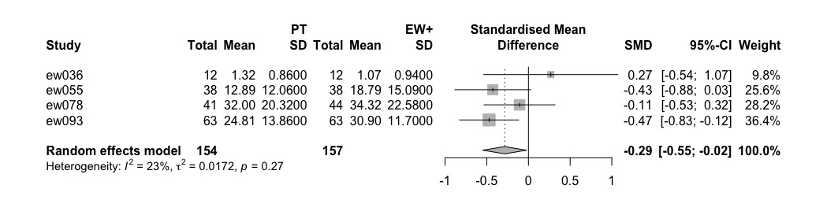
Psychotherapy vs expressive writing
SMD 95%-CI z p-value
-0.4106 [-0.8380; 0.0169] -1.88 0.0597

Details:
- Inverse variance method
- Hedges' g (bias corrected standardised mean difference)
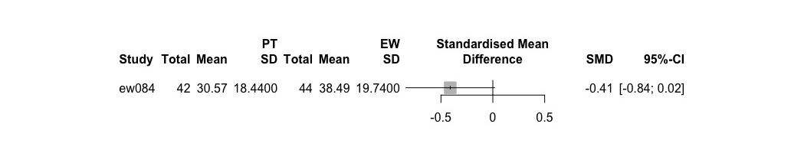
Psychotherapy vs neutral writing
No studies

Psychotherapy vs waiting list
SMD 95%-CI z p-value
0.7817 [0.3318; 1.2317] 3.41 0.0007

Details:
- Inverse variance method
- Hedges' g (bias corrected standardised mean difference)
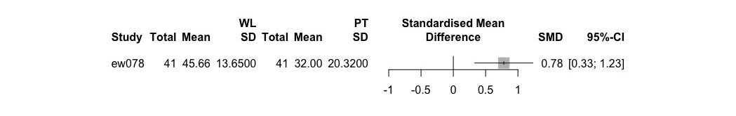
Enhanced writing vs expressive writing
No studies

Enhanced writing vs neutral writing
SMD 95%-CI z p-value
0.1401 [-0.1295; 0.4097] 1.02 0.3083

Details:
- Inverse variance method
- Hedges' g (bias corrected standardised mean difference)

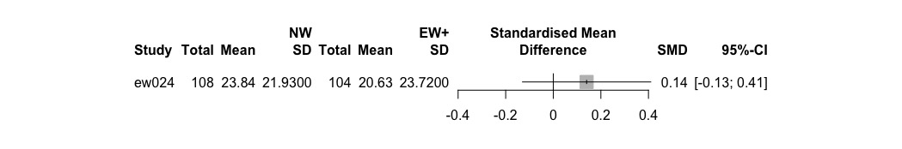
Enhanced writing vs waiting list
Number of studies combined: k = 10

SMD 95%-CI z p-value
Random effects model 0.9966 [0.6891; 1.3042] 6.35 < 0.0001

Quantifying heterogeneity:
tau^2 = 0.1777; H = 2.11 [1.56; 2.86]; I^2 = 77.6% [59.0%; 87.8%]

Test of heterogeneity:
Q d.f. p-value
40.25 9 < 0.0001

Details on meta-analytical method:
- Inverse variance method
- DerSimonian-Laird estimator for tau^2
- Hedges' g (bias corrected standardised mean difference)
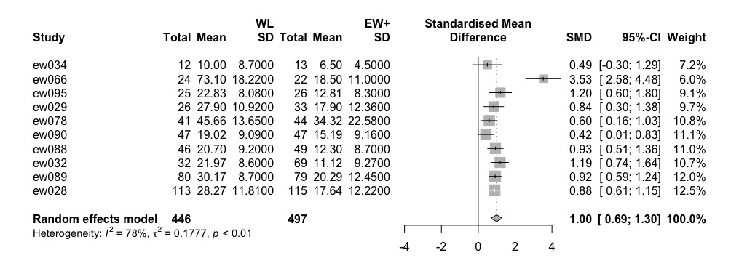

Expressive writing vs neutral writing
Number of studies combined: k = 15

SMD 95%-CI z p-value
Random effects model 0.0702 [-0.2079; 0.3483] 0.49 0.6206

Quantifying heterogeneity:
tau^2 = 0.2202; H = 2.03 [1.58; 2.61]; I^2 = 75.8% [60.1%; 85.3%]

Test of heterogeneity:
Q d.f. p-value
57.89 14 < 0.0001

Details on meta-analytical method:
- Inverse variance method
- DerSimonian-Laird estimator for tau^2
- Hedges' g (bias corrected standardised mean difference)
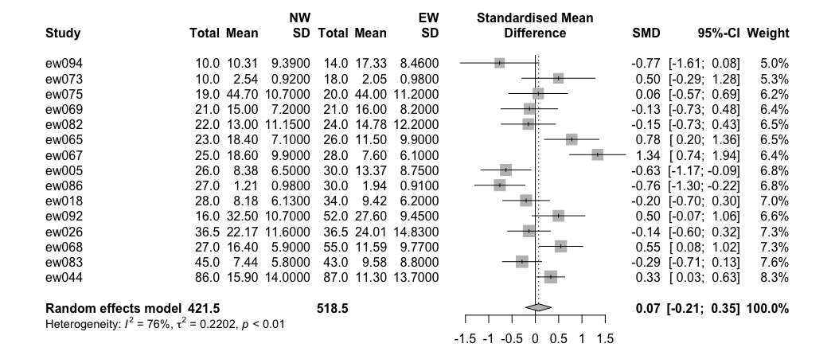

Expressive writing vs waiting list
Number of studies combined: k = 4

SMD 95%-CI z p-value
Random effects model 0.1798 [-0.1643; 0.5239] 1.02 0.3058

Quantifying heterogeneity:
tau^2 = 0.0403; H = 1.22 [1.00; 2.05]; I^2 = 32.7% [0.0%; 76.1%]

Test of heterogeneity:
Q d.f. p-value
4.46 3 0.2161

Details on meta-analytical method:
- Inverse variance method
- DerSimonian-Laird estimator for tau^2
- Hedges' g (bias corrected standardised mean difference)
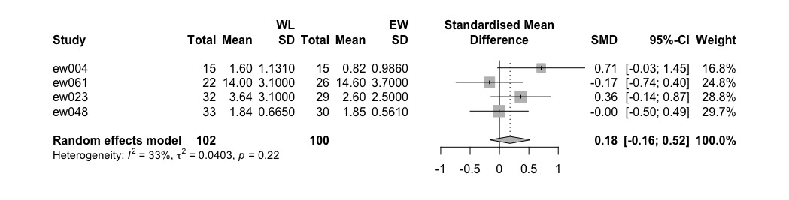
Neutral writing vs waiting list
No studies

Longest available follow-up

Psychotherapy vs enhanced writing
Number of studies combined: k = 4

SMD 95%-CI z p-value
Random effects model -0.0715 [-0.2948; 0.1518] -0.63 0.5303

Quantifying heterogeneity:
tau^2 = 0; H = 1.00 [1.00; 2.25]; I^2 = 0.0% [0.0%; 80.2%]

Test of heterogeneity:
Q d.f. p-value
2.32 3 0.5095

Details on meta-analytical method:
- Inverse variance method
- DerSimonian-Laird estimator for tau^2
- Hedges' g (bias corrected standardised mean difference)
> summary(pooledSMD92)

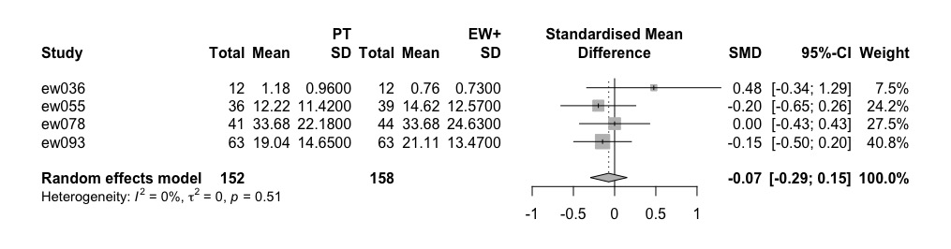

Psychotherapy vs expressive writing
Number of studies combined: k = 2

SMD 95%-CI z p-value
Random effects model -0.3636 [-1.0616; 0.3345] -1.02 0.3074

Quantifying heterogeneity:
tau^2 = 0.1990; H = 2.15; I^2 = 78.4% [6.0%; 95.0%]

Test of heterogeneity:
Q d.f. p-value
4.63 1 0.0314

Details on meta-analytical method:
- Inverse variance method
- DerSimonian-Laird estimator for tau^2
- Hedges' g (bias corrected standardised mean difference)

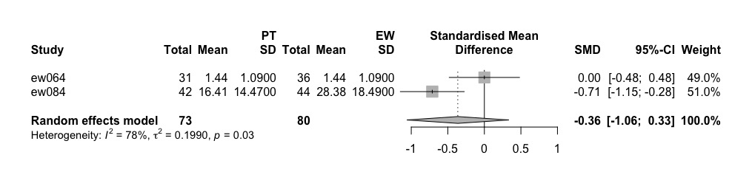

Psychotherapy vs neutral writing
SMD 95%-CI z p-value
-0.0824 [-0.5693; 0.4046] -0.33 0.7402

Details:
- Inverse variance method
- Hedges' g (bias corrected standardised mean difference)

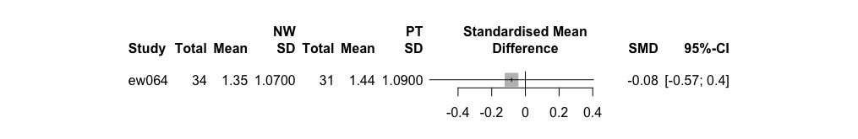

Psychotherapy vs waiting list
SMD 95%-CI z p-value
0.7033 [0.2566; 1.1500] 3.09 0.0020

Details:
- Inverse variance method
- Hedges' g (bias corrected standardised mean difference)
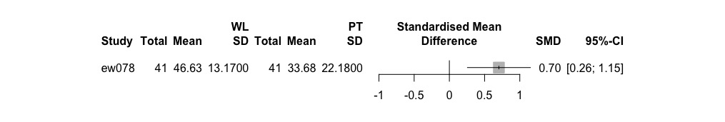

Enhanced writing vs expressive writing
SMD 95%-CI z p-value
-0.1077 [-0.4917; 0.2763] -0.55 0.5826

Details:
- Inverse variance method
- Hedges' g (bias corrected standardised mean difference)
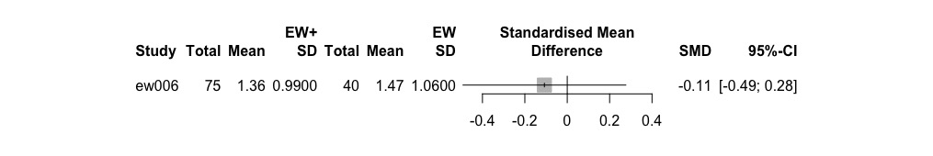

Enhanced writing vs neutral writing
Number of studies combined: k = 2

SMD 95%-CI z p-value
Random effects model 0.0487 [-0.1900; 0.2875] 0.40 0.6892

Quantifying heterogeneity:
tau^2 = 0; H = 1.00; I^2 = 0.0%

Test of heterogeneity:
Q d.f. p-value
0.40 1 0.5290

Details on meta-analytical method:
- Inverse variance method
- DerSimonian-Laird estimator for tau^2
- Hedges' g (bias corrected standardised mean difference)
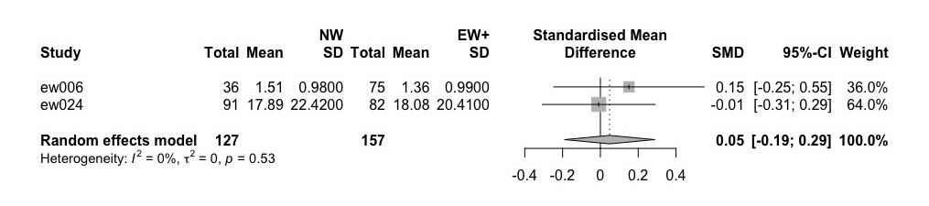

Enhanced writing vs waiting list
Number of studies combined: k = 10

SMD 95%-CI z p-value
Random effects model 0.9529 [0.6969; 1.2089] 7.30 < 0.0001

Quantifying heterogeneity:
tau^2 = 0.1076; H = 1.77 [1.27; 2.46]; I^2 = 68.0% [38.0%; 83.5%]

Test of heterogeneity:
Q d.f. p-value
28.11 9 0.0009

Details on meta-analytical method:
- Inverse variance method
- DerSimonian-Laird estimator for tau^2
- Hedges' g (bias corrected standardised mean difference)
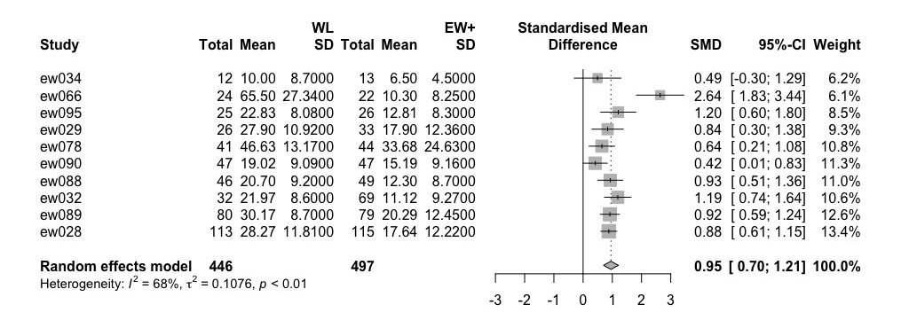

Expressive writing vs neutral writing
Number of studies combined: k = 24

SMD 95%-CI z p-value
Random effects model 0.0734 [-0.0648; 0.2116] 1.04 0.2980

Quantifying heterogeneity:
tau^2 = 0.0516; H = 1.49 [1.18; 1.87]; I^2 = 54.8% [28.4%; 71.5%]

Test of heterogeneity:
Q d.f. p-value
50.88 23 0.0007

Details on meta-analytical method:
- Inverse variance method
- DerSimonian-Laird estimator for tau^2
- Hedges' g (bias corrected standardised mean difference)
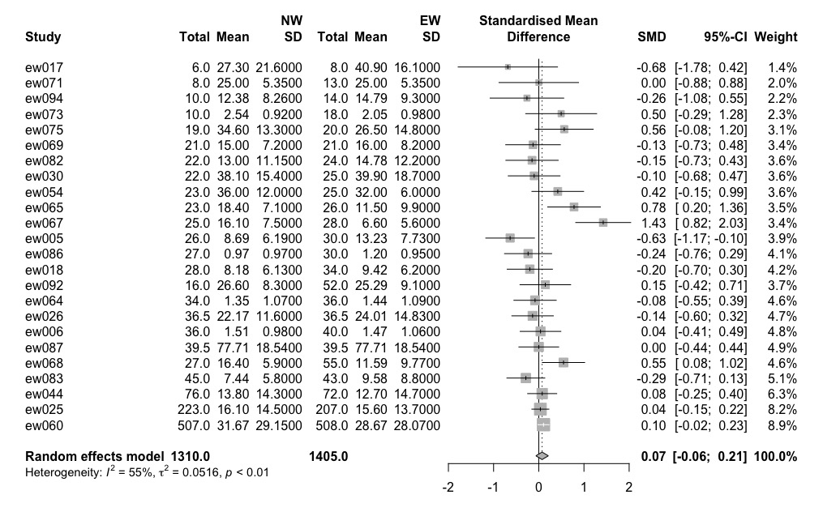

Expressive writing vs waiting list
Number of studies combined: k = 7

SMD 95%-CI z p-value
Random effects model 0.2846 [0.0680; 0.5012] 2.58 0.0100

Quantifying heterogeneity:
tau^2 = 0.0411; H = 1.68 [1.12; 2.53]; I^2 = 64.7% [20.6%; 84.3%]

Test of heterogeneity:
Q d.f. p-value
17.01 6 0.0093

Details on meta-analytical method:
- Inverse variance method
- DerSimonian-Laird estimator for tau^2
- Hedges' g (bias corrected standardised mean difference)
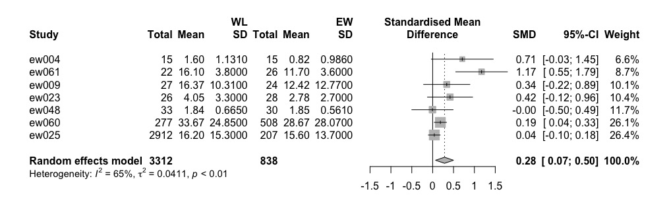

Neutral writing vs waiting list
Number of studies combined: k = 2

SMD 95%-CI z p-value
Random effects model 0.0369 [-0.0628; 0.1367] 0.73 0.4678

Quantifying heterogeneity:
tau^2 = 0; H = 1.00; I^2 = 0.0%

Test of heterogeneity:
Q d.f. p-value
0.41 1 0.5206

Details on meta-analytical method:
- Inverse variance method
- DerSimonian-Laird estimator for tau^2
- Hedges' g (bias corrected standardised mean difference)
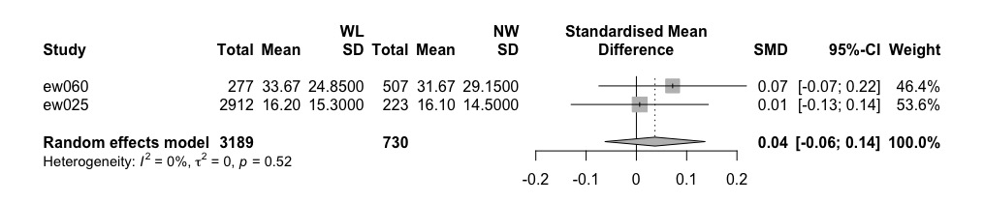

eAppendix 7: Additional Results from Netowrk Meta-analysis: Comparative Acceptability

##########################################################################
> ## ------------------------------------------Drop-outs--------------

Original data (with adjusted standard errors for multi-arm studies):

treat1 treat2 TE seTE seTE.adj narms multiarm
ew004 EW WL 0.0000 0.5164 0.5164 2
ew005 EW NW 0.5500 0.8235 0.8235 2
ew006 EW NW -1.4917 1.0942 1.6941 3 *
ew006 EW+ NW -0.1744 0.5931 0.6175 3 *
ew006 EW EW+ -1.3173 1.0510 1.2934 3 *
ew018 EW NW -0.8873 1.1979 1.1979 2
ew023 EW WL 2.0487 1.4793 1.4793 2
ew024 EW+ NW 0.0165 0.3706 0.3706 2
ew025 EW NW 1.6094 0.6259 0.6259 2
ew028 EW+ WL 0.1901 0.3491 0.3491 2
ew029 EW+ WL 0.2288 0.4167 0.4167 2
ew034 EW+ WL -0.4855 0.8204 0.8204 2
ew044 EW NW -0.1141 0.2154 0.2154 2
ew048 EW WL 0.0953 1.9840 1.9840 2
ew054 EW NW -1.1820 1.1180 1.1180 2
ew055 EW+ PT 0.2198 0.3665 0.3665 2
ew060 EW NW 0.2725 0.1208 0.1208 2
ew064 EW PT -0.8427 0.8306 1.0140 3 *
ew064 NW PT -0.3801 0.7223 0.8135 3 *
ew064 EW NW -0.4626 0.8810 1.1980 3 *
ew065 EW NW -0.1226 1.9794 1.9794 2
ew066 EW+ WL 1.4733 1.5533 1.5533 2
ew067 EW NW -0.1133 1.9810 1.9810 2
ew069 EW NW 0.0000 1.9760 1.9760 2
ew071 EW NW 0.3567 1.6818 1.6818 2
ew073 EW NW 0.0606 0.1850 0.1850 2
ew075 EW NW -0.0513 1.9742 1.9742 2
ew084 EW PT 0.6466 1.7186 1.7186 2
ew086 EW NW -0.1054 1.9823 1.9823 2
ew088 EW+ WL 2.0163 1.0406 1.0406 2
ew089 EW+ WL -0.0182 0.1908 0.1908 2
ew090 EW+ WL 0.6931 0.6763 0.6763 2
ew093 EW+ PT -1.8326 0.5082 0.5082 2
ew094 EW NW 1.0090 0.5583 0.5583 2
ew095 EW+ WL 1.0594 1.1202 1.1202 2

Number of studies: k = 31
Number of treatments: n = 5
Number of pairwise comparisons: m = 35
Number of designs: d = 8

Random effects model

Treatment estimate (sm = 'RR'):
EW EW+ NW PT WL
EW . 1.1019 1.1701 0.6572 1.3472
EW+ 0.9075 . 1.0619 0.5964 1.2226
NW 0.8546 0.9417 . 0.5616 1.1513
PT 1.5217 1.6768 1.7806 . 2.0500
WL 0.7423 0.8179 0.8686 0.4878 .

Lower 95%-confidence limit:
EW EW+ NW PT WL
EW . 0.6320 0.8950 0.3175 0.7402
EW+ 0.5205 . 0.6205 0.3299 0.8585
NW 0.6537 0.5502 . 0.2744 0.6374
PT 0.7352 0.9275 0.8701 . 1.0406
WL 0.4079 0.5744 0.4809 0.2476 .

Upper 95%-confidence limit:
EW EW+ NW PT WL
EW . 1.9211 1.5298 1.3602 2.4517
EW+ 1.5822 . 1.8176 1.0782 1.7410
NW 1.1173 1.6117 . 1.1493 2.0795
PT 3.1497 3.0313 3.6440 . 4.0383
WL 1.3509 1.1648 1.5690 0.9609 .

Quantifying heterogeneity / inconsistency:
tau^2 = 0.0463; I^2 = 17.7%

Tests of heterogeneity (within designs) and inconsistency (between designs):
Q d.f. p-value
Total 35.24 29 0.1969
Within designs 31.96 23 0.1009
Between designs 3.28 6 0.7736

> # Inconsistency
Back-calculation method to split direct and indirect evidence

Random effects model:

comparison k prop nma direct indir. RoR z p-value
EW:EW+ 1 0.07 1.10 0.27 1.23 0.22 -1.37 0.1716
EW:NW 16 0.96 1.17 1.17 1.19 0.98 -0.03 0.9788
EW:PT 2 0.23 0.66 0.58 0.68 0.84 -0.19 0.8477
EW:WL 3 0.36 1.35 1.27 1.39 0.92 -0.14 0.8890
EW+:NW 2 0.60 1.06 0.96 1.24 0.77 -0.46 0.6440
EW+:PT 2 0.80 0.60 0.58 0.67 0.87 -0.18 0.8534
EW+:WL 8 0.91 1.22 1.23 1.13 1.09 0.14 0.8890
NW:PT 1 0.24 0.56 0.68 0.53 1.29 0.30 0.7651

Legend:
comparison - Treatment comparison
k - Number of studies providing direct evidence
prop - Direct evidence proportion
nma - Estimated treatment effect (RR) in network meta-analysis
direct - Estimated treatment effect (RR) derived from direct evidence
indir. - Estimated treatment effect (RR) derived from indirect evidence
RoR - Ratio of Ratios (direct versus indirect)
z - z-value of test for disagreement (direct versus indirect)
p-value - p-value of test for disagreement (direct versus indirect)>

Q statistics to assess homogeneity / consistency

Q df p-value
Total 35.24 29 0.1969
Within designs 31.96 23 0.1009
Between designs 3.28 6 0.7736

Design-specific decomposition of within-designs Q statistic

Design Q df p-value
EW:NW 12.85 13 0.4591
EW:WL 1.71 2 0.4246
EW+:PT 10.73 1 0.0011
EW+:WL 6.66 7 0.4646

Between-designs Q statistic after detaching of single designs

Detached design Q df p-value
EW:NW 2.30 5 0.8066
EW:PT 2.92 5 0.7124
EW:WL 3.27 5 0.6588
EW+:NW 3.25 5 0.6611
EW+:PT 3.27 5 0.6584
EW+:WL 3.27 5 0.6588
EW:EW+:NW 0.92 4 0.9212
EW:NW:PT 2.72 4 0.6062

Q statistic to assess consistency under the assumption of
a full design-by-treatment interaction random effects model

Q df p-value tau.within tau2.within
Between designs 3.16 6 0.7887 0.2751 0.0757
eAppendix 8. Additional Results from Pairwise Meta-analyses on Comparative Acceptability (Drop-out rates between beginning and end of treatment)

Psychotherapy vs enhanced writing
RR 95%-CI z p-value
0.8027 [0.3913; 1.6464] -0.60 0.5487

Details:
- Inverse variance method

Psychotherapy vs expressive writing
Number of studies combined: k = 2

RR 95%-CI z p-value
Random effects model 1.7518 [0.4045; 7.5870] 0.75 0.4535

Quantifying heterogeneity:
tau^2 = 0; H = 1.00; I^2 = 0.0%

Test of heterogeneity:
Q d.f. p-value
0.61 1 0.4347

Details on meta-analytical method:
- Mantel-Haenszel method
- DerSimonian-Laird estimator for tau^2

Psychotherapy vs neutral writing
RR 95%-CI z p-value
1.4624 [0.3550; 6.0235] 0.53 0.5987

Details:
- Inverse variance method

Psychotherapy vs waiting list
No studies

Enhanced writing vs expressive writing
RR 95%-CI z p-value
3.7333 [0.4759; 29.2872] 1.25 0.2101

Details:
- Inverse variance method

Enhanced writing vs neutral writing
Number of studies combined: k = 2

RR 95%-CI z p-value
Random effects model 0.9636 [0.5205; 1.7840] -0.12 0.9061

Quantifying heterogeneity:
tau^2 = 0; H = 1.00; I^2 = 0.0%

Test of heterogeneity:
Q d.f. p-value
0.07 1 0.7849

Details on meta-analytical method:
- Mantel-Haenszel method
- DerSimonian-Laird estimator for tau^2

Enhanced writing vs waiting list
Number of studies combined: k = 8

RR 95%-CI z p-value
Random effects model 1.1542 [0.8618; 1.5457] 0.96 0.3360

Quantifying heterogeneity:
tau^2 = 0.0027; H = 1.01 [1.00; 1.77]; I^2 = 1.1% [0.0%; 67.9%]

Test of heterogeneity:
Q d.f. p-value
7.08 7 0.4206

Details on meta-analytical method:
- Mantel-Haenszel method
- DerSimonian-Laird estimator for tau^2

Expressive writing vs neutral writing
Number of studies combined: k = 16

RR 95%-CI z p-value
Random effects model 1.1747 [0.9589; 1.4390] 1.55 0.1200

Quantifying heterogeneity:
tau^2 = 0.0100; H = 1.03 [1.00; 1.49]; I^2 = 5.4% [0.0%; 54.9%]

Test of heterogeneity:
Q d.f. p-value
15.86 15 0.3913

Expressive writing vs waiting list
Number of studies combined: k = 3

RR 95%-CI z p-value
Random effects model 1.2402 [0.4903; 3.1369] 0.45 0.6493

Quantifying heterogeneity:
tau^2 = 0; H = 1.00 [1.00; 3.08]; I^2 = 0.0% [0.0%; 89.5%]

Test of heterogeneity:
Q d.f. p-value
1.98 2 0.3722

Neutral writing vs waiting list
No studies

