Supplemental file 1: Deviations from protocol
- Protocol: examine the effect of a LID on ablation/therapy.
Deviation: Phenomenon of interest included IS.
Reason for deviation: During the initial search, studies were identified that assessed whether there was an association between IS and treatment success regardless of whether someone had been advised a LID. We considered this to be as an important question and deviated from protocol to include these studies.
- Protocol: stated GRADE would be considered for all outcomes.
Deviation: only conducted GRADE for ablation success.
Reason for deviation: This was our main outcome of interest.
- Protocol: The Newcastle-Ottawa Scale (NOS) would be used for Assessing the Quality of Nonrandomized Studies and the modified NOS will be used for cross-sectional studies. Deviation: ROBINS-I was used.
Reason for deviation: ROBINS-I was considered to provide a clearer indication of quality.
- Protocol: stated analysis would only comprise between-group comparisons.
Deviation: included within-in group comparisons.
Reason for deviation: A large proportion of studies were single arm in design and we did not want to exclude these studies.
- Protocol: analysis would be carried out in RevMan.
Deviation: analysis was conducted in Stata 16.
Reason for deviation: This offered more flexible and accurate data analysis.

Supplemental file 2: Medline search 29.1.20

1. (low-iodine adj1 diet*).tw.
2. (low adj1 iodine adj1 diet*).ti,ab.
3. (restricted adj1 iodine adj1 diet*).ti,ab.
4. (reduced adj1 iodine).ti,ab.
5. (no adj1 iodine adj1 diet*).ti,ab.
6. (low-iodide adj1 diet*).ti,ab.
7. 1 or 2 or 3 or 4 or 5 or 6
8. exp Thyroid Neoplasms/
9. thyroid ad1 remnant*.ti,ab.
10. (thyroid adj1 neoplasm*).ti,ab.
11. (thyroid adj1 cancer*).ti,ab.
12. (follicular adj1 cancer*).ti,ab.
13. (papillary adj1 cancer*).ti,ab.
14. (papillary adj1 thyroid adj1 cancer*).ti,ab.
15. (follicular adj1 thyroid adj1 cancer*).ti,ab.
16. PTC.ti,ab.
17. "well differentiated thyroid cancer*".ti,ab.
18. exp Carcinoma, Papillary/
19. exp Adenocarcinoma, Follicular/
20. DTC.ti,ab.
21. (differentiated adj1 thyroid adj1 cancer*).ti,ab.
22. 8 or 10 or 11 or 12 or 13 or 14 or 15 or 16 or 17 or 18 or 19 or 20 or 21
23. (radioactive adj1 iodine adj1 ablation).ti,ab.
24. radioiodine.ti,ab.
25. (radioactive adj1 iodine).ti,ab.
26. iodine-131.ti,ab.
27. 131-I.ti,ab.
28. iodine 131.ti,ab.
29. 131-iodine.ti,ab.
30. 131 iodine.ti,ab.
31. (radioactive adj1 iodine adj1 treatment*).ti,ab.
32. (radioiodine adj1 treatment*).ti,ab.
33. RRA.ti,ab.
34. radioiodine therap*.ti,ab.
35. RIA.ti,ab.
36. RAI.ti,ab.
37. RAIA.ti,ab.
38. (radioactive adj1 iodine adj1 therap*).ti,ab.
39. 23 or 24 or 25 or 26 or 27 or 28 or 29 or 30 or 31 or 32 or 34 or 37 or 38
40. 22 or 39
41. 7 and 40

Supplemental file 3: Contact with authors for additional information/missing data
Author | Contact details | Date | Request | Response
Dobrenic (2017) | margareta.dobrenic@gmail.com | 14/12/2021 | Abstract – requested full paper. | No response
Ito (2018) | Shinji Ito itoshj@med.nagoya-u.ac.jp | 19/01/2021 | Figure 3 displays the urinary iodine–creatinine ratios of pre-LID and post-LID with strict methods and self-managed methods. Requested means and standard deviations for these time points and groups. | No response
Jang (2011) | biomed@skku.edu  https://www.samsunghospital.com  /gb/language/m_english/education/  sungkunkwanUniversity.do?sub=saihst | 25/11/2020 | Asked for Jang's contact details - would like more data on ablation outcome as only an abstract | No response
Lee (2014) | ryuyh@yuhs.ac | 02/11/2020 | Expected error: Confidence intervals are not symmetrical. Wanted confirmation of the lower confidence limit for the UIE after two-week LID result which is in table 5 (Odds ratio 1.01, 95% CI 0.10-1.03, p =0.18). | No response
Lee (2016b) | inhamedicalcenter@gmail.com | 24/11/2020 | Asked for the contact details of Lee (2016b). Abstract - no medians reported for differences in iodine status. | No response
Markovic (2015) | Contacted through research gate | 18.07.2020 | Abstract – requested full paper. | No response
Nakada (2016) | Contacted through research gate | 14/12/2021 | Abstract –requested full paper. | No response
Nakada (2020) | Contacted through research gate | 14/12/2021 | Abstract –requested full paper. | No response
Nakano (2020) | Department of Surgery, Division of Breast and Endocrine Surgery, Aichi Medical University, Japan. Unable to locate emails for lead and senior authors. Research gate -not available. | 14/12/2021 | Abstract – would have requested if there was a full paper. | NA
Pluijmen (2003) | m_pluijmen@hetnet.nl | 09/11/2020 | Table 3, p.432 reports neck activity absent and Tg < 2 ug/l. The paper presents these numbers: Control: 48% (?/61); LID: 65% (?/59); P<0.001. We have calculated the number that were successfully ablated in each group (29/61 and 38/59) but are then unable to reproduce the chi square result. Could you please confirm if these numbers are correct? | No response
Sohaimi 2019 | fatihahkk@usm.my | 20/10/2020 | They detail effect of LID on UI status and I have requested whether they had data on effect of UI on ablation success. | No response
Sohn (2013) | drsohnsy@gmail.com | Sent: 27/07/2020  Reply:  31/07/2020 | Additional information request. Table 6 displays the multivariate logistic regression analysis. Request to tell us how many people were in each of the 4 urine iodine level groups. | In table 6, numbers of patients were 205, 54, 16 and 20 for each group of urinary iodine <50, 50-100, 100-250, and >250, respectively.
Sun (2015) | Department of nuclear medicine, Zhujiang Hospital, Southern Medical University, Guangzhou, China. Unable to locate emails for lead and senior contacts.  Research gate – not available. | 14/12/2021 | Abstract – would have requested if there was a full paper. | NA
Tobey (2018) | joanna.klubo-gwiezdzinska@nih.gov | 13/12/2021; 29/12/2021 | Requested missing effect size | No response
Waxman (2000) | No contact details found. | 14/12/2021 | Abstract – would have requested if there was a full paper. | NA

Supplemental file 4: Sensitivity analyses

a. Fixed effect models

b. LID on ablation success: inclusion of abstracts (Markovic et al 2015; Waxman et al, 2000)

c. LID on iodine status: exclusion of Ju et al (2016)

Supplemental file 5: Flowchart of studies included in the synthesis
Included
Articles screened
(n=1109)
Articles excluded
(n=1019)
Full-text articles assessed
for eligibility
(n=90)
Articles excluded (n=24)
- Not LID: 13
- Opinion piece: 2
- Duplicates: 2
- Not thyroid cancer: 2
- Review: 2
- Focus was iodine measurement: 2
- Radioiodine uptake: 1

Included articles (n=59)
(7 abstracts connected to full text articles, n=66)
Eligibility
Screening
Identification
Articles identified through database searches:
Initial (n=1081) (Jan 2020)
Update (n=23) (Feb 2021)
Total (n=1104)

Articles identified through handsearching
(n=5)

Supplemental file 6: Table of excluded studies
 | Author year | Title of paper | Reason for exclusion (notes)
 | Ain 1994 | Low-iodine tube-feeding diet for iodine-131 scanning and therapy | Not LID (tube feeding)
 | Alavi 2017 | Evaluation of a Number of Blood Biochemical Markers after Radioiodine Therapy in Papillary Thyroid Cancer Patients | LID incidental
 | Chang 2013 | Is it necessary to measure repeat stimulated thyroglobulin in patients with differentiated thyroid carcinoma 6-12 months after ablation? | LID incidental
 | Clerc 2012 | Outpatient thyroid remnant ablation using repeated low 131-iodine activities (740 MBq/20 mCix2) in patients with low-risk differentiated thyroid cancer | LID incidental
 | Smallridge 2014 | Practice trends in patients with persistent detectable thyroglobulin and negative diagnostic radioiodine whole body scans: a survey of American Thyroid Association members | LID is incidental
 | Smallridge 2013 | Management of patients with detectable thyroglobulin and negative iodine scan | LID is incidental
 | Cating 2011 | Cerebral edema: An unusual complication of radioactive iodine therapy for papillary thyroid carcinoma | Hyponatremia but LID incidental
 | Choi 2012 | The impact of intravenous iodinated contrast agent on urine iodine excretion in patients with differentiated thyroid cancer | Not LID
 | Clero 2012 | Dietary Iodine and Thyroid Cancer Risk in French Polynesia: A Case-Control Study | Not LID
 | de Oliverira 2009 | Nursing care in radioiodine therapy: focusing on clients' need for assistance | Not LID
 | Fitch 2003 | The needs of family members of patients receiving radioactive iodine | Not LID
 | McGrath 2003 | Patient perspectives on the impact of receiving radioactive iodine: implications for practice | Not LID
 | Rosenthal 2006 | Patient misconceptions and ethical challenges in radioactive iodine scanning and therapy | Not LID
 | Caplan 1977 | The usual dose of I-131 used to ablate thyroid | Opinion piece (letter)
 | Yoshimura 2012 | Successful low iodine diet for outpatient-based thyroid remnant ablation with differentiated thyroid carcinoma after total thyroidectomy | Opinion piece
 | Kim 2017 | Preparation for radioactive iodine therapy is not a risk factor for the development of hyponatremia in thyroid cancer patients | Duplicate (of Jahae 2017)
 | Yungang 2015 | Association between iodine intake and treatment outcomes dioiodine remnant ablation in patients with papillary thyroid cancer | Same study as Sun 2015
 | Bishopric 1955 | The thyroidal uptake of radioactive iodine as modified by an iodine-restricted diet | Not thyroid cancer
 | Morsh 2011 | Two weeks of a low-iodine diet are equivalent to 3 weeks for lowering urinary iodine and increasing thyroid radioactive iodine uptake | Not thyroid cancer
 | Chung 2013 | Low iodine diet for preparation for radioactive iodine therapy in differentiated thyroid carcinoma in Korea | Review
 | Turner 2017 | Low-iodine diet and urine iodine measurements for 131i treatments in patients in differentiated thyroid cancer: A comparison of 18 clinical practice guidelines | Review
 | Jahae 2017 | Preparation for radioactive iodine therapy is not a risk factor for the development of hyponatremia in thyroid cancer patients | Validation of urinary iodine measurement
 | Sohn 2011 | Usefulness of measurement of serum iodine level to assess the appropriate low iodine diet preparation for radioactive iodine therapy in thyroid carcinoma | Validation of urinary iodine measurement
 | Tommasi 2017 | Correlation between urinary iodine and 131I uptake in post surgical thyroid remnant during ablative radioiodine therapy for differentiated thyroid cancer | Only radioiodine uptake as outcome

Supplemental file 7: Summary table of studies examining the effect of iodine status on ablation success.
Study (date), design, country (n) ª | UI measure-ment (units); LID duration | Preparation; Dose (GBq) | Assessment method;  Post ablation follow-up | UIC <50 mcg/L (or mcg/gCr): % ablated (total n) | UIC >250 mcg/L (or mcg/gCr): %ablated (total n) | Other Cut-offs mcg/L (or mcg/gCr)]: % ablated (total n) | Continuous  OR (95% CI),  p value | Comparison of UIC by ablation status, n, mean (SD) | ROBINS-I overall score
Sohn (2013), HC, South Korea (n=295) | Spot (mcg/gCr)  2 wks | THW;  1.11 | Negative WBS  Undetectable sTg (<2ng/mL)  Undetectable TgAb (<60U/mL)  6-12 months^{b} | 76% (205) | 50% (20) | 50-100: 80% (54)  100-250: 75% (16) | NR | Ablated: n=221  75.8 (168.3)  Non-ablated: n=74  126.9 (248.2) | Moderate
Tala Jury (2010), HC, Italy  (n=201) | Spot (mcg/L)  4 wks | THW (125)  rhTSH (76);  Ablated: 1.1–5.55; Nonablated: 1.1-4.81 | Negative WBS^{c}  8-12 months | 88% (41) | 82% (17) | 50-100: 82% (54)  100-150: 81% (47)  150-200: 85% (25)  200-250: 88% (17) | NR | Ablated: n=170  129 (158)  Non-ablated: n=31  148 (166)  P=0.95 | Moderate
Lee (2014), PC, Korea (n=195) | Spot (mcg/L)  2 wks | THW;  3.70–7.40 | Negative WBS  Undetectable sTg (<1ng/mL)  Undetectable TgAb (124.2 U/ml)  9-10 months ^{b} | 79%  (NR) | NR | 50 – 100: 86% (NR) | 1.01 (0.10^{d}-1.03),  p=0.18 | NR | Moderate
Pluijmen (2003), HC, Netherlands, (n=120)^{e} | 24-h (mcg/24hr)  4d | THW;  2.8 | Negative WBS  Undetectable Tg (<2 mcg/L)  Undetectable TgAb  6 months^{b} | 65% (59) | NR | ≥50: 48% (61) | NR | NR | Critical
Sun (2015) [abstract], HC, China  (n=95) | NR (mcg/L)  2-4wks | NR;  NR | Negative WBS  Undetectable sTg (<2 ng/mL)  8-12 months | 97% (30) | NR | 50 – 100: 85% (26)  100 – 300: 74%  (39) | 3.473 (NR),  NR | NR | NA
Passero (2002), HC, USA (n=59) | NR (mcg/gCr)  NR | Both;  Mean: 4.09 (1.12) | Negative WBS  6-30 months | NR | NR | NR | NR | Ablated: n=50  77.1 (101.8)  Non-ablated: n=9  87.8 (75.8) | NA
Ito (2015 abstract; 2018), PC, Japan (n=37) | Spot (mcg/gCR)  2 wks | THW (12); rhTSH (33);  1.11 | Negative WBS  6-8 months; | NR | NR | NR | 1.005 (0.997–1.013),  p=0.457 | Ablated: n=25  Median (range): 82.0 (NR)  Non-ablated: n=20  Median (range): 71.5 (NR)  p=0.253 | NA
Jang (2011) [abstract], HC, Korea,  (n=299) | NR (mcg/gCr)  NR | THW; low dose | Negative WBS  Undetectable sTg  6-12 months | NR | NR | NR | NR | Adequate iodine restriction significantly associated with successful ablation in univariate analysis but not multivariate analysis. | NA
Nakano (2020), [abstract], HC, Japan  (n = 24) | Spot (mcg/gCr)  1 wk | NR | Negative WBS  Undetectable sTg (<1 ng/mL)  Negative TgAb  NR | NR | NR | NR | NR | NSD between ablated and non-ablated | NA
Key: DD: diet duration; DM: distant metastases I/Cr: iodine/creatinine ratio; H: Historical cohort; LID: low iodine diet; NSD: no significant difference; PC: prospective cohort; sTg: stimulated thyroglobulin; RAI: radioactive iodine treatment; RD: Regular diet; rhTSH: recombinant human thyroid-stimulating hormone; THW: thyroid hormone withdrawal; UI: urinary iodine; UIE: urinary iodine excretion; WBS: whole body scan; wks: weeks.
ª Bold: included in main meta-analysis. Italicised did not provide suitable data for analysis (did not report cut-offs of interest or compared UIC by ablation status or as a continuous variable).
^{b} Study also reports assessment of success using WBS alone but WBS+Tg results are reported as the more complete assessment.
^{c} This study also reported assessment of ablation using Tg and TgAb levels but not for the result we are reporting.
^{d} Expected error: confidence intervals not symmetrical.
^{e} This study excluded ppts who had UI levels >49.4 mcg/d from the LID group (expected typo and UI cut off was >49.9). Therefore, we deemed it more appropriate to include their results as <50 mcg/d and a cut off of ≥50 mcg/d (presuming the regular diet group were likely to have a UIC of > 50 mcg/d).

Supplemental file 8: Summary table of studies examining dietary advice (less-strict LID vs. stricter LIDª) on ablation success.
Study (date), design ^{b} | Analysed n/total n; group: n | Staging | Preparation;  Dose (GBq) | Diet duration before ablation | Iodine intake from diet (mcg/d) | Assessment method;  Timing of DxWBS | IS before ablation | Difference in success rates % (n); analysis | ROBINS-I judgement
Ito (2018), PC | 37/45  1. LS-LID: 25  2. LID: 12 | LNI | THW (12); rhTSH (33);  1.11 | 2wks | 1. NR  2. < 30 | Negative WBS  6-8 months | No diff. in UI/Cr between the groups after LID p=0.57 | 1. 64% (16/25)  2. 25% (3/12)  p=0.026  X² | Serious
Morris (2001), HC | 94/140  1. LS-LID: 50  2. LID: 44 | LNI: 27  Metastasis: 3 | THW;  Range: 3.7–7.4  LS-LID vs MS-LID  3.7: 18 vs. 25  5.55: 30 vs. 13  >5.55: 2 vs. 6 | 10–14d | NR | Negative WBS;  4–42 months (mean 11.8) | 1. 381.4 ± 196.3 (range: 140-630)  2. 173.9 ± 127.7 (range: 45-445) (mcg/L) | 1. 62% (31/50)  2. 68.2% (30/44)  p=0.53  X² | Serious
Yoo (2012), HC | 161  1. LS-LID: 71  2. LID: 90 | Capsular invasion: 109  Ex: 58 | THW;  5.5 | 2wks (at least) | NR | Negative WBS  Undetectable Tg (<2 ng/mL)  Undetectable TgAb (<70 IU/mL)  6-12 months | NR | 1. 80.3% (46^{c}/57)  2. 75.6% (51^{c}/68)  p=0.475  X² | Serious
Markovic (2015) [abstract], HC | 135  1. RD: 34^{d}  2. LS-LID: 30  3. LID: 71 | T1-2N0M0 | NR; 1.1 | 2 wk | NR | NR | NR | 1. 68%  2. 73%  3. 70%  P=0.313 | NA (abstract)
Waxman (2000), [abstract], NRSI | 89  1. LS-LID: 41  2. LID: 48 | NR | THW;  3.7 | 1. assumed 2wks  2. 2wks | NR | Negative WBS  8-14 months | NR | 1. 61% (25/41)  2. 65% (31/48)  p=0.7254  NR | NA (abstract)

Key: DxWBS: diagnostic whole body scan; Ex: extrathyroidal invasion; GBq: gigabecquerel; Historical cohort study: HC; LID: low iodine diet; IS: iodine status; LNI: Lymph node involvement; LS: less-strict; ppts: participants; NA: not applicable; NR: not reported; PC: prospective cohort study; RD: regular diet; sTg: stimulated thyroglobulin; THW: thyroid hormone withdrawal; Tg: thyroglobulin; WBS: whole body scan; wks: weeks.
ª Greater restriction of iodine containing foods advised in the stricter LID groups compared to the less-strict LID groups.
^{b} Italicised: included in sensitivity analysis
^{c} Studies provided percentages but not numbers in each group. Group numbers derived by reviewers based on percentages.
^{d} Arm 1 not included in meta-analysis.

Supplemental File 9: Risk of bias

ROBINS-I assessment: Iodine status: outcome ablation success
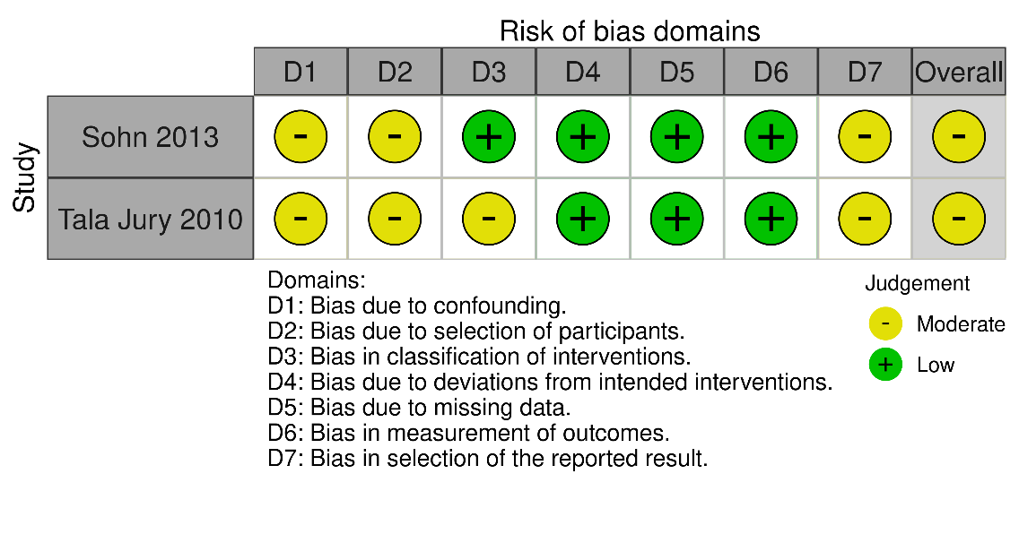

b. ROBINS-I assessment: Stricter LID vs. less strict LID: outcome ablation success
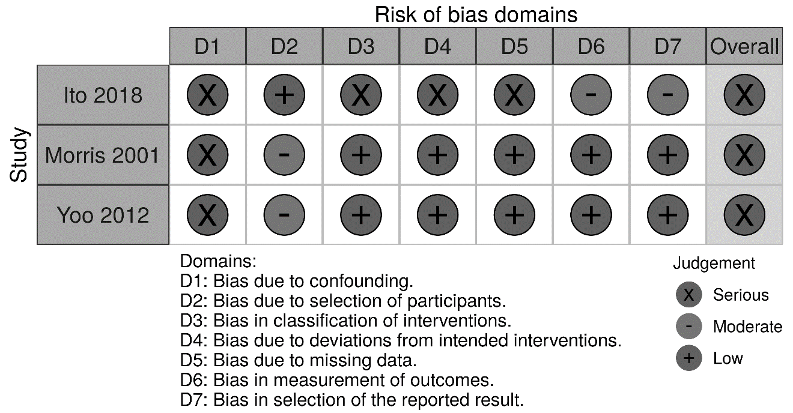

c. ROBINS-I assessment: effect of the LID on iodine status
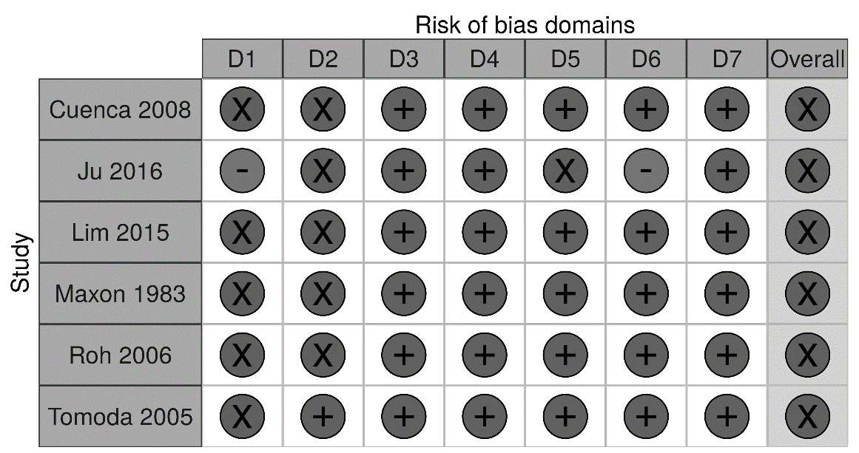
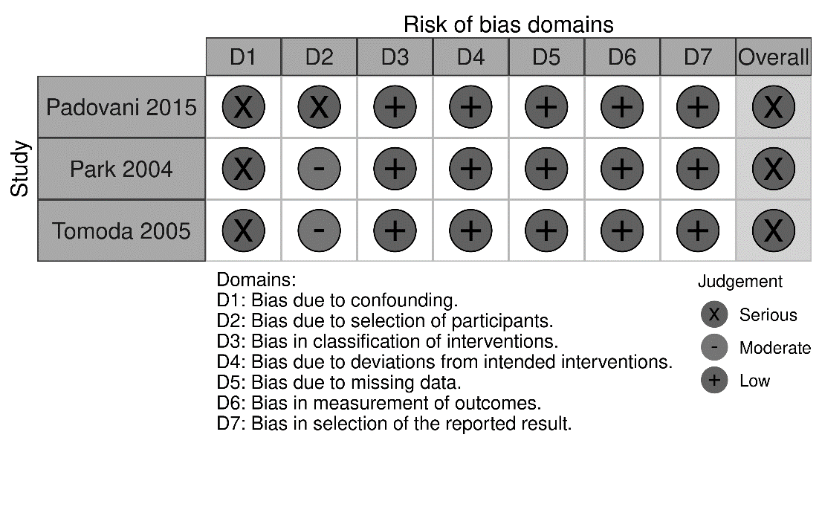

d. ROB-2 assessment: effect of the LID on iodine status

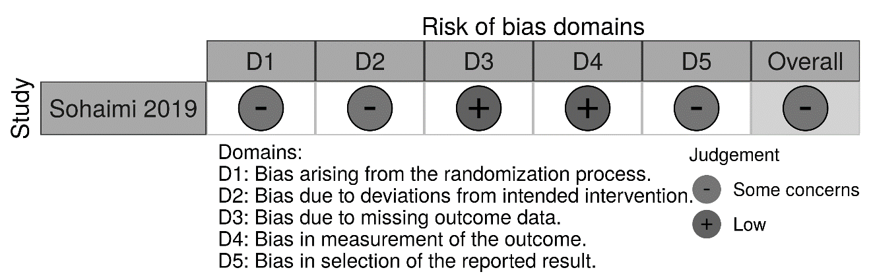

e. Critical Appraisal Skills Programme (CASP) Quality appraisal tool questions * and scores ** (n=3)
Study | Q1 | Q2 | Q3 | Q4 | Q5 | Q6 | Q7 | Q8 | Q9 | Q10 | Score | Notes
Herbert 2020 | Yes | Yes | ? | Yes | Yes | ? | Yes | Yes | Yes | Yes | 18/20 | ? related to not reporting
Lee  2016 | Yes | Yes | ? | ? | Yes | ? | Yes | ? | No | ? | 13/20 | ? related to not reporting and also ambiguity between what findings can be attributed to the LID or hormone imbalance. Issues with analysis e.g. headings not matching interpretative text.
Stajduhar 2000 | Yes | Yes | ? | ? | Yes | ? | ? | Yes | Yes | Yes | 16/20 | ? related to not reporting
* Q1. Was there a clear statement of the aims of the research?; Q2. Is a qualitative methodology appropriate?; Q3. Was the research design appropriate to address the aims of the research?; Q4. Was the recruitment strategy appropriate to the aims of the research?; Q5. Was the data collected in a way that addressed the research issue?; Q6. Has the relationship between researcher and participants been adequately considered?; Q7. Have ethical issues been taken into consideration?; Q8. Was the data analysis sufficiently rigorous?; Q9. Is there a clear statement of findings?; Q10. How valuable is the research?
**CASP questions scoring: Yes = 2; ? (Can’t tell) = 1; No = 0

f. Quality assessment of survey studies (n=3)
Item # | Domain | Item | Moon 2012 |  | Tamura 2016* | England 2019
1 | Introduction | Was the problem or phenomenon under investigation defined, described, and justified? | Yes |  | Yes | Yes
2 | Introduction | Was the population under investigation defined, described, and justified? | NSC |  | No | Yes
3 | Introduction | Were specific research questions or hypotheses stated? | Yes |  | Yes | Yes
4 | Introduction | Were operational definitions of all study variables provided? | Yes |  | No | Yes
5 | Participants | Were participant inclusion criteria stated? | Yes |  | No | Yes
6 | Participants | Was the participant recruitment strategy described? | NSC |  | NSC | Yes
7 | Participants | Was a justification/rationale for the sample size provided? | NSC |  | No | NSC
8 | Data | Was the attrition rate provided? (applies to cross-sectional and prospective studies) | Yes |  | No | Yes
9 | Data | Was a method of treating attrition provided? (applies to cross-sectional and prospective studies) | No |  | No | NSC
10 | Data | Were the data analysis techniques justified (i.e., was the link between hypotheses/aims/research questions and data analyses explained)? | Yes |  | NSC | Yes
11 | Data | Were the measures provided in the report (or in a supplement) in full? | Yes |  | Yes | Yes
12 | Data | Was evidence provided for the validity of all the measures (or instrument) used? | Yes |  | No | No
13 | Data | Was information provided about the person(s) who collected the data (e.g., training, expertise, other demographic characteristics)? | No |  | No | Yes
14 | Data | Was information provided about the context (e.g., place) of data collection? | NSC |  | Yes | Yes
15 | Data | Was information provided about the duration (or start and end date) of data collection? | Yes |  | No | Yes
16 | Data | Was the study sample described in terms of key demographic characteristics? | Yes |  | No | No
17 | Data | Was discussion of findings confined to the population from which the sample was drawn? | Yes |  | Yes | Yes
18 | Ethics | Were participants asked to provide (informed) consent or assent? | Yes |  | No | Yes
19 | Ethics | Were participants debriefed at the end of data collection? | No |  | No | No
20 | Ethics | Were funding sources or conflicts of interest disclosed? | No |  | No | Yes
Overall score (yes responses/ total number of applicable items) |  |  |  | 12/20=60% | 5/20=25% | 15/20=75%
Quality assessment |  |  |  | Questionable | Questionable | Acceptable
Key: NA: Not applicable; NSC: not stated clearly
*A retrospective study with the inclusion of a survey

g. GRADE assessments for ablation outcome
Iodine status of <50mcg/L (or mcg/gCR) compared to iodine status of >250 mcg/L (or mcg/gCr) for ablation success in differentiated thyroid cancer
Patient or population: ablation success in differentiated thyroid cancer
Setting: hospital
Intervention: iodine status of <50mcg/L (or mcg/gCR)
Comparison: iodine status of >250 mcg/L (or mcg/gCr)
Outcomes | Anticipated absolute effects* (95% CI) |  | Relative effect  (95% CI) | № of participants  (studies) | Certainty of the evidence  (GRADE) | Comments
Outcomes | Risk with iodine status of >250 mcg/L (or mcg/gCr) | Risk with iodine status of <50mcg/L (or mcg/gCR)
Ablation success  assessed with: whole body scans alone or in combination with thyroglobulin and thyroglobulin antibody measurements  follow-up: range 6 months to 12 months | 649 per 1,000 | 828 per 1,000  (685 to 915) | OR 2.63  (1.18 to 5.86) | 283  (2 observational studies) | ⨁◯◯◯  Very low^{a,b,c}
*The risk in the intervention group (and its 95% confidence interval) is based on the assumed risk in the comparison group and the relative effect of the intervention (and its 95% CI).
CI: confidence interval; OR: odds ratio
GRADE Working Group grades of evidence
High certainty: we are very confident that the true effect lies close to that of the estimate of the effect.
Moderate certainty: we are moderately confident in the effect estimate: the true effect is likely to be close to the estimate of the effect, but there is a possibility that it is substantially different.
Low certainty: our confidence in the effect estimate is limited: the true effect may be substantially different from the estimate of the effect.
Very low certainty: we have very little confidence in the effect estimate: the true effect is likely to be substantially different from the estimate of effect.
Explanations
a. overall ROBIN-I score was judged to be moderate
b. CIs wider than we would like
c. small sample size

Stricter LID compared to less-strict LID for differentiated thyroid cancer
Patient or population: differentiated thyroid cancer
Setting: hospital
Intervention: stricter LID
Comparison: less strict LID
Outcomes | Anticipated absolute effects* (95% CI) |  | Relative effect  (95% CI) | № of participants  (studies) | Certainty of the evidence  (GRADE) | Comments
Outcomes | Risk with less strict LID | Risk with stricter LID
Ablation success  assessed with: WBS alone or in combination with Tg and TgAb measurements  follow up: range 4 months to 42 months | 497 per 1,000 | 391 per 1,000  (216 to 595) | OR 0.67  (0.26 to 1.73) | 256  (3 observational studies) | ⨁◯◯◯  VERY LOW ^{a,b,c}
*The risk in the intervention group (and its 95% confidence interval) is based on the assumed risk in the comparison group and the relative effect of the intervention (and its 95% CI).
CI: Confidence interval; OR: Odds ratio
GRADE Working Group grades of evidence
High certainty: We are very confident that the true effect lies close to that of the estimate of the effect
Moderate certainty: We are moderately confident in the effect estimate: The true effect is likely to be close to the estimate of the effect, but there is a possibility that it is substantially different
Low certainty: Our confidence in the effect estimate is limited: The true effect may be substantially different from the estimate of the effect
Very low certainty: We have very little confidence in the effect estimate: The true effect is likely to be substantially different from the estimate of effect
Explanations
a. ROBINS-I score was judged to be serious in the 3 studies
b. inconsistency in CIs and direction of effect inconsistent
c. CIs wider than we would like

Supplemental file 10: Summary table of studies examining effect of LID compared to normal diet on IS

Study (date), design, country ª | Analysed n/total n;  group: n | Preparation (THW, rhTSH) | Iodine measurement (24hr urine / spot urine/ iodine intake)  (units)** | Difference in IS
 |  |  |  | Pre-LID  Mean (SD), if not otherwise stated | Post-LID  Mean (SD), if not otherwise stated | p value/change (%) (RoB)
Studies comparing two groups
Maxon (1983), PC, USA (1 week LID) | 40  1. RD: 21  2. LID: 19 | THW | 24 hr I/Cr (mcg/gCr) | 346.9 ± 211.7  Range: 69-749 | 42.8 ± 49.3  Range: 4-175 | <0.001 (ROB: serious)
Single arm studies
< 1 week
Gosling (1975; 1973) [abstract], NRS,Netherlands (4 day LID) | 15  1. LID only: 7  2. LID + ethacrynic acid: 8 | NR | NR (mcg/d) | 1. 121.6 (36.9) | 1. 30 (9.7) | NR
Maruca (1984), Case series, USA  (5 day LID) | 3 (4 cases, 1 ppt counted twice) | THW | 24 hr | 1A: 148  1B: 291.5  2. 283.5  3: 247.5 | 1A: 98.8  1B: 219.0  2: 96.4  3: 144.8 | - 33.2  -24.9  -66.0  -41.5
1 week
Kim (2011), PC, South Korea | 19/20^{d} | THW | Spot (mcg/gCr) | 576.9 (825.5) | 26.7 (16.2) | <0.05
Nakano (2020) [abstract], HC, Japan | 24 | NR | Spot (mcg/gCr) | 306.84 (285.02)^{g}  (Median (range): 225 (57-881) | 88.29 (61.48)^{g}  Median (range): 68 (31-216) | NR
Sohaimi (2019), RCT, Malaysia | 104/110^{c}  1: LS-LID: 49  2: LID: 55 | THW | Spot (mcg/L) | 1. 107.8 (69.04)  2. 89.24 (69.2) | 1. 63.82 (51.21)  2. 56.85 (50.07) | Mean diff (95% CI)  1. 43.98 (20.7, 67.3), p< 0.001  2. 32.38 (12.37, 52.32), p=0.002
Tamura (2016) [translated], HC, Japan^{f} | 38/39^{c} | rhTSH | Spot (mcg/gCr) | 795.9 (282.4) | 119.2 (49.7) | 0.005
Nakada (2016) [abstract], NRS, Japan^{f} | 40 | rhTSH | Spot (mcg/gCRE) | 713 (range: 25-7840) | 151 (range: 19–1850) | NR
Nakada (2020) [abstract], NRS,, Japan | 38 | rhTSH | Spot (mcg/gCRE); | 463.7 (NR) | 78.8 (NR) | 0.0091
2 weeks
Choi (2008) [translated], PC, South Korea | 51/67^{c} | THW | 24h (mcg/d) | 787 (2242) | 85 (85) | 0.03
Dobrenic (2011), PC, Croatia | 16 | THW | Spot (mcg/L) | 153.1 (24.8) | 76.6 (19) | 0.001
Jin (2010) [abstract]  NRS, Korea | 221 | THW | Spot (mcg/gCr) | 234.01 (206.4) | 187.43 (165.73) | 0.0013
Ju (2016), NRS, South Korea | 78/92^{c} | THW: 77 (83%)  rhTSH: 15 (16%) | Spot (mcg/gCr) | 1107.6 (230.7) | 129.3 (714.6) | 0.0009
Kim (2011), PC, South Korea | 19/20^{d} | THW | Spot (mcg/gCr) | 576.9 (825.5) | 19.5 (8.8) | NR
Morris (2001), RP, USA | 1. Regular diet (RD): 57  2. LID: 7 (out of 44)^{c}  3. Control: 39 (all healthy) | THW | Spot (mcg/l) | 567.7 (347.8) | 173.9 (127.7) | 0.33
Ito (2015 abstract; 2018), PC, Japan | 37/45e  1. Less strict LID: 25  2. LID: 12 | THW: 12 (27%)  rhTSH: 33 (73%) | Spot (mcg/gCr) | 1: --  2: -- | 1: --  2: -- | 0.001  0.002
Ju (2015), case series, South Korea | 3 | rhTSH | 3-day diet records (mcg/d) | P1: 317.2  P2: 125.2  P2: 217.7 | P1: 117.0  P2: 110.9  P2: 100.4 | NR
4 weeks
Lakshmanan (1988), Single arm prospective study, North America | 5 (providing 45 samples)  1. Usual diet (3 samples per ppt)  2. LID (6 samples per ppt) | THW | Spot (mcg/gCr) | 209 (SEM: 31) | 69 (SEM: 14) | <0.01
Hinds (2008), case study, USA | 1 | NR | 24 hr (mcg) | 608 | 56 | NR

Key: hr(s): hour(s); LID: low iodine diet; LS-LID: less strict low iodine diet; mcg: micrograms; NA: not applicable; NR: not reported; n: number; NSD: no significant differences; ppts: participants; SEM: standard error of the mean; THW: thyroid hormone withdrawal; rhTSH: recombinant human thyroid-stimulating hormone; IS: iodine status; wk(s): week(s); --: Uninterpretable
ª Italicised: did not provide suitable data for meta-analysis.
^{b} If a study reported iodine measurements using multiple techniques, the result adjusted for creatinine has been reported. If dietary records and spot measurements were conducted, spot is reported.
^{c} Excluded due to missing urine samples; default in treatment.
^{d} Excluded due to non-adherence of the LID.
^{e} Excluded as used both protocols.
^{f} Ppts also followed the LID for 3 days after ablation/DxWBS.
^{g} SD values were imputed using information on median and range.

Supplemental file 11: Summary table of studies examining effect of stricter LID compared to less strict LID on IS ª
Study (year), design, country, (other results) ^{b} | Analysed n/total n; group: n | Iodine intake from diet (mcg/d) | Preparation (THW, rhTSH) | LID duration | Iodine measurement (24hr urine / spot urine/ iodine intake)  (units) | Baseline iodine status | Differences in UI status/I intake after the diets |  |  | Overall bias judge-ment^{e}
 |  |  |  |  |  |  | Less-Strict Diet (group 1)  Mean (SD) (if not otherwise stated) | Stricter LID  (group 2)  Mean (SD) (if not otherwise stated) | p value | Overall bias judge-ment^{e}
RCT
Sohaimi (2019), RCT, Malaysia | 104/110^{c}  1: LS-LID: 49  2: LID: 55 | 1. NR  2. <50 | THW | 1 wk | Spot UI  (mcg/L) | 1. 107.8 ± 69.04  2. 89.24 ± 69.20 | 63.82 (51.21) | 56.85 (50.07) | NR | Some concerns
NRSI
Cuenca (2008) [translated], HC, Spain | 371  1. LS-LID: 150  2. LID: 221 | NR | THW | 2 wks | 12 hr UI  (mcg/L) | NR | 56 ± 32 | 43 ± 30 | <0.001 | Serious
Ju (2016), NRS, South Korea | 92  1. LS-LID: 49  2. LID: 43 | 1 + 2:<100 | THW: 77 (83%)  rhTSH: 15 (16%) | 2 wks | 3-day diet records (mcg/d) | NR | 82.7 ± 57.3 | 68.1 ± 28.8 | 0.040 | Serious
Lim (2011 abstract; 2015), NRS, Korea | 101/108^{d}  1. LS-LID: 47  2. LID: 54 | 1. 50–100  2. < 50 | THW | 2 wks | 24 h I/Cr (mcg/gCr) | NR | 35.8 ± 35.2 | 28.6 ± 23.6 | NSD | Serious
Roh (2006), NRS, South Korea | 27  1. LS-LID: 14  2. LID: 13 | NR | NR | 1. 2 wks  2. 1 wk | Spot I/Cr  (mcg/gCr) | NR | 289.75 ± 188.24 | 127.87 ± 78.52 | 0.008 | Serious
Tomoda (2005), NRS, Japan | 252  1. 1 wk LS-LID: 210  2. 1 wk LID: 15  3. 2 wks LID: 17 | NR | NR | 1 wk | Spot I/Cr (mcg/gCr) | NR | 182.2 ± 161.59^{f} | 119.4 ± 62.27^{f} | NR | Serious
Ito (2015 abstract; 2018), PC, Japan | 37/45  1. LS-LID: 25  2. LID: 12 | 1. NR  2. < 30 | THW: 12 (27%)  rhTSH: 33 (73%) | 2 wks | Spot I/Cr (mcg/gCr) | p=0.82 | -- | -- | 0.57 | NA
Key: RD: regular diet; I: iodine; I/Cr: iodine to creatinine ratio; IS: iodine status; LID: low iodine diet; LS-LID: less strict low iodine diet; mcg: micrograms; NA: not applicable; NR: not reported; NRSI: non-randomised studies of interventions; NSD: no significant differences; rhTSH: recombinant human TSH; THW: thyroid hormone withdrawal; DxWBS: diagnostic whole body scan; ppts: participants; SD: standard deviation; UI: urinary iodine; --: uninterpretable.
ª Greater restriction of iodine containing foods advised in the stricter LID groups compared to the less-strict LID groups.
^{b} Bolded text indicates group(s) of interest; Italicised: insufficient information to include in meta-analysis.
^{c} Excluded due to missing urine samples; default in treatment
^{d} Excluded due to non-adherence to the LID
^{e} All studies except Sohaimi (2019) were assessed using ROBINS-I. Sohaimi (2019) was assessed using ROB-2.
^{f} SD values were imputed using information on median and range.

Supplemental file 12: Summary table of studies examining duration of LID on iodine status.
Study (year), design, country, (type of comparison)ª | Analysed n/total n; group: n | Preparation (THW, rhTSH) | Iodine measurement (24hr urine / spot urine/ iodine intake)  (units) | Baseline IS: mean (SD) | Difference in IS |  |  |  |  |  | ROBINS-I judgement
 |  |  |  |  | Time point 1  mean (SD), if not otherwise stated |  | Time point 2  mean (SD), if not otherwise stated |  | P value
1 vs. 2 wks |  |  |  |  |  | 1 wk |  | 2 wks
Park (2004), HC and PC, USA  (Two groups) | 45  1. 1 wk LID: 21  2. 2 wk LID: 24 | Both | Spot I/Cr  (mcg/gCr) | NR | 199.87 (169.53) |  | 84.69 (44.03) |  | <0.003 |  | Serious
Tomoda (2005), NRS, Japan  (Two groups) | 1 wk LID: 15  2 wk LID: 17 | NR | Spot I/Cr  (mcg/gCr) | NR | 119.4 (62.27)^{d}  Median (range): 130 (23-218) |  | 63.1 (40.58)^{d}  Median (range): 66 (7-134) |  | <0.01 (median) |  | Serious
Kim (2011), PC, South Korea (Single arm) | 19/20^{b} | THW | a. Spot UI (mcg/L)  b. Spot I/Cr (mcg/gCr) | a. 809.7 (1174.2)  b. 576.9 (825.5) | a. 43.1 (43.9)  b. 26.7 (16.2)^{c} |  | a. 35.3 (35.4)  b. 19.5 (8.8)^{c} |  | 0.306  <0.05 |  | NA (single arm)
Lee (2014), PC, South Korea (Single arm) | 195/202^{b} | THW | Spot UI  (mcg/L) | NR | 28.20 (28.96) |  | 22.62 (15.48) |  | 0.03 (median) |  | NA (single arm)
Lee 2016b [abstract]  Non-randomised cross over trial, Korea  (Single arm) | 72  1. 1 wk LS-LID: (before DxWBS)  2.2 wk LID: (before ablation) | rhTSH at DxWBS;  NR at ablation | Spot UI  (mcg/L) | NR | 111.38 (median) |  | 12.80 (median) |  | <0.05 |  | NA
Nakada (2020) [abstract], NRS, Japan  (Single arm) | 38 | rhTSH | Spot I/Cr  (mcg/gCr) | 463.7 | 78.8 (NR) |  | 130.2 (NR) |  | 0.0416 |  | NA
2 vs. 3 wks |  |  |  |  |  | 2 wks |  | 3 wks
Dobrenic (2017) [abstract] PC, Croatia  (Single arm) | 77 | NR | NR | NR | NR |  | NR |  | >0.05 |  | NA
2 vs. 4 wks |  |  |  |  |  | 2 wks |  | 4 wks
Padovani (2015), NRS, Brazil (Two groups) | 125/306^{b}  1. 15d: 79/153  2. 30d: 46/153 | THW | a. Spot UI  b. 24h UI  (mcg/L) | a. 226  b. 210 | a. 81  b. 75.6 ^{c} |  | a. 68  b.63 ^{c} |  | 0.06 |  | Serious
Lim (2011 abstract; 2015), NRS, Korea  (Single arm) | 101/108^{b}  1. LS-LID: 47  2. LID: 54 | THW | 24h I/Cr  (mcg/gCr) | NR | 1. LS-LID: 35.8 ± 35.2  2. LID: 28.6 ± 23.6 |  | 1. LS-LID: 35.0 ± 31.0  2. LID: 35.0 ± 33.0 |  | 0.253  0.884 |  | NA (single arm)
Key: I/Cr: iodine to creatinine ratio; LID: low iodine diet; LS-LID: less strict low iodine diet; mcg: micrograms; NA: not applicable; NR: not reported; n: number; THW: thyroid hormone withdrawal; rhTSH: recombinant human thyroid-stimulating hormone; IS: iodine status; UI: urinary iodine; wk(s): week(s).
ª Italicised: insufficient information or lack of strength to infer causal effects to include in meta-analysis.
^{b} Excluded due to non-adherence to the LID
^{c} Result included in meta-analysis as more accurate measurement of IS
^{d} SD values were imputed using information on median and range.

Supplemental file 13: Table summarising the facilitators and barriers to consuming a LID
Themes ª | Subthemes | No. of sources | Type of evidence (study, date) | Supporting evidence (1st or 2nd OC ^{b})
Self -perception | + Strong belief: Understandable rationale/ clear coherence | 3 | Qualitative 1  (Herbert, 2020) | - I found it very simple just to switch over for two weeks, knowing that I had to do it … If I didn’t do this then this treatment wouldn’t work and I’d be back in for another, following treatment where I’d have to go through the LID again. (1st oc)  - It's easily understandable why you have to go on that diet. Without it, the treatment isn't as effective, so I'd rather the treatment be effective and try and get cured than eat stuff that I'm normally eating...(1st oc)  - …when they explain it to you that you’re starving your body of something and then when they give it the treatment it’s almost like a Pac-man effect, it’s like “Yummy, yummy, yummy. Here it comes, let’s grab it. (1st oc)  - Many of those who had been given the dietary advice held strong beliefs that if they didn’t adhere to the diet their treatment may not be as effective. (2nd oc)  - Participants in this study were able to visualise how depleting their body of iodine (through the diet) would help the cancer cells to absorb the radioactive iodine. This could have invoked individuals’ sense of control and empowerment in their recovery rather than being a passive recipient of care. (2nd oc)
Self -perception | + Strong belief: Understandable rationale/ clear coherence | 3 | Qualitative 2  (Lee, 2016) | - They longed for an unconstrained diet but understood the importance of the LID treatment enough that they demonstrated a strong will to remain focused on it. (2nd oc)  - By accommodating themselves to the treatment environment, they demonstrated a strong will to make the treatment successful. Additionally, they would regularly check their daily diet logs and took an active role in the treatment by performing tasks such as cooking for themselves or remembering to drink enough water. This demonstrated that the patients had hopes for a positive outcome from the treatment and were willing to do whatever it took to achieve that. (2nd oc)  - They were interested in everything about their diets and proactively searched online to get information about the regimen... They had a great desire to finish the treatment in one go and did their best to carefully follow the regimen. (2nd oc)  - …these patients adhered to the restricted diet and altered their lifestyles, cancer patients usually do; it means that they accept changes in their lifestyle during disease as a part of their life. (2nd oc)
Self -perception | + Strong belief: Understandable rationale/ clear coherence | 3 | Survey  (Moon, 2012) | Perceived barrier related to LID practice: I do not believe that LID is helpful for my treatment (1 strongly disagree – 7 strongly agree): 1.93 ± 1.24.
Self -perception | + Active role in treatment/ sense of control | 3 | Qualitative 1  (Herbert, 2020) | - I wanted to make sure that I was really strict, because at the end of the day, that is something that I can kind of control. As long as I have a LID, then I have done everything I can to make sure that the treatment works... (1st oc)  - For a few, the diet offered control over their treatment at a time when they felt disempowered. (2nd oc)
Self -perception | + Active role in treatment/ sense of control | 3 | Qualitative 2  (Lee, 2016) | - I also checked and kept a daily record of what I ate. (1st oc)  - They were interested in everything about their diets and proactively searched online to get information about the regimen. (2nd oc)
Self -perception | + Active role in treatment/ sense of control | 3 | Qualitative 3  (England, 2019) | …clinicians also said that there were people who liked feeling in control of a part of their cancer treatment. (2nd oc)
Changes to health | + Other health benefits | 2 | Qualitative 1  (Herbert, 2020) | …some stated that it helped them to lose weight and feel healthier. (2nd oc)
Changes to health | + Other health benefits | 2 | Qualitative 2  (England, 2019) | …clinicians also said that there were people…who experienced other health benefits from thinking about what they were eating. (2nd oc)
Changes to health | +/- Reduction in energy intake | 3 | Qualitative  (Herbert, 2020) | + …some stated that it helped them to lose weight (Herbert, 2020: 2nd oc)
Changes to health | +/- Reduction in energy intake | 3 | Quantitative  (Ju, 2016) | - The mean level of energy intake during the LID period was 1,325 kcal, which was 446 kcal lower than the intake during  the usual diet (1,771 kcal).
Changes to health | +/- Reduction in energy intake | 3 | EBE  (Maxon, 1983) | - Participants were informed that the LID did not meet recommended daily calories (i.e. 1400kcal).
Changes to health | - Negative impact on psychological (guilt over relapses, blame, anxiety, depression, boredom, overwhelming, early unsettled feelings) and physical (fatigue, hunger, loss of appetite, nutrient content) health | 8 | Qualitative 1  (Herbert, 2020) | - Then when I went in, I explained that I'd messed up, so they had to look into it. I think they went to see Doctor [Name] then to see if it was okay to continue, which it was at that time. (1st oc)  - The present study found that individuals held a strong belief in the diet and were self-blaming and anxious if they had consumed food containing iodine, and so logically there is concern that people may partly attribute treatment failure to their actions during the LID phase. (2nd oc)  - Early feelings towards the LID were challenging for some with initial apprehension or a negative mood. (2nd oc).  - There is also another opportunity for guilt and blame if the person relapses. The LID may add to the psychological distress of thyroid cancer recurrence which is a concern if there is little evidence of benefit. (2nd oc)  - Some reported accidently eating products that may have contained iodine and used language expressing concern over their actions e.g. ‘messed up’ and ‘damage’ and thought it may have negative implications for their treatment. (2nd oc)  - A few participants voiced the fatigue they felt from being on the diet while others found the diet boring and struggled with the monotony of repeatedly eating the same foods. A few discussed the moment when the recommended time to be on the diet had elapsed. There was a feeling that participants were ‘watching the clock’ and there were reports of euphoria and relief when they could return to their normal diet and “over indulged” (2nd oc)
Changes to health |  | 8 | Qualitative 2  (Lee, 2016) | - I had some food I wasn't allowed to eat in the first treatment. I regret and feel sorry for my body because it's due my carelessness that I am going through this second treatment. (1st oc)  - “I felt queasy when I ate and feeble when I didn't eat, so I had one meal a day in the evening. I ate to survive, not because I wanted to eat. I sometimes had nuts and fruits as a snack, but they made me feel queasy too.” (1st oc)  - The participants experienced two weeks of unfamiliar sensitivity in physical, emotional, and social functions caused by the LID. (2nd oc)  - The burden of going through the LID by herself led to depression, and she constantly saw herself as diseased. (2nd oc)  - They became more isolated and endeavoured to find ways to spend their time privately. More time alone leads to introspection and regret. Feelings of guilt over contracting the disease grow in their mind. Through this process they become more vulnerable to anxiety and depression. (2nd oc)  - Participant 2: This was his second time getting the treatment. He believed the reason for his relapse was that he did not follow the LID strictly. This notion led him to an extreme state in which he chose to starve himself instead of risking a mistake that would require him to undergo a third treatment. (2nd oc)  - Eating the same limited selection of foods every day caused the participants to lose their appetites. (2nd oc)  - During the LID period, she struggled to find dietarily allowed foods which would satiate her hunger (2nd oc)  - Due to the restricted LID, the participants were not only exhausted but were emotionally and physically vulnerable to the point that it was difficult for them to sustain a normal lifestyle. (2nd oc)
Changes to health |  | 8 | Qualitative 3  (England, 2019) | The diet was identified as being a source of anxiety for some people… (2nd oc)
Changes to health |  | 8 | Qualitative 4  (Stajduhar, 2000) | Yet, little nutritional consultation was offered to assist them in understanding what constituted a low-iodine diet. As a result, many participants did their own research, yet some continued to be unclear and worried that this might have affected their treatment.
Changes to health |  | 8 | Quantitative  (Ju, 2016) | The intake levels of most nutrients, were significantly lower during LID compared to the usual diet.
Changes to health |  | 8 | EBE 1  (Lee, 2014) | In our experience, a LID could be a source of anxiety because the patients feel that the variety of foods that could be eaten safely is low.
Changes to health |  | 8 | EBE 2  (Maxon, 1983) | They did complain that the diet was boring.
Changes to health |  | 8 | EBE 3  (Morris, 2001) | Others found it “overwhelming” to maintain the diet while adapting to a new diagnosis of cancer and withdrawing from medications.
Dietary adaptation | +/- Cancer treatment context  + Easy compared to other cancer journeys; short time frame.  - Dealing with other treatment and medication side effects | 4 | Qualitative 1  (Herbert, 2020) | - I mean compared to having chemotherapy or radiotherapy, anything like that, if this can sort it out and it means me not on anything else, it's far easier on me and my family than anything else... (1st oc)  - No, I figured it was only for two weeks, so it’s not a long-term thing, bear with it for two weeks, and then I can have what I want. (1st oc)  - I think if it had been a month, I probably would have been like, “Oh, it’s too much.” (Herbert, 2020: 1st oc)  - We found it quite easy. You hear any diet, you think, "This is going to be complicated." It wasn't. It wasn't far away from what we were eating, not at all. (1st oc)  - Many participants reported finding the LID easy to follow because in the context of cancer they thought they had the ‘good cancer’ and the easier cancer journey without chemotherapy. (Herbert, 2020: 2nd oc)  - They also reported that they were able to adhere to the diet because it was only for a short period of time (1-2 weeks) (Herbert, 2020: 2nd oc)  - …when you are already experiencing… Your emotions are all over the place because you have just been told you have got cancer. You have just had surgery or whatever and now you have got to take more treatment that you don’t know is definitely going to work and then you have got to go and do this [referring to the LID], it is a lot. (Herbert, 2020: 1st oc).  - A couple of individuals however spoke about how emotionally vulnerable they were feeling after their cancer treatment and experienced the diet as an added difficulty and burden (Herbert, 2020: 2nd oc)
Dietary adaptation |  | 4 | Survey  (England, 2019) | +/- 31 of the 56 clinicians (53%) indicated that they thought people coped very well with the diet.
Dietary adaptation |  | 4 | Qualitative 2  (Lee, 2016) | - As time went on and the hormone deficiency grew more severe while the LID aggravated nutrition deficiencies, patients became more worn out from the physical symptoms they experienced. (2nd oc)  - She commented that her life was very tiring and difficult due to her LID, so much so that she could not stand up straight due to the deterioration in her physical strength. She complained of insomnia and headaches which made her life difficult. (2nd oc)  - Their daily life was also affected owing to weakened physical and emotional functions caused by RAI therapy. (2nd oc)
Dietary adaptation |  | 4 | EBE  (Morris, 2001) | - Others found it “overwhelming” to maintain the diet while adapting to a new diagnosis of cancer and withdrawing from  - medications.
Dietary adaptation | - Greater difficulty for sub-groups:  - who experience existing dietary restriction for other health or lifestyle reasons e.g. older people, diabetics, vegetarians, those culturally consuming diets higher in iodine | 6 | Qualitative 1  (Lee, 2016) | It was difficult to refrain from what I wanted to eat. I am going to have kimchi when the treatment is over. (1st oc)  The study participants also reported that the LID (in which iodine intake was limited to <50 mg/day) was challenging. (2nd oc)
Dietary adaptation |  | 6 | Qualitative 2  (Herbert, 2020) | I am vegetarian so I did find the diet very hard. (1st oc)
Dietary adaptation |  | 6 | Qualitative 3  (England, 2019) | …some groups of people were more likely to find the diet difficult, specifically, people with diabetes, vegans/vegetarians, older people and people from non-British backgrounds (2nd oc)
Dietary adaptation |  | 6 | Quantitative  (Nakada, 2016) | Practice of LID may be difficult in older patients or patients with higher UIC under routine diet. Since risk of failure of LID increases in such group, it is recommended LID plan for rh-TSH aided remnant tissue ablation should be applied on a patient-to-patient basis taking patients’ personal characteristics into consideration.
Dietary adaptation |  | 6 | Survey  (Moon, 2012) | Perceived barrier related to LID practice: I enjoy foods with high iodine content (1 strongly disagree – 7 strongly agree): 4.53 ± 1.48
Dietary adaptation |  | 6 | EBE  (Ju, 2015) | Maintaining the LID is challenging for Korean patients, whose regular diet consists of foods with very high iodine content, such as seaweeds, seafoods, soy sauce, soybean pastes, and salted vegetables such as kimchi The food item in the guideline that all 3 patients did not follow was avoiding salted vegetables, mainly kimchi during the LID.
Dietary adaptation | - Unable to moderate: Over restriction in terms of time on the diet and dietary choices (especially for those on a LID for recurrence). | 4 | Qualitative 1  (Herbert, 2020) | - …if I can go all low iodine and not have any at all then it would probably bode well for a better response in the treatment. I really stuck to it, I didn’t even have the allowed guidance which you could potentially have. (1st oc)  - …I would say, yes, certainly for a year afterwards, I didn’t eat fish and I was quite neurotic about iodine. (1st oc)  - An individual who had experienced recurring thyroid cancer and had therefore been on the diet several times, reported particular restriction during the last treatment cycle. “I think each time, probably the last time I’ve been even more obsessed kind of thing. My husband was saying, “Surely one cup of tea a day would be fine in the mornings with normal milk. Possibly the first or second time I may have had the odd cup of milk and stuff like that. This time I made sure I didn’t. (1st and 2nd oc)  - Sometimes you may eat something that you think, Oh my gosh, that might have had dairy in or iodine. Literally once I find something that hasn’t got any iodine or low iodine in, this time I was living on a jacket potato.” (1st oc)  - A few participants reported that the confusion had caused them to limit their food intake and skip meals or repeatedly eat the same meal they considered to be low in iodine. (2nd oc)  - This study found individuals receiving advice at a hospital setting were generally knowledgeable about the timeframe of the diet. However, a couple of individuals from the hospital site that did not deliver LID advice reported adhering to a LID and for a greater timeframe than recommended. (2nd oc)  - For many, the level of restriction went beyond what was recommended. For example, there were reports of caution or concern having eaten a nugget covered in breadcrumbs, when deciding to eat a piece of birthday cake or tasting a sauce due to the iodine content and the effect this may have on treatment. (2nd oc)  - Some individuals reported restricting their diet further than recommended to include no iodine (2nd oc)  - It is noteworthy that a couple of participants reported continuing with the diet and restricting their iodine content of the cancer. (2nd oc)  - Restriction was a strong theme discussed by most participants in the present study. This restriction went further than recommended both in terms of time and dietary choices probably due to a strong belief that the diet was going to influence treatment. (2nd oc)
Dietary adaptation |  | 4 | Qualitative 2  (Lee, 2016) | - Because there isn't much I am allowed to eat, I cannot eat regularly. I would eat only once a day, when I felt like I was starving. (1st oc)  - Since I couldn't have anything, I had a bit of meat and eggs, maybe 200g, throughout a day. I was afraid to eat anything because the hospital warned me about limiting quantities. I want to eat my fill of meat after this treatment. (1st oc)  - The patients thought of the LID not as a period of temperate living but as a restriction that caused them to eat just enough to get by. (2nd oc)  - Participant 2: This was his second time getting the treatment. He believed the reason for his relapse was that he did not follow the LID strictly. This notion led him to an extreme state in which he chose to starve himself instead of risking a mistake that would require him to undergo a third treatment. (2nd oc)  - Participant 4: She admitted that not being able to eat was the most painful torment and thought that irregular meals exacerbated her disease. She believed that eating regularly and following the prescribed treatment more strictly would result in a better outcome than the first treatment had achieved. (2nd oc)  - Because of the limited dietary options she had during the LID period, she often chose to skip breakfast and simply sleep in. (2nd oc)
Dietary adaptation |  | 4 | Qualitative 3  (England, 2019) | …and there were comments that some people were more restrictive than advised and attempted to follow no- iodine diets, rather than reduced iodine (2nd oc)
Dietary adaptation |  | 4 | Survey  (Moon, 2012) | Knowledge questionnaire item – “I have to practice LID after radioactive iodine treatment” Almost half (46.2%) thought this statement was true when the answer was false.
Behavioural strategies | + Substituting high for low iodine products | 2 | Qualitative 1  (Herbert, 2020) | Substitutions for milk were discussed by most people particularly because of its importance in tea, coffee and cereal. Participants reported trying non-dairy substitutes for milk such as soya, oat, rice and coconut…Other substitutions included swapping milk for dark chocolate, butter for dairy-free spreads and consuming gluten free products. (2nd oc)
Behavioural strategies | + Substituting high for low iodine products | 2 | Qualitative 2  (Lee, 2016) | I love sweets! But since I couldn't have them, I had apples and pears instead. (1st oc)
Behavioural strategies | +/- Information seeking: Checking products are low in iodine (on ingredients lists/with companies) | 4 | Qualitative  (Herbert, 2020) | - Also, it got me checking the labels on the ingredients a little bit more thoroughly just so I could prep a couple of days before going on the diet and then also during the diet, I'd look and see, “This is okay or not”. (1st oc)  - Whilst on the LID, people reported being careful before buying and consuming foods, checking products for their iodine content. (2nd oc)  - There were accounts of people emailing food companies and examining ingredient lists of products to find out the levels of iodine to check if they could eat them. Some participants discussed the extra time it took at the supermarket to check if products had iodine in and the difficulty of reading ingredient lists (2nd oc)  - But it's very difficult to find, although everybody says to you, "Everything has to be labelled with everything so you should see what it's..." but actually finding iodine in a list of ingredients isn't possible. It's not listed as iodine. You can't actually do that. (1st oc)  - Just going to the supermarket, taking so long to check products that haven't got iodine in, that's the only hard part is identifying the products you can't have…” (1st oc)
Behavioural strategies |  | 4 | Qualitative (Lee, 2016) | + They were interested in everything about their diets and proactively searched online to get information about the regimen. (2nd oc)
Behavioural strategies |  | 4 | Qualitative (Stajduhar, 2000) | - Yet, little nutritional consultation was offered to assist them in understanding what constituted a low-iodine diet. As a result, many participants did their own research, yet some continued to be unclear and worried that this might have affected their treatment. (2nd oc)
Behavioural strategies |  | 4 | Survey  (Moon, 2012) | - Perceived barrier related to LID practice: I cannot distinguish foods high in iodine from those low in iodine (1 strongly  disagree – 7 strongly agree): 4.79 ± 1.81
Behavioural strategies | +/- Preparing low iodine meals | 5 | Qualitative 1  (Lee, 2016) | - From two weeks prior to the RAI treatment, I started to freeze what I could eat. I also checked and kept a daily record of what I ate. (1st oc)  - They would try buying the recommended foods through LID specialist online sites such as the Yae-Eun Food Market and prepared vegetable-based dishes for themselves. (2nd oc)
Behavioural strategies | +/- Preparing low iodine meals | 5 | Qualitative 2  (Herbert, 2020) | - Forward planning and preparation of low iodine food/meals e.g. bread facilitated the consumption of a LID. (2nd oc)  - A few participants discussed repeatedly eating the same meal due to a lack of time to prepare and organise a LID  meal: “I was back at work, so I just used to have jam sandwiches, usually” (1st and 2nd oc)
Behavioural strategies | +/- Preparing low iodine meals | 5 | Quantitative  (Yoo, 2012) | - We thought that those who work and thus cannot cook every meal according to the LID might have a lower radioactive iodine ablation success rate, but there was no difference between actively working patients and stay at home patients.
Behavioural strategies | +/- Preparing low iodine meals | 5 | Survey 1  (Moon, 2012) | - The following items showed high self-efficacy (these items were related with the intake of foods allowed in LID):  - I am confident in consuming various fruits while I practice LID for 2 weeks (5.9)  - I am confident in consuming various vegetables excluding seaweeds (5.7)  - I am confident in eating potatoes and sweet potatoes rather than commercial bakery products for snacks (5.6)  - Item: I am not knowledgeable about how to prepare low-iodine menus (1 strongly disagree – 7 strongly agree): 5.51  ± 1.72
Behavioural strategies | +/- Preparing low iodine meals | 5 | Survey 2  (Tamura, 2016) | - Response of patients to questionnaire survey. Have you had any difficulties in preparing LID? 60% said yes.
Information provision | + Clear advice about the LID  UK LID working group diet sheet and HCP | 2 | Qualitative 1  (Herbert, 2020) | - Also, it got me checking the labels on the ingredients a little bit more thoroughly just so I could prep a couple of days before going on the diet and then also during the diet, I'd look and see, This is okay or not. (1st oc)  - I used to keep that [referring to the ‘diet sheet’] in my bag, so when I went shopping, I could look at the list and then look at what was in it…because I kept forgetting. (1st oc)  - The main resource to help people in their decision-making in whether to consume an item of food was the UK Low Iodine Diet Working Group’s diet sheet. Everyone from the advice-sites referred to this source and it was considered an informative and useful resource. It laid out which foods were high in iodine that should be avoided and those which were low in iodine that could be consumed. For some, the UK LID Working Group’s diet sheet provided security that they were consuming the correct foods. (2nd oc)  - The UK LID-WG diet sheet was highlighted as making advice clearer and easier to follow. (2nd oc)  - Healthcare professionals were a trusted source of information and helped settle confusion. (2nd oc)
Information provision |  | 2 | Survey  (England, 2019) | There was good awareness and usage of the UK LID-WG diet sheet (66% reported using it) and only four centres indicated that they were unaware of it.
Information provision | - Confusion  Lack of clear advice, limited knowledge on acceptable foods. Led to skipping meals, repetition of same meals and feelings of limited food choice. | 7 | Qualitative 1  (Herbert, 2020) | - I did quite a bit of research online, because I found it quite confusing, really, about what you can and cannot eat – particularly the salt bit, so in the end I just… My husband kept saying, “You can’t eat that. You can’t eat that.” In the end, I just didn’t eat any salt, really. I tried to cut it all out. I wasn’t quite sure which I was meant to have or not. (1st oc)  - I did get a bit confused about the whole thing, so I just really limited my diet to a few recipes and I just repeated them over and over again. At the end of it, I was, kind of, getting a bit desperate for food. (1st oc)  - ….the things I found difficult were where it was the iodine in the salt, trying to get the clarification of whether it was sea salt, or UK sea salt in things. (1st oc)  - …because they did say, “Oh, don’t read too much online about the LID, because you’ll find a lot of American information,” and I think their [salt] is iodised, isn’t it, and ours isn’t. So, yes, I found that a little bit confusing (1st oc)  - I think it was quite easy this time because I’d done it twice before, so I’d got a bit of an old hand at it, but I think the first time it was more difficult because just I got quite confused about what I could have. (1st oc)  - For some, eating a LID in the hospital was a challenge and confusing due to non-low iodine options being offered or products that they thought they couldn’t eat: “I had to keep reminding them. Even though it said on my door, 'low iodine diet,' they kept bringing me the wrong menu. So one time, they were trying to give me tagliatelle with a cream sauce on it. The other thing was corned beef hash. I was trying to explain that was made with mashed potato, and they put milk and butter in. (1st and 2nd oc)  - The most common was confusion surrounding what they could eat as part of the diet which caused additional concern and stress. There was particular concern regarding salt and whether items contained iodised salt but also salt in general. (2nd oc)  - Although the internet was a useful resource for some, especially those from the no-advice site, a dominance of American medical literature online extended the confusion. (2nd oc)
Information provision |  | 7 | Qualitative 2  (Lee, 2016) | - I would cook a porridge with rice crust. I skipped lunch at work because I was so concerned with what I was not allowed to eat. (1st oc)  - Patients who dislike this diet because of the few options and exclusion of spicy foods are not aware of the foods they can eat during LID. (Lee, 2016: 2nd oc)  - Participant 3: She expressed great anxiety over not having much choice in what she could eat. (2nd oc)
Information provision |  | 7 | Qualitative 3  (Stajduhar, 2000) | Participants were concerned about the lack of information about dietary considerations associated with treatment. Participants explained that they must be on a LID six weeks prior to treatment and approximately 24-48 hours post-treatment. Yet, little nutritional consultation was offered to assist them in understanding what constituted a LID. (2nd oc)
Information provision |  | 7 | Survey 1  (Moon, 2012) | The respondents also possessed little knowledge on the foods restricted in LID, such as soybean paste, soy sauce, multi-vitamins, processed meats, milk, and dairy products. The item ‘LID is a low-salt diet (false)’ presented the lowest percentage of correct answers (12%).
Information provision |  | 7 | Survey 2  (England, 2019) | For some questionnaire items, different responses were provided by different clinicians from the same centre.
Information provision |  | 7 | EBE 1  (Morris, 2001) | Since 1997 some patients submitted feedback on the LID. Some suggested the diet was difficult to understand and confusing.
Information provision |  | 7 | EBE 2  (Lee, 2014) | In our experience, a LID could be a source of anxiety because the patients feel that the variety of foods that could be eaten safely is low.
Environment | + Positive and effective reinforcement  e.g. practical and emotional support and responsive HCP | 3 | Qualitative 1  (Herbert, 2020) | - … my parents, obviously, were here as well, so they’ve just reminded me not to have milk and stuff (1st oc)  - … it was my friend that helped me. I gave the list to my friend, because I'm a bit dipsy. (Laughter). (1st oc)  - Most participants discussed the support they had experienced from family and friends in the form of reminding, cooking and checking to adhere to the diet. For some there was a reliance on others (2nd oc)  - Social support from family and friends who would cook, remind or check ingredients also facilitated adherence. (2nd oc)  - Healthcare professionals were a trusted source of information and helped settle confusion. (2nd oc)
Environment |  | 3 | Qualitative 2  (Lee, 2016) | - …they wanted emotional support to maintain a temperate lifestyle and to remain disciplined. (2nd oc)  - She believed…following her doctor's instructions was important.. (2nd oc)
Environment |  | 3 | Survey  (Moon, 2012) | Perceived barrier related to LID practice: I do not have someone who will prepare low-iodine menus for myself (1 strongly disagree – 7 strongly agree): 4.86 ± 2.14.

Key: +: facilitating factor to consuming a LID; - barrier to consuming a LID; EBE: experience-based evidence; HCP: health care professional; OC: order construct.
ª The synthesis of both first and second order constructs, into 3rd order constructs (interpretations of the review authors).
^{b} 1st and 2nd order constructs relevant for qualitative studies: 1st order constructs are those that reflect participants’ understandings, as reported in the included studies (usually found in the results); 2nd order constructs are interpretations of participants’ understandings made by authors of these studies (usually found in the discussion/conclusion).

Supplemental file 14: Box and whisker plot of mean post iodine status after following a LID by overall intervention investment for educator/level of empowerment.

