Supplementary data
Table S1: PRISMA Checklist
Table S2: Summary table of 133 articles that that assessed the prevalence of faecal ESBL E. coli carriage either in healthy persons or inpatients worldwide, 2000-2021.
Table S3: Quality assessment criteria for the eligible studies

Figure S1: The global pooled prevalence in human intestinal carriage of ESBL E. coli in community versus healthcare settings. Abbreviations: E. coli, Escherichia coli.

Figure S2: The prevalence of human faecal ESBL E.coli carriage among the six WHO regions²¹ in community setting. Abbreviations: E. coli, Escherichia coli.

Figure S3: The prevalence of human faecal ESBL E.coli carriage among the six WHO regions²¹ in healthcare setting. Abbreviations: E. coli, Escherichia coli.

Figure S4: The global trend in the prevalence of human faecal ESBL E. coli carriage in the community setting by subgrouping studies every five years of study period.
Figure S5: The global trend in the prevalence of human faecal ESBL E. coli carriage in the healthcare setting by subgrouping studies every five years of study period
Figure S6: The prevalence of human faecal ESBL E. coli carriage by amount (in time) of contact to healthcare settings in Europe. Abbreviations: E. coli, Escherichia coli.

Figure S7: The prevalence of human faecal ESBL E. coli carriage in South Americas by study setting. Abbreviations: E. coli, Escherichia coli.

Figure S8: The prevalence of human faecal ESBL E. coli carriage in North Americas by study setting. Abbreviations: E. coli, Escherichia coli.
Figures S9-S13: Sub-meta-analysis results by sub-regions of Europe and the West Pacific
Figure S14: Funnel plots

Table S1: PRISMA 2020 Checklist
Section and Topic | Item # | Checklist item | Location where item is reported
TITLE
Title | 1 | Identify the report as a systematic review. | p2
ABSTRACT
Abstract | 2 | See the PRISMA 2020 for Abstracts checklist. | P2 and 3
INTRODUCTION
Rationale | 3 | Describe the rationale for the review in the context of existing knowledge. | P4
Objectives | 4 | Provide an explicit statement of the objective(s) or question(s) the review addresses. | P4
METHODS
Eligibility criteria | 5 | Specify the inclusion and exclusion criteria for the review and how studies were grouped for the syntheses. | P5-8
Information sources | 6 | Specify all databases, registers, websites, organisations, reference lists and other sources searched or consulted to identify studies. Specify the date when each source was last searched or consulted. | P5-8
Search strategy | 7 | Present the full search strategies for all databases, registers and websites, including any filters and limits used. | P5-8
Selection process | 8 | Specify the methods used to decide whether a study met the inclusion criteria of the review, including how many reviewers screened each record and each report retrieved, whether they worked independently, and if applicable, details of automation tools used in the process. | P5-8
Data collection process | 9 | Specify the methods used to collect data from reports, including how many reviewers collected data from each report, whether they worked independently, any processes for obtaining or confirming data from study investigators, and if applicable, details of automation tools used in the process. | P5-8
Data items | 10a | List and define all outcomes for which data were sought. Specify whether all results that were compatible with each outcome domain in each study were sought (e.g. for all measures, time points, analyses), and if not, the methods used to decide which results to collect. | P8
Data items | 10b | List and define all other variables for which data were sought (e.g. participant and intervention characteristics, funding sources). Describe any assumptions made about any missing or unclear information. | P5-8
Study risk of bias assessment | 11 | Specify the methods used to assess risk of bias in the included studies, including details of the tool(s) used, how many reviewers assessed each study and whether they worked independently, and if applicable, details of automation tools used in the process. | P8-9
Effect measures | 12 | Specify for each outcome the effect measure(s) (e.g. risk ratio, mean difference) used in the synthesis or presentation of results. | P8-9
Synthesis methods | 13a | Describe the processes used to decide which studies were eligible for each synthesis (e.g. tabulating the study intervention characteristics and comparing against the planned groups for each synthesis (item #5)). | P8-9
Synthesis methods | 13b | Describe any methods required to prepare the data for presentation or synthesis, such as handling of missing summary statistics, or data conversions. | P8-9
Synthesis methods | 13c | Describe any methods used to tabulate or visually display results of individual studies and syntheses. | P8-9
Synthesis methods | 13d | Describe any methods used to synthesize results and provide a rationale for the choice(s). If meta-analysis was performed, describe the model(s), method(s) to identify the presence and extent of statistical heterogeneity, and software package(s) used. | P8-9
Synthesis methods | 13e | Describe any methods used to explore possible causes of heterogeneity among study results (e.g. subgroup analysis, meta-regression). | P8-9
Synthesis methods | 13f | Describe any sensitivity analyses conducted to assess robustness of the synthesized results.
Reporting bias assessment | 14 | Describe any methods used to assess risk of bias due to missing results in a synthesis (arising from reporting biases). | P8-9
Certainty assessment | 15 | Describe any methods used to assess certainty (or confidence) in the body of evidence for an outcome. | P8-9
RESULTS
Study selection | 16a | Describe the results of the search and selection process, from the number of records identified in the search to the number of studies included in the review, ideally using a flow diagram. | P9-10
Study selection | 16b | Cite studies that might appear to meet the inclusion criteria, but which were excluded, and explain why they were excluded. | P8-9
Study characteristics | 17 | Cite each included study and present its characteristics. | P9-10, Table S2
Risk of bias in studies | 18 | Present assessments of risk of bias for each included study. | P8-9
Results of individual studies | 19 | For all outcomes, present, for each study: (a) summary statistics for each group (where appropriate) and (b) an effect estimate and its precision (e.g. confidence/credible interval), ideally using structured tables or plots. | P9-15, FiguresS1-S8
Results of syntheses | 20a | For each synthesis, briefly summarise the characteristics and risk of bias among contributing studies. | P8-9
Results of syntheses | 20b | Present results of all statistical syntheses conducted. If meta-analysis was done, present for each the summary estimate and its precision (e.g. confidence/credible interval) and measures of statistical heterogeneity. If comparing groups, describe the direction of the effect. | P9-15, FiguresS1-S8
Results of syntheses | 20c | Present results of all investigations of possible causes of heterogeneity among study results. | P8-9, FiguresS1-S8
Results of syntheses | 20d | Present results of all sensitivity analyses conducted to assess the robustness of the synthesized results.
Reporting biases | 21 | Present assessments of risk of bias due to missing results (arising from reporting biases) for each synthesis assessed. | P8-9
Certainty of evidence | 22 | Present assessments of certainty (or confidence) in the body of evidence for each outcome assessed. | P9-15, FiguresS1-S8
DISCUSSION
Discussion | 23a | Provide a general interpretation of the results in the context of other evidence. | P15-18
Discussion | 23b | Discuss any limitations of the evidence included in the review. | P15-18
Discussion | 23c | Discuss any limitations of the review processes used. | P17
Discussion | 23d | Discuss implications of the results for practice, policy, and future research. | P18
OTHER INFORMATION
Registration and protocol | 24a | Provide registration information for the review, including register name and registration number, or state that the review was not registered. | NA
Registration and protocol | 24b | Indicate where the review protocol can be accessed, or state that a protocol was not prepared.
Registration and protocol | 24c | Describe and explain any amendments to information provided at registration or in the protocol.
Support | 25 | Describe sources of financial or non-financial support for the review, and the role of the funders or sponsors in the review. | P18
Competing interests | 26 | Declare any competing interests of review authors. | P18
Availability of data, code and other materials | 27 | Report which of the following are publicly available and where they can be found: template data collection forms; data extracted from included studies; data used for all analyses; analytic code; any other materials used in the review. | P18

From: Page MJ, McKenzie JE, Bossuyt PM, Boutron I, Hoffmann TC, Mulrow CD, et al. The PRISMA 2020 statement: an updated guideline for reporting systematic reviews. BMJ 2021;372:n71. doi: 10.1136/bmj.n71

Table S2: Summary table of 133 articles that that assessed the prevalence of faecal ESBL E. coli carriage either in healthy persons or inpatients worldwide, 2000-2021.
WHO area | Study name | Country | Year of study | Average (approximated) year of study | Study design | Study setting | Healthcare contact | Total number of individuals screened (stool sample) | Number of ESBL E. coli positive individuals among screened | Faecal ESBL E. coli carriage rate in (%) | Method of ESBL detection (stool sample) Screening, confirmatory | Quality score
Africa | Medboua-Benbalagh et al., 2017 ²⁹ | Algeria | 2012-2013 | 2013 | Cross-Sectional | Healthcare | admitted 48 hours | 171 | 93 | 54.4% | MacConkey with 4ug/ml  ml of either cefotaxime or ceftazidimeDDST, PCR | Good
Africa | Ouedraogo et al., 2016 ³⁰ | Burkina Faso | 2014 | 2014 | Prospective cohort | Healthcare | admitted | 113 | 39 | 34.5% | DDST, PCR | Good
Africa | Lonchel et al., 2013 ³¹ | Cameroon | 2009 | 2009 | Cross-sectional | Healthcare | admitted | 121 | 34 | 28.1% | DDST, PCR | Good
Africa | Mahamat et al., 2019 ⁷ | Chad | 2017 | 2017 | Cross-Sectional | Healthcare | admitted | 100 | 35 | 35.0% | ESBL agar plates (bioMérieux) DDST, PCR | Good
Africa | Aklilu et al., 2020 ³² | Ethiopia | 2018-2019 | 2019 | Cross-Sectional | Healthcare | admitted | 421 | 62 | 14.7% | DDST | Good
Africa | Desta et al., 2016 ³³ | Ethiopia | 2012 | 2012 | Cross-Sectional | Healthcare | admitted | 267 | 95 | 35.6% | Chrome agar, Vitek 2 system (bioMérieux, France). | Good
Africa | Falgenhauer et al., 2019 ³⁴ | Ghana | 2015 | 2015 | Prospective cohort | Healthcare | admitted | 54 | 33 | 61.1% | MacConkey agar with 1 mg/L ceftazidime and 1 mg/L cefotaxime, DDST, WGS | Good
Africa | Isendahl et al., 2012 ³⁵ | Guinea-Bissau | 2010 | 2010 | Cross-Sectional | Healthcare | admitted 48 hours | 408 | 133 | 32.6% | VITEK2, PCR | Good
Africa | Rakotomalala et al., 2019 ³⁶ | Madagascar | 2017-2018 | 2018 | Cross-Sectional | Healthcare | admitted 48 hours | 46 | 8 | 17.4% | Phenotypic, DDST | Good
Africa | Ben Sallem et al., 2014 ³⁷ | Mauritanian Hospital | 2009 | 2009 | Cross-sectional | Healthcare | admitted | 87 | 5 | 5.7% | MacConkey agar with 2 ulg/mL cefotaxime, DDST, PCR | Good
Africa | Kurz et al., 2017 ⁹ | Rwanda | 2014 | 2014 | Prospective cohort | Healthcare | admitted | 392 | 134 | 34.2% | Chromogenic agar (Chromagar-ESBL, Mast Diagnostica, Germany), ESBL-AmpC-Detection Test, Mast Diagnostica (DDST I think) | Good
Africa | Founou et al., 2018 ³⁸ | South Africa | 2017 | 2017 | Prospective cohort | Healthcare | admitted | 26 | 11 | 42.3% | ROSCO DIAGNOSTICA (Taastrup, Denmark, Vitek® 2 System, PCR) | Good
Africa | Lonchel et al., 2012 ³¹ | Cameroon | 2009 | 2009 | Cross-sectional | Community setting | Not applicable | 150 | 9 | 6.0% | Drigalski and MacConkey with cefotaxime (1.5 mg/L) and ceftazidime (2 mg/L), DDST, PCR | Good
Africa | Akinduti et al., 2018 ³⁹ | Nigeria | 2016 | 2016 | Cross-sectional | Community setting | Not applicable | 406 | 14 | 3.4% | Starch-iodide paperacidometric method, double disc method, PCR | Fair
Africa | Ouedraogo et al., 2016 ³⁰ | Burkina Faso | 2014 | 2014 | Cross-sectional | Community setting | Not applicable | 101 | 21 | 20.8% | Biomerieux ESBL agar plates (France), DDST, PCR | Good
Africa | Mahamat et al., 2019 ⁷ | Chad | 2017 | 2017 | Cross-sectional | Community setting | Not applicable | 100 | 29 | 29.0% | BioMérieux ESBL agar plates (France), double-disc synergy test, PCR | Good
Africa | Herindrainy et al., 2018 ⁴⁰ | Madagascar | 2015-2016 | 2016 | Prospective cohort | Community setting | Not applicable | 275 | 28 | 10.2% | Chromagar ESBL (France), DDST | Good
Africa | Kurz et al., 2017 ⁹ | Rwanda | 2014 | 2014 | Prospective cohort | Community setting | Not applicable | 361 | 87 | 24.1% | Chromagar-ESBL Mast Diagnostica (Germany), ESBL-AmpC-Detection Test Mast  Diagnostica | Good
Africa | Mshana et al., 2016 ²⁸ | Tanzania | 2014 | 2014 | Cross-sectional | Community setting | Not applicable | 334 | 37 | 11.1% | Chromagar ESBL (France), VITEK-2 system, PCR | Good
Africa | Bu¨del et al., 2019 ⁴¹ | Tanzania | 2018 | 2018 | Cross-sectional | Community setting | Not applicable | 59 | 45 | 76.3% | Biomerieux ChromID ESBL (France), PCR | Good
America | Cort´es-Cort´es et al., 2017 ⁴² | Mexico | 2012 | 2012 | Cross-sectional | Community setting | Not applicable | 60 | 11 | 18.3% | Disk containig lactamaseinhibitr +PCR | Fair
America | Marusinec et al., 2021 ⁴³ | Ecuador | 2018 | 2018 | Prospective cohort | Community setting | Not applicable | 374 | 44 | 11.8% | DDST | Good
America | Woerther et al.,2013 ⁴⁴ | Guyana | 2010 | 2010 | Cross-sectional | Community setting | Not applicable | 151 | 8 | 5.3% | Chemunex ESBL plates (France), DDST, PCR | Good
America | Islam et al., 2019 ⁴⁵ | USA | 2013-2015 | 2014 | Prospective cohort | Community setting | Not applicable | 519 | 18 | 3.5% | ESBL Chromagar plates (France), DDST | Good
America | Weisenberget al, 2012 ⁴⁶ | USA | 2009-2010 | 2010 | Prospective cohort | Community setting | Not applicable | 60 | 1 | 1.7% | MacConkey with cefpodoxime (4ug/ml), DDST, PCR | Good
America | Araque, 2018 ⁴⁷ | Venezuela | 2015 | 2015 | Cross-sectional | Community setting | Not applicable | 78 | 27 | 34.6% | MacConkey agar plates with cefotaxime (2mg/L), VITEK 2 system,PCR | Good
Americas | Vasques et al., 2010 ⁴⁸ | Brazil | 2007 | 2007 | Cross-Sectional | Healthcare | ICU | 41 | 9 | 22.0% | Phenotypic, disk diffusion, PCR | Good
Americas | Harris et al., 2007 ⁴⁹ | USA | 2001-2004 | 2003 | Prospective cohort | Healthcare | ICU | 1806 | 94 | 5.2% | MacConkey agar with 1 mg/mL of ceftazidime, disk diffusion, PFGE | Good
Americas | Han et al., 2012 ⁵⁰ | USA | 2007-2009 | 2008 | Cross- sectional | Healthcare | admitted | 389 | 4 | 1.0% | DDST, PCR | Good
Eastern Mediterranean | Hashemizadeh et al., 2018 ⁵¹ | Iran | 2014-2015 | 2015 | Cross- sectional | Community setting | Not applicable | 100 | 48 | 48.0% | DDST, PCR | Good
Eastern Mediterranean | Rahman and El-Sherif, 2011 ⁵² | Egypt | 2010-2011 | 2011 | Cross- sectional | Community setting | Not applicable | 632 | 285 | 45.1% | MacConkey with 1ug/ml of cefotaxime, DDST | Good
Eastern Mediterranean | Fam et al., 2015 ⁵³ | Egypt | 2013 | 2013 | Prospective cohort | Healthcare | admitted 48 hours | 58 | 44 | 75.9% | Drigalski agar with 0·5 mg/l cefotaxime,DDST, PCR | Good
Eastern Mediterranean | Aghamohammada et al., 2018 ⁵⁴ | Iran | 2016 | 2016 | Cross-sectional | Healthcare | ICU | 61 | 32 | 52.5% | MacConkey agar with cefotaxime (1 mg/L) , DDST, PCR | Good
Eastern Mediterranean | Hashemizadeha et al., 2019 ⁵⁵ | Iran | 2018 | 2018 | Cross-Sectional | Healthcare | admitted | 70 | 38 | 54.3% | DDST, PCR | Good
Eastern Mediterranean | Moubareck et al., 2005 ⁵⁶ | Lebanon | 2003 | 2003 | Prospective cohort | Community setting | Not applicable | 382 | 9 | 2.4% | DDST, PCR | Good
Eastern Mediterranean | Hijazi et al., 2016 ⁵⁷ | Lebanon | 2013 | 2013 | Cross- sectional | Community setting | Not applicable | 117 | 45 | 38.5% | DDST, PCR | Good
Eastern Mediterranean | Daoud et al., 2006 ⁵⁸ | Lebanon | 2003 | 2003 | Prospective cohort | Healthcare | admitted | 378 | 58 | 15.3% | DDST | Good
Eastern Mediterranean | Barguigua et al., 2015 ⁵⁹ | Morocco | 2013 | 2013 | Cross- sectional | Community setting | Not applicable | 93 | 1 | 1.1% | MacConkey (cefotaxime or ceftazidime 1mg/L), DDST | Good
Eastern Mediterranean | Kader and Kamath, 2009 ⁶⁰ | Saudi Arabia | 2006-2007 | 2007 | Cross- sectional | Community setting | Not applicable | 505 | 62 | 12.3% | MacConkey (cefotaxime or ceftazidime 1ug/ml), DDST | Good
Eastern Mediterranean | Elkersh et al., 2015 ⁶¹ | Saudi Arabia | 2012-2013 | 2013 | Cross- sectional | Community setting | Not applicable | 150 | 22 | 14.7% | Disc diffusion(screening), DDST | Good
Eastern Mediterranean | Kader et al., 2007 ⁶² | Saudi Arabia | 2006 | 2006 | Prospective cohort | Healthcare | admitted | 144 | 46 | 31.9% | MacConkey agar with 1 ug/mL cefotaxime or ceftazidime, DDST | Good
Eastern Mediterranean | Sana et al., 2016 ⁶³ | Tunisia | 2013 | 2013 | Cross- sectional | Community setting | Not applicable | 105 | 7 | 6.7% | Cefotaxime (2µg/ml), DDST, PCR | Fair
Europe | Valenza et al., 2013 ⁶⁴ | Germany | 2009-2012 | 2011 | Prospective cohort | Community setting | Not applicable | 3344 | 211 | 6.3% | MacConkey agar with 1mg/L cefotaxime, DDST, PCR | Good
Europe | Lübbert et al., 2015 ⁶⁵ | Germany | 2013 | 2013 | Prospective cohort | Community setting | Not applicable | 205 | 14 | 6.8% | BioMérieux ChromagarTM ESBL (Paris, France), Etest (bioMérieux, Marcy l’Etoile, France), PCR | Good
Europe | Guimaraes et al., 2009 ⁶⁶ | Portugal | 2007-2008 | 2008 | Cross- sectional | Community setting | Not applicable | 112 | 3 | 2.7% | Levine agar plates with 2mg/L cefotaxime, DDST, PCR | Good
Europe | Latour et al., 2019 ⁶⁷ | Belgium | 2015 | 2015 | Cross-Sectional | Healthcare | Nursing care | 1423 | 143 | 10.0% | DDST, PCR | Good
Europe | Ruh et al., 2019 ⁶⁸ | Cyprus | 2017 | 2017 | Cross-sectional | Community setting | Not applicable | 500 | 101 | 20.2% | MacConkey agar with cefotaxime and ceftazidime 1mg/L, DDST | Good
Europe | Dall et al., 2019 ⁶⁹ | Denmark | 2014-2017 | 2016 | Prospective cohort | Community setting | Not applicable | 50 | 6 | 12.0% | Biomerieux ChromID ESBL (France), ESBL + AmpC Screen Kit (Rosco, Denmark) | Good
Europe | Chanoine et al., 2012 ⁷⁰ | France | 2011 | 2011 | Cross-sectional | Community setting | Not applicable | 345 | 21 | 6.1% | Biomerieux Chromogenic ESBL agar plates (France), DDST, PCR | Good
Europe | Guibout et al., 2008 ⁷¹ | France | 2006 | 2006 | Cross-sectional | Community setting | Not applicable | 322 | 2 | 0.6% | Drigalski agar plates with 0.5mg/L cefotaxime, PCR | Good
Europe | Janvier et al., 2011 ⁷² | France | 2009 | 2009 | Prospective cohort | Community setting | Not applicable | 512 | 22 | 4.3% | DDST, PCR | Good
Europe | Pilmis et al., 2018 ⁷³ | France | 2014 | 2014 | Cross-sectional | Healthcare | admitted | 554 | 97 | 17.5% | ChromID ESBL, bioMérieux, Marcy-l'Etoile,France; combination disc method | Good
Europe | Navarro et al., 2010 ⁷⁴ | France | 2009 | 2009 | Prospective cohort | Healthcare | admitted | 303 | 32 | 10.6% | Drigalski agar with, ceftazidime, ESBL Chromagar, DDST
Europe | Boutet-Dubois et al., 2013 ⁷⁵ | France | 2010-2011 | 2011 | Prospective cohort | Healthcare | admitted 48 hours | 1118 | 58 | 5.2% | Drigalski agar with ceftazidime,ESBL Chromagar® media, Rosco tablets test, PCR | Good
Europe | Bastard et al., 2020 ⁷⁶ | France | 2019 | 2019 | Cross-Sectional | Healthcare | Nursing care | 144 | 7 | 4.9% | Method not written | Good
Europe | Jolivet et al., 2018 ⁷⁷ | France | 2016 | 2016 | Cross-Sectional | Healthcare | admitted | 844 | 98 | 11.6% | ChromID ESBL (bioMérieux),DDST, PCR | Good
Europe | Meyer et al., 2012 ⁷⁸ | Germany | 2011 | 2011 | Cross- sectional | Community setting | Not applicable | 231 | 8 | 3.5% | ChromID ESBL screening, VITEK 2 system. | Good
Europe | Vehreschild et al., 2014 ⁷⁹ | Germany | 2011-2012 | 2012 | Prospective cohort | Healthcare | admitted | 497 | 49 | 9.9% | Vitek 2 (bioMe´ rieux, Nu¨ rtingen, Germany) | Good
Europe | Hamprecht et al., 2016 ⁸⁰ | Germany | 2014 | 2014 | Prospective cohort | Healthcare | admitted | 4376 | 344 | 7.9% | ChromID ESBL agar (Biomerieux, Nu¨ rtingen, Germany) DDST, PCR | Good
Europe | Reinheimer et al., 2016 ⁸¹ | Germany | 2014-2016 | 2015 | Cross-sectional | Healthcare | admitted | 218 | 25 | 11.5% | Chromagar ESBL plates, VITEK 2 | Good
Europe | Valenza et al., 2015 ⁶⁴ | Germany | 2013-2014 | 2014 | Cross-Sectional | Healthcare | Nursing care | 156 | 23 | 14.7% | MacConkey with cefotaxime (1 mg/L), DDST | Good
Europe | Arvand et al., 2017 ⁸² | Germany | 2010-2011 | 2011 | Cross-Sectional | Healthcare | Nursing care | 305 | 23 | 7.5% | Brilliance ESBL agar (oxoid), PCR | Good
Europe | Ebrahimi et al., 2016 ⁸³ | Hungary | 2013-2014 | 2014 | Cross-sectional | Community setting | Not applicable | 779 | 18 | 2.3% | EMB with 2 mg/L cefotaxime, DDST, PCR | Good
Europe | Ebrahimi et al., 2016 ⁸⁴ | Hungary | 2010-2013 | 2012 | Prospective cohort | Healthcare | admitted | 4343 | 323 | 7.4% | EMB with 2 mg/L cefotaxime, double disk synergy test | Good
Europe | Adler et al., 2012 ⁸⁵ | Israel | 2008-2009 | 2009 | Prospective cohort | Healthcare | admitted | 492 | 125 | 25.4% | Brilliance ESBL Agar (Oxoid,Basingstoke, UK), DDST, PCR | Good
Europe | Giufre et al., 2017 ⁸⁶ | Italy | 2015 | 2015 | Cross-sectional | Healthcare | Nursing care | 487 | 239 | 49.1% | Double-disc synergy testing, PCR | Good
Europe | March et al., 2009 ⁸⁷ | Italy | 2008 | 2008 | Cross-sectional | Healthcare | Nursing care | 111 | 41 | 36.9% | Vitek 2 System | Good
Europe | Meletiadis et al., 2017 ⁸⁸ | Italy, Serbia, Romania | 2007-2013 | 2010 | Prospective cohort | Healthcare | admitted 48 hours | 10035 | 1102 | 11.0% |  | Fair
Europe | Willemsen, et al., 2015 ⁸⁹ | Netherlands | 2012 | 2012 | Cross- sectional | Healthcare | Nursing care | 160 | 32 | 20.0% | DDST, PCR | Good
Europe | Bunt et al., 2019 ¹⁰ | Netherlands | 2014-2016 | 2015 | Cross- sectional | Community setting | Not applicable | 4177 | 174 | 4.2% | MacConkey agar with 1 mg/L cefotaxime, PCR | Good
Europe | Overdevest et al., 2016 ⁹⁰ | Netherlands | 2013-2014 | 2014 | Prospective cohort | Healthcare | Nursing care | 296 | 69 | 23.3% | DDST, PCR | Good
Europe | Bergh et al., 2017 ⁹¹ | Netherlands | 2011-2014 | 2013 | Multi-center cluster-randomized studies | Healthcare | admitted | 2797 | 223 | 8.0% | EbSA (Cepheid Benelux, Apeldoorn, the Netherlands), ChromID ESBL (bioMérieux, Marcy l’Etoile, France), DDST, Etest | Good
Europe | Ulstad et al., 2016 ⁹² | Norway | 2014-2016 | 2015 | Cross- sectional | Community setting | Not applicable | 308 | 14 | 4.5% | MacConkey agar plates with cefotaxime (1 mg/L), Total ESBL + AmpC Confirm kit (Rosco Diagnostica,  Denmark), PCR | Good
Europe | Sadowska-Klasa et al., 2017 ⁹³ | Poland, | 2012-2014 | 2013 | Cross-sectional | Healthcare | admitted | 120 | 32 | 26.7% | Not mentioned | Fair
Europe | Aires-de-Sousa et al., 2019 ⁹⁴ | Portugal | 2018-2019 | 2019 | Cross-Sectional | Healthcare | admitted 48 hours | 151 | 14 | 9.3% | Chromagar ESBL (Frilabo,Maia, Portugal),disk diffusion, PCR | Good
Europe | Valverde et al., 2004 ⁹⁵ | Spain | 2003 | 2003 | Cross-sectional | Community setting | Not applicable | 108 | 4 | 3.7% | MacConkey (cefotaxime or ceftazidime 1ug/ml), DDST, PCR | Good
Europe | Rámila et al., 2018 ⁹⁶ | Spain | 2014-2015 | 2015 | Cross- sectional | Community setting | Not applicable | 815 | 57 | 7.0% | Combination disk test on Mueller Hinton with and without 250 mg/L cloxacillin, PCR | Fair
Europe | Paniagua et al., 2010 ⁹⁷ | Spain | 2007 | 2007 | Prospective cohort | Healthcare | admitted | 146 | 13 | 8.9% | ceftazidime or cefotaxime (1 mg/L), ChromID ESBL, bioMérieux, Marcy-l'Etoile,France | Good
Europe | Valverde et al., 2004 ⁹⁵ | Spain | 2003 | 2003 | Prospective cohort | Healthcare | admitted | 102 | 12 | 11.8% | MacConkey agar with 1 ug/mL ceftazidime and 1 ug/mL cefotaxime, DDST | Good
Europe | Calatayud et al., 2008 ⁹⁸ | Spain | 2006-2007 | 2007 | Prospective cohort | Healthcare | admitted | 154 | 49 | 31.8% | MacConkey agar with cefotaxime (2ug/ml) and ceftazidime (4ug/ml), DDST, PCR | Good
Europe | Miro et al., 2005 ⁹⁹ | Spain | 2001-2002 | 2002 | Cross-Sectional | Healthcare | admitted | 1321 | 44 | 3.3% | MacConkey agar with cefotaxime (2ug/ml) , DDST, PCR | Good
Europe | Colmenarejo et al., 2020 ¹⁰⁰ | Spain | 2018 | 2018 | Cross- sectional | Healthcare | Nursing care | 187 | 55 | 29.4% | Brilliance ESBL agar(UK), DDST, PCR | Good
Europe | Kaarme et al., 2013 ¹⁰¹ | Sweden | 2010 | 2010 | Prospective cohort | Community setting | Not applicable | 313 | 8 | 2.6% | Luria-Bertani broth (USA) with cefpodoxime (5ug/mL), double disc approximation, PCR | Good
Europe | Kaarme et al., 2018 | Sweden | 2016 | 2016 | Prospective cohort | Community setting | Not applicable | 334 | 43 | 12.9% | Luria-Bertani broth (USA) with cefpodoxime (5ug/mL), double disc approximation, PCR | Good
Europe | Ny et al., 2016 ¹⁰² | Sweden | 2012-2013 | 2013 | Cross-sectional | Community setting | Not applicable | 2134 | 101 | 4.7% | Chromoriental-agar plate supplemented with 3 mg/L cefpodoxime+ PCR | Good
Europe | Strömdahl et al., 2011 ¹⁰³ | Sweden | 2008-2010 | 2009 | Cross-Sectional | Healthcare | admitted | 231 | 10 | 4.3% | ChromID ESBL (bioMérieux),DDST, PCR | Good
Europe | Chabok et al., 2010 ¹⁰⁴ | Sweden | 2006-2007 | 2007 | Cross-Sectional | Healthcare | admitted | 208 | 9 | 4.3% | Chromogenic agar, Etest, PCR | Good
Europe | Blom et al., 2016 ¹⁰⁵ | Sweden | 2014 | 2014 | Cross-Sectional | Healthcare | Nursing care | 91 | 10 | 11.0% | ChromID ESBL (bioMérieux), DDST | Good
Europe | Andersson et al., 2012 ¹⁰⁶ | Sweden | 2008 | 2008 | Prospective cohort | Healthcare | Nursing care | 495 | 14 | 2.8% | ChromID ESBL (bioMérieux), DDST, PCR | Good
Europe | Kuenzli et al., 2014 ¹⁰⁷ | Switzerland | 2012-2013 | 2013 | Prospective cohort | Community setting | Not applicable | 179 | 5 | 2.8% | BioMérieux ChromID® ESBL (France), Vitek-2® system, PCR | Good
Europe | Tigen et al., 2014 ¹⁰⁸ | Turkey | 2008-2010 | 2009 | Prospective cohort | Community setting | Not applicable | 400 | 75 | 18.8% | MacConkey with 1 mg/mL cefotaxime or 1mg/mL ceftazidime, Modified combined disk method, PCR | Good
Europe | Kizilates et al., 2020 ¹⁴ | Turkey | 2015 | 2015 | Cross- sectional | Healthcare | admitted <48 hours | 168 | 39 | 23.2% | Vitek-2 (bioMerieux), PCR | Good
Europe | Blane et al., 2016 ¹⁰⁹ | UK | 2014 | 2014 | Prospective cohort | Healthcare | Nursing care | 37 | 15 | 40.5% | ChromID and Brilliance ESBL agars,MALDI-TOF MS,Vitek 2 instrument, PCR | Good
Europe | Munday et al., 2004 ¹¹⁰ | UK | 2003 | 2003 | Cross-Sectional | Healthcare | admitted | 394 | 1 | 0.3% | MacConkey agar with vancomycin (6 mg/L) and either cefpodoxime (4 mg/L), cefotaxime (1 mg/L) or ceftazidime (1 mg/L). DDST, PCR | Good
South east asia | Mathai et al., 2014 ¹¹¹ | India | 2005-2007 | 2006 | Cross-sectional | Community setting | Not applicable | 115 | 22 | 19.1% | MacConkey with Ceftazidime (2ug/ul), DDST, PCR | Good
South east asia | Rousham et al., 2021 ¹¹² | Bangladesh | 2017-2018 | 2018 | Cross- sectional | Community setting | Not applicable | 200 | 135 | 67.5% | Chromagar ESBL, PCR | Good
South east asia | Babu et al., 2016 ¹¹³ | India | 2011-2013 | 2012 | Prospective cohort | Community setting | Not applicable | 260 | 69 | 26.5% | MacConkey with 1ug/ml ceftazidime, PCR | Good
South east asia | Maharjan et al., 2018 ¹¹⁴ | Nepal | 2016 | 2016 | Cross-sectional | Community setting | Not applicable | 510 | 34 | 6.7% | DDST, PCR | Good
South east asia | Luvsansharav et al., 2012 ¹¹⁵ | Thailand | 2010 | 2010 | Cross-sectional | Community setting | Not applicable | 417 | 234 | 56.1% | MacConkey with cefotaxime 2 mg /ml, DDST, PCR | Good
South-East Asia | Babu et al., 2016 ¹¹³ | India | 2011-2013 | 2012 | Prospective cohort | Healthcare | admitted | 220 | 97 | 44.1% | MacConkey agar supplemented with ceftazidime | Good
South-East Asia | Mulki et al., 2017 ¹¹⁶ | India | 2016 | 2016 | Cross-Sectional | Healthcare | ICU | 60 | 22 | 36.7% | ChromID ESBL media, BioMerieux, France, DDST | Good
South-East Asia | Severin et al., 2012 ¹¹⁷ | Indonesia | 2001–2002 | 2002 | Cross-sectional | Healthcare | admitted | 999 | 95 | 9.5% | Chromagar(Becton Dickinson, Heidelberg, Germany), DDST, PCR | Good
South-East Asia | Kiddee et al., 2019 ¹¹⁸ | Thailand | 2014-2015 | 2015 | Prospective cohort | Healthcare | ICU | 215 | 90 | 41.9% | Chrome UTI agar (Oxoid, Basingstoke, United Kingdom) with vancomycin (25ug/mL) and cefotaxime(1ug/mL) LDDST, PCR | Good
Western Pacific Region | Tian et al., 2008 ¹¹⁹ | China | 2007* | 2007 | Cross-sectional | Community setting | Not applicable | 270 | 19 | 7.0% | EMB with 1ug cefotaxime, VITEK 2 system (bioMérieux, Marcy l’Etoile, France), PCR | Good
Western Pacific Region | Sadahira et al., 2017 ¹²⁰ | Japan | 2013-2015 | 2014 | Prospective cohort | Community setting | Not applicable | 640 | 85 | 13.3% | ChromAgar/ESBL plates- Kanto Chemical (Tokyo, Japan) | Good
Western Pacific Region | Nakane et al., 2016 ¹²¹ | Japan | 2010-2011 | 2011 | Cross- sectional | Community setting | Not applicable | 2230 | 70 | 3.1% | DDST, PCR | Good
Western Pacific Region | Nakayama et al., 2015 ¹²² | Vietnam | 2013 | 2013 | Cross-sectional | Community setting | Not applicable | 198 | 93 | 47.0% | MacConkey with 1 mg/L cefotaxime, DDST, PCR | Good
Western Pacific Region | Kennedy & Collignon, 2010 ¹²³ | Australia | 2008-2009 | 2009 | Prospective cohort | Community setting | Not applicable | 106 | 2 | 1.9% | chro mID ESBL (bioMérieux, France), PCR | Good
Western Pacific Region | Stuart et al., 2011 ¹²⁴ | Australia | 2010 | 2010 | Cross-Sectional | Healthcare | Nursing care | 119 | 14 | 11.8% | ChromID ESBL (bioMérieux),DDST, PCR | Good
Western Pacific Region | Lim et al., 2014 ¹²⁵ | Australia | 2011 | 2011 | Cross-Sectional | Healthcare | Nursing care | 115 | 12 | 10.4% | ChromID ESBL (bioMérieux), DDST, PCR | Good
Western Pacific Region | Atterby et al., 2019 ¹²⁶ | Cambodia | 2011 | 2011 | Cross- sectional | Community setting | Not applicable | 307 | 53 | 17.3% | ChromID OXA-48 (BioMérieux), ChromID CARBA (BioMérieux) and C3GR Chromag), PCR | Good
Western Pacific Region | Zhou et al., 2015 ¹²⁷ | China | 2012 | 2012 | Cross- sectional | Community setting | Not applicable | 200 | 117 | 58.5% | ChromID ESBL agar (Biomerieux, Marcy l’Etoile, France), DDST, PCR | Good
Western Pacific Region | Qin et al., 2013 ¹²⁸ | China | 2008-2011 | 2010 | Prospective cohort | Community setting | Not applicable | 41 | 3 | 7.3% | ESBL scre, Disk diffusion, PCR | Good
Western Pacific Region | Ni et al., 2011 ¹²⁹ | China | 2009 | 2009 | Cross- sectional | Community setting | Not applicable | 109 | 55 | 50.5% | MacConkey with 1 mg/L cefotaxime or 1 mg/L ceftazidime, PCR | Good
Western Pacific Region | Ni et al., 2016 ¹³⁰ | China | 2014 | 2014 | Cross-sectional | Community setting | Not applicable | 1732 | 528 | 30.5% | MacConkey with 4 µg/ml cefotaxime, Chromagar ESBL plates (Mei xiang, China), PCR | Fair
Western Pacific Region | Xu et al., 2017 ¹³¹ | China | 2012 | 2012 | Retrospective cohort | Healthcare | admitted | 650 | 167 | 25.7% | ChromID ESBL agar, Vitek 2 automatic system, pcr | Good
Western Pacific Region | Wen et al., 2010 ¹³² | China | 2007-2008 | 2008 | Prospective intervention study (non-controlled) | Healthcare | admitted | 296 | 119 | 40.2% | DDST | Good
Western Pacific Region | Kamei et al., 2017 ¹³³ | Japan | 2013-2015 | 2014 | Prospective cohort | Community setting | Not applicable | 379 | 22 | 5.8% | ChromID ESBL (Sysmex-bio-Merieux, Tokyo, Japan), PCR | Good
Western Pacific Region | Higa et al., 2018 ¹³⁴ | Japan | 2017 | 2017 | Cross- sectional | Community setting | Not applicable | 263 | 31 | 11.8% | Mackonckey with 2ug/ml cefotaxime, DDST | Good
Western Pacific Region | Nakamura et al., 2016 ¹³⁵ | Japan | 2011-2012 | 2012 | Prospective cohort | Community setting | Not applicable | 496 | 42 | 8.5% | MacConkey with 1 mg/L cefotaxime or 1 mg/L ceftazidime, DDST, PCR | Good
Western Pacific Region | Nakamura et al., 2015 ¹³⁵ | Japan | 2011-2012 | 2012 | Prospective cohort | Healthcare | admitted | 257 | 32 | 12.5% | Double-disk synergy test (DDST), PCR | Good
Western Pacific Region | Luvsansharav et al., 2013 ¹³⁶ | Japan | 2010 | 2010 | Cross-sectional | Healthcare | Nursing care | 225 | 41 | 18.2% | MacConkey agar with 2 mg/L cefotaxime or ceftazidime, DDST, PCR | Good
Western Pacific Region | Takano et al., 2018 ¹³⁷ | Japan | 2016 | 2016 | Cross-Sectional | Healthcare | Nursing care | 146 | 38 | 26.0% | Neg EN Combo1J panel, DDST, PCR
Western Pacific Region | Kawamura et al., 2018 ¹³⁸ | Japan | 2015-2017 | 2016 | Cross-Sectional | Healthcare | Nursing care | 258 | 59 | 22.9% | Chromagar ESBL medium(Kanto Chemical Co.,Inc., Tokyo, Japan),PCR | Good
Western Pacific Region | Nakayama et al., 2015 ¹²² | Laos | 2012 | 2012 | Cross- sectional | Community setting | Not applicable | 57 | 40 | 70.2% | MacConkey with 2 mg/L cefotaxime, DDST, PCR | Good
Western Pacific Region | Balji et al., 2016 ¹³⁹ | Mongolia | 2014 | 2014 | Cross-sectional | Healthcare | admitted | 1050 | 412 | 39.2% | (Chromagar ESBL, VITEK 2 sys  tem | Good
Western Pacific Region | Mo et al., 2019 ¹⁴⁰ | Singapore | 2016-2017 | 2017 | Cross- sectional | Community setting | Not applicable | 305 | 71 | 23.3% | Chromagar ESBL((bioMérieux), whole genome sequencing of all ESBL positive E. coli | Good
Western Pacific Region | Joo et al., 2018 ¹⁴¹ | South Korea | 2014 | 2014 | Cross-sectional | Community setting | Not applicable | 109 | 20 | 18.3% | PCR | Good
Western Pacific Region | Ko et al., 2013 ⁸ | South Korea | 2011 | 2011 | Cross-sectional | Healthcare | ICU | 94 | 22 | 23.4% | Chromogenic medium, Vitek 2 system, | Good
Western Pacific Region | Wu et al., 2019 ¹⁴² | Taiwan | 2016-2017 | 2017 | Cross- sectional | Community setting | Not applicable | 724 | 14 | 1.9% | Chromagar™,ESBL plate (Chromagar Paris, France), PCR | Good
Western Pacific Region | Huang et al., 2020 ¹⁴³ | Taiwan | 2017-2018 | 2018 | Cross- sectional | Community setting | Not applicable | 187 | 74 | 39.6% | ChromID ESBL agar (BioMerieux), PCR | Good
Western Pacific Region | Nhi et al., 2018 ¹⁴⁴ | Vietnam | 2016 | 2016 | Prospective cohort | Community setting | Not applicable | 498 | 374 | 75.1% | MacConkey with ceftriaxone 6mg/L, PCR | Good
Western Pacific Region | Thuy et al., 2018 ¹⁴⁵ | Vietnam | 2014-2016 | 2015 | Prospective cohort | Healthcare | ICU | 364 | 124 | 34.1% | Chromagar (Chromagar, Paris, France), DDST | Fair

Table S3: Quality assessment criteria for the eligible studies

Criteria | Yes | No | Other  (CD, NR, NA)*
1. Was the research question or objective in this paper clearly stated?
2. Was the study population clearly specified and defined?
3. Was the participation rate of eligible persons at least 50%?
4. Were all the subjects selected or recruited from the same or similar populations (including the same time period)? Were inclusion and exclusion criteria for being in the study prespecified and applied uniformly to all participants?
5. Was a sample size justification, power description, or variance and effect estimates provided?
6. For the analyses in this paper, were the exposure(s) of interest measured prior to the outcome(s) being measured?
7. Was the timeframe sufficient so that one could reasonably expect to see an association between exposure and outcome if it existed?
8. For exposures that can vary in amount or level, did the study examine different levels of the exposure as related to the outcome (e.g., categories of exposure, or exposure measured as continuous variable)?
9. Were the exposure measures (independent variables) clearly defined, valid, reliable, and implemented consistently across all study participants?
10. Was the exposure(s) assessed more than once over time?
11. Were the outcome measures (dependent variables) clearly defined, valid, reliable, and implemented consistently across all study participants?
12. Were the outcome assessors blinded to the exposure status of participants?
13. Was loss to follow-up after baseline 20% or less?
14. Were key potential confounding variables measured and adjusted statistically for their impact on the relationship between exposure(s) and outcome(s)?

Quality Rating (Good, Fair, or Poor)
Rater #1 initials: YB
Rater #2 initials: WB
Additional Comments (If POOR, please state why):
*CD, cannot determine; NA, not applicable; NR, not reported

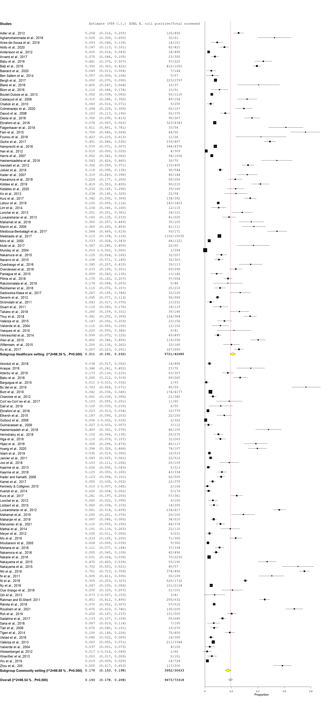

Figure S1: The global pooled prevalence in human intestinal carriage of ESBL E. coli in community versus healthcare settings.
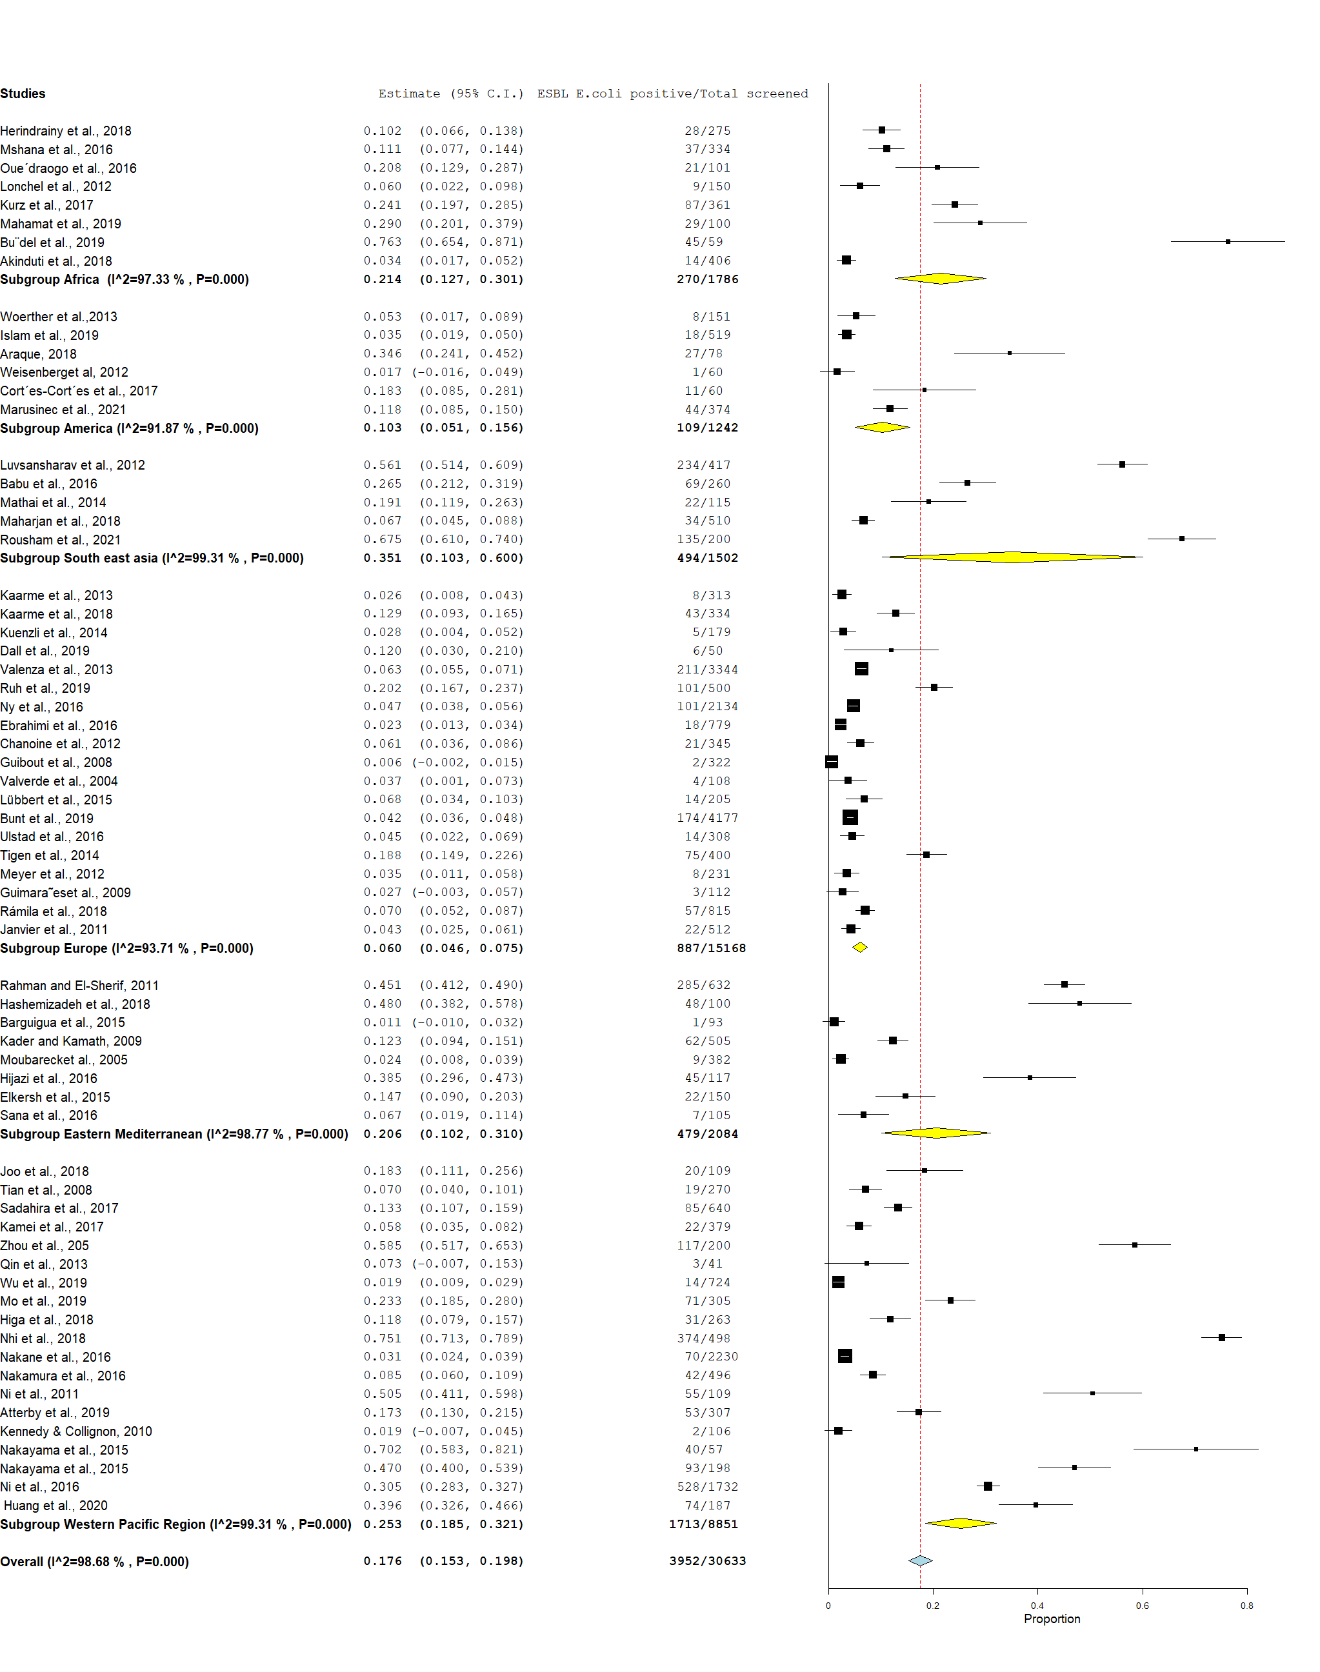
Figure S2: The prevalence of human faecal ESBL E. coli carriage among the six WHO regions²¹ in community settings.

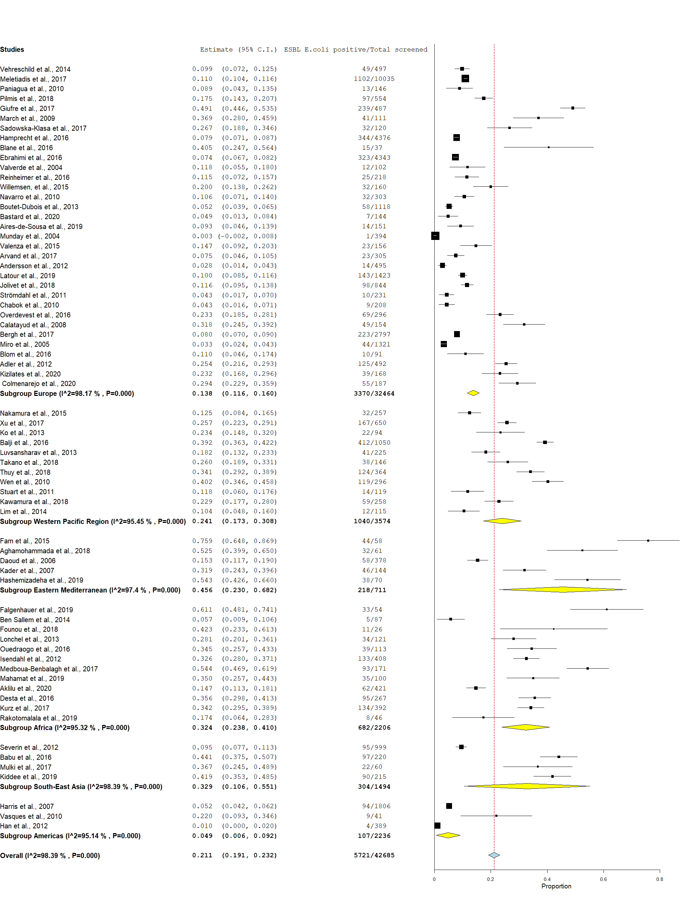
Figure S3: The prevalence of human faecal ESBL E. coli carriage among the six WHO regions²¹ in healthcare settings.

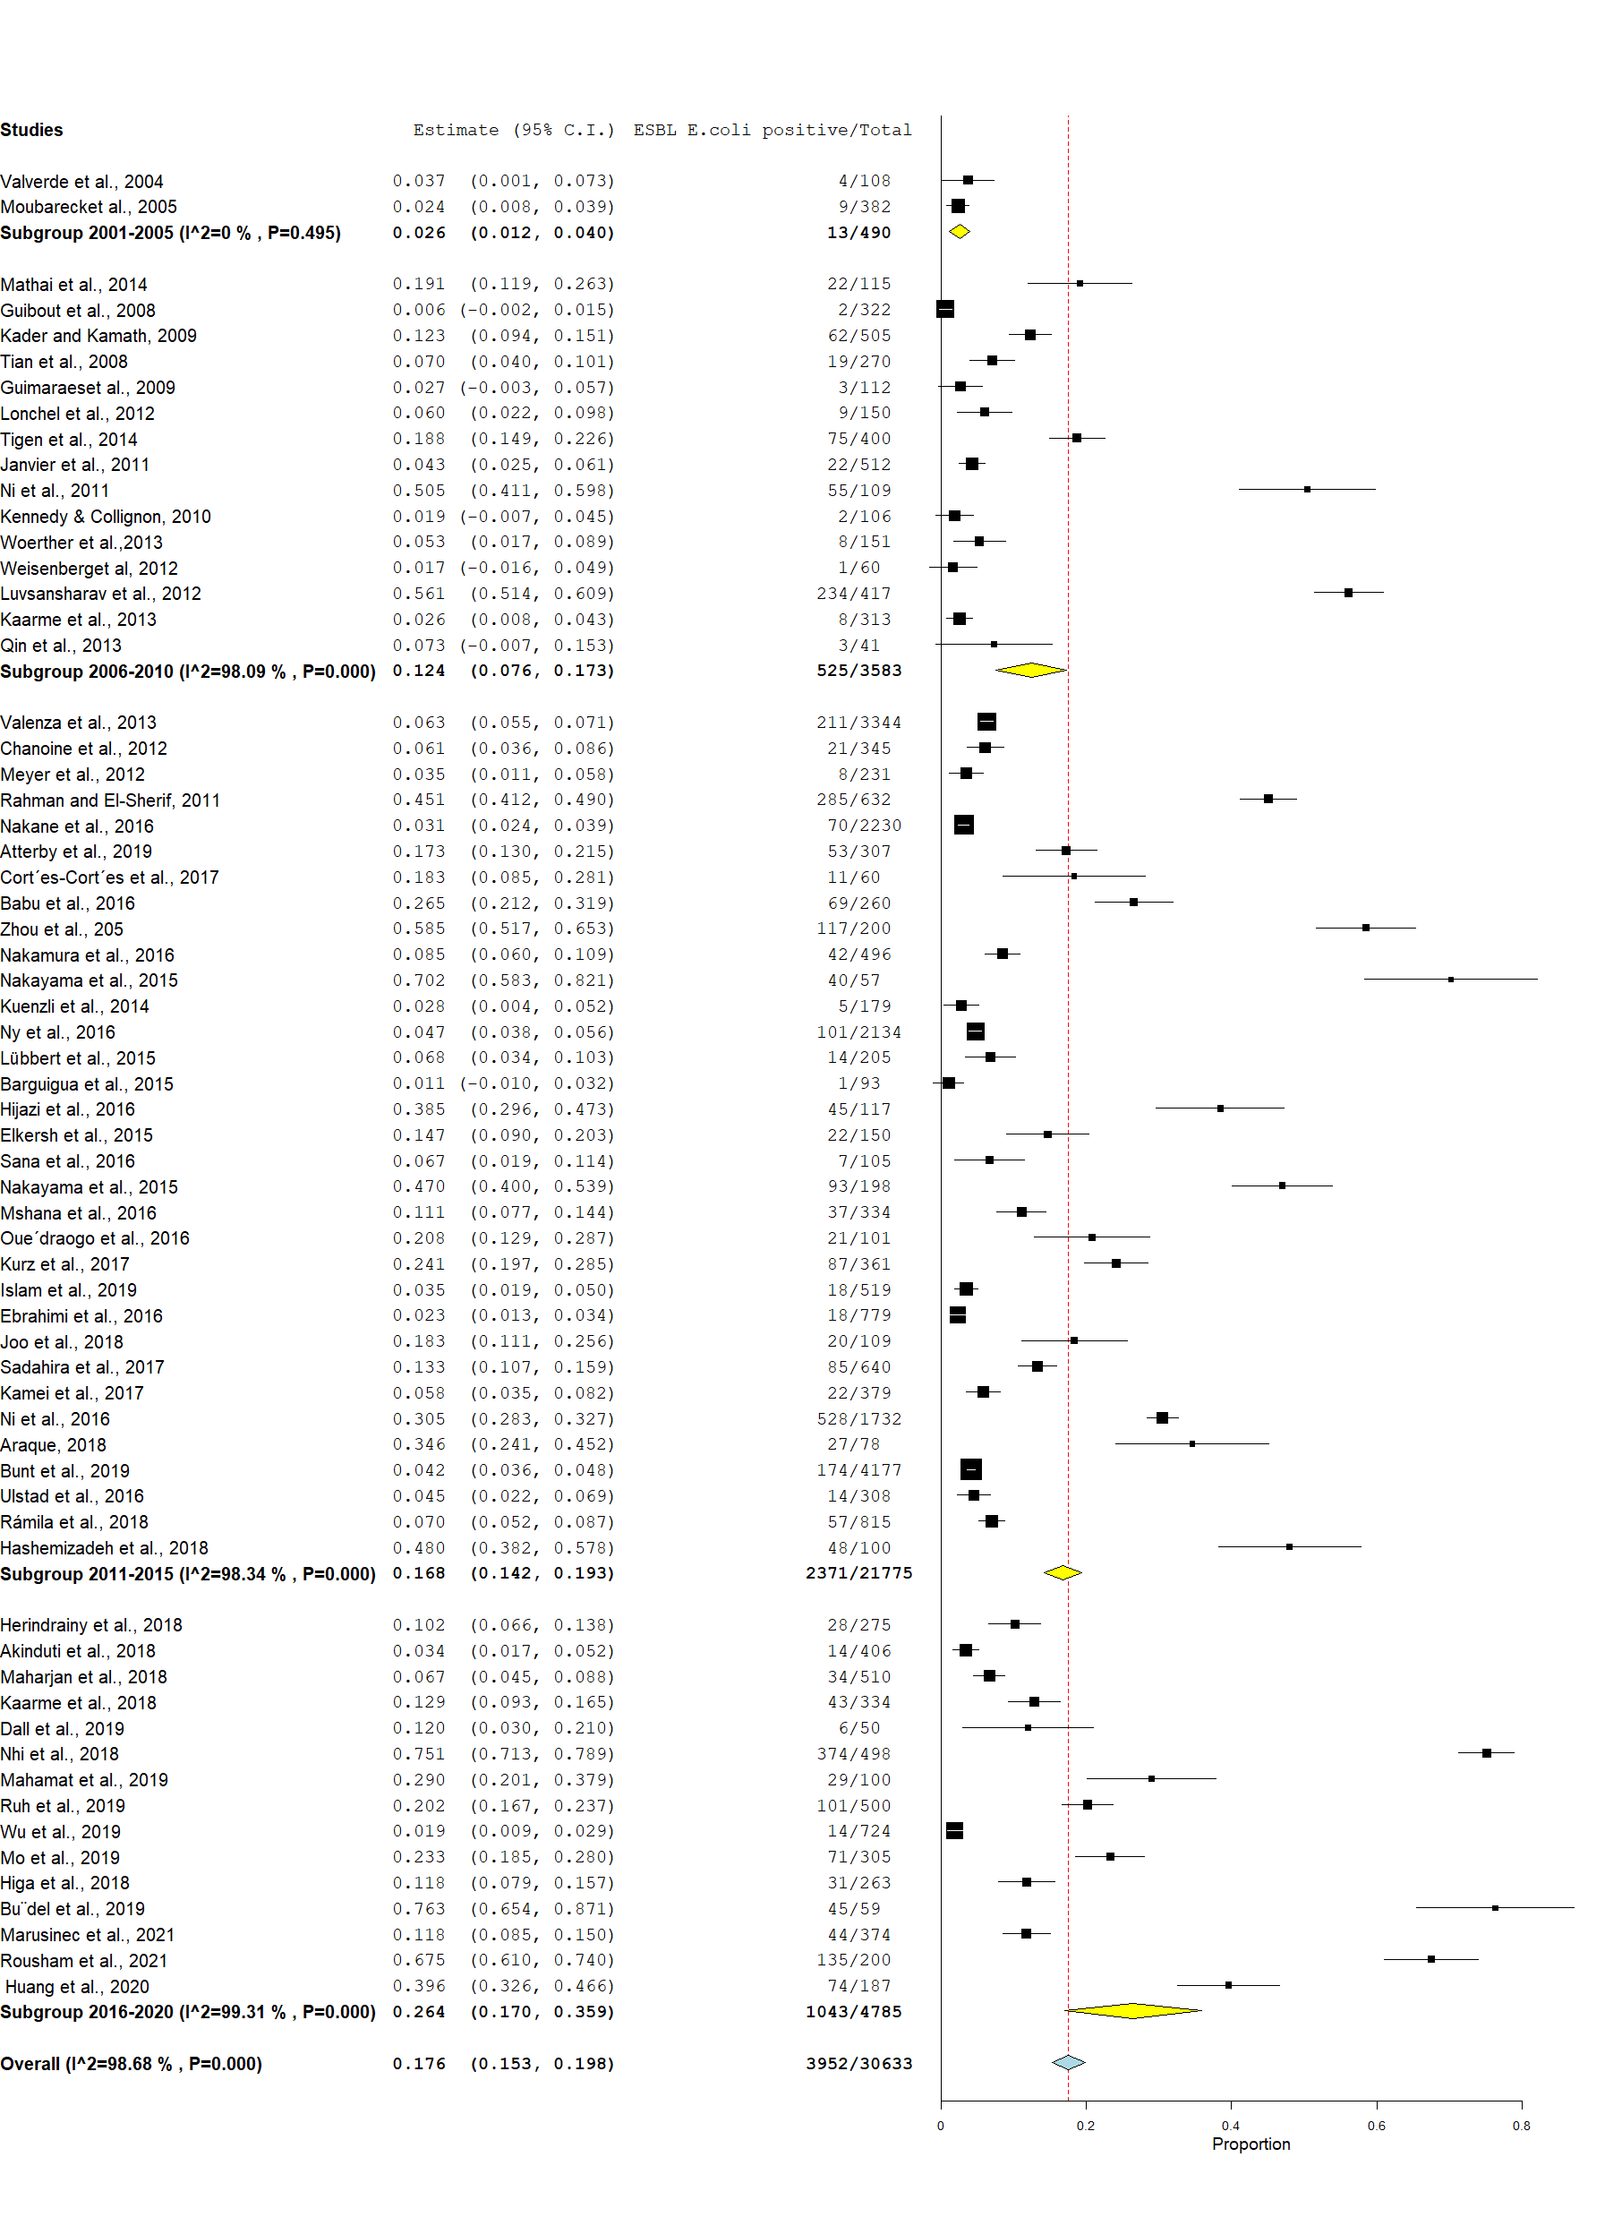

Figure S4: The global trend in the prevalence of human faecal ESBL E. coli carriage in the community setting by subgrouping studies every five years of study period.

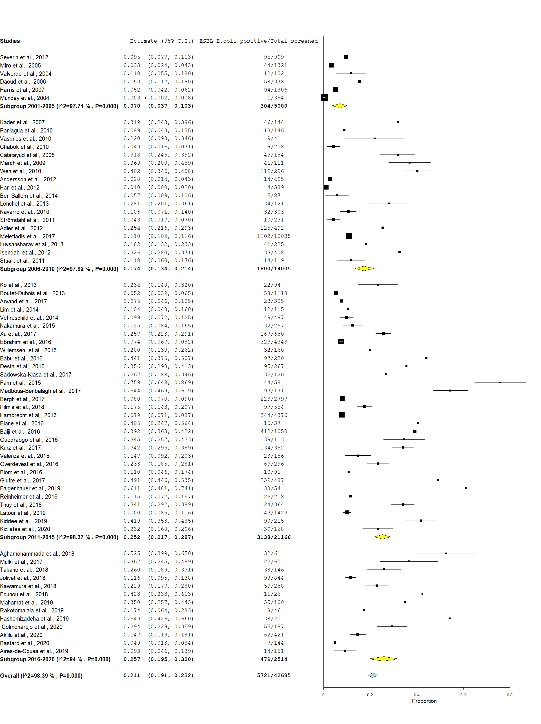
Figure S5: The global trend in the prevalence of human faecal ESBL E. coli carriage in the healthcare setting by subgrouping studies every five years of study period.

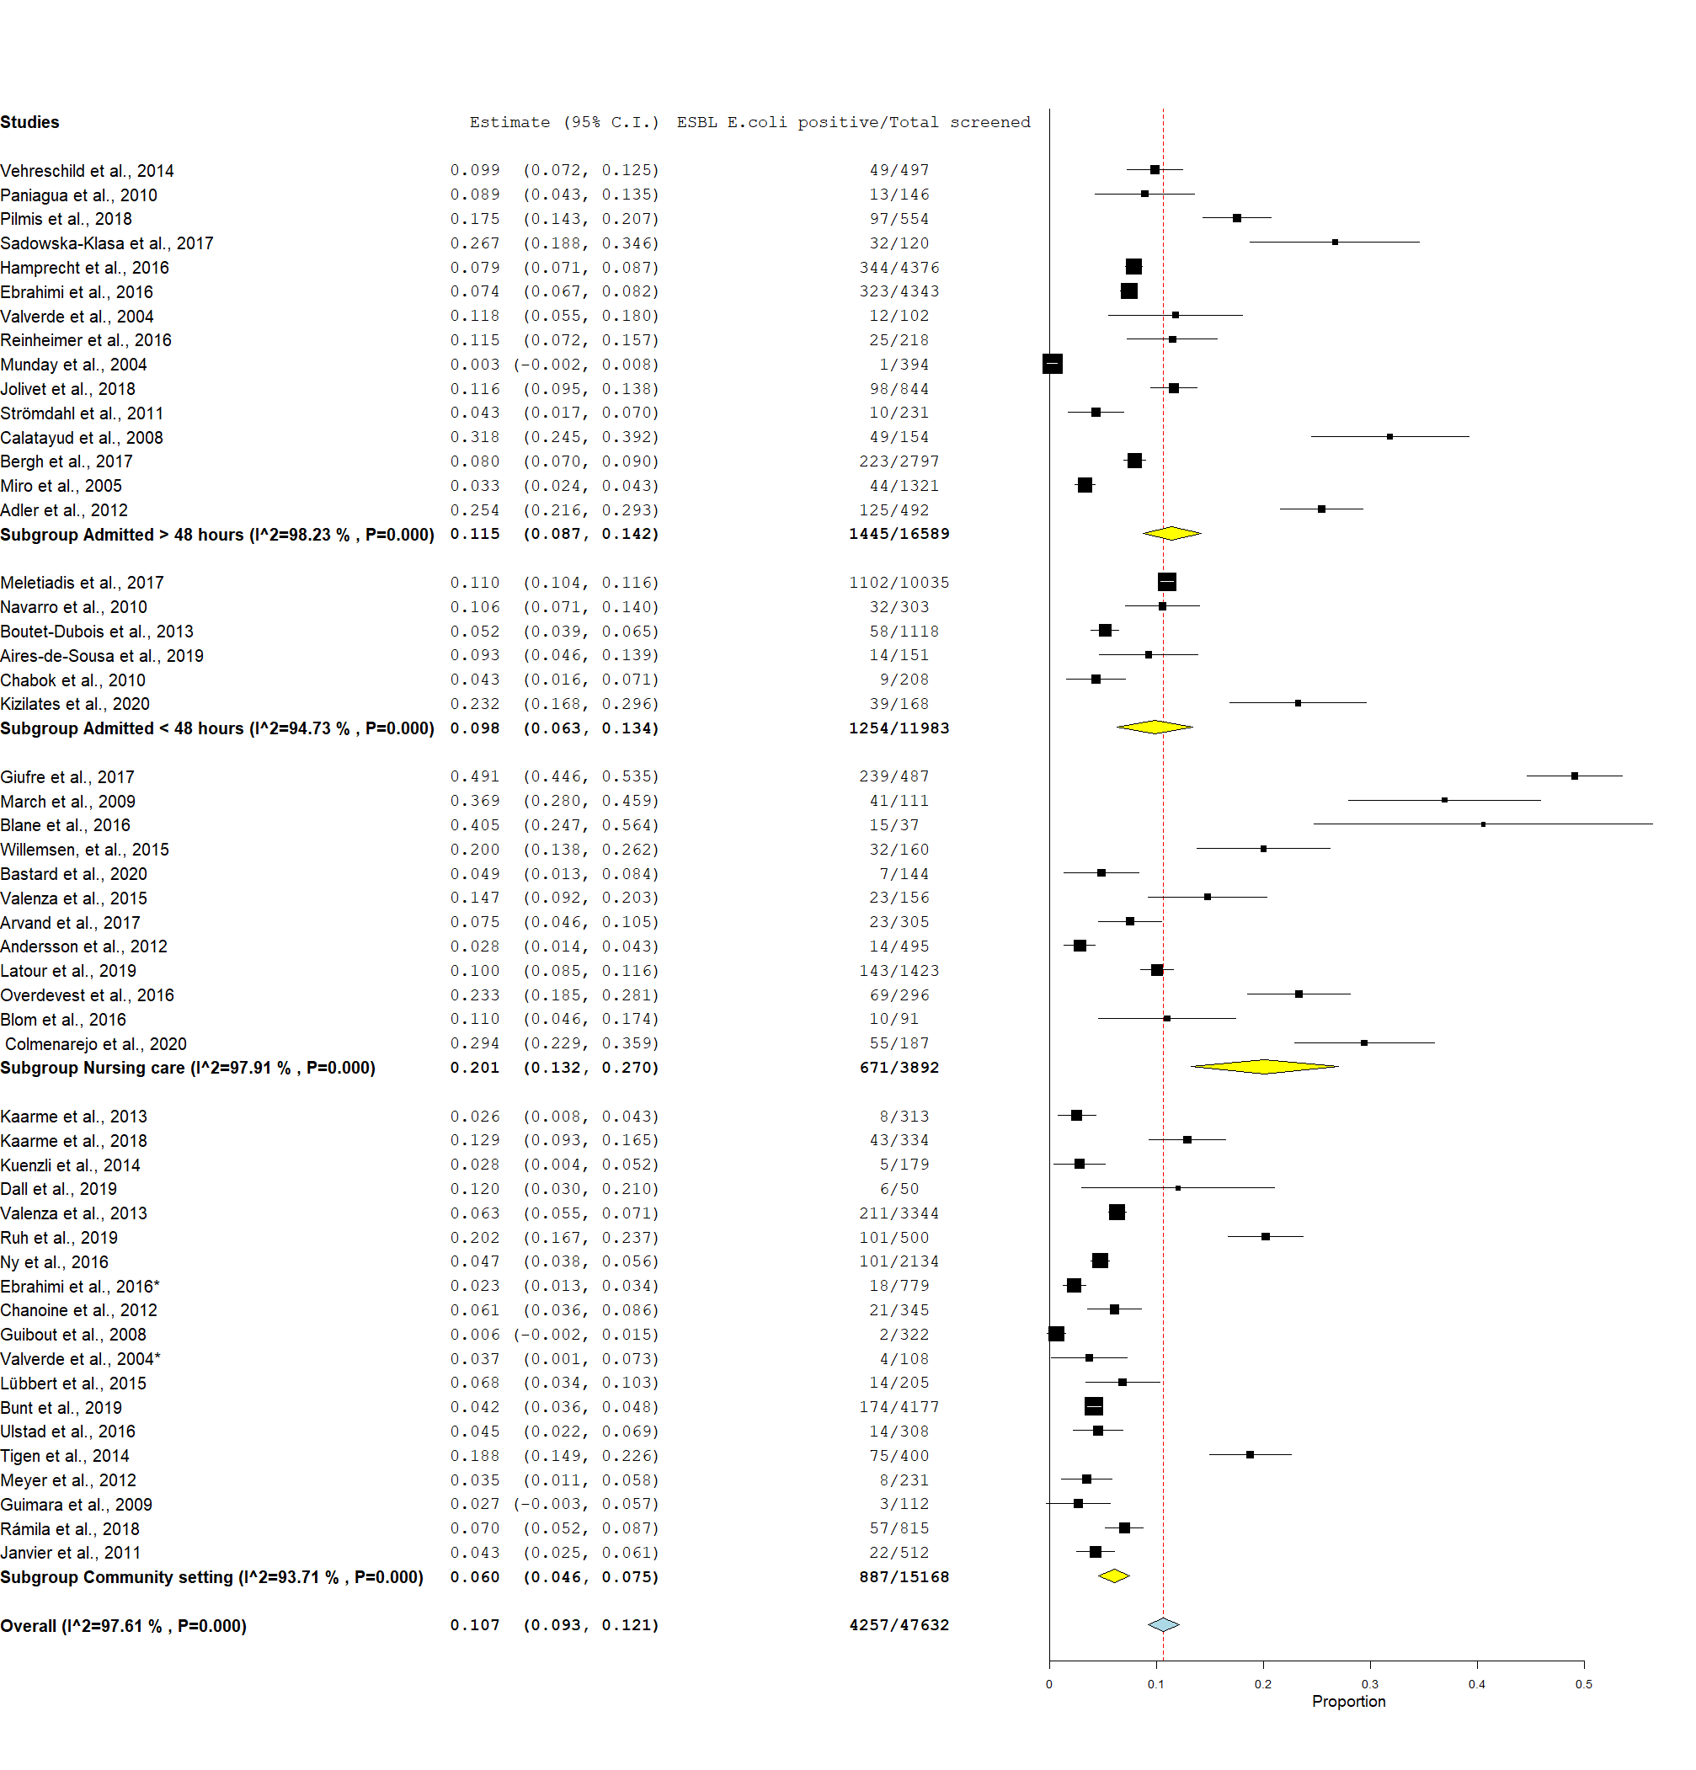 Figure S6: The prevalence of human faecal ESBL E. coli carriage by amount (in time) of contact to healthcare settings in Europe.

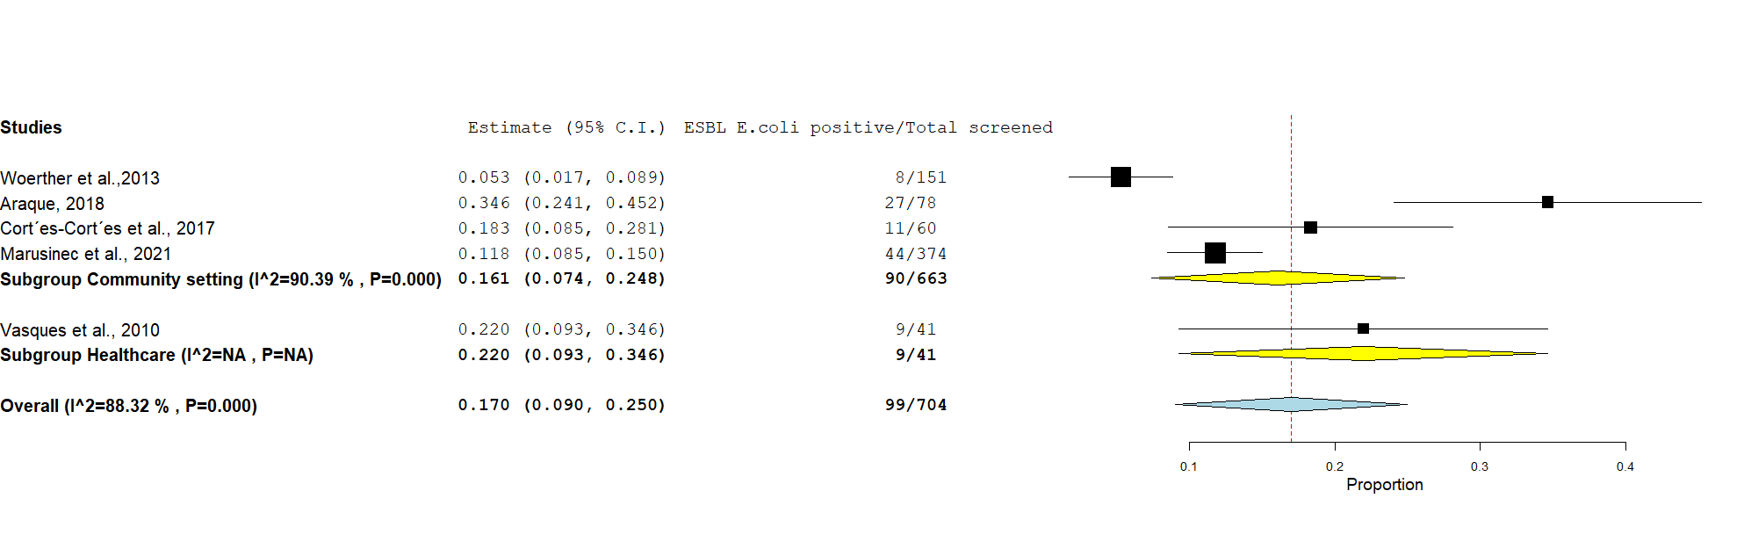

Figure S7: The prevalence of human faecal ESBL E. coli carriage in South Americas by study setting. Abbreviations: E. coli, Escherichia coli.
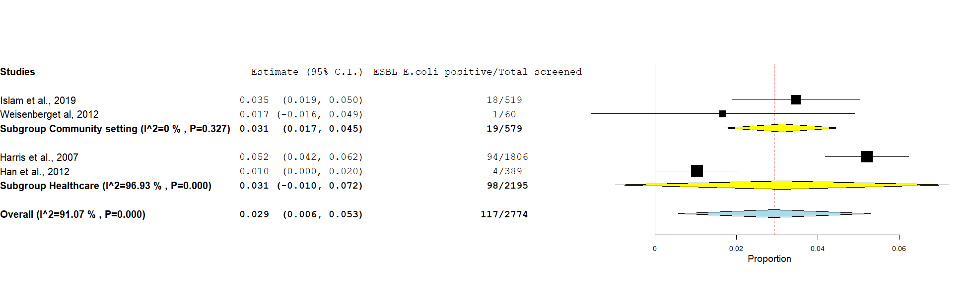

Figure S8: The prevalence of human faecal ESBL E. coli carriage in North Americas by study setting. Abbreviations: E. coli, Escherichia coli.

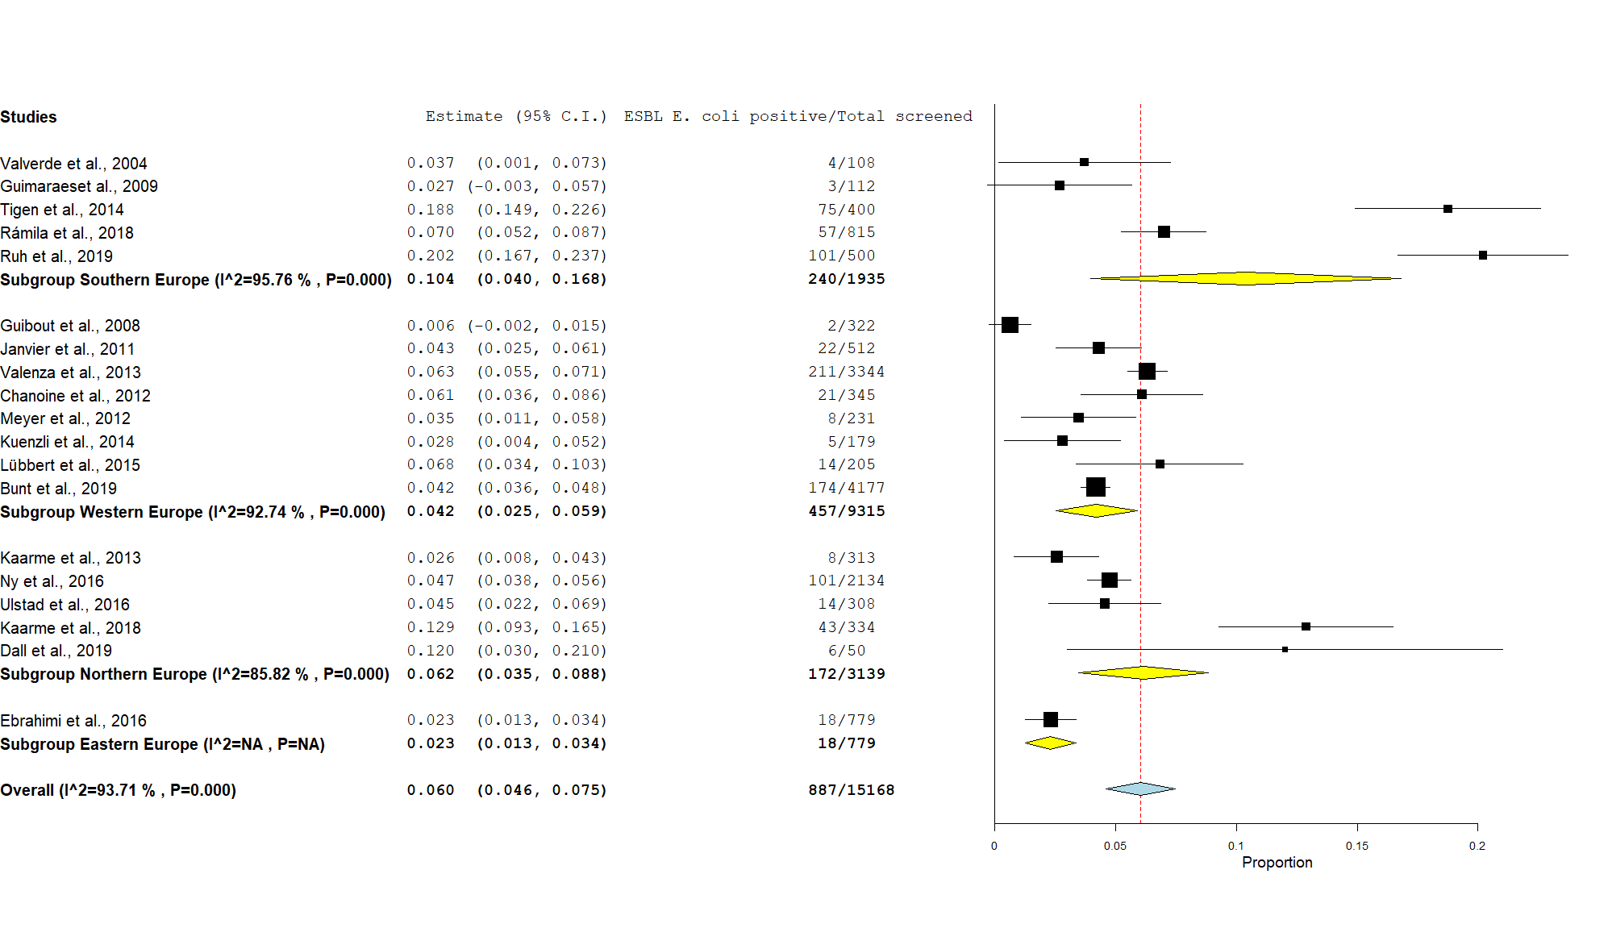

Figure S9: The prevalence of human faecal ESBL E. coli carriage in different sub-regions of Europe ¹⁴⁶in the community setting. Abbreviations: E. coli, Escherichia coli

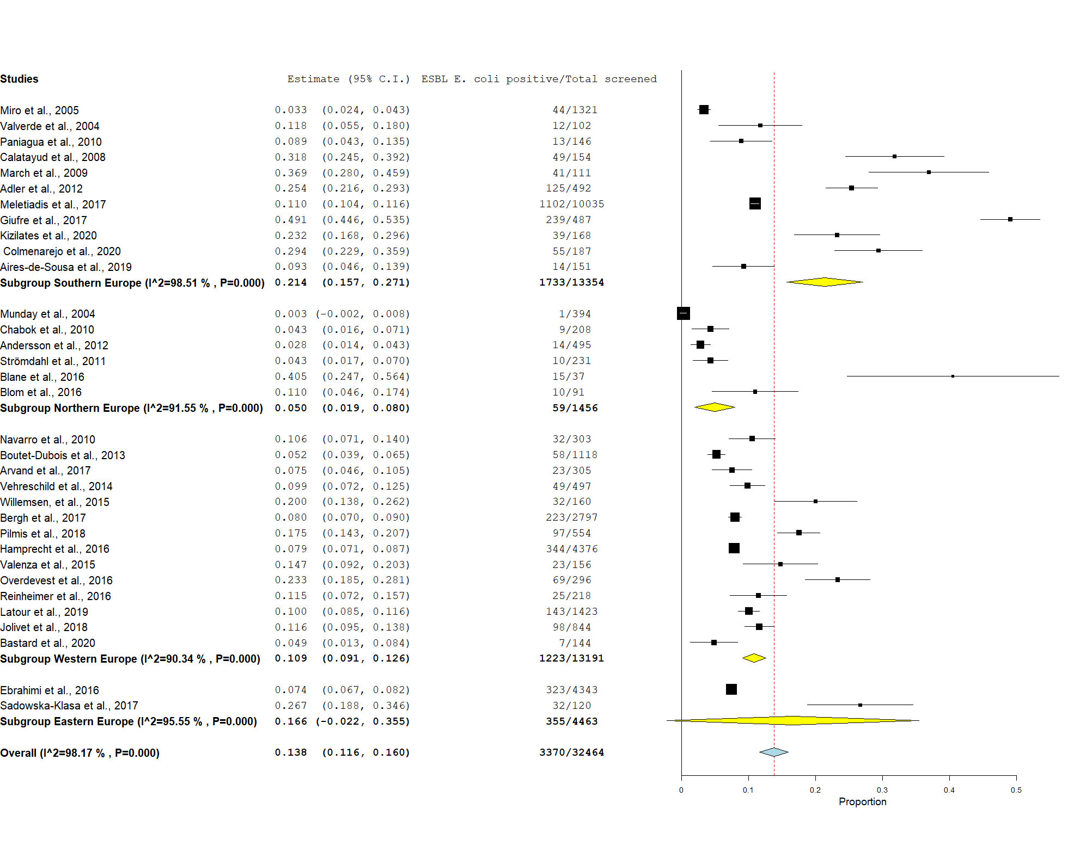

Figure S10: The prevalence of human faecal ESBL E. coli carriage in different sub-regions of Europe ¹⁴⁶in the healthcare setting. Abbreviations: E. coli, Escherichia coli.

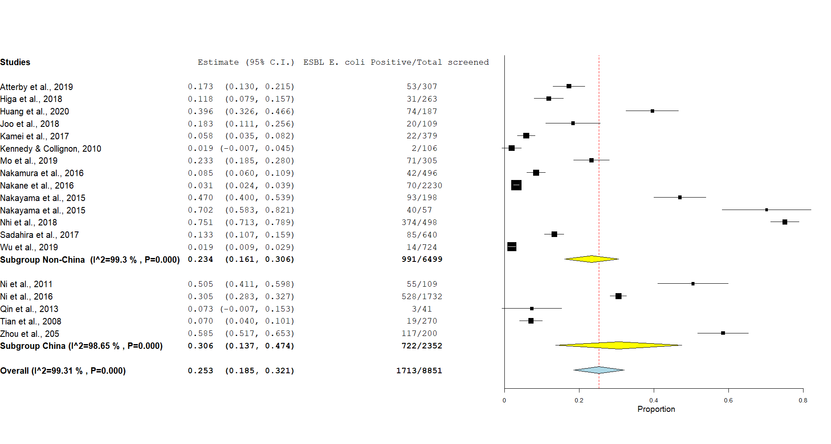

Figure S11: The prevalence of human faecal ESBL E. coli carriage in China versus the rest of West Pacific countries in the community setting. Abbreviations: E. coli, Escherichia coli.

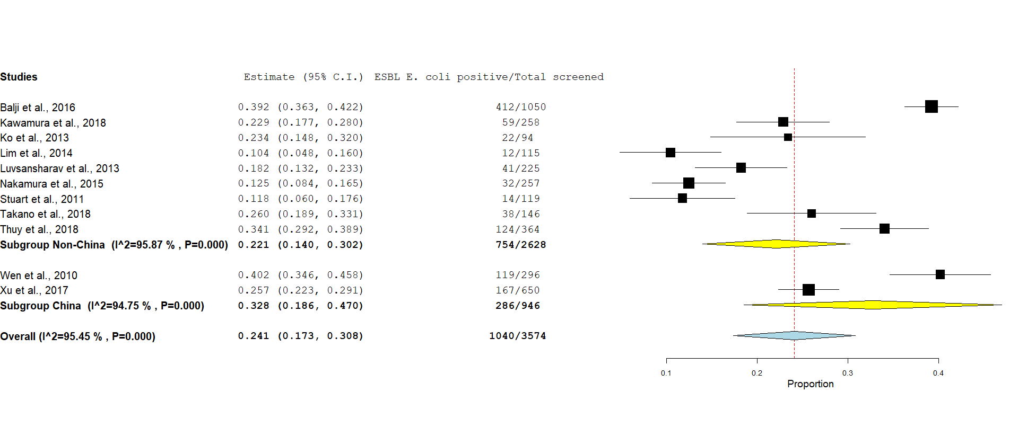

Figure S12: The prevalence of human faecal ESBL E. coli carriage in China versus the rest of West Pacific countries in the healthcare setting. Abbreviations: E. coli, Escherichia coli.

a)
b)
Figure S13: The prevalence of human faecal ESBL E. coli carriage in healthcare settings in different Sub-regions of Europe ¹⁴⁶ (a). The figure below the bar graph (b) summarizes the prevalence of human faecal ESBL E. coli carriage by sub-region and study setting in Europe and Western Pacific regions. Abbreviations: E. coli, Escherichia coli. Note, non-China sub-region includes all West Pacific countries other than China.

Figure S14: Funnel plots of the included studies in community (a) and healthcare (b) settings. The dotted vertical lines pass through a value on x-axis that represent the global pooled prevalence for each study setting (17.6% for the community and 21.1% for healthcare settings). Lower prevalence with larger sample size in both plots was due to the presence of larger scale studies mainly from Europe which has a low ESBL E. coli carriage.

