eTable 1. Literature Searches and Keywords

- Medline

("neck dissection" OR "cervical lymphadenectomy" OR "neck lymphadenectomy" OR "cervical lymph node dissection" OR "neck lymph node dissection") AND ("vessel sealing" OR "ligasure" OR "energy")
- EMBASE

('neck dissection'/exp OR 'neck dissection' OR 'cervical lymphadenectomy' OR 'neck lymphadenectomy' OR 'cervical lymph node dissection' OR 'neck lymph node dissection') AND ('vessel sealing' OR 'ligasure'/exp OR 'ligasure' OR 'energy'/exp OR 'energy')

- Cochrane library

(("neck dissection" OR "cervical lymphadenectomy" OR "neck lymphadenectomy" OR "cervical lymph node dissection" OR "neck lymph node dissection") AND ("vessel sealing" OR "ligasure" OR "energy")):ti,ab,kw

eTable 2: Newcastle-Ottawa Scale Quality Assessment of Included Non-randomized Studies
Study ID | Selection |  |  |  | Comparability* | Outcome |  |  | Total (⋆)
Study ID | Representativeness of the Exposed Cohort | Selection of the Non-Exposed Cohort | Ascertainment of Exposure | Demonstration that Outcome of Interest was not Present at Start of Study | Comparability of Cohorts on the Basis of the Design or Analysis | Assessment of Outcome | Follow-up was  Long Enough  for Outcomes  to Occur | Adequacy of  Follow-up of  Cohorts
Tirelli 2017 | ⋆ | ⋆ | ⋆ | ⋆ | ⋆⋆ | ⋆ | ⋆ | ⋆ | 9
Suzuki 2018 | ⋆ | ⋆ | ⋆ | ⋆ | ⋆⋆ | ⋆ | ⋆ | ⋆ | 9
Ozturk 2016 | ⋆ | ⋆ | ⋆ | ⋆ |  | ⋆ |  |  | 5

eTable 3: Risk of Bias Assessment of Included Randomized Studies

Study ID | Random sequence generation | Allocation concealment | Blinding of participants and personnel | Blinding of outcome assessment | Selective reporting | Other biases
Lin 2017 | Low | Unclear | High | Low | Unclear | Unclear

eTable 4: Funnel plots

Parameter | I² | Egger’s Test | Funnel Plot
Operative Time  (overall study group) | 81.725 | 0.717 | 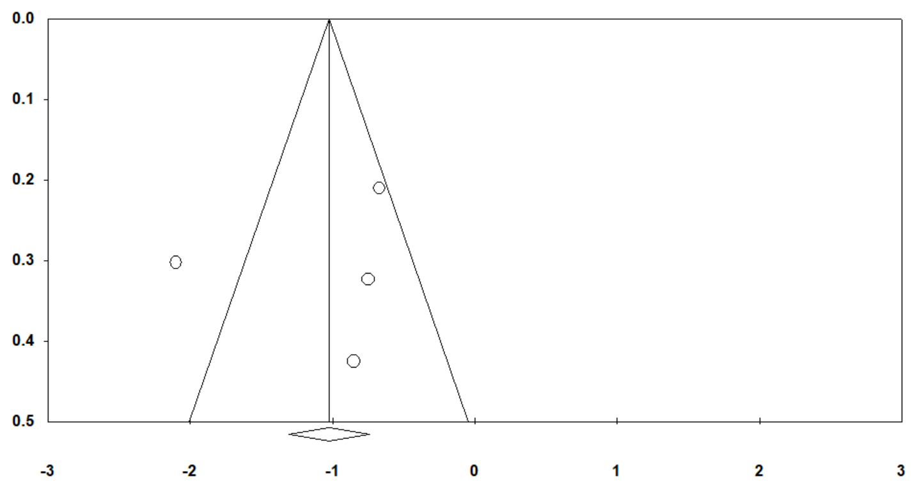
Operative Time  (studies including only selective neck dissection) | 0.000 | X | X
Intraoperative blood loss | 0.000 | X | X
Postoperative hematoma | 0.000 | 0.833 | 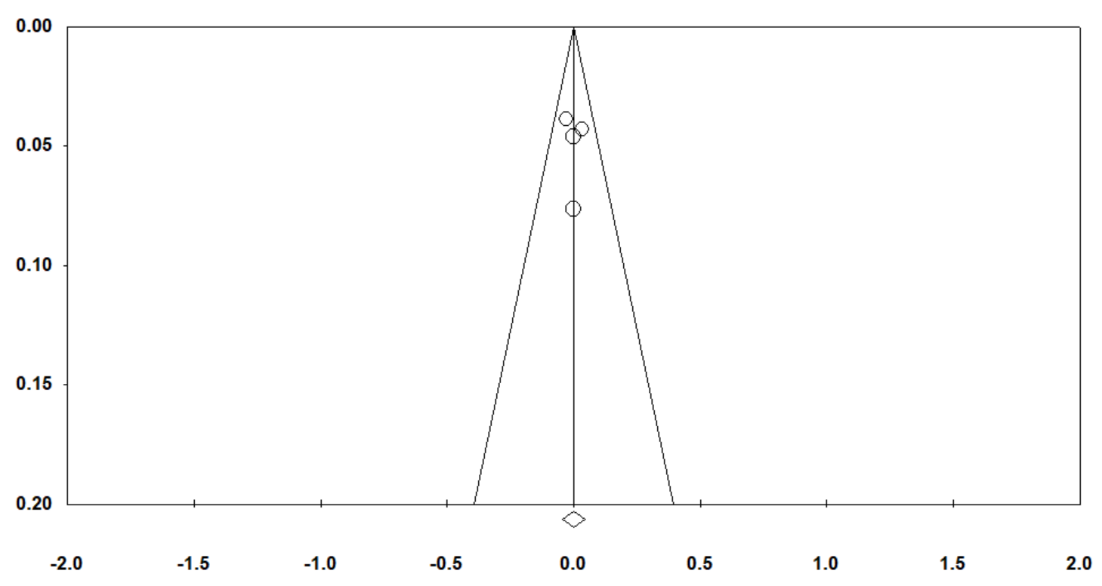
Postoperative surgical site infection | 0.000 | 0.862 | 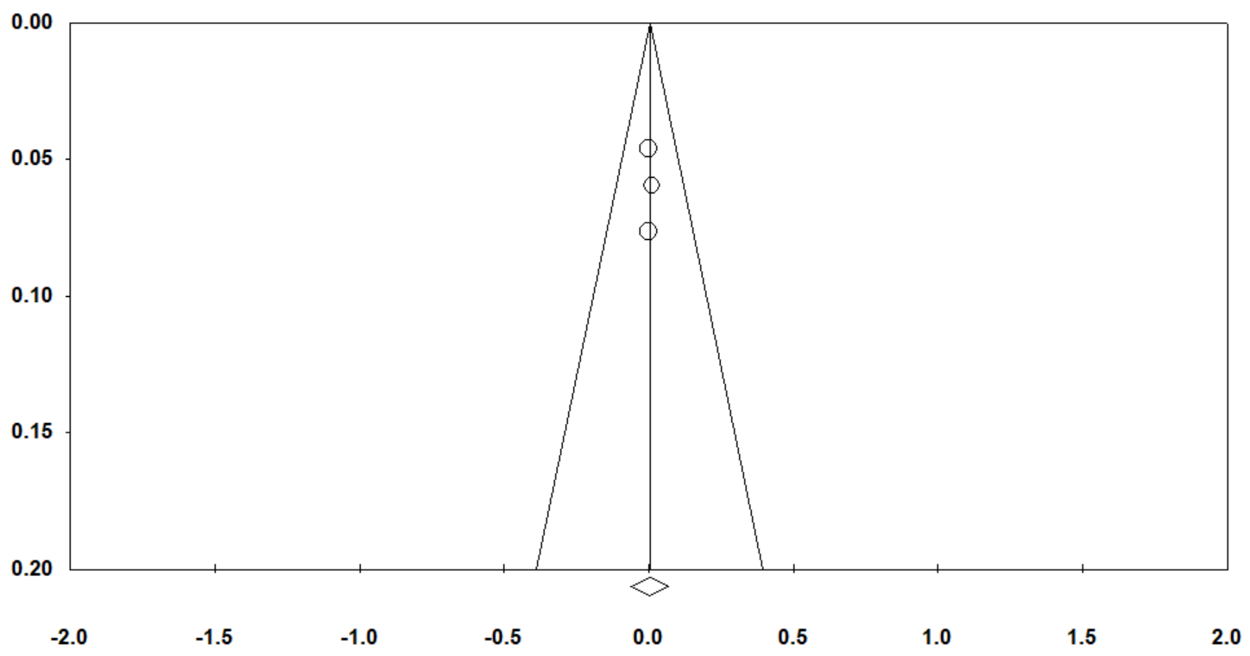
Length of hospital stay | 0.000 | X | X
Drainage amount | 88.411 | 0.031 | 

