Supplementary material
Intensive versus less-intensive antileukemic therapy in older adults with acute myeloid leukemia: a systematic review
S2. Forest plots

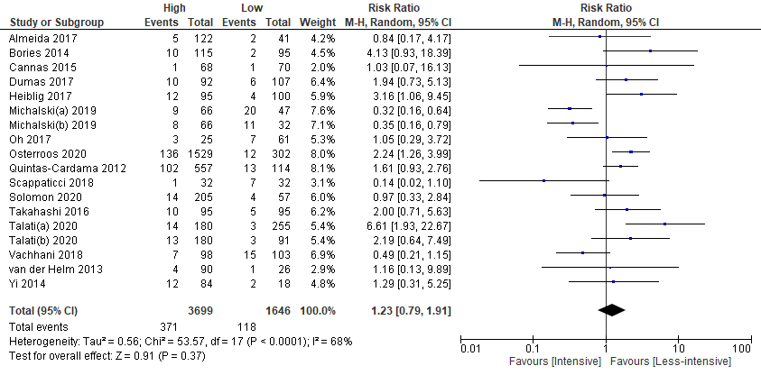
e-Figure 1. All-cause mortality at 30 days after treatment initiation (all from observational studies).

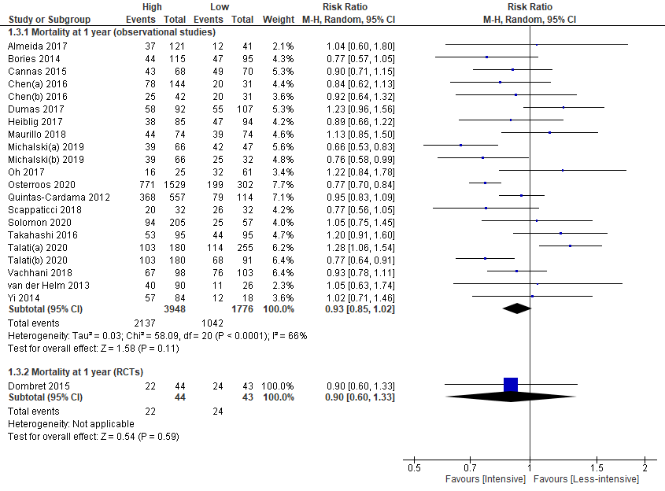
e-Figure 2. All-cause mortality at 1 year after treatment initiation. RCT, randomized controlled trial.

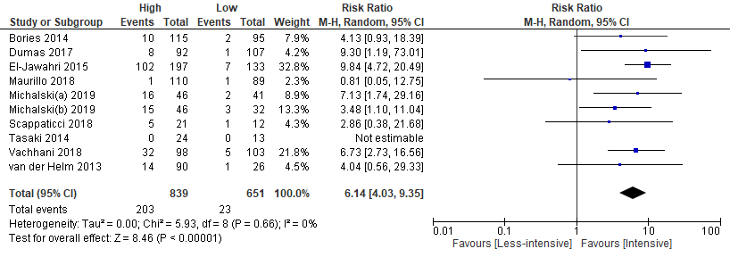
e-Figure 3. Proportion of patients who received allogeneic hematopoietic stem cell transplantation (all from observational studies).

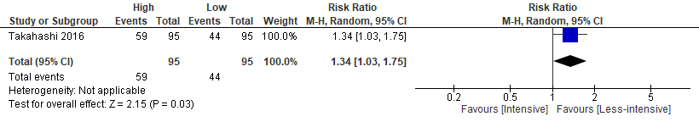
e-Figure 4. Proportion of patients who had serious treatment-emergent adverse events (Grade 3 to 4 severe toxicity, from a single observational study).

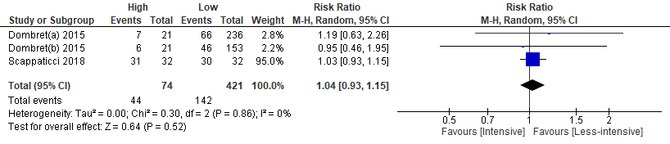
e-Figure 5. Proportion of patients who had febrile neutropenia (all from observational studies).

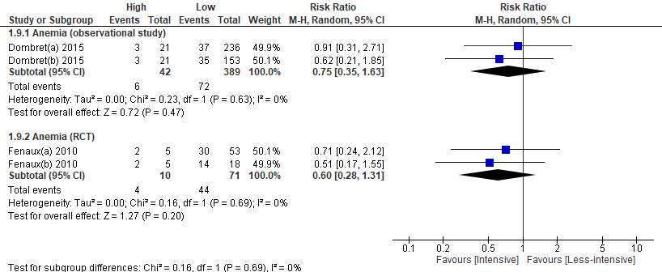
e-Figure 6. Proportion of patients who had anemia.

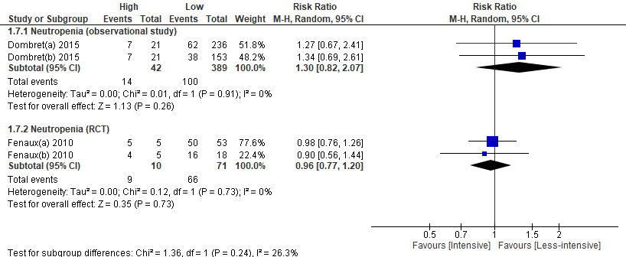
e-Figure 7. Proportion of patients who had neutropenia.

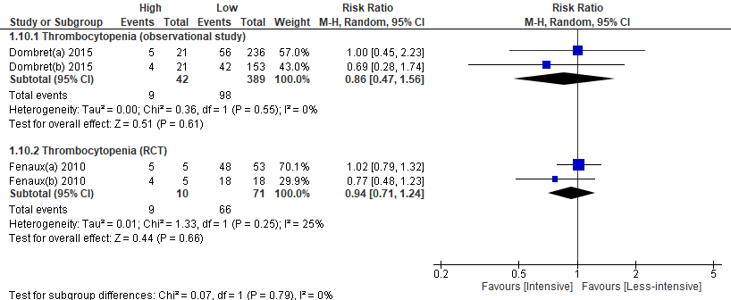
e-Figure 8. Proportion of patients who had thrombocytopenia.

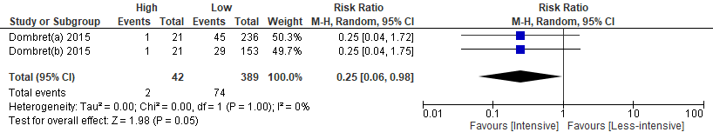
e-Figure 9. Proportion of patients who had pneumonia (from a single study with non-randomized data).

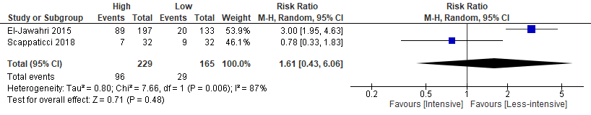
e-Figure 10. Proportion of patients who admitted to intensive care unit (ICU) (from observational studies).

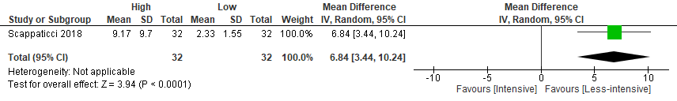
e-Figure 11. Duration of ICU hospitalization (days) (from a single observational study). SD, standard deviation.

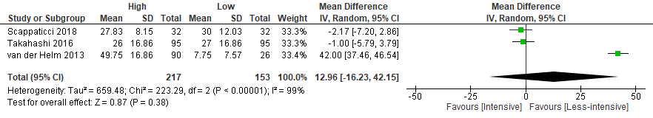
e-Figure 12. Duration of overall hospitalization in days (all from observational studies, SDs in one study (Takahashi 2016) were imputed).

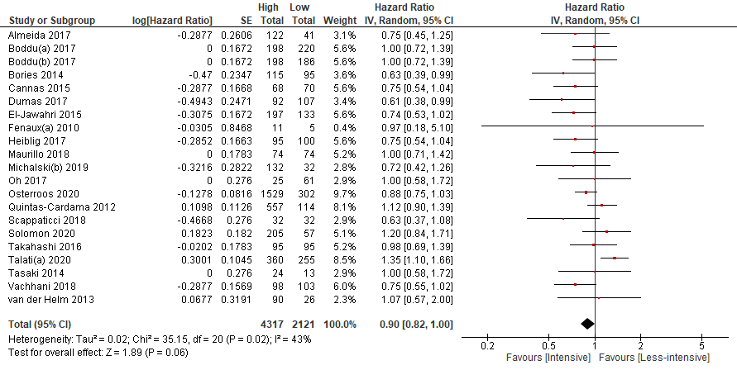
e-Figure 13. Sensitivity analysis of all-cause mortality assessed with risk of death (all from observational studies, HRs and CIs in four studies (Boddu 2017, Maurillo 2018, Oh 2017, and Tasaki 2014) were imputed).

