Appendix 2 – Additional tables and figures

Random-Effect Models
Figure S1. Post-treatment standardized mean difference (Hedge’s g) between internet-delivered treatment and control groups for functioning outcomes. CBT: cognitive behavioral therapy; iCBT-GEN: generic internet-delivered cognitive behavioral therapy; iCBT-SAD: internet-delivered cognitive behavioral therapy for social anxiety disorder; SMD: standardized mean difference; WL: wait-list.
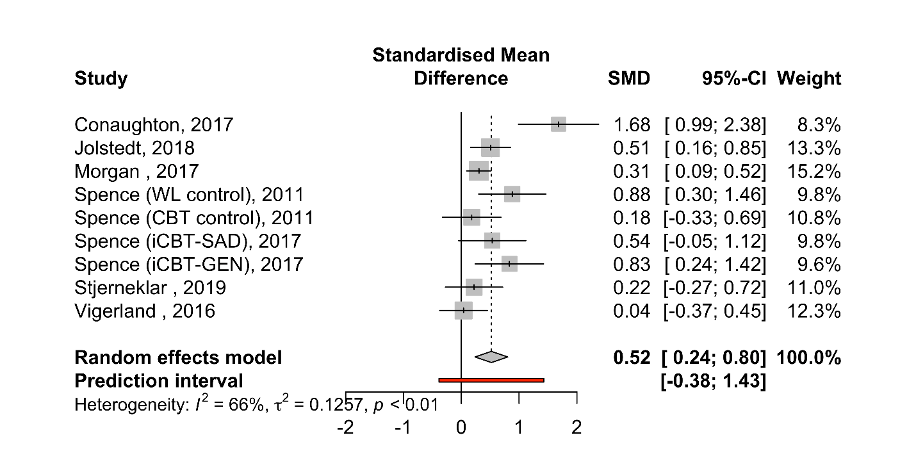

Figure S2. Post-treatment standardized mean difference (Hedge’s g) between internet-delivered treatment and control groups for quality of life outcomes. SMD: standardized mean difference.
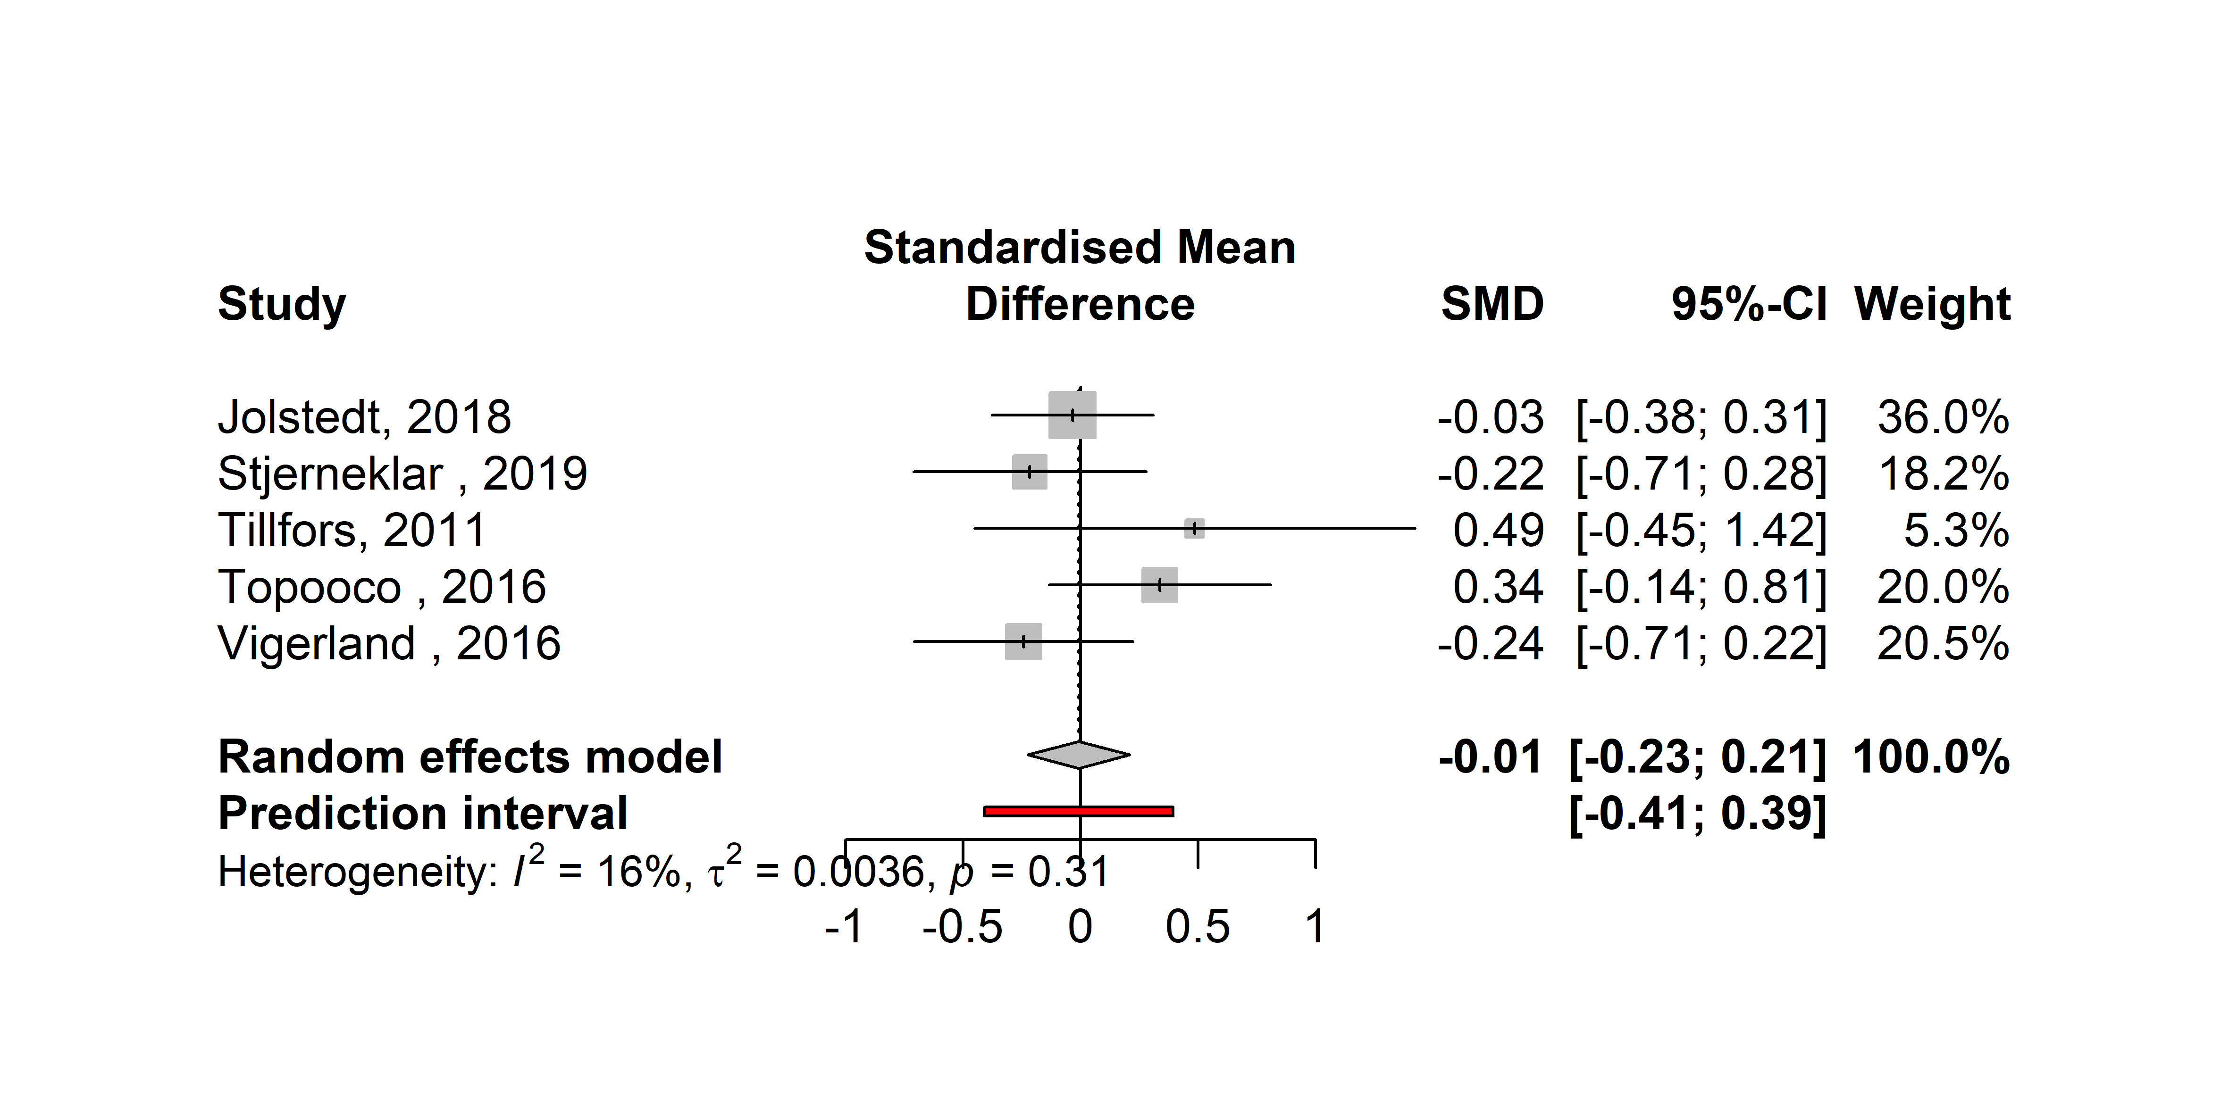

Meta-analysis of follow-up outcomes
Figure S3. Follow-up standardized mean difference (Hedge’s g) between internet-delivered treatment and control groups for anxiety outcomes. GT: group treatment; NT: no treatment; PL: placebo; PWT-iCBM: picture-word training internet-delivered cognitive bias modification; SMD: standardized mean difference; ST-iCBM: scenario training internet-delivered cognitive bias modification; WL: wait-list.
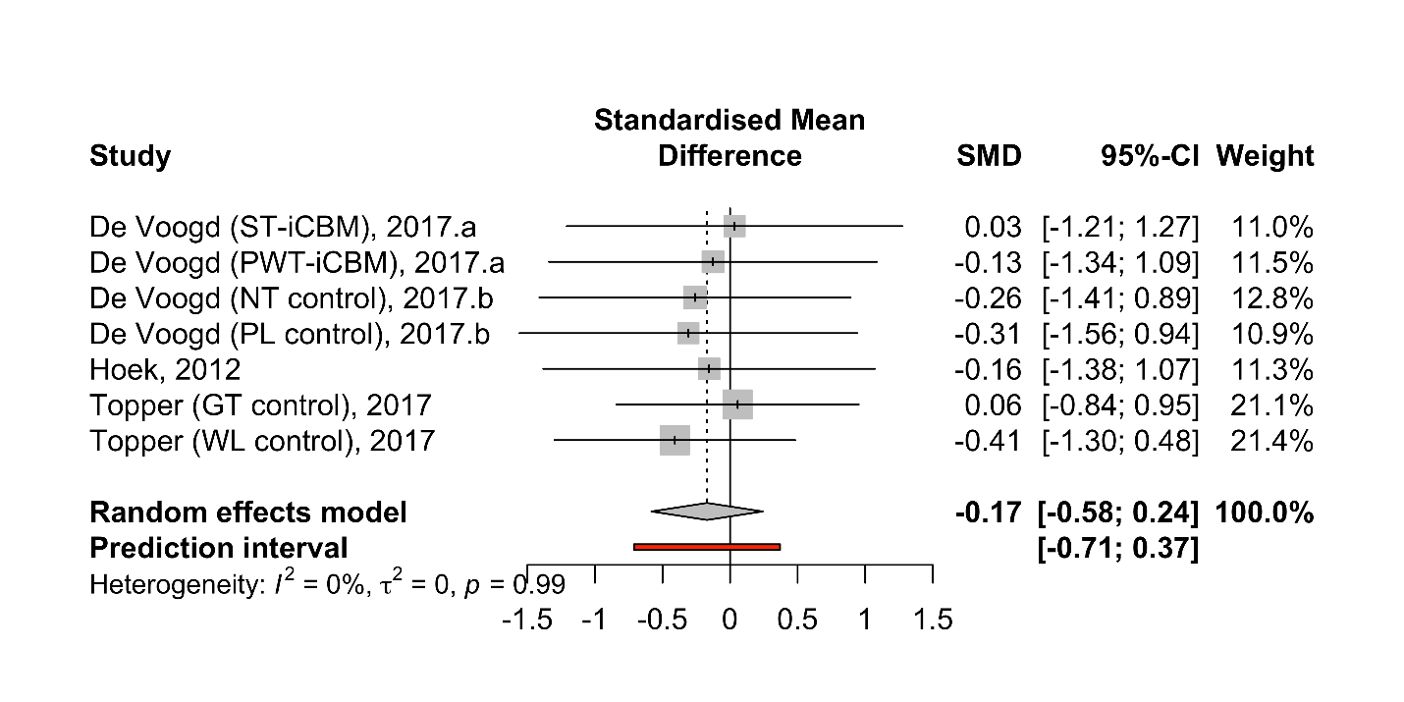

Figure S4. Follow-up standardized mean difference (Hedge’s g) between internet-delivered treatment and control groups for depression outcomes. GT: group treatment; NT: no treatment; PL: placebo; PWT-iCBM: picture-word training internet-delivered cognitive bias modification; SMD: standardized mean difference; ST-iCBM: scenario training internet-delivered cognitive bias modification; WL: wait-list.
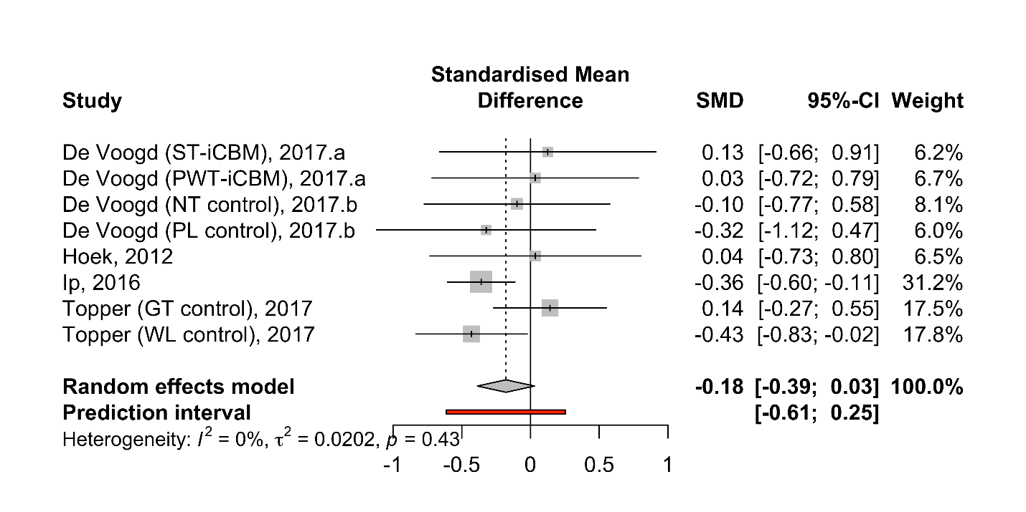

Moderator analyses

Table S1. Mixed effect models.
Moderator | Anxiety | Depression
 | Q_{(df)}, P | Q_{(df)}, P
Effect size based on ITT vs on observed means | Q₍₁₎=3.042, P=.081 | Insufficient data to conduct analyses
Passive vs active control group | Q₍₁₎=0.535, P=.464 | Q₍₁₎=1.553, P=.213
Supported vs unsupported intervention | Q₍₁₎=1.123, P=.288 | Q₍₁₎=1.213, P=.271
CBT-based vs non-CBT based intervention | Q₍₁₎=0.244, P=.621 | Q₍₁₎=0.086, P=.769
Intervention delivered to  only youth vs youth and parent | Q₍₁₎=0.005, P=.942 | All interventions were delivered to youth
 | Test of Moderators (coefficient 2):  F_{(df1, df2)}, P | F_{(df1, df2)}, P
Average age of sample | F_{(1,18)}=0.082, P=.778 | F_{(1, 11)}=1.64, P=.227
Treatment length (in weeks) | F_{(1,18)}=1.221, P=.283 | F_{(1, 11)}=0.083, P=.778
No modules | F_{(1,18)}=0.811, P=.3797 | F_{(1, 11)}=0.488, P=.499
Percentage of sample female | F_{(1,18)}=0.027, P=.872 | F_{(1, 11)}=6.043, P=.032
Average percentage of intervention completed at post-treatment | F_{(1,18)}=1.149, P=.298 | F_{(1, 11)}=0.064, P=.806

Risk of Bias Assessment
Figure S5. Quality ratings for the risk of bias assessment of included studies.

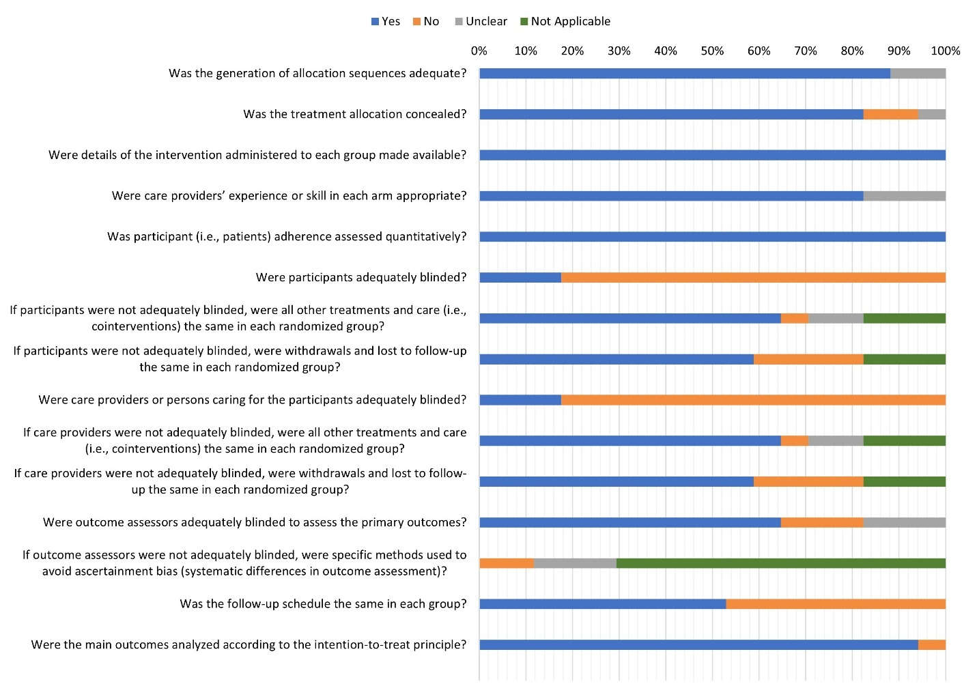

Publication Bias Assessment
Figure S6. Funnel plot for anxiety (6a) and depression (6b) outcomes.
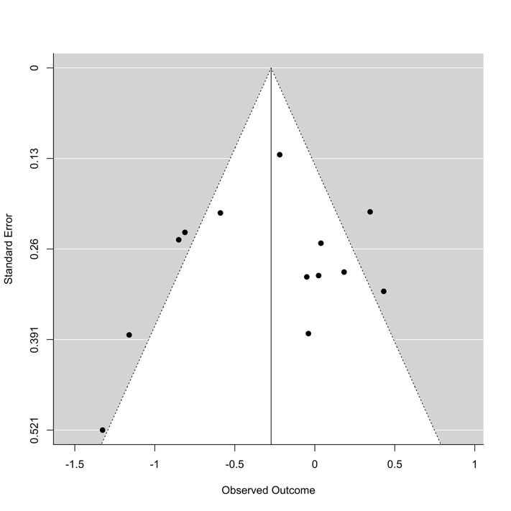
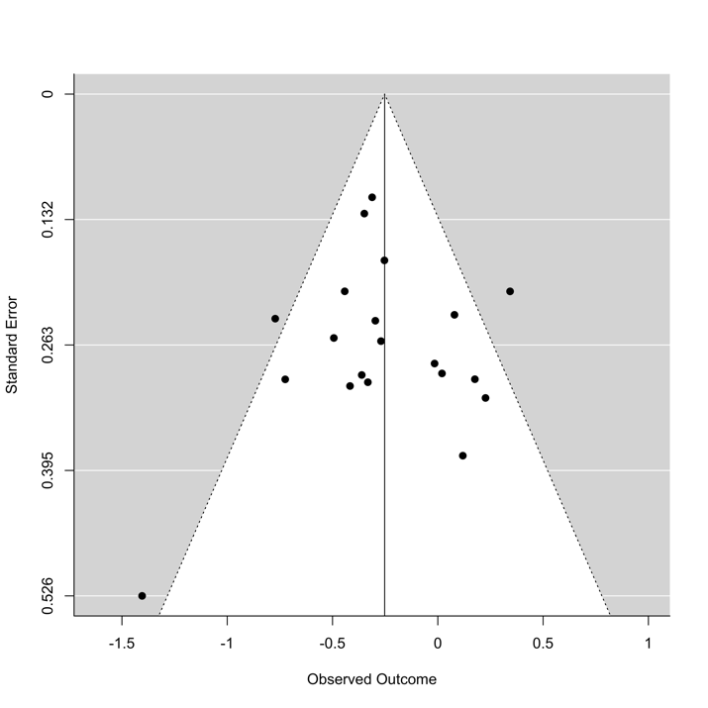
6b.a
6a.a

