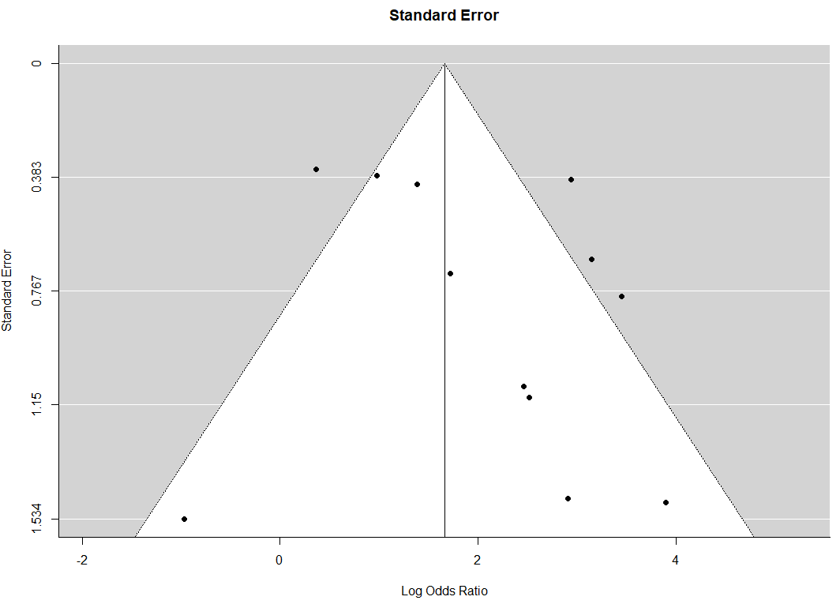
Funnel plot for estimation of publication bias

