Supplementary materials

e-Appendix 1. The literature search strategies.
e-Table 1. The quality assessment for literatures.
e-Table 2. GRADE Assessment of each outcome.
e-Table 3. The sensitivity analysis for risk factors reported in at least two high NOS studies.
e-Figure 1 Meta-analyses of the association between female and impaired diffusing capacity for carbon monoxide (DLCO).
e-Figure 2. Meta-analyses of the association between female and impaired DLCO: Subgroup analysis of follow-up time.
e-Figure 3. Meta-analyses of the association between altered CT and impaired DLCO.
e-Figure 4. Meta-analyses of the association between age and impaired DLCO.
e-Figure 5. The sensitivity analyses of the association between age and impaired DLCO: before excluding heterogeneous literature.
e-Figure 6. Meta-analyses of the association between age and impaired DLCO: after excluding heterogeneous literature.
e-Figure 7. Meta-analyses of the association between age and impaired DLCO: Subgroup analysis of follow-up time.
e-Figure 8. Meta-analyses of the association between D-dimer and impaired DLCO.
e-Figure 9. Meta-analyses of the association between urea nitrogen and impaired DLCO.
e-Figure 10. The Begg's funnel plot of studies on the association between age and impaired DLCO.
e-Figure 11. The Egger's publication bias plot of studies on the association between age and impaired DLCO.
e-Figure 12. The funnel plot of studies on the association between age and impaired DLCO.

e-Appendix 1. The literature search strategies
1. Records identified through database searching until 29 June 2021
(1) Pubmed: #((COVID-19) OR (SARS-CoV-2) OR (2019-nCoV)) AND ((("Respiratory Function Tests") OR ("Lung Function" ) OR ("Pulmonary function") OR (“Vital Capacity”) OR (“Forced Expiratory Volume”) OR (“Forced vital capacity”)) OR (("diffusing capacity for carbon monoxide ") OR ("diffusing capacity") OR (DLCO) OR ("lung diffusion for carbon monoxide") OR（KCO）OR (“carbon monoxide transfer coefficient”) OR (“transfer coefficient of the lung for carbon monoxide”)))# 500

(2) Wos: #((COVID-19) OR (SARS-CoV-2) OR (2019-nCoV)) AND ((("Respiratory Function Tests") OR ("Lung Function" ) OR ("Pulmonary function") OR (“Vital Capacity”) OR (“Forced Expiratory Volume”) OR (“Forced vital capacity”)) OR (("diffusing capacity for carbon monoxide ") OR ("diffusing capacity") OR (DLCO) OR ("lung diffusion for carbon monoxide") OR（KCO）OR (“carbon monoxide transfer coefficient”) OR (“transfer coefficient of the lung for carbon monoxide”)))# 569

(3) Embase
#1 'covid 19' OR 'sars cov 2' OR '2019 ncov' 141582
#2 'respiratory function tests' OR 'lung function' OR 'pulmonary function' OR 'vital capacity' OR 'forced expiratory volume' OR ‘forced vital capacity’ 214220
#3 'diffusing capacity for carbon monoxide' OR 'diffusing capacity' OR dlco OR 'lung d diffusion for carbon monoxide' OR kco OR 'carbon monoxide transfer coefficient' OR 'transfer coefficient of the lung for carbon monoxide' 14018
#4 #2 0R #3 217999
#5 #1 AND#4 991

(4) Ovid
#1 (COVID-19 or SARS-CoV-2 or 2019-nCoV).mp. [mp=ti, ab, tx, ct, sh, ot, nm, hw,, kf, ox, px,, an, ui, sy] 1944225
#2 (“Respiratory Function Tests" or "Lung Function or "Pulmonary function" or "Vital Capacity" or "Forced Expiratory Volume" or "Forced vital capacity").mp. [Imp=ti, ab, tx ct, sh, ot, nm, hw, fx, ktf, ox, px, rx,ui,sy] 138308
#3 ("'diffusing capacity for carbon monoxide" or "diffusing capacity" or DLCO or "lung diffusion for carbon monoxide" or KCo or "carbon monoxide transfer coefficient" or "transfer coefficient of the lung for carbon monoxide"). mp. [mp-=ti, ab, tx, ct, sh, ot, nm, hw, tx, ktf, ox, px,, an, ui, sy] 1385
#4 #2 or #3 140963
#5 #1 and #4 1503
#6 remove duplicates from #5 1349

2.Found in hand searches from 30 June 2021 to 7 January 2022
Pubmed: #((COVID-19) OR (SARS-CoV-2) OR (2019-nCoV)) AND ((("Respiratory Function Tests") OR ("Lung Function" ) OR ("Pulmonary function") OR (“Vital Capacity”) OR (“Forced Expiratory Volume”) OR (“Forced vital capacity”)) OR (("diffusing capacity for carbon monoxide ") OR ("diffusing capacity") OR (DLCO) OR ("lung diffusion for carbon monoxide") OR（KCO）OR (“carbon monoxide transfer coefficient”) OR (“transfer coefficient of the lung for carbon monoxide”)))# 315

e-Table 1. The quality assessment for literatures.
Author | Year | Selection（4☆） | Comparability（2☆） | Outcome（3☆） | NOS
Bellan M et al | 2021 | ☆☆☆ | ☆☆ | ☆☆☆ | 8 Star
Blanco JR et al | 2021 | ☆☆☆☆ | ☆☆ | ☆☆☆ | 9 Star
Labarca G et al | 2021 | ☆☆☆ | ☆☆ | ☆☆ | 7 Star
Marta NF et al | 2021 | ☆☆☆ | ☆ | ☆☆☆ | 7 Star
Qin W et al | 2021 | ☆☆☆☆ | ☆☆ | ☆☆ | 8 Star
Wu XJ et al | 2021 | ☆☆☆☆ | ☆☆ | ☆☆ | 8 Star
Labarca G et al | 2021 | ☆☆☆ | ☆☆ | ☆☆ | 7 Star
Zhang SD et al | 2021 | ☆☆☆ | ☆☆ | ☆☆ | 7 Star
Salem AM et al | 2021 | ☆☆☆ | ☆☆ | ☆☆☆ | 8 Star
Huang LX et al | 2021 | ☆☆☆ | ☆☆ | ☆☆☆ | 8 Star
Zhao YM et al | 2020 | ☆☆☆☆ | ☆☆ | ☆☆ | 8 Star
Lerum TV et al | 2020 | ☆☆☆ | ☆☆ | ☆☆ | 7 Star
Steinbeis F et al | 2021 | ☆☆☆☆ | ☆☆ | ☆☆☆ | 9 Star
Bellan M et al | 2021 | ☆☆☆ | ☆☆ | ☆☆ | 7 Star
Liao TT et al | 2021 | ☆☆☆ | ☆☆ | ☆☆ | 7 Star
Safont B et al | 2021 | ☆☆☆ | ☆☆ | ☆☆ | 7 Star
Zhao YM et al | 2021 | ☆☆☆ | ☆☆ | ☆☆ | 7 Star
Chen M et al | 2021 | ☆☆☆ | ☆☆ | ☆☆ | 7 Star
Abbreviations: NOS, Newcastle-Ottawa scale

e-Table 2. GRADE Assessment of each outcome
Certainty Assessment |  |  |  |  |  |  | Summary of Findings
Outcome  Examined  (No. of  Studies) | Study Design | Risk of Bias | Inconsistency | Indirectness | Imprecision | Publication bias | Estimate (95% CI) | Certainty
Female  (7) | observational studies | Moderate | Not inconsistency | Not Serious | Not Serious | Not Serious | 4.011  (2.928-5.495) | Low
Altered CT  (4) | observational studies | Moderate | Serious inconsistency | Not Serious | Not Serious | Not Serious | 3.002  (1.319-6.835) | Very low
Age  (8) | observational studies | Moderate | Not inconsistency | Not Serious | Not Serious | Not Serious | 1.018  (1.007-1.030) | Low
- dimer  (3) | observational studies | Moderate | Not inconsistency | Not Serious | Not Serious | Not Serious | 1.012  (1.001-1.023) | Low
Urea nitrogen  (2) | observational studies | Low | Not inconsistency | Not Serious | Serious | Not Serious | 1.004  (1.002-1.007) | Very low

e-Table 3: The sensitivity analysis for risk factors reported in at least two high NOS studies
 | High NOS |  |  | Overall result
Risk factors | Paper | OR;  95%CI | I²;  P | Paper | OR;  95%CI | I²;  P
Female | 3 | 4.179;  (2.422, 7.211) | 28.3%;  0.248 | 7 | 4.011;  (2.928, 5.495) | 0.0%;  0.461
Altered CT | 2 | 3.419;  (0.488, 23.935) | 85.4%;  0.009 | 4 | 3.002;  (1.319, 6.835) | 71.1%;  0.016
Age | 5 | 1.012;  (0.995, 1.029) | 46.4%;  0.113 | 8 | 1.018;  (1.007, 1.030) | 28.4%;  0.201
- dimer | 3 | 1.012;  (1.001, 1.023) | 34.6%;  0.217 | 3 | 1.012;  (1.001, 1.023) | 34.6%;  0.217
- Urea nitrogen was not available for meta-analysis due to the limited number of literature.
- Abbreviations: NOS, Newcastle-Ottawa scale; OR, Odds ratio; CI, confidence intervals; CT, computerized tomography.

e-Figure 1. Meta-analyses of the association between female and impaired diffusing capacity for carbon monoxide (DLCO)
1.Heterogeneity was insignificant (I²=0.0%, P=0.461) and a fixed-effects model was used to summarize test performance.
2.The data of age are Mean±SD, Median (IQR) or the full range of ages (Minimum-Maximum).
3.Total, sample size.
4.Follow-up, The interval between the patient's discharge from hospital and the pulmonary function tests.
5.Regression, The method of logistic regression analysis.
6.The square size indicates the weight of each study and of pooled data.
7.Abbreviations: OR, Odds ratio; CI, confidence intervals.

e-Figure 2. Meta-analyses of the association between female and impaired DLCO: Subgroup analysis of follow-up time
1.Heterogeneity was insignificant (I²=0.0%, P=0.461) and a fixed-effects model was used to summarize test performance.
2.The data of age are Mean±SD, Median (IQR) or the full range of ages (Minimum-Maximum).
3.Total, sample size.
4.Follow-up, The interval between the patient's discharge from hospital and the pulmonary function tests.
5.Regression, The method of logistic regression analysis.
6.The square size indicates the weight of each study and of pooled data.
7.Abbreviations: OR, Odds ratio; CI, confidence intervals.

e-Figure 3. Meta-analyses of the association between altered CT and impaired DLCO.
1.Heterogeneity was insignificant (I²=71.1%, P=0.016) and a random-effects model was used to summarize test performance.
2.The data of age are Mean±SD, Median (IQR) or Median (Minimum-Maximum).
3.Total, sample size.
4.Follow-up, The interval between the patient's discharge from hospital and the pulmonary function tests.
5.Regression, The method of logistic regression analysis.
6.The square size indicates the weight of each study and of pooled data.
7.Abbreviations: CT, computerized tomography; OR, Odds ratio; CI, confidence intervals.

e-Figure 4. Meta-analyses of the association between age and impaired DLCO
1.Heterogeneity was insignificant (I²=52.8%, P=0.031) and a fixed-effects model was used to summarize test performance.
2.The data of age are Mean±SD, Median (IQR) or the full range of ages (Minimum-Maximum).
3.Total, sample size.
4.Follow-up, The interval between the patient's discharge from hospital and the pulmonary function tests.
5.Regression, The method of logistic regression analysis.
6.The square size indicates the weight of each study and of pooled data.
7.Abbreviations: OR, Odds ratio; CI, confidence intervals.

e-Figure 5. The sensitivity analyses of the association between age and impaired DLCO: before excluding heterogeneous literature
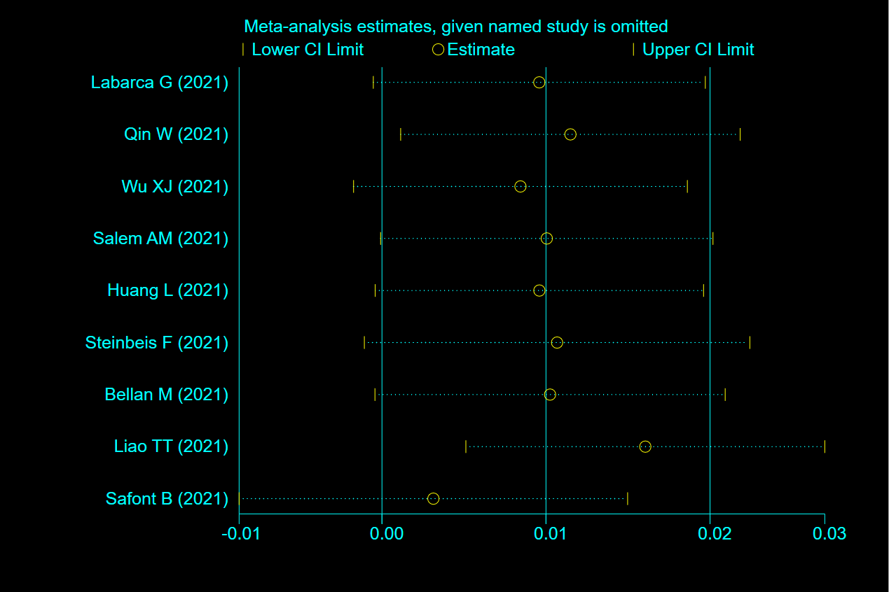

e-Figure 6. Meta-analyses of the association between age and impaired DLCO: after excluding heterogeneous literature.
1.Heterogeneity was insignificant (I²=28.4%, P=0.201) and a fixed-effects model was used to summarize test performance.
2.The data of age are Mean±SD, Median (IQR) or the full range of ages (Minimum-Maximum).
3.Total, sample size.
4.Follow-up, The interval between the patient's discharge from hospital and the pulmonary function tests.
5.Regression, The method of logistic regression analysis.
6.The square size indicates the weight of each study and of pooled data.
7.Abbreviations: OR, Odds ratio; CI, confidence intervals.
e-Figure 7. Meta-analyses of the association between age and impaired DLCO: Subgroup analysis of follow-up time
1.Heterogeneity was insignificant (I²=28.4%, P=0.201) and a fixed-effects model was used to summarize test performance.
2.The data of age are Mean±SD, Median (IQR) or the full range of ages (Minimum-Maximum).
3.Total, sample size.
4.Follow-up, The interval between the patient's discharge from hospital and the pulmonary function tests.
5.Regression, The method of logistic regression analysis.
6.The square size indicates the weight of each study and of pooled data.
7.Abbreviations: OR, Odds ratio; CI, confidence intervals.
e-Figure 8. Meta-analyses of the association between D-dimer and impaired DLCO.
1.Heterogeneity was insignificant (I²=34.6%, P=0.217) and a fixed-effects model was used to summarize test performance.
2.The data of age are Mean±SD, Median (IQR) or the full range of ages (Minimum-Maximum).
3.Total, sample size.
4.Follow-up, The interval between the patient's discharge from hospital and the pulmonary function tests.
5.Regression, The method of logistic regression analysis.
6.The square size indicates the weight of each study and of pooled data.
7.Abbreviations: OR, Odds ratio; CI, confidence intervals.

e-Figure 9. Meta-analyses of the association between urea nitrogen and impaired DLCO.
1.Heterogeneity was insignificant (I²=47.2%, P=0.169) and a fixed-effects model was used to summarize test performance.
2.The data of age are Mean±SD,or Median (Minimum-Maximum).
3.Total, sample size.
4.Follow-up, The interval between the patient's discharge from hospital and the pulmonary function tests.
5.Regression, The method of logistic regression analysis.
6.The square size indicates the weight of each study and of pooled data.
7.Abbreviations: OR, Odds ratio; CI, confidence intervals.

e-Figure 10. The Begg's funnel plot of studies on the association between age and impaired DLCO.

e-Figure 11.The Egger's publication bias plot of studies on the association between age and impaired DLCO.

e-Figure 12. The funnel plot of studies on the association between age and impaired DLCO.

