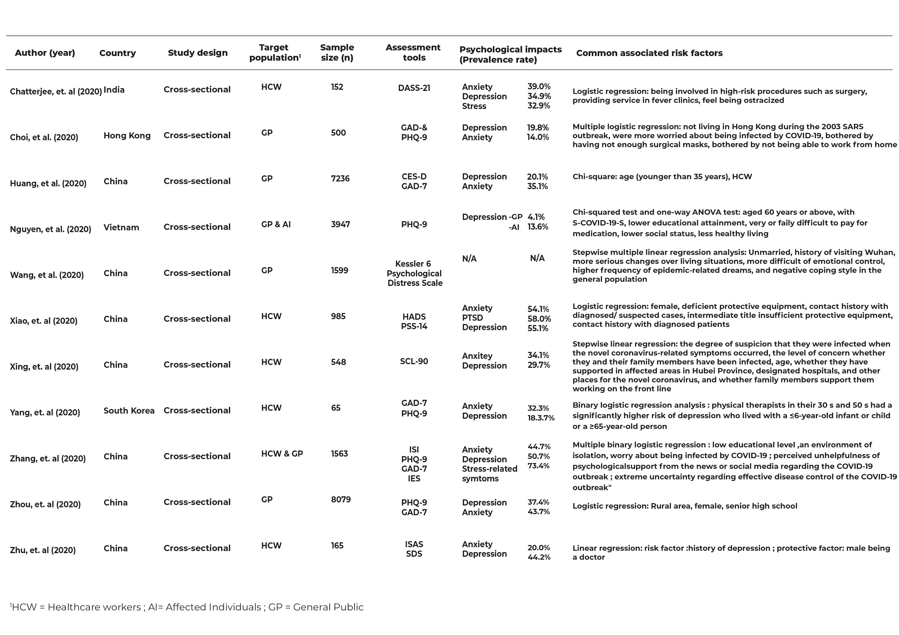
Appendix 1

Appendix 2

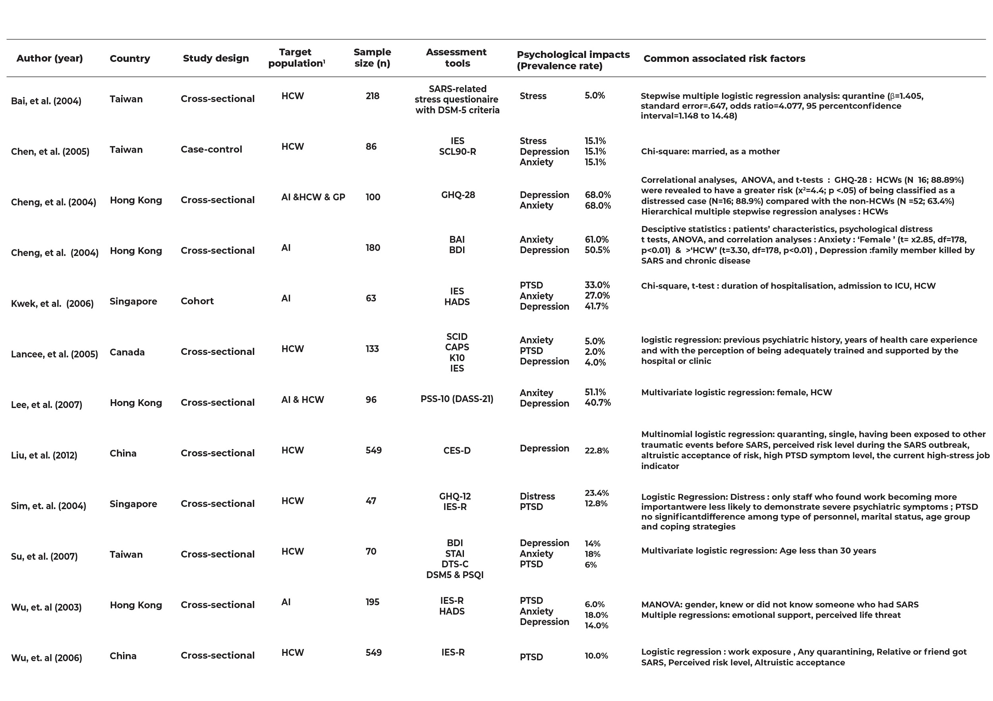

Supplementary Table 1. Studies conducted in Asian countries
Author (year) | Asian  Country | Study design | Target population¹ | Sample size (n) | Assessment tools | Psychological impacts  (prevalence rate) |  | Common associated risk factors
Chen, et al. (2021) | Taiwan | Cross-sectional | HCW | 492 | Chuang & Lou (2003) SARS stress scale | Stress | N/A | aged 41 or above, female, married, parents and nurses; experience of treating SARS; frontline healthcare workers with experience of treating SARS
Czeisler, et al. (2021) | Australia | Cross-sectional | GP | 1157 | The COVID-19 Outbreak Public Evaluation (COPE) Initiative | Anxiety/depressive disorder symptoms | 33.4% | Multivariable Poisson regressions: adjusted prevalence of adverse mental or behavioural health conditions
Tzeng, et al. (2020) | Taiwan | Cohort | AI, GP | AI–79  GP-340 | N/A | Anxiety  Depression  Sleep disorders  PTSD | N/A | Fine and Gray’s survival analysis: female, aged 45-64 years, ≧65 years, with the CCI score ≧2, care from medical centers and regional hospitals

¹HCW = Healthcare workers; AI = Affected Individuals; GP = General Public

Supplementary Table 2. Studies conducted in European countries
Author (year) | European  Country |  | Study design |  | Target population¹ |  | Sample size (n) |  | Assessment tools | Psychological impacts  (prevalence rate) |  |  |  | Common associated risk factors
Albert, et al. (2021) | Italy | Cross-sectional |  | AI |  | 56 |  | SAS  SDS |  |  | Anxiety  Depression |  | 63.0%  50.0% |  | Chi-squared test, t-tests: significant reduction in anxiety scores after lockdown
Buselli, et al. (2021) | Italy | Cross-sectional |  | HCW |  | 265 |  | PHQ-9  GAD-7 |  |  | Depression  Anxiety |  | N/A |  | Linear regression analysis (depression): burnout, secondary traumatization; (anxiety): first line activity, ICU working, burnout, secondary traumatization
De Giacomo, et al. (2021) | Italy | Cross-sectional |  | GP |  | 164 |  | PSS-10 |  |  | Stress |  | 6.84% |  | ANOVAs and Moderation analysis: lockdown; children with Neurodevelopmental Disorder (NDD)
Deledda, et al. (2021) | Italy | Cross-sectional |  | GP |  | 506 |  | DASS-21  IES-R |  |  | Depression  Anxiety  Stress  PTSD |  | 32.6%  33.4%  48.3%  40.3% |  | Univariable logistic regression models: Pervasive dysfunctional use of experiential avoidance, feelings of loneliness and high post-traumatic stress scores; fear of COVID-19
Juchnowicz, et al. (2021) | Poland |  | Cross-sectional |  | GP |  | 2172 |  | DASS-21 | Depression  Anxiety  Stress |  | 43.4%  27.3%  41.0% |  | U Mann–Whitney and H Kruskal–Wallis tests: female, studying sciences, co-residence with the roommates, suffering from a mental disorder, loneliness, psychiatric support before pandemic, poor economic situation, employed
Korukcu, et al. (2021) | Turkey |  | Cross-sectional |  | AI |  | 497 |  | EDS | Depression |  | N/A |  | Multiple linear regression models: healthy pregnancy, social media and news programs related to COVID-19, hospitalization, having bad dreams, request for elective cesarean delivery, breastfeeding, own health

¹HCW = Healthcare workers; AI = Affected Individuals; GP = General Public
Supplementary Table 3. Studies conducted in the other countries
Author (year) | Other  Country | Study design |  | Target population¹ |  | Sample size (n) |  | Assessment tools |  | Psychological impacts  (prevalence rate) |  |  |  | Common associated risk factors
Ferreira, et al. (2021) | Brazil |  | Cross-sectional |  | HCW |  | 483 |  | Self-structured scales |  | Anxiety |  | N/A |  | Chi-squared, t-tests: excessive amount of COVID-19 information, long family physical distance, living in a different state
Lopes, et al. (2021) | USA |  | Cross-sectional |  | GP |  | 1,624 |  | HADS |  | Anxiety  Depression |  | 8.1%  2.1% |  | Logistic regression models (depression): women, sleep hours and occasional alcohol consumption; (anxiety) male gender, older age, and sleep hours
Peluso, et al. (2021) | USA |  | Cross-sectional |  | AI |  | 179 |  | PHQ-8  GAD-7  4-item PCL-5 |  | Depression  Anxiety  PTSD |  | 19.0%  0%  11.0% |  | N/A
Temsah, et al. (2021) | Saudi Arabia |  | Cross-sectional |  | HCW |  | 1058 |  | GAD-7 |  | Anxiety |  | 13.2% |  | Multivariate linear regression analyses (travelling abroad): older age, female sex, higher GAD-7 scores, abstinence from traveling abroad in previous 3 months, belief of tighter infection control measures
Vally (2020) | UAE | Cross-sectional |  | GP |  | 634 |  | STAI-6 |  | Anxiety |  | 92.1% |  | Mann-Whitney U-test: N/A

¹HCW = Healthcare workers; AI = Affected Individuals; GP = General Public

