Supplementary Appendix

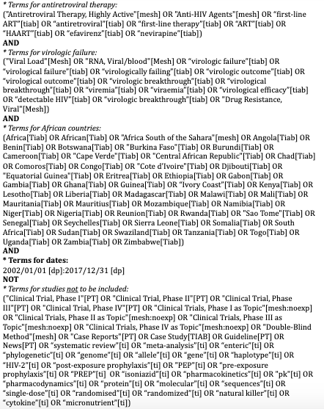
Supplementary Figure 1. Search terms used to identify relevant literature from PubMed for studies reporting CD4 cell count at the time of virologic failure in sub-Saharan Africa

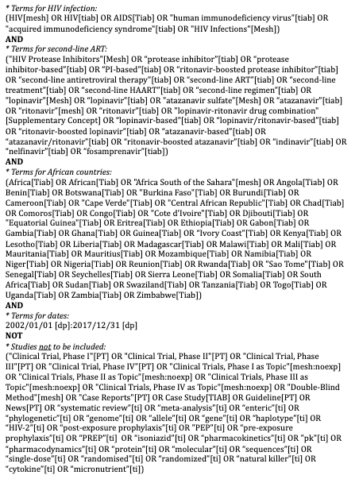
Supplementary Figure 2. Search terms used to identify relevant literature from PubMed for studies reporting CD4 cell count at time of switch to second-line ART following virologic failure

References (articles included in meta-analysis)
12345678910111213141516171819202122232425262728293031323333343536
1. Hawkins C, Hertzmark E, Spiegelman D, et al. Switching to second-line ART in relation to mortality in a large Tanzanian HIV cohort. J Antimicrob Chemother. 2017;72(7 PG-2060-2068):2060-2068. doi:10.1093/jac/dkx098
2. De Beaudrap P, Thiam M, Diouf A, et al. Risk of virological failure and drug resistance during first and second-line antiretroviral therapy in a 10-year cohort in Senegal: results from the ANRS 1215 cohort. J Acquir Immune Defic Syndr. 2013;62(4 PG-381-7):381-387. doi:10.1097/QAI.0b013e31827a2a7a
3. Okoboi S, Ding E, Persuad S, et al. Community-based ART distribution system can effectively facilitate long-term program retention and low-rates of death and virologic failure in rural Uganda. AIDS Res Ther. 2015;12(PG-37):37. doi:10.1186/s12981-015-0077-4
4. Osinusi-Adekanmbi O, Stafford K, Ukpaka A, et al. Long-term outcome of second-line antiretroviral therapy in resource-limited settings. J Int Assoc Provid AIDS Care. 2014;13(4 PG-366-71):366-371. NS -.
5. Petersen ML, Tran L, Geng EH, et al. Delayed switch of antiretroviral therapy after virologic failure associated with elevated mortality among HIV-infected adults in Africa. AIDS. 2014;28(14):2097-2107. doi:10.1097/QAD.0000000000000349
6. Jobanputra K, Parker LA, Azih C, et al. Impact and programmatic implications of routine viral load monitoring in Swaziland. J Acquir Immune Defic Syndr. 2014;67(1 PG-45-51):45-51. doi:10.1097/qai.0000000000000224
7. Jespersen S, Tolstrup M, Honge BL, et al. High level of HIV-1 drug resistance among patients with HIV-1 and HIV-1/2 dual infections in Guinea-Bissau. Virol J. 2015;12(PG-41):41. doi:10.1186/s12985-015-0273-9
8. Charpentier C, Talla F, Nguepi E, Si-Mohamed A, Belec L. Virological failure and HIV type 1 drug resistance profiles among patients followed-up in private sector, Douala, Cameroon. AIDS Res Hum Retroviruses. 2011;27(2 PG-221-30):221-230. doi:10.1089/aid.2010.0103
9. von Braun A, Sekaggya-Wiltshire C, Scherrer AU, et al. Early virological failure and HIV drug resistance in Ugandan adults co-infected with tuberculosis. AIDS Res Ther. 2017;14(1 PG-1):1. doi:10.1186/s12981-016-0128-5
10. Boender TS, Kityo CM, Boerma RS, et al. Accumulation of HIV-1 drug resistance after continued virological failure on first-line ART in adults and children in sub-Saharan Africa. J Antimicrob Chemother. 2016;71(10 PG-2918-27):2918-2927. doi:10.1093/jac/dkw218
11. Castelnuovo B, John L, Lutwama F, et al. Three-year outcome data of second-line antiretroviral therapy in Ugandan adults: good virological response but high rate of toxicity. J Int Assoc Physicians AIDS Care. 2009;8(1 PG-52-9):52-59. doi:10.1177/1545109708328538
12. Arnedo M, Alonso E, Eisenberg N, et al. Monitoring HIV viral load in resource limited settings: still a matter of debate? PLoS One. 2012;7(12 PG-e47391):e47391. doi:10.1371/journal.pone.0047391
13. Orrell C, Walensky RP, Losina E, Pitt J, Freedberg KA, Wood R. HIV type-1 clade C resistance genotypes in treatment-naive patients and after first virological failure in a large community antiretroviral therapy programme. Antivir Ther. 2009;14(4 PG-523-31):523-531. https://www.ncbi.nlm.nih.gov/pmc/articles/PMC3211093/pdf/nihms331141.pdf NS -.
14. Wallis CL, Mellors JW, Venter WD, Sanne I, Stevens W. Varied patterns of HIV-1 drug resistance on failing first-line antiretroviral therapy in South Africa. J Acquir Immune Defic Syndr. 2010;53(4 PG-480-4):480-484. doi:10.1097/QAI.0b013e3181bc478b
15. Murphy RA, Sunpath H, Lu Z, et al. Outcomes after virologic failure of first-line ART in South Africa. AIDS. 2010;24(7):1007-1012. doi:10.1097/QAD.0b013e3283333639
16. Shearer K, Evans D, Moyo F, et al. Treatment outcomes of over 1000 patients on second-line, protease inhibitor-based antiretroviral therapy from four public-sector HIV treatment facilities across Johannesburg, South Africa. Trop Med Int Heal. 2017;22(2 PG-221-231):221-231. doi:10.1111/tmi.12804
17. Adetunji AA, Achenbach C, Feinglass J, et al. Optimizing treatment switch for virologic failure during first-line antiretroviral therapy in resource-limited settings. J Int Assoc Provid AIDS Care. 2013;12(4 PG-236-40):236-240. doi:10.1177/1545109712463733
18. Rossouw TM, Nieuwoudt M, Manasa J, et al. HIV drug resistance levels in adults failing first-line antiretroviral therapy in an urban and a rural setting in South Africa. HIV Med. 2017;18(2 PG-104-114):104-114. doi:10.1111/hiv.12400
19. Fofana DB, Soulie C, Balde A, et al. High level of HIV-1 resistance in patients failing long-term first-line antiretroviral therapy in Mali. J Antimicrob Chemother. 2014;69(9 PG-2531-5):2531-2535. doi:10.1093/jac/dku153
20. Schoffelen AF, Wensing AMJ, Tempelman HA, Geelen SPM, Hoepelman AIM, Barth RE. Sustained Virological Response on Second-Line Antiretroviral Therapy following Virological Failure in HIV-Infected Patients in Rural South Africa. PLoS One. 2013;8(3). doi:10.1371/journal.pone.0058526
21. Johnston V, Fielding KL, Charalambous S, Churchyard G, Phillips A, Grant AD. Outcomes following virological failure and predictors of switching to second-line antiretroviral therapy in a South African treatment program. J Acquir Immune Defic Syndr. 2012;61(3 PG-370-80):370-380. doi:10.1097/QAI.0b013e318266ee3f
22. Onyedum CC, Iroezindu MO, Chukwuka CJ, Anyaene CE, Obi FI, Young EE. Profile of HIV-infected patients receiving second-line antiretroviral therapy in a resource-limited setting in Nigeria. Trans R Soc Trop Med Hyg. 2013;107(10 PG-608-14):608-614. doi:10.1093/trstmh/trt071
23. De Luca A, Sidumo ZJ, Zanelli G, et al. Accumulation of HIV-1 drug resistance in patients on a standard thymidine analogue-based first line antiretroviral therapy after virological failure: implications for the activity of next-line regimens from a longitudinal study in Mozambique. BMC Infect Dis. 2017;17(1 PG-605):605. doi:10.1186/s12879-017-2709-x
24. Etta EM, Mavhandu L, Manhaeve C, et al. High level of HIV-1 drug resistance mutations in patients with unsuppressed viral loads in rural northern South Africa. AIDS Res Ther. 2017;14(1 PG-36):36. doi:10.1186/s12981-017-0161-z
25. Seu L, Mulenga LB, Siwingwa M, et al. Characterization of HIV drug resistance mutations among patients failing first-line antiretroviral therapy from a tertiary referral center in Lusaka, Zambia. J Med Virol. 2015;87(7 PG-1149-57):1149-1157. doi:10.1002/jmv.24162
26. Brooks K, Diero L, DeLong A, et al. Treatment failure and drug resistance in HIV-positive patients on tenofovir-based first-line antiretroviral therapy in western Kenya. J Int AIDS Soc. 2016;19(1 PG-20798):20798. doi:10.7448/ias.19.1.20798
27. Labhardt ND, Ringera I, Lejone TI, et al. When patients fail UNAIDS’ last 90 - the “failure cascade” beyond 90-90-90 in rural Lesotho, Southern Africa: a prospective cohort study. J Int AIDS Soc. 2017;20(1 PG-21803):21803. doi:10.7448/ias.20.1.21803
28. Hosseinipour MC, Kumwenda JJ, Weigel R, et al. Second-line treatment in the Malawi antiretroviral programme: high early mortality, but good outcomes in survivors, despite extensive drug resistance at baseline. HIV Med. 2010;11(8 PG-510-8):510-518. doi:10.1111/j.1468-1293.2010.00825.x
29. Akanmu AS, Adeyemo T, Lesi F, et al. Immunological and Virological Outcomes of Patients Switched from LPV/r to ATV/r-Containing Second- Line Regimens. Curr HIV Res. 2015;13(3 PG-176-83):176-183. http://www.eurekaselect.com/131087/article NS -.
30. Sunpath H, Wu B, Gordon M, et al. High rate of K65R for antiretroviral therapy-naive patients with subtype C HIV infection failing a tenofovir-containing first-line regimen. Aids. 2012;26(13 PG-1679-84):1679-1684. doi:10.1097/QAD.0b013e328356886d
31. SR M, HH K, HB A, et al. Patterns of acquired HIV-1 drug resistance mutations and predictors of virological failure in Moshi, Northern Tanzania. PLoS One. 15(9 PG-e0232649):e0232649. doi:10.1371/journal.pone.0232649
32. Takou D, Fokam J, Teto G, et al. HIV-1 drug resistance testing is essential for heavily-treated patients switching from first- to second-line regimens in resource-limited settings: evidence from routine clinical practice in Cameroon. BMC Infect Dis. 2019;19(1 PG-246):246. doi:10.1186/s12879-019-3871-0
33. A von B, Sekaggya-Wiltshire C, Bachmann N, et al. HIV-1 Drug Resistance Among Ugandan Adults Attending an Urban Out-Patient Clinic. J Acquir Immune Defic Syndr. 78(5 PG-566-573):566-573. doi:10.1097/QAI.0000000000001717
34. FP H, Mulenga L, AO W, et al. Evolution of HIV-1 drug resistance after virological failure of first-line antiretroviral therapy in Lusaka, Zambia. Antivir Ther. 24(4 PG-291-300):291-300. doi:10.3851/IMP3299
35. Bell Gorrod H, Court R, Schomaker M, Maartens G, Murphy RA. Increased Mortality With Delayed and Missed Switch to Second-Line Antiretroviral Therapy in South Africa. J Acquir Immune Defic Syndr. 2020. doi:10.1097/QAI.0000000000002313
36. Mulu A, Maier M, Liebert UG. Low Incidence of HIV-1C Acquired Drug Resistance 10 Years after Roll-Out of Antiretroviral Therapy in Ethiopia: A Prospective Cohort Study. PLoS One. 2015;10(10 PG-e0141318):e0141318. doi:10.1371/journal.pone.0141318

