Supplementary Material
Supplementary Table 1. PICOS format for the research question
P: Covid -19 patients
I: Oral anticoagulation
C: No oral anticoagulation
O: Mortality or ICU admission
S: RCTs or cohort studies

Supplementary Table 2. Search strategy for the included databases based (PubMed as an example)
PubMed (July 24, 2021)
Number | Searches | Results
#3 | #1 AND #2 | 123
#2 | "COVID-19"[MeSH Terms] OR "SARS-CoV-2"[MeSH Terms] OR "2019 novel coronavirus"[Title/Abstract] OR "COVID-19"[Title/Abstract] OR "2019 ncov infection"[Title/Abstract] OR "coronavirus disease 19"[Title/Abstract] OR "2019 novel coronavirus"[Title/Abstract] OR "2019 ncov disease"[Title/Abstract] OR "novel coronavirus"[Title/Abstract] | 151,982
#1 | "Dabigatran"[MeSH Terms] OR "Warfarin"[MeSH Terms] OR "Rivaroxaban"[MeSH Terms] OR "apixaban"[Supplementary Concept] OR "edoxaban"[Supplementary Concept] OR "oral anticoagulants"[Title/Abstract] OR "novel oral anticoagulants"[Title/Abstract] OR "new oral anticoagulants"[Title/Abstract] OR "non vitamin k oral anticoagulants"[Title/Abstract] OR "NOACs"[Title/Abstract] OR "direct oral anticoagulants"[Title/Abstract] OR "DOACs"[Title/Abstract] OR "direct acting oral anticoagulants"[Title/Abstract] OR "vitamin k antagonist"[Title/Abstract] | 35,108

Supplementary Table 3. Univariable meta-regression for all-cause mortality
Variables | No. of cohorts | P value
Sample size | 14 | 0.134
Study setting | 14 | 0.782
Mean age | 13 | 0.207
Male | 14 | 0.113
Hypertension | 14 | 0.986
Diabetes mellitus | 14 | 0.772
Congestive heart failure | 12 | 0.354
Pulmonary disease | 10 | 0.476
Renal disease | 11 | 0.832

Supplementary Table 4. Sensitivity analysis with leave‐one‐out method for all-cause mortality
Study Omitted | RR (95% CI)
Aslan et al (2021) | 0.92(0.82-1.03)
Buenen et al (2021) | 0.94(0.83-1.06)
Chocron et al (2021) | 0.90(0.80-1.01)
Covino et al (2021) | 0.91(0.81-1.02)
Denas et al (2021) | 0.93(0.82-1.06)
Gülcü et al (2021) | 0.94(0.83-1.04)
Iaccarino et al (2021) | 0.93(0.82-1.05)
Rivera-Caravaca et al b (2021) | 0.90(0.80-1.00)
Russo et al (2021) | 0.90(0.80-1.01)
Spiegelenberg et al (2021) | 0.91(0.81-1.03)
Fröhlich et al DOACs (2021) | 0.93(0.82-1.06)
Fröhlich et al VKAs (2021) | 0.94(0.83-1.06)
Harrison et al DOACs (2021) | 0.94(0.84-1.06)
Harrison et al VKAs (2021) | 0.93(0.83-1.04)
RR, relative risk; CI, confidence interval.

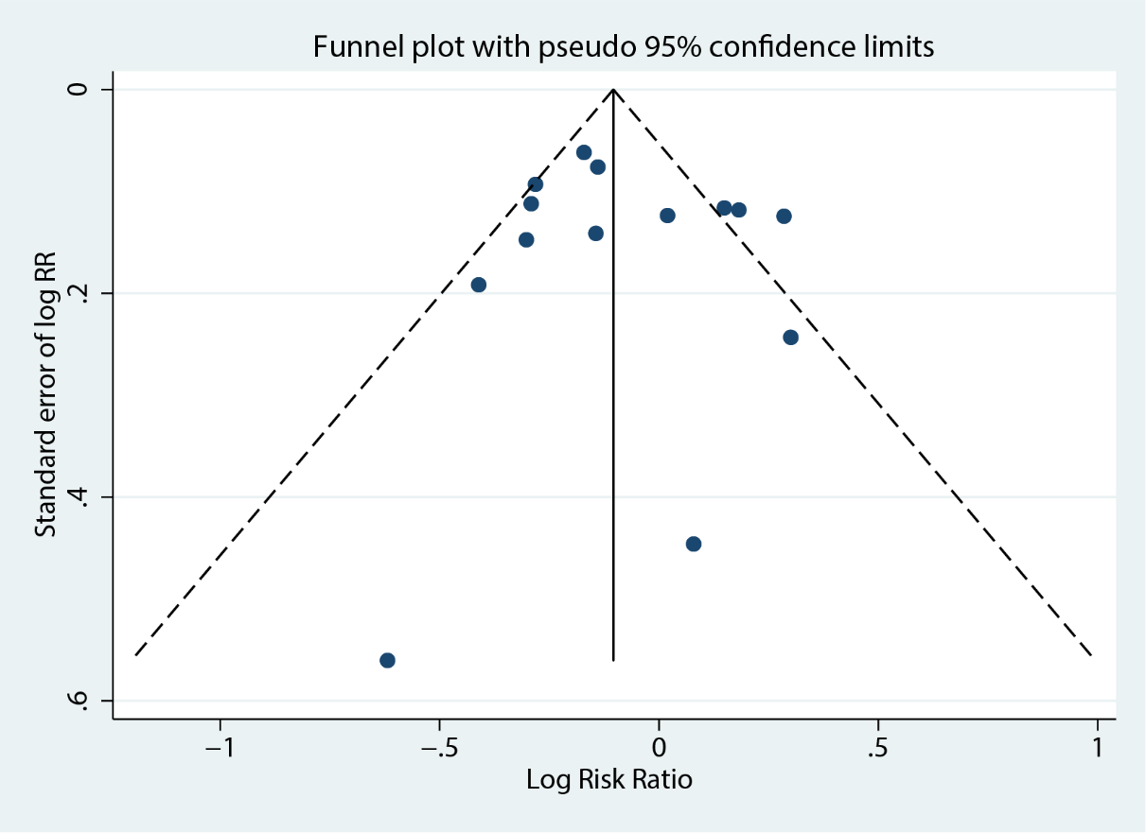
Supplementary Figure 1. Funnel plot analysis for the association of chronic OAC with all-cause mortality of COVID-19. OAC oral anticoagulation, COVID-19 coronavirus disease 2019.

