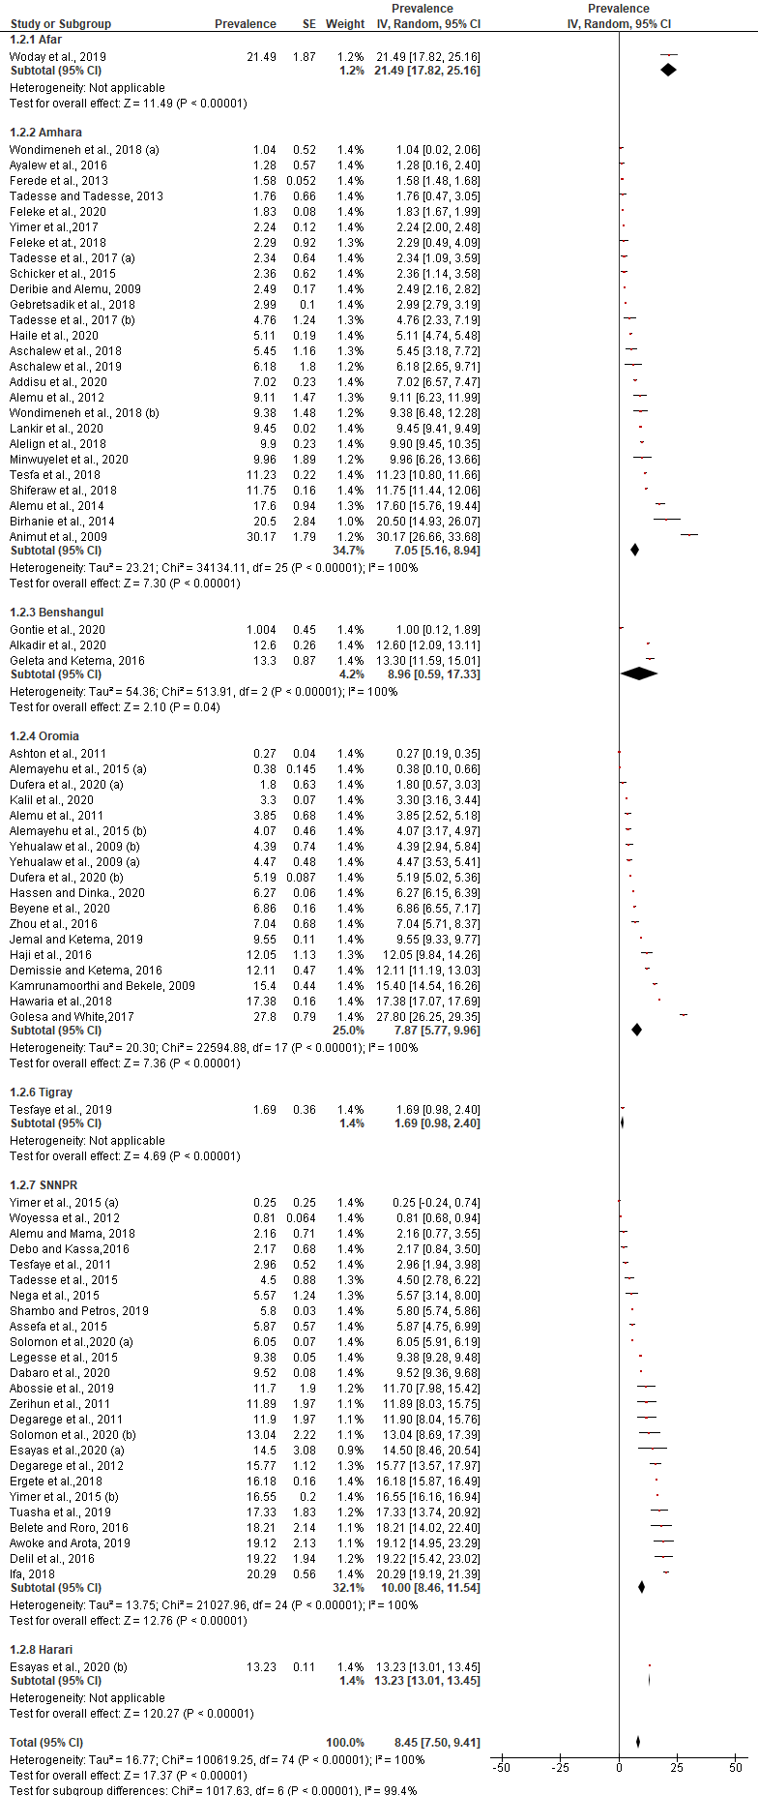
S3_Fig. Pooled estimates of prevalence of P. vivax for different locations/regions of Ethiopia

