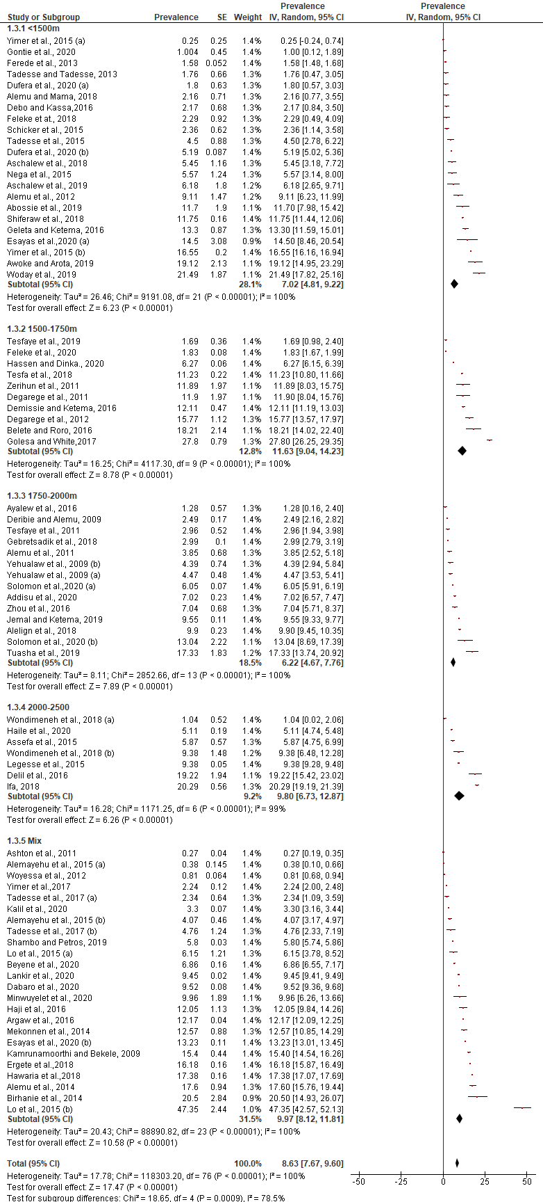
S4_Fig. Estimate prevalence of P. vivax in different eco-epidemiological zones of Ethiopia

