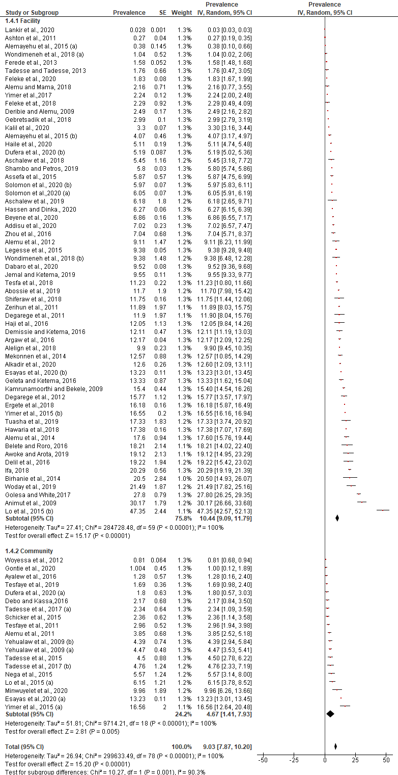
S5_Fig. Prevalence of P. vivax at different study settings in Ethiopia

