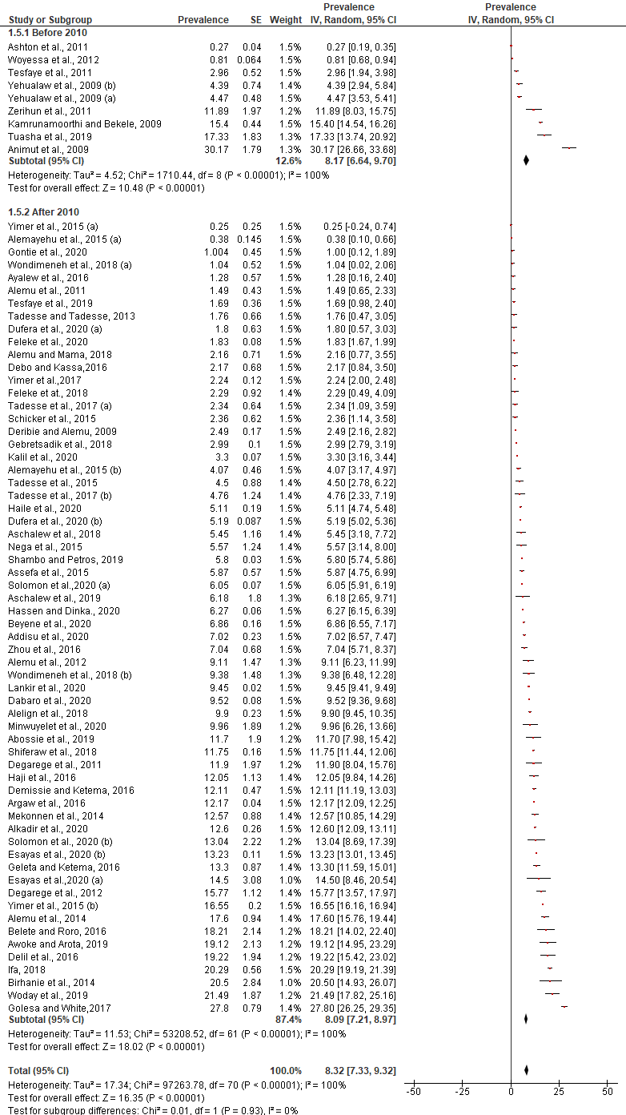
S6_Fig. Prevalence of P. vivax with respect to year of survey in Ethiopia

