STATIN USE AND MORTALITY IN COVID-19 PATIENTS: UPDATED SYSTEMATIC REVIEW AND META-ANALYSIS

APPENDIX B

Figure 1. Sensitivity analysis by excluding one study each time and pooling the estimate for the rest of the studies reporting hazard (A) and odds (B) ratios.

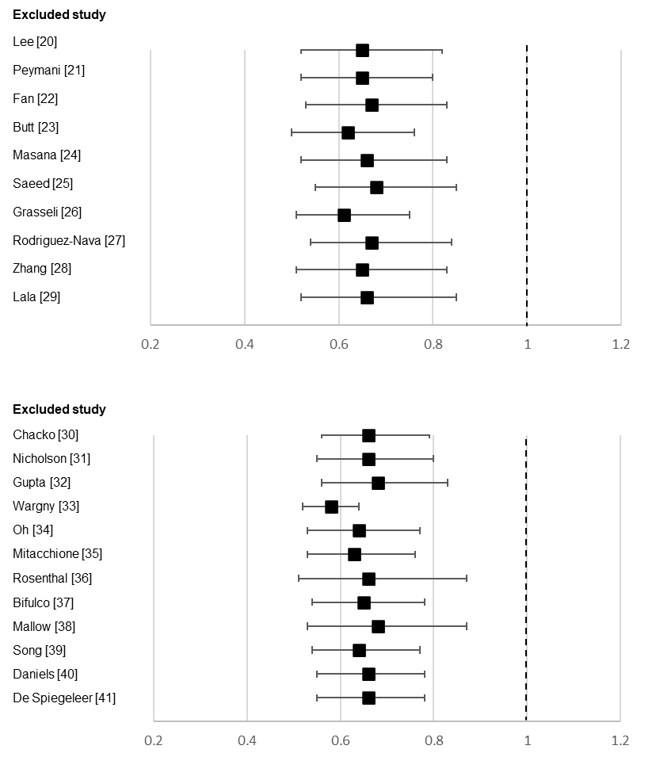
(A)
(B)
Figure 2. Begg’s funnel plot for studies reporting hazard (A) and odds (B) ratios
(B)
(A)
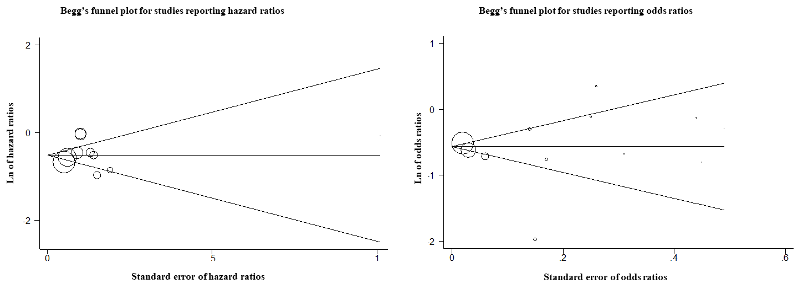
p= 0.93
p= 0.95

Table 1. Sensitivity and stratified analyses of studies reporting hazard and odds ratios

Included studies | Pooled hazard ratio (95% CI)
Mean age ≥ 65 years [24,25,27,29] | 0.54 (0.48, 0.61)
Mean age < 65 years [20-23,26,28] | 0.78 (0.62, 0.98)
Percentage of males ≥ 50% [21,24-27,29] | 0.62 (0.46, 0.84)
Percentage of males < 50% [20,22,23,28] | 0.70 (0.52, 0.95)
Excluding studies performed exclusively in ICU setting [26,27] | 0.63 (0.52, 0.77)
Excluding studies performed exclusively in diabetic patients [25] | 0.68 (0.55, 0.85)
Included studies | Pooled odds ratio (95% CI)
Mean age ≥ 65 years [30,32,33,35,37,38,41] | 0.66 (0.46, 0.96)
Mean age < 65 years [31,36,39,40] | 0.60 (0.56, 0.65)
Percentage of males ≥ 55% [31-33,35,37,39,40] | 0.74 (0.47, 1.15)
Percentage of males < 55% [30,36,38,41] | 0.56 (0.50, 0.64)
Excluding studies performed exclusively in diabetic patients [33] | 0.58 (0.52, 0.64)

Table 2. Assessment of risk of bias of the included studies
Study | Were the criteria for inclusion in the sample clearly defined? |  | Were the study subjects and the setting described in detail? | Was the exposure measured in a valid and reliable way? | Were objective, standard criteria used for measurement of the condition? | Were confounding factors identified? | Were strategies to deal with confounding factors stated? | Were the outcomes measured in a valid and reliable way? | Was the follow-up time reported? | Was appropriate statistical analysis used? | Overall quality rating
 |  | Studies reporting adjusted Hazard Ratios
Lee et al. [20] | Yes |  | Yes | Unclear | Yes | Yes | Yes | Yes | Yes | Yes | High
Peymani et al. [21] | Unclear |  | Yes | Yes | Yes | Yes | Unclear | Yes | Yes | Yes | High
Fan et al. [22] | Yes |  | Yes | Yes | Yes | Yes | Yes | Yes | No | Yes | High
Butt et al. [23] | Unclear |  | No | Yes | Yes | Yes | Yes | Yes | Yes | Yes | High
Masana et al. [24] | No |  | Yes | Yes | Yes | Yes | Yes | Yes | Yes | Yes | High
Saeed et al. [25] | Yes |  | Yes | Yes | Yes | Yes | Yes | Yes | Yes | Yes | High
Grasselli et al. [26] | Yes |  | Yes | Unclear | Yes | Yes | Yes | Yes | Yes | Yes | High
Rodriguez-Nava et al. [27] | Unclear |  | Yes | Yes | Yes | Unclear | Yes | Yes | No | Yes | Moderate
Zhang et al. [28] | Unclear |  | Yes | Yes | Yes | Yes | Yes | Yes | Yes | Yes | High
Lala et al. [29] | Yes |  | Yes | Unclear | Yes | Yes | Yes | Yes | No | Yes | High
 |  | Studies reporting adjusted Odds Ratios
Chacko et al. [30] | Unclear |  | Yes | Unclear | Yes | Yes | Yes | Yes | No | Yes | Moderate
Nicholson et al. [31] | Yes |  | Yes | Unclear | Yes | Yes | Unclear | Yes | No | Yes | Moderate
Gupta et al. [32] | Unclear |  | Yes | Yes | Yes | Yes | Yes | Yes | Yes | Yes | High
Wargny et al. [33] | No |  | Yes | Unclear | Yes | Yes | Yes | Yes | Yes | Yes | High
Oh et al. [34] | Yes |  | Yes | Unclear | Yes | Unclear | Unclear | Yes | No | Yes | Moderate
Mitacchione et al. [35] | Yes |  | Yes | Yes | Yes | Yes | Yes | Yes | No | Yes | High
Rosenthal et al. [36] | Unclear |  | Yes | Unclear | Yes | Yes | Unclear | Yes | No | Yes | Moderate
Bifulco et al. [37] | Unclear |  | Yes | Unclear | Unclear | Yes | Yes | Yes | No | Yes | Moderate
Mallow et al. [38] | Unclear |  | Yes | Yes | Yes | Yes | Yes | Yes | No | Yes | High
Song et al. [39] | Yes |  | Yes | Yes | Yes | Yes | Yes | Yes | No | Yes | High
Daniels et al. [40] | Yes |  | Yes | Unclear | Yes | Yes | Yes | Yes | No | Yes | High
De Spiegeleer et al. [41] | No |  | No | Yes | Yes | Unclear | Yes | Yes | Yes | Yes | Moderate
Studies with ≥7 ‘Yes’ were categorized as of high quality; 4-6 ‘Yes’ as of moderate

